TSG-SA Working Group 1 (Services) meeting #7 TSG S1 (00) 010
Sophia Antipolis, France 7 - 11 February 2000 Agenda Item: 6.1

Draft ETSI EG 201 721 V1.1.1 (1999-11)
ETSI Guide
Universal Mobile Telecommunication Systems (UMTS);
Strategies

Reference
DEG/SPAN-061309 (fxo00icq.PDF)
Keywords
ATM, IN, ISDN, PSTN, UMTS
ETSI
Postal address
F-06921 Sophia Antipolis Cedex - FRANCE
Office address
650 Route des Lucioles - Sophia Antipolis
Valbonne - FRANCE
Tel.: +33 4 92 94 42 00 Fax: +33 4 93 65 47 16
Siret N° 348 623 562 00017 - NAF 742 C
Association à but non lucratif enregistrée à la
Sous-Préfecture de Grasse (06) N° 7803/88
Internet
secretariat@etsi.fr
Individual copies of this ETSI deliverable
can be downloaded from
http://www.etsi.org
If you find errors in the present document, send your comment to: editor@etsi.fr
Important notice
This ETSI deliverable may be made available in more than one electronic version or in print. In any case of existing or perceived difference in contents between such versions, the reference version is the Portable Document Format (PDF). In case of dispute, the reference should be the printing on ETSI printers of the PDF version kept on a specific network drive within ETSI Secretariat.

Copyright Notification
No part may be reproduced except as authorized by written permission.
The copyright and the foregoing restriction extend to reproduction in all media.

© European Telecommunications Standards Institute 1999.
All rights reserved.
Contents
Intellectual Property Rights 4
Foreword 4
Introduction 4
1 Scope 5
2 References 5
3 Definitions, symbols and abbreviations 5
3.1 Definitions 5
3.2 Abbreviations 6
4 Generic requirements 7
4.1 General requirements for support of mobile multimedia services 7
4.2 Intelligent network capabilities 7
4.3 Quality of Service requirements 7
4.4 Features related to security and privacy: 8
4.5 Cost-effective network 8
4.6 Requirements for packet networks 8
5 Access scenarios to UMTS 8
5.1 Scenario 1 - fixed terminal access 9
5.2 Scenarios 2 & 3 - roaming in private UMTS networks 10
5.3 Scenario 4 - support of private access systems 11
5.4 Scenario 5 - public cellular access to the fixed network 12
6 Evolution Scenarios 13
6.1 Starting Points 13
6.2 Starting point 1 - PSTN / POTS 13
6.3 Evolution scenario for starting point 1 13
6.3.1 Starting point 2 - N-ISDN 14
6.4 Evolution scenario for starting point 2 15
6.4.1 Starting point 3 - B-ISDN 15
6.5 Evolution scenario for starting point 3 16
6.6 Addition of BRAN access 17
6.7 Internet access evolution 17
6.7.1 Mobility spanning IP and IN networks 20
6.8 Recommendations for standards development 21
6.8.1 Service aspects 21
6.8.2 System aspects 21
6.8.3 Radio aspects 21
6.8.4 Access aspects 21
6.8.5 Protocol aspects 21
Annex A (informative): Standardization committees of interest 22
History 23

Intellectual Property Rights
IPRs essential or potentially essential to the present document may have been declared to ETSI. The information pertaining to these essential IPRs, if any, is publicly available for ETSI members and non-members, and can be found in SR 000 314: "Intellectual Property Rights (IPRs); Essential, or potentially Essential, IPRs notified to ETSI in respect of ETSI standards", which is available from the ETSI Secretariat. Latest updates are available on the ETSI Web server (http://www.etsi.org/ipr).
Pursuant to the ETSI IPR Policy, no investigation, including IPR searches, has been carried out by ETSI. No guarantee can be given as to the existence of other IPRs not referenced in SR 000 314 (or the updates on the ETSI Web server) which are, or may be, or may become, essential to the present document.

Foreword
This ETSI Guide (EG) has been produced by ETSI Technical Committee Services and Protocols for Advanced Networks (SPAN), and is now submitted for the ETSI standards Membership Approval Procedure.

Introduction
Broadband multimedia services, which can be accessed from fixed and mobile terminals, have considerable market potential. International standards are being developed to provide for such services and several technologies will soon be available. IMT-2 000 and UMTS requirements are the basis of a target network that will enable operators to offer such multimedia services. UMTS, which will be operational in 2002, gives a time frame within which the evolution of fixed networks could occur.
These developments offer opportunities and present challenges for fixed network operators. Systems capable of supporting mobile multimedia services require very large investments. Customers will only invest in expensive terminals if these offer attractive new services of the highest quality and at an acceptable price. Fixed network operators will have to develop and evolve their core and access networks to meet these demands.
The present document provides scenarios for the evolution of fixed networks to UMTS. Several starting points based on PSTN, N-ISDN and B-ISDN networks are being considered to support the different access options available for UMTS. Recognizing the importance of the Internet Protocol (IP) in today's networks, this technology has been included in the evolution strategies outlined in this document.

1 Scope
The scope of the present document is to describe possible strategies for the evolution of fixed networks towards UMTS. The following issues are covered by this document:
- Identification of access scenarios to UMTS.
- Definition of networks/network components that need to be upgraded with UMTS capabilities.
- Interworking with legacy networks / network components.
- Introduction of wireless access networks as specified by 3GPP RAN and EP BRAN and interconnection to the fixed network (e.g. ISDN, PSTN, IP, ATM) evolved to UMTS.
- Introduction of mobility-supporting capabilities in fixed networks to facilitate global roaming within the IMT-2 000 family of third generation systems.

2 References
The following documents contain provisions which, through reference in this text, constitute provisions of the present document.
• References are either specific (identified by date of publication, edition number, version number, etc.) or non-specific.
• For a specific reference, subsequent revisions do not apply.
• For a non-specific reference, the latest version applies.
• A non-specific reference to an ETS shall also be taken to refer to later versions published as an EN with the same number.
[1] EN 301 061-1: "Integrated Services Digital Network (ISDN); Digital Subscriber Signalling System No. one (DSS1) protocol; Generic functional protocol for the support of supplementary services at the "b" service entry point for Virtual Private Network (VPN) applications; Part 1: Protocol specification".
[2] ITU-T Recommendation H.323: "Packet based multimedia communications systems".
[3] ITU-T Recommendation T.120: "Data protocols for multimedia conferencing".
[4] EN 301 005-1: "V interfaces at the digital Service Node (SN); Interfaces at the VB5.1 reference point for the support of broadband or combined narrowband and broadband Access Networks (ANs); Part 1: Interface specification".
[5] EN 301 217-1: "V interfaces at the digital Service Node (SN); Interfaces at the VB5.2 reference point for the support of broadband or combined narrowband and broadband Access Networks (ANs); Part 1: Interface specification".

3 Definitions, symbols and abbreviations

3.1 Definitions
For the purposes of the present document, the following definition applies:
fixed network: network that does not deploy the infrastructure (equipment and protocols) that is required for mobility management. However, a fixed network may provide fixed wireless access to terminals or private networks. A fixed network does not provide support for continuous mobility (i.e. handover)

3.2 Abbreviations
For the purposes of the present document, the following abbreviations apply:
3GPP Third Generation Partership Project
3GPP RAN Third Generation Partership Project - Radio Access Network
AAL2 ATM Adaptation Layer 2
ABR Available Bit Rate
ATM Abstract Test Method
B-ISDN Broadband-ISDN
BRAN Broadband Radio Access Networks
BS Base Station
BSS Base Station System
CBR Constant Bit Rate
CN Core Network
CT2 Cordless Telephone 2nd generation
DECT Digital Enhanced Cordless Telecommunications
DSS1 Digital Signalling System number one
DSS2 Digital Signalling System number two
FT Fixed Terminal
GK Gatekeeper
GSM Global System for Mobile communications
GW Gateway
HLR Home Location Register
VLR Visitor Location Register
IMT-2 000 International Mobile Telecommunications for year 2000
IN Intelligent Network
INAP IN Application Protocol
IP Internet Protocol
ISDN Integrated Services Digital Network
ISP Internet Service Provider
ISUP ISDN User Part
IWU InterWorking Unit
LAN Local Area Network
MT Mobile Terminal
N-ISDN Narrowband Integrated Services Digital Network
NNI Network Node Interface
PDN Plesiochronous Digital Network
PHS Portable HandSet
PIG PSTN/Internet Gateway
POTS Plain Old Telephone Service
PSTN Public Switched Telephone Network
Q-SIG Q Interface SignallinG protocol (ECMA standard)
QoS Quality of Service
RNC Radio Network Controller
SCF Selective Call Forwarding
SDF Service Data Function
TDD Time Division Duplex
TIPHON Telecommunications and Internet ProtocolHarmonization over Network
TUP Telephone User Part
UBR Unspecified Bit Rate
UMTS Universal Mobile Telecommunications System
USIM UMTS Subscriber Identity Module
VBR Variable Bit Rate
WATM Wireless ATM
WWW World-Wide Web
xDSL generic Digital Subscriber Line technology

4 Generic requirements
The target system must provide a user access to broadband multimedia services from different access points and while on the move. From these general user requirements, target network requirements can be derived.
The target system resulting from the fixed network evolution shall satisfy the requirements in the following subclauses.

4.1 General requirements for support of mobile multimedia services
This subclause covers requirements related to Internet access and radio & network bearer capabilities. Fixed-evolved UMTS will be required to:
- be compatible with the Internet Protocol;
- provide routeing capability based on IP version 4 and/or IP vervion 6;
- support a wide variety of services, including "push", "pull" and multicast-type services;
- provide packet mode bearers up to 2 Mbps;
- support of global mobility;
- support of terminal mobility, personal mobility and service portability;
- support roaming between UMTS and GSM;
- support global Roaming:
- UMTS aims to be compatible with IMT-2 000 systems, to provide global terminal mobility (e.g. to provide access to the subscribers of various IMT-2 000 member networks), and to transparently provide all subscribed home services to roaming IMT-2 000 users;
- UMTS aims to be inter-operable with all IMT-2 000 Family members in order to offer the global roaming capability to its users roaming in other IMT-2 000 networks. Therefore, UMTS standards need to be common to the maximum extent possible with the standards of other IMT-2 000 Family members;
- the UMTS inter-operability with other IMT-2 000 networks is to be implemented via an inter-working function in the short term leading towards the development of a common NNI in the long-term.

4.2 Intelligent network capabilities
- Support of rapid service creation and introduction;
- Support of Virtual Home Environment (VHE) i.e. operator specific services.

4.3 Quality of Service requirements
- Speech quality comparable to fixed network;
- High quality audio, data, image, and video;
- Selection of QoS classes / parameters required by users' applications;
- QoS indication/negotiation (CBR, VBR, ABR, UBR).

4.4 Features related to security and privacy:
- Protection from impersonation (authentication);
- Protection of user and service profile from malicious attacks;
- Privacy of communications (encryption of user data);
- Location privacy.

4.5 Cost-effective network
- Support of a multivendor environment based on open (standard) interfaces;
- Effective use of transmission facility:
- ATM technology as one possible candidate:
- ATM switching system;
- AAL2 for efficient use of resources for low bandwidth applications;
- circuit and packet switching capabilities on the same ATM platform.
- Support of a broad range of applications;
- Cellular, Wireless IP, WATM, …;
- IP technology as a further possible candidate.

4.6 Requirements for packet networks
Packet based networks as part of the fixed network evolved UMTS should provide the following capabilities:
- Wide area and large scale;
- Efficient use of radio and network resources;
- Mobile multimedia capabilities:
- High Speed;
- Support of point to point, point to multipoint, broadcast connections;
- Support of QoS.
- To provide IP based applications (e.g. e-mail, WWW, …)
Support of fixed and / or dynamic IP addresses.

5 Access scenarios to UMTS
Fixed network operators will have a variety of options at their disposal for providing customers access to UMTS services. These options are identified as access scenarios in this clause, and may have different implications on the protocol requirements at the user-network interface.
The basis for the description of these access scenarios is figure 1, which identifies different system / network domains in UMTS.
These scenarios are:
- fixed Terminal Access;
- fixed Access Roaming in Private Networks;
- radio Access Roaming in Private Networks;
- support of Private Access Systems;
- public Cellular Access to the Fixed Network.
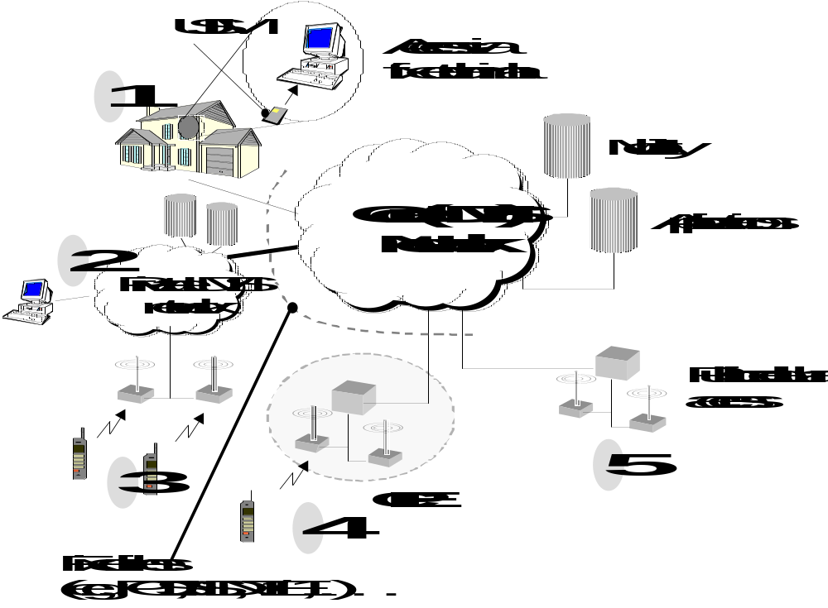
Figure 1: Implementation of the different access scenarios

5.1 Scenario 1 - fixed terminal access
In this scenario, USIM roaming is assumed, i.e. the only type of mobility supported is personal mobility. This scenario can be accomplished by providing a wired terminal with a USIM . This arrangement would be beneficial when the user:
- is out of range of public UMTS radio coverage;
- only requires terminal transportability, thus releasing UMTS radio capacity for other users;
- needs higher data rates than supported by UMTS radio access.
The support of UMTS capabilities on fixed terminals (including support of discrete mobility between UMTS-capable fixed terminals) offers opportunities both in the business and residential user environment.
In a residential environment, this scenario allows a UMTS user (more specifically the USIM) to roam between wired terminals giving the user same support of his service profile on these terminals. This scenario takes advantage of the network operator's significant investment in the access network.
In a business user environment, this scenario allows a corporate UMTS user (the USIM) to roam between wired terminals located in a business or residential environment. This scenario gives the user the same support of his service profile on each terminal. It takes advantage of the business's investment in the access and switching infrastructure. The expedient solution for UMTS phase 1 (circa 2002) may be based on private network standards (e.g. evolution of Q-SIG).

5.2 Scenarios 2 & 3 - roaming in private UMTS networks
These scenarios involve customers owning and operating their own UMTS core networks. These self-contained systems will interwork with other private and public UMTS core networks, and typically will operate in licence exempt spectrum. These systems should provide a home network capability for internal users across multiple, possibly isolated, sites to enable users to access the same services when roaming within the private network. Such networks will typically be used by organizations with large industrial sites or office complexes.
Private Networks involve the implementation of UMTS Core Network (CN) functionality. This allows customers to own and operate their own UMTS core and radio access network within their own premises.
Private Networks require an extension of the SMG UMTS Model to include an additional interface between the private network and the access network of the public network . This is included in the SPAN UMTS Task Force extension of the SMG UMTS Model as another use of the Wu Interface, this time between the Access Network Domain and the Private Network Domain (see figure 4). However, the use of this interface is quite different from that of the Private Access System.
In order to understand the standards implications of the private networks, it is necessary to consider the next level of detail of the Private Network Domain. This is illustrated in Figure 2 which shows how a Private Network is made up of a number of BSs which serve the Uu interface and are connected to and controlled by an RNC. The RNCs are connected to the CN which provides the connection to the Access Network via the Wu Interface. The simplest private network may include the functionality of the BS, RNC and CN within a single physical entity. It is not clear whether or not interfaces within the private network (i.e. between the BS and RNC and between the RNC and CN) should be specified.
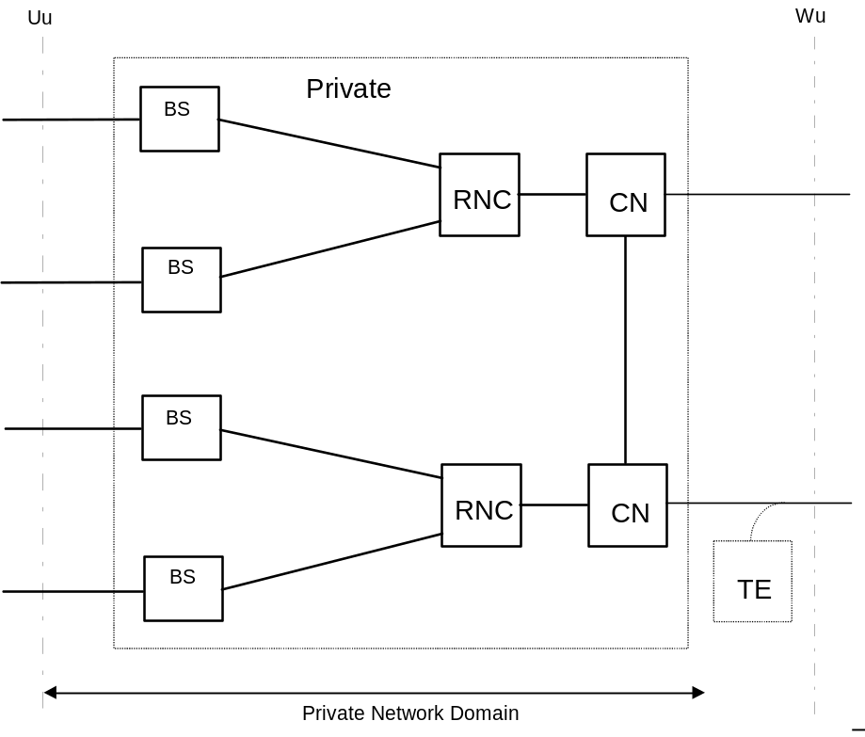
Figure 2: The private network domain
As with private access systems, it is not known whether there is any specification work being pursued on the network aspects of UMTS Private Networks. However, much of what has been done for wireless/cordless terminal mobility in private networks (CT2, DECT and PHS) in ETSI, ECMA TC32, and ISO/IEC JTC1 may apply.
In general, private networks will have their own service provision capability for their internal users. Private networks may also provide access for visiting users from other private or public networks. Private network registered users could also roam into other private or public networks. Therefore, the interworking over the Wu Interface between the Core Network Domain and the Private Network Domain will be similar to that between different UMTS public CNs.
To interconnect with public networks, private networks may need to share the same public network termination point with other terminal equipment / services (the TE in Figure 2). This will be particularly important for small business installations where a single connection to the public network may need to be shared with other non-UMTS services.

5.3 Scenario 4 - support of private access systems
This scenario involves customers owning and operating their own UMTS radio access network within their premises. These systems will operate in licence exempt spectrum and will be connected to a public UMTS core network. This arrangement would be beneficial when the user:
- is out of range of public UMTS radio coverage;
- requires access to UMTS services in the residential environment.
Functions of the core network include authentication, support of service profiles, network interconnect and traffic routeing. Applications will range from residential use to private organizations such as universities and conference centres.
The implementation of this scenario requires an extension of the SMG UMTS Model to include an additional interface between the access network of the public network and the private access system. This is included in the current NA6 WG SPAN6 UMTS Task Force extension of the SMG UMTS model as the Wu interface between the Access Network Domain and the Private Access Domain, see figure 4. In order to understand the standards implications of private access systems, it is necessary to consider the next level of detail of the Private Access Domain, see Figure 4. This figure shows how the Private Access System is made up of a number of BSs which serve the Uu interface and are connected to and controlled by an RNC which provides the connection to the access network via the Wu interface. (Note that the RNC here may not need the full functionality required in public access systems).
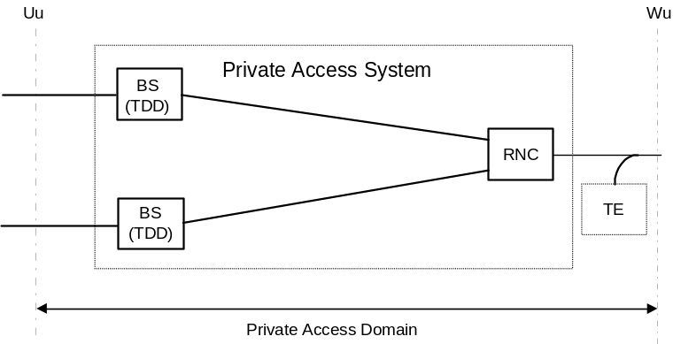
Figure 3: The private access domain
Note that, in order to interconnect with public networks, private access systems may need to share the same public network termination point with other terminal equipment / services (the TE in Figure 3). This will be particularly important for residential and small business installations where a single connection to the public network may need to be shared with other non-UMTS services. The simplest private access system will include the functionality of the BS and RNC within a single physical entity (which could be applicable to the residential user scenario).

5.4 Scenario 5 - public cellular access to the fixed network
Only one service scenario is considered. A PNO with an existing fixed network has obtained a licence for UMTS spectrum and wishes to introduce a public wide-area UMTS cellular network.
In this scenario, special considerations in the access network domain are not required. The addition of UMTS mobility management capabilities in the fixed network needs to be considered.
Interfaces between individual domains, as identified in figure 4 shall be open and thus require standardization. The identification of further interfaces between sub-components within individual domains is out of the scope of this document.
The interface between the access network domain and the core network domain is the Iu interface being specified by 3GPP. The interface between the mobile equipment domain and the access network domain is the Uu interface being specified by 3GPP.
Figure 1 introduces a new reference point Wu, which takes into account the possibility that only a subset of the features specified by the Iu interface might be required.
The physical implementation of the different access scenarios is illustrated in Figure 1.
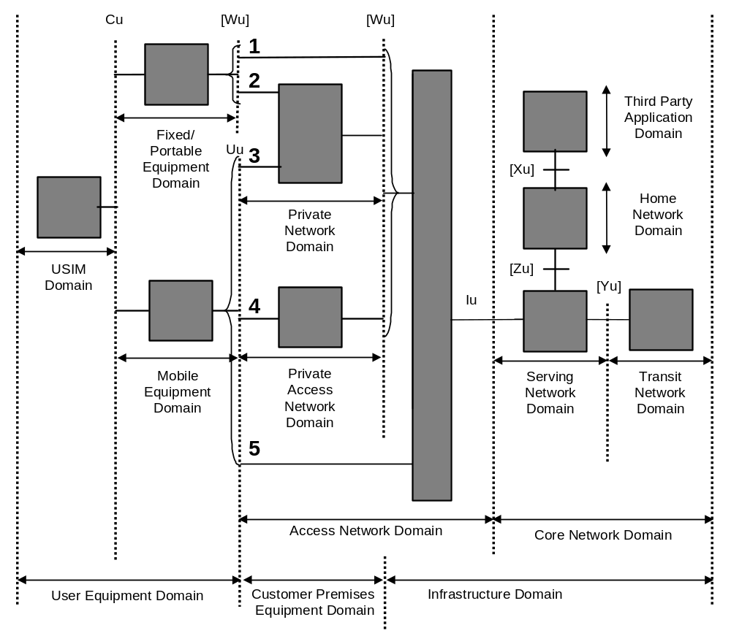
NOTE : The domains identified in the figure will generally result from an evolution of existing network infrastructures. The core network domain may result from evolutions of existing network infrastructures, e.g. a GSM infrastructure, an N-ISDN infrastructure, a B-ISDN infrastructure or a PDN infrastructure. The evolution of these infrastructures may be performed via the use of IWUs, hidden within the domains shown in the figure.

Figure 4: Additional reference points for fixed and cordless access to public
and private networks

6 Evolution Scenarios

6.1 Starting Points
Three different types of fixed networks have been selected as starting points for the network evolution scenarios towards a target core network supporting broadband services and mobility. The selected starting points are considered to represent the most common public fixed network types.

6.2 Starting point 1 - PSTN / POTS
The first starting point is POTS terminals connected to the PSTN as shown in Figure 5. The following assumptions have been made:
- the Fixed Terminal (FT) is a POTS terminal;
- the core network uses N-ISDN for transport and switching;
- the core network has not implemented any intelligence.
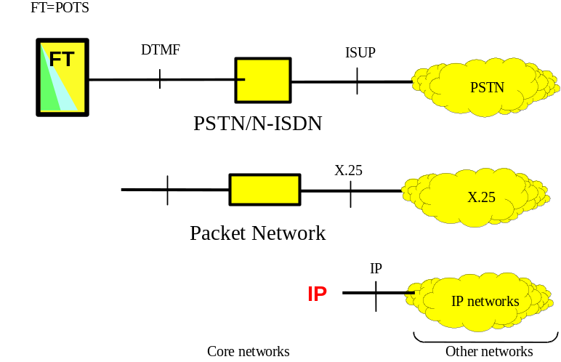
Figure 5: Scenario 1: PSTN / POTS starting point

6.3 Evolution scenario for starting point 1
A first step in the evolution of a PSTN core network that satisfies some of the requirements of a target system is illustrated in Figure 6. The evolution is based on installation of a UMTS Base Station Sub-systems (BSS) and introduction of a mobility server in the core network to provide support for terminal and personal mobility. The mobility server is a generic concept that describes storage of user location information. Interactions between network elements and the mobility server may be based on enhancements to IN, or in IP networks on mobile IP, with appropriate extensions to meet the requirements of public network operators. Handover is unlikely to be supported in this scenario.
An InterWorking Unit (IWU) is introduced in the access point Iu, to separate circuit switched and packet data traffic in the core network. From the UMTS BSS over the Iu interface xDSL modem technology may be used over the copper local loop. The use of xDSL will offer a bandwidth of more than 300 kbit/s.
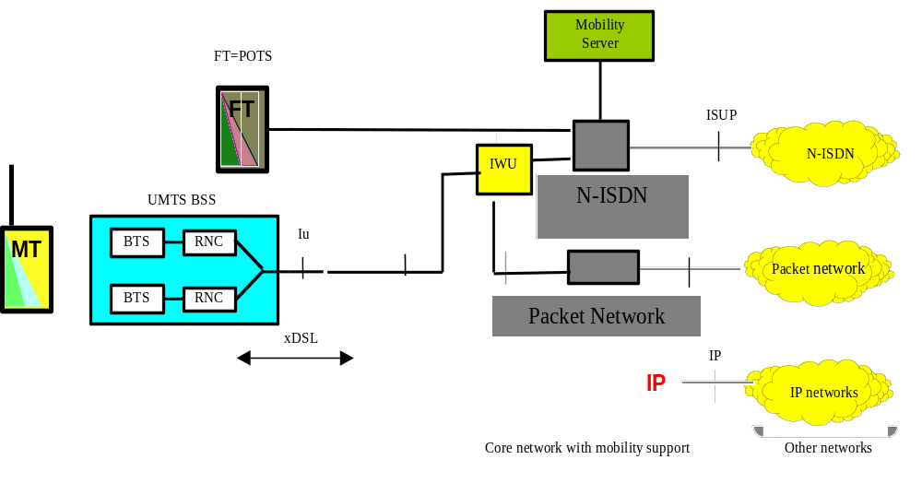
Figure 6: Addition of UMTS radio access

6.3.1 Starting point 2 - N-ISDN
This starting point, shown in Figure 7 is based on N-ISDN with the following assumptions:
- the FT is an ISDN terminal, with DSS1 access signalling;
- the core network uses N-ISDN transport and switching;
- the deployment of network intelligence for the implementation of supplementary and value-added services is optional.
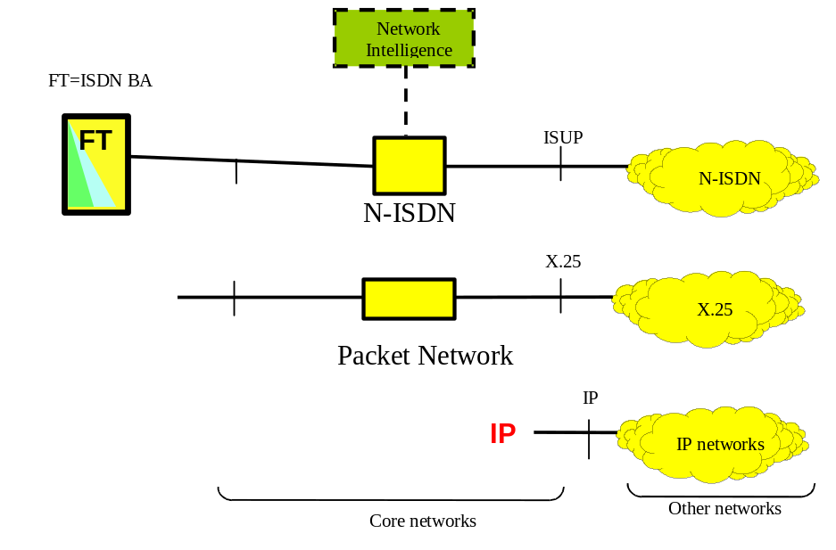
Figure 7: Scenario 2: N-ISDN starting point

6.4 Evolution scenario for starting point 2
As a first step to provide mobility, mobility server functionality may be added to the core network. This is illustrated in Figure 8. This update of the core network provides the user with terminal mobility via fixed access provided that a terminal / user registration procedure is introduced. The maximum bit rate that can be supported over ISDN basic access is 144 kbit/s.
In a next step the N-ISDN network may be updated with radio access. This may be in terms of a UMTS radio access. To support UMTS the DSS1+ (see EN 301 061-1 [1]) protocol used over the user network interface must be enhanced.
The support of mobility in this scenario is still limited so that only mobility within the UMTS BSS coverage area is supported, i.e. no handover support between private and public UMTS networks is assumed. However a UMTS / terminal may roam into another subsystem assuming the necessary access rights have been granted.
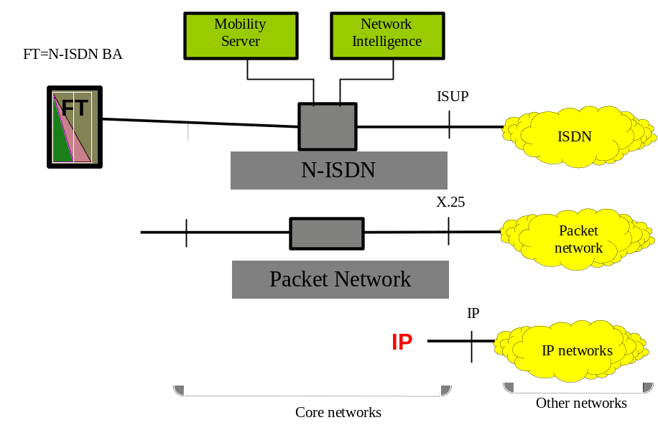
Figure 8: Addition of mobility support

6.4.1 Starting point 3 - B-ISDN
This starting point for fixed networks is B-ISDN based on ATM. Broadband ATM networks, shown in Figure 9 provide the infrastructure to facilitate integration of telecommunication and computer communication for the provisioning of advanced multimedia services to the user. Within the target of 3G UMTS integration with B-ISDN based on ATM transport, integration with Intelligent Network concept and support of numerous and diverse radio interfaces have to be provided. The assumptions for the B-ISDN based network are:
- B-ISDN core network with ATM transport;
- fixed line N- or B-ISDN terminals, with DSS1/DSS2 access signalling;
- the deployment of network intelligence for the implementation of supplementary and value-added services is optional.
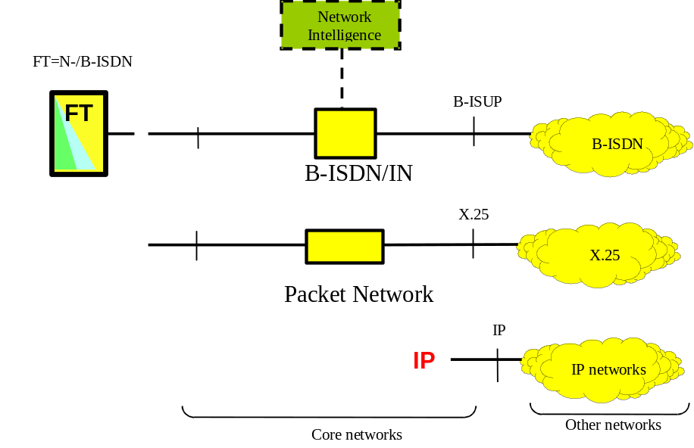
Figure 9: Scenario 3: B-ISDN starting point

6.5 Evolution scenario for starting point 3
From the B-ISDN starting point Figure 9, a first evolution step is illustrated in Figure 10. This step will offer personal mobility and terminal mobility via fixed access. The core B-ISDN network is extended with IN functionality with mobility support.
In order to support terminal mobility via fixed access the DSS2 access protocol has to be extended, in the figure indicated as DSS2+. These enhancements may lead to INAP extensions as well, if INAP is used to implement mobility server functionality.
In a second step radio access may be added to the B-ISDN network. The fixed terminal access is extended with mobile access using a Mobile Terminal (MT).
The B-ISDN network is updated with radio access via an IWU. The IWU is assumed to support both DSS2 and VB5 (see EN 301 005-1 [4] and EN 301 217-1 [5]) interfaces. The transport from the access network to the IWU can be xDSL. In this example, access to the Iu interface is based on xDSL technology.
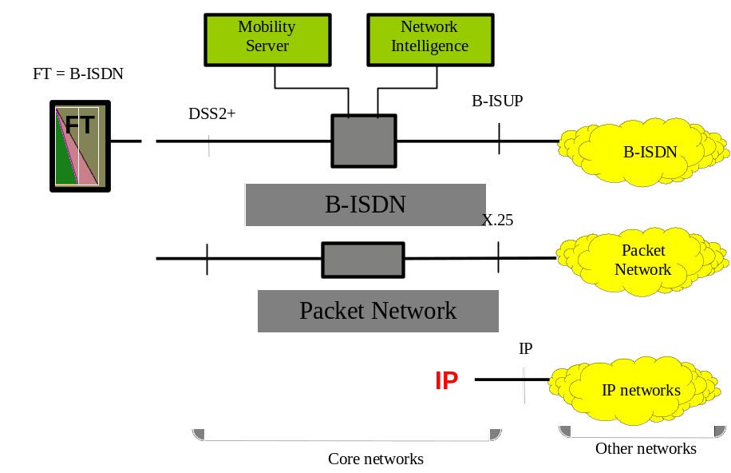
Figure 10: Addition of mobility support

6.6 Addition of BRAN access
The above scenarios all indicate evolutions possible in the short term towards UMTS, while the following evolution will be possible only in a second phase when the Broadband Radio Access Network (BRAN) standardization is completed.
BRAN denotes a number of technologies being suitable for the implementation of broadband radio access networks. The technologies are described in Technical Reports produced by ETSI Project BRAN. These technologies are known as HIPERLAN/2 and HIPERACCESS.
These wireless access networks are intended to support a variety of core networks, including those based on ATM and IP. BRAN networks will provide point-to-point, point-to-multipoint or multipoint-to-multipoint access at a typical rate of 25 Mb/s or more.
From the last steps of the above fixed network evolution scenarios, BRAN access may be added. This scenario shown in Figure 11 will be the last step in the evolution towards a fixed network supporting the target system requirement for broadband multimedia services and mobility.
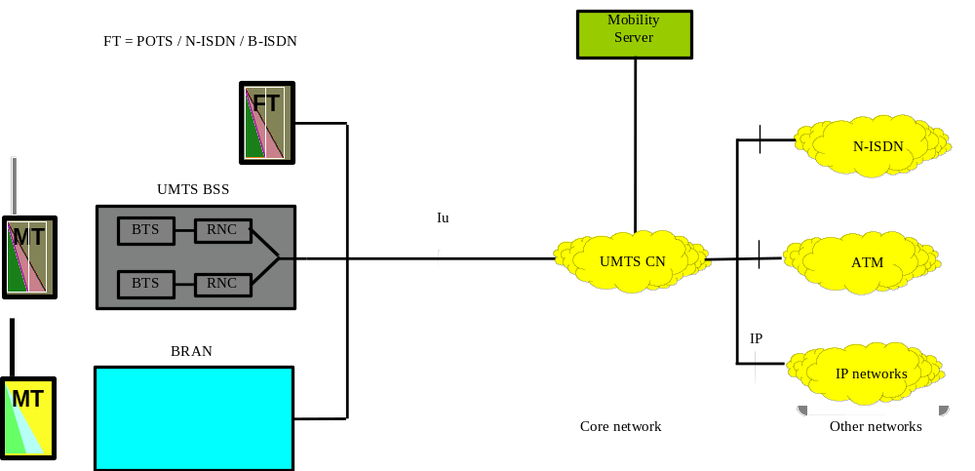
Figure 11: Adding BRAN access to the evolved fixed network
The radio and fixed access may support a number of terminals. The UMTS core network will provide wide area transport for all the access types. Mobility control may be supported in the ATM switches, in mobility servers or via IN with mobility support. Protocol extensions are needed in order to fulfil all the mobility requirements.

6.7 Internet access evolution
The method used today to access the Internet backbone is through a call to a PSTN / Internet Gateway (PIG) provided by an Internet Service Provider (ISP). The essential network components to provide this access are a voice-band modem e.g. V.90 56 kbit/s, using PSTN transport and switching to access an ISP gateway (with a bank of voice-band modems) to the internet backbone.
This arrangement supports "on-demand" access to the Internet, i.e. the user dials the access number of the ISP and a bearer is maintained throughout the internet session, irrespective of any packet transfer. Terminal mobility is supported by using alternative network access points and possibly different access numbers.
Home WWW pages would have to be stored on space provided by the ISP to make them always available to other WEB browsers.
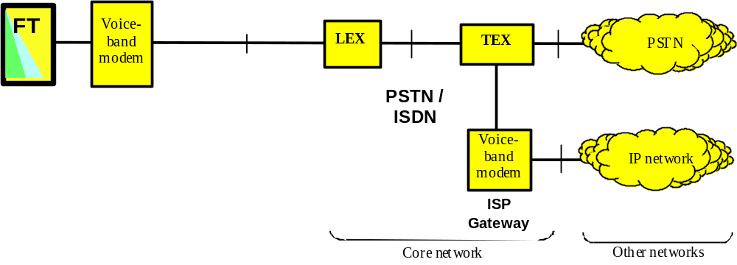
Figure 12: Today's access to internet
"Always-on" broadband access
In this scenario, the essential network components to provide this access are:
- high capacity modem (e.g. xDSL) to carry bearer and signalling over copper line plant;
- packet network transport and routeing;
- ISP gateway to the internet backbone.
This arrangement supports "always on" access to the internet, i.e. the terminal is always connected to the internet backbone irrespective of any requirement to transfer packets. Terminal mobility is unlikely to be supported as this is not compatible with the "always on" feature. Home WWW pages could be stored on space provided by the ISP or on the user's terminal.
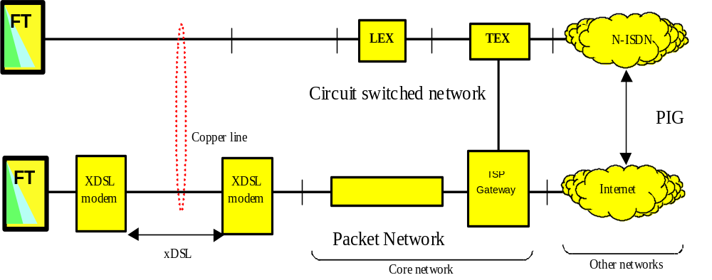
Figure 13: "Always-on" broadband access
"Always-on" broadband access with mobility
In this scenario, the essential network components to provide this access are:
- broadband base-station ( e.g. UMTS, Bluetooth™, wireless-LAN);
- high capacity modem (e.g. xDSL) to carry bearer and signalling over copper line plant;
- mobility support using Home and Mobility servers.
This arrangement supports "always on" access to the internet provided the terminal is in range of a radio access, i.e. the terminal is always connected to the internet backbone irrespective of any requirement to transfer packets.
Location and authentication procedures required for terminal mobility are supported through call unrelated signalling mechanisms to the mobility server. The interface between the Home and Mobility servers is the same as for UMTS HLR-VLR. Home WWW pages would have to be stored on space provided by the ISP to make them always available to other WEB browsers.
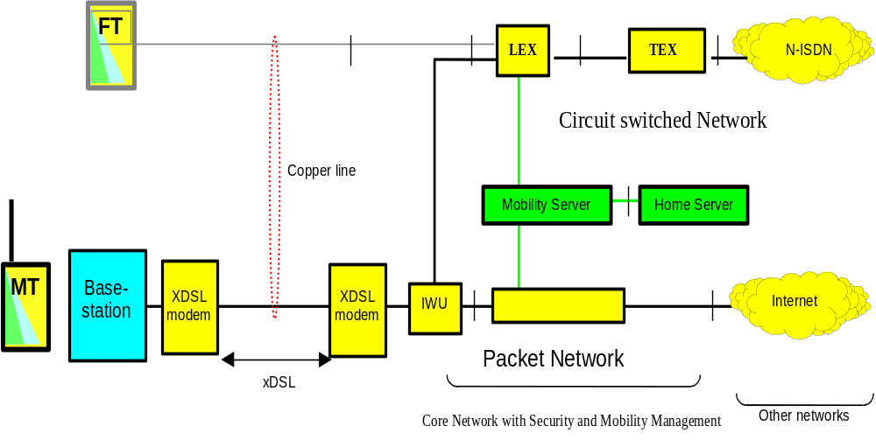
Figure 14: "Always-on" broadband access with mobility
Long-term vision
In this scenario, the essential network components to provide this access are:
- broadband base-station ( e.g. UMTS, Bluetooth™, wireless-LAN);
- high capacity modem (e.g. xDSL) to carry bearer and signalling over copper line plant;
- UMTS core network introduced;
- mobile IP used for mobility (Home Agent and Foreign Agent).
The introduction of the UMTS core network as an IP network with QoS guarantees eliminates the need for the circuit switched network to handle any telecom traffic from the terminal. Unnecessary network elements have been removed.
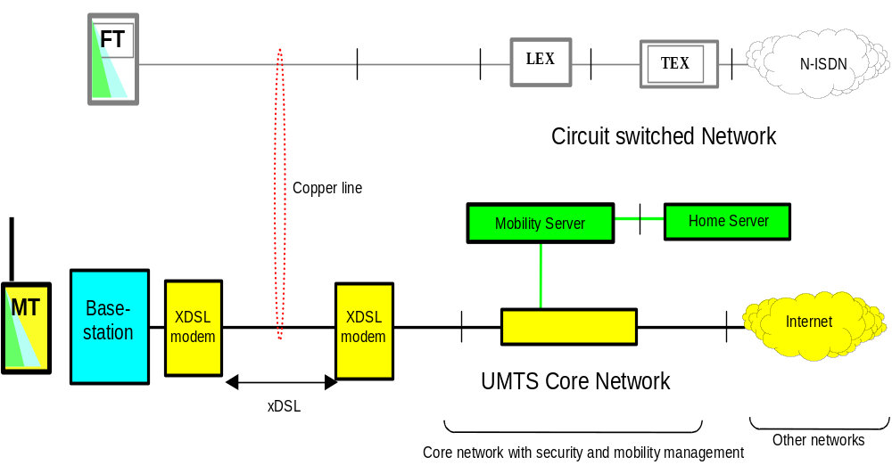
Figure 15: Long-term vision

6.7.1 Mobility spanning IP and IN networks
This subclause addresses the issue of personal mobility in interworking environments that merge traditional switching and IP based ITU-T Recommendation H.323 [2] networks. ITU-T Recommendation H.323 [2] is well adapted to integrated working environments, offering multiparty services that support audio-visual components and data sharing, in conjunction with ITU-T Recommendation T.120 [3] standards.
In order to integrate the two environments, allowing personal mobility interoperation, some evolution needs to be considered in the architecture. Although interworking of ITU-T Recommendation H.323 [2] with switched network calls is already addressed by standards, interworking of features such as personal mobility is still unresolved. In this subclause, the adaptation of IN to an ITU-T Recommendation H.323 [2] environment is foreseen in the medium term and a longer-term convergence towards a wider scenario is considered.
The starting point for interworking of switched to ITU-T Recommendation H.323 [2] networks is shown in Figure 16. Interconnecting the two domains is a Gateway (GW) that converts signalling and communication streams in both directions. A Gatekeeper (GK) assures access control and auxiliary functions. GW and GK, if not associated in the same physical device, communicate with each other using IP. Interface between GW and the external signalling world is through ISUP or TUP.
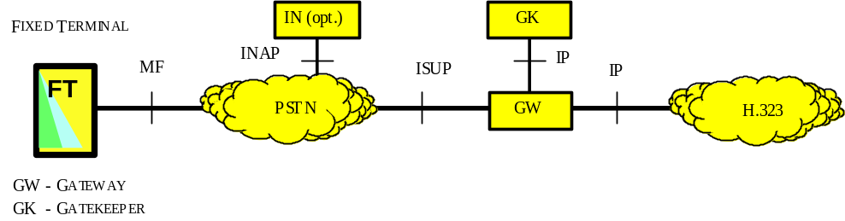
Figure 16: Signalling interfaces in PSTN to ITU-T Recommendation H.323 [2] interworking
In this configuration personal mobility is limited to a ITU-T Recommendation H.323 [2] GK domain area. A local end user is able to use any access point in the network through registration. The GK is able to resolve user aliases transparently to the outside world.
In a first step network intelligence capabilities are added to both ISDN and IP networks, allowing personal mobility through inter-network UPT service provision. Functional architecture is represented in Figure 17. On the IP side, the Gatekeeper is upgraded with IN capabilities, including INAP SCF and SDF functionality.
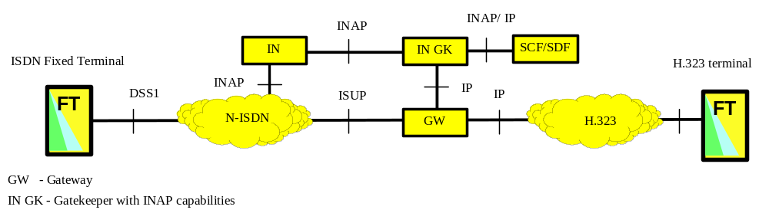
Figure 17: Interworking of PSTN and H323 networks with IN support
In a next step the core ISDN network is upgraded with IN mobility support, (IN CS4). This also changes the way in which personal mobility is achieved within the ISDN / ITU-T Recommendation H.323 [2] environment. Specific location services in the ISDN environment allow mobility interworking between the ISDN and ITU-T Recommendation H.323 [2] environment. The ITU-T Recommendation H.323 [2] gatekeeper is updated to interwork with the new INAP mobility management capabilities.
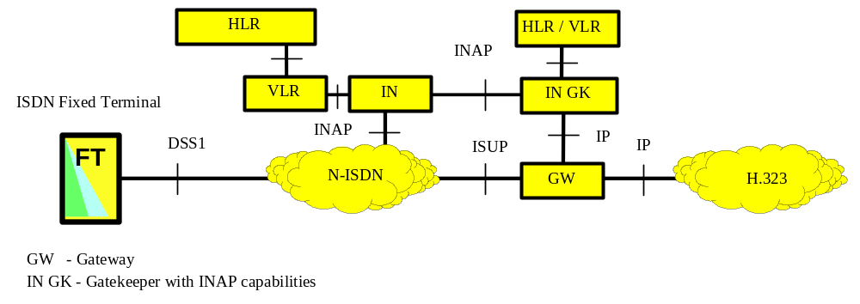
Figure 18: Interworking with mobile networks (cellular)

6.8 Recommendations for standards development
This subclause proposes where the standardization work related to the above scenarios should be carried out for UMTS.

6.8.1 Service aspects
The services are largely expected to be the same as those specified by 3GPP but may require some additional work from SPAN2 and ECMA

6.8.2 System aspects
While this work could be continued within SPAN there is recognition that there is very active IP telephony expertise in EP TIPHON which could be utilized

6.8.3 Radio aspects
The radio aspects are fully covered by 3GPP

6.8.4 Access aspects
The most promising evolution scenario for the access network uses xDSL technology to provide transport rates in excess of 2 Mbit/s over existing copper access. (This technology can also provide an "always on" IP access irrespective of UMTS service).

6.8.5 Protocol aspects
The long term vision for UMTS requires a high speed packet network. An IP network is envisaged with appropriate QoS, mobility, billing and management aspects.
Table 1 indicates specific groups where work may be carried out.
Table 1
Scenario | Service Aspects | System Aspects | Radio Aspects | Access Aspects | Protocol Aspects
Public Access -licensed spectrum | 3GPP | 3GPP | 3GPP | TM6 (xDSL)  SPAN5 (DSS*) | 3GPP, SPAN, TIPHON, IETF
Private Access | 3GPP / SPAN2 | SPAN / EP UMTS | 3GPP | TM6 (xDSL)  SPAN5 (DSS*) | SPAN (ECMA), TIPHON, IETF
Private Network | 3GPP / SPAN2 / ECMA TC32 | EP UMTS, ECMA TC32 | 3GPP | ECMA TC32 | SPAN + ECMA

Annex A (informative):
Standardization committees of interest
3GPP RAN: Third Generation Partership Project - Radio Access Network
IETF: Internet Engineering Task Force
TIPHON: Telecommunications and Internet Protocol Harmonization Over Networks
ECMA TC32: European Computer Manufacturers Association
ETSI NA: Network Aspects
ETSI TM: Transmission and Multiplexing
ETSI SPS: Signalling Protocol and Switching
ETSI BRAN: Broadband Radio Access Networks
ETSI DECT: Digital Enhanced Cordless Telecommunications
ETSI JTC1: Joint Technical Committee

History
Document history
V1.1.1 | November 1999 | Membership Approval Procedure MV 200004: 1999-11-30 to 2000-01-28

