3GPP TSG-RAN WG4 Meeting #95-e DRAFT R4-2008856
Online, 25 May - 5 Jun 2020

Source: Huawei
Title: [OTA TR] TP to TR 37.941 MU budget procedure update
Agenda Item: 6.19.5
Document for: Approval

Introduction
It was agreed that the OTA budgets already agreed in the donor TR’s would be implemented in the new external TR. In the last few meetings the MU budgets have been updated and many corrections made using pre agreed excel MU budgets, the tables have then been copied into the new TR.
There has been some discussion however about the existing TYR sections where the MU budget and the MU calculation are captured in 2 tables, which contain almost the same information. As the new TR contains many such tables the approach has been taken to combine the tables into a single one. This has the advantage that many pages are saved in the TR.
However it has been argued that this method of recording the results is not directly in line with the agreed procedure.
As a compromise between the procedure and saving space in the document it is proposed that a single requirement (EIRP) is captured with the 2 table method and the procedure is updated to explain that the tables are combined into a single table in the rest of the document to save space, but the assessment procedure is the same.
This TP capture the updates to the procedure clause in the TR.

TP to TR 37.941 v0.2.0
--- Start of changes ---

5 Conformance testing aspects

5.1 Conformance testing framework
Traditionally when calculating the MU for the conducted tests it was sufficient to analyse a single test method, while for OTA tests the chamber is an integral part of the test environment and it is important to derive MU based on multiple chamber types and test methodologies. As such a framework has been developed to estimate MU’s for different test methods and compare them equally.
The following 11 points have been agreed as a framework for developing OTA test:
1) Multiple test methods may exist for each requirement.
2) Each test method will require its own test procedure.
3) A single conformance requirement applies for each core requirement, regardless of test procedure.
4) Common maximum accepted test system uncertainty applies for all test methods addressing the same test requirement. Test methods producing significantly worse uncertainty than others at comparable cost should not impact the common maximum accepted test system uncertainty assessment.
5) Common test tolerances apply for all test methods addressing the same test requirement.
6) A common way of establishing the uncertainty result from all test methods' individual budgets is established.
7) A common method of making an uncertainty budget (not a common uncertainty budget) is established.
8) Establish budget format examples for each addressed test method in the form of lists of uncertainty contributions. Contributions that may be negligible with some BS and substantial with others should be in this list. For each combination of measurement method and test parameter, develop a list with measurement uncertainties.
9) Describe potential OTA test methods relevant for testing radiated requirements (e.g. directional, TRP, or co-location requirements). The description requires information about the applicable test range architectures and test procedures. Addressing each item in each uncertainty budget with respect to the expected distribution of the errors, the mechanism creating the error and how it interacts with properties of the BS.
10) Providing example uncertainty budgets will be useful in order to demonstrate the way a budget should be defined and how calculating its resulting measurement uncertainty is done, but the figures used in the examples will clearly be only examples and not applicable in general.
11) Each test instance may require an individual uncertainty budget applicable for the combination of the test facility, the BS and the test procedure and property tested. Here, the tester demonstrates that the uncertainty requirement is fulfilled during the conformance testing.
The linking of core requirements via OTA test methods to conformance requirements is depicted in figure 5.1-2.
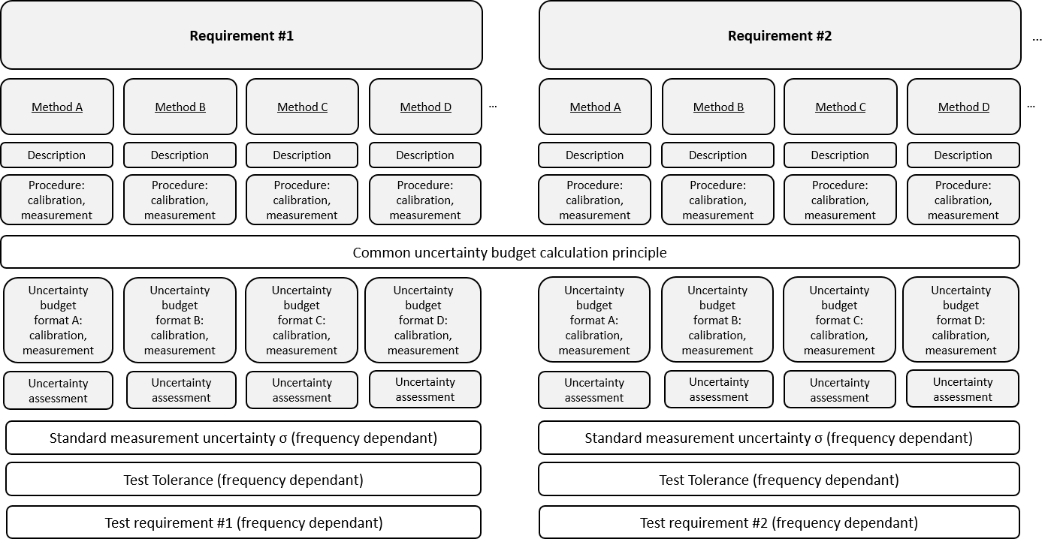
Figure 5.1-2: Examples of OTA core requirement to test requirement mapping
For TRP requirements the OTA conformance testing framework also considers additional aspects of the TRP measurements as detailed in clause 6.3. Depending on the TRP measurement procedure those additional aspects are, e.g. TRP sampling grids, additional MU contributors, TRP summation error, or ΔTRP correction factor, if applicable.

5.2 Uncertainty budget calculation principles
Uncertainty contributions listed in clauses 9 – 15 with descriptions in annex A to C need to be calculated to provide an overall total measurement uncertainty for each OTA test method for the accompanying conformance requirement.
The uncertainty tables are presented with two stages:
- Stage 1: the calibration of the absolute level of the BS measurement results is performed by means of using a calibration antenna (for example a standard gain horn) whose absolute gain is known at the frequencies of measurement,
- Stage 2: the actual measurement with the BS as either the transmitter or receiver (depending on the considered requirement) is performed.
The final uncertainty budget should comprise of a minimum 5 headings:
1) The uncertainty source,
2) Uncertainty value,
3) Distribution of the probability,
4) Divisor based on distribution shape,
5) Sensitivity coefficient c_{i} and its calculated standard uncertainty u_{i} (based on uncertainty value, divisor and sensitivity coefficient c_{i}).
NOTE: All measurement uncertainty contributions are assumed independent. Measurement uncertainty contributor’s values in tables are given in log scale.
The calculation of the uncertainty contribution is based on the ISO Guide [8] to the expression of uncertainty in measurement. Each individual uncertainty is expressed by its standard deviation (termed as ‘standard uncertainty’) and represented by symbol u_{i}.
The procedure for forming the uncertainty budget can be as follows:
1) Compile lists of individual uncertainty contributions for the requirement specific measurement, both in Stage 1 (i.e. Calibration measurement) and Stage 2 (i.e. BS measurement).
2) Determine the standard uncertainty of each contribution u_{i} by:
a) Determining the distribution of the uncertainty (i.e. Gaussian, U-shaped, rectangular, or exponentially normal).
b) Determining the maximum value of each uncertainty (unless the distributions is Gaussian).
c) Calculating the standard uncertainty by dividing the uncertainty by if the distribution is U-shaped, by 2 if the distribution exponentially normal and by if the distribution is rectangular.
d) Multiplying the standard uncertainty by the sensitivity coefficient c_{i.}
3) Convert the units into decibel, if necessary.
4) Combine all the standard uncertainties by the Root of the Sum of the Squares (RSS) method.
5) Combine the uncertainties in Stage 1 and Stage 2 into the combined uncertainty u_{c} also by the RSS method:
$${u }_{u}=\sqrt{U_{c,DUT measurement}^{2}+U_{c,calibrate measurement}^{2}}$$
6) Multiply the result of the combined uncertainty u_{c} by an expansion factor of 1.96 to derive expanded uncertainty u_{e} at 95 % confidence level:
u_{e} = 1.96 u_{c}
7) For TRP requirements where multiple directional measurements have been taken add the summation error (SE) to the combined uncertainty u_{c} using RSS method.
$${Total Uncertainy}_{TRP}=\sqrt{U_{u}^{2}+{SE}^{2}}$$
The above procedure calls for forming a list of uncertainty contributors in step 1, followed by an assessment of each in the following steps. This process traditionally results in 2 tables, e.g. as captured in the legacy technical reports in. The 1st table consisting of an uncertainty budget with a list of contributors, their associated UID and reference to a full description. The 2nd table carrying out the uncertainty assessment of uncertainty contributions listed in the 1st table.
In this report there are many tables so to keep the document manageable the full documentation method is used just for a single requirement type (i.e. EIRP accuracy, Normal test conditions in clause 9.2) in order to demonstrate the process for all considered chamber types. For the all the remaining requirements the same process is followed and the data in the 2 tables is merged into a single one (e.g. as in table 9.3.2.3-1) in order to save space in the report. In the merged table the UID column contains the annex where the uncertainty contributor description is given.

--- End of changes ---

