3GPP TSG-RAN WG4 Meeting #117 R4-2522446

Dallas, USA, Nov. 17-21, 2025

Agenda item: 8.1
Source: Feature lead (China Telecom)
Title: WF on [117][104] 6G spectrum
Document for: Approval

Introduction
At RAN4#116 a plan R4-2511652 for the 6G study in RAN4 was presented by the RAN4 chair. One of the topics was “Spectrum” with a scope listed as Band/band combination definition and simplification, Definition of frequency ranges and Spectrum related regulatory survey.
In RAN4#116bis the spectrum was firstly discussed and reach some agreements as captured in the WF of R4-2514626, which further clarifies the scopes of the 6G spectrum discussion.
According to agenda of RAN4#117 meeting and WF above mentioned, the topics/sub-topics for 6G spectrum are listed as follows:
- Topic#1: Band/band combination definition and simplification
- Topic#2: Definition of frequency ranges
- Topic#3: 6G spectrum related other aspects, including the regulatory status survey

Topic #1: Band/band combination definition and simplification

Open issues summary

Sub-topic 1-1: Bands naming and Bands Number range
Issue 1-1-1: 6G Bands Naming Convention
Agreement: use letter “s” as the prefix for 6G bands

Issue 1-1-2: 6G Bands Number Range
Agreement:
  - It is agreed to re-use the NR number range for 6G bands including both 5G refarming bands and new 6G bands. Both TN and NTN bands are covered by this agreement.
    - The band numbers of refarming bands in 6GR should be reused as much as possible.
      - It is not precluded to enhance the band numbers of 6G over 5G NR.
      - FFS on how to define the band numbers for the bands which are partially or fully overlapped, including both TN and NTN bands.
        - Potential regulatory requirement difference should be taken into consideration.

Sub-topic 1-2: Band and Band combination introduction/simplification
Issue 1-2-1: Band introduction
Agreement:
- Introduce the 6G bands by considering the following option.
  - RAN4 to further evaluate NR refarming bands into 6GR as case-by-case manner instead of inheriting all the bands from 5G to 6G.
    - The consideration factors include commercial deployment status, operator’s request.
                - New 6GR bands should be introduced on “first come first served” basis
  - For 6G band definition
    - FFS on how to harmonize bands which are partly overlapping and subset.

Issue 1-2-2: Band combination introduction
Agreement:
- For band combination introduction in 6G: RAN4 will study and define 6G band combinations per the request, meaning no 5G band combinations will be automatically transferred to 6G. .
  - FFS how to handle operator request to transfer 5G combination to 6G
  - FFS on how to port 5G combinations to 6G
- RAN4 to study the Band Group Concept to structure the RF requirement improvement
  - Concept of band group includes RF requirements simplifications and FFS on whether include RF architecture assumptions.
  - Note that the Band Group Concept is not a replacement to normal CA.
  - No restriction on operators’ request on band combination

Issue 1-2-3: Meanings/benefits for band combination simplification
Tentative Agreement:
The BC simplification will primarily focus on how to
- Improve the procedure, if feasible, to introduce BC compared to 5G
- Make the spec leaner and simpler to understand
- Simplify UE conformance test
It is noted the market needs and the related proposals by the operators should not be sacrificed. RAN4 will further study how to maintain the reasonable workload and meeting cycle when new BC is introduced.

Sub-topic 1-3: Band Group Concept for band combination simplification
Issue 1-3-3: UE behaviour and RF requirements impact under band group concept
Chair: Band group discussion will be handled in the 6G spectrum thread.
Recommendation by FL
Following aspects are taken into consideration for band group concept study
- Frequency ranges for band group
- Restriction for band group including how to support switching UL/DL transmission between each two of the bands within one band group
- Impacted requirements such as delte Tib/Rib, MSD etc.

Topic #2: Definition of frequency ranges

Open issues summary

Sub-topic 2-1: Frequency Range framework
Issue 2-1-1: Basis of frequency range definitions
- Proposals
  - Option 1: Extend FR1 and FR2 to “close the gap” from 7.125 – 24.25 GHz
    - Option 1a: Extended existing NR FR1 and FR2 without overlapping frequency
    - No new frequency range designation between extended FR1 and FR2
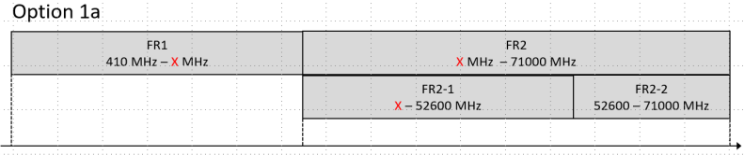
    - Option 1b: Extended existing NR FR1 and FR2 with overlapping frequency
      - No new frequency range designation for 7.125-24.25GHz
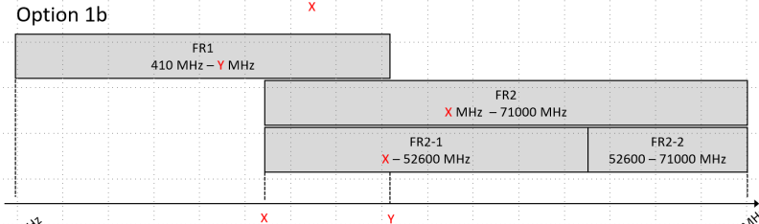
  - Option 2: Define a new frequency range for the 7.125 – 24.25 GHz and keep the current FR1 and FR2-1 definitions
  - Option 3: Extend FR1, define a new frequency range and keep FR2-1 definitions.
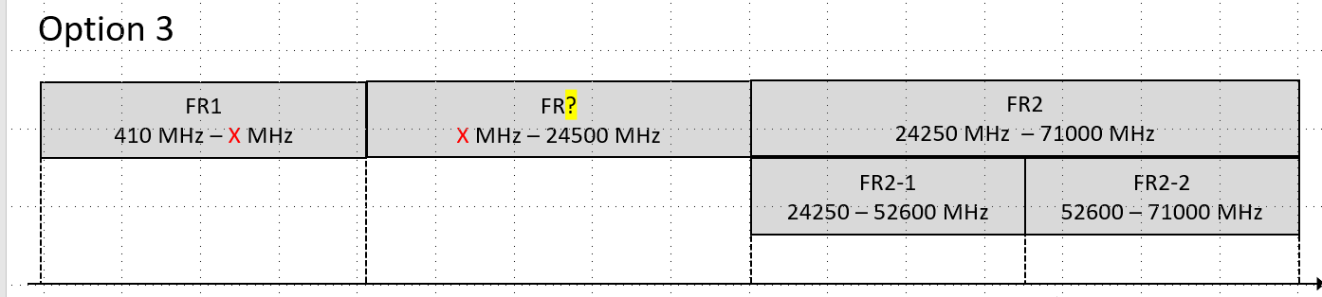
  - Option 4: Sub-divide FR1, define new frequency ranges and keep FR2-1 definitions.
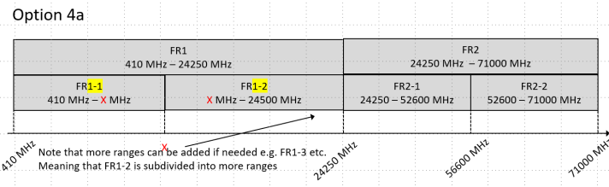
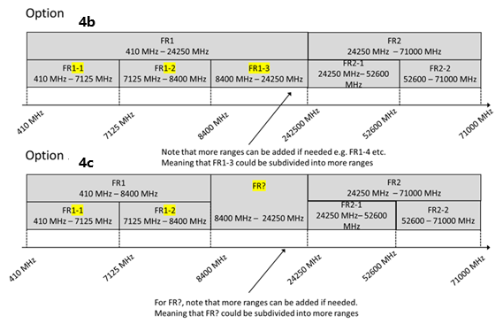
  - Option 5: Clean slate and define new frequency ranges from around 400MHz to 52.6GHz
  - Option 6: Postpone the discussion on FR1 extension
  - Option 7: Extend existing NR FR1 and FR2 to cover partial part of 7.124-24GHz
    - New frequency range designation for remaining part between extended FR1 and FR2
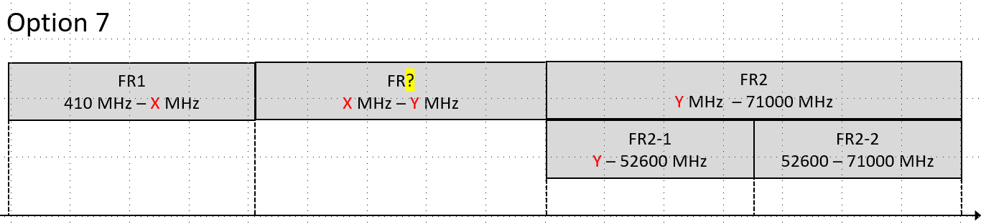
  - Option 8: Extend existing NR FR1 and FR2 to cover partial part of 7.124-24GHz
    - Sub-divide FR1, define new frequency ranges
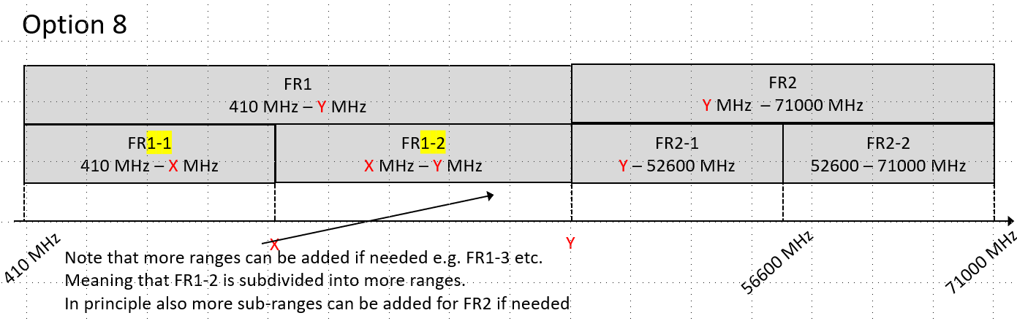
Recommendation by FL
- Down select to the following options
  - Option 1: Extend FR1 and FR2 to “close the gap” from 7.125 – 24.25 GHz
  - Option 3: Extend FR1, define a new frequency range and keep FR2-1 definitions.
  - Option 4: Sub-divide FR1, define new frequency ranges and keep FR2-1 definitions.
  - Option 7: Extend existing NR FR1 and FR2 to cover partial part of 7.124-24GHz
  - Option 8: Extend existing NR FR1 and FR2 to cover partial part of 7.124-24GHz
  - Option 9: Extend FR1, keep FR2-1 definitions, no to define a new frequency range
- Observation: All the options as down select above share same extension to extend 5G FR1 frequency range to x MHz, in which x is proposed to be more or equal to 8400MHz.

Topic #3: Spectrum related regulatory survey

Companies’ contributions summary

Sub-topic 3-1: New spectrum for consideration during the 6G SI
Issue 3-1-1: New spectrum/bands for consideration during the 6G SI
- Proposals
  - Option 1: Study candidates as 6G bands for 6.425-7.125GHz identified in WRC-23.
  - Option 2: Study candidates as 6G bands for 4.4-4.8, 7.125-8.4 and 14.8-15.35 GHz being discussed toward WRC-27 considering the regulatory discussions are still ongoing.
  - Option 3: RAN4 shall initially focus on a new 6GR band around 7GHz.
  - Option 4: Postpone further regulatory survey in the 7-24 GHz frequency range until Regulators published a new decision.
  - Option 4: The ITU-R is working on the in-band sharing and compatibility study for searching and identification new spectrum for DC-MSS-IMT service, the potential frequency bands including the IMT bands: 694-960 MHz, 1 710-1 880 MHz, 1 885-2 025 MHz, 2 110-2 200 MHz, 2 300-2 400 MHz, 2 496-2 690 MHz
Agreement:
- For new 6G spectrum, RAN4 shall initially focus on a new 6GR band around 7GHz.

