3GPP TR 38.922 V1.1.0 (2025-02)
Technical Report

3rd Generation Partnership Project;
Technical Specification Group Radio Access Network;
NR;
Study on International Mobile Telecommunications (IMT) parameters for 4400 - 4800 MHz, 7125 - 8400 MHz and 14800 - 15350 MHz;

(Release 19)
The present document has been developed within the 3rd Generation Partnership Project (3GPP TM) and may be further elaborated for the purposes of 3GPP.
The present document has not been subject to any approval process by the 3GPP Organizational Partners and shall not be implemented.
This Specification is provided for future development work within 3GPP only. The Organizational Partners accept no liability for any use of this Specification.
Specifications and Reports for implementation of the 3GPP TM system should be obtained via the 3GPP Organizational Partners' Publications Offices.

3GPP
Postal address

3GPP support office address
650 Route des Lucioles - Sophia Antipolis
Valbonne - FRANCE
Tel.: +33 4 92 94 42 00 Fax: +33 4 93 65 47 16
Internet
http://www.3gpp.org

Copyright Notification
No part may be reproduced except as authorized by written permission.
The copyright and the foregoing restriction extend to reproduction in all media.

© 2024, 3GPP Organizational Partners (ARIB, ATIS, CCSA, ETSI, TSDSI, TTA, TTC).
All rights reserved.

UMTS™ is a Trade Mark of ETSI registered for the benefit of its members
3GPP™ is a Trade Mark of ETSI registered for the benefit of its Members and of the 3GPP Organizational Partners
LTE™ is a Trade Mark of ETSI registered for the benefit of its Members and of the 3GPP Organizational Partners
GSM® and the GSM logo are registered and owned by the GSM Association

Contents
Foreword 6
1 Scope 8
2 References 8
3 Definitions of terms, symbols and abbreviations 10
3.1 Terms 10
3.2 Symbols 10
3.3 Abbreviations 11
4 4400 - 4800 MHz frequency range 12
4.1 General parameters 12
4.1.1 Duplex mode 12
4.1.2 Channel Bandwidth 12
4.1.3 Signal Bandwidth 12
4.2 BS parameters 13
4.2.1 Transmitter characteristics 13
4.2.1.1 Power dynamic range 13
4.2.1.2 Spectral mask 13
4.2.1.3 ACLR 13
4.2.1.4 Spurious emissions 13
4.2.1.5 Maximum output power 14
4.2.1.6 Average output power 15
4.2.2 Receiver characteristics 15
4.2.2.1 Noise figure 15
4.2.2.2 Sensitivity 15
4.2.2.3 Blocking response 17
4.2.2.4 ACS 20
4.3 UE parameters 21
4.3.1 Transmitter characteristics 21
4.3.1.1 Power dynamic range 21
4.3.1.2 Spectral mask 21
4.3.1.3 ACLR 22
4.3.1.4 Spurious emissions 22
4.3.1.5 Maximum output power 23
4.3.1.6 Average output power 23
4.3.2 Receiver characteristics 23
4.3.2.1 Noise figure 23
4.3.2.2 Sensitivity 23
4.3.2.3 Blocking response 23
4.3.2.4 ACS 25
4.4 Antenna characteristics 26
4.4.1 BS antenna characteristics 26
4.4.1.1 Antenna model 26
4.4.1.2 Antenna parameters 26
4.4.2 UE antenna characteristics 26
5 7125 - 8400 MHz frequency range 27
5.1 General parameters 27
5.1.1 Duplex mode 27
5.1.2 Channel Bandwidth 27
5.1.3 Signal Bandwidth 27
5.2 BS parameters 27
5.2.1 Transmitter characteristics 27
5.2.1.1 Power dynamic range 27
5.2.1.2 Spectral mask 27
5.2.1.3 ACLR 28
5.2.1.4 Spurious emissions 28
5.2.1.5 Maximum output power 28
5.2.1.6 Average output power 29
5.2.2 Receiver characteristics 29
5.2.2.1 Noise figure 29
5.2.2.2 Sensitivity 29
5.2.2.3 Blocking response 29
5.2.2.4 ACS 30
5.3 UE parameters 30
5.3.1 Transmitter characteristics 30
5.3.1.1 Power dynamic range 30
5.3.1.2 Spectral mask 30
5.3.1.3 ACLR 31
5.3.1.4 Spurious emissions 31
5.3.1.5 Maximum output power 31
5.3.1.6 Average output power 31
5.3.2 Receiver characteristics 31
5.3.2.1 Noise figure 31
5.3.2.2 Sensitivity 31
5.3.2.3 Blocking response 31
5.3.2.4 ACS 32
5.4 Antenna characteristics 32
5.4.1 BS antenna characteristics 32
5.4.1.1 Antenna model 32
5.4.1.2 Antenna parameters 32
5.4.2 UE antenna characteristics 32
6 14800 - 15350 MHz frequency range 33
6.1 Co-existence study 33
6.1.1 Co-existence simulation scenarios 33
6.1.2 Co-existence simulation assumption 33
6.1.2.1 Network layout model 33
6.1.2.1.1 Urban macro 33
6.1.2.1.2 Dense urban 35
6.1.2.1.3 Indoor 35
6.1.2.2 Propagation model 36
6.1.2.2.1 Pathloss 36
6.1.2.2.2 LOS probability 38
6.1.2.2.3 O-to-I penetration loss 39
6.1.2.3 Antenna and beam forming pattern modelling 40
6.1.2.3.1 BS antenna modelling 40
6.1.2.3.3 UE antenna modelling 41
6.1.2.4 Other simulation parameters 42
6.1.3 Co-existence simulation results 42
6.1.3.1 Urban Macro scenario 42
6.1.3.1.1 Downlink 42
6.2 General parameters 46
6.2.1 Duplex mode 46
6.2.2 Channel Bandwidth 46
6.2.3 Signal Bandwidth 46
6.3 BS parameters 47
6.3.1 Transmitter characteristics 47
6.3.1.1 Power dynamic range 47
6.3.1.2 Spectral mask 47
6.3.1.3 ACLR 47
6.3.1.4 Spurious emissions 47
6.3.1.5 Maximum output power 48
6.3.1.6 Average output power 48
6.3.2 Receiver characteristics 48
6.3.2.1 Noise figure 48
6.3.2.2 Sensitivity 48
6.3.2.3 Blocking response 49
6.3.2.4 ACS 49
6.4 UE parameters 49
6.4.1 Transmitter characteristics 49
6.4.1.1 Power dynamic range 49
6.4.1.2 Spectral mask 50
6.4.1.3 ACLR 50
6.4.1.4 Spurious emissions 50
6.4.1.5 Maximum output power 50
6.4.1.6 Average output power 50
6.4.2 Receiver characteristics 50
6.4.2.1 Noise figure 50
6.4.2.2 Sensitivity 50
6.4.2.3 Blocking response 50
6.4.2.4 ACS 51
6.5 Antenna characteristics 51
6.5.1 BS antenna characteristics 51
6.5.1.1 Antenna model 51
6.5.1.2 Antenna parameters 51
6.5.2 UE antenna characteristics 53
6.5.2.1 General considerations 53
6.5.2.2 Design with patch antennas 55
6.5.2.3 Design with metal frame antennas 56
7 Additional information on AAS 58
7.1 Array antenna model 58
7.1.1 Overview 58
7.1.2 Parameters 59
7.1.3 Model equations 61
7.2 MIMO modelling 62
7.2.1 Simulation methodologies 62
7.2.1.1 Methodology 1 62
7.2.1.2 Methodology 2 64
7.2.1.2.1 Beamforming equations 64
7.2.1.2.2 ZF and MMSE-based beamforming for Rank-1 MU-MIMO Transmission 65
7.2.2 Simulation results 67
7.2.2.1 Methodology 1 67
7.2.2.1.1 Ericsson [30] 67
7.2.2.1.2 Qualcomm [31] 71
7.2.2.1.3 Huawei [32] 74
7.2.2.1.4 Nokia [34] 75
7.2.2.2 Methodology 2 79
7.2.2.2.1 Spark [33] 79
7.2.2.2.2 Huawei [32] 81
7.2.3 Summary and Conclusion of MIMO modelling 83
7.3 Modelling array antenna gain outside the carrier 83
7.3.1 General 83
7.3.1.1 Purpose 83
7.3.1.2 ITU radio regulations on adjacent terrestrial IMT systems with other co-primary services 83
7.3.2 Adjacent channel modelling 84
7.3.2.1 Correlation roll-off based model 84
7.3.2.1.1 Modelling overview 84
7.3.2.1.2 Correlation roll-off model 85
7.3.2.1.3 EIRP model 86
7.3.2.2 Array ACLR based model 87
7.3.2.2.1 Overview 87
7.3.2.2.2 Array performance at adjacent band frequencies 88
7.3.2.2.3 Modelling of PA non-linearities 91
7.3.2.2.4 Modelling of band pass filters 92
Annex A (normative): Additional observations for 7125-8400 MHz frequency range 93
A.1 Impact of higher channel bandwidth on the ACLR/ACS 93
A.2 Impact of higher channel bandwidth on spectral emission mask 93
A.3 Impact of higher channel bandwidth on cumulative in-band and adjacent band emissions. 94
A.4 Impact of higher UE maximum output power on the ACLR/ACS 94
Annex B (informative): Change history 95

Foreword
This Technical Report has been produced by the 3rd Generation Partnership Project (3GPP).
The contents of the present document are subject to continuing work within the TSG and may change following formal TSG approval. Should the TSG modify the contents of the present document, it will be re-released by the TSG with an identifying change of release date and an increase in version number as follows:
Version x.y.z
where:
x the first digit:
1 presented to TSG for information;
2 presented to TSG for approval;
3 or greater indicates TSG approved document under change control.
y the second digit is incremented for all changes of substance, i.e. technical enhancements, corrections, updates, etc.
z the third digit is incremented when editorial only changes have been incorporated in the document.
In the present document, modal verbs have the following meanings:
shall indicates a mandatory requirement to do something
shall not indicates an interdiction (prohibition) to do something
The constructions "shall" and "shall not" are confined to the context of normative provisions, and do not appear in Technical Reports.
The constructions "must" and "must not" are not used as substitutes for "shall" and "shall not". Their use is avoided insofar as possible, and they are not used in a normative context except in a direct citation from an external, referenced, non-3GPP document, or so as to maintain continuity of style when extending or modifying the provisions of such a referenced document.
should indicates a recommendation to do something
should not indicates a recommendation not to do something
may indicates permission to do something
need not indicates permission not to do something
The construction "may not" is ambiguous and is not used in normative elements. The unambiguous constructions "might not" or "shall not" are used instead, depending upon the meaning intended.
can indicates that something is possible
cannot indicates that something is impossible
The constructions "can" and "cannot" are not substitutes for "may" and "need not".
will indicates that something is certain or expected to happen as a result of action taken by an agency the behaviour of which is outside the scope of the present document
will not indicates that something is certain or expected not to happen as a result of action taken by an agency the behaviour of which is outside the scope of the present document
might indicates a likelihood that something will happen as a result of action taken by some agency the behaviour of which is outside the scope of the present document
might not indicates a likelihood that something will not happen as a result of action taken by some agency the behaviour of which is outside the scope of the present document
In addition:
is (or any other verb in the indicative mood) indicates a statement of fact
is not (or any other negative verb in the indicative mood) indicates a statement of fact
The constructions "is" and "is not" do not indicate requirements.

1 Scope
The present document is a technical report for the study item on IMT parameters for 4400 to 4800 MHz, 7125 to 8400 MHz and 14800 to 15350 MHz frequency ranges [2]. It covers the study on transmitter and receiver characteristics for both NR BS and NR UE, and related parameters, including co-existence studies, AAS antenna models, and responses to the ITU-R W5PD’s requests as well as three additional questions received in [3].
Findings and evaluations captured in this technical report are based on the Rel-18 version of the NR specifications, unless otherwise stated.
Related LS replies for each of the frequency ranges in question were sent out to ITU-R W5PD in [4, 5, 6].

2 References
The following documents contain provisions which, through reference in this text, constitute provisions of the present document.
- References are either specific (identified by date of publication, edition number, version number, etc.) or non-specific.
- For a specific reference, subsequent revisions do not apply.
- For a non-specific reference, the latest version applies. In the case of a reference to a 3GPP document (including a GSM document), a non-specific reference implicitly refers to the latest version of that document in the same Release as the present document.
[1] 3GPP TR 21.905: "Vocabulary for 3GPP Specifications".
[2] RP-241326: “Study on IMT parameters for 4400 to 4800 MHz, 7125 to 8400 MHz and 14800 to 15350 MHz”, SID, FS_NR_IMT_4400_7125_14800MHz, RAN#104.
[3] R4-2400333: “Parameters of terrestrial component of IMT for sharing and compatibility studies in the frequency bands 4 400-4 800 MHz, 7 125-8 400 MHz and 14.8-15.35 GHz”, ITU-R WP 5D, LSin.
[4] R4-2410576: “LS on Parameters for 4400 to 4800 MHz of terrestrial component of IMT for sharing and compatibility studies in preparation for WRC-27”, RAN4#111, LSout
[5] R4-2414449: “LS Reply on Parameters for 7125 to 8400 MHz of terrestrial component of IMT for sharing and compatibility studies in preparation for WRC-27”, RAN4#112, LSout
[6] R4-2420385: “LS Reply on Parameters for 14800 to 15350 MHz of terrestrial component of IMT for sharing and compatibility studies in preparation for WRC-27”, RAN4#113, LSout
[7] 3GPP TR 38.858: “Study on evolution of NR duplex operation”
[8] RP-241614: “Evolution of NR duplex operation: Sub-band full duplex (SBFD)”, WID, NR_duplex_evo, RAN#104
[9] 3GPP TS 38.104: “NR; Base Station (BS) radio transmission and reception”
[10] 3GPP TS 36.104: “Evolved Universal Terrestrial Radio Access (E-UTRA); Base Station (BS) radio transmission and reception”
[11] 3GPP TS 38.101-3: “NR; User Equipment (UE) radio transmission and reception; Part 3: Range 1 and Range 2 Interworking operation with other radios”
[12] 3GPP TS 38.101-1: “NR; User Equipment (UE) radio transmission and reception; Part 1: Range 1 Standalone”
[13] ITU-R Recommendation SM.329: "Unwanted emissions in the spurious domain"
[14] 3GPP TR 38.921: “Study on International Mobile Telecommunications (IMT) parameters for 6.425 – 7.025 GHz, 7.025 – 7.125 GHz and 10.0. – 10.5 GHz”
[15] C A Balanis, “Antenna Theory Analysis and Design”, John Wiley and sons
[16] H. Jin et al., "Massive MIMO Evolution Toward 3GPP Release 18," in IEEE Journal on Selected Areas in Communications, vol. 41, no. 6, pp. 1635-1654, June 2023
[17] Christopher Mollen, Ulf Gustavsson, Thomas Eriksson, Erik G Larsson, “Out of Band radiation Measure for MIMO arrays with beamformed transmission “, Proc. IEEE Int. Conf. Commun., May 2016.
[18] Erik Larsson, Liesbet Van der Perre, “Out of band Radiation for Antenna arrays Clarified”, arXiv : 1802.02745v1, Feb 2018
[19] E. Sienkiewicz, N. McGowan, B. Göransson, T. Chapman and T. Elfström, "Spatially dependent ACLR modelling," 2014 IEEE Conference on Antenna Measurements & Applications (CAMA), Antibes Juan-les-Pins, France, 2014, pp. 1-4,
[20] A. S. Tehrani, H. Cao, S. Afsardoost, T. Eriksson, M. Isaksson and C. Fager, "A Comparative Analysis of the Complexity/Accuracy Trade off in Power Amplifier Behavioural Models," in IEEE Transactions on Microwave Theory and Techniques, vol. 58, no. 6, pp. 1510-1520, June 2010
[21] C. Mollén, U. Gustavsson, T. Eriksson and E. G. Larsson, "Spatial Characteristics of Distortion Radiated From Antenna Arrays With Transceiver Nonlinearities," in IEEE Transactions on Wireless Communications, vol. 17, no. 10, pp. 6663-6679, Oct. 2018.
[22] Y. Zou et al., "Impact of Power Amplifier Nonlinearities in Multi-User Massive MIMO Downlink,” 2015 IEEE Globecom Workshops, San Diego, CA, USA, 2015, pp. 1-7.
[23] P Nandin et al, “Web Lab: A Web based set up for PA digital distortion and Characterisation”, IEEE Microwave Magazine, vol 16, no1, p 138- 140, Feb 2015
[24] 3GPP TR 38.817-1: “General aspects for User Equipment (UE) Radio Frequency (RF) for NR” V16.4.0, September 2022.
[25] 3GPP TR 38.820: “Study on NR: 7-24 GHz frequency range” V16.1.0, March 2021.
[26] 3GPP TR 37.840: “Study of Radio Frequency (RF) and Electromagnetic Compatibility (EMC) requirements for Active Antenna Array System (AAS) base station” V12.1.0
[27] 3GPP TR 36.897: “Study on Elevation Beamforming/Full-Dimension (FD) MIMO for LTE. Status: Under change control” V13.0.0.
[28] ITU-R Recommendation M.2101: " Modelling and simulation of IMT networks and systems for use in sharing and compatibility studies"
[29] 3GPP TR 38.803: “Evolved Universal Terrestrial Radio Access (E-UTRA); User Equipment (UE) radio transmission and reception”
[30] R4-2418397: “TP to TR 38.922: Addition of MIMO modelling simulation results in subclause 7.3”, 3GPP RAN4#113
[31] R4-2418608: ” Views on Additional AAS aspects related to spatial beamforming”, 3GPP RAN4#113
[32] R4-2419238: ” Simulation methodologies and results of AAS Modelling”, 3GPP RAN4#113
[33] R4-2417545: ” TP for other issues (MIMO Beamforming) in TR 38 922”, 3GPP RAN4#113
[34] R4-2500072: ” TP to TR 38.922: Simulation results on MIMO modeling”, 3GPP RAN4#114

3 Definitions of terms, symbols and abbreviations

3.1 Terms
For the purposes of the present document, the terms given in TR 21.905 [1] and the following apply. A term defined in the present document takes precedence over the definition of the same term, if any, in TR 21.905 [1].
array element: subdivision of a passive antenna array, consisting of a single radiating element or a group of radiating elements, with a fixed radiation pattern
basic limit: emissions limit relating to the power supplied by a single transmitter to a single antenna transmission line in ITU-R SM.329 [13] used for the formulation of unwanted emission requirements for FR1.
beam: beam (of the antenna) is the main lobe of the radiation pattern of an antenna array
NOTE: For certain BS antenna array, there may be more than one beam.
beamwidth: beam which has a half-power contour that is essentially elliptical, the half-power beamwidths in the two pattern cuts that respectively contain the major and minor axis of the ellipse
BS type 1-C: NR base station operating at FR1 with requirements set consisting only of conducted requirements defined at individual antenna connectors
BS type 1-H: NR base station operating at FR1 with a requirement set consisting of conducted requirements defined at individual TAB connectors and OTA requirements defined at RIB
BS type 1-O: NR base station operating at FR1 with a requirement set consisting only of OTA requirements defined at the RIB
front-to-back ratio: ratio of maximum directivity of an antenna to its directivity in a specified rearward direction
gain: ratio of the radiation intensity, in a given direction, to the radiation intensity that would be obtained if the power accepted by the antenna were radiated in an isotropic manner.
NOTE: If the direction is not specified, the direction of maximum radiation intensity is implied.
operating band: frequency range in which NR operates (paired or unpaired), that is defined with a specific set of technical requirements
radiated interface boundary: operating band specific radiated requirements reference where the radiated requirements apply
NOTE: For requirements based on EIRP/EIS, the radiated interface boundary is associated to the far-field region
TAB connector: transceiver array boundary connector
total radiated power: is the total power radiated by the antenna
NOTE: The total radiated power is the power radiating in all direction for two orthogonal polarizations. Total radiated power is defined in both the near-field region and the far-field region
transceiver array boundary: conducted interface between the transceiver unit array and the composite antenna
transmission bandwidth: RF Bandwidth of an instantaneous transmission from a UE or BS, measured in resource block units

3.2 Symbols
For the purposes of the present document, the following symbols apply:
A_{A} Composite antenna array pattern in dBi
A_{E} Array element pattern in dBi
A_{m} Front to back ratio in dB
d_{h} Horizontal element separation in meters
d_{v} Vertical element separation in meters
G_{E,max} Array element peak gain in dBi
SLA_{v} Side lobe suppression in dB
ϕ_{3dB} Horizonal half power beamwidth
θ_{3dB} Vertical half power beamwidth
θ_{etilt} Electrical down-tilt angle in degrees (defined from antenna array normal and downwards)
ϕ_{escan} Electrical scan angle in degrees
ϕ Horizontal angle (defined between -180° and 180°).
θ Vertical angle of the signal direction (defined between -0° and 180°,90° represents the direction perpendicular to the antenna array
N_{RB} Transmission bandwidth configuration, expressed in resource blocks
BW_{Channel} BS channel bandwidth
BW_{Config} Transmission bandwidth configuration, where BW_{Config} = N_{RB} x SCS x 12
Δf Separation between the channel edge frequency and the nominal -3 dB point of the measuring filter closest to the carrier frequency
Δf_{max} f_offset_{max} minus half of the bandwidth of the measuring filter
Δf_{OBUE} Maximum offset of the operating band unwanted emissions mask from the downlink operating band edge
Δf_{OOB} Maximum offset of the out-of-band boundary from the uplink operating band edge
F_{C} RF reference frequency on the channel raster, given in table 5.4.2.2-1
f_offset Separation between the channel edge frequency and the centre of the measuring
f_offset_{max} The offset to the frequency Δf_{OBUE} outside the downlink operating band
F_{UL,low} The lowest frequency of the uplink operating band
F_{UL,high} The highest frequency of the uplink operating band
P_{REFSENS} Conducted Reference Sensitivity power level

3.3 Abbreviations
For the purposes of the present document, the abbreviations given in TR 21.905 [1] and the following apply. An abbreviation defined in the present document takes precedence over the definition of the same abbreviation, if any, in TR 21.905 [1].
AAS Active Antenna System
ACIR Adjacent Channel Interference Ratio
ACLR Adjacent Channel Leakage Ratio
ACS Adjacent Channel Selectivity
AWGN Additive White Gaussian Noise
BS Base Station
BW Bandwidth
EIRP Effective Isotropic Radiated Power
FDD Frequency Division Duplex
FR Frequency Range
FRC Fixed Reference Channel
IMT International Mobile Telecommunications
ITU-R Radiocommunication Sector of the International Telecommunication Union
LA Local Area
LOS Line-Of-Sight
MMSE Minimum Mean Squared Error
MR Medium Range
MU-MIMO Multi User- Multiple Input Multiple Output
NLOS Non-Line-Of-Sight
NR New Radio
OCNG OFDMA Channel Noise Generator
OTA Over The Air
O-to-I Outdoor-to-Indoor
RB Resource Block
RF Radio Frequency
SBFD Sub-Band Full Duplex
SCS Sub-Carrier Spacing
TAB Transceiver Array Boundary
TDD Time division Duplex
TRP Total Radiated Power
WA Wide Area
ZF Zero Forcing

4 4400 - 4800 MHz frequency range

4.1 General parameters
The general parameters can be extracted from requirements defined for NR operating band n79.
Figure 4.1-1: NR band definition in the 4.4 – 5.0 GHz frequency range

4.1.1 Duplex mode
RAN4 considered TDD as the current duplexing candidate. An enhancement of TDD duplexing, via allowing the simultaneous existence of non-overlapping downlink and uplink sub-band at the BS side within a TDD carrier in a conventional TDD band (i.e., sub-band non-overlapping full duplex), was studied in Rel-18 TR 38.858 [7]. RAN4 Rel-19 normative work for SBFD operation at the BS side within a TDD carrier is on-going in the current release [8]. The requirements and conformance aspects for Rel-19 SBFD work item can be tracked through the list of impacted specifications captured in [8].

4.1.2 Channel Bandwidth
While a number of channel bandwidth would be specified for this frequency range, 100 MHz has been considered as a representative channel bandwidth that is expected to be used.
Channel bandwidths supported by n79 in Rel-18 are listed in Table 4.1.2-1.
Table 4.1.2-1: BS channel bandwidths for band n79
NR Band | SCS (kHz) | BS channel bandwidth (MHz)
NR Band | SCS (kHz) | 3 | 5 | 10 | 15 | 20 | 25 | 30 | 35 | 40 | 45 | 50 | 60 | 70 | 80 | 90 | 100
 | 15 |  |  | 10 |  | 20 |  | 30 |  | 40 |  | 50
n79 | 30 |  |  | 10 |  | 20 |  | 30 |  | 40 |  | 50 | 60 | 70 | 80 | 90 | 100
 | 60 |  |  | 10 |  | 20 |  | 30 |  | 40 |  | 50 | 60 | 70 | 80 | 90 | 100

4.1.3 Signal Bandwidth
The signal bandwidth for a NR channel bandwidth signal is calculated based on the NR spectrum utilization for the associated SCS:
Signal bandwidth = N_{RB} x SCS x 12
where N_{RB} is the number of resource blocks for particular bandwidth and the associated SCS, as specified in TS 38.104 [9], clause 5.3.2.

4.2 BS parameters

4.2.1 Transmitter characteristics

4.2.1.1 Power dynamic range
There is no power control in downlink and fixed power per resource block is assumed during the study phase. Hence 0 dB power dynamic range was agreed for the LS reply in [4].

4.2.1.2 Spectral mask
The requirement limits applicable for band n79 are re-used. Refer to TS 38.104 [9], clause 6.6.4 for conducted requirements and TS 38.104 [9] Clause 9.7.4.2 for radiated requirements applicable for this range.

4.2.1.3 ACLR
The ACLR limit applicable for band n79 are re-used. Related extracts from TS 38.104 [9], clause 6.6.3 are listed in Table 4.2.1.3-1.
Table 4.2.1.3-1: Base station ACLR limit
BS channel bandwidth of lowest/highest carrier transmitted BW_{Channel} (MHz) | BS adjacent channel centre frequency offset below the lowest or above the highest carrier centre frequency transmitted | Assumed adjacent channel carrier (informative) | Filter on the adjacent channel frequency and corresponding filter bandwidth | ACLR limit
10, 20, 30, 40, 50, 60, 70, 80, 90,100 | BW_{Channel} | NR of same BW (Note 2) | Square (BW_{Config}) | 45 dB
 | 2 x BW_{Channel} | NR of same BW (Note 2) | Square (BW_{Config}) | 45 dB
NOTE 1: BW_{Channel} and BW_{Config} are the BS channel bandwidth and transmission bandwidth configuration of the lowest/highest carrier transmitted on the assigned channel frequency.
NOTE 2: With SCS that provides largest transmission bandwidth configuration (BW_{Config}).

4.2.1.4 Spurious emissions
The spurious emission limits applicable for band n79 are re-used. Related extracts from TS 38.104 [9] are listed in Table 4.2.1.4-1 and Table 4.2.1.4-2. for conducted requirements.
Table 4.2.1.4-1: General BS transmitter spurious emission limits in FR1, Category A
Spurious frequency range | Basic limit | Measurement bandwidth | Notes
9 kHz – 150 kHz |  | 1 kHz | Note 1, Note 4
150 kHz – 30 MHz |  | 10 kHz | Note 1, Note 4
30 MHz – 1 GHz |  | 100 kHz | Note 1
1 GHz 12.75 GHz | -13 dBm | 1 MHz | Note 1, Note 2
12.75 GHz – 5th harmonic of the upper frequency edge of the DL operating band in GHz |  | 1 MHz | Note 1, Note 2, Note 3
NOTE 1: Measurement bandwidths as in ITU-R SM.329, s4.1.
NOTE 2: Upper frequency as in ITU-R SM.329, s2.5 table 1.
NOTE 3: Applies for Band for which the upper frequency edge of the DL operating band is greater than 2.55 GHz and less than or equal to 5.2 GHz.
NOTE 4: This spurious frequency range applies only to BS type 1-C and BS type 1-H.

Table 4.2.1.4-2: General BS transmitter spurious emission limits in FR1, Category B
Spurious frequency range | Basic limit | Measurement bandwidth | Notes
9 kHz – 150 kHz |  | 1 kHz | Note 1, Note 4
150 kHz – 30 MHz | -36 dBm | 10 kHz | Note 1, Note 4
30 MHz – 1 GHz |  | 100 kHz | Note 1
1 GHz – 12.75 GHz |  | 1 MHz | Note 1, Note 2
12.75 GHz – 5th harmonic of the upper frequency edge of the DL operating band in GHz | -30 dBm | 1 MHz | Note 1, Note 2, Note 3
NOTE 1: Measurement bandwidths as in ITU-R SM.329, s4.1.
NOTE 2: Upper frequency as in ITU-R SM.329, s2.5 table 1.
NOTE 3: Applies for Band for which the upper frequency edge of the DL operating band is greater than 2.55 GHz and less than or equal to 5.2 GHz.
NOTE 4: This spurious frequency range applies only to BS type 1-C and BS type 1-H.

Additional spurious emissions requirements relevant for band n79 can be found in TS 38.104 [9], clause 6.6.5.2.3 and clause 6.6.5.2.4. Refer to TS 38.104 [9] Clause 9.7.5 for radiated requirements applicable for this range.

4.2.1.5 Maximum output power
The maximum base station output power/ sector (e.i.r.p.) was provided in the antenna parameter table of the LS [4], as extracted in Table 4.2.1.5-1. It was agreed to be aligned with antenna characteristics.
Table 4.2.1.5-1: Maximum BS output power in 1710 to 4990 MHz
 | Rural | Macro suburban | Macro urban | Small cell outdoor/  Micro urban | Small cell indoor/  Indoor urban
Maximum base station output power/sector (e.i.r.p.) (dBm) | 72.2 | 72.2 | 72.2 | 61.5 | N/A

The Total Radiated Power (TRP) for two polarizations was agreed as shown in Table 4.2.1.5-2 below.
Table 4.2.1.5-2: Total Radiated Power
Parameter | Rural | Macro Sub-urban | Macro Urban | Micro Urban
Total Radiated Power for two polarizations (dBm) | 46 | 46 | 46 | 37

4.2.1.6 Average output power
It was agreed the average output power won’t be mentioned in the reply LS in [4].

4.2.2 Receiver characteristics

4.2.2.1 Noise figure
The BS noise figure is listed in Table 4.2.2.1-1.
Table 4.2.2.1-1: Noise figure
BS class | Noise figure (dB)
Wide Area | 5
Medium Range | 10
Local Area | 13

4.2.2.2 Sensitivity
The BS reference sensitivity levels are listed in Table 4.2.2.2-1, Table 4.2.2.2-2 and Table 4.2.2.2-3, as re-used from TS 38.104 [9].
Table 4.2.2.2-1: NR Wide Area BS reference sensitivity levels
BS channel bandwidth (MHz) | Sub-carrier spacing (kHz) | Reference measurement channel | Reference sensitivity power level, P_{REFSENS}  (dBm)
3 | 15 | G-FR1-A1-7 (Note 1) | -103.6
3 | 15 | G-FR1-A1-21 (Note 6) | -103.6
5, 10, 15 | 15 | G-FR1-A1-1 (Note 1) | -101.7
 |  | G-FR1-A1-10 (Note 3) | -101.7 (Note 2)
10, 15 | 30 | G-FR1-A1-2 (Note 1) | -101.8
10, 15 | 60 | G-FR1-A1-3 (Note 1) | -98.9
20, 25, 30, 35, 40, 45, 50 | 15 | G-FR1-A1-4 (Note 1) | -95.3
 |  | G-FR1-A1-11 (Note 4) | -95.3 (Note 2)
20, 25, 30, 35, 40, 45, 50, 60, 70, 80, 90, 100 | 30 | G-FR1-A1-5 (Note 1) | -95.6
20, 25, 30, 35, 40, 45, 50, 60, 70, 80, 90, 100 | 60 | G-FR1-A1-6 (Note 1) | -95.7
NOTE 1: P_{REFSENS} is the power level of a single instance of the reference measurement channel. This requirement shall be met for each consecutive application of a single instance of the reference measurement channel mapped to disjoint frequency ranges with a width corresponding to the number of resource blocks of the reference measurement channel each, except for one instance that might overlap one other instance to cover the full BS channel bandwidth.
NOTE 2: The requirements apply to BS that supports NB-IoT operation in NR in-band.
NOTE 3: P_{REFSENS} is the power level of a single instance of the reference measurement channel. This requirement shall be met for a single instance of G-FR1-A1-10 mapped to the 24 NR resource blocks adjacent to the NB-IoT PRB, and for each consecutive application of a single instance of G-FR1-A1-1 mapped to disjoint frequency ranges with a width of 25 resource blocks each.
NOTE 4: P_{REFSENS} is the power level of a single instance of the reference measurement channel. This requirement shall be met for a single instance of G-FR1-A1-11 mapped to the 105 NR resource blocks adjacent to the NB-IoT PRB, and for each consecutive application of a single instance of G-FR1-A1-4 mapped to disjoint frequency ranges with a width of 106 resource blocks each.
NOTE 6: P_{REFSENS} is the power level of a single instance of the reference measurement channel. This requirement shall be met for a single instance of G-FR1-A1-21 mapped to the 12 NR resource blocks adjacent to the NB-IoT PRB, and for each consecutive application of a single instance of G-FR1-A1-7 mapped to disjoint frequency ranges with a width of 15 resource blocks each.

Table 4.2.2.2-2: NR Medium Range BS reference sensitivity levels
BS channel bandwidth (MHz) | Sub-carrier spacing (kHz) | Reference measurement channel  (Note 5) | Reference sensitivity power level, P_{REFSENS}  (dBm)
3 | 15 | G-FR1-A1-7 (Note 1) | -98.6
3 | 15 | G-FR1-A1-21 (Note 6) | -98.6
5, 10, 15 | 15 | G-FR1-A1-1 (Note 1) | -96.7
 |  | G-FR1-A1-10 (Note 3) | -96.7 (Note 2)
10, 15 | 30 | G-FR1-A1-2 (Note 1) | -96.8
10, 15 | 60 | G-FR1-A1-3 (Note 1) | -93.9
20, 25, 30, 35, 40, 45, 50 | 15 | G-FR1-A1-4 (Note 1) | -90.3
 |  | G-FR1-A1-11 (Note 4) | -90.3 (Note 2)
20, 25, 30, 35, 40, 45, 50, 60, 70, 80, 90, 100 | 30 | G-FR1-A1-5 (Note 1) | -90.6
20, 25, 30, 35, 40, 45, 50, 60, 70, 80, 90, 100 | 60 | G-FR1-A1-6 (Note 1) | -90.7
Note 1: P_{REFSENS} is the power level of a single instance of the reference measurement channel. This requirement shall be met for each consecutive application of a single instance of the reference measurement channel mapped to disjoint frequency ranges with a width corresponding to the number of resource blocks of the reference measurement channel each, except for one instance that might overlap one other instance to cover the full BS channel bandwidth.
Note 2: The requirements apply to BS that supports NB-IoT operation in NR in-band.
Note 3: P_{REFSENS} is the power level of a single instance of the reference measurement channel. This requirement shall be met for a single instance of G-FR1-A1-10 mapped to the 24 NR resource blocks adjacent to the NB-IoT PRB, and for each consecutive application of a single instance of G-FR1-A1-1 mapped to disjoint frequency ranges with a width of 25 resource blocks each.
Note 4: P_{REFSENS} is the power level of a single instance of the reference measurement channel. This requirement shall be met for a single instance of G-FR1-A1-11 mapped to the 105 NR resource blocks adjacent to the NB-IoT PRB, and for each consecutive application of a single instance of G-FR1-A1-4 mapped to disjoint frequency ranges with a width of 106 resource blocks each.
Note 5: These reference measurement channels are not applied for band n46, n96 and n102.
Note 6: P_{REFSENS} is the power level of a single instance of the reference measurement channel. This requirement shall be met for a single instance of G-FR1-A1-21 mapped to the 12 NR resource blocks adjacent to the NB-IoT PRB, and for each consecutive application of a single instance of G-FR1-A1-7 mapped to disjoint frequency ranges with a width of 15 resource blocks each.

Table 4.2.2.2-3: NR Local Area BS reference sensitivity levels
BS channel bandwidth (MHz) | Sub-carrier spacing (kHz) | Reference measurement channel  (Note 5) | Reference sensitivity power level, P_{REFSENS}  (dBm)
3 | 15 | G-FR1-A1-7 (Note 1) | -95.6
3 | 15 | G-FR1-A1-21 (Note 6) | -95.6
5, 10, 15 | 15 | G-FR1-A1-1 (Note 1) | -93.7
 |  | G-FR1-A1-10 (Note 3) | -93.7 (Note 2)
10, 15 | 30 | G-FR1-A1-2 (Note 1) | -93.8
10, 15 | 60 | G-FR1-A1-3 (Note 1) | -90.9
20, 25, 30, 35, 40, 45, 50 | 15 | G-FR1-A1-4 (Note 1) | -87.3
 |  | G-FR1-A1-11 (Note 4) | -87.3 (Note 2)
20, 25, 30, 35, 40, 45, 50, 60, 70, 80, 90, 100 | 30 | G-FR1-A1-5 (Note 1) | -87.6
20, 25, 30, 35, 40, 45, 50, 60, 70, 80, 90, 100 | 60 | G-FR1-A1-6 (Note 1) | -87.7
Note 1: P_{REFSENS} is the power level of a single instance of the reference measurement channel. This requirement shall be met for each consecutive application of a single instance of the reference measurement channel mapped to disjoint frequency ranges with a width corresponding to the number of resource blocks of the reference measurement channel each, except for one instance that might overlap one other instance to cover the full BS channel bandwidth.
Note 2: The requirements apply to BS that supports NB-IoT operation in NR in-band.
Note 3: P_{REFSENS} is the power level of a single instance of the reference measurement channel. This requirement shall be met for a single instance of G-FR1-A1-10 mapped to the 24 NR resource blocks adjacent to the NB-IoT PRB, and for each consecutive application of a single instance of G-FR1-A1-1 mapped to disjoint frequency ranges with a width of 25 resource blocks each.
Note 4: P_{REFSENS} is the power level of a single instance of the reference measurement channel. This requirement shall be met for a single instance of G-FR1-A1-11 mapped to the 105 NR resource blocks adjacent to the NB-IoT PRB, and for each consecutive application of a single instance of G-FR1-A1-4 mapped to disjoint frequency ranges with a width of 106 resource blocks each.
Note 5: These reference measurement channels are not applied for band n46, n96 and n102.
Note 6: P_{REFSENS} is the power level of a single instance of the reference measurement channel. This requirement shall be met for a single instance of G-FR1-A1-21 mapped to the 12 NR resource blocks adjacent to the NB-IoT PRB, and for each consecutive application of a single instance of G-FR1-A1-7 mapped to disjoint frequency ranges with a width of 15 resource blocks each.

4.2.2.3 Blocking response
The BS blocking characteristics is listed in Table 4.2.2.3-1, Table 4.2.2.3-2, Table 4.2.2.3-3 and Table 4.2.2.3-4, are re-used from TS 38.104 [9].
The in-band blocking requirement shall apply from F_{UL,low} - Δf_{OOB} to F_{UL,high} + Δf_{OOB}. The Δf_{OOB} for BS type 1-C and BS type 1-H is defined in Table 4.2.2.3-1.
Table 4.2.2.3-1: Δf_{OOB} offset for NR operating bands
BS type | Operating band characteristics | Δf_{OOB} (MHz)
 | F_{UL,high} – F_{UL,low} ≤ 200 MHz | 20
BS type 1-C | 200 MHz < F_{UL,high} – F_{UL,low} ≤ 900 MHz | 60
 | F_{UL,high} – F_{UL,low} < 100 MHz | 20
BS type 1-H | 100 MHz ≤ F_{UL,high} – F_{UL,low} ≤ 900 MHz | 60

Table 4.2.2.3-2: Base station general blocking requirement
BS channel bandwidth of the lowest/highest carrier received (MHz) | Wanted signal mean power (dBm)  (Note 2) | Interfering signal mean power (dBm) | Interfering signal centre frequency minimum offset from the lower/upper Base Station RF Bandwidth edge or sub-block edge inside a sub-block gap (MHz) | Type of interfering signal
3 | PREFSENS + x dB | Wide Area BS: -43  Medium Range BS: -38  Local Area BS: -35 | ±4.5 | 3 MHz DFT-s-OFDM NR signal  15 kHz SCS, 15 RBs
5, 10, 15, 20 | P_{REFSENS} + x dB | Wide Area BS: -43  Medium Range BS: -38  Local Area BS: -35 | ±7.5 | 5 MHz DFT-s-OFDM NR signal  15 kHz SCS, 25 RBs
25, 30, 35, 40, 45, 50, 60, 70, 80, 90, 100 | P_{REFSENS} + x dB | Wide Area BS: -43  Medium Range BS: -38  Local Area BS: -35 | ±30 | 20 MHz DFT-s-OFDM NR signal  15 kHz SCS, 100 RBs
NOTE 1: P_{REFSENS} depends on the RAT. For NR, P_{REFSENS} depends also on the BS channel bandwidth as specified in tables 7.2.2-1, 7.2.2-2 and 7.2.2-3. For band n104, P_{REFSENS} depends on the BS channel bandwidth as specified in tables 7.2.2-1a, 7.2.2-2c, and 7.2.2-3c. For NB-IoT, P_{REFSENS} depends also on the sub-carrier spacing as specified in tables 7.2.1-5, 7.2.1-5a and 7.2.1-5c of TS 36.104 [10].
NOTE 2: For a BS capable of single band operation only, "x" is equal to 6 dB. For a BS capable of multi-band operation, "x" is equal to 6 dB in case of interfering signals that are in the in-band blocking frequency range of the operating band where the wanted signal is present or in the in-band blocking frequency range of an adjacent or overlapping operating band. For other in-band blocking frequency ranges of the interfering signal for the supported operating bands, "x" is equal to 1.4 dB.

Table 4.2.2.3-3: Base Station narrowband blocking requirement
BS channel bandwidth of the lowest/highest carrier received (MHz) | Wanted signal mean power (dBm) | Interfering signal mean power (dBm)
3, 5, 10, 15, 20, 25, 30, 35, 40, 45, 50, 60, 70, 80,90, 100 (Note 1) | P_{REFSENS} + 6 dB | Wide Area BS: -49  Medium Range BS: -44  Local Area BS: -41
NOTE 1: The SCS for the lowest/highest carrier received is the lowest SCS supported by the BS for that BS channel bandwidth
NOTE 2: P_{REFSENS} depends on the BS channel bandwidth as specified in tables 7.2.2-1, 7.2.2-2 and 7.2.2-3.
NOTE 3: 7.5 kHz shift is not applied to the wanted signal.

Table 4.2.2.3-4: Base Station narrowband blocking interferer frequency offsets
BS channel bandwidth of the lowest/highest carrier received (MHz) | Interfering RB centre frequency offset to the lower/upper Base Station RF Bandwidth edge or sub-block edge inside a sub-block gap (kHz) (Note 2) | Type of interfering signal
3 | ±(255+m*180),  m=0, 1, 2, 3, 4, 7, 10, 13 | 3 MHz DFT-s-OFDM NR signal, 15 kHz SCS, 1 RB
5 | ±(350+m*180),  m=0, 1, 2, 3, 4, 9, 14, 19, 24 | 5 MHz DFT-s-OFDM NR signal, 15 kHz SCS, 1 RB
10 | ±(355+m*180),  m=0, 1, 2, 3, 4, 9, 14, 19, 24
15 | ±(360+m*180),  m=0, 1, 2, 3, 4, 9, 14, 19, 24
20 | ±(350+m*180),  m=0, 1, 2, 3, 4, 9, 14, 19, 24
25 | ±(565+m*180),  m=0, 1, 2, 3, 4, 29, 54, 79, 99 | 20 MHz DFT-s-OFDM NR signal, 15 kHz SCS, 1 RB
30 | ±(570+m*180),  m=0, 1, 2, 3, 4, 29, 54, 79, 99
35 | ±(560+m*180),  m=0, 1, 2, 3, 4, 29, 54, 79, 99
40 | ±(565+m*180),  m=0, 1, 2, 3, 4, 29, 54, 79, 99
45 | ±(570+m*180),  m=0, 1, 2, 3, 4, 29, 54, 79, 99
50 | ±(560+m*180),  m=0, 1, 2, 3, 4, 29, 54, 79, 99
60 | ±(570+m*180),  m=0, 1, 2, 3, 4, 29, 54, 79, 99
70 | ±(565+m*180),  m=0, 1, 2, 3, 4, 29, 54, 79, 99
80 | ±(560+m*180),  m=0, 1, 2, 3, 4, 29, 54, 79, 99
90 | ±(570+m*180),  m=0, 1, 2, 3, 4, 29, 54, 79, 99
100 | ±(565+m*180),  m=0, 1, 2, 3, 4, 29, 54, 79, 99
NOTE 1: Interfering signal consisting of one resource block positioned at the stated offset, the channel bandwidth of the interfering signal is located adjacently to the lower/upper Base Station RF Bandwidth edge or sub-block edge inside a sub-block gap.
NOTE 2: The centre of the interfering RB refers to the frequency location between the two central subcarriers.

The out-of-band blocking requirement listed in Table 4.2.2.3-5 shall apply from 1 MHz to F_{UL,low} - Δf_{OOB} and from F_{UL,high} + Δf_{OOB} up to 12750 MHz.

Table 4.2.2.3-5: Out-of-band blocking performance requirement for NR
Wanted Signal mean power (dBm) | Interfering Signal mean power (dBm) | Type of Interfering Signal
P_{REFSENS} +6 dB  (Note) | -15 | CW carrier
NOTE 1: P_{REFSENS} depends on the RAT. For NR, P_{REFSENS} depends also on the BS channel bandwidth as specified in Table 7.2.2-1, 7.2.2-2, and 7.2.2-3. For band n104, P_{REFSENS} depends on the BS channel bandwidth as specified in tables 7.2.2-1a, 7.2.2-2c, and 7.2.2-3c. For NB-IoT, P_{REFSENS} depends also on the sub-carrier spacing as specified in tables 7.2.1-5, 7.2.1-5a and 7.2.1-5c of TS 36.104 [13].
NOTE 2: For NB-IoT, up to 24 exceptions are allowed for spurious response frequencies in each wanted signal frequency when measured using a 1MHz step size. For these exceptions the above throughput requirement shall be met when the blocking signal is set to a level of -40 dBm for 15 kHz subcarrier spacing and -46 dBm for 3.75 kHz subcarrier spacing. In addition, each group of exceptions shall not exceed three contiguous measurements using a 1MHz step size.

The blocking requirement for co-location with BS in other bands is listed in Table 4.2.2.3-6.
Table 4.2.2.3-6: Blocking performance requirement for NR BS when co-located with BS in other frequency bands.
Frequency range of interfering signal | Wanted signal mean power (dBm) | Interfering signal mean power for WA BS (dBm) | Interfering signal mean power for MR BS (dBm) | Interfering signal mean power for LA BS (dBm) | Type of interfering signal
Frequency range of co-located downlink operating band | P_{REFSENS} +6dB  (Note 1) | +16 | +8 | x (Note 2) | CW carrier
NOTE 1: P_{REFSENS} depends on the BS channel bandwidth as specified in Table 7.2.2-1, 7.2.2-2, and 7.2.2-3.
NOTE 2: x = -7 dBm for NR BS co-located with Pico GSM850 or Pico CDMA850
x = -4 dBm for NR BS co-located with Pico DCS1800 or Pico PCS1900
x = -6 dBm for NR BS co-located with UTRA bands or E-UTRA bands or NR bands
NOTE 3: The requirement does not apply when the interfering signal falls within any of the supported uplink operating band(s) or in Δf_{OOB} immediately outside any of the supported uplink operating band(s).
NOTE 4: For unsynchronized base stations (except in band n46, n96 and n102), special co-location requirements may apply that are not covered by the 3GPP specifications.

4.2.2.4 ACS
The BS ACS is listed in Table 4.2.2.4-1 and Table 4.2.2.4-2, as re-used from TS 38.104 [9].
Table 4.2.2.4-1: Base station ACS requirement
BS channel bandwidth of the lowest/highest carrier received (MHz) | Wanted signal mean power (dBm) | Interfering signal mean power (dBm)
3 | P_{REFSENS} + 8 dB | Wide Area BS: -52  Medium Range BS: -47  Local Area BS: -44
5, 10, 15, 20,  25, 30, 35, 40, 45, 50, 60, 70, 80, 90, 100  (Note 1) | P_{REFSENS} + 6 dB | Wide Area BS: -52  Medium Range BS: -47  Local Area BS: -44
NOTE 1: The SCS for the lowest/highest carrier received is the lowest SCS supported by the BS for that bandwidth.
NOTE 2: P_{REFSENS} depends on the RAT. For NR, P_{REFSENS} depends also on the BS channel bandwidth as specified in tables 7.2.2-1, 7.2.2-2, 7.2.2-3. For NB-IoT, P_{REFSENS} depends also on the sub-carrier spacing as specified in tables 7.2.1-5, 7.2.1-5a and 7.2.1-5c of TS 36.104 [10].

Table 4.2.2.4-2: Base Station ACS interferer frequency offset values
BS channel bandwidth of the lowest/highest carrier received (MHz) | Interfering signal centre frequency offset from the lower/upper Base Station RF Bandwidth edge or sub-block edge inside a sub-block gap (MHz) | Type of interfering signal
3 | ±1.5075 | 3 MHz DFT-s-OFDM NR signal  15 kHz SCS, 15 RBs
5 | ±2.5025
10 | ±2.5075 | 5 MHz DFT-s-OFDM NR signal
15 | ±2.5125 | 15 kHz SCS, 25 RBs
20 | ±2.5025
25 | ±9.4675
30 | ±9.4725
35 | ±9.4625
40 | ±9.4675
45 | ±9.4725
50 | ±9.4625 | 20 MHz DFT-s-OFDM NR signal
60 | ±9.4725 | 15 kHz SCS, 100 RBs
70 | ±9.4675
80 | ±9.4625
90 | ±9.4725
100 | ±9.4675

4.3 UE parameters

4.3.1 Transmitter characteristics

4.3.1.1 Power dynamic range
The minimum controlled output power of the UE is defined as the power in the channel bandwidth for all transmit bandwidth configurations (resource blocks) when the power is set to a minimum value. For Rel-18 FR1 bands, the minimum output power is -33 dBm for 100 MHz channel bandwidth. Hence, the power dynamic range is 56 dB for 100 MHz channel bandwidth with power class 3 (i.e. 23 dBm maximum output power) UE.

4.3.1.2 Spectral mask
The UE spectral mask is described in Table 4.3.1.2-1.
Table 4.3.1.2-1: General NR spectrum emission mask
Δf_{OOB}  (MHz) | Channel bandwidth (MHz) / Spectrum emission limit (dBm) |  |  |  | Measurement bandwidth
Δf_{OOB}  (MHz) | 3 | 5 | 10, 15, 20, 25, 30, 35, 40, 45 | 50, 60, 70, 80, 90, 100 | Measurement bandwidth
± 0-1 | -13 | -13 | -13 |  | 1 % of channel BW
± 0-1 |  |  |  | -24 | 30 kHz
± 1-5 | -10 | -10 | -10 |  | 1 MHz
± 5-6 | -25 | -13 |  |  | 1 MHz
± 6-10 |  | -25 |  |  | 1 MHz
± 5-BW_{Channel} |  |  | -13 |  | 1 MHz
± BW_{Channel}-(BW_{Channel}+5) |  |  | -25 |  | 1 MHz

4.3.1.3 ACLR
The UE ACLR requirement is listed in Table 4.3.1.3-1.
Table 4.3.1.3-1: NR ACLR requirement
 | Power class 1 | Power class 1.5 | Power class 2 | Power class 3
NR ACLR | 37 dB | 31 dB | 31 dB | 30 dB

4.3.1.4 Spurious emissions
The UE spurious emission requirement is captured in Table 4.3.1.4-1 and Table 4.3.1.4-2.
Table 4.3.1.4-1: Boundary between NR out of band and general spurious emission domain
Channel bandwidth | OOB boundary F_{OOB} (MHz)
3 | 6
5, 10, 15, 20, 25, 30, 35, 40, 45, 50, 60, 70, 80, 90, 100 | BW_{Channel} + 5

Table 4.3.1.4-2: Requirement for general spurious emissions limits
Frequency Range | Maximum Level | Measurement bandwidth | NOTE
9 kHz ≤ f < 150 kHz | -36 dBm | 1 kHz
150 kHz ≤ f < 30 MHz | -36 dBm | 10 kHz
30 MHz ≤ f < 1000 MHz | -36 dBm | 100 kHz
1 GHz ≤ f < 12.75 GHz | -30 dBm | 1 MHz | 4
1 GHz ≤ f < 12.75 GHz | -25 dBm | 1 MHz | 3
12.75 GHz ≤ f < 5th harmonic of the upper frequency edge of the UL operating band in GHz | -30 dBm | 1 MHz | 1
12.75 GHz < f < 26 GHz | -30 dBm | 1 MHz | 2
NOTE 1: Applies for Band for which the upper frequency edge of the UL Band is greater than 2.55 GHz and less than or equal to 5.2 GHz
NOTE 2: Applies for Band that the upper frequency edge of the UL Band more than 5.2 GHz
NOTE 3: Applies for Band n41, CA configurations including Band n41, and EN-DC configurations that include n41 specified in clause 5.2B of TS 38.101-3 [11] when NS_04 is signalled.
NOTE 4: Does not apply for Band n41, CA configurations including Band n41, and EN-DC configurations that include n41 specified in subclause 5.2B of TS 38.101-3 [11] when NS_04 is signalled.

4.3.1.5 Maximum output power
The UE maximum output power requirement is listed in Table 4.3.1.5-1.
Table 4.3.1.5-1: UE Power Class
NR  band | Class 1 (dBm) | Tolerance (dB) | Class 1.5 (dBm) | Tolerance (dB) | Class 2 (dBm) | Tolerance (dB) | Class 3 (dBm) | Tolerance (dB)
n79 |  |  | 29⁵ | +2/-3 | 26 | +2/-3 | 23 | +2/-3
NOTE 1: P_{PowerClass} is the maximum UE power specified without taking into account the tolerance
NOTE 2: Power class 3 is default power class unless otherwise stated
NOTE 3: Refers to the transmission bandwidths confined within F_{UL_low} and F_{UL_low} + 4 MHz or F_{UL_high} – 4 MHz and F_{UL_high}, the maximum output power requirement is relaxed by reducing the lower tolerance limit by 1.5 dB.
NOTE 4: The maximum output power requirement is relaxed by reducing the lower tolerance limit by 0.3 dB
NOTE 5: Achieved via dual Tx
NOTE 6: Generally, PC1 UE is not targeted for smartphone form factor.

4.3.1.6 Average output power
It was agreed the average output power won’t be mentioned in the reply LS to WP5D in [4].

4.3.2 Receiver characteristics

4.3.2.1 Noise figure
The UE noise figure is 9 dB.

4.3.2.2 Sensitivity
The UE sensitivity requirement limits applicable for band n79 are re-used. Related extracts from TS 38.101-1 [12] is listed in Table 4.3.2.2-1.
Table 4.3.2.2-1: Two antenna port reference sensitivity QPSK P_{REFSENS} for TDD, SDL and FDD with variable duplex operation bands
Operating band / SCS / Channel bandwidth / REFSENS
Operating band | SCS  kHz | Channel bandwidth (MHz) | REFSENS (dBm) | Duplex Mode
n79 | 15 | 10, 20, 30, 40, 50 | -95.8 + 10log₁₀(N_{RB}/52) | TDD
n79 | 30 | 10, 20, 30, 40, 50, 60, 70, 80, 90, 100 | -96.1 + 10log₁₀(N_{RB}/24) | TDD
n79 | 60 | 10, 20, 30, 40, 50, 60, 70, 80, 90, 100 | -96.5 + 10log₁₀(N_{RB}/11) | TDD

4.3.2.3 Blocking response
The UE blocking requirement is listed in Table 4.3.2.3-1, Table 4.3.2.3-2, Table 4.3.2.3-3 and Table 4.3.2.3-4, as re-used from TS 38.101-1 [12].
Table 4.3.2.3-1: In-band blocking parameters for NR bands with F_{DL_low} ≥ 3300 MHz and F_{UL_low} ≥ 3300 MHz
RX parameter | Units | Channel bandwidth (MHz)
 |  | 10, 15, 20, 25, 30, 35, 40, 45, 50, 60, 70, 80, 90, 100
Power in transmission bandwidth configuration | dBm | REFSENS + 6 dB³
BW_{interferer} | MHz | BW_{Channel}
F_{Ioffset, case 1} | MHz | (3/2)*BW_{Channel}
F_{Ioffset, case 2} | MHz | (5/2)*BW_{Channel}
NOTE 1: The transmitter shall be set to 4 dB below P_{CMAX_L,f,c} at the minimum UL configuration specified in Table 7.3.2-3 with P_{CMAX_L,f,c} defined in clause 6.2.4.
NOTE 2: The interferer consists of the RMC specified in Annexes A.3.2.2 and A.3.3.2 with one sided dynamic OCNG Pattern OP.1 FDD/TDD for the DL-signal as described in Annex A.5.1.1/A.5.2.1
NOTE 3: For Band n104, the power in transmission bandwidth configuration is REFSENS + 9 dB

Table 4.3.2.3-2: In-band blocking for NR bands with F_{DL_low} ≥ 3300 MHz and F_{UL_low} ≥ 3300 MHz
NR band | Parameter | Unit | Case 1 | Case 2
 | P_{interferer} | dBm | -56 | -44
n77, n78, n79, n104 | F_{interferer} (offset) | MHz | -BW_{Channel}/2 –  F_{Ioffset, case 1}  and  BW_{Channel}/2 +  F_{Ioffset, case 1} | ≤ -BW_{Channel}/2 –  F_{Ioffset, case 2}  and  ≥ BW_{Channel}/2 +  F_{Ioffset, case 2}
 | F_{interferer} |  | NOTE 2 | F_{DL_low} – 3*BW_{Channel}  to  F_{DL_high} + 3*BW_{Channel}
NOTE 1: The absolute value of the interferer offset Finterferer (offset) shall be further adjusted to MHz with SCS the sub-carrier spacing of the wanted signal in MHz. The interferer is an NR signal with an SCS equal to that of the wanted signal.
NOTE 2: For each carrier frequency, the requirement applies for two interferer carrier frequencies: a: -BW_{Channel}/2 – F_{Ioffset, case 1}; b: BW_{Channel}/2 + F_{Ioffset, case 1}
NOTE 3: BW_{Channel} denotes the channel bandwidth of the wanted signal

Table 4.3.2.3-3: Out-of-band blocking parameters for NR bands with F_{DL_low} ≥ 3300 MHz and F_{UL_low} ≥ 3300 MHz
RX parameter | Units | Channel bandwidth (MHz)
 |  | 10 | 15 | 20, 25, 30, 35, 40, 45, 50, 60, 70, 80, 90, 100
Power in transmission bandwidth configuration | dBm | REFSENS + 6 dB | REFSENS + 7 dB | REFSENS + 9 dB
NOTE: The transmitter shall be set to 4 dB below P_{CMAX_L,f,c} at the minimum UL configuration specified in Table 7.3.2-3 with P_{CMAX_L,f,c} defined in clause 6.2.4.

Table 4.3.2.3-4: Out of-band blocking for NR bands with F_{DL_low} ≥ 3300 MHz and F_{UL_low} ≥ 3300 MHz
NR band | Parameter | Unit | Range1 | Range 2 | Range 3
n79 (NOTE 4) | F_{interferer} (CW) | MHz | N/A | -150 < f – F_{DL_low} ≤ -MAX(60,3*BW_{Channel})  or  MAX(60,3*BW_{Channel}) ≤ f – F_{DL_high} < 150 | 1 ≤ f ≤ F_{DL_low} – MAX(150,3*BW_{Channel})  or  F_{DL_high} + MAX(150,3*BW_{Channel})  ≤ f ≤ 12750
NOTE 1: The power level of the interferer (P_{Interferer}) for Range 3 shall be modified to -20 dBm for F_{Interferer} > 6000 MHz.
NOTE 2: BW_{Channel} denotes the channel bandwidth of the wanted signal
NOTE 3: The power level of the interferer (P_{Interferer}) for Range 3 shall be modified to -20 dBm, for F_{Interferer} > 2700 MHz and F_{Interferer} < 4800 MHz. For BW_{Channel} > 15 MHz, the requirement for Range 1 is not applicable and Range 2 applies from the frequency offset of 3*BW_{Channel} from the band edge. For BW_{Channel} larger than 60 MHz, the requirement for Range 2 is not applicable and Range 3 applies from the frequency offset of 3*BW_{Channel} from the band edge.
NOTE 4: The power level of the interferer (P_{Interferer}) for Range 3 shall be modified to -20 dBm, for F_{Interferer} > 3650 MHz and F_{Interferer} < 5750 MHz. For BW_{Channel} ≥ 40 MHz, the requirement for Range 2 is not applicable and Range 3 applies from the frequency offset of 3*BW_{Channel} from the band edge.
NOTE 5: The power level of the interferer (P_{Interferer}) for Range 3 shall be modified to -20 dBm, for F_{Interferer} > 5175 MHz. For BW_{Channel} > 60 MHz, the requirement for Range 2 is not applicable and Range 3 applies from the frequency offset of 3*BW_{Channel} from the band edge. The power level of the interferer (P_{Interferer}) for Range 2 shall be modified to -33 dBm for the range 5925 – MAX(60,3*CBW) ≤ f < F_{DL_low} - MAX(60,3*CBW).

4.3.2.4 ACS
The UE ACS requirement is listed in Table 4.3.2.4-1 and Table 4.3.2.4-2, as re-used from TS 38.101-1 [12].
Table 4.3.2.4-1: Test parameters for NR bands with F_{DL_low} ≥ 3300 MHz and F_{UL_low} ≥ 3300 MHz, case 1
RX parameter | Units | Channel bandwidth (MHz)
 |  | 10, 15, 20, 25, 30, 35, 40, 45, 50, 60, 70, 80, 90, 100
Power in transmission bandwidth configuration | dBm | REFSENS + 14 dB
P_{interferer} | dBm | REFSENS + 45.5 dB
BW_{interferer} | MHz | BW_{Channel}
F_{interferer} (offset) | MHz | BW_{Channel}  /  -BW_{Channel}
NOTE 1: The transmitter shall be set to 4 dB below P_{CMAX_L,f,c} at the minimum UL configuration specified in Table 7.3.2-3 with P_{CMAX_L,f,c} defined in clause 6.2.4.
NOTE 2: The absolute value of the interferer offset F_{interferer} (offset) shall be further adjusted to MHz with SCS the sub-carrier spacing of the wanted signal in MHz. The interferer is an NR signal with an SCS equal to that of the wanted signal.
NOTE 3: The interferer consists of the RMC specified in Annexes A.3.2.2 and A.3.3.2 with one sided dynamic OCNG Pattern OP.1 FDD/TDD for the DL-signal as described in Annex A.5.1.1/A.5.2.1.

Table 4.3.2.4-2: Test parameters for NR bands with F_{DL_low} ≥ 3300 MHz and F_{UL_low} ≥ 3300 MHz, case 2
RX parameter | Units | Channel bandwidth (MHz)
 |  | 10, 15, 20, 25, 30, 35, 40, 45, 50, 60, 70, 80, 90, 100
Power in transmission bandwidth configuration | dBm | -56.5
P_{interferer} | dBm | -25
BW_{interferer} | MHz | BW_{Channel}
F_{interferer} (offset) | MHz | BW_{Channel}  /  -BW_{Channel}
NOTE 1: The transmitter shall be set to 24 dB below P_{CMAX_L,f,c} at the minimum UL configuration specified in Table 7.3.2-3 with P_{CMAX_L,f,c} defined in clause 6.2.4.
NOTE 2: The absolute value of the interferer offset F_{interferer} (offset) shall be further adjusted to MHz with SCS the sub-carrier spacing of the wanted signal in MHz. The interferer is an NR signal with an SCS equal to that of the wanted signal.
NOTE 3: The interferer consists of the RMC specified in Annexes A.3.2.2 and A.3.3.2 with one sided dynamic OCNG Pattern OP.1 FDD/TDD for the DL-signal as described in Annex A.5.1.1/A.5.2.1.

4.4 Antenna characteristics

4.4.1 BS antenna characteristics

4.4.1.1 Antenna model
The antenna model is described in clause 7.1.

4.4.1.2 Antenna parameters
The BS antenna parameters are listed in Table 4.4.1.2-1.
Table 4.4.1.2-1: IMT parameters relevant for 1710 to 4990 MHz
Parameter | Macro Rural | Macro suburban | Macro urban | Micro urban
A_{m} | 30 dB | 30 dB | 30 dB | 30 dB
SLA_{v} | 30 dB | 30 dB | 30 dB | 30 dB
ϕ_{3dB} | 90 deg. | 90 deg. | 90 deg. | 90 deg.
θ_{3dB} | 65 deg. | 65 deg. | 65 deg. | 65 deg.
G_{E,max} | 6.4 dBi | 6.4 dBi | 6.4 dBi | 6.4 dBi
M_{sub} | 3 | 3 | 3 | N/A
d_{v,sub} | 0.7λ m | 0.7λ m | 0.7λ m | N/A
θ_{subtilt} | 3 deg. | 3 deg. | 3 deg. | N/A
M | 4 | 4 | 4 | 8
N | 8 | 8 | 8 | 8
d_{h} | 0.5λ m | 0.5λ m | 0.5λ m | 0.5λ m
d_{v} | 2.1λ m | 2.1λ m | 2.1λ m | 0.7λ m
θ_{etilt} | $90{≤θ}_{escan}≤100$ deg. | $90{≤θ}_{escan}≤100$ deg. | $90{≤θ}_{escan}≤100$ deg. | $90{≤θ}_{escan}≤120$ deg.
ϕ_{escan} | $-60{≤φ}_{escan}≤60$ deg. | $-60{≤φ}_{escan}≤60$ deg. | $-60{≤φ}_{escan}≤60$ deg. | $-60{≤φ}_{escan}≤60$ deg.
ρ | 1 | 1 | 1 | 1
P_{tx} | 46 dBm | 46 dBm | 46 dBm | 37 dBm
θ_{mech} | 3 deg. | 6 deg. | 6 deg. | N/A

4.4.2 UE antenna characteristics
The UE is expected to have a conducted interface assuming an isotropic radiation pattern antenna and without beamforming.

5 7125 - 8400 MHz frequency range

5.1 General parameters

5.1.1 Duplex mode
Even though FDD is not precluded, most likely TDD will be used in this frequency range. This frequency range is adjacent to existing TDD bands, e.g. n104 (6425 – 7125 MHz) and n79 (4400 – 5000 MHz), making also SBFD as a candidate duplexing method. The core requirements for Rel-19 SBFD work item can be tracked through the list of impacted specifications captured in [8].

5.1.2 Channel Bandwidth
While a number of channel bandwidth will be specified for this frequency range, 100 MHz is considered as a typical channel bandwidth. Higher channel bandwidths compared to 100MHz are not precluded for this range. Annex A entails additional information on the impact of higher channel bandwidth on different RF parameters.

5.1.3 Signal Bandwidth
The signal bandwidth for a 100 MHz typical channel bandwidth signal is calculated based on the NR spectrum utilization:
Signal bandwidth = N_{RB} x SCS x 12
with N_{RB}: Number of Resource block for 100 MHz channel bandwidth and the associated SCS, as specified in TS 38.104 [9], clause 5.3.2.

5.2 BS parameters

5.2.1 Transmitter characteristics

5.2.1.1 Power dynamic range
There is no power control in downlink and fixed power per resource block is assumed during the study phase. Hence 0 dB power dynamic range was agreed for the LS reply.

5.2.1.2 Spectral mask
Both Category A and B spectral mask are specified. Since the frequency range 7125 to 8400 MHz is just adjacent to existing NR band n104, it is proposed that existing spectral mask (Category B) for band n104 in TS 38.104 subclause 6.6.4 for conducted requirements and subclause 9.7.4.2 for radiated requirements are applicable for the range. Category A limits for Wide Area BS are specified in Table 5.2.1.2-1 for non-AAS BS and in Table 5.2.1.2-2 for AAS BS in macro cell scenarios.
Table 5.2.1.2-1: Wide Area BS operating band unwanted emission limits for non-AAS BS (Category A)
Frequency offset of measurement filter ‑3dB point from the carrier frequency, Δf | Limits | Measurement Bandwidth
0 MHz ≤ Δf < 20MHz | $$-7dBm-\frac{7}{20}\left(\frac{f_offset}{MHz}-0.05\right)$$ | 100 kHz
20 MHz ≤ Δf < min(40 MHz, Δf_{max}) | -14 dBm | 100 kHz
40 MHz ≤ Δf ≤ Δf_{max} | -13 dBm | 1 MHz
NOTE: Δf_{max} is equal to f_offset_{max} minus half of the bandwidth of the measuring filter, where f_offset_{max} is the offset to the frequency Δf_{OBUE} = 40 MHz outside the downlink operating band.

Table 5.2.1.2-2: Wide Area BS operating band unwanted emission limits for AAS BS (Category A)
Frequency offset of measurement filter ‑3dB point from the carrier frequency, Δf | Limits | Measurement Bandwidth
0 MHz ≤ Δf < 50MHz | $$2dBm-\frac{7}{50}\left(\frac{f_offset}{MHz}-0.05\right)$$ | 100 kHz
50 MHz ≤ Δf < min(100 MHz, Δf_{max}) | -5 dBm | 100 kHz
100 MHz ≤ Δf ≤ Δf_{max} | -4 dBm | 1 MHz
NOTE: Δf_{max} is equal to f_offset_{max} minus half of the bandwidth of the measuring filter, where f_offset_{max} is the offset to the frequency Δf_{OBUE} = 100 MHz outside the downlink operating band.

5.2.1.3 ACLR
It is agreed to re-use n104 ACLR. The ACLR should be higher than the value specified in Table 5.2.1.3-1.
Table 5.2.1.3-1: Base station ACLR limit
BS channel bandwidth of lowest/highest carrier transmitted BW_{Channel} (MHz) | BS adjacent channel centre frequency offset below the lowest or above the highest carrier centre frequency transmitted | Assumed adjacent channel carrier (informative) | Filter on the adjacent channel frequency and corresponding filter bandwidth | ACLR limit
20, 25, 30, 35, 40, 45, 50, 60, 70, 80, 90,100 | BW_{Channel} | NR of same BW (Note 2) | Square (BW_{Config}) | 38 dB
 | 2 x BW_{Channel} | NR of same BW (Note 2) | Square (BW_{Config}) | 38 dB
NOTE 1: BW_{Channel} and BW_{Config} are the BS channel bandwidth and transmission bandwidth configuration of the lowest/highest carrier transmitted on the assigned channel frequency.
NOTE 2: With SCS that provides largest transmission bandwidth configuration (BW_{Config}).

5.2.1.4 Spurious emissions
The general spurious emissions in TS 38.104 subclause 6.6.5 are applicable for the frequency range 7125 to 8400 MHz. It is agreed to adopt Δf_{OBUE} = 40 MHz for non-AAS BS and Δf_{OBUE} = 100 MHz for AAS BS.

5.2.1.5 Maximum output power
The maximum base station output power/ sector (e.i.r.p.) was provided in the antenna parameter table of the LS [4], as extracted in Table 5.2.1.5-1. It was agreed to be aligned with antenna characteristics.
Table 5.2.1.5-1: Maximum BS output power in 7125 to 8400 MHz
 | Macro suburban | Macro urban | Small cell outdoor/  Micro urban
Maximum base station output power/sector (e.i.r.p.) (dBm) | 78.3 | 78.3 | 61.5

The Total Radiated Power (TRP) for two polarizations was agreed as shown in Table 5.2.1.5-2 below.
Table 5.2.1.5-2: Total Radiated Power
Parameter | Macro Sub-urban | Macro Urban | Micro Urban
Total Radiated Power for two polarizations (dBm) | 46 | 46 | 37

5.2.1.6 Average output power
It was agreed the average output power won’t be mentioned in the reply LS in [5].

5.2.2 Receiver characteristics

5.2.2.1 Noise figure
The BS typical noise figure is listed in Table 5.2.2.1-1.
Table 4.2.2.1-1: Noise figure
BS class | Noise figure (dB)
Wide Area | 6
Medium Range | 11
Local Area | 14

5.2.2.2 Sensitivity
The sensitivity is not a critical parameter for sharing and compatibility studies. It was agreed to not mention any value for this parameter.

5.2.2.3 Blocking response
The in-band blocking requirement should apply from F_{UL,low} - Δf_{OOB} to F_{UL,high} + Δf_{OOB}, excluding the downlink frequency range of the FDD operating band. It is agreed to adopt Δf_{OOB} = 60 MHz for non-AAS BS and Δf_{OOB} = 100 MHz for AAS BS. The in-band blocking levels are reused from existing FR1 requirements, as listed in Table 5.2.2.3-1 for non-AAS and requirements defined in TS 38.104 [9] clause 10.5.2.2 for AAS BS.

Table 5.2.2.3-1: Base station general blocking requirement
BS channel bandwidth of the lowest/highest carrier received (MHz) | Wanted signal mean power (dBm) | Interfering signal mean power (dBm) | Interfering signal centre frequency minimum offset from the lower/upper Base Station RF Bandwidth edge or sub-block edge inside a sub-block gap (MHz) | Type of interfering signal
20, 25, 30, 40, 50, 60, 70, 80, 90, 100 | P_{REFSENS} + 6 dB | Wide Area BS: -43  Medium Range BS: -38  Local Area BS: -35 | ±30 | 20 MHz DFT-s-OFDM NR signal  15 kHz SCS, 100 RBs
NOTE: P_{REFSENS} depends on the RAT.

The out-of-band blocking requirement applies from 1 MHz to 12.75 GHz, excluding the in-band blocking frequency range, but including the downlink frequency range in case of an FDD operating band. It is agreed to use n104 out-of-band levels as defined in TS 38.104 [9] clause 7.5.2 Table 7.5.2-1a for non-AAS and requirements defined in TS 38.104 [9] clause 10.6.2.1 for AAS BS.

5.2.2.4 ACS
It is agreed to specify 42 dB.

5.3 UE parameters

5.3.1 Transmitter characteristics

5.3.1.1 Power dynamic range
The minimum controlled output power of the UE is defined as the power in the channel bandwidth for all transmit bandwidth configurations (resource blocks), when the power is set to a minimum value. For existing FR1 bands, the minimum output power is -33 dBm for 100 MHz channel bandwidth. The minimum output power can be reused for 7.125 – 8.4 GHz, i.e. power dynamic range is 56 dB for 100 MHz channel bandwidth with power class 3 (i.e. 23 dBm maximum output power) UE.

5.3.1.2 Spectral mask
The UE spectral mask is described in Table 5.3.1.2-1.
Table 5.3.1.2-1: General NR spectrum emission mask
Δf_{OOB}  (MHz) | Channel bandwidth (MHz) / Spectrum emission limit (dBm) |  |  |  | Measurement bandwidth
Δf_{OOB}  (MHz) | 3 | 5 | 10, 15, 20, 25, 30, 35, 40, 45 | 50, 60, 70, 80, 90, 100 | Measurement bandwidth
± 0-1 | -13 | -13 | -13 |  | 1 % of channel BW
± 0-1 |  |  |  | -24 | 30 kHz
± 1-5 | -10 | -10 | -10 |  | 1 MHz
± 5-6 | -25 | -13 |  |  | 1 MHz
± 6-10 |  | -25 |  |  | 1 MHz
± 5-BW_{Channel} |  |  | -13 |  | 1 MHz
± BW_{Channel}-(BW_{Channel}+5) |  |  | -25 |  | 1 MHz

5.3.1.3 ACLR
According to the previous studies and simulation results in TR 38.921 [14] sub-clause 4.3, it was concluded that 26 dB ACLR would be sufficient for 6.425 - 7.125 GHz. Thus, ACLR of 26dB can be considered for the frequency range 7.125 – 8.4 GHz.
The actual ACLR for this frequency range or parts there-of should be further studied in the WI phase.

5.3.1.4 Spurious emissions
The general spurious emissions defined in TS 38.101-1 [12] clause 6.5.3.1 can apply to the frequency range 7.125 – 8.4 GHz.

5.3.1.5 Maximum output power
The UE maximum output power for the considered frequency ranges could be 23 dBm. Other UE power classes, e.g. 20dBm, 26dBm and 29dBm, are not precluded (corresponding ACLR limit will be adapted accordingly to avoid additional interference). Annex A entails additional information on the impact of higher output power on ACIR.

5.3.1.6 Average output power
This parameter was not mentioned in the previous response to ITU-R WP5D in [5].

5.3.2 Receiver characteristics

5.3.2.1 Noise figure
A noise figure in the [9, 13] dB interval was agreed for 6.425 - 7.125 GHz in the previous response to ITU-R WP5D sharing studies. The noise figure of 12 dB was assumed for the 3GPP band n104. For the frequency range 7.125 – 8.4 GHz noise figure of 13dB can be assumed.
The actual noise figure for this frequency range or parts there-of to define RF requirements should be further studied in the WI phase.

5.3.2.2 Sensitivity
The sensitivity is not a critical parameter for sharing and compatibility studies. It was agreed to not mention any value for this parameter.

5.3.2.3 Blocking response
The blocking characteristic specified in clause 7.6 of TS 38.101-1 [12] for frequency larger than 3300 MHz could be applied for the frequency range 7.125 – 8.4 GHz.
The actual requirements for this frequency range or parts there-of may differ depending on the band plan and possible re-use of RF hardware components.

5.3.2.4 ACS
According to the previous studies and simulation results in TR 38.921 [14] sub-clause 4.3, adjacent channel selectivity (ACS) is agreed as 32 dBc for 6425 – 7125 MHz. Thus, ACS of 32dB can be considered for the frequency range 7.125 – 8.4 GHz.
The actual ACS for this frequency range or parts there-of should be further studied in the WI phase.

5.4 Antenna characteristics

5.4.1 BS antenna characteristics

5.4.1.1 Antenna model
The BS antenna model is described in subclause 7.1.

5.4.1.2 Antenna parameters
The BS antenna parameters are listed in Table 5.4.1.2-1.
Table 5.4.1.2-1: IMT parameters relevant for 7125 to 8400 MHz
Parameter | Macro suburban | Macro urban | Micro urban
A_{m} | 30 dB | 30 dB | 30 dB
SLA_{v} | 30 dB | 30 dB | 30 dB
ϕ_{3dB} | 90 deg. | 90 deg. | 90 deg.
θ_{3dB} | 65 deg. | 65 deg. | 65 deg.
G_{E,max} | 6.4 dBi | 6.4 dBi | 6.4 dBi
M_{sub} | 3 | 3 | N/A
d_{v,sub} | 0.7λ m | 0.7λ m | N/A
θ_{subtilt} | 3 deg. | 3 deg. | N/A
M | 8 | 8 | 8
N | 16 | 16 | 8
d_{h} | 0.5λ m | 0.5λ m | 0.5λ m
d_{v} | 2.1λ m | 2.1λ m | 0.7λ m
θ_{etilt} | $90{≤θ}_{escan}≤100$ deg. | $90{≤θ}_{escan}≤100$ deg. | $90{≤θ}_{escan}≤120$ deg.
ϕ_{escan} | $-60{≤φ}_{escan}≤60$ deg. | $-60{≤φ}_{escan}≤60$ deg. | $-60{≤φ}_{escan}≤60$ deg.
ρ | 1 | 1 | 1
P_{tx} | 46 dBm | 46 dBm | 37 dBm
θ_{mech} | 6 deg. | 6 deg. | N/A

5.4.2 UE antenna characteristics
The outcome of the RAN WG4 study in TR 38.820 [25] for collecting technical background information relevant for the frequency range 7 to 24 GHz indicated that the frequency range 7.125 - [10-13] GHz would have "FR1 like" requirements. Therefore, the UE is expected to have a conducted interface assuming an isotropic radiation pattern antenna and without beamforming.

6 14800 - 15350 MHz frequency range

6.1 Co-existence study

6.1.1 Co-existence simulation scenarios
Table 6.1.1-1 summarizes the proposed simulation scenarios for 14800 - 15350 MHz.
Table 6.1.1-1: Summary of simulation scenarios for 14800 - 15350 MHz
No. | Usage scenario | Aggressor | Victim | Direction | Simulation frequency | Deployment Scenario | Priority
1 | eMBB | NR, 100/200 MHz | Same as aggressor | DL to DL | 15 GHz | Indoor hotspot | Down-prioritized
2 | eMBB | NR, 100/200 MHz | Same as aggressor | DL to DL | 15 GHz | Urban macro
3 | eMBB | NR, 100/200 MHz | Same as aggressor | DL to DL | 15 GHz | Dense urban | Down-prioritized
4 | eMBB | NR, 100/200 MHz | Same as aggressor | UL to UL | 15 GHz | Indoor hotspot | Down-prioritized
5 | eMBB | NR, 100/200 MHz | Same as aggressor | UL to UL | 15 GHz | Urban macro
6 | eMBB | NR, 100/200 MHz | Same as aggressor | UL to UL | 15 GHz | Dense urban | Down-prioritized
Note: It is agreed to down-prioritize the dense urban and indoor hotspot scenarios in this coexistence study, as urban macro scenario is the worst case among the three simulated scenarios and will drive the ACIR requirements.

6.1.2 Co-existence simulation assumption

6.1.2.1 Network layout model

6.1.2.1.1 Urban macro
Details on urban macro network layout model are listed in Table 6.1.2.1.1-1 and 6.1.2.1.1-2.
Table 6.1.2.1.1-1: Single operator layout for urban macro
Parameters |  | Values | Remark
Network layout |  | hexagonal grid, 19 macro sites, 3 sectors per site with wrap around
Inter-site distance |  | 450 m
BS antenna height |  | 25 m
UE location | Outdoor/indoor | Outdoor and indoor
UE location | Indoor UE ratio | 20/0%
UE location | Low/high Penetration loss ratio | 50% low loss, 50% high loss
UE location | LOS/NLOS | LOS and NLOS
UE location | UE antenna height | Same as 3D-UMa in TR 36.873
UE distribution (horizontal) |  | Uniform
Minimum BS - UE distance (2D) |  | 35 m
Channel model |  | UMa
Shadowing correlation |  | Between cells: 1.0  Between sites: 0.5

Table 6.1.2.1.1-2: Multi operators layout for urban macro
Parameters | Values | Remark
Multi operators layout | Coordinated operation (0% Grid Shift) and Un-coordinated operation (100% Grid Shift)

Coordinated Operation: each network with co-location of sites

Figure 6.1.2.1.1-1: Coordinated operation
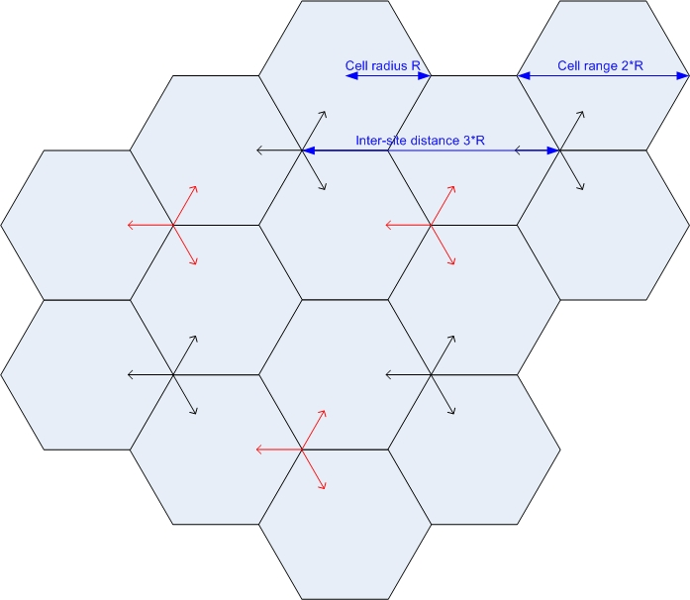
Figure 6.1.2.1.1-2: Uncoordinated operation

6.1.2.1.2 Dense urban
Details on dense urban network layout model are listed in Table 6.1.2.1.2-1 and 6.1.2.1.2-2.
Table 6.1.2.1.2-1: Single operator layout for dense urban
Parameters |  | Values | Remark
Network layout |  | Fixed cluster circle within a macro cell. | note1
Number of micro BSs per macro cell |  | 3 | 3 cluster circles are in a macro cell. 1 cluster circle has 1 micro BS.
Radius of UE dropping within a micro cell |  | < 65.03 m
BS antenna height |  | 10 m
UE location | Outdoor/indoor | Outdoor and indoor
UE location | Indoor UE ratio | 80 %
UE location | 50% low loss, 50% high loss | Low/high Penetration loss ratio
UE location | LOS/NLOS | LOS and NLOS
UE location | UE antenna height | Same as 3D-UMi in TR 36.873
UE distribution (horizontal) |  | Uniform
Minimum BS - UE distance (2D) |  | 3m
Channel model |  | UMi
Shadowing correlation |  | Between cite: 0.5
Note 1: Micro BS is randomly dropped on an edge of the cluster circle. All UEs communicate with micro BS, i.e. macro cell is only used for determining position of micro BS. As a layout of macro cell, hexagonal grid, 19 macro sites, 3 sectors per site model with wrap around with ISD = 450 m is assumed.

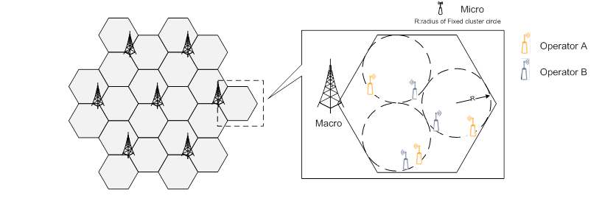
Figure 6.1.2.1.2-1: Network layout for dense urban
Table 6.1.2.1.2-2: Multi operators layout for dense urban
Parameters | Values | Remark
Multi operator layout | Cluster circle is coordinated | Note 1
Minimum distance between micro BSs in different operator | 10 m
Note 1: Macro cell is collocated. Micro BS itself is randomly dropped.

6.1.2.1.3 Indoor
Details on indoor network layout model are listed in Table 6.1.2.1.3-1 and 6.1.2.1.3-2.
Table 6.1.2.1.3-1: Single operator layout for indoor
Parameters |  | Values | Remark
Network layout |  | 50m x 120m, 12BSs
Inter-site distance |  | 20m | Single sector per site
BS antenna height |  | 3 m | Mounted on ceiling
UE location | Outdoor/indoor | Indoor
UE location | LOS/NLOS | LOS and NLOS
UE location | UE antenna height | 1 m
UE distribution (horizontal) |  | Uniform
Minimum BS - UE distance (2D) |  | 0 m
Channel model |  | Indoor Office
Shadowing correlation |  | NA

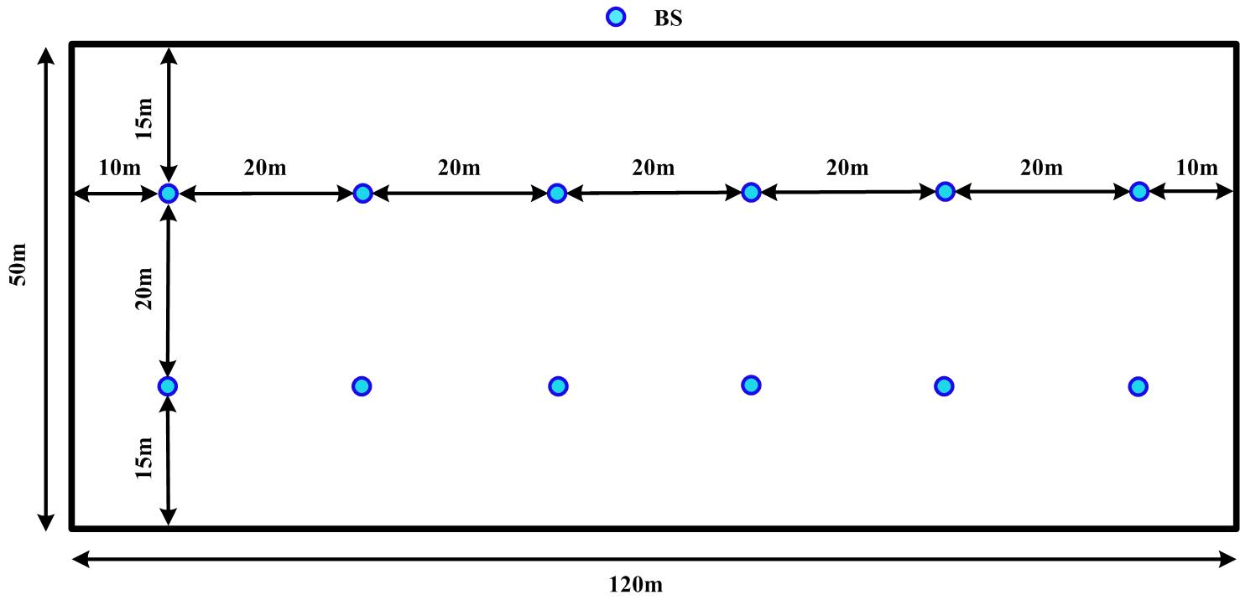
Figure 6.1.2.1.3-1: Network layout for indoor
Table 6.1.2.1.3-2: Multi operators layout for indoor
Parameters | Values | Remark
Multi operator layout | Coordinated operation (0% Grid Shift)

6.1.2.2 Propagation model

6.1.2.2.1 Pathloss
The pathloss models are summarized in Table 6.1.2.2.1-1 and the distance definitions are indicated in Figure 6.1.2.2.1-1 and Figure 6.1.2.2.1-2. Note that the distribution of the shadow fading is log-normal, and its standard deviation for each scenario is given in Table 6.1.2.2.1-1.

Figure 6.1.2.2.1-1: Definition of d_{2D} and d_{3D}  for outdoor UTs | Figure 6.1.2.2.1-2: Definition of d_{2D-out}, d_{2D-in}  and d_{3D-out}, d_{3D-in} for indoor UTs.
Note that
(6.1.2.2-1)

Table 6.1.2.2.1-1: Pathloss models
Scenario | LOS/NLOS | Pathloss [dB], f_{c} is in GHz and d is in meters, see note 6 | Shadow  fading  std [dB] | Applicability range,  antenna height  default values
UMa | LOS | , see note 1
UMa | NLOS | for |  | Explanations: see note 3
UMa | NLOS | Optional
UMi - Street Canyon | LOS | , see note 1
UMi - Street Canyon | NLOS | for |  | Explanations: see note 4
UMi - Street Canyon | NLOS | Optional
InH - Office | LOS
InH - Office | NLOS
InH - Office | NLOS | Optional
Note 1: Breakpoint distance d'_{BP} = 4 h'_{BS} h'_{UT} f_{c}/c, where f_{c} is the centre frequency in Hz, c = 3.0×10⁸ m/s is the propagation velocity in free space, and h'_{BS} and h'_{UT} are the effective antenna heights at the BS and the UT, respectively. The effective antenna heights h'_{BS} and h'_{UT} are computed as follows: h'_{BS} = h_{BS} – h_{E}, h'_{UT} = h_{UT} – h_{E}, where h_{BS} and h_{UT} are the actual antenna heights, and h_{E} is the effective environment height. For UMi h_{E} = 1.0m. For UMa h_{E}=1m with a probability equal to 1/(1+C(d_{2D}, h_{UT})) and chosen from a discrete uniform distribution uniform(12,15,…,(h_{UT}-1.5)) otherwise. With C(d_{2D}, h_{UT}) given by
,
where
.
Note that h_{E} depends on d_{2D} and h_{UT} and thus needs to be independently determined for every link between BS sites and UTs. A BS site may be a single BS or multiple co-located BSs.
Note 2: The applicable frequency range of the PL formula in this table is 0.5 < f_{c} < f_{H} GHz, where f_{H} = 30 GHz for RMa and f_{H} = 100 GHz for all the other scenarios. It is noted that RMa pathloss model for >7 GHz is validated based on a single measurement campaign conducted at 24 GHz.
Note 3: UMa NLOS pathloss is from TR36.873 with simplified format and PL_{UMa-LOS} = Pathloss of UMa LOS outdoor scenario.
Note 4: PL_{UMi-LOS} = Pathloss of UMi-Street Canyon LOS outdoor scenario.
Note 5: Break point distance d_{BP} = 2π h_{BS} h_{UT} f_{c}/c, where f_{c} is the centre frequency in Hz, c = 3.0 × 10⁸ m/s is the propagation velocity in free space, and h_{BS} and h_{UT} are the antenna heights at the BS and the UT, respectively.
Note 6: f_{c} denotes the center frequency normalized by 1GHz, all distance related values are normalized by 1m, unless it is stated otherwise.

6.1.2.2.2 LOS probability
The Line-Of-Sight (LOS) probabilities are given in Table 6.1.2.2.2-1.
Table 6.1.2.2.2-1: LOS probability
Scenario | LOS probability (distance is in meters)
UMi – Street canyon | Outdoor users:  Indoor users:  Use d_{2D-out} in the formula above instead of d_{2D}
UMa | Outdoor users:  where  and  Indoor users:  Use d_{2D-out} in the formula above instead of d_{2D}
Indoor – Open office
Note: The LOS probability is derived with assuming antenna heights of 3m for indoor, 10m for UMi, and 25m for UMa

6.1.2.2.3 O-to-I penetration loss
The Path loss incorporating O-to-I building penetration loss is modelled as in the following:
PL = PL_{b} + PL_{tw} + PL_{in} + N(0, σ_{P}²)
where PL_{b} is the basic outdoor path loss given in Section 6.1.2.2.1. PL_{tw} is the building penetration loss through the external wall, PL_{in} is the inside loss dependent on the depth into the building, and σ_{P} is the standard deviation for the penetration loss.
PL_{tw} is characterized as:
is an additional loss is added to the external wall loss to account for non-perpendicular incidence;
, is the penetration loss of material i, example values of which can be found in Table 6.1.2.2.3-1.
p_{i} is proportion of i-th materials, where ; and
N is the number of materials.
Table 6.1.2.2.3-1: Material penetration losses
Material | Penetration loss [dB]
Standard multi-pane glass | $$L_{glass}=2+0.2⋅f$$
IRR glass | $$L_{IRRglass}=23+0.3⋅f$$
Concrete | $$L_{concrete}=5+4⋅f$$
Wood | $$L_{wood}=4.85+0.12⋅f$$
Note: f is in GHz

Table 6.1.2.2.3-2 gives PL_{tw}, PL_{in} and σ_{P} for two O-to-I penetration loss models. The O-to-I penetration is UT-specifically generated, and is added to the SF realization in the log domain.
Table 6.1.2.2.3-2 O-to-I penetration loss model
 | Path loss through external wall: ${PL}_{tw}$ [dB] | Indoor loss: ${PL}_{in}$ [dB] | Standard deviation: σ_{P} [dB]
Low-loss model | $$5-10\log_{10}\left(0.3⋅{10}^{-{L_{glass}}/{10}}+0.7⋅{10}^{-{L_{concrete}}/{10}}\right)$$ | 0.5d_{2D-in} | 4.4
High-loss model | $$5-10\log_{10}\left(0.7⋅{10}^{-{L_{IRRglass}}/{10}}+0.3⋅{10}^{-{L_{concrete}}/{10}}\right)$$ | 0.5d_{2D-in} | 6.5

d_{2D}-_{in} is minimum of two independently generated uniformly distributed variables between 0 and 25 m for RMa, UMa and UMi-Street Canyon. d_{2D}-_{in} shall be UT-specifically generated.
Both low-loss and high-loss models are applicable to UMa and UMi-Street Canyon.
Only the low-loss model is applicable to RMa.
The composition of low and high loss is a simulation parameter that should be determined by the user of the channel models, and is dependent on the use of metal-coated glass in buildings and the deployment scenarios. Such use is expected to differ in different markets and regions of the world and also may increase over years to new regulations and energy saving initiatives. Furthermore, the use of such high-loss glass currently appears to be more predominant in commercial buildings than in residential buildings in some regions of the world.
The pathloss incorporating O-to-I car penetration loss is modelled as in the following:
PL = PL_{b} + N(μ, σ_{P}²)
where PL_{b} is the basic outdoor path loss given in Section 6.1.2.2.1. μ = 9, and σ_{P} = 5. Optionally, for metallized car windows, μ = 20 can be used. The O-to-I car penetration loss models are applicable for at least 0.6-60 GHz.

6.1.2.3 Antenna and beam forming pattern modelling

6.1.2.3.1 BS antenna modelling

Aθ,φ=-min--min12φφ3dB2,Am-min12θ-90θ3dB2,SLAv ,Am

AEθ,φ=GE,max+Aθ,φ
wm=1Msubexpj2πm-1dv,subλsinθsubtilt
Asubθ,φ=AEθ,φ+10log10m=1Msubwmvm2

vm=expj2πm-1dv,subλcosθ
wm,n=1MNexpj2πm-1dvλsinθetilt-n-1dhλcosθetiltsinφescan
AAθ,φ=Asubθ,φ+10log10m=1Mn=1Nwm,nvm,n2

vm,n=expj2πm-1dvλcosθ+n-1dhλsinθsinφ
The antenna model for AAS BS is described in subclause 7.1.
In Table 6.1.2.3.1-1, representable parameter sets relevant for an AAS base station operating within 14800 - 15350 MHz are provided.
Table 6.1.2.3.1-1: Antenna array parameters
Parameter | Indoor | Urban macro | Dense urban
Element gain (dBi) ^{(Note 2)} | 5 | 6.4 | 6.4
Horizontal/vertical 3 dB beam width of single element (degree) | 90º for H  90º for V | 90º for H  65º for V | 90º for H  65º for V
Horizontal/vertical front-to-back ratio (dB) | 30 for both H/V | 30 for both H/V | 30 for both H/V
Antenna polarization | Linear ±45º | Linear ±45º | Linear ±45º
Antenna array configuration (Row × Column)  ^{(Note 4)} | 4 x 4 | 16 x 24 | 16 x 24
Horizontal/Vertical radiating sub-array spacing | 0.5 of wavelength for H, 0.5 of wavelength for V | 0.5 of wavelength for H, 2.8 of wavelength for V ^{(Note 5)} | 0.5 of wavelength for H, 2.8 of wavelength for V ^{(Note 5)}
Number of element rows in sub-array | N/A | 4 | 4
Vertical element separation in sub-array ($d_{v,sub}$) | 0.5 of wavelength of V | 0.7 of wavelength of V | 0.7 of wavelength of V
Pre-set sub-array down-tilt (degrees) | N/A | 3 | 3
Array Ohmic loss (dB) ^{(Note 2)} | 2 | 2 | 2
Conducted power (before Ohmic loss) per sub-array or element (dBm) ^{(Note 3)} | 8 | 17.2 | 7.2
Base station horizontal coverage range (degrees) | +/-90 | +/-60 | +/-60
Base station vertical coverage range (degrees) ^{(Note 1)} | 0-180 | 90-100 | 90-100
Mechanical down-tilt (degrees) | N/A^{(Note 6)} | 6 | 6
Note 1: The vertical coverage range is given for the elevation angle θ, defined between 0° and 180° i.e. 90° being at the horizon
Note 2: The element gain includes the loss and is per polarization.
Note 3: The conducted power per sub-array assumes 16 × 24 sub-arrays and 2 polarizations for urban macro and dense urban cases; the conducted power per element assumes 4 x 4 elements and 2 polarizations for indoor case
Note 4: 16 × 24 means there are 16 vertical and 24 horizontal radiating sub-arrays for urban macro and dense urban cases; 4 x 4 means there are 4 vertical and 4 horizontal radiating elements for indoor case.
Note 5: For the case of 4 elements per sub array, dv will be 2.8 wavelengths.
Note 6: Roof mounted equipment with antenna boresight pointing downward

6.1.2.3.3 UE antenna modelling
For the FR1-like RF design, the UE is expected to have a conducted interface assuming an isotropic radiation pattern antenna and without beamforming (only for simulation and not reflecting deployment, coverage, implementation, or requirement aspects).

AE,V(θ″)=-min12θ″-90°θ3dB2,SLAV,θ3dB=90°,SLAV=25dB
AE,H(ϕ″)=-min12ϕ″ϕ3dB2,Am,ϕ3dB=90°,Am=25dB

A″(θ″,ϕ″)=-min-AE,Vθ″+AE,Hϕ″,Am

6.1.2.4 Other simulation parameters
Table 6.1.2.4-1: Other simulation parameters
Parameters | Indoor | Urban macro | Dense urban
Channel bandwidth | 100/200 MHz | 100/200 MHz | 100/200 MHz
Scheduled channel bandwidth per UE (DL) | 100/200 MHz | 100/200 MHz | 100/200 MHz
Scheduled channel bandwidth per UE (UL) | 100/200 MHz | 100/200 MHz | 100/200 MHz
The number of active UE (DL) | Same as the number of BS beam | Same as the number of BS beam | Same as the number of BS beam
The number of active UE (UL) | 1 UE per slot (first priority)  3 UE per slot (second priority) | 1 UE per slot (first priority)  3 UE per slot (second priority) | 1 UE per slot (first priority)  3 UE per slot (second priority)
Traffic model | Full buffer | Full buffer | Full buffer
DL power control | NO | NO | NO
UL power control | YES | YES | YES
BS max TX power in dBm (2 polarizations) | 23dBm | 46dBm | 36dBm
UE max TX power in dBm | 23dBm | 23dBm | 23dBm
UE min TX power in dBm | -40dBm | -40dBm | -40dBm
BS Noise figure in dB | 16 | 8 | 13
UE Noise figure in dB | 13 | 13 | 13
Handover margin | 3dB | 3dB | 3dB

6.1.3 Co-existence simulation results

6.1.3.1 Urban Macro scenario

6.1.3.1.1 Downlink
For Urban macro scenarios, simulation results for DL throughput loss with baseline assumption ACLR = 45 dBc at BS and ACS = 33 dBc at UE are summarized in Table 6.1.3.1.1-1/2/3/4/5. The following results are based on the FR1 like UE with omni-directional antenna and no beamforming.
Table 6.1.3.1.1-1: DL throughput loss for 14800 – 15350 MHz [Relative ACIR value]
Company | Throughput loss | Relative ACIR offset
Company | Throughput loss | 0 | -2 | -3 | -4 | -6 | -8 | -9 | -10 | -12 | -15
Nokia (R4-2417536) | Average throughput loss in % (15 GHz) | 0.17 |  | 0.28 |  | 0.45 |  | 0.70 |  | 1.06 | 1.55
Nokia (R4-2417536) | 5%-tile throughput loss in % (15 GHz) | 0.00 |  | 0.18 |  | 0.35 |  | 1.00 |  | 1.38 | 3.53
ZTE | Average throughput loss in % (15 GHz) | 0.33 | 0.41 |  | 0.52 | 0.67 | 0.85 |  | 1.09
ZTE | 5%-tile throughput loss in % (15 GHz) | 2.50 | 2.75 |  | 3.41 | 4.38 | 4.97 |  | 5/89

Table 6.1.3.1.1-2: DL throughput loss for 14800 – 15350 MHz [Absolute ACIR value]
 | ACIR (dB) | 5 | 10 | 15 | 17 | 18 | 19 | 20 | 21 | 25 | 30 | 32
Apple | Average throughput loss in % |  |  | 0.47 |  |  |  | 0.232 |  |  | 0.49 | 0.026
Apple | 5%-tile throughput loss in % |  |  | 0.623 |  |  |  | 0.247 |  |  | 0.054 | 0.006
CATT | Average throughput loss in % | 0.043 | 0.026 | 0.015 |  |  |  | 0.0082 |  | 0.0042 | 0.0023
CATT | 5%-tile throughput loss in % | 0.16 | 0.15 | 0.14 |  |  |  | 0.11 |  | 0.10 | 0.046
MediaTek | Average throughput loss in % | 7.41 | 4.61 | 2.74 |  | 1.97 |  |  | 1.39 | 0.86 | 0.44
MediaTek | 5%-tile throughput loss in % | 35.10 | 22.03 | 12.45 |  | 8.57 |  |  | 5.90 | 3.78 | 1.70
Vivo | Average throughput loss in % |  | 3.11 | 1.79 |  |  |  | 0.91 |  | 0.46 | 0.24
Vivo | 5%-tile throughput loss in % |  | 17.71 | 10.13 |  |  |  | 6.21 |  | 2.67 | 1.49
Qualcomm | Average throughput loss in % | 6.4 | 3.8 | 2.2 |  |  |  | 1.2 |  | 0.7 | 0.4
Qualcomm | 5%-tile throughput loss in % | 34.5 | 20.4 | 10 |  |  |  | 5.4 |  | 2.5 | 1.5
Ericsson | Average throughput loss in % |  |  |  | 0.0134 | 0.0121 | 0.01 | 0.009 | 0.008
Ericsson | 5%-tile throughput loss in % |  |  |  | 8 | 7 | 6.24 | 5.25 | 4.6
Huawei | Average throughput loss in % | 5.63 | 3.29 | 1.83 |  |  |  | 0.97 |  | 0.49 | 0.23
Huawei | 5%-tile throughput loss in % | 25.58 | 16.08 | 9.49 |  |  |  | 5.24 |  | 2.64 | 1.21
Samsung | Average throughput loss in % | 4 | 3 | 2 |  |  |  | 1 |  | 0 | 0
Samsung | 5%-tile throughput loss in % | 34 | 20 | 12 |  |  |  | 7 |  | 3 | 2

In addition, coexistence simulation results for 3 active UEs and Indoor Probability 0% are summarized in Table 6.1.3.1.1-3. and 6.1.3.1.1-4 below.
Table 6.1.3.1.1-3: DL throughput loss for 14800 – 15350 MHz [Relative ACIR with 3 active UEs]
Company | Throughput loss | Relative ACIR offset
Company | Throughput loss | 0 | -2 | -3 | -4 | -6 | -8 | -9 | -10 | -12 | -15
Nokia (R4-2417537) | Average throughput loss in % (15 GHz) | 0.31 |  | 0.51 |  | 0.82 |  | 1.29 |  | 2.00 | 3.02
Nokia (R4-2417537) | 5%-tile throughput loss in % (15 GHz) | 0 |  | 0 |  | 2.11 |  | 2.11 |  | 2.99 | 4.86

Table 6.1.3.1.1-4: DL throughput loss for 14800 – 15350 MHz [Absolute ACIR with Indoor Probability 0%]
Company | Throughput loss | Absolute ACIR
Company | Throughput loss | 17 | 18 | 19 | 20 | 21 | 22 | 23
Ericsson | Average throughput loss in % (15 GHz) | 0.015 | 0.014 | 0.0125 | 0.01 | 0.01 | 0.009 | 0.008
Ericsson | 5%-tile throughput loss in % (15 GHz) | 11 | 10 | 8 | 7.5 | 7.2 | 6.7 | 5.5

Based on the above simulation results, the required DL ACIR for 14800 – 15350 MHz for urban macro scenarios are in summarized in Table 6.1.3.1.1-5. The range of ACIR is derived as 20-26 dB, and the range of 22-24 dB by excluding the highest/lowest.

Table 6.1.3.1.1-5: DL simulation results for 14800 – 15350 MHz
 | ACIR (dB)
Company | Urban macro
Nokia | -12 dB (relative)
Apple | 28-30
CATT | 24
MediaTek | 23-24
Vivo | 22
Qualcomm | 22
Ericsson | 20-24
ZTE | -8 dB (relative)
Huawei | 21
Samsung | 24-25
[Average in range] | 20-26
[Excluding the highest/lowest] | 22-24

6.1.3.1.2 Uplink
For Urban macro scenarios, simulation results for UL throughput loss with baseline assumption ACLR = 30 dBc at UE and ACS = 45 dBc at BS are summarized in Table 6.1.3.1.2-1/2/3/4/5. The following results are based on the FR1 like UE with omni-directional antenna and no beamforming.

Table 6.1.3.1.2-1: UL throughput loss for 14800 – 15350 MHz [Relative ACIR value]
Company | Throughput loss | Relative ACIR offset
Company | Throughput loss | 0 | -2 | -3 | -4 | -6 | -8 | -9 | -10 | -12 | -15
Nokia (R4-2417536) | Average throughput loss in % (15 GHz) | 0.07 |  | 0.12 |  | 0.20 |  | 0.30 |  | 0.46 | 0.68
Nokia (R4-2417536) | 5%-tile throughput loss in % (15 GHz) | 1.14 |  | 2.21 |  | 3.52 |  | 3.55 |  | 3.61 | 3.73
ZTE | Average throughput loss in % (15 GHz) | 0.26 | 0.30 |  | 0.34 | 0.39 | 0.46 |  | 0.55
ZTE | 5%-tile throughput loss in % (15 GHz) | 6.36 | 7.20 |  | 8.95 | 9.10 | 9.36 |  | 10.98

Table 6.1.3.1.2-2: UL throughput loss for 14800 – 15350 MHz [Absolute ACIR value]
 | ACIR (dB) | 8 | 9 | 10 | 11 | 12 | 13 | 14 | 15 | 20 | 22 | 23 | 25 | 30
Apple | Average throughput loss in % |  |  | 0.6 |  |  |  |  | 0.3 | 0.13 | 0.099 | 0.079 | 0.06 | 0.022
Apple | 5%-tile throughput loss in % |  |  | 0.59 |  |  |  |  | 0.22 | 0.14 | 0.131 | 0.1 | 0.1 | 0.01
CATT | Average throughput loss in % |  |  | 0.027 |  |  |  |  | 0.018 | 0.01 |  |  | 0.0055 | 0.0024
CATT | 5%-tile throughput loss in % |  |  | 0.088 |  |  |  |  | 0.0032 | 0.0001 |  |  | 3.1e-5 | 9.7e-6
MediaTek | Average throughput loss in % |  |  | 2.12 |  |  |  |  | 1.15 | 0.60 |  |  | 0.3 | 0.14
MediaTek | 5%-tile throughput loss in % |  |  | 8.48 |  |  |  |  | 4.05 | 1.94 |  |  | 0.75 | 0.16
Vivo | Average throughput loss in % |  |  | 0.80 |  |  |  |  | 0.38 | 0.18 |  |  | 0.08 | 0.04
Vivo | 5%-tile throughput loss in % |  |  | 5.77 |  |  |  |  | 2.82 | 0.93 |  |  | 0.14 | 0
Qualcomm | Average throughput loss in % |  |  | 1.4 |  |  |  |  | 0.7 | 0.4 |  |  | 0.18 | 0.09
Qualcomm | 5%-tile throughput loss in % |  |  | 7.4 |  |  |  |  | 2.8 | 1.8 |  |  | 0.7 | 0.4
Ericsson | Average throughput loss in % | 0.0088 | 0.0078 | 0.0068 | 0.006 | 0.0052 | 0.0046 | 0.004
Ericsson | 5%-tile throughput loss in % | 6 | 5.66 | 5 | 4.6 | 4.22 | 3.6 | 3.3
Huawei | Average throughput loss in % |  |  | 3.57 |  |  |  |  | 2.00 | 1.08 |  |  | 0.56 | 0.27
Huawei | 5%-tile throughput loss in % |  |  | 8.59 |  |  |  |  | 5.63 | 3.58 |  |  | 2.30 | 1.28

In addition, coexistence simulation results for 3 active UEs and Indoor Probability 0% are summarized in Table 6.1.3.1.2-3.and 6.1.3.1.2-4 below.
Table 6.1.3.1.2-3: UL throughput loss for 14800 – 15350 MHz [Relative ACIR with 3 active UEs]
Company | Throughput loss | Relative ACIR offset
Company | Throughput loss | 0 | -2 | -3 | -4 | -6 | -8 | -9 | -10 | -12 | -15
Nokia (R4-2411537) | Average throughput loss in % (15 GHz) | 0.23 |  | 0.33 |  | 0.48 |  | 0.72 |  | 1.08 | 1.63
Nokia (R4-2411537) | 5%-tile throughput loss in % (15 GHz) | 1.81 |  | 3.40 |  | 3.47 |  | 5.06 |  | 6.14 | 9.49

Table 6.1.3.1.2-4: UL throughput loss for 14800 – 15350 MHz [Absolute ACIR with Indoor Probability 0%]
Company | Throughput loss | Absolute ACIR
Company | Throughput loss | 8 | 9 | 10 | 11 | 12 | 13 | 14
Ericsson | Average throughput loss in % (15 GHz) | 0.02 | 0.017 | 0.015 | 0.013 | 0.012 | 0.01 | 0.009
Ericsson | 5%-tile throughput loss in % (15 GHz) | 12.52 | 11 | 10 | 8.2 | 7.2 | 6 | 5

Based on the above simulation results, the required UL ACIR for 14800 – 15350 MHz for urban macro scenarios are in summarized in Table 6.1.3.1.2-5. Many results suggest ACIR around e.g. 13-15dB excluding highest and lowest values.
Table 6.1.3.1.2-5: UL simulation results for 14800 – 15350 MHz
 | ACIR (dB)
Company | Urban macro
Nokia | -9 (relative)
Apple | 22-24
CATT | 20
MediaTek | 15-17
Vivo | 12
Qualcomm | 13
Ericsson | 11-14
ZTE | -10 (relative)
Huawei | 18

6.2 General parameters

6.2.1 Duplex mode
There is no defined 3GPP band for the 14800 - 15350 MHz frequency range. Even though FDD is not precluded, TDD is assumed as a baseline duplexing in this frequency range. SBFD can be a candidate duplexing method for this frequency range. The core requirements for Rel-19 SBFD work item can be tracked through the list of impacted specs captured in [8].

6.2.2 Channel Bandwidth
While a number of channel bandwidth will be specified for this frequency range, 200 MHz is considered as a typical channel bandwidth. Other channel bandwidths compared to 200MHz are not precluded for this range.

6.2.3 Signal Bandwidth
The signal bandwidth for a 200MHz typical channel bandwidth signal is associated with both SCS and spectrum utilization, and can be calculated based on the spectrum utilization:
Signal bandwidth = N_{RB} x SCS x 12
with N_{RB}: Number of Resource block for 200 MHz channel bandwidth and SCS to be specified when introducing new band(s) for this frequency range.

6.3 BS parameters

6.3.1 Transmitter characteristics

6.3.1.1 Power dynamic range
There is no power control in downlink and fixed power per resource block is assumed during the study phase. Hence 0 dB power dynamic range was agreed for the LS reply [6].

6.3.1.2 Spectral mask
Category A limits for Wide Area BS for AAS BS are listed in Table 6.3.1.2-1.
Table 6.3.1.2-1: Wide Area BS operating band unwanted emission limits for AAS BS (Category A)
Frequency offset of measurement filter ‑3dB point from the carrier frequency, Δf | Basic Limits | Measurement Bandwidth
0 MHz ≤ Δf < 50MHz | -7dBm-750f_offsetMHz-0.05 | 100 kHz
50 MHz ≤ Δf < min(100 MHz, Δf_{max}) | -14 dBm | 100 kHz
100 MHz ≤ Δf ≤ Δf_{max} | -13 dBm | 1 MHz
NOTE: Δf_{max} is equal to f_offset_{max} minus half of the bandwidth of the measuring filter, where f_offset_{max} is the offset to the frequency Δf_{OBUE} = 100 MHz outside the downlink operating band.

Note: AAS BS Category B limits for Wide Area BS are not yet specified by regional regulatory bodies.

6.3.1.3 ACLR
The ACLR should be higher than the value specified in Table 6.3.1.3-1.
Table 6.3.1.3-1: Base station ACLR limit
BS channel bandwidth of lowest/highest carrier transmitted BW_{Channel} (MHz) | BS adjacent channel centre frequency offset below the lowest or above the highest carrier centre frequency transmitted | Assumed adjacent channel carrier (informative) | Filter on the adjacent channel frequency and corresponding filter bandwidth | ACLR limit
200 | BW_{Channel} | NR of same BW (Note 2) | Square (BW_{Config}) | 30 dB
200 | 2 x BW_{Channel} | NR of same BW (Note 2) | Square (BW_{Config}) | 30 dB
NOTE 1: BW_{Channel} and BW_{Config} are the BS channel bandwidth and transmission bandwidth configuration of the lowest/highest carrier transmitted on the assigned channel frequency.
NOTE 2: With SCS that provides largest transmission bandwidth configuration (BW_{Config}).

6.3.1.4 Spurious emissions
The Category A spurious emission limits applicable are extracted from TS 38.104 [9], as listed in Table 6.3.1.4-1.
Table 6.3.1.4-1: General BS transmitter spurious emission limits for 14800 - 15350 MHz operation (Category A)
Frequency range | Limit | Measurement Bandwidth | Note
30 MHz – 1 GHz | -13 dBm | 100 kHz | Note 1
1 GHz – 2nd harmonic of the upper frequency edge of the DL operating band | -13 dBm | 1 MHz | Note 1, Note 2
NOTE 1: Bandwidth as in ITU-R SM.329, s4.1
NOTE 2: Upper frequency as in ITU-R SM.329, s2.5 table 1.

Note: AAS BS Category B limits are not yet specified by regional regulatory bodies.

6.3.1.5 Maximum output power
The maximum base station output power/ sector (e.i.r.p.) was provided in the antenna parameter table of the LS [6], as extracted in Table 6.3.1.5-1. It was agreed to be aligned with antenna characteristics.
Table 6.3.1.5-1: Maximum BS output power in 14800 to 15350 MHz
 | Macro suburban | Macro urban | Micro urban | Indoor Hotspot
Maximum base station output power/sector (e.i.r.p.) (dBm) | 84.3 | 84.3 | 74.3 | 40.0

The Total Radiated Power (TRP) for two polarizations was agreed as shown in Table 6.3.1.5-2 below.
Table 6.3.1.5-2: Total Radiated Power
Parameter | Macro Sub-urban | Macro Urban | Micro Urban | Indoor Hotspot
Total Radiated Power for two polarizations (dBm) | 46 | 46 | 36 | 23

6.3.1.6 Average output power
It was agreed the average output power won’t be mentioned in the reply LS in [6].

6.3.2 Receiver characteristics

6.3.2.1 Noise figure
The BS typical noise figure is listed in Table 6.3.2.1-1, and BS class definitions can be seen in [9], § 4.4.
Table 6.3.2.1-1: Noise figure
BS class | Noise figure (dB)
Wide Area | 8
Medium Range | 13
Local Area | 16

6.3.2.2 Sensitivity
The OTA sensitivity requirement will be based on the NF and the antenna gain:
EISREFSENS=PkT+10*log10BW+NF+IM+SNR-G (dBm)
Where:
- BW is the configured bandwidth of the FRC,
- NF is the noise figure,
- IM is implementation margin not related to antenna array,
- SNR is the required SNR to reach 95% throughput, and
- G is the antenna gain including RF losses and 3dB off peak margin.

However, the sensitivity is not a critical parameter for sharing and compatibility studies. It was agreed to not mention any value for this parameter in LS [6].

6.3.2.3 Blocking response
The out-of-band blocking requirement applies from 30 MHz to 2nd harmonic of the upper frequency edge of the operating band, excluding the in-band blocking frequency range, but including the downlink frequency range in case of an FDD operating band as listed in Table 6.3.2.3-1. It is agreed to adopt Δf_{OOB} = 100 MHz for AAS BS.
Table 6.3.2.3-1: OTA out-of-band blocking performance requirement for 14800 – 15350 MHz operation
Frequency range of interfering signal  (MHz) | Wanted signal mean power  (dBm) | Interferer RMS field-strength (V/m) | Type of interfering signal
30 to 12750 | EIS_{REFSENS} + 6 dB | 0.36 | CW
12750 to F_{UL,low} – 100 | EIS_{REFSENS} + 6 dB | 0.1 | CW
F_{UL,high} + 100 to 2nd harmonic of the upper frequency edge of the operating band | EIS_{REFSENS} + 6 dB | 0.1 | CW

The out-of-band blocking conductive requirements and in-band blocking requirements should be further studied in the WI phase.

6.3.2.4 ACS
According to the simulation results in clause 6.1.3, it is agreed to specify 30 dB ACS.

6.4 UE parameters

6.4.1 Transmitter characteristics

6.4.1.1 Power dynamic range
The minimum controlled output power of the UE is defined as the power in the channel bandwidth for all transmit bandwidth configurations (resource blocks), when the power is set to a minimum value. Based on the study in sub-clause 6.5.2, the UE antenna type for 14800 – 15350 MHz can reuse existing FR1 antenna characteristics so that both nominal maximum and minimum output power refer to existing FR1 bands, i.e., power dynamic range is 56 dB with power class 3 (i.e. 23 dBm maximum output power) UE.

6.4.1.2 Spectral mask
The UE spectral mask is described in TS 38.101-1 [12] clause 6.5.2.2 Table 6.5.2.2-1. Emission mask for 200 MHz BW is based on the CA mask as defined in TS 38.101-1 [12] clause 6.5A.2.2. The SEM requirements in this frequency range may be relaxed than FR1 intra-band CA with 200MHz aggregated bandwidth in the WI phase.

6.4.1.3 ACLR
Considering that the UE needs to meet the Occupied bandwidth (OBW) requirements which is higher than the ACLR needed for co-existence as noted in sub-clause 6.1.3, it was concluded that 24 dB ACLR would be sufficient for 14800 – 15350 MHz. Thus, ACLR of 24 dB can be considered for the frequency range 14800 – 15350 MHz.
The actual ACLR for this frequency range or parts there-of should be further studied in the WI phase.

6.4.1.4 Spurious emissions
The general spurious emissions defined in TS 38.101-1 [12] clause 6.5.3 Table 6.5.3.1-2 with OOB boundary given in Table 6.5A.3.1-1 can apply to the frequency range 14800 -15350 MHz.

6.4.1.5 Maximum output power
Based on the study in sub-clause 6.5.2, the UE maximum output power for the considered frequency ranges could be 23 dBm. Other UE power classes, e.g., 20dBm, 26dBm and 29dBm, are not precluded (corresponding ACLR limit will be adapted accordingly to avoid additional interference).

6.4.1.6 Average output power
NOTE: This parameter was not mentioned in the previous response to ITU-R WP5D.

6.4.2 Receiver characteristics

6.4.2.1 Noise figure
A noise figure of 11 dB was assumed for coexistence simulation in sub-clause 6.1.2. For the frequency range 14800 – 15350 MHz noise figure of 13 dB can be reused.
The actual noise figure for this frequency range or parts there-of to define RF requirements should be further studied in the WI phase.

6.4.2.2 Sensitivity
The sensitivity is not a critical parameter for sharing and compatibility studies. It was agreed to not mention any value for this parameter.

6.4.2.3 Blocking response
The blocking characteristic specified in clause 7.6A Tables 7.6A.2.1-1 and 7.6A.3-1 Bandwidth Class C and clause 7.7 Table 7.7A-1 Bandwidth class C for spurious response of TS 38.101-1 [12] could be applied for 200 MHz BW requirements of the frequency range 14800 – 15350 MHz.
The actual requirements for this frequency range or parts there-of may differ depending on the band plan and possible re-use of RF hardware components.

6.4.2.4 ACS
According to the previous studies and simulation results in sub-clause 6.1.3, adjacent channel selectivity (ACS) is agreed as 24 dBc for 14800 – 15350 MHz. Thus, ACS of 24 dB can be considered for the frequency range 14800 – 15350 MHz.
The actual ACS for this frequency range or parts there-of should be further studied in the WI phase.

6.5 Antenna characteristics

6.5.1 BS antenna characteristics

6.5.1.1 Antenna model
The antenna model for AAS BS is described in subclause 7.1.

6.5.1.2 Antenna parameters
In Table 6.5.1.2-1, representable parameter sets relevant for an AAS base station operating within 14800 - 15350 MHz are provided.
Table 6.5.1.2-1: Antenna array parameters
 |  | Macro suburban | Macro urban | Micro urban | Small cell indoor/  Indoor urban
1 | Base station Antenna Characteristics
1.1 | Antenna pattern | Table 3 |  |  | N/A
1.2 | Element gain (dBi) ^{(Note 2)} | 6.4 | 6.4 | 6.4 | 5
1.3 | Horizontal/vertical 3 dB beam width of single element (degree) | 90º for H  65º for V | 90º for H  65º for V | 90º for H  65º for V | 90º for H  90º for V
1.4 | Horizontal/vertical front-to-back ratio (dB) | 30 for both H/V | 30 for both H/V | 30 for both H/V | 30 for both H/V
1.5 | Antenna polarization | Linear ±45º polarized sub-array | Linear ±45º polarized sub-array | Linear ±45º polarized sub-array | Linear ±45º polarized sub-array
1.6 | Antenna array configuration (Row × Column)  ^{(Note 4)} | 16x24 | 16x24 | 16x24 | 4x4
1.7 | Horizontal/Vertical radiating sub-array or element spacing ^{(Note 5)} | 0.5 of wavelength for H, 2.8 of wavelength for V | 0.5 of wavelength for H, 2.8 of wavelength for V | 0.5 of wavelength for H, 2.8 of wavelength for V | 0.5 of wavelength for H, 0.5 of wavelength for V
1.7a | Number of element rows in sub-array | 4 | 4 | 4 | N/A
1.7b | Vertical element separation in sub-array ($d_{v,sub}$) | 0.7 of wavelength for V | 0.7 of wavelength for V | 0.7 of wavelength for V | N/A
1.7c | Pre-set sub-array down-tilt (degrees) ^{(Note 6)} | 3 | 3 | 3 | N/A
1.8 | Array Ohmic loss (dB) ^{(Note 2)} | 2 | 2 | 2 | 2
1.9 | Conducted power (before Ohmic loss) per sub-array or element (dBm) ^{(Note 3)} | 17.2 | 17.2 | 7.2 | 8.0
1.10 | Base station horizontal coverage range (degrees) | ±60 | ±60 | ±60 | ±90
1.11 | Base station vertical coverage range (degrees) ^{(Note 1)} | 90-100 | 90-100 | 90-100 | 0-180
1.12 | Mechanical down-tilt (degrees) | 6 | 6 | 6 | N/A
1.13 | Base station output power/sector (e.i.r.p.) (dBm) ^{(Note 7)} | 84.3 | 84.3 | 74.3 | 40.0

Note 1: The vertical coverage range is given in global coordinate system, i.e., 90° being at the horizon. This range includes the mechanical down-tilt given in row 1.12.
Note 2: The element gain in row 1.2 includes the loss given in row 1.8 and is per polarization.
Note 3: Conducted power values are per polarization. The conducted power per sub-array assumes 16 × 24 sub-arrays and 2 polarizations for the Macro Suburban, Macro Urban and Micro Urban cases; the conducted power per element assumes 4x4 elements for the Small cell indoor/ Indoor Urban case. This power is typical power, there is no upper limit for Wide Area Base station (For BS class definitions, see 3GPP TS 38.104 [1], § 4.4).
Note 4: 16 × 24 means there are 16 rows and 24 columns of radiating sub-arrays for Macro Suburban, Macro Urban and Micro Urban cases. 4x4 means there are 16 rows and 24 columns of radiating elements for Small cell indoor/ Indoor Urban case.
Note 5: For the case of 4 elements per sub-array, d_{v} will be 2.8 wavelengths.
Note 6: The pre-set sub array down-tilt is a fixed design parameter for a base station. It is envisaged as a passive fixed (non-varying) electrical tilt within the sub-array elements.
Note 7: The base station e.i.r.p per sector is calculated as total power (including power from two orthogonal polarizations).
Note 8: Mechanical down-tilt is handled by a coordinate system transformation described in 3GPP TR 36.814 section A.2.1.6.2.
Note 9: $θ_{etilt}$ and $φ_{escan}$ is the BS array antenna beam steering direction used in Table 3, they should be set so that the beam steering direction is within the vertical and horizontal coverage ranges in row 1.11 and row 1.10, respectively.

6.5.2 UE antenna characteristics

6.5.2.1 General considerations
One of the key issues for this range is the UE RF architecture. While existing FR1 system parameters are defined for frequencies up to 7.1GHz, same FR1 principles are already assumed for e.g. 7.1-8.4GHz, which is however below the considered range of 14.8-15.3GHz. At the same time, the lower bound for the FR2 starts at 24.25GHz, which is notably higher than 15.3GHz. A choice for a particular UE RF architecture at these frequency ranges should consider implementation feasibility, e.g. physical constraints in case of handheld devices, and anticipated performance, such as coverage (as highlighted in Figure 6.5.2-1 in TR 38.820). The capabilities of PA technology in the FR2 frequency range motivated 3GPP to consider a UE architecture which relies on panels performing analog beam-forming, which was also considered as a feasible option from the handheld device implementation perspective. In contrast, panels and analog beam-forming are not feasible for lower FR1 frequencies.
In the context of the UE RF architecture, better UL coverage at FR2 frequencies was one of the key driving factors to consider the UE RF design with panels performing analog beam-forming. An FR2-like array antenna system incorporates analog beamforming into the array antenna to increase the coherent EIRP gain, thus helping to reduce the path loss between the UE and the base station. Furthermore, the FR2 array antenna, LNAs, PAs, beamformers, and PMIC are integrated into a single package, small form factor of which was also considered as a feasible option from the handheld device implementation perspective. As for the frequencies around 10-15GHz, previous work in TR 38.820 studied feasibility of FR2 principles in hand-held devices operating in that frequency range. One of the main challenges is the size of potential FR2 panel and, as noted in TR 38.820, "… we can see that the antenna module doubles in size going from 28 GHz to 20 GHz and further doubles at 14 GHz". Figure 6.5.2.1-1 presents an example of the patch width and ground plane extension based on the microstrip patch array design assuming four elements with half-wavelength spacing.
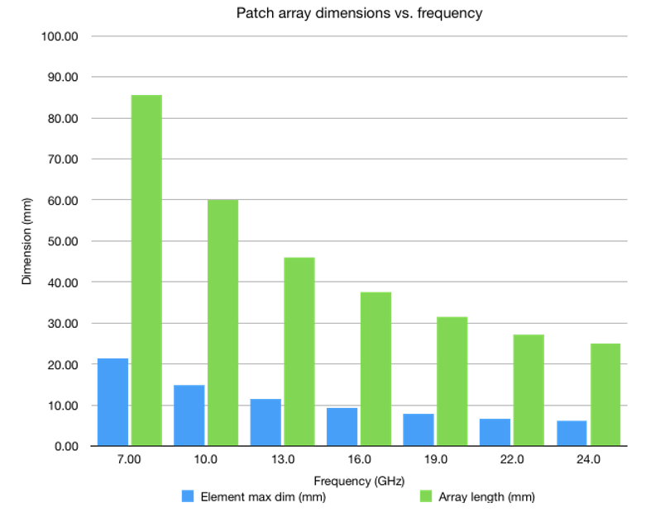
Figure 6.5.2.1-1: Patch array dimensions vs. frequency
For more detailed information on the potential array antenna size operating at the considered frequency of 15GHz, Figure 6.5.2.1-2 below presents several example cases with different antenna arrangements accounting for the typical spacing between elements of the array antenna of half wavelength. As can be seen from the figure for a typical inter-element antenna spacing, the total antenna array size becomes much larger comparing to the FR2 sizes.

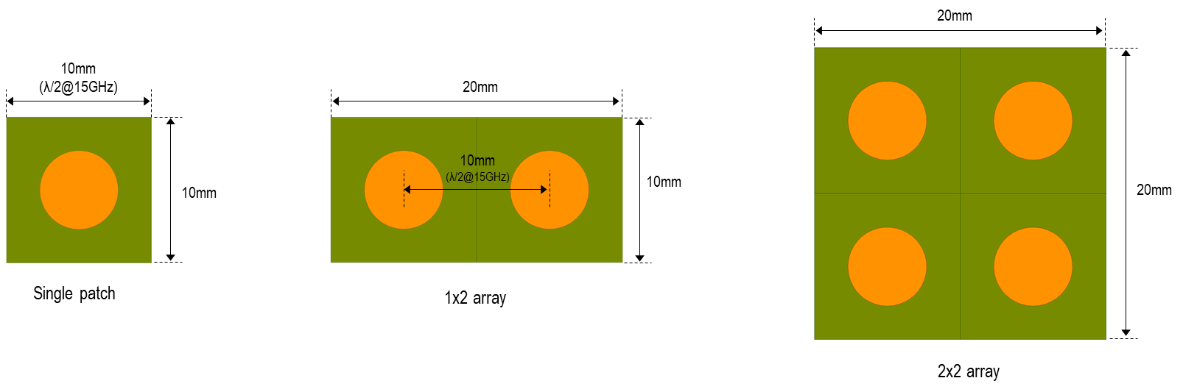
Figure 6.5.2.1-2: Estimated antenna size at 15GHz
Figure 6.5.2.1-3 below illustrates an example of a survey of the internal area used by four different commercially available 5G devices for FR1 (based on individual company contributions in RAN4). The FR2 area is calculated based a single 4x1 reference design, the configuration used as the basis for current FR2 spherical coverage requirements. Additionally, an estimate of the required 12-15GHz antenna array area is provided for comparison, similarly based on a 4x1 microstrip patch array with half-wavelength spacing. So, assuming dedicated apertures, an estimated 4x1 array at 12-15 GHz would represent an additional area growth on the order of 30-70% relative to antenna area usage currently needed to support FR1.
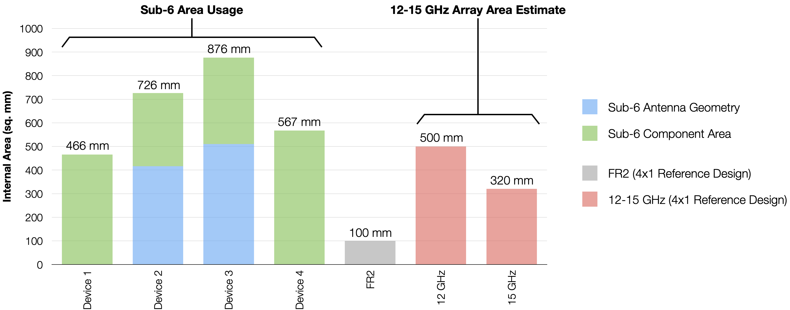
Figure 6.5.2.1-3: A survey of internal area usage for FR1, FR2 and estimated 13-15GHz antennas
In addition, support of analog beamforming in 15GHz might impose a substantial growth and volume requirements dedicated for cellular antennas. Furthermore, the nature of such an array might constrain the dimensions leading to implementation challenges in densely integrated consumer devices that can be of different form factors. For instance, Figure 6.5.2.1-4 shows an example of the PCB of a foldable phone, from which one can see that it might be challenging to mount single patch antennas on four edges or the backside of the smartphone considering the larger array size and the already-packed smartphone space. In other words, it can be difficult for a hand-held to assume that there will be extra space in all required physical dimensions making it challenging, at least from the packing perspective, to put FR2-like panels supporting the 15GHz range.
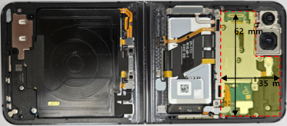
Figure 6.5.2.1-4: Main PCB of a foldable mobile phone.

6.5.2.2 Design with patch antennas
A possible design approach is the adoption of patch antennas (i.e., FR1-like design) which gives more flexibility to the OEM vendors because even if a device implements more than one Tx, there is an additional flexibility on where Tx antennas can be placed. Furthermore, more than one Tx antenna can attain coherent EIRP gain through the corresponding placement of co-directional and co-located antennas when coherent Tx is implemented. Each antenna in such FR1-like system is linked to its own digital chain, allowing for easy support of coherent Tx. It can also reduce the PA power requirement for each antenna element, thus enhancing the overall power consumption of the UE at 15GHz, and it can help increase the coverage distance between the base station and the UE. For instance, Figure 6.5.2.2-1 presents an example of a general mobile device form factor with two patch antennas placed within the device as presented at the distance corresponding to approximately three wavelengths.

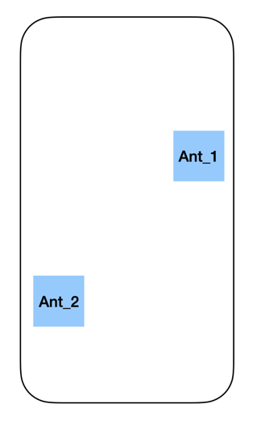
Figure 6.5.2.2-1: Exemplary placement of two patch antennas within a mobile device.
In this example, each patch antenna gain is around 2dB with the Tx power 23dBm. Additionally, Figure 6.5.2.2-2 below presents separately distribution of antenna and EIRP gains for the considered example antennas, where the baseline curve is only one antenna. Gain values are obtained by probing all points in 3D space around considered antennas, which allows us to find the best beam at each point of space independent of the base station location. In other words, these figures illustrate possible gain values, including the best one, regardless of the phone orientation with respect to the base station. As can be seen from this example, from the antenna gain perspective, the average gain comparing to one Tx is around 2.5dB. From the EIRP perspective, the average gain comparing to one Tx is around 5.5dB, which comprises 2.5dB antenna gain and 3dB coming from the fact that there are two Tx antennas each transmitting at 23dBm.

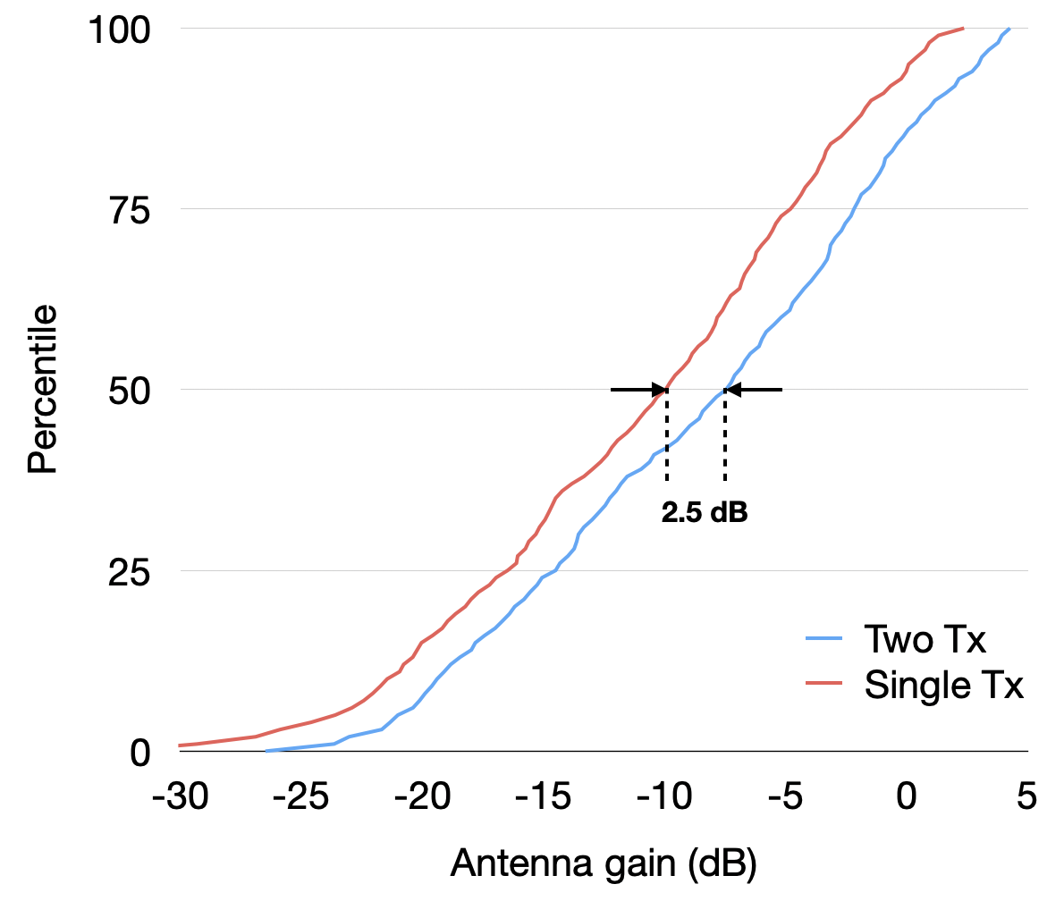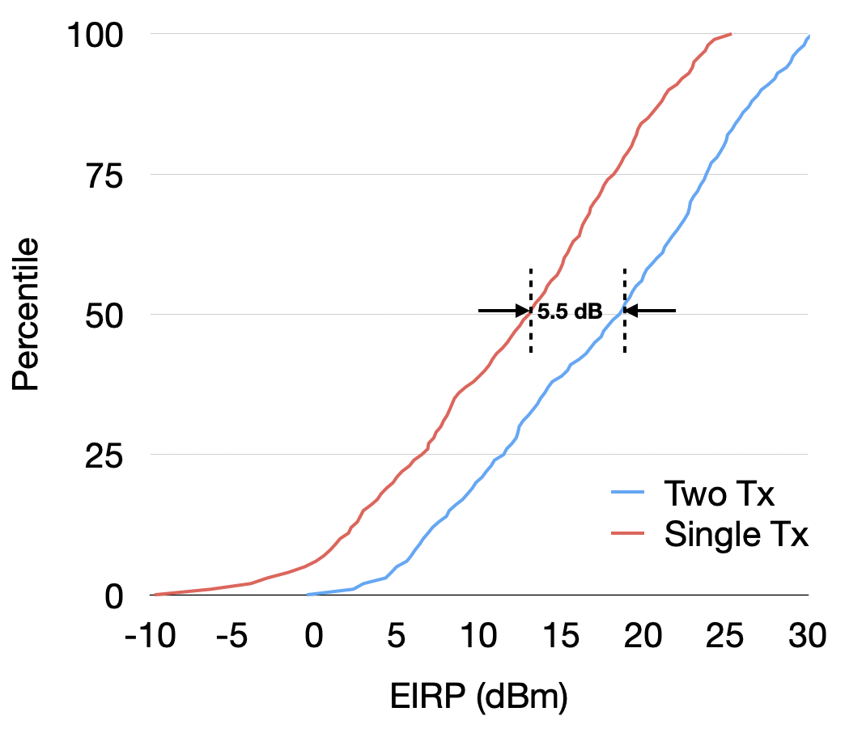

Figure 6.5.2.2-2: Antenna and EIRP gain for the considered two Tx antennas.
An additional aspect for the FR1-like antenna design is the resulting radiation pattern. It is worth noting that unlike at the antenna and EIRP gain, which are not very sensitive for the actual placement of Tx antennas, the radiation pattern may vary a lot. For instance, Figure 6.5.2.2-3 below presents an example resulting beam pattern from two Tx antennas physical location of which is the same as in Figure 6.5.2.2-1. For the sake of better clarity, we present the resulting radiation pattern in 2D and 3D spaces. Since two Tx antennas are placed at the back side of the phone, the resulting radiation pattern has a big negative gain in the opposite direction.
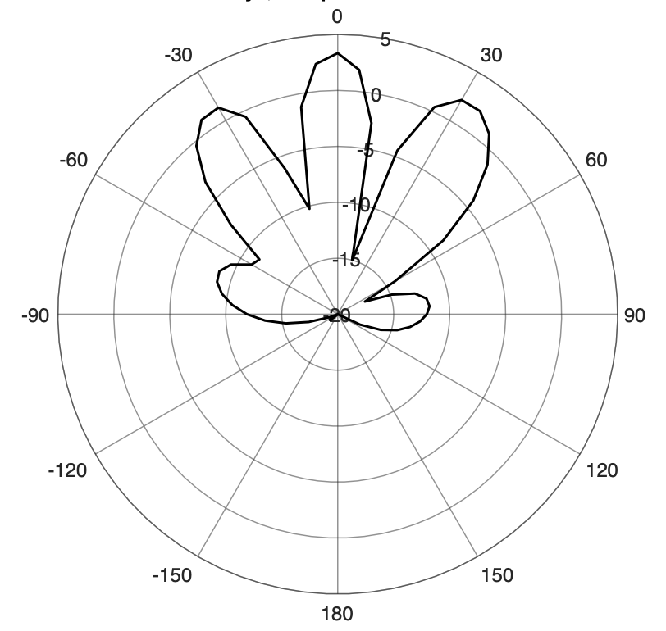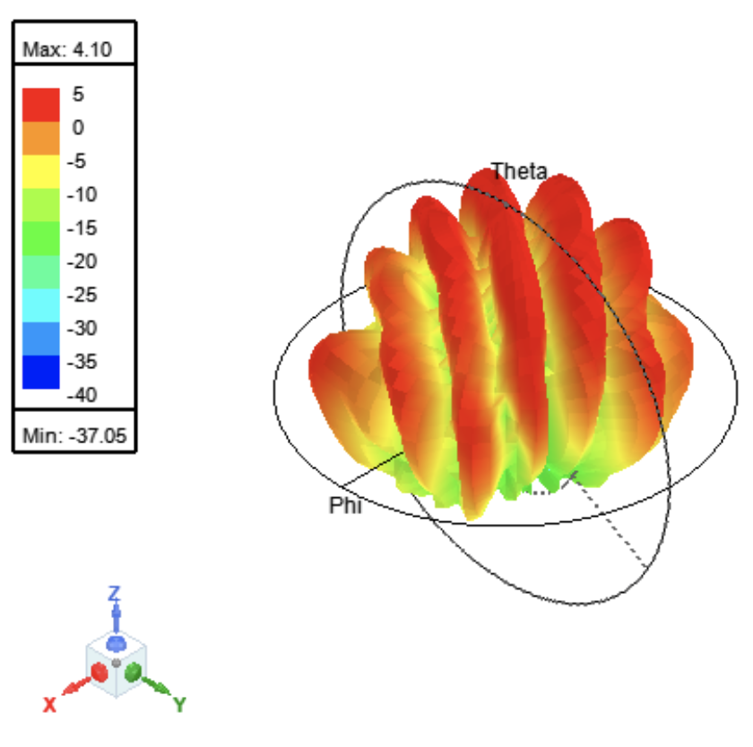
Figure 6.5.2.2-3: Radiation pattern for two Tx antennas presented in Figure 6.5.2.x-2.
On the Rx side, more than one discrete/ FR1-like antenna with digital beamforming can maximize the received signal power to improve the cell edge performance. For a cell-center user, instead of maximizing the received signal power, all antennas can be used jointly to achieve spatial multiplexing gain.

6.5.2.3 Design with metal frame antennas
A simulation with two general metal frame Tx antennas was conducted to estimate the antenna gain and performance for cases of single-Tx and multi-Tx without beam steering assumptions. The antenna placement for the evaluation is captured in 6.5.2.3-1.

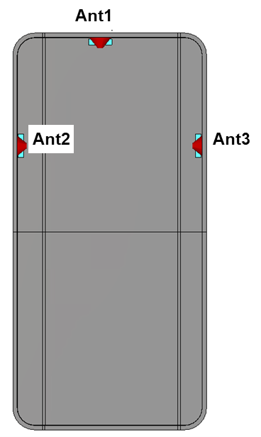
Figure 6.5.2.3-1: Exemplary placement of metal frame antennas within a mobile device.
With the assumption above, simulation results of the above example related to antenna performance are summarized in Figure 6.5.2.3-2 and Table 6.5.2.3-1, which also capture radiation efficiency and directivity in terms of peak antenna gains of each scenario.

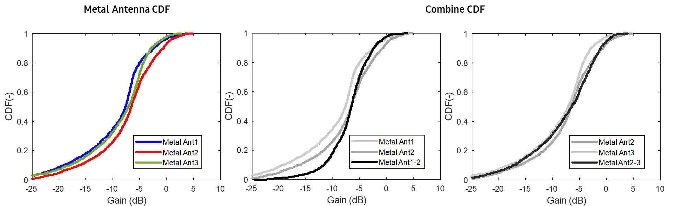
Figure 6.5.2.3-2: CDF of peak antenna gains for metal antennas
Table 6.5.2.3-1: Peak antenna gains for one-Tx and two-Tx
 | Ant1 | Ant2 | Ant3
Gain (dB) | 3.9 | 4.8 | 2.7
Rad. Efficiency (dB) | -6.3 | -4.8 | -6.3
Directivity (dB) | 10.2 | 9.6 | 9.0
 | Ant1 + Ant2 | Ant1 + Ant 3 | Ant2 + Ant3
Combined gain (dB) | 3.8 | 2.6 | 3.9
Gain drop (dB) | -1.0 | -1.3 | -0.9

As seen from Figure 6.5.2.3-2 and Table 6.5.2.3-1, in terms of the peak antenna gain with metal frame antennas, it is shown that for the considered example, the single-Tx antenna gain can reach up to 4.8 dB with its directivity and efficiency characteristics at the frequency range around 15 GHz. However, for the case of two-Tx, it is shown that the peak gain of combined two Tx antennas does not show better performance, but rather drops compared to the single-Tx case for the antenna placement in Figure 6.5.2.3-1. This would be coming from two different radiation patterns as depicted in Figure 6.5.2.3-3.

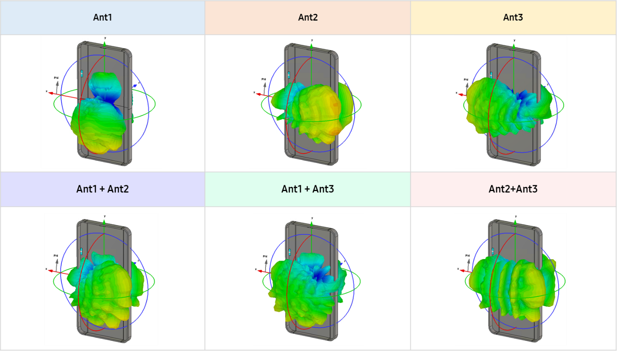
Figure 6.5.2.3-3: Simulated radiation patterns for one-Tx and two-Tx cases
The radiation pattern of antennas in a practical device has different peak direction compared with the boresight direction since the UE ground has much longer electric strength at this frequency range as shown in Figure 6.5.2.3-3. For example, Ant2 would form its peak direction toward Ant3, and similarly, Ant1 has the peak gain at the opposite direction toward the bottom side of UE at this case. On the other hand, if two Tx antennas are adjacent with the same orientation, it may have increased peak antenna gain thanks to the same radiation pattern between two Tx antennas although it would face a different issue such as antenna isolation to keep the fundamental performance.
In this regard, for FR1-like design with metal frame antennas, similar to the design approach with FR1-like patch antenna case, it should be noted that multi-Tx antennas may not help improving peak gain performance unless their placements are not designed carefully in terms of both radiation patterns and isolation.

7 Additional information on AAS

7.1 Array antenna model

7.1.1 Overview
A parameterized array antenna model has been developed over time in 3GPP. The technical background and modelling aspects relevant for AAS base stations was originally described in TR 37.840, subclause 5.4.4.[26] The model has been used for numerous studies in RAN4, including AAS, NR, HST, IAB, etc. The model has been adopted in other forums outside RAN4 and is also described in RAN1 in e.g., TR 36.897 [27] and in ITU-R in recommendation M.2101.[28]. The extended model including sub-array structures is documented in TR 38.803, subclause 5.2.3.2.4.[29].
The model is defined around a set of equations, which rely on a set of input parameters to describe the array antenna. At a high level the model can be described as shown in Figure 7.1.1-1.
Figure 7.1.1-1: Array antenna model overview
Parameters can be divided into different categories:
- General parameters, which are parameters that will be required for the simulator (spatial angles, considered wavelength).
- Element parameters used to model the radiating elements.
- Sub-array parameters used to model the sub-array.
- Array parameters used to model the array.
The model will produce gain normalized radiation pattern for given θ, ϕ angles defined in the range $0≤θ≤180$ degrees and $-180≤φ≤180$ degrees.
The wavelength, λ_{d} is related to the design of the array and is fixed by design, while the excitation wavelength, λ_{e} may vary as function of considered frequency within a specific operating band.

7.1.2 Parameters
The input parameters required to describe the antenna is summarized and described in Table 7.1.2-1.

Table 7.1.2-1: Model input parameters
Category | Parameter | Description | Note
General | λ_{d} | Design wavelength for array antenna in meters | The wavelength is fixed and selected for a given design frequency. The wavelength will not vary within a given operating band for a given design.
General | λ_{e} | Array excitation wavelength in meters | This wavelength varies within the considered band.
General | θ | Vertical angle in degrees
General | ϕ | Horizontal angle in degrees
General | P_{tx} | Total conducted power in dBm | For a dual polarized antenna, the total conducted power is calculated over MxNx2 ports
General | θ_{mech} | BS mechanical down-tilt angle in degrees | The mechanical down-tilt angle is a deployment parameter selected to maximize coverage within a given coverage area. The mechanical tilt can be applied as a coordinate transformation as described in TR 36.814, subclause A.2.1.6.2.
Element | A_{m} | Element front-to-back ratio in dB
Element | SLA_{v} | Element side-lobe suppression in dB
Element | ϕ_{3dB} | Element horizontal half power beamwidth in degrees
Element | θ_{3dB} | Element vertical half power beamwidth in degrees
Element | G_{E,max} | Element peak gain in dBi | This parameter is related to the selection of ϕ_{3dB}, θ_{3dB} and L_{E}, where  $G_{E,max}=D_{E,max}-L_{E}$ and D_{E,max} is related to ϕ_{3dB}, θ_{3dB} and array lattice unit area for the element.
Element | L_{E} | Element loss in dB
Sub-array | M_{sub} | Number of element rows in sub-array
Sub-array | d_{v,sub} | Vertical element separation in sub-array in meters
Sub-array | θ_{subtilt} | Electrical pre-set sub-array down-tilt angle in degrees | The pre-set sub array down-tilt is a fixed design parameter for a base station. It is envisaged as a passive fixed (non-varying) electrical tilt within the sub-array elements. The deployment configuration (including mechanical tilt) for a base station is dependent on the environment. Thus, a same base station with fixed pre-set subarray tilt could also be used across different environments. The value of the pre-set tilt is determined based on the intended deployment scenarios and targeted user distribution and coverage range.
Array | M | Number of sub-array rows in array
Array | N | Number of sub-array columns in array
Array | d_{h} | Horizontal sub-array separation in array in meters
Array | d_{v} | Vertical sub-array separation in array in meters | This parameter is related to M_{sub} and d_{v,sub}.
Array | θ_{etilt} | Electrical beam direction down-tilt angle in degrees
Array | ϕ_{escan} | Electrical beam direction scan angle in degrees
Array | ρ | Array excitation correlation factor | For wanted signal $ρ=1$, while for unwanted emission the correlation falls of as function of frequency offset from carrier within the interval $0≤ρ<1$.

The total conducted power, P_{tx} at the Transceiver Array Boundary (TAB) is related to Total Radiated Power (TRP) in logarithmical scale as:
$P_{tx}=10\log_{10}\left(2MN\right)+P_{n}$
$TRP=P_{tx}-L_{E}$
Where, P_{n} is the power per transmitter branch in dBm. Total conducted power is defined as the total power for all ports, including two orthogonal polarizations.
The equivalent isotropic radiated power (EIRP) is calculated in dBm using the model as:
$EIRP\left(θ,φ\right)=P_{tx}+A_{A}\left(θ,φ\right)$
The peak EIRP can also be derived from parameters as:
${EIRP}_{0}=P_{tx}+G_{E,max}+10\log_{10}\left(M_{sub}\right)+10\log_{10}\left(MN\right)$
When co-existence is evaluated in RAN4, the focus is on the main beam pointing towards the UE, but for other compatibility scenarios, e.g., with other services, the focus is not necessarily just the main beam. Spatial regions outside the main beam may also be highly relevant. Since the sub-array topology will affect the radiating characteristics in the sidelobe region, the model needs to be extended to provide the ability to model the sidelobe region characteristics correctly with reasonable complexity.
For the case where single element array geometries is considered (M_{sub}=1), the extended array model collapses to the original model described in TR 37.840 [26].
The antenna element separation is an important parameter that must be selected with care. Obviously, the value is static for a specific base station design, whereas the compatibility analysis may need to cover an entire frequency band. Typically, the antenna is designed to support given element separations for the highest frequency to avoid grating lobes for lower frequencies, but other design principles can be used for base stations supporting multiple bands or very wide operating bands.
Some parameters, such as the element beamwidths are related to the peak element gain via the element loss. This means that these parameters must be selected carefully.
Considering base stations are optimized for various factors including performance, cost, and coverage, it is expected that sub array configurations are relevant for these bands as well as a set of physical antenna elements are combined to form a logical element. The model comprises of a basic element pattern which is then combined appropriately based on the equations to form the sub array pattern and the composite pattern. Since dual polarized elements are used in typical base stations, it is sufficient to model each polarization separately as considered in the specific model. The models are selected so that they are simple and representative to model base station performance with sufficient confidence. The element pattern is based on a simple gaussian beam which has a flat sidelobe level. The Gaussian pattern is sufficiently wide and cover most of the regions of interest, especially in the elevation domain. At high elevation angles, the flat sidelobe level is sufficient to model the side lobes of the antenna element which are significantly lower than the main beam. Thus, the proposed extended antenna model to model sub arrays is sufficient to model the beamforming capability of IMT base stations in considered frequency ranges.
Another aspect also to consider is the performance and coexistence simulator complexity. The antenna model provides is reasonable complex and produce a gain normalized radiation pattern. If parameters are selected properly, no additional directory normalization is required which will reduce complexity and save processing capacity and simulation time.
The antenna model has support to model the array response outside the wanted carrier bandwidth, within adjacent channels using the correlation factor, ρ. When the wanted signal is considered ρ is equal to 1. For unwanted emissions outside the wanted signal bandwidth values within the range $0≤ρ<1$can be considered. Further details on the frequency response of ρ require further investigations.

7.1.3 Model equations
The array antenna model is built around pattern multiplication between the element radiation pattern, sub-array array factor radiation pattern and array factor radiation pattern, as described by equations listed in Table 7.1.3-1.

Table 7.1.3-1: Array antenna model equations
Description | Equation
Peak normalized element radiation pattern | $$A\left(θ,φ\right)=-min\left[-\left(-min\left[12{\left(\frac{φ}{φ_{3dB}}\right)}^{2},A_{m}\right]-min\left[12{\left(\frac{θ-90}{θ_{3dB}}\right)}^{2},{SLA}_{v}\right] \right),A_{m}\right]$$
Peak gain normalized element radiation pattern | $$A_{E}\left(θ,φ\right)=G_{E,max}+A\left(θ,φ\right)$$
Sub-array excitation | $$w_{m}=\frac{1}{\sqrt{M_{sub}}}exp\left(j2π\left(m-1\right)\frac{d_{v,sub}}{λ_{d}}sin\left(θ_{subtilt}\right)\right)$$
Sub-array radiation pattern | $$A_{sub}\left(θ,φ\right)=A_{E}\left(θ,φ\right)+10\log_{10}\left({\left|\sum_{m=1}^{M_{sub}}{w_{m}v_{m}}\right|}^{2}\right)$$  , where  $$v_{m}=exp\left(j2π\left(m-1\right)\frac{d_{v,sub}}{λ_{d}}cos\left(θ\right)\right)$$
Array excitation | $$w_{m,n}=\frac{1}{\sqrt{MN}}exp\left(j2π\left(\left(m-1\right)\frac{d_{v}}{λ_{e}}sin\left(θ_{etilt}\right)-\left(n-1\right)\frac{d_{h}}{λ_{e}}cos\left(θ_{etilt}\right)sin\left(φ_{escan}\right)\right)\right)$$
Composite array radiation pattern | $$A_{A}\left(θ,φ\right)=A_{sub}\left(θ,φ\right)+10\log_{10}\left(1+ρ\left({\left|\sum_{m=1}^{M}{\sum_{n=1}^{N}{w_{m,n}v_{m,n}}}\right|}^{2}-1\right)\right)$$  , where  $$v_{m,n}=exp\left(j2π\left(\left(m-1\right)\frac{d_{v}}{λ_{d}}cos\left(θ\right)+\left(n-1\right)\frac{d_{h}}{λ_{d}}sin\left(θ\right)sin\left(φ\right)\right)\right)$$

7.2 MIMO modelling

7.2.1 Simulation methodologies

7.2.1.1 Methodology 1
The following simulation methodology was adopted to produce simulation results:
1. For the k-th UE, generate array coefficients, $U_{k_{n,m}}$, to reflect the UE angles from the BS antenna array in both azimuth and elevation (NOTE 1):
$$U_{k_{n,m}}=exp\left(j2π\left(\left(n-1\right)\frac{d_{v}}{λ}cos\left(θ_{k}\right)+\left(m-1\right)\frac{d_{h}}{λ}sin\left(θ_{k}\right)sin\left(φ_{k}\right)\right)\right)$$
where, for the k-th UE, $θ_{k}$ and $φ_{k}$ are the angles of elevation and azimuth, respectively. The ranges of $θ_{k}$ and $φ_{k}$ are $\left[0,π\right]$ and [-$π,π$] radians. The size of the matrix $U_{k_{n,m}}$ is N×M, where N is the number of rows and M is the number of columns of the antenna array.

2. Assess the angular separation between the K UEs in the cell (NOTE 2).
3. For each UE (NOTE 3), if there is at least another UE which with the minimum angular separation requirement is fulfilled, create a concatenated K×MN channel matrix, H_{k} (NOTE 4):
$$H_{k}={\left[\begin{matrix}h_{k}^{T} & … & h_{p}^{T}\end{matrix}\right]}^{T}$$where ^{T} is the transpose operator and h_{k} corresponds to the vectorization of U_{k} resulting in a vector of size MN×1 (NOTE 5).
4. For each UE, the zero-forcing beamforming (precoding) matrix W_{k} (MNxK) is:
$$W_{k}=H_{k}^{H}{\left(H_{k}H_{k}^{H}\right)}^{-1}$$where H_{k} represents the channel matrix with its number of columns corresponding to the number of RX antennas (i.e., UEs) and its number of rows corresponding to the number of TX antennas (BS antenna ports), and ^{H} is the conjugate transpose operator.
1. The entire W_{k} matrix can be normalized by diving it by its Frobenius norm, or, doing a column wise normalization by diving each column with its norm (NOTE 6).
2. The actual precoding weights for each UE (w_{k}) are obtained by selecting the first column of W_{k}. The size of w_{k} is MN×1.
3. Obtain the individual Zero Forcing beam pattern: The precoding weights for each beam w_{k} of size MNx1 may be used to obtain the k-th zero forcing beam pattern by reordering the column vector w_{k} of size MNx1 into a matrix W_{k} of size NxM which can be used as element weight in:
$$A_{k}\left(θ,φ\right)=A_{E}\left(θ,φ\right)+10\log_{10}\left({\left|\sum_{m=1}^{M}{\sum_{n=1}^{N}{w_{k_{n,m}}∙v_{k_{n,m}}}}\right|}^{2}\right)$$where w_{k} refers to the entry in the n-th row and m-th column of weighting matrix W_{k} and ν_{n,m} is the superposition vector. Note that for AAS with sub-arrays, A_{E}(θ,ϕ) is updated by A_{sub}(θ,ϕ):
$$A_{k}\left(θ,φ\right)=A_{sub}\left(θ,φ\right)+10\log_{10}\left({\left|\sum_{m=1}^{M}{\sum_{n=1}^{N}{w_{k_{n,m}}∙v_{k_{n,m}}}}\right|}^{2}\right)$$where A_{sub}(θ,ϕ) calculation follows the method defined in the extended AAS modelling supporting vertical sub-array configurations.
1. The resulting composite ZF beam pattern may be obtained by summing up the individual Zero Forcing beam patterns in linear scale (and transforming them back to dB):

$$A_{ZF}\left(θ,φ\right)=10\log_{10}\left(\sum_{k=1}^{K}{{10}^{\frac{A_{k}\left(θ,φ\right)}{10}}}\right)$$
where A_{ZF}(θ,ϕ) refers to the composite ZF beam pattern and A_{k}(θ,ϕ) refers to the k-th individual zero forcing beam pattern.

NOTE 1: For the computation of U_{k}, θ_{k} and φ_{k} are in Local Coordinate System (LCS) which accounts for the mechanical down-tilt.
NOTE 2: The total 3D angular separation should be considered to determine the fulfillment of the minimum angular separation requirement. Additionally, only the azimuth angular separation may be considered in cases where the elevation angle does not significantly contribute to the total 3D angular separation.
NOTE 3: H_{k} must be constructed for each UE separately, since in some instances, one UE can be paired with all other UEs while another UE could be paired with only a single other UE. The next figure depicts this situation: UE₁ can be paired with UE₂ and UE₃ since the min. angular separation is fulfilled (as shown in (a)), UE₂ can only be paired with UE₁ (as shown in (b)), and UE₃ can only be paired with UE₁ (as shown in (c)).
NOTE 4: H_{k} only includes the UEs that fulfill the minimum angular separation requirement depending on the size of the BS antenna, so H_{k} may have two or three columns (K=2 or 3) in each Monte Carlo snapshot depending on the geometry of the BS and the UEs. For the UEs that cannot be paired with any other UEs (K=1), H_{k} is not constructed, and the current beamforming model is used.
NOTE 5: The vectorization must ensure that the vector of size 1×MN correspond to the concatenation of the rows of U_{k}:
$$\left(\begin{matrix}u_{11} & ⋯ & u_{1m} \\ ⋮ & ⋱ & ⋮ \\ u_{n1} & ⋯ & u_{nm}\end{matrix}\right)→concatenation→\left[\begin{matrix}\begin{matrix}u_{11}…u_{1m} & u_{21}…u_{2m}\end{matrix} & \begin{matrix}… & u_{n1}…u_{nm}\end{matrix}\end{matrix}\right]$$
NOTE 6: The total power constraint simplifies the design problem and leads to simple and efficient precoders. However, the magnitude of some elements of $w_{k}$ may be larger than $\sqrt{1/(MN)}$, which can introduce per-antenna port transmit power larger than $1/(MN)$. In practice, many systems are subject to individual per-antenna port power constraints.

7.2.1.2 Methodology 2

7.2.1.2.1 Beamforming equations
An alternative to a single-user MIMO (a.k.a. point-to-point MIMO) system is MU-MIMO in which an antenna array at the mobile base station simultaneously serves a multiplicity of autonomous user equipments (UEs). These UEs can be single-antenna devices, in which case the multiplexing throughput gains of the MU-MIMO system are shared among the different UEs. A MU-MIMO system is more tolerant of the propagation environments than a single-user MIMO system. For instance, under line-of-sight dominant propagation conditions (implying strong levels of correlation across user channels), the multiplexing gains can disappear for a single-user MIMO system but are retained in the MU-MIMO case provided that the angular separation of the user equipments exceeds the Rayleigh resolution of the array. The co scheduled UEs should lie in uncorrelated or weakly correlated positions. Considering the propagation conditions, , in dominant non-line-of-sight conditions, the multiplexing gains are naturally also retained for the MU-MIMO system. Keeping this in mind, it is worth noting that irrespective of the propagation conditions, the conclusions from standard MU-MIMO techniques like ZF and MMSE to serve multiple user equipments remain consistent. To this end, where necessary, we will assume the existence of a given propagation environment coupled with the appropriate model for generating the propagation channel impulse responses, without specifying or recommending a particular propagation model.
When the mobile base station employs multiuser spatial beamforming techniques like ZF, the antenna array produces spatial nulls in the direction of undesired users. Hence, assuming rank-1 transmission (in 3GPP terminology), if there are K users, then the array forms K analog beams towards the K users where retrieval of the single data streams will occur. Each of the K beams is given by the composite array radiation pattern, as given in Table 7.2.3-1. Yet the separation of users via analog beamforming (BF) alone is not adequate to sufficiently separate the K users signals. To do this, it is preferable to have the users adequately separated say in the azimuth. Spatial beamforming techniques are used in combination with analog beamforming. This will result in nulls in the undesired direction(s).
Consider the simple example below:
Suppose there are say three users communicating with a base station. The three users can be assumed to be located at \phi_{1} = -10 degrees, \phi_{2} = 0 degrees and \phi_{3} = +10 degrees in the azimuthal plane. One can also assume that the base station array (e.g., uniform planar configuration say of size (32x8) is able to steer three independent beams to the three user equipments via the composite radiation patterns generated via the array factor in Table 7.1.3-1 above, with the azimuth main lobe of each beam pointing towards the azimuth angles of -10, 0, and+10 degrees respectively, observed at a fixed elevation angle cut of, say, 90 degrees. Furthermore, one can assume that the base station can implement a multiuser beamforming technique which allows the base station to form nulls in certain undesired directions relative to a desired direction. Then, when serving the user at \phi_{2} = 0 degrees, the base station will form nulls in the direction of the other users (signifying the undesired directions), at \phi_{1}=-10 degrees and \phi_{3} = +10 degrees respectively.
When extrapolating this logic to the case when the base station is serving a higher number of users, e.g., eight users, located in eight different azimuth directions, allowing the base station to generate seven nulls in the direction of other users relative to the desired user in the azimuthal plane.

7.2.1.2.2 ZF and MMSE-based beamforming for Rank-1 MU-MIMO Transmission
When spatial beamforming is used in conjunction with analogue beamforming, the beamforming weights may be estimated as below:

7.2.1.2.2.1 ZF based beamforming
Here, we consider ZF-based beamforming for two users, denoted by UE 1 and UE 2 served by a single base station (BS) within the same time-frequency resource. Large numbers of antennas enable the focussing and steering of energy in desired directions [3]. The BS is assumed to have $MN$ antenna elements in total configured in a uniform planar array in the $x-z$ plane in the standard three-dimensional (3D) local coordinate system. For the sake of simplicity, perfect channel estimation at both the BS and UEs are assumed. Both UEs are assumed to have a single antenna. UE 1 and UE 2 is assumed to be located at two discrete azimuth angles, $ϕ_{e-scan}^{1}$ and $ϕ_{e-scan}^{2}$, respectively, with say the same elevation angle, $θ_{1}=θ_{2}$. Considering this, the composite antenna array radiation pattern towards UE 1 and UE 2 can be obtained by following the mathematical expressions given in the Table 7.1.3-1 above, where the azimuth angles, $ϕ_{e-scan}^{1}$ and $ϕ_{e-scan}^{2}$, are used Two RF matrices corresponding to UE 1 and 2 as $F_{RF}^{1}$ and $F_{RF}^{2}$.respectively are derived. The size of the matrices $F_{RF}^{1}$ and $F_{RF}^{2}$is equal to MN x N_{t}^{RF}. where N_{t}^{RF} is the number of RF chains at the base station. If every antenna has a transmitter then the size of the beamforming matrices $F_{RF}^{1}$ and $F_{RF}^{2}$ is MN x MN respectively.

Even though the UEs may be lying say in one dimension say the azimuth only their impulse response has both an azimuth and elevation component see the impulse response channel matrix in [2].
Note that the exact structure of $h_{1}$and $h_{2}$ depends on the radio propagation conditions at the time of transmission from the BS to both UEs. However, this notation is agnostic to the type of conditions and propagation mechanisms present in the channel responses and hence is preferred for use in this document.

Concatenating the equivalent channel responses into a total equivalent channel matrix of appropriate size $by$stacking the two equivalent user channels, one can write:

$\tilde{H}={\left[{\tilde{ h}}_{1}^{T} {\tilde{h}}_{2}^{T} \right]}^{T}$ (1)

Where $\tilde{h_{1}}$ and $\tilde{h_{2}}$ are the two equivalent channels and are in turn equal $h_{1} F_{RF}^{1}$ and $h_{2}$ $F_{RF}^{2}$ respectively.
Now the ZF-based beamforming to null the inter-user interference can be used on $\tilde{H}$. To this end, the ZF beamforming matrix, $W,$ can be calculated as:

$$W={\tilde{H}}^{H}{\left(\tilde{H}{\tilde{H}}^{H}\right)}^{-1}. (2)$$

This will ensure that if the BS is transmitting the desired signal in the direction of UE 1, i.e., towards $(ϕ_{e-scan}^{1},θ_{1})$, a null in the radiation pattern of the BS can be formed towards the unintended direction of UE 2, i.e., towards $\left(ϕ_{e-scan}^{2},θ_{2}\right)$. We note that the ZF beamformer should be normalized to satisfy a total power constraint. There are two different ways to normalize the ZF beamformer, namely via a vector normalization or via a matrix normalization. Using the example of a vector normalization, the per-user digital beamforming weight vector specific to UE 1 and UE 2 can be written as $w_{1}$and $w_{2}$ forming the two columns of $W.$ Normalizing these using the vector normalization method yields

$$w_{1}^{normalized}=\frac{w_{1}}{\left\|F_{RF}^{1} w_{1}\right\|}, (3)$$

and

$$w_{2}^{normalized}=\frac{w_{2}}{\left\|F_{RF}^{2} w_{2}\right\|}. (4)$$

This implies that for UE 1, multiplying the $\tilde{h_{1}}w_{1}^{normalized}=1$, while $\tilde{h_{1}}w_{2}^{normalized}=0$ and vice-versa for UE 2. Therefore, a null in the azimuth direction can be formed towards UE 2 while serving UE 1.
The array response v_{mn} ( in the 3GPP AAS model) can be made to provide maxima at given angular directions by an appropriate choice of the angles in w_{mn} which can be viewed as additional phase terms in the array response. It should be noted that pseudo inverse based on concatenated channels in eqn (1) that are in turn based on w_{mn} alone is flawed and will not provide an exact impact of ZF on the complete array response.

7.2.1.2.2.2 MMSE based beamforming
In the case of MMSE beamforming, the MMSE beamforming matrix, $W$, is given by

$$W={\tilde{H}}^{H}{\left(\tilde{H}{\tilde{H}}^{H}+βI\right)}^{-1}, (5)$$

where $β>0$ is the regularisation constant/factor and $I$ is the identity matrix of the same dimension as $\tilde{H}{\tilde{H}}^{H}$. By maximizing the SINR at the UEs, the optimal regularisation constant/factor was derived in [6] as $β=K/ρ$, where $ρ$ is the operating signal-to-noise ratio (SNR) typically computed by taking the ratio of the EIRP with the noise variance (power spectral density) of the UE. Note that optimal regulariser was only obtained for the case of equal conducted transmit power being split across the K user equipments and only applies to rank-1 transmission.
It is noteworthy that when $ρ →∞$ (holding the value in K as constant), reflecting high SNR scenarios, the MMSE beamforming matrix in (5) reduces to the ZF beamforming matrix in (2) as $β→0$.
The normalization of the beamforming vectors of the MMSE approach is identical to the ZF and hence the expressions in (3) and (4) apply with $w_{1}$ and $w_{2}$ now derived from the MMSE expression in (5).

7.2.2 Simulation results

7.2.2.1 Methodology 1

7.2.2.1.1 Ericsson [30]
The parameters values listed in Table 7.2.2.1.1-1 and 7.2.2.1.1-2 is used for the simulation.
Table 7.2.2.1.1-1: IMT deployment-related parameters
Parameter | Macro Urban
Base station
Carrier frequency | 6 GHz
Channel bandwidth | 100 MHz
BS antenna height | 18 m
Cell size | 300 m
Sectorization | 1 sector ¹
Frequency reuse | 1
User Equipment
UE height | 1.5 m
UE density for terminal that are transmitting simultaneously | 3 UEs per sector
NOTE 1: This study considers only a single-entry scenario.

Table 7.2.2.1.1-2: IMT base station beamforming antenna characteristics for IMT
Parameter | Macro Urban
Antenna pattern | Refer to Recommendation ITU-R M.2101 Annex 1
Element gain (incl. Ohmic loss) (dBi) | 5.5
Horizontal/vertical 3 dB beamwidth of single element (degree) | 90º for H  90º for V
Horizontal/vertical front to back ratio (dB) | 30 for both H/V
Antenna polarization | Linear ±45º
Antenna array configuration (Row × Column) | 16 × 8
Horizontal/Vertical radiating element spacing | 0.5 of wavelength for H  0.5 of wavelength for V
Array Ohmic loss (dB) | 2
Base station maximum coverage angle in the horizontal plane (degrees) | ±60
Base station vertical coverage range (degrees) | 90-120 ¹
Mechanical down-tilt (degrees) | 10
NOTE 1: The vertical coverage range includes the mechanical down-tilt. A minimum BS-UE distance along the ground of 35 m should be used for urban/suburban and rural macro environments.

For the sake of completeness, additional results are provided with an AAS with a subarray configuration. The parameters for this AAS are taken from the WRC-23 studies 5D/1235 and 5D/1461 and are presented in the Table 7.2.2.1.1-3.
Table 7.2.2.1.1-3: IMT base station beamforming antenna characteristics for IMT with subarray configuration
Parameter | Macro Urban
Antenna pattern | Refer to the extended AAS model in 5D/716 (Annex 4.4 - WRC23)
Element gain (incl. Ohmic loss) (dBi) | 6.4
Horizontal/vertical 3 dB beamwidth of single element (degree) | 90º for H  65º for V
Horizontal/vertical front to back ratio (dB) | 30 for both H/V
Antenna polarization | Linear ±45º
Antenna array configuration (Row × Column) | 16 × 16
Horizontal/Vertical radiating element spacing | 0.5 of wavelength for H  1.4 of wavelength for V
Number of element rows in sub-array | 2
Vertical radiating element spacing in sub-array | 0.7 of wavelength
Pre-set sub-array down-tilt (degrees) | 3
Array Ohmic loss (dB) | 2
Base station maximum coverage angle in the horizontal plane (degrees) | ±60
Base station vertical coverage range (degrees) | 90-100 ¹
Mechanical down-tilt (degrees) | 6
NOTE 1: The vertical coverage range includes the mechanical down-tilt. A minimum BS-UE distance along the ground of 35 m should be used for urban/suburban and rural macro environments.

The IMT network consists of a single site with a single sector. In each snapshot of the Monte Carlo simulation, 3 UEs are uniformly distributed within the sector, and the BS serves each UE with a dedicated beam. These beams can be generated by both the traditional antenna model and as described in subclause 7.2.1.1, assuming a UE minimum angular separation of 10 degrees.
To assess the interference to possible interfered-with receivers, two scenarios are considered, where these receivers are represented by sample points:
1. Equidistant sample points towards the horizon around the IMT BS (Figure 7.2.2.1.1-1a)
2. Equidistant sample points on a hemisphere above the IMT BS excluding the sample points towards the horizon (Figure 7.2.2.1.1-1b)
It is noted that the angular separation between sample points is approximately 15.5 degrees, with scenario 1 having 23 sample points and scenario 2 having 62 sample points.
Figure 7.2.2.1.1-1: Equidistant sample points (a) towards the horizon around the BS, and (b) on a hemisphere above the BS

In this section the Monte Carlo simulations results are presented. For each sample point in the considered scenarios, 10.000 snapshots are simulated. The cumulative distribution functions (CDFs) curves of the IMT BS gain towards the sample points of the different scenarios are shown in Figures 7.2.2.1.1-2 to 7.2.2.1.1-5. The CDF results for scenario 1 using a BS without and with subarrays are shown in Figures 7.2.2.1.1-2 and 7.2.2.1.1-3 respectively. The CDF results for scenario 2 using a BS without and with subarrays are shown in Figures 7.2.2.1.1-4 and 7.2.2.1.1-5 respectively. For instance, since scenario 1 has 23 sample points, Figures 7.2.2.1.1-2a and 7.2.2.1.1-3a show 23 pairs of CDFs.

Figure 7.2.2.1.1-2: Scenario 1 (without subarrays) CDFs: BS gain towards (a) each sample point, and (b) all sample points (composite)
Figure 7.2.2.1.1-3: Scenario 1 (with subarrays) CDFs: BS gain towards (a) each sample point, and (b) all sample points (composite)
Figure 7.2.2.1.1-4: Scenario 2 (without subarrays) CDFs: BS gain towards (a) each sample point, and (b) all sample points (composite)
Figure 7.2.2.1.1-5: Scenario 2 (with subarrays) CDFs: BS gain towards (a) each sample point, and (b) all sample points (composite)
To assess the impact on long- and short-term statistics, the 80th percentile and 99.9th percentile are considered respectively. For Figures 7.2.2.1.1-2a, 7.2.2.1.1-3a, 7.2.2.1.1-4a, and 7.2.2.1.1-5a, Table 7.2.2.1.1-1 contains the summary of the average BS antenna gain difference between traditional beamforming model and ZF beamforming model.

Table 7.2.2.1.1-1: Average BS antenna gain difference between traditional beamforming model and ZF beamforming
Scenario | Long-term (80th percentile) | Short-term (99.9th percentile)
Scenario 1 (without subarrays) | 0.39 dB | 0.14 dB
Scenario 1 (with subarrays) | 0.05 dB | ~0 dB
Scenario 2 (without subarrays) | 0.48 dB | 0.06 dB
Scenario 2 (with subarrays) | 0.08 dB | ~0 dB

Furthermore, the BS antenna gain integrated over parts of or the entire angular sphere around the antenna, i.e., the Total Integrated Gain (TIG), is also evaluated to provide a set of more consistent results by considering all angular directions. The TIG is calculated as follows:
$TIG≈\frac{π}{2N_{θ}N_{φ}}\sum_{φ=0}^{N_{φ}-1}{\sum_{θ=0}^{N_{θ}-1}{G\left(θ,φ\right)}sinθ}$ (Eq.7.3.2.1.1-1)
where θ and φ represent the elevation and azimuth angles, respectively, $N_{θ}$ and $N_{φ}$ are the number of samples on elevation and azimuth, respectively, and G is the antenna gain in linear units at the spherical coordinates (θ, φ).
For this assessment, the BS antenna gain is integrated over the whole sphere and over only the upper hemisphere by limiting the range of θ. The integrated gain is calculated for each individual beam for 10000 snapshots, resulting in three values per snapshot. Note that the integrated gain of the upper hemisphere of the AAS, where θ = 90 degrees is the AAS boresight direction including down-tilt, is not exactly the integrated above the horizon but includes most of it. This is depicted in Figure 7.2.2.1.1-6.
Figure 7.2.2.1.1-6: Upper hemisphere: (a) upper hemisphere above horizon, and (b) upper hemisphere considered in this study
Figures 7.2.2.1.1-7 and Figure 7.2.2.1.1-8 show the BS antenna gain integrated over the whole sphere and over only the upper hemisphere (Figure 7.2.2.1.1-6b), including the horizon, for the BS without and with subarrays, respectively. For simplicity, it is noted that for all the presented results, the integrated gain is always normalized by $π/{\left(2N_{θ}N_{φ}\right)}$, as indicated in Eq.7.2.2.1.1-1, regardless of the number of samples considered.
Figure 7.2.2.1.1-7: CDFs of the BS antenna gain without subarrays, integrated over (a) the upper hemisphere, including the horizon, and (b) the entire angular sphere around the antenna
Figure 7.2.2.1.1-8: CDFs of the BS antenna gain with subarrays, integrated over (a) the upper hemisphere, including the horizon, and (b) the entire angular sphere around the antenna
As can be seen, in all cases considered, the TIG difference between the beamforming schemes is negligible.

7.2.2.1.2 Qualcomm [31]
BS AAS parameters and configurations that are considered in our Monte-Carlo simulation campaign are provided in Table 7.2.2.1.2-1, Table 7.2.2.1.2-2, and Table 7.2.2.1.2-3, respectively. In terms of scenario/deployment, we consider a single sector where within each snapshot, 3 UEs are randomly deployed within the coverage region of that sector with a given minimum angular/spatial separation of 10 degrees. The location of those UEs is assumed to be known at the BS and a dedicated beam is generated to serve each UE. In order to investigate the impact of BS emissions above the horizon, probing points in the upper hemisphere have been placed, as visualized in Figure 7.2.2.1.2-1. Black points represent the total probing points, while blue points represent the 3 UEs dropped in each snapshot, taking into account the minimum angular separation among those UEs (i.e., 10 degrees as assumed in this contribution). The probing points are equidistantly distributed on a hemisphere above the horizon with angular separation between them approximately 18 degrees. It is worth mentioning that the objective of our study is to investigate the experienced emissions at the different probing points, since they represent possible incumbent services that will suffer from to the IMT BS unwanted emissions above the horizon.
Table 7.2.2.1.2-1 IMT deployment-related parameters
 | Urban macro
Base station
Carrier frequency | 6 GHz-band
Channel bandwidth | 100 MHz
BS Antenna height | 18 m
Cell size | 300 m
Sectorization | 1 sector
Frequency reuse | 1
User terminal
UE height | 1.5 m
UE density for terminals that are transmitting simultaneously | 3 UEs per sector

Table 7.2.2.1.2-2: IMT base station beamforming antenna characteristics for IMT
 | Urban Macro
Antenna pattern | Refer to Recommendation ITU-R M.2101 Annex 1
Element gain (incl. Ohmic loss) (dBi) | 5.5
Horizontal/vertical 3 dB beamwidth of single element (degree) | 90º for H  90º for V
Horizontal/vertical front-to-back ratio (dB) | 30 for both H/V
Antenna polarization | Linear ±45º
Antenna array configuration (Row × Column) | 16 × 8
Horizontal/Vertical radiating element spacing | 0.5 of wavelength for H  0.5 of wavelength for V
Array Ohmic loss (dB) | 2
Base station maximum coverage angle in the horizontal plane (degrees) | ±60
Base station vertical coverage range (degrees) | 90-120 (Note 1)
Mechanical downtilt (degrees) | 10
Note 1: The vertical coverage range includes the mechanical downtilt. A minimum BS-UE distance along the ground of 35 m should be used for urban/suburban and rural macro environments.

Table 7.2.2.1.2-3: IMT base station beamforming antenna characteristics for IMT with subarray configuration
 | Urban Macro
Antenna pattern | Refer to the extended AAS model in 5D/716 (Annex 4.4 - WRC23)
Element gain (incl. Ohmic loss) (dBi) | 6.4
Horizontal/vertical 3 dB beamwidth of single element (degree) | 90º for H  65º for V
Horizontal/vertical front-to-back ratio (dB) | 30 for both H/V
Antenna polarization | Linear ±45º
Antenna array configuration (Row × Column) | 16 × 16
Horizontal/Vertical radiating sub-array spacing | 0.5 of wavelength for H  1.4 of wavelength for V
Number of element rows in sub-array | 2
Vertical radiating element spacing in sub-array | 0.7 of wavelength
Pre-set sub-array downtilt (degrees) | 3
Array Ohmic loss (dB) | 2
Base station maximum coverage angle in the horizontal plane (degrees) | ±60
Base station vertical coverage range (degrees) | 90-100 (Note 1)
Mechanical downtilt (degrees) | 6
Note 1: The vertical coverage range includes the mechanical downtilt. A minimum BS-UE distance along the ground of 35 m should be used for urban/suburban and rural macro environments.

. 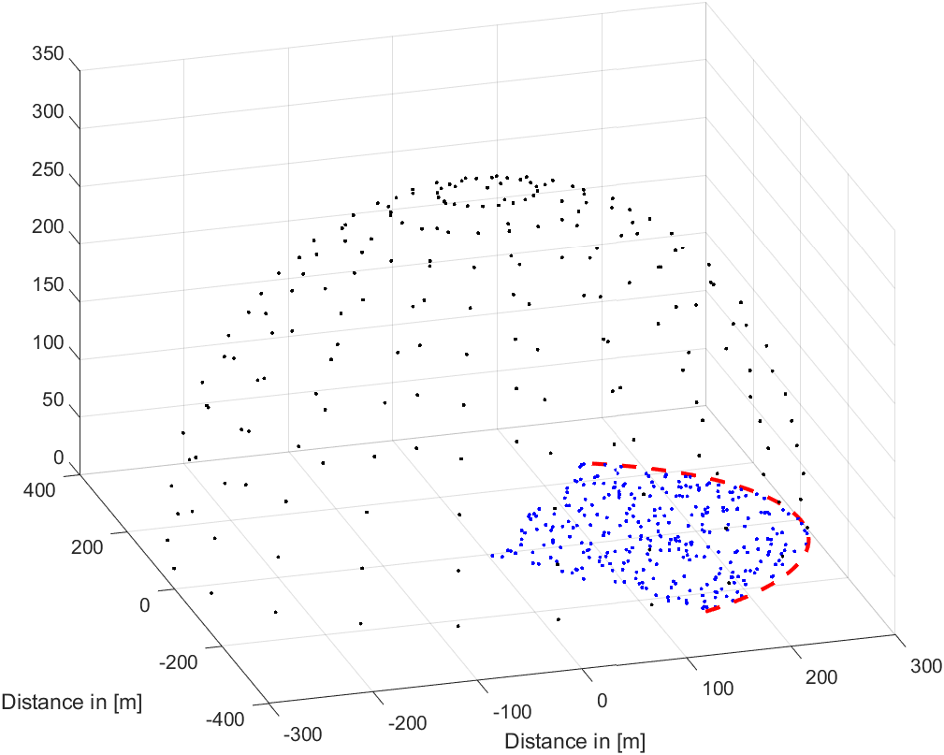
Figure 7.2.2.1.2-1 System layout for a given sector
The CDF curves of the IMT BS gain towards the black probing points are shown in Figure 7.2.2.1.2-2, considering the AAS without subarray structure (left figure) and with subarray structure (right figure). It can be observed the performance degradation observed when ZF is applied is negligible. Such behaviour shows that when considering large number of snapshots in a Monte-Carlo framework, the impact of the spatial beamforming above the horizon has minimal impact on the emissions above the horizon.
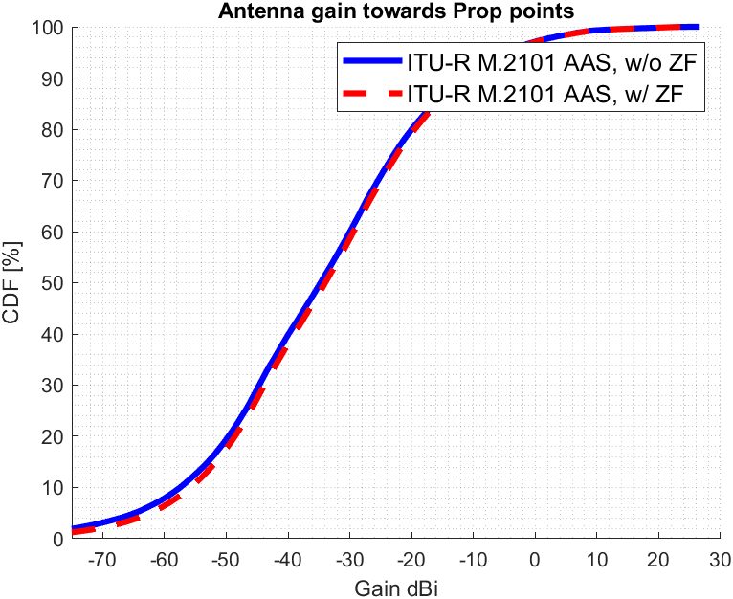 | 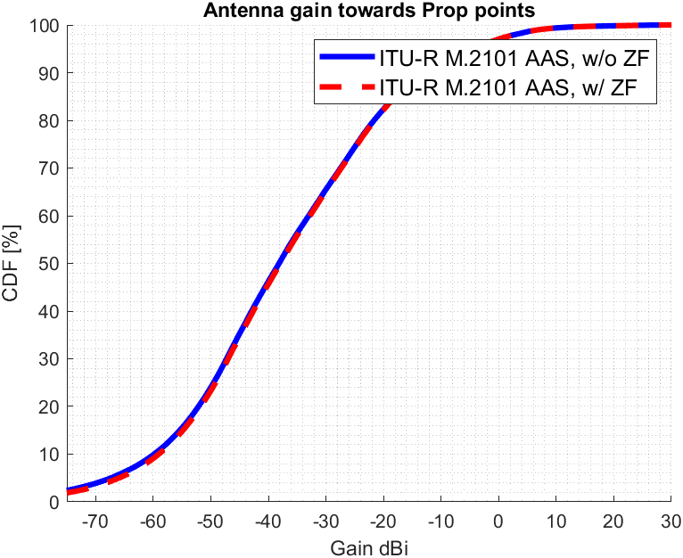
Figure 7.2.2.1.2-2 Composite AAS gain from IMT BS towards probing points considering AAS with (left) and without subarrays (right)

7.2.2.1.3 Huawei [32]
In order to assess the necessity and accuracy of interference comes from IMT systems for ITU-R sharing and compatibility studies, the IMT BS gain towards a number of potential interfered-with receivers located in the upper hemisphere are simulated. The angular separation between sample points is assumed 10 degrees.

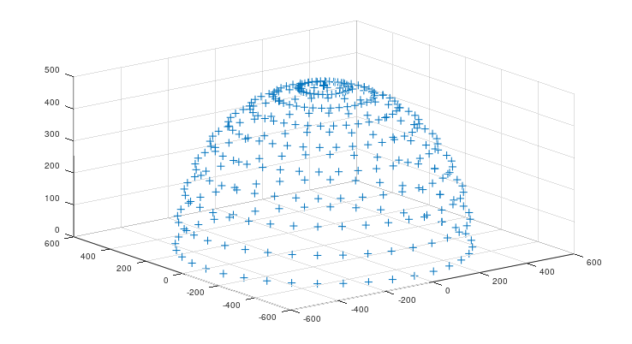
Figure 7.2.2.1.3-1: 10-degree sample points in the upper hemisphere above the BS
Deployment related parameters of BSs and UEs are based on the agreed technical and operational characteristics in the document 5D/716 (Annex 4.4 - WRC-23), and beamforming antenna characteristics are referred to 3GPP liaison statement on parameters for 4400 to 4800 MHZ of terrestrial component of IMT for sharing and compatibility studies in preparation for WRC-27, see 5D/136.
The cumulative distribution functions (CDFs) curves of the IMT BS gain towards the sample points of the different scenarios are shown in Figures 7.2.2.1.3-2 with additional individual per-antenna power constraint. It can be seen that the difference between ITU-R M.2101 and ZF gains are minor.

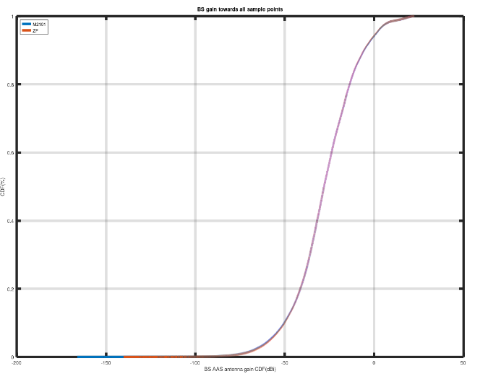

Figure 7.2.2.1.3-2: BS gain towards all sample points (composite) with individual per-antenna power constraint
To assess the impact on long- and short-term statistics, the 80th percentile and 99.9th percentile are considered respectively. Table 7.2.2.1.3-1 contains the summary of the BS antenna gain difference between ITU-R M.2101 model and ZF beamforming model with & without additional individual per-antenna power constraint. Additional individual per-antenna power constraint influences the simulation results very little. In addition, it shows that ZF beamforming get slightly less antenna gain than M.2101 towards to the sample points with individual per-antenna power constraint:
Table 7.2.2.1.3-1: BS antenna gain difference between ITU-R M.2101 beamforming model and ZF beamforming (Method 1)
C band Urban (with subarrays)  Scenario | Long-term (80th percentile) | Short-term (99.9th percentile)
M.2101 | -13.720 | 20.861
ZF without individual per-antenna power constraint | -13.587 | 20.855
ZF with individual per-antenna power constraint | -13.779 | 20.719
M.2101- ZF difference (dB) (without individual per-antenna power constraint) | -0.133 | 0.006
M.2101- ZF difference (dB)  (with individual per-antenna power constraint) | 0.059 | 0.142

7.2.2.1.4 Nokia [34]
A detailed MIMO system level simulator was used to model the BS radiation for ZF and the ITU MU-MIMO beamforming where modeling included standard MU-MIMO scheduling using NR numerology. ZF MU-MIMO is applied in both azimuth and elevation. For the assessment of impact of these two MU-MIMO schemes, parameters of a 2.6 GHz IMT system were used. The study measures the downlink (DL) signal level (interference) seen at different spatial points for each beamforming technique. Table 7.2.2.1.4-1 describes the main system parameters assumed.
Table 7.2.2.1.4-1: Main IMT system parameters
Parameter | Base Station | UE
Network topology, cell structure and characteristics
Centre frequency | 2.6 GHz
Channel bandwidth | 20 MHz
Network Configuration  (Duplex Mode) | TDD
Cell radius | 0.8 km (suburban macro) | N.A.
Antenna height | 25 m | 1.5 m
Sectorization | 3 sectors | N.A.
User equipment density for terminals that are receiving simultaneously | N.A. | 3 UEs per sector
Frequency reuse | 1 | N.A.
Indoor user terminal usage | N.A. | 70%
Antenna characteristics
Antenna pattern model | Extended AAS model [2]. | Isotropic, -3 dBi gain
Element gain (Note 1) | 6.4 dBi | N.A.
Horizontal/vertical 3 dB beamwidth of single element | 90º for H  65º for V | N.A.
Horizontal/vertical front-to-back ratio | 30 dB for both H/V | N.A.
Antenna polarization | Linear/±45 degrees | N.A.
Antenna array configuration (Row × Column) | 4 x 8 elements | N.A.
Horizontal/Vertical radiating element/sub-array spacing | 0.5 of wavelength for H,  2.1 of wavelength for V | N.A.
Number of element rows in sub-array | 3 | N.A.
Vertical radiating element spacing in sub-array | 0.7 of wavelength of V | N.A.
Pre-set sub-array down-tilt | 3º | N.A.
Array ohmic loss (Note 1) | 2 dB | N.A.
Conducted power (before Ohmic loss) per antenna element/sub-array | 28 dBm | N.A.
Base station horizontal coverage range | ±60º | N.A.
Base station vertical coverage range | 90º -100º | N.A.
Mechanical down tilt | 6º | N.A.
Maximum base station output power/sector (e.i.r.p.) | 72.28 dBm | N.A.
Note 1: The element gain includes the ohmic loss. Therefore, ohmic loss is not needed for the calculation of the BS composite antenna gain and e.i.r.p.

In the simulation, up to 3 of 10 available UEs per cell are MU-MIMO scheduled per slot in DL by a serving cell (21 total cells simulated) over 50 subframes (500 slots) where only the most recent interference measured at each measurement point is saved for each Monte Carlo drop. A minimum separation distance of 10 degrees (in azimuth and elevation) between the BS beams steered towards the served UEs is considered for MU-MIMO scheduling. The measurement points are equidistant from the center on a hemisphere above the IMT cell grid, as illustrated by the blue points in Figure 7.2.2.1.4-1, with the red points indicating the locations of the tri-sector sites. Given 100 Monte Carlo drops, 648 measurement points per drop, then 64800 snapshots of interference radiation are taken (64800 = 100 x 648) for each case modeled.

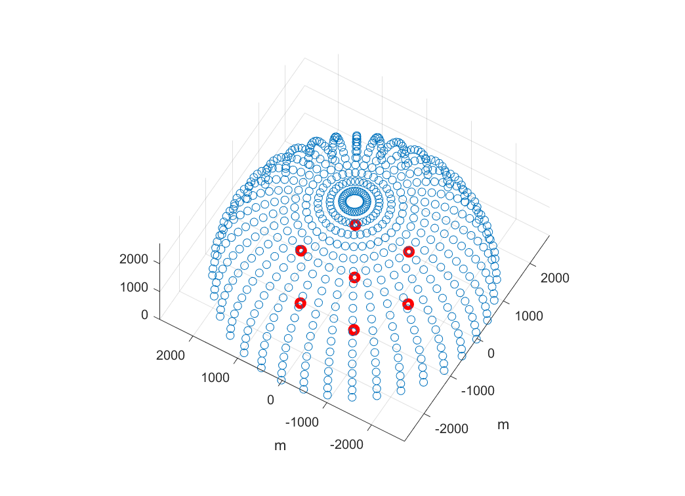
Figure 7.2.2.1.4-1: Measurement points in blue: equidistant from the center on a hemisphere above the IMT cell grid; locations of tri-sector sites in red

Figure 7.2.2.1.4-2 shows interference CDFs for ZF MU-MIMO and ITU MU-MIMO for LOS channel. The delta of CDFs at the 5%-ile, 50%-ile, and 80%-ile points from Figure 7.2.2.1.4-2 are shown in Table 7.2.2.1.4-2 below. Since the interference delta CDF values are less than ~0.3 dB, the considered beam forming techniques have very similar impact to victim services.
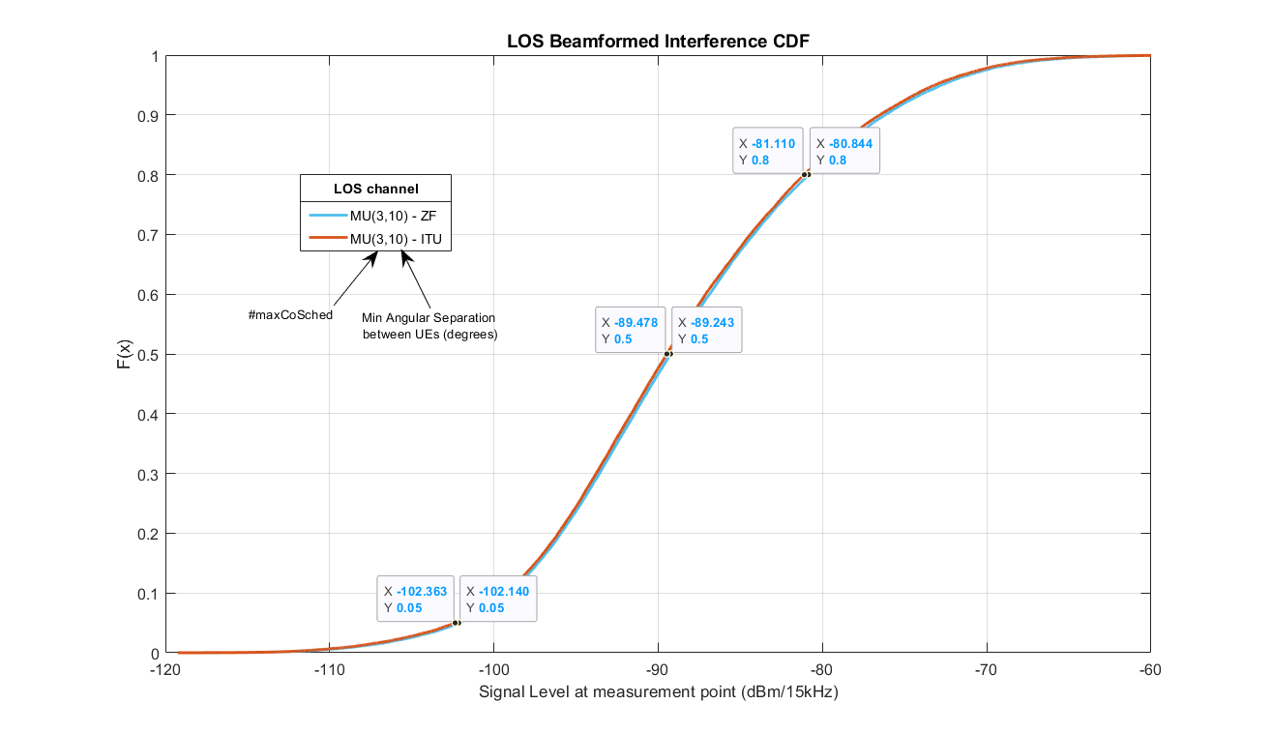
Figure 7.2.2.1.4-2: Interference CDFs for ZF MU-MIMO and ITU MU-MIMO for LOS channel and for minimum separation of 10 degrees for determining pairing

Table 7.2.2.1.4-2: Interference CDF values for ZF and ITU MU-MIMO for LOS channel
Beamforming Type | Interference CDF values (dB)
 | 5%-ile | 50%-ile | 80%-ile
ZF MU-MIMO | -102.13 | -89.24 | -80.81
ITU MU-MIMO | -102.36 | -89.48 | -81.08
Delta CDF values | ~ 0.23 | ~ 0.24 | ~ 0.27

Similar study was conducted considering UMa channel for ZF MU-MIMO. Figure 7.2.2.1.4-3 shows the interference CDFs for ZF MU-MIMO and ITU MU-MIMO for this case. The delta of CDFs at the 5%-ile, 50%-ile, and 80%-ile points from Figure 3 are shown in Table 7.2.2.1.4-3 below. Since the interference delta CDF values are less than ~0.25 dB, the considered beam forming techniques have negligible difference in the impact to victim services.
Figure 7.2.2.1.4-3: Interference CDFs for ZF MU-MIMO and ITU MU-MIMO for UMa channel and for minimum separation of 10 degrees for determining pairing

Table 7.2.2.1.4-3: Interference CDF values for ZF and ITU MU-MIMO for UMa channel
Beamforming Type | Interference CDF values (dB)
 | 5%-ile | 50%-ile | 80%-ile
ZF MU-MIMO | -100.36 | -87.53 | -79.5
ITU MU-MIMO | -100.43 | -87.76 | -79.71
Delta CDF values | ~ 0.07 | ~ 0.23 | ~ 0.21

7.2.2.2 Methodology 2

7.2.2.2.1 Spark [33]
We provide below example simulation results for using ZF with two UEs, both are in the azimuth at 0 and 10 degrees respectively and are at the same elevation with a 5 degrees down tilt (angle from the Z axis is 95 degrees). The antenna and other parameters are:

Table 7.2.2.2.1-1 IMT deployment-related parameters
Parameter | Value
Environment | Macro Urban
Carrier frequency | 6 GHz
Sectorization | 1 sector
Frequency reuse | 1

Table 7.2.2.2.1-2 IMT base station beamforming antenna characteristics for IMT
Parameter | Macro Urban
Antenna pattern | Refer to Section 5 of Recommendation ITU-R M.2101
Element gain (incl. Ohmic loss) (dBi) | 5.5
Horizontal/vertical 3 dB beamwidth of single element (degree) | 90º for H  90º for V
Horizontal/vertical front to back ratio (dB) | 30 for both H/V
Antenna polarization | Linear ±45º
Antenna array configuration (Row × Column) | 16 × 8
Horizontal/Vertical radiating element spacing | 0.5 of wavelength for H  0.5 of wavelength for V
Array Ohmic loss (dB) | 2
Base station maximum coverage angle in the horizontal plane (degrees) | ±60
Base station vertical coverage range (degrees) | 90-120
Mechanical down-tilt (degrees) | 10

The cdf of the array gain of the elevation pattern above the horizon for methodology 2 using ZF MU MIMO is shown below for 1000 simulation runs.

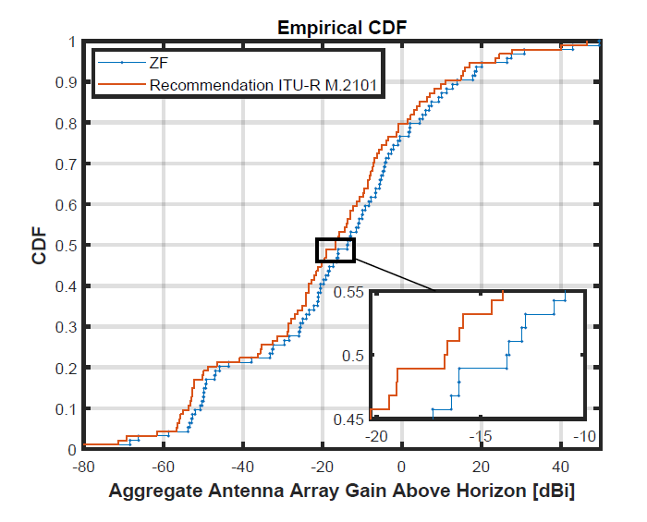
Figure 7.2.2.2.1-1 Aggregate Antenna Array Gain Above Horizon [dBi]

The following observations may be made:
The median gain difference is about 3 dB.
When more UEs are added to the ZF set, the placement of nulls in the azimuth pattern will have a consequential impact on the elevation pattern and will further increase this difference.
The example is for two UEs with a given azimuth placement. The median gain difference will also be sensitive to the actual azimuth angles at which the UEs are placed. The point of this exercise is just to demonstrate the impact of ZF beamforming using the correct formulation of pseudo inverse to accurately assess the aggregate antenna array gain above the horizon. The conclusions presented here can be replicated for a larger number of users in a given sector with the same methodology.

7.2.2.2.2 Huawei [32]
The cumulative distribution functions (CDFs) curves of the IMT BS gain towards the target UE are shown in Figure 7.2.2.2.2-1. It can be seen that this method can also get reasonable target antenna gain compared to M.2101.
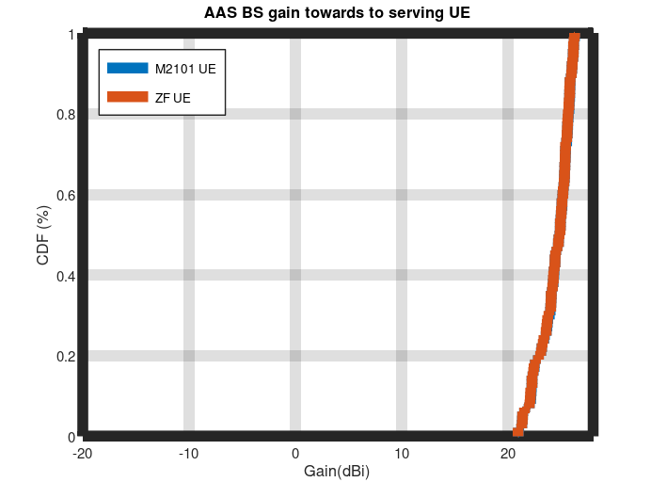
Figure 7.2.2.2.2-1: BS gain towards to target UEs

The cumulative distribution functions (CDFs) curves of the IMT BS gain towards the sample points of the different scenarios are shown in Figures 7.2.2.2.2-2 without additional individual per-antenna power constraint. It can be seen that the difference between ITU-R M.2101 and ZF gains are minor.
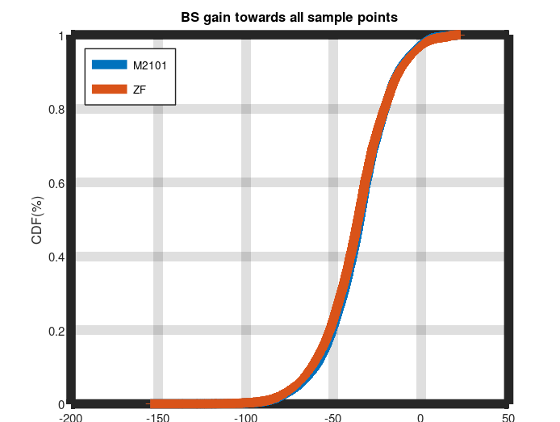
Figure 7.2.2.2.2-2: BS gain towards all sample points (composite) without individual per-antenna power constraint (Method 2)

Table 7.2.2.2.2-1: BS antenna gain difference between ITU-R M.2101 beamforming model and ZF beamforming (Method 2)
C band Urban (with subarrays)  Scenario | Long-term (80th percentile) | Short-term (99.9th percentile)
M.2101 | -20.810 | 19.527
ZF (Method 2) without individual per-antenna power constraint | -20.992 | 19.197
M.2101- ZF (Method 2) difference (dB) (without individual per-antenna power constraint) | 0.182 | 0.33

7.2.3 Summary and Conclusion of MIMO modelling
The simulation results in clause 7.2.2 using the simulation methodologies in clause 7.2.1 have indicated that MU MIMO based ZF BF does not need to be considered for the pure LOS case, and Rec. ITU-R M.2101 methodology remains valid for performing sharing and compatibility studies in WP5D.

7.3 Modelling array antenna gain outside the carrier

7.3.1 General

7.3.1.1 Purpose
This clause aims to provide IMT base station and IMT user equipment technical parameters for analyzing adjacent band compatibility of terrestrial IMT systems with other co-primary services in the ITU Radio Regulations covering aspects related to modelling array antenna gain outside the wanted carrier relevant for modelling spatial characteristics for unwanted emissions.

7.3.1.2 ITU radio regulations on adjacent terrestrial IMT systems with other co-primary services
There are adjacent services in the bands being considered for IMT 2030.
For example: for the case of 4400-4800 MHz, the adjacent band services are:

On the lower edge below 4400 MHz:
- Aeronautical radio navigation;
- Aeronautical mobile;
- Additional possible allocation of EESS (passive) as per Agenda Item 1.19 of WRC-27;

On the upper edge above 4800 MHz:
- Fixed service;
- Radio Astronomy;
- Radio navigation satellite;

For the case of 7125-8400 MHz, the adjacent band services are:
On the lower edge below 7125 MHz:
- Fixed
- Fixed Service Satellite (Earth-to-space)

On the upper edge above 8400 MHz:
- Space Research Service (space-to-Earth)
- Additional possible allocations of EESS (passive) as per Agenda Item 1.19 of WRC-27
- Earth Exploration Satellite
- Radiolocation
- Space Research (active).

For the case of 14.8-15.35 GHz, the adjacent band services are:
On the lower edge below 14.8 GHz:
- Fixed Service;
- Fixed Satellite Service (Earth-to-space)
- Radionavigation

On the upper edge above 15.35 GHz:
- Space research (passive)
- EESS (passive)
- Radio Astronomy
In particular, the frequency range 15.35 – 15.4 GHz is marked as a footnote 5.340 band, which is stating “All Emissions are Prohibited” with the exception of those provided by RR 5.511.
It is therefore important that out of band emissions are correctly modelled so that appropriate guidance is provided for the above question to WP 5D.

7.3.2 Adjacent channel modelling

7.3.2.1 Correlation roll-off based model

7.3.2.1.1 Modelling overview
The array antenna model adopted by 3GPP in TR 38.803 [29] creates the composite pattern as a multiplication between the element factor (or sub-array element factor) and array factor. The array antenna model was first introduced in TR 37.840 [26] in the early days of AAS for BS. Based on the antenna model, the average radiation pattern produced by an array antenna was evaluated and an analytical expression for the average radiation pattern was established.
The composite radiation gain pattern for pure LOS channel can be expressed in logarithmical scale as:
$A_{A}\left(θ,φ\right)=A_{sub}\left(θ,φ\right)+10\log_{10}\left(1+ρ\left({\left|\sum_{m=1}^{M}{\sum_{n=1}^{N}{w_{m,n}v_{m,n}}}\right|}^{2}-1\right)\right)$ (Eq. 7.4.1-1)
, where ρ is the correlation factor defined in the interval $0≤ρ≤1$. Relevant parameter values for the frequency range 4400 to 4800 MHz can be found in subclause 4.4.1.2 and for 7125 to 8400 MHz in subclause 5.4.1.2, and for 14800 to 15350 MHz in subclause 6.5.1.2.

It can be noticed that the average antenna gain for the wanted signal where ρ is equal to 1, the composite array gain is produced (G_{E,max} + 10log₁₀(M_{sub}) + 10log₁₀(MN) dBi), while for unwanted emission away from the carrier where ρ is equal to 0 only the gain of the element/sub-array is produced (G_{E,max} + 10log₁₀(M_{sub}) dBi). For sharing studies, it would be relevant to consider ρ being represented as a function of frequency.
The impact of array signal correlation to directivity and gain response have been evaluated for different array antenna structures considered for 4400 to 4800 MHz, 7125 to 8400 MHz and 14800 to 15350 MHz considering 10 degrees down-tilt beam steering direction. The results are plotted in Figure 7.3.2.1.1-1.
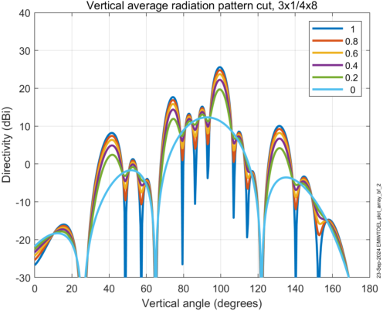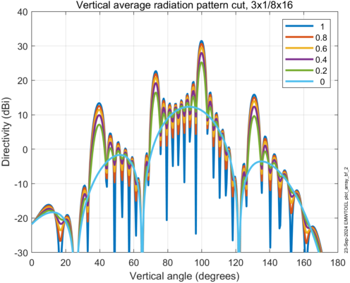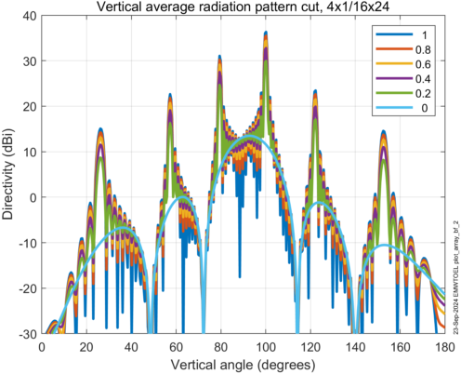
Figure 7.3.2.1.1-1: Vertical radiation pattern considering different array geometries and correlation factor.
The array factor impact due decorrelation can be analysed for all antenna geometries separately. The array factor drops gradually for low correlation as shown in Figure 7.3.2.1.1-2.
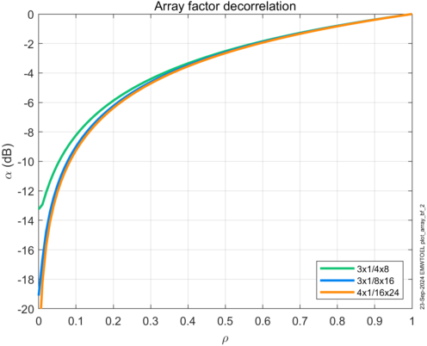
Figure 7.3.2.1.1-2: Array factor decorrelation characteristics plotted as function of correlation.
It can be noticed that the average gain drops gradually when the array correlation reduces. At array correlation 0.5 the array factor has reduced approximately 3 dB.
The characteristic is visualized in Figure 7.3.2.1.1-2 can be used to translate measured directivity drop to correlation factors to use for modelling purposes.

7.3.2.1.2 Correlation roll-off model
Since the array factor gain relies on coherent combining of signals it is not expected that the array factor will operate outside the carrier with full strength in situations outside the carrier where the emission is created as the sum of correlated intermodulation distortion and uncorrelated wide band noise. The Inter-Modulation Distortion (IMD) is coming from non-linear transmitter. The characteristics is typically categorized as distortions due third order (IM3), fifth order (IM5), seven order (IM7), etc. IMD. It is known that the order of IMD will determine the spectral distribution of the distortion. The IMD will also depend on the wanted signal carrier bandwidth, B. The IMD response typically reduces moving away from the edge of the wanted signal.
For the wanted carrier (within the interval $-0.5B≤f_{c}≤0.5B$, f_{c} is the carrier centre frequency) full array factor is expected which means that the correlation factor is equal to 1. Moving away from the carrier edge ($f_{c}>\left|0.5B\right|$) the correlation will drop gradually due to the composition of the emission outside the carrier. The emission will be created as the sum of correlated noise due to intermodulation products and non-correlated noise due to wideband transmitter noise. The relation to the induvial noise levels will determine the out-of-carrier correlation properties in the adjacent emission regions. At a certain frequency offset to the carrier edge the emission noise will be dominated by wideband noise which means that the correlation is equal to 0.
Therefore, it would be appropriate to define a model for the array correlation factor to account for carrier bandwidth and decaying correlation moving away from the carrier edge.
To properly model the AAS base station array antenna gain pattern outside the carrier the correlation factor needs to be modelled as a function of frequency offset to the carrier centre frequency. To capture fundamental aspects of the array antenna gain drop outside the wanted signal a parameterized piece-wise linear roll-off model can be adopted for the correlation factor, as visualized in Figure 7.3.2.1.2-1.

Figure 7.3.2.1.2-1: Array correlation factor roll-off model.
The roll-off is modelled to reduce stepwise moving away from the centre frequency, also the characteristics is assumed to be symmetrical around the wanted carrier. Close to the carrier the correlation is expected to be close to 1, while moving towards +/-1.5B reducing to ρ₂. At f₁ the correlation have reduced even more to ρ₁. At f₀ the correlation has reduced to 0, which corresponds to that the array factor gain in 0 dB.
For this model to be use-full parameter values for B, f₀, f₁, ρ₁ and ρ₂ needs to be determined.
Using the approach above the antenna model can be extended to capture array antenna gain outside the wanted carrier as:
$A_{A}\left(θ,φ,f\right)=A_{sub}\left(θ,φ\right)+10\log_{10}\left(1+ρ\left(f\right)\left({\left|\sum_{m=1}^{M}{\sum_{n=1}^{N}{w_{m,n}v_{m,n}}}\right|}^{2}-1\right)\right)$ (Eq. 7.3.2-1)

Observe that the extended array antenna model only captures effect due to array signal correlation and not effects due to antenna element detuning effects of mismatch effects in transmission lines and Radio Distribution Network (RDN).

7.3.2.1.3 EIRP model
Observe that the array correlation roll-off model presented above only captures decorrelation effects related to the array factor. Keep in mind that even though the array factor totally collapses the sub-array still produce gain far outside the carrier. Typically, the sub-array starts to collapse outside the operating band until the antenna is completely detuned far from the centre of the operating band.
Another aspect to consider when modelling spatial unwanted emission outside the carrier is the suppression of unwanted emission outside the carrier in the adjacent channel regions as well as in the spurious domain. In these regions the emission is suppressed by the ACLR and RF filter suppression.
The radiated emission from a base station to be studied in a sharing situation can be calculated as:
$$EIRP\left(θ,φ,f\right)=P_{tx}\left(f\right)+A_{A}\left(θ,φ,f\right)$$
, where P_{tx} is the power fed to the antenna, f is the frequency offset between the carrier centre frequency and the considered frequency. The frequency dependence for the gain pattern A_{A}(θ,ϕ,f) as described in Eq. 7.3.2.1.2-1.
The power fed to the antenna can be expressed as a function of frequency offset as:
$$P_{tx}\left(f\right)=P-S(f)$$
, where is P is the carrier power, S(f) is the suppression achieved by ACLR₁ (First adjacent channel), ACLR₂ (Second adjacent channel), ACLR₃ (Third adjacent channel) and additional RF filter suppression (if frequencies outside the operating band is considered) as function frequency offset.
It is evident that the radiated power in the adjacent channel regions depends on the drop of antenna gain and the power fed to the antenna. The combined effect should be considered to properly model sharing situations.

7.3.2.2 Array ACLR based model

7.3.2.2.1 Overview
Out of band emissions are well understood but often for a single transmitter.
It is necessary to distinguish between a single element ACLR, and an array ACLR. In a non AAS system, where the radiation pattern is “constant” over a sector, the single element ACLR makes sense, since the received power ratio at any point is the same as the transmitted. However, with AAS, the desired signal experiences also an array/beamforming gain that might be different from the array/beamforming gain of the interfering signal received in the adjacent band; this later observation is also dependent if SU or MU MIMO is used (i.e. the array may send distortions in unintended directions).
When an array in AAS base stations is used, the 3GPP specifications provide a method to compute the array ACLR (albeit in a TRP mode) [9]:
“The ACLR (CACLR) absolute basic limits in table 6.6.3.2-2 + X, 6.6.3.2-2a + X (where X = 9 dB) or the ACLR (CACLR) basic limit in table 6.6.3.2-1, 6.6.3.2-2a or 6.6.3.2-3, whichever is less stringent, shall apply.”
However, the above method is array pattern agnostic and does not account for beamforming variations due to MU MIMO.
Recent published results, discussed/summarized in this report, show that that array ACLR is spatially sensitive and is also dependent if SU or MU MIMO functionality is utilized. There is thus a need to accurately model the ACLR when AAS is used.
As part of additional information requested by ITU-R WP 5D establish a model for array correlation factor (ρ) roll-off to describe how the array factor collapses moving away from the centre frequency. If the beamforming performance degrades towards a single element radiation pattern, then the frequency when the continuity of array features is regarded as degraded, will also need to be determined.
To address the SI, the questions posed may be devolved into topics below:
1. Establish a model for array correlation factor-ie the correlation of the in-band signal with the out of band signal.
There is no definition of an array correlation factor. Is it the correlation of the in-band signal with out of band signal. But the in-band signal, P_{inband} (θ,φ), is spatially sensitive and as discussed below the out of band signal , P _{oob} (θ,φ), may also be spatially sensitive. Then the array correlation ρ is also spatially sensitive may be defined as:
ρ (θ, φ) = Ε (P_{inband} (θ,φ) P^{T} _{oob} (θ,φ) ) ………………………….(6)
2. How does the array factor collapse when moving away from the centre frequency?
This also means that ρ (θ, φ) defined above is a function of frequency separation from the band centre. In this case best to denote this as:
ρ_{Δ f}(θ, φ)………………………………………………………………..(7)
Where Δf is the frequency separation from band centre
3. If the beamforming performance degrades towards a single element radiation pattern, then the frequency when the continuity of array features is regarded as degraded, will also need to be determined.
Therefore we would need to characterize and investigate the constituent components of P _{oob} (θ,φ) as a function of Δf
The above topics are interrelated but need to be separately discussed as well. The discussion below addresses topics 2 and 3 respectively.
Array performance in adjacent bands is governed by:
- Array performance at different frequencies arising due to adjacent bands.
- Modelling of the impact of PA non linearities
- Modelling of band pass filters
- Putting all of the above together to obtain an end-to-end model
Additionally, one must also consider if the array is supporting a single user or multi-user systems.

7.3.2.2.2 Array performance at adjacent band frequencies
Assume that the lower and upper adjacent bands have a bandwidth of 100 MHz each respectively. Arrays in a band are designed at the centre frequency of a given band ie vertical and horizontal spacing is determined by the centre frequency of the band which for example in band 1 is 4600 MHz shown in Table 7.3.2.2.2-1 below. Likewise for other bands. The lower and upper adjacent bands can be simulated via a proxy array with different spacings e.g for band 1, the lower adjacent band is 4300-4400 MHz with centre frequency 4350 MHz. Therefore, for band 1, changing the vertical spacing to 0.74 lambda and horizontal spacing to 0.53 lambda will effectively simulate the lower adjacent band. Likewise for the upper adjacent band (0.66, 0.474) will simulate the upper adjacent band.
Table 7.3.2.2.2-1: Array performance in adjacent bands
Band | Centre Frequency | 0.7 Lambda, 0.5 Lambda  (cm) | Centre freq of Lower adj band | Centre freq of Upper adj band | 0.7 Lambda, 0.5 Lambda for lower adj band | 0.7 Lambda, 0.5 Lambda for upper adj band
1 | 4600 MHz | 4.565/3.26 | 4350 MHz | 4850 MHz | 4.827/3.45  (0.74, 0.53) | 4.33/3.09  (0.66, 0.474)
2 | 7762.5 MHz | 2.7/1.93 | 7075 MHz | 8450 MHz | 2.96/2.118  (0.767, 0.55) | 2.48/1.773  (0.64, 0.46)
3 | 15.075 GHz | 1.39/0.99 | 14.75 GHz | 15.40 GHz | 1.42/1.012  (0.715, 0.511) | 1.36/0.97  (0.68, 0.49)

The following parameter/metrics are impacted [15] when the inter element spacing is changed:
- Nulls
- Maxima
- Half power points
- Minor lobe maxima
- First null beamwidth
- Half power beamwidth
- First side lobe beamwidth
Exact expressions for the above are given below from [15] for a ULA along the z axis and for omni directional antennas. Considering the exact formulas below in Table 7.3.2.2.2-2 and Table 7.3.2.2.2-3 the changes due to inter element spacing in the proxy array will result in some changes to the values of the above metrics. See Figure 7.3.2.2.2-1, Figure 7.3.2.2.2-2 and Figure 7.3.2.2.2-3 for an eight element ULA for 0.5 lambda, 0.7 lambda and 0.8 lambda inter element spacing respectively. However these frequency/wavelength adjustments are no different to what is present today in systems that have a wide operating bandwidth and antennas are designed at the centre frequency of the band). Note that the results below are not for an array of sub arrays and 3GPP antenna element patterns, but the trends will be similar for the array of sub array case as well.
Table 7.3.2.2.2-2: Broadside array antenna pattern equations
Nulls, Maxima, Half-Power points and Minor Lobe maxima for Broadside Arrays
Nulls | θ_{n} = cos⁻¹ ($±\frac{n}{N} \frac{λ}{d}$), n = 1,2,3….,  $$n≠N, 2N,3N..$$
Maxima | θ_{m} = cos⁻¹ ($±m \frac{λ}{d}$), m = 0,1,2,3….,
Half Power Points | θ_{h} = cos⁻¹ ($±1.391\frac{λ}{π Nd}$), $\frac{πd}{λ}$ $≪ 1$
Minor Lobe Maxima | θ_{s}= cos⁻¹ ($±\frac{λ}{2d} \frac{2s+1}{N}$), s = 1,2,3, $\frac{πλ}{d} ≪ 1$

Table 7.3.2.2.2-3: Broadside array beamwidth equations
Beamwidths for Uniform Amplitude Broadside Arrays
First Null beamwidth (FNBW) | $θ$_{n}=$\left[\frac{π}{2}-{\text{cos}}^{-1}\left(\frac{λ}{Nd}\right)\right]$
Half Power beamwidth (HPBW) | $θ$_{h}$≅2\left[\frac{π}{2}-{\text{cos}}^{-1}\left(\frac{1.391λ}{πNd}\right)\right]$  $\frac{πd}{λ}$ $≪ 1$
First sidelobe beamwidth (FSLBW) | $$θs≅2\left[\frac{π}{2}-{\text{cos}}^{-1}\left(\frac{3λ}{2Nd}\right)\right]$$  $\frac{πd}{λ}$ $≪ 1$

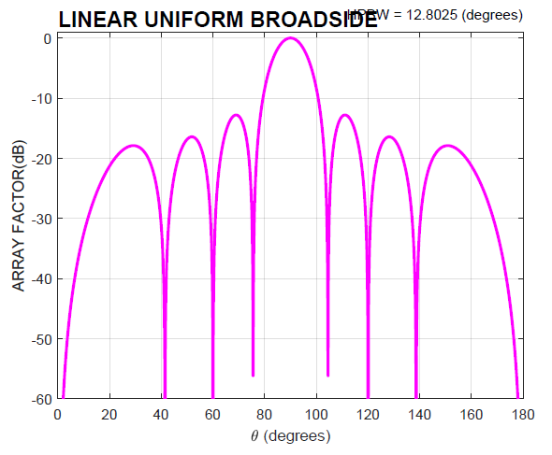
Figure 7.3.2.2.2-1: Eight element ULA response with 0.5 lambda spacing

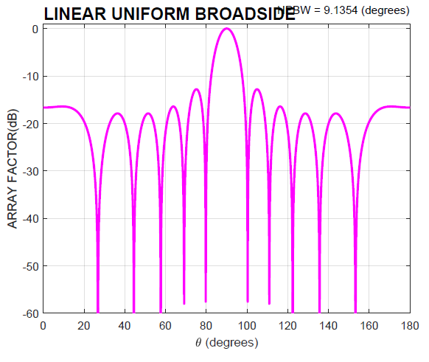
Figure 7.3.2.2.2-2: Eight element ULA response with 0.7 lambda spacing

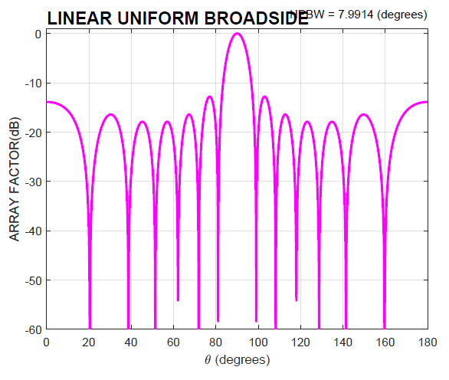
Figure 7.3.2.2.2-3: Eight element ULA response with 0.8 lambda spacing

It is also to be noted that in case of band 2 where the band is very wide (operating bandwidth 1275 MHz) proxy antenna inter element spacings for a carrier at the lower end of the band will almost have a similar impact as the lower adjacent band. Likewise for the upper end of the band.
The above inferences will also remain valid for the second adjacent band.
The above observations will remain valid even if the array is made of sub arrays and the notion that an array may drop down to a sub array in adjacent bands is not valid.

7.3.2.2.3 Modelling of PA non-linearities
Non linearities in hardware in the RF path cause signal distortions- both in band and out of band-(adjacent bands). The nonlinear components in the RF path consist of power amplifiers that are the main cause of nonlinear distortions but other components such as D/A converters, mixers, beam forming circuitry may also contribute to the nonlinear distortions. When antenna arrays are deployed, multiple users may be served by beam forming either in the analog domain or both in the analog and digital domain. Digital beamforming is commonly employed in today’s systems- such as zero forcing, MMSE [16]. This results in the placing of nulls in the path of all users except the desired user, but this operation may also cause out of band distortions to fall in unintended spatial directions.
The modelling of PA non linearities has received a lot of interest in the published literature [see 17,18-22 and references therein]. PA behavioural models can be classified as:
- Volterra series based,
- Artificial neural networks,
- Table look up methods,
- Models with linear and nonlinear memory, with and without memory etc.
Ref [17] gives a very good comparison of PA behavioural models in terms of metrics like identification complexity, adaptation complexity, running complexity etc. Measurements on some PAs and the accuracy of the models are presented in [20]. Some commonly used models use polynomials or memory polynomials [18,22], here PA units are modelled via 9th order polynomials whose coefficients are obtained from RF measurements. These papers conclude that the received signal with massive MIMO consists of a desired term with linear gain of the array and also a nonlinear distortion term. Additionally, if the linear response coefficients of the different parallel PAs (in the massive MIMO unit) are different (and they do have small differences), then even the linear signal terms are not fully coherently combining at the receiver. In case of the nonlinear distortion terms, this effect is even more evident as here the phase characteristics of the constituent terms representing the component PAs are different. These two effects manifest in the decrease of the desired instantaneous SINR. When pre-coded multiuser MIMO is used, [21,22] derive analytical models for three different precoder types and for each case derives the received signal. The later now consists of a linear useful signal part and several distortion terms arising from multiuser interference and nonlinear distortion. The conclusion of this paper is:
The choice of a PA behavioural model validated by measurements is needed. Ref [18,19] provide a good framework to model these non-linearities via polynomial models.
The differences in the linear responses of the parallel PAs have a large impact on the system performance. The nonlinear terms do not necessarily adopt the digital predistortion as easily and efficiently. Therefore, the impact of nonlinear power amplifiers is nontrivial both in band and out of band. However, to do this we would need a model for the differences in the PA models in an AAS.
Power Amplifier non linearities should be carefully modelled when considering adjacent channel impacts when MIMO arrays are used. The choice of a PA model should be agreed (say via polynomial models), then it may be validated by measurements and also agree on a model for the differences in the parameters for the distributed PAs.
We may assume for the sake of simplicity there are no differences in the PA model parameters in a distributed PA AAS.
Adjacent band impacts is however not the main focus of [18], but they are considered in [17,18,21]. These papers give the spatial distribution of out of band radiation in the presence of non-linear amplifiers that are modelled by orthogonal polynomials- a special case of the more general Volterra series as described in [17]. Refs [8,21] derive an expression for array ACLR when linear precoding is used with MIMO arrays and a spatial distribution of the ACLR is derived for 1, 2 and 10 users respectively. In particular, [21] develops a framework for rigorous analysis of the spatial characteristics of nonlinear distortion from arrays both in band and out of band. The framework is validated via measurements on a GaN class AB amplifier [23]. It is shown that in the immediate adjacent bands, the third order distortion terms are significant. For a two user MU MIMO case it is shown that the desired signal is beamformed in two directions but the adjacent band distortion signal (arising from PA non linearities) is not beamformed in the same direction as the desired signal. Consideration of this will be important in evaluating the impact of adjacent band victims due to PA non linearities in the operating band.

7.3.2.2.4 Modelling of band pass filters
The filters modelled in some references [15,] use a root raised cosine filter with an excess bandwidth of 0.22. Also, the adjacent channel has the same bandwidth as the operating bandwidth. This is clearly not the case, for all the bands under consideration the operating bandwidths are much larger than the carrier bandwidth. The adjacent channel bandwidth may be saying 100 MHz. However, the framework in [23] can be used to change the bandwidth of the BPF to reflect the operating bandwidth. However, we must specify the bandwidth of the BPF and a model for the BPF.

Annex A (normative): Additional observations for 7125-8400 MHz frequency range

A.1 Impact of higher channel bandwidth on the ACLR/ACS
This Annex presents additional simulation studies to compare the throughput loss% as a function of ACIR for both downlink and uplink transmissions in UMa deployments for both 100MHz and 200MHz, as shown in Figure A.1-1.
NOTE 1: The impact of the higher channel bandwidth on the spectral mask is given in A.2-1.
Note that all the network, BS, and UE parameters follow the adjacent channel coexistence conducted in TR 38.921 [14]. It can be observed that the ACIR required to meet the 5% throughput loss degradation target is nearly identical for the 100 MHz and 200 MHz channel bandwidths. Note that in the above simulations, the conducted power is assumed to be the same for both channel configurations. It is expected that with scaling the conducted power to account for the increased channel bandwidth (i.e., equivalent PSD), the wanted and interfering signal will be scaled accordingly, resulting in comparable ACIR values between the two channel bandwidth configurations. As a result, the BS/ UE ACLR and ACS will not be affected by higher channel bandwidths.
CHBW = 100MHz
CHBW = 200MHz
Figure A.1-1 Throughput loss for UMa scenario for 100MHz (black) and 200MHz channel bandwidths (magenta)

A.2 Impact of higher channel bandwidth on spectral emission mask
The BS spectral mask given in Section 5.2.1.2 can be reused for 200MHz channel bandwidth as the BS spectral mask is given as a function of the frequency offset Δf and it is agnostic to the assumed operating channel bandwidth.
The UE spectral mask given in Section 5.3.1.2 can be reused for 200MHz channel bandwidth following Section 5.5.2.1 in [5], where the limit in this first MHz will remain -24dBm/30kHz. Accordingly, the UE spectral mask in Section 5.3.1.2 can be updated to accommodate 200MHz channel bandwidth as given in Table A.2-1.
Table A.2-1: General NR spectrum emission mask
Δf_{OOB}  (MHz) | Channel bandwidth (MHz) / Spectrum emission limit (dBm) |  |  |  | Measurement bandwidth
Δf_{OOB}  (MHz) | 3 | 5 | 10, 15, 20, 25, 30, 35, 40, 45 | 50, 60, 70, 80, 90, 100, 200 | Measurement bandwidth
± 0-1 | -13 | -13 | -13 |  | 1 % of channel BW
± 0-1 |  |  |  | -24 | 30 kHz
± 1-5 | -10 | -10 | -10 |  | 1 MHz
± 5-6 | -25 | -13 |  |  | 1 MHz
± 6-10 |  | -25 |  |  | 1 MHz
± 5-BW_{Channel} |  |  | -13 |  | 1 MHz
± BW_{Channel}-(BW_{Channel}+5) |  |  | -25 |  | 1 MHz

A.3 Impact of higher channel bandwidth on cumulative in-band and adjacent band emissions.
Based on the observations in sections A.1 and A.2, in case of higher channel bandwidth the amount of emissions in-band and in adjacent-band is expected to be similar or lower compared to the case when 100 MHz channels are used. For the same total transmit power, adopting larger channel bandwidth will lead to lower in-band PSD compared to multiple 100 MHz channels. In terms of adjacent band impact, since the same spectral mask can be reused (as observed in section A.2), the cumulative adjacent band emission is expected to be similar to the case of 100 MHz transmission.

A.4 Impact of higher UE maximum output power on the ACLR/ACS
In order to ensure that the adjacent channel coexistence (i.e., BS and UE ACLR/ACS) derived for PC3 (i.e., UE maximum output power equals 23 dBm) is not impacted when considering higher UE maximum output power (e.g., PC2, with maximum output power equals 26 dBm), we compare the throughput loss % as a function of ACIR for both downlink and uplink transmissions in UMa deployments for both PC3 and PC2 was compared, as shown in Figure A.4-1. Note that all the network, BS, and UE parameters follow the adjacent channel coexistence conducted in TR 38.921 [14]. It can be observed that the ACIR required to meet the 5% throughput loss degradation mark is nearly the same for both PC3 and PC2. As a result, the BS/ UE ACLR and ACS will not be affected by higher UE maximum output power.
UE max power = 26 dBm
UE max power = 23 dBm
Figure A.4-1 Throughput loss for UL UMa scenario for 23 dBm (magenta) and 26 dBm (black) UE maximum output power

Annex B (informative): Change history
Change history
Date | Meeting | TDoc | CR | Rev | Cat | Subject/Comment | New version
2024-04 | RAN4#110bis | R4-2406614 |  |  |  | TR skeleton | 0.0.1
2024-05 | RAN4#111 | R4-2408494 |  |  |  | Table of contents corrected | 0.0.2
2024-05 | RAN4#111 | R4-2410763 |  |  |  | R4-2410722 TP for TR 38.922: Addition of technical background for 4400 to 4800 MHz in clause 4  R4-2410592 TP to TR 38.922: System level simulation methodology and assumptions for co-existence study for 14800 – 15350 MHz frequency range  R4-2408083 TP to TR 38.922: Addition of array antenna model description in clause 7 | 0.1.0
2024-08 | RAN4#112 | R4-2412608 |  |  |  | R4-2412587 TP to TR 38.922: Corrections and clarifications on IMT parameters for 4400 to 4800 MHz frequency range  R4-2413278 TP for IMT technology related parameters for 4400 to 4800 MHz  R4-2414300 TP for 38.922 on UE IMT parameters for 7125-8400 MHz  R4-2414301 TP for BS IMT parameters for range 7125 to 8400 MHz  R4-2414303 TP to TR 38.922: Revisions of system level simulation assumptions for study on IMT parameters for 14800 to 15350 MHz frequency range | 0.2.0
2024-10 | RAN4#112bis | R4-2417200 |  |  |  | R4-2417190 TP to TR 38.922: Scope clarification  R4-2417102 TP to TR 38.922 Update Clause 1-4  R4-2417103 TP for TR 38.922: Correction on BS IMT parameters for range 7125 to 8400 MHz  R4-2417101 Text proposal on 7125-8400 MHz IMT parameters in TR 38.922  R4-2417104 TP for TR 38.922: corrections for 7125 to 8400 MHz frequency range  R4-2417105 TP to TR 38.922: Revisions of system level simulation assumptions for study on IMT parameters for 14800 to 15350 MHz frequency range  R4-2417106 TP to TR 38.922: Addition of new subclause for MIMO modelling aspects in subclause 7.3 | 0.3.0
2024-11 | RAN4#113 | R4-2419346 |  |  |  | R4-2420386 TP on coexistence simulation results for 14800 to 15350 MHz frequency range  R4-2420387 TP on UE parameters for 14800 to 15350 MHz frequency range  R4-2417534 TP to TR 38.922: Corrections and clarifications on IMT parameters for 4400 to 4800 MHz frequency range  R4-2417538 TP to TR 38.922: Revisions of system level simulations for study on IMT parameters for 14800 to 15350 MHz frequency range  R4-2417874 TP to TR 38.922: Scope clarification  R4-2418607 Text proposal on 7125 – 8400 MHz IMT parameters in TR 38.922  R4-2418994 TP to TR 38.922 Updates to Clause 5  R4-2420388 TP on general considerations for the UE antenna parameters for the 14800-15350 MHz frequency range  R4-2420389 TP on UE RF design options for the 14800-15350MHz frequency range  R4-2420407 TP to TR 38.922: Summary and conclusion for MIMO modelling aspects  R4-2420516 TP to TR 38.922: OBUE limits for AAS BS in 7125 to 8400 MHz frequency range  R4-2420529 TP for other issues (Adjacent channel modelling)  R4-2420390 Discussion on radio and antenna parameters for 14800 to 15350 MHz | 0.4.0
2024-12 | RAN#106 | RP-242945 |  |  |  | Presented to RAN for information | 1.0.0
2024-12 | RAN#106 |  |  |  |  | Editorial corrections | 1.0.1
2025-02 | RAN4#114 | R4-2501512 |  |  |  | R4-2502880 TP to TR 38.922 Editorial corrections for 4400 to 4800 MHz frequency range  R4-2502881 TP to TR 38.922: Corrections and clarifications on IMT parameters for 7125 to 8400 MHz frequency range  R4-2502883 TP to TR 38.922 on parameters for 14.8 - 15.35 GHz frequency range  R4-2501862 Co-existence study for 15 GHz  R4-2500072 TP to TR 38.922: Simulation results on MIMO modelling  R4-2502884 TP to TR 38.922 Editorial corrections for Additional Information on AAS | 1.1.0

It should be note that the array response is both in the azimuth and elevation.
We assume a broadside array. An elevation angle of 90 degrees is when users are in the elevation boresight.
Whilst antenna numbers can increase due to advancements in semiconductor technology [3], the numbers of users to be nulled must be less than or equal to the number of RF chains
In practice, this is not the case, as Sounding Reference Signals (SRS) are used in time-division duplex (TDD) systems, where the UEs would send an uplink SRS signal based on which the BS will estimate the uplink channel and using channel reciprocity, will estimate the downlink channel. In frequency-division duplex (FDD) systems, Channel State Information-Reference Signal (CSI-RS) is transmitted from the BS periodically and the UEs will estimate the channel and feedback the channel response via a codebook to the BS [5].
Mathematical notation: We note that $h_{1}$ denotes a vector, while $H$ denotes a matrix. Furthermore, $h$ is denoted as a real scalar value, where as ${\left(⋅\right)}^{T}$and ${\left(⋅\right)}^{H}$ are used to denote a transpose and a Hermitian transpose operation. Finally, ${\left(H\right)}^{-1}$ is used to denote the matrix inverse of a square matrix (same number of rows and columns), $H$.

