3GPP TSG-RAN4 Meeting #112bis R4-2417013
Hefei, China, 14th – 18th Oct 2024

Agenda item: 6.10.5
Source: CMCC
Title: WF on UE RF for ATG enhancement
Document for: Approval

Introduction
This document captures the agreements on Rel-19 ATG UE RF requirements in RAN4#112bis.

Topic #1: R19 UE RF for intra-band contiguous CA
Issue 1-1: Whether to specify a separate configuration table for ATG UE
Agreement:
- Since ATG reuse the existing configuration table for ATG UE supporting DL CA_n79C, no separate configuration table is needed for ATG UE CA_n79C.

Issue 1-2: ACS testing parameters for case 2
Agreement:
- Table 3: Test parameters for intra-band contiguous CA with F_{DL_low} ≥ 3300 MHz and F_{UL_low} ≥ 3300 MHz, case 2
Rx Parameter | Units | NR CA bandwidth class
 |  | C
Pw in Transmission Bandwidth Configuration, per CC | dBm | -73.5⁴  -61.5⁵
P_{Interferer} | dBm | -42⁴  -30⁵
BW_{Interferer} | MHz | BW_{channel CA}
F_{Interferer} (offset) | MHz | BW_{channel CA}  /  -BW_{channel CA}
NOTE 1: The transmitter shall be set to 24 dB below P_{CMAX_L,f,c} at the minimum UL configuration specified in Table 7.3.2-3 with P_{CMAX_L,f,c} defined in clause 6.2.4.
NOTE 2: The absolute value of the interferer offset F_{interferer} (offset) shall be further adjusted to MHz with SCS the sub-carrier spacing of the carrier closest to the interferer in MHz. The interferer is an NR signal with an SCS equal to that of the closest carrier.
NOTE 3: The interferer consists of the RMC specified in Annexes A.3.2.2 and A.3.3.2 with one sided dynamic OCNG Pattern OP.1 FDD/TDD for the DL-signal as described in Annex A.5.1.1/A.5.2.1.
NOTE 4: P_{interferer} shall be set to -42dBm for omni-directional antenna.
NOTE 5: P_{interferer} shall be set to -30dBm for antenna array.

Topic #2: R19 UE RF for inter-band CA
Issue 2-1: whether to allow n39 UL for CA_n3A-n39A
Agreement:
- The conclusions about allowing n39 UL for CA_n3A-n39A if any should only apply to ATG and will not have any impact on existing NR specification for legacy NR UE.
- Further check if the performance of these parameters in the following table can be achieved in ATG UE with 5MHz frequency gap in n39 filter.
- Parameters | Values
Antenna Isolation | 20dB
The rejection for band n3 Rx filter at 1885~1915MHz | 50dB
n39 Tx filter rejection at 1805~1880MHz | 50dB

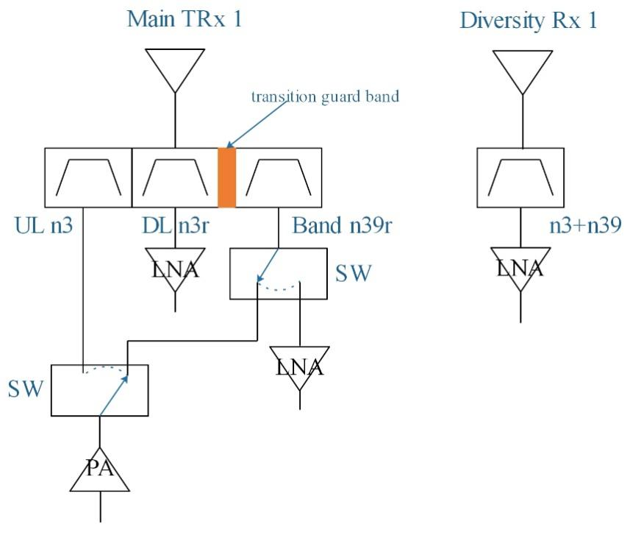
- Other RF architectures or paramters are not precluded.

Qulacomm: RF parameters should be included.
Skyworks: also want to make it clear for parameters.

Issue 2-2: BCS for DL CA_n3_n39
WF:
Further consider the following table, if the feasibility is confirmed for uplink of n39.
Table 1. Supported bandwidths per CA band combination of band n3+n39
NR CA configuration | Uplink CA configuration or single uplink carrier | NR Band | Channel bandwidth (MHz) | Bandwidth combination set
CA_n3A-n39A | n3, [n39] | n3 | 5, 10, 15, 20, 25, 30 | 0
 |  | n39 | 5, 10, 15, 20, 25, 30, 35, 40

Issue 2-3: MSD for CA_n3A-n39A with n39 UL
WF:
Further check the MSD value with 5MHz frequency gap in 1880~1885MHz, if the feasibility is confirmed for uplink of n39
UL band | DL band | UL F_{c} | UL BW | SCS of UL band | UL RB Allocation | DL F_{c} | DL BW | MSD | Cross-band  Interference  source
UL band | DL band | (MHz) | (MHz) | (kHz) | L_{CRB} | (MHz) | (MHz) | (dB) | Cross-band  Interference  source
n39 | n3 | 1900 | 30 | 15 | 160 (RBstart=0) | 1827.5 | 5 | [TBD] | ACLR2

Topic #3: R19 UE RF for UL-MIMO
Issue 3-1-1: ULFPTx mode for UL-MIMO
WF:
Consider whether and how to introduce this requirement.
- Option 1: ULFPTx mode 1/2/Full in the following table can be supported depending on UE PA implementation
- Table 2: Example of ATG ULFPTx (R-MOP = x dBm)
ATG ULFPTx mode | PA1(dBm) | PA2(dBm)
Mode2 | x | (x-3)~(x-1)
Mode-Full | x | x
Mode1 | (x-3)~(x-1) | (x-3)~(x-1)

- Option 2: Current ULFPTx mode requirements for legacy UE in TS38.101-1 can be reused for ATG UE, and there is no other specification affect.
- Option 3: No need to extend ULFPTx mode to ATG UE.

Issue 3-1-2: whether preclude the single antenna port related requirement
WF:
- Option 1: Yes.
- Option 2: No.

ZTE: there is no need for single antenna port. Small CDD is used in fading channel. ATG faces the single channel.
Ericsson: We do not think we need to preclude the single antenna. ATG can be scheduled for this single port operation.
ZTE: How do you implement Tx diversity?
Ericsson: refer to the requirement 6.5.

Issue 3-2-1: how to modify the NR UL MIMO requirement with ATG capability antennaArrayType-r18
Agreement in RAN4#102 meeting:
- If the legacy requirement for UL MIMO is defined at each antenna connector,
  - For ATG UE with antenna array, the requirement should be updated [at each TAB connector].
- If the legacy requirement for UL MIMO is defined per layer, FFS
  - Option 1: for ATG UE with capability antennaArrayType-r18, the requirement should be updated as sum of all TAB connectors per layer.
  - Option 2: for ATG UE with capability antennaArrayType-r18, the requirement should be updated per layer without explicitly emphasize the TAB connector.

Agreement:
- If the legacy requirement for UL MIMO is defined at each antenna connector,
  - For ATG UE with antenna array, the requirement should be updated at each TAB connector
- If the legacy requirement for UL MIMO is defined per layer
  - for ATG UE with capability antennaArrayType-r18, the requirement should be updated as sum of all TAB connectors per layer

Issue 3-2-2: whether to apply coherent UL MIMO requirement for ATG UE
Agreement:
Since coherent UL MIMO is the optional requirement, it could be supported without specification impact.

ZTE: From our understanding, we have two schemes. Coherent based. Coherent is not useful.
Huawei: For ATG scenario, we only have direct part. For uplink MIMO, it uses two polarization, which is different from coherent UL MIMO. I do not know what is the harm.
Ericsson: To our understanding, we do see any spec impact.

Issue 3-3-1: How to test Rx requirements
Agreement:
No need to test the Rx requirements under the UL MIMO scenario for ATG UE, since general Rx requirements have been tested.

Issue 3-3-2: How to test Tx requirements
Agreement:
Further discuss the method of definition for general ATG Tx requirements referring to agreed CR R4-2414321 can be used.

Issue 3-3-3: Transmit modulation quality for ATG
Agreement:

6.4J.2 Transmit modulation quality for ATG
The requirements for transmit modulation quality defined in clause 6.4.2 shall apply for ATG UE except for the phase continuity requirements for DMRS bundling in 6.4.2.5. And the requirements for 256QAM modulation are only applicable to ATG UE indicating support of 256QAM.
For ATG UE, the requirements for Error Vector Magnitude, Carrier leakage and EVM equalizer spectrum flatness are defined per layer. The requirements for In-band emission are defined at each transmit antenna connector or each TAB connector.

