Invitation for BSRF session - RAN4 #107

Dear all,
This is an invitation to RAN4#107 BSRF Webinar sessions on 22 – 27 May 2023.

Please remember that consistent registration format is important for session chairing and hence use the following format when you register: BriefCompanyName - Firstname, Lastname. An example is shown below

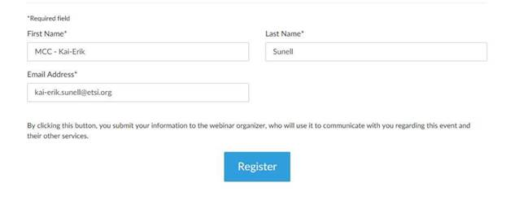
where BriefCompanyName is ‘MCC’, Firstname is ‘Kai-Erik’ and Lastname is ‘Sunell’.

Your email address for Webinar registration needs to be the same as for your 3GPP meeting registration.

Registration link is found below and they are session-specific. You may register to all sessions, e.g. if you plan to switch between sessions or if you are able to listen to all sessions at the same time. Once you have registered for a session your registration is valid for the whole week.

The starting time for BSRF session (22 May) is 9:30 KST but you can join already 15 minutes earlier, i.e. 9:15 KST , to check that your speakers and microphones work fine. (Observe, registration links below show time in CET which is UTC + 2 hour.) Webinars are scheduled to stop at 20:30 KST.

3GPP TOHRU will be used in this meeting (previously RAN4 used external TOHRU tool)
Hyperlink: https://tohru.3gpp.org/

Together with the invitation for the GotoWebinar MCC provides you with a "Meeting name" individually after your registration
- The BSRF session meeting TOHRU Meeting ID is listed below:
  - RAN4_BSRF (TOHRU Meeting ID for BSRF)

- This "3GPP TOHRU Meeting ID" has to be entered on the web page and in addition under "Your Name:" you have to provide:
<represented company> - <first name> <family name>
e.g.: XY Telecom - Peter Mustermann

Need to manually push "Refresh Queue" or use "Automatically refresh queue every 3 seconds", since this is different from the original TOHRU tool.
The other buttons are similar as the previous external TOHRU tool

Instructions on how to join the Webinars will be sent automatically every day.

RAN4#107 BSRF Webinar Sessions
Mon, May 22, 2023 9:30 AM - 8:30 PM KST

RAN4#107 BSRF Webinar Sessions
Join us for a webinar beginning on May 22, 2023 at 9:30 AM KST.
Register now!

After registering, you will receive a confirmation email containing information about joining the webinar.
View System Requirements

