3GPP TSG-RAN WG4 Meeting #102-e R4-2207307
Electronic Meeting, February 21 – March 3, 2022

Agenda item: 10.1.3.3
Source: vivo, CAICT, Spirent
Title: TP to TS38.151 on channel model validation limits
Document for: Approval

1 Introduction
March RAN Plenary meeting is the target to release the initial version of TS 38.151 v1.0.0 as the outcome of WI core part. Except for MU assessment, one unsettled part for permitted test methodology in TS 38.151 is the channel model validation pass/fail limits, as described in the latest SR for MIMO OTA WI [1]:

2.4.2 Remaining Open issues
- Pass/fail limits of FR1/FR2 channel model validation
- Further discuss “frequent re-positioning” for FR2 PSP
- FR1/FR2 MIMO OTA lab alignment and requirement development activities
  - Lab volunteers submit channel model validation results
  - Lab volunteers finish the PADs measurement
  - Process lab alignment results
  - Aligned labs share FR1 MIMO OTA measurement data
  - FR2 simulation activity
- Preliminary MU assessment for FR1/FR2 MIMO OTA

In addition, the correction of power validation procedure for TR 38.827 is endorsed in [2], the update should also be reflected in the TS 38.151.
This TP prepares the text proposals to TS 38.151 based on the agreements in [3] [4] and potential new outcome in RAN4#102e meeting, to finalize the core part work of MIMO OTA WI.

2 References
- RP-213100, SR for MIMO OTA WI, CAICT, RAN#94e, Dec. 6-17, 2021
- R4-2204947, Draft CR to TR38.827:power validation procedure correction, vivo, 3GPP RAN4#102-e, Mar 2022.
- R4-2203063, “WF on NR MIMO OTA,” vivo, CAICT, 3GPP RAN4#101-bis-e, Jan 2022.
- R4-2119093, Channel Model Spatial Validation Pass/Fail limits, Spirent Communications, 3GPP RAN4#101 -e, Nov. 2021.
- 3GPP TS 38.151 v0.7.0

3 Text Proposal to TS 38.151
--------------Start of text proposal 1 -------------

C.3.6 Power validation
This measurement checks the total power in the centre of the test zone. The power validation is measured with a spectrum analyser as shown in Figure C.3.6-1.
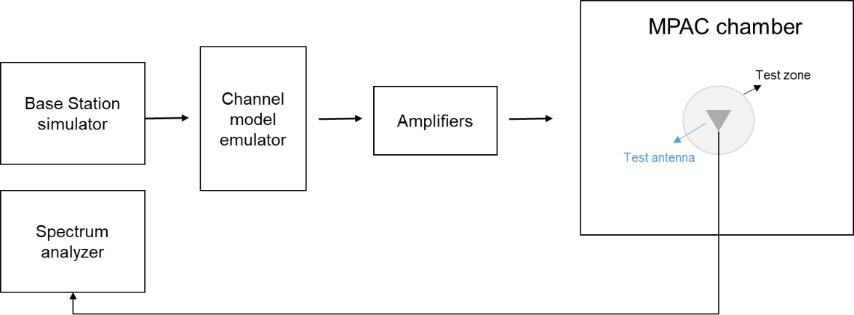
Figure C.3.6-1: Setup for power validation measurements
Spectrum analyser settings:
Table C.3.6-1: Spectrum analyser settings for power validation measurements
Item | Unit | Value
Centre frequency | MHz | Downlink centre frequency  in Table C.3.1-2
Integrated Channel Span | Hz | 40MHz
RBW | Hz | 30 kHz
VBW | Hz | ≥10MHz
Number of points |  | ≥400
Averaging |  | ≥100
Detector |  | RMS

Measurement Procedure:
1. Place a vertical reference dipole in the centre of the test zone connected to a spectrum analyser (or power meter) via a cable.
2. Record the cable and reference dipole gains.
3. Load the target channel model into the channel emulator and play the model.
4. Start the NR FR1 signaling in the base station emulator with the required parameter identical to the measurements conditions.
5. Average the power received by the spectrum analyser for a sufficient amount of time to account for the fading channel – one full channel simulation might be unnecessary.
6. Repeat steps 1 to 4 with a magnetic loop for the horizontal polarization, or a horizontally polarized sleeve dipole measured in at least four orthogonal horizontal positions and average the summed orientations to get the H component.
7. Calculate the total power received at the test area as the sum of the power in the two polarizations.
Note: in step 6, if horizontally polarized sleeve dipole is used, the reference gain correction should be the average of the theta gain pattern cut of the dipole. Besides, more horizontal positions for averaging will improve the measurement accuracy but increase the total measurement time.
The power validation result is considered as systematic offset, which needs to be corrected on the UE final sensitivity value to further reduce measurement uncertainty.
The detailed power validation setup for CDL-C UMi and CDL-C UMa channel models are illustrated in Figure C.3.6-2 and Figure C.3.6-3.

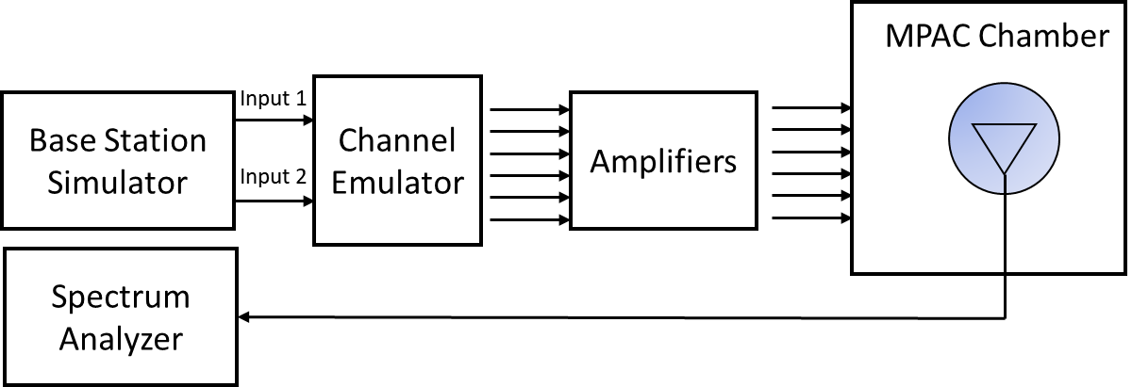
Figure C.3.6-2: Setup for power validation measurements for CDL-C UMi

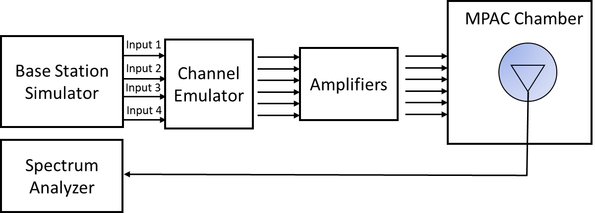
Figure C.3.6-3: Setup for power validation measurements for CDL-C UMa

--------------End of text proposal 1-------------

--------------Start of text proposal 2 -------------

C.4 Validation Pass/fail limit

C.4.1 General
This clause defines the pass/fail limit of FR1 MPAC system for FR1 channel model validation.

C.4.2 Pass/Fail Criteria of PDP
This clause defines the pass/fail criteria of PDP, this pass/fail limits apply for all FR1 frequency bands, for both combined and individual beams.
The detailed pass/fail limits for each cluster of CDL-C UMa are defined in Table C.4.2-1.
Table C.4.2-1: PDP pass/fail limits for CDL-C UMa
 | Power Tolerance | Delay Tolerance
Paths from 0dB to 10dB | ±1dB | ±6ns
Paths from 10dB to 20dB | ±2.5dB | ±6ns
Paths from 20dB to 30dB | ±5dB | ±6ns
Paths from 30dB to 40dB | TBD | ±6ns

The detailed pass/fail limits for each cluster of CDL-C UMi are defined in Table C.4.2-2.
Table C.4.2-2: PDP pass/fail limits for CDL-C UMi
 | Power Tolerance | Delay Tolerance
Paths from 0dB to 10dB | TBD | TBD
Paths from 10dB to 20dB | TBD | TBD
Paths from 20dB to 30dB | TBD | TBD
Paths from 30dB to 40dB | TBD | TBD

C.4.3 Pass/Fail Criteria of Doppler/Temporal correlation
This clause defines the pass/fail criteria of doppler/temporal correlation, this pass/fail limits apply for all channel models in all FR1 frequency bands, for both combined and individual beams.
The pass/fail limits for temporal correlation are formed as bands of ±10% of correlation capped at 100% from the target defined in clause C.3.3. Additionally, when the upper bound reaches 30%, the limit stays at 30% and the lower limit drops to 0%.
Table C.4.3-1: pass/fail limits for temporal correlation
CDL-C UMa beam 1 at ≤ 2.5 GHz |  | CDL-C UMa beam 2 at ≤ 2.5 GHz |  | CDL-C UMa beam 1 at > 2.5 GHz |  | CDL-C UMa beam 2 at > 2.5 GHz |  | CDL-C UMi beam 1 at ≤ 2.5 GHz |  | CDL-C UMi beam 1 at > 2.5 GHz
Lower | Upper | Lower | Upper | Lower | Upper | Lower | Upper | Lower | Upper | Lower | Upper
0.9 | 1 | 0.9 | 1 | 0.9 | 1 | 0.9 | 1 | 0.9 | 1 | 0.9 | 1
0.886 | 1 | 0.874 | 1 | 0.885 | 1 | 0.873 | 1 | 0.895 | 1 | 0.895 | 1
0.845 | 1 | 0.807 | 1 | 0.842 | 1 | 0.804 | 1 | 0.882 | 1 | 0.882 | 1
0.782 | 0.982 | 0.732 | 0.932 | 0.774 | 0.974 | 0.725 | 0.925 | 0.862 | 1 | 0.861 | 1
0.701 | 0.901 | 0.676 | 0.876 | 0.687 | 0.887 | 0.665 | 0.865 | 0.836 | 1 | 0.835 | 1
0.609 | 0.809 | 0.638 | 0.838 | 0.589 | 0.789 | 0.623 | 0.823 | 0.806 | 1 | 0.805 | 1
0.513 | 0.713 | 0.595 | 0.795 | 0.486 | 0.686 | 0.575 | 0.775 | 0.772 | 0.972 | 0.771 | 0.971
0.418 | 0.618 | 0.523 | 0.723 | 0.386 | 0.586 | 0.499 | 0.699 | 0.734 | 0.934 | 0.734 | 0.934
0.33 | 0.53 | 0.425 | 0.625 | 0.294 | 0.494 | 0.396 | 0.596 | 0.693 | 0.893 | 0.693 | 0.893
0.253 | 0.453 | 0.326 | 0.526 | 0.215 | 0.415 | 0.291 | 0.491 | 0.65 | 0.85 | 0.649 | 0.849
0.189 | 0.389 | 0.26 | 0.46 | 0.152 | 0.352 | 0.219 | 0.419 | 0.605 | 0.805 | 0.604 | 0.804
0.14 | 0.34 | 0.235 | 0.435 | 0.106 | 0.306 | 0.19 | 0.39 | 0.559 | 0.759 | 0.558 | 0.758
0.104 | 0.304 | 0.22 | 0.42 | 0 | 0.3 | 0.173 | 0.373 | 0.514 | 0.714 | 0.512 | 0.712
0 | 0.3 | 0.187 | 0.387 | 0 | 0.3 | 0.139 | 0.339 | 0.469 | 0.669 | 0.468 | 0.668
0 | 0.3 | 0.133 | 0.333 | 0 | 0.3 | 0 | 0.3 | 0.427 | 0.627 | 0.425 | 0.625
0 | 0.3 | 0 | 0.3 | 0 | 0.3 | 0 | 0.3 | 0.387 | 0.587 | 0.385 | 0.585
0 | 0.3 | 0 | 0.3 | 0 | 0.3 | 0 | 0.3 | 0.35 | 0.55 | 0.348 | 0.548
0 | 0.3 | 0 | 0.3 | 0 | 0.3 | 0 | 0.3 | 0.317 | 0.517 | 0.315 | 0.515
0 | 0.3 | 0 | 0.3 | 0 | 0.3 | 0 | 0.3 | 0.287 | 0.487 | 0.285 | 0.485
0 | 0.3 | 0 | 0.3 | 0 | 0.3 | 0 | 0.3 | 0.261 | 0.461 | 0.258 | 0.458
0 | 0.3 | 0 | 0.3 | 0 | 0.3 | 0 | 0.3 | 0.237 | 0.437 | 0.235 | 0.435
0 | 0.3 | 0 | 0.3 | 0 | 0.3 | 0 | 0.3 | 0.216 | 0.416 | 0.213 | 0.413
0 | 0.3 | 0 | 0.3 | 0 | 0.3 | 0 | 0.3 | 0.196 | 0.396 | 0.193 | 0.393
0 | 0.3 | 0 | 0.3 | 0 | 0.3 | 0 | 0.3 | 0.177 | 0.377 | 0.174 | 0.374
0 | 0.3 | 0 | 0.3 | 0 | 0.3 | 0 | 0.3 | 0.158 | 0.358 | 0.155 | 0.355
0 | 0.3 | 0 | 0.3 | 0 | 0.3 | 0 | 0.3 | 0.139 | 0.339 | 0.136 | 0.336
0 | 0.3 | 0 | 0.3 | 0 | 0.3 | 0 | 0.3 | 0.119 | 0.319 | 0.116 | 0.316
0 | 0.3 | 0 | 0.3 | 0 | 0.3 | 0 | 0.3 | 0 | 0.3 | 0 | 0.3
0 | 0.3 | 0 | 0.3 | 0 | 0.3 | 0 | 0.3 | 0 | 0.3 | 0 | 0.3
0 | 0.3 | 0 | 0.3 | 0 | 0.3 | 0 | 0.3 | 0 | 0.3 | 0 | 0.3
0 | 0.3 | 0 | 0.3 | 0 | 0.3 | 0 | 0.3 | 0 | 0.3 | 0 | 0.3
0 | 0.3 | 0 | 0.3 | 0 | 0.3 | 0 | 0.3 | 0 | 0.3 | 0 | 0.3
0 | 0.3 | 0 | 0.3 | 0 | 0.3 | 0 | 0.3 | 0 | 0.3 | 0 | 0.3
0 | 0.3 | 0 | 0.3 | 0 | 0.3 | 0 | 0.3 | 0 | 0.3 | 0 | 0.3
0 | 0.3 | 0 | 0.3 | 0 | 0.3 | 0 | 0.3 | 0 | 0.3 | 0 | 0.3
0 | 0.3 | 0 | 0.3 | 0 | 0.3 | 0 | 0.3 | 0 | 0.3 | 0 | 0.3
0 | 0.3 | 0 | 0.3 | 0 | 0.3 | 0 | 0.3 | 0 | 0.3 | 0 | 0.3
0 | 0.3 | 0 | 0.3 | 0 | 0.3 | 0 | 0.3 | 0 | 0.3 | 0 | 0.3
0 | 0.3 | 0 | 0.3 | 0 | 0.3 | 0 | 0.3 | 0 | 0.3 | 0 | 0.3
0 | 0.3 | 0 | 0.3 | 0 | 0.3 | 0 | 0.3 | 0 | 0.3 | 0 | 0.3
0 | 0.3 | 0 | 0.3 | 0 | 0.3 | 0 | 0.3 | 0 | 0.3 | 0 | 0.3
0 | 0.3 | 0 | 0.3 | 0 | 0.3 | 0 | 0.3 | 0 | 0.3 | 0 | 0.3
0 | 0.3 | 0 | 0.3 | 0 | 0.3 | 0 | 0.3 | 0 | 0.3 | 0 | 0.3
0 | 0.3 | 0 | 0.3 | 0 | 0.3 | 0 | 0.3 | 0 | 0.3 | 0 | 0.3
0 | 0.3 | 0 | 0.3 | 0 | 0.3 | 0 | 0.3 | 0 | 0.3 | 0 | 0.3
0 | 0.3 | 0 | 0.3 | 0 | 0.3 | 0 | 0.3 | 0 | 0.3 | 0 | 0.3
0 | 0.3 | 0 | 0.3 | 0 | 0.3 | 0 | 0.3 | 0 | 0.3 | 0 | 0.3
0 | 0.3 | 0 | 0.3 | 0 | 0.3 | 0 | 0.3 | 0 | 0.3 | 0 | 0.3
0 | 0.3 | 0 | 0.3 | 0 | 0.3 | 0 | 0.3 | 0 | 0.3 | 0 | 0.3
0 | 0.3 | 0 | 0.3 | 0 | 0.3 | 0 | 0.3 | 0 | 0.3 | 0 | 0.3
0 | 0.3 | 0 | 0.3 | 0 | 0.3 | 0 | 0.3 | 0 | 0.3 | 0 | 0.3

Based on the value defined in Table C.4.3-1, Figure C.4.3-1 shows the pass/fail and reference curve of temporal correlation.
Figure C.4.3-1: pass/fail limits and targets of Temporal correlation for CDL-C UMa and CDL-C UMi channel model: red curve (reference), blue (upper limit) and green (lower limit)

C.4.4 Pass/Fail Criteria of Spatial correlation
This clause defines the pass/fail criteria of spatial correlation, this pass/fail limits apply for all channel models in all FR1 frequency bands, for both combined and individual beams.
The pass/fail limits for spatial correlation are formed as bands of ±10% of correlation capped at 100% for the upper limit for target correlation defined in clause C.3.4 of 35% and above. For target correlations below 35%, the band is widened to ±20% capped at 0%.

Table C.4.4-1: Spatial correlation pass/fail limits for CDL-C UMi channel model
617 MHz |  | 722 MHz |  | 836.5 MHz |  | 1575.42 MHz |  | 1800 MHz
Lower | Upper | Lower | Upper | Lower | Upper | Lower | Upper | Lower | Upper
0.90 | 1.00 | 0.90 | 1.00 | 0.90 | 1.00 | 0.90 | 1.00 | 0.90 | 1.00
0.90 | 1.00 | 0.90 | 1.00 | 0.90 | 1.00 | 0.90 | 1.00 | 0.90 | 1.00
0.90 | 1.00 | 0.90 | 1.00 | 0.90 | 1.00 | 0.90 | 1.00 | 0.90 | 1.00
0.90 | 1.00 | 0.90 | 1.00 | 0.90 | 1.00 | 0.90 | 1.00 | 0.89 | 1.00
0.89 | 1.00 | 0.89 | 1.00 | 0.89 | 1.00 | 0.89 | 1.00 | 0.89 | 1.00
0.88 | 1.00 | 0.88 | 1.00 | 0.88 | 1.00 | 0.89 | 1.00 | 0.88 | 1.00
0.74 | 0.94 | 0.74 | 0.94 | 0.86 | 1.00 | 0.89 | 1.00 | 0.87 | 1.00
0.70 | 0.90 | 0.70 | 0.90 | 0.72 | 0.92 | 0.88 | 1.00 | 0.85 | 1.00
 |  | 0.81 | 1.00 | 0.63 | 0.83 | 0.87 | 1.00 | 0.82 | 1.00
 |  | 0.89 | 1.00 | 0.71 | 0.91 | 0.86 | 1.00 | 0.77 | 0.97
 |  |  |  | 0.85 | 1.00 | 0.84 | 1.00 | 0.29 | 0.49
 |  |  |  | 0.90 | 1.00 | 0.81 | 1.00 | 0.00 | 0.35
 |  |  |  |  |  | 0.77 | 0.97 | 0.04 | 0.44
 |  |  |  |  |  | 0.56 | 0.76 | 0.52 | 0.72
 |  |  |  |  |  | 0.34 | 0.54 | 0.84 | 1.00
 |  |  |  |  |  | 0.10 | 0.50
 |  |  |  |  |  | 0.08 | 0.48
 |  |  |  |  |  | 0.27 | 0.47
 |  |  |  |  |  | 0.44 | 0.64
 |  |  |  |  |  | 0.65 | 0.85
 |  |  |  |  |  | 0.81 | 1.00
 |  |  |  |  |  | 0.89 | 1.00
2132.5 MHz |  | 2450 MHz |  | 3600 MHz |  | 4700 MHz
Lower | Upper | Lower | Upper | Lower | Upper | Lower | Upper
0.90 | 1.00 | 0.90 | 1.00 | 0.90 | 1.00 | 0.90 | 1.00
0.90 | 1.00 | 0.90 | 1.00 | 0.90 | 1.00 | 0.90 | 1.00
0.90 | 1.00 | 0.90 | 1.00 | 0.90 | 1.00 | 0.90 | 1.00
0.89 | 1.00 | 0.89 | 1.00 | 0.89 | 1.00 | 0.89 | 1.00
0.89 | 1.00 | 0.89 | 1.00 | 0.89 | 1.00 | 0.89 | 1.00
0.88 | 1.00 | 0.89 | 1.00 | 0.89 | 1.00 | 0.89 | 1.00
0.87 | 1.00 | 0.88 | 1.00 | 0.88 | 1.00 | 0.88 | 1.00
0.85 | 1.00 | 0.87 | 1.00 | 0.88 | 1.00 | 0.88 | 1.00
0.82 | 1.00 | 0.85 | 1.00 | 0.87 | 1.00 | 0.88 | 1.00
0.77 | 0.97 | 0.82 | 1.00 | 0.87 | 1.00 | 0.87 | 1.00
0.29 | 0.49 | 0.78 | 0.98 | 0.85 | 1.00 | 0.87 | 1.00
0.00 | 0.35 | 0.73 | 0.93 | 0.83 | 1.00 | 0.86 | 1.00
0.04 | 0.44 | 0.66 | 0.86 | 0.80 | 1.00 | 0.85 | 1.00
0.52 | 0.72 | 0.00 | 0.39 | 0.76 | 0.96 | 0.83 | 1.00
0.84 | 1.00 | 0.06 | 0.46 | 0.71 | 0.91 | 0.81 | 1.00
0.90 | 1.00 | 0.27 | 0.47 | 0.65 | 0.85 | 0.77 | 0.97
0.90 | 1.00 | 0.00 | 0.39 | 0.58 | 0.78 | 0.73 | 0.93
0.90 | 1.00 | 0.09 | 0.49 | 0.49 | 0.69 | 0.68 | 0.88
 |  | 0.64 | 0.84 | 0.39 | 0.59 | 0.62 | 0.82
 |  | 0.87 | 1.00 | 0.03 | 0.43 | 0.54 | 0.74
 |  |  |  | 0.52 | 0.72 | 0.46 | 0.66
 |  |  |  | 0.75 | 0.95 | 0.37 | 0.57
 |  |  |  | 0.83 | 1.00 | 0.27 | 0.47
 |  |  |  | 0.82 | 1.00 | 0.07 | 0.47
 |  |  |  | 0.69 | 0.89 | 0.00 | 0.38
 |  |  |  | 0.32 | 0.52 | 0.41 | 0.61
 |  |  |  | 0.00 | 0.35 | 0.73 | 0.93
 |  |  |  | 0.50 | 0.70 | 0.85 | 1.00
 |  |  |  | 0.80 | 1.00 | 0.79 | 0.99
 |  |  |  | 0.90 | 1.00 | 0.70 | 0.90
 |  |  |  |  |  | 0.68 | 0.88
 |  |  |  |  |  | 0.78 | 0.98
 |  |  |  |  |  | 0.88 | 1.00
 |  |  |  |  |  | 0.81 | 1.00
 |  |  |  |  |  | 0.43 | 0.63
 |  |  |  |  |  | 0.00 | 0.29
 |  |  |  |  |  | 0.40 | 0.60
 |  |  |  |  |  | 0.72 | 0.92
 |  |  |  |  |  | 0.87 | 1.00

Table C.4.4-1: Spatial correlation pass/fail limits for CDL-C UMi channel model
617 MHz |  | 722 MHz |  | 836.5 MHz |  | 1575.42 MHz |  | 1800 MHz
Lower | Upper | Lower | Upper | Lower | Upper | Lower | Upper | Lower | Upper
0.90 | 1.00 | 0.90 | 1.00 | 0.90 | 1.00 | 0.90 | 1.00 | 0.90 | 1.00
0.89 | 1.00 | 0.89 | 1.00 | 0.89 | 1.00 | 0.89 | 1.00 | 0.89 | 1.00
0.89 | 1.00 | 0.88 | 1.00 | 0.88 | 1.00 | 0.88 | 1.00 | 0.86 | 1.00
0.88 | 1.00 | 0.87 | 1.00 | 0.87 | 1.00 | 0.86 | 1.00 | 0.83 | 1.00
0.86 | 1.00 | 0.86 | 1.00 | 0.86 | 1.00 | 0.84 | 1.00 | 0.80 | 1.00
0.51 | 0.71 | 0.84 | 1.00 | 0.85 | 1.00 | 0.82 | 1.00 | 0.79 | 0.99
0.37 | 0.57 | 0.48 | 0.68 | 0.82 | 1.00 | 0.81 | 1.00 | 0.78 | 0.98
0.75 | 0.95 | 0.20 | 0.40 | 0.46 | 0.66 | 0.80 | 1.00 | 0.77 | 0.97
 |  | 0.46 | 0.66 | 0.09 | 0.29 | 0.79 | 0.99 | 0.74 | 0.94
 |  | 0.85 | 1.00 | 0.17 | 0.37 | 0.78 | 0.98 | 0.69 | 0.89
 |  |  |  | 0.60 | 0.80 | 0.77 | 0.97 | 0.00 | 0.36
 |  |  |  | 0.89 | 1.00 | 0.74 | 0.94 | 0.10 | 0.50
 |  |  |  |  |  | 0.69 | 0.89 | 0.02 | 0.42
 |  |  |  |  |  | 0.32 | 0.52 | 0.26 | 0.46
 |  |  |  |  |  | 0.00 | 0.33 | 0.47 | 0.67
 |  |  |  |  |  | 0.10 | 0.50
 |  |  |  |  |  | 0.11 | 0.51
 |  |  |  |  |  | 0.09 | 0.49
 |  |  |  |  |  | 0.13 | 0.53
 |  |  |  |  |  | 0.09 | 0.49
 |  |  |  |  |  | 0.38 | 0.58
 |  |  |  |  |  | 0.78 | 0.98
2132.5 MHz |  | 2450 MHz |  | 3600 MHz |  | 4700 MHz
Lower | Upper | Lower | Upper | Lower | Upper | Lower | Upper
0.90 | 1.00 | 0.90 | 1.00 | 0.90 | 1.00 | 0.90 | 1.00
0.89 | 1.00 | 0.89 | 1.00 | 0.88 | 1.00 | 0.88 | 1.00
0.86 | 1.00 | 0.85 | 1.00 | 0.85 | 1.00 | 0.84 | 1.00
0.83 | 1.00 | 0.81 | 1.00 | 0.80 | 1.00 | 0.79 | 0.99
0.80 | 1.00 | 0.77 | 0.97 | 0.74 | 0.94 | 0.73 | 0.93
0.79 | 0.99 | 0.75 | 0.95 | 0.70 | 0.90 | 0.68 | 0.88
0.78 | 0.98 | 0.73 | 0.93 | 0.67 | 0.87 | 0.63 | 0.83
0.77 | 0.97 | 0.72 | 0.92 | 0.65 | 0.85 | 0.60 | 0.80
0.74 | 0.94 | 0.72 | 0.92 | 0.63 | 0.83 | 0.58 | 0.78
0.69 | 0.89 | 0.70 | 0.90 | 0.62 | 0.82 | 0.56 | 0.76
0.00 | 0.36 | 0.67 | 0.87 | 0.61 | 0.81 | 0.55 | 0.75
0.10 | 0.50 | 0.63 | 0.83 | 0.60 | 0.80 | 0.54 | 0.74
0.02 | 0.42 | 0.56 | 0.76 | 0.59 | 0.79 | 0.53 | 0.73
0.26 | 0.46 | 0.06 | 0.46 | 0.57 | 0.77 | 0.52 | 0.72
0.47 | 0.67 | 0.03 | 0.43 | 0.54 | 0.74 | 0.51 | 0.71
0.90 | 1.00 | 0.00 | 0.39 | 0.51 | 0.71 | 0.50 | 0.70
0.89 | 1.00 | 0.00 | 0.33 | 0.46 | 0.66 | 0.49 | 0.69
0.86 | 1.00 | 0.00 | 0.35 | 0.39 | 0.59 | 0.47 | 0.67
 |  | 0.28 | 0.48 | 0.31 | 0.51 | 0.45 | 0.65
 |  | 0.64 | 0.84 | 0.32 | 0.52 | 0.42 | 0.62
 |  |  |  | 0.00 | 0.39 | 0.38 | 0.58
 |  |  |  | 0.54 | 0.74 | 0.32 | 0.52
 |  |  |  | 0.37 | 0.57 | 0.15 | 0.55
 |  |  |  | 0.34 | 0.54 | 0.06 | 0.46
 |  |  |  | 0.08 | 0.48 | 0.00 | 0.38
 |  |  |  | 0.00 | 0.36 | 0.49 | 0.69
 |  |  |  | 0.00 | 0.36 | 0.06 | 0.46
 |  |  |  | 0.31 | 0.51 | 0.69 | 0.89
 |  |  |  | 0.30 | 0.50 | 0.33 | 0.53
 |  |  |  | 0.85 | 1.00 | 0.58 | 0.78
 |  |  |  |  |  | 0.53 | 0.73
 |  |  |  |  |  | 0.65 | 0.85
 |  |  |  |  |  | 0.77 | 0.97
 |  |  |  |  |  | 0.57 | 0.77
 |  |  |  |  |  | 0.00 | 0.29
 |  |  |  |  |  | 0.05 | 0.45
 |  |  |  |  |  | 0.12 | 0.52
 |  |  |  |  |  | 0.32 | 0.52
 |  |  |  |  |  | 0.63 | 0.83

C.4.5 Pass/Fail Criteria of Cross-polarization
This clause defines the pass/fail criteria of cross-polarization, this pass/fail limits apply for all channel models in all FR1 frequency bands, for both combined and individual beams.
The cross-polarization ratio pass/fail limit is specified as ±1dB.

C.4.6 Pass/Fail Criteria of Power validation
This clause defines the pass/fail criteria of power validation, this pass/fail limits apply for all channel models.
The power validation pass/fail limit is specified as [TBD].

--------------End of text proposal 2-------------

