3GPP TSG-RAN WG4 Meeting #101-e R4-2120651

Electronic, 1st– 12th November, 2021
CR-Form-v12.1
CHANGE REQUEST
 | 38.847 | CR |  | rev | - | Current version: | 17.0.0
For HELP on using this form: comprehensive instructions can be found at
http://www.3gpp.org/Change-Requests.

Proposed change affects: | UICC apps |  | ME | x | Radio Access Network |  | Core Network

Title: | CR to TR 38.847: UE performance requirements
Source to WG: | Intel Corporation
Source to TSG: | RAN4
Work item code: | NR_47GHz_Band-Core/Perf |  |  |  |  |  | Date: |  |  | 2021-11-01
Category: | F |  |  |  |  |  | Release: |  |  | Rel-17
 | Use one of the following categories:  F (correction)  A (mirror corresponding to a change in an earlier release)  B (addition of feature),  C (functional modification of feature)  D (editorial modification)  Detailed explanations of the above categories can  be found in 3GPP TR 21.900. |  |  |  |  |  |  |  | Use one of the following releases:  Rel-8 (Release 8)  Rel-9 (Release 9)  Rel-10 (Release 10)  Rel-11 (Release 11)  …  Rel-15 (Release 15)  Rel-16 (Release 16)  Rel-17 (Release 17)  Rel-18 (Release 18)
Reason for change: |  | Conclusions on study for UE performance requirements do not consider the latest progress
Summary of change: |  | Update analysis for UE performance requirements extension to 47GHz using the recent sumbitted results from different companies
Consequences if not approved: |  | There will be inconsistency between perfomance specification and TR
Clauses affected: |  | 10.2
 |  | Y | N
Other specs |  |  | x | Other core specifications
affected: |  |  | x | Test specifications
(show related CRs) |  |  | x | O&M Specifications
Other comments:
This CR's revision history:

START OF CHANGE

10.2 UE requirements

The UE performance requirements in 38.101-4 have prior to the introduction of n262 been specified for frequencies of up to 40GHz. To check whether the requirements can also be applicable to band n262, it was agreed to perform simulations for three of the most stringent test cases: TS38.101-1 Table 7.2.2.2.1-4 Test 2-6, Table 7.2.2.2.1-3 Test 1-4, Table 7.2.2.2.1-5 Test 3-1. It is assumed that if no significant difference is observable with this test cases between 40GHz and 47GHz then no difference will occur for all other requirements. Phase noise model from TR 38.803 Example 2 was considered as a baseline assumption for evaluation. Same time other phase noise models were not precluded.
Figures 10.2-1 to 10.2-6 and Tables 10.2-1 and 10.2-2 summarize all simulation results submitted by different companies.
Figure 10.2-1 Intel, R4-2109218

Figure 10.2-2 Intel, R4-2109218

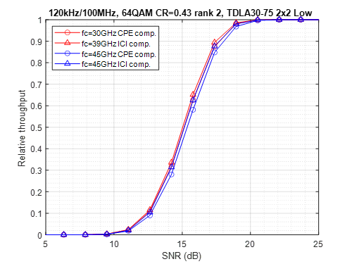 | 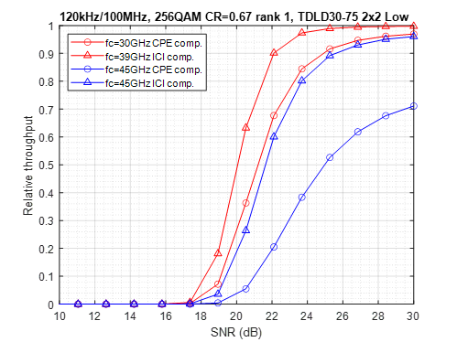
Figure 10.2-3 Ericsson, R4-2113459. Phase noise model: Example 2 in TR38.803.

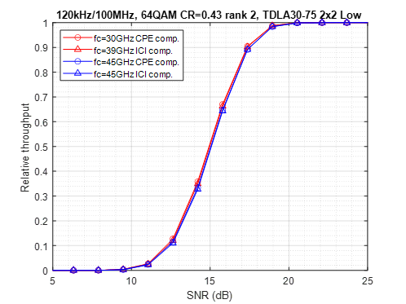 | 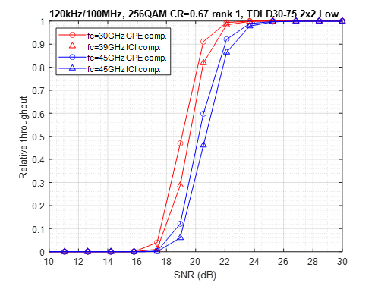
Figure 10.2-4 Ericsson, R4-2113459. Phase noise model: Example 2 in in R4-2010176 Proposal 1

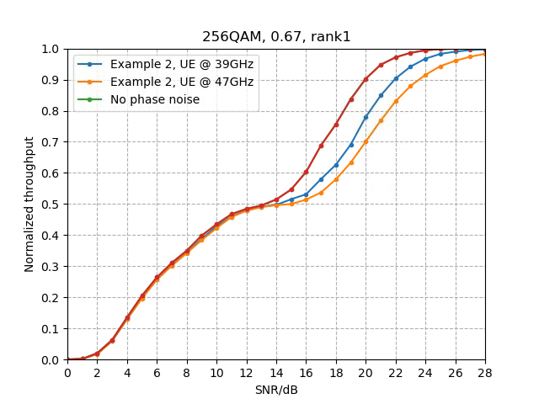 | 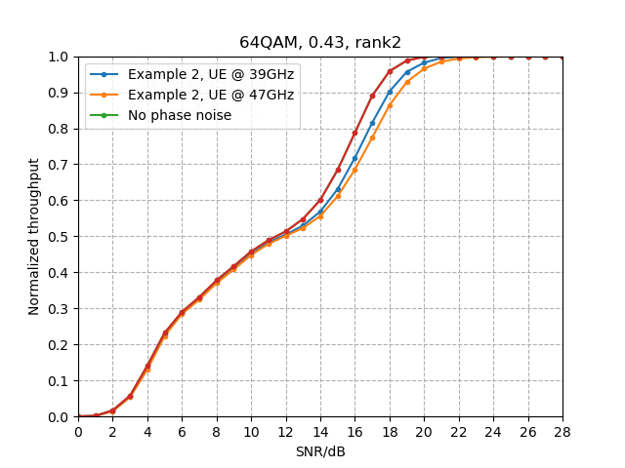
Figure 10.2-5 Huawei, HiSilicon, R4-2113796

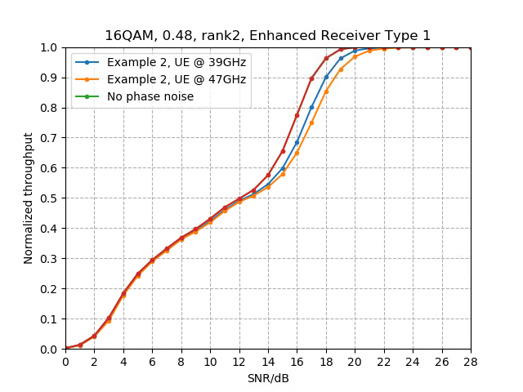
Figure 10.2-6 Huawei, HiSilicon, R4-2113796

Table 10.2-1: Qualcomm, R4-2112250.
Test Number | Table | Test | Carrier Frequency | Alignment SNR  (@70% Peak Throughput)
Test 3-1 | 7.2.2.2.1-3 | 16QAM Rank 1 with Enhanced Receiver Type 1 | 39GHz | 16.05 dB
“ | “ | 16QAM Rank 1 with Enhanced Receiver Type 1 | 48GHz | 16.35dB

Table 10.2-2: Qualcomm, R4-2112250.
Test Number | Table | Test | Carrier Frequency | Alignment SNR  (@70% Peak Throughput)
Test 2-6 | 7.2.2.2.1-4 | 64QAM (MCS 17), Rank 2 | 39GHz | 15.55 dB
“ | “ | 64QAM (MCS 17), Rank 2 | 48GHz | 15.85 dB

Some companies observed small performance difference at 70% of the maximum throughput for test cases Table 7.2.2.2.1-4 Test 2-6 and Table 7.2.2.2.1-5 Test 3-1. Other companies observed about one dB degradation for these tests. To provide sufficient margin and same time not to relax requirements too much it was concluded to add additional margin as 0.5 dB for band n262 for these test cases.

For test case Table 7.2.2.2.1-3 Test 1-4 it was also concluded on necessity of the additional margin to extend this requirement to band n262. The 1.5 dB margin was agreed.
Although RAN5 specifies UE conformance testing, absolute Noc levels are specified in 38.101-4. For n262, the Noc levels are calculated based on the reference sensitivity as described in section 4.5.3.3 of TS 38.101-2.
END OF CHANGE

