3GPP TSG RAN WG4 Meeting #101-bis-e R4-2200906r1
Electronic Meeting, 17th - 25th January 2022

Agenda item: 6.1.3.3
Source: Apple Hungary Kft.
Title: FR1 MIMO OTA Lab Alignment, Channel Model Validation
Document for: Discussion

1 Introduction
As defined on previous contributions [1,2], the FR1 MIMO OTA Lab Alignment activity is currently under way. Based on the initial timeline defined on [3] the volunteer test labs were defined prior to RAN4 #101-e as follows:

 | Lab volunteer | City (Lab address) | Contact Info.
1 | CAICT | Beijing, China | Xuan Yi, yixuan@caict.ac.cn  Siting Zhu, zhusiting@caict.ac.cn
2 | Huawei | Shanghai, China | Li jin xing, lijinxing3@huawei.com  Lin hui, linhui20@huawei.com
3 | Xiaomi | Beijing, China | Rui Zhou, zhourui1@xiaomi.com  Baojun Feng, fengbaojun@xiaomi.com
4 | MediaTek | Beijing, China | ting-wei.kang@mediatek.com
5 | Apple | Cupertino, USA | Istvan Szini, iszini@apple.com
6 | BUPT & CMCC Joint Lab | Beijing, China | Yuxiang Zhang, zhangyx@bupt.edu.cn  Yichen Zhao, zhaoyichen@cmdc.chinamobile.com
7 | SGS | New Taipei City, Taiwan | Peter.liao@sgs.com

PADs will be provided by vivo, Xiaomi, OPPO and Samsung
As reiterated on [4] this paper provides channel model validation evidences, fulfilling the requirement to finalize the process on considering Apple’s FR1 MIMO OTA lab as a participant on this lab alignment effort.

2 Discussion
In this document, results of channel model validations are provided. The setup is composed by MVG StarMIMO – 1.2m with 16 dual polarized probes equipped with F64 for a total of 32 channels setup (3GPP standard probe layout). The following channel model CDL-C Uma parameters have been validated:
- PDP 2450MHz Beam 1 (1+2)
- PDP 2450MHz Beam 2 (3+4)
- PDP 3600MHz Beam 1 (1+2)
- PDP 3600MHz Beam 2 (3+4)
- TCF (Doppler) 2450MHz Beam 1 (1+2)
- TCF (Doppler) 2450MHz Beam 2 (3+4)
- TCF (Doppler) 3600MHz Beam 1 (1+2)
- TCF (Doppler) 3600MHz Beam 2 (3+4)
- Spatial Correlation 2450MHz Combined Beams
- Spatial Correlation 3600MHz Combined Beams
- Cross-polarization 2450MHz Beam 1
- Cross-polarization 2450MHz Beam 2
- Cross-Polarization 3600MHz Beam 1
- Cross-Polarization 3600MHz Beam2
Test procedures and instrument settings are according to TR 38.827 clause 7.4.1. Two frequencies have been tested 2450MHz (representing n41) and 3600MHz (representing n78). CE inputs have also been configured properly for specific beam, namely Beam 1 (Input 1 + Input 2) and Beam 2 (Input 3 + Input 4)

PDP
2450MHz -> Beam 1 (Input 1 + Input 2)
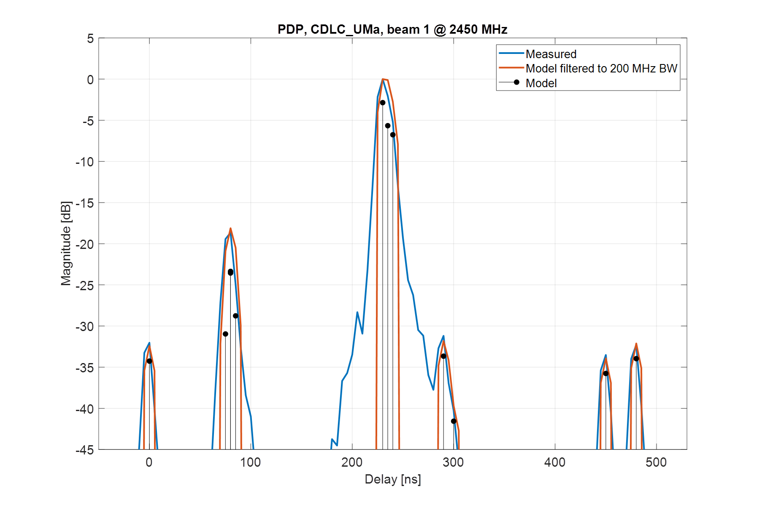

2450MHz -> Beam 2 (Input 3 + Input 4)
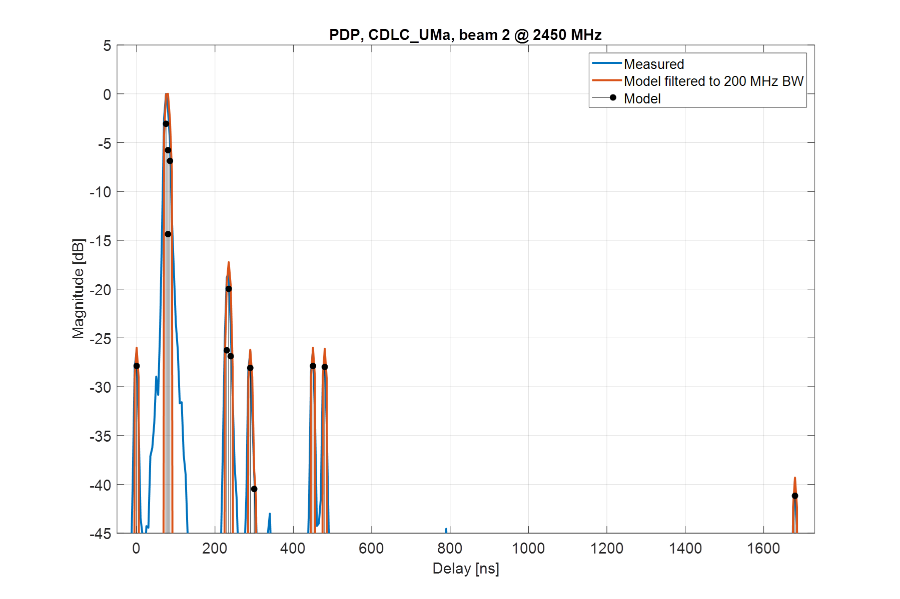
3600MHz -> Beam 1 (Input 1 + Input 2)
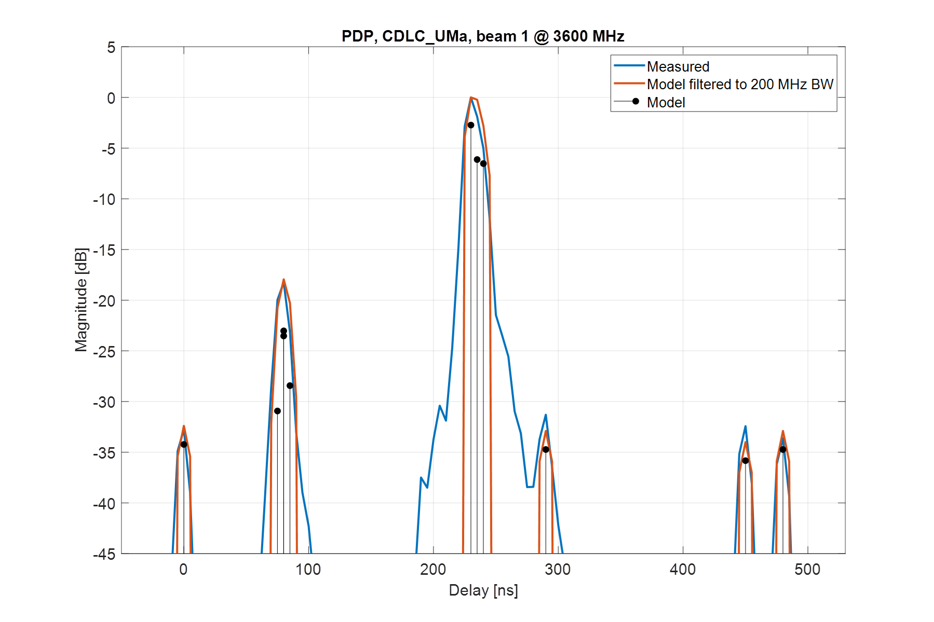

3600MHz -> Beam 2 (Input 3 + Input 4)
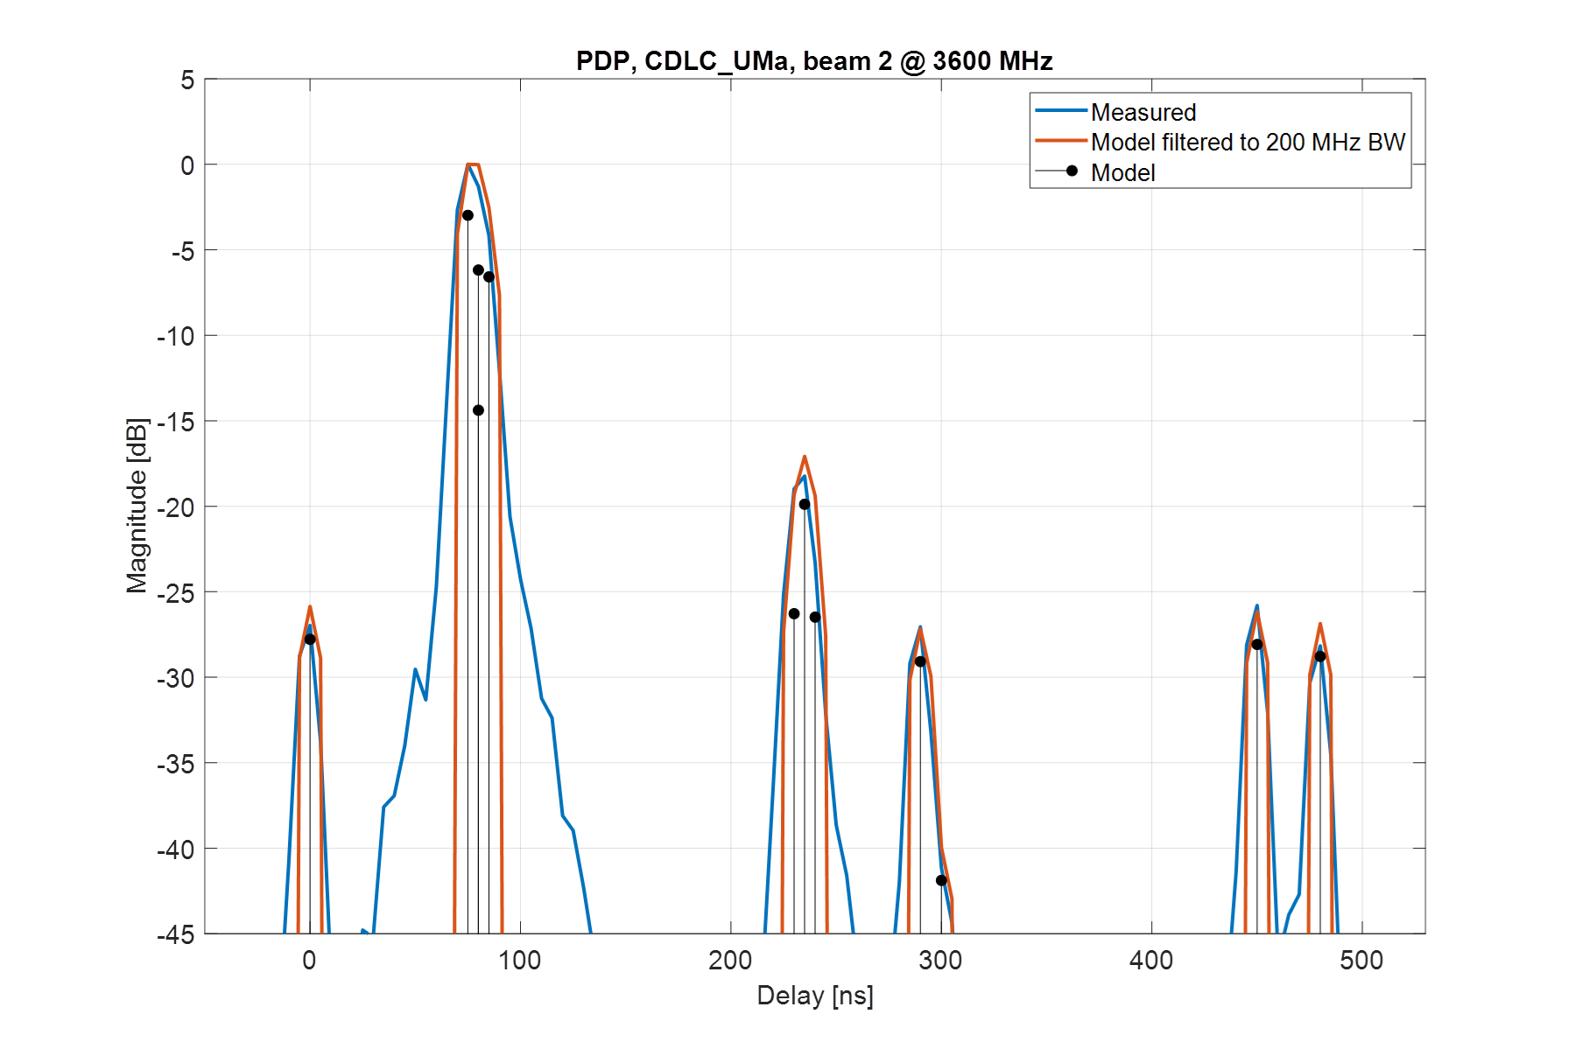
Observation 1: 3GPP has not yet agreed on the filtering method. The majority view is to filter the theoretical (compute with no filtering) with using a 200MHz BW.
Observation 2: Using the proposed filtering, the delta is around +/- 1.6dB for the amplitude and 5ns in time.
Observation 3: With no agreement on Obervation1, it is difficult to judge the PDP measured results.

TCF
2450MHz -> Beam 1 (Input 1 + Input 2)
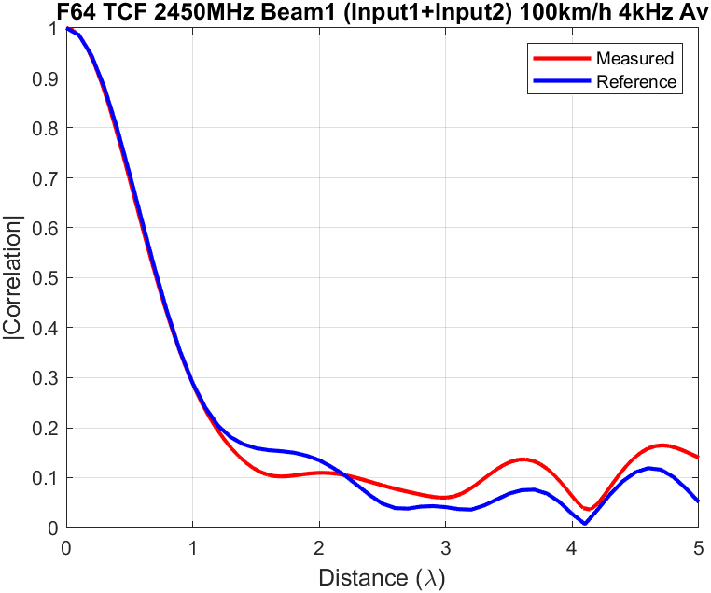
2450MHz -> Beam 2 (Input 3 + Input 4)
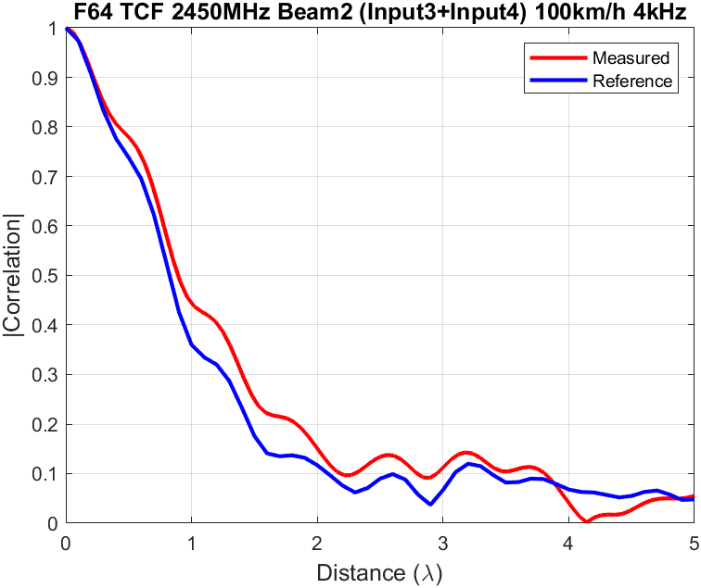

3600MHz -> Beam 1 (Input 1 + Input 2)
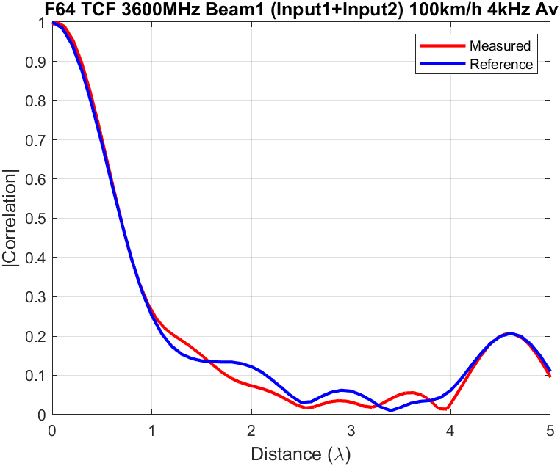
3600MHz -> Beam 2 (Input 3 + Input 4)
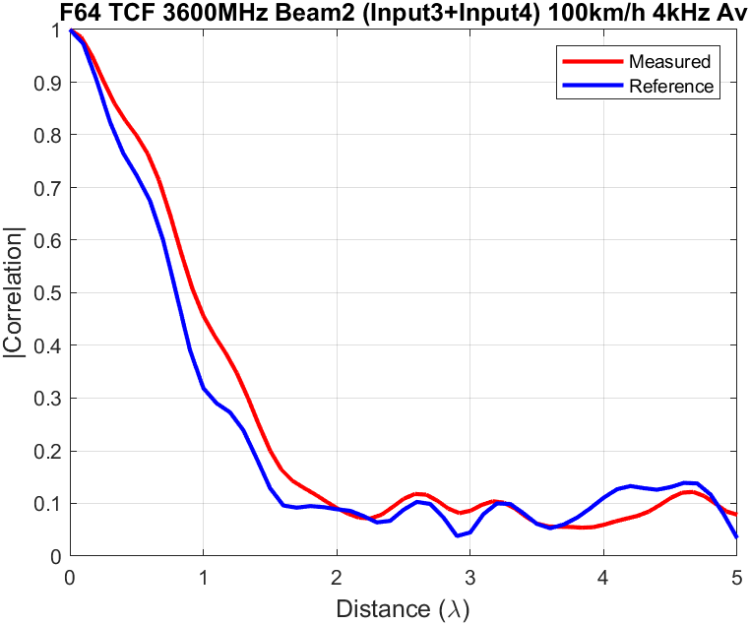

Spatial Correlation 2450MHz combined beams
These Spatial Correlation results were measured at the system integrator lab adopting the same setup configuration

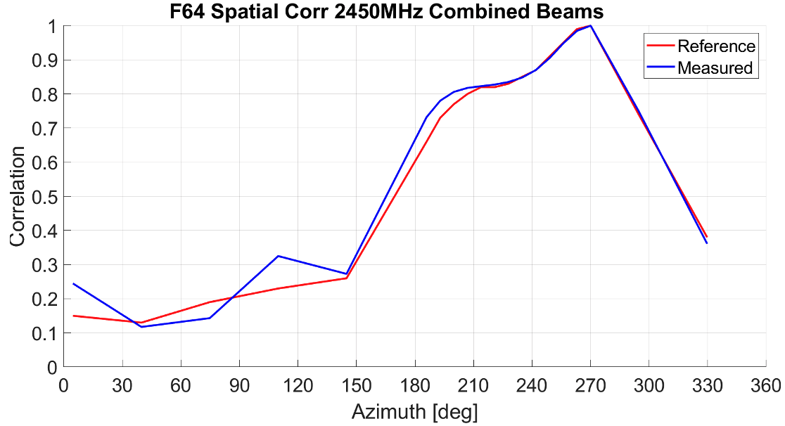

Spatial Correlation 3600MHz combined beams

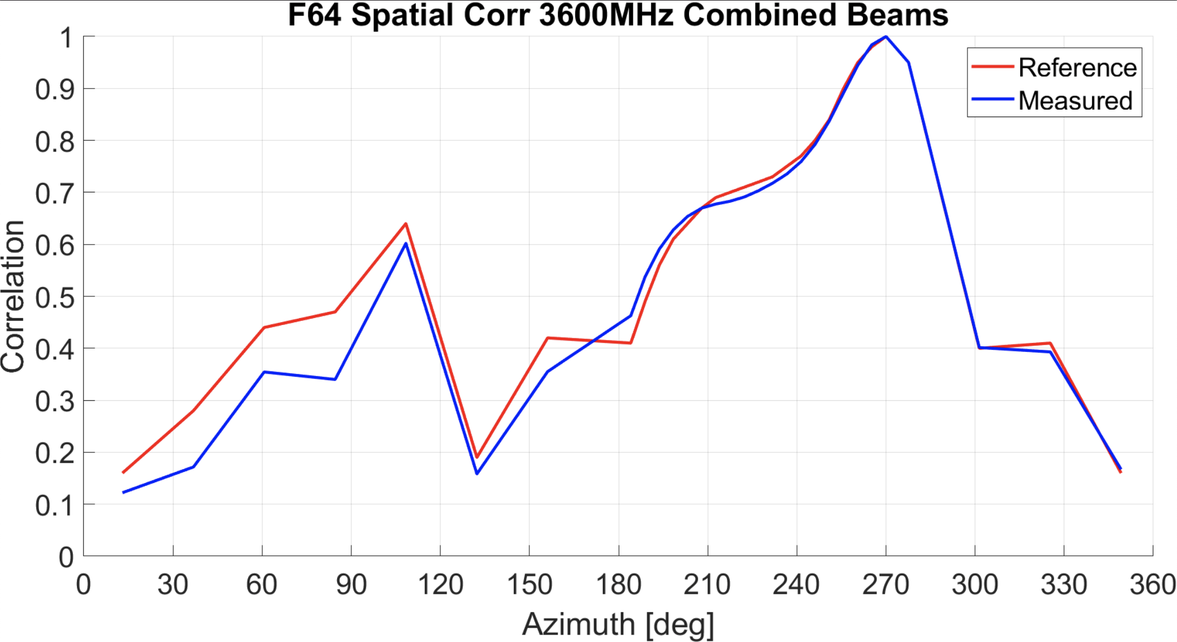

Cross-Polarization, 2450MHz Beam 1 and 2
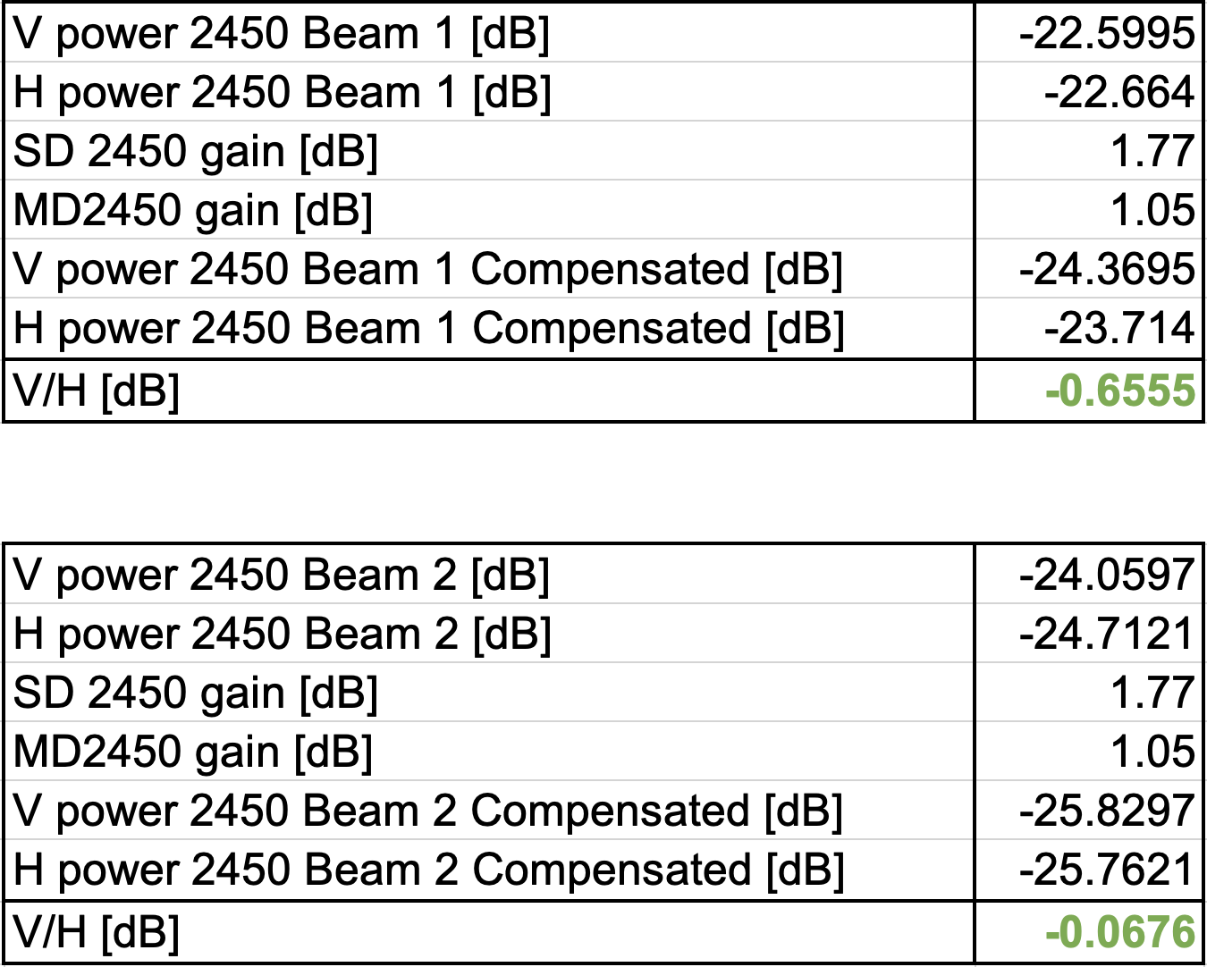
Cross-Polarization, 3600MHz Beam 1 and 2
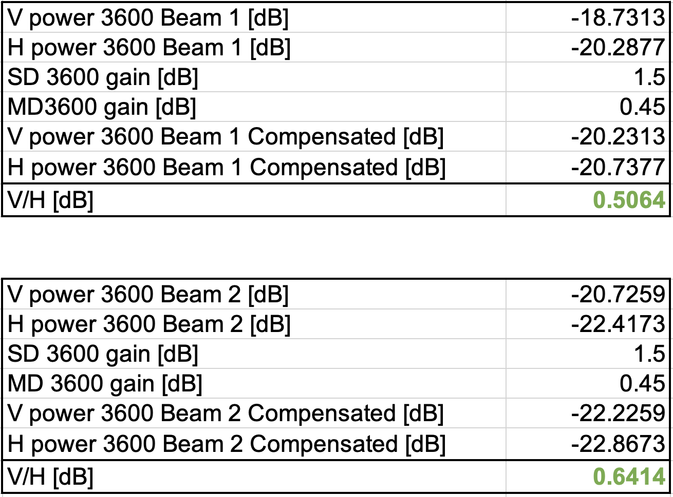

3 Conclusion
This contribution provide the channel model validation factual evidences to fulfil the 3GPP FR1 MIMO OTA lab alignment requirements.

4 References
- R4-2108613, WF on NR MIMO OTA, RAN4 #99-e
- R4-2108617, Framework on FR1 MIMO OTA requirements development, RAN4 #99-e
- R4-2113312, Time plan for FR1 lab alignment and requirement development, RAN4 #100-e
- R4-2120683, Updated time plan for FR1 lab alignment and requirement, RAN4 #101-e

