3GPP TSG-RAN WG4 Meeting #100-e Revision of R4-2113312
Electronic Meeting, 16th Aug. – 27th Aug., 2021
Agenda item: 9.1.2.1
Source: CAICT, OPPO, vivo
Title: Time plan for FR1 lab alignment and requirement development
Document for: Approval

1 Introduction
The FR1 framework on performance requirement [1] is agreed in the last meeting of RAN4 #99-e [2]. According to the updated work plan of NR MIMO OTA Work Item, the lab alignment activity will be launched from RAN4 #100-e. In order to make laboratory volunteers and related participants have a whole picture of the lab alignment and performance requirement development activities, this paper presents the time plan and corresponding actions for developing FR1 MIMO OTA performance requirement.
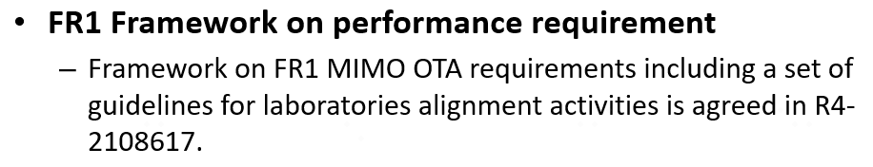

2 Discussion
Regarding the performance part of the WI should be finished by September of 2022, the following time plan is specified based on the MIMO OTA WI work plan and the agreed set of activities on lab alignment and requirement development as below.
Lab alignment & requirement development activities | Action required | Action deadline | Note
Lab volunteer application | Rapporteur initiate the lab alignment activity in the NR MIMO OTA reflector, and Lab volunteers submit application | 2021/10/15
PAD candidates information provided | Interested companies share volunteered devices for alignment activity in the NR MIMO OTA reflector. | 2021/10/22
PAD list frozen | RAN4 decides PAD list from PAD candidates | 2021/11/12
Channel model validation | Lab volunteer submits channel model validation results to RAN4 for review | 2022/1/14
Performance alignment start | PADs arrive at lab volunteers | 2022/1/14 | 1. Performance alignment can start before 2022/1/14 once the lab volunteer is permitted.  2. Delivery the PAD to each permitted test lab, the progress in each lab should be shared in the NR MIM OTA reflector for easy tracing, when PAD comes in and testing is finalized.
Performance alignment finish | Lab volunteers should finish the PADs measurement in 7 days and submit the measurement results to RAN4 #102-bis-e meeting | 2022/3/25 | The PAD measurement results should NOT be shared to anyone, before submitting to RAN4 #102-bis-e meeting.
Performance alignment result review | RAN4 review the performance alignment results | RAN4 #102-bis-e | Comparison and alignment analyses should only be done in RAN4 meeting.
FR1 MIMO OTA measurement data collection | Aligned labs share results into data pool | RAN4 #103-e

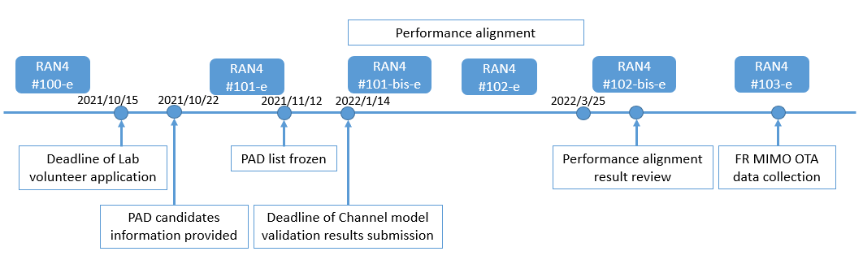
Lab volunteers should note the deadlines on lab volunteer application and channel model validation results submission, which relates to lab qualification and the following performance alignment arrangement.
Performance alignment device (PAD) providers should guarantee the PADs arrive at the lab volunteers as the PAD distribution arrangement before the corresponding deadline.
After lab alignment activity, the aligned labs can collect measurement results of commercial devices on the selected bands. In case, labs fail to reach alignment for specific test case or test band, there can be one chance for the lab to optimize/check the test system for re-alignment. Meanwhile, the aligned labs can collect measurement data.
How to select the device for final measurement results collection, avoid that the same UE model is measured in several test labs is FFS.
Proposal: Adopt the above time plan and corresponding actions for FR1 MIMO OTA lab alignment and performance requirement development, and update the progress in the following RAN4 meetings.

3 Conclusion
Proposal: Adopt the above time plan and corresponding actions for FR1 MIMO OTA lab alignment and performance requirement development, and update the progress in the following RAN4 meetings.

References
- R4-2108617 Framework on FR1 MIMO OTA requirements development
- R4-2108613 WF on NR MIMO OTA-v4

