3GPP TSG-RAN WG3 Meeting #127 R3-250850
Athens, Greece, 17 – 21 Feb, 2025

Agenda item: 10.4
Source: Samsung
Title: (TP for SON BLCR for 38.423) MRO for MR-DC SCG failure
Document for: Discussion and Decision

1 Introduction
The contribution provided a TP for SON BLCR for TS38.423 on MRO for MR-DC SCG failure.

TP for TS38.423 on MR-DC SCG failure

8.3.17.2 Successful Operation

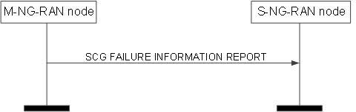
Figure 8.3.17.2-1: SCG Failure Information Report, successful operation
The M-NG-RAN node initiates the procedure by sending the SCG FAILURE INFORMATION REPORT message to the S-NG-RAN node. Upon receiving the message, the S-NG-RAN node shall assume that a PSCell change failure event was detected.
The SCG FAILURE INFORMATION REPORT message may include:
- the SN Mobility Information IE, if the SN Mobility Information IE was sent for the PSCell change procedure from the S-NG-RAN node;
- the Source PSCell CGI IE, if the Source PSCell CGI IE was sent for the PSCell change procedure from the S-NG-RAN node.
If the SCG FAILURE INFORMATION REPORT message includes the Source PSCell CGI IE, the S-NG-RAN node shall, if supported, store the information.
If the SCG FAILURE INFORMATION REPORT message includes the Failed PSCell CGI IE, the S-NG-RAN node shall, if supported, store the information and act as specified in TS 38.300 [9].
If the SCG FAILURE INFORMATION REPORT message includes the Time SCG Failure IE, the S-NG-RAN node shall, if supported, store the information and act as specified in TS 37.340 [8].
If received, the S-NG-RAN node uses the above information for SCG failure reason detection and optimisation.

