3GPP TSG-RAN WG2 Meeting #130 DRAFT R2-2504740
Malta, 19th – 23rd May 2025

Agenda item: 8.20.1
Source: Apple
Title: Summary of [AT130][206][NR_Others] CSSF enhancements
WID: NR_RRM_Ph5-Core
Document for: Discussion and Decision

Introduction
This document aims to provide the way forwards for the following offline discussion:
- [AT130][206][NR_Others] CSSF enhancements (Apple)
Intended outcome: agreeable proposals on RRC signalling in R2-2504740 (if needed)
Deadline: Before Friday CB

Discussion
RAN2 had an initial discussion on enabling/disabling of LP-WUS based on the proposals from contribution R2-2503809 and R2-2503900. Below is the related excerpt from the chairman notes:

RAN4 LS
RAN4 LS in [1] on CSSF optimization requests RAN2 to consider the signalling design to support it:
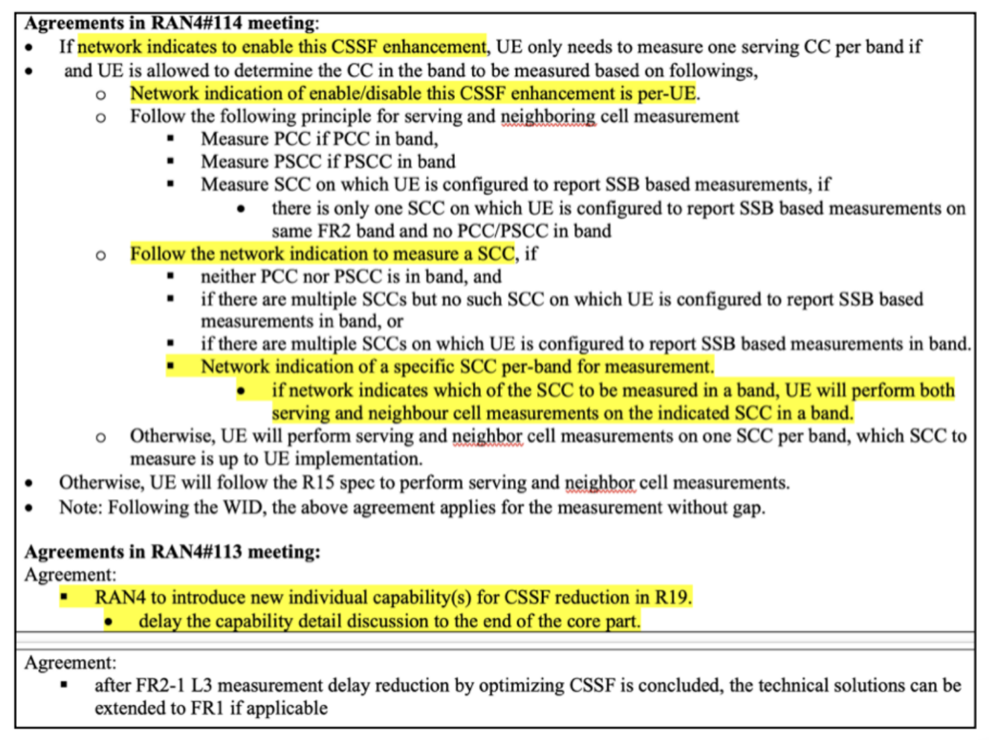
RAN2 signalling design include two parts:
1) Introduce the UE specific configuration to enable/disable this CSSF enhancement.
RAN2#130 agreements:
- Introduce the UE specific RRC configuration (per UE) to enable/disable the CSSF optimization feature.

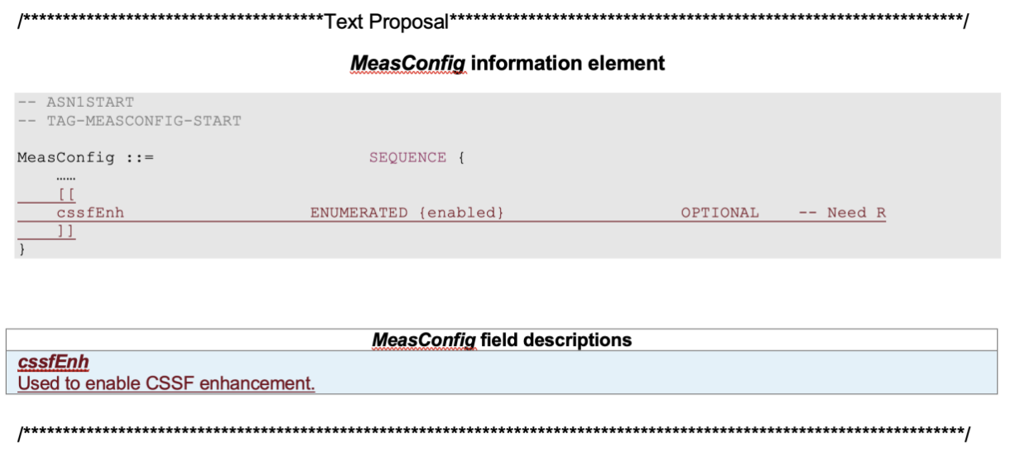
2) Consider how to indicate the SCC to be measured per band for serving and neighbour measurement.
=> Discussion in [AT130][206] offline.

How to indicate the SCC per band to be measured?
Two alternatives:

- Alternative 1: Introduce new RRC configuation to indicate which SCC to be measured.
  - RRC signaling: New SCC indication needs to be introduced in measurement configuration.
  - UE operation when CSSF optimization is enabled:
    - UE only performs the serving and intra-frequency neighbor measurement on the indicated SCC per band.
    - If network doesnot provide the indication, how to select the SCC is up to UE implementation.

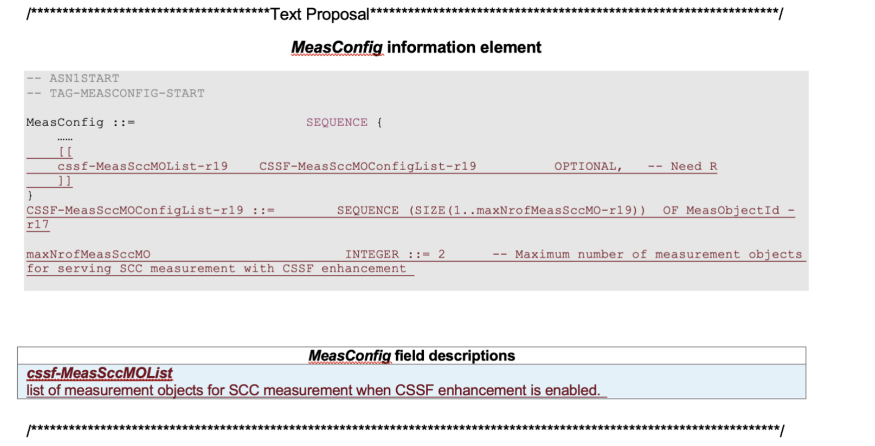

- Alternative 2: The SCC to be measured is indicated by the SCC configured with the SS-RSRP based measurement reporting.

  - RRC siganling: No new RRC signaling needs to be introduced.
  - UE operation when CSSF optimization is enabled:
    - UE only performs the serving and intra-frequency neighbor measurement on the SCC configured with the SS-RSRP based measurement reporting.
    - If multiple SCCs of one band are configured with such measurement reporting, the selected SCC is up to UE implementation.
(NOTE: In existing design, the report config is used to indicated which SCC to perform neighbor measurement. When the CSSF enhancement is enabled, the report config is used to indicate the SCC for neigbhor and serving measurement.)

Companies view:
- Alternative 1: Huawei, OPPO, ZTE have concern.
- Alternative 2: Nokia and Ericsson have concern, and would like to check RAN4’s view.

Way forwards
Four WFs could be considered considered:

WF1

  - Agree Alternative 1 to design the RRC configuration for CSSF enhancement.

WF2

  - Agree Alternative 2 to design the RRC configuration for CSSF enhancement.

WF3 (support both)
  - Agree both Alternatives design the RRC configuration for CSSF enhancement.
    - If network provides the new SCC indication per band
      - UE operation is follow alternative 1.
    - If network doesnot provide the new indication
      - UE operation is follow alternative 2.

WF4 (Let RAN4 to make decision)
  - Send LS to RAN4 with both alternatives, and let RAN4 to decide which one (or both) is adopted.
  - RAN2 prepare RRC CRs for both alternatives, approve the one based on RAN4 decision in next RAN2 meeting.

Based on the company's view on Alternative 1 and Alternative 2, WF3 and WF4 are suggested to be discussed online for down selection.

Conclusions
Based on the inputs from companies, the following proposals are made:
Proposal: RAN2 is proposed to go for WF3 or WF4.
WF3 (support both)
  - Agree both Alternatives design the RRC configuration for CSSF enhancement.
    - If network provides the new SCC indication per band
      - UE operation is follow alternative 1.
    - If network doesnot provide the new indication
      - UE operation is follow alternative 2.
  - Prepare RRC CR for approval in the next RAN2 meeting.

WF4 (Let RAN4 to make decision)
  - Send LS to RAN4 with both alternatives, and let RAN4 decide which design to adopt.
  - Prepare RRC CR for both alternatives and approve the one based on RAN4’s decision in next RAN2 meeting.

References
- R2-2501739, LS on CSSF optimization for NR RRM Phase 5, RAN4 LS
- R2-2503579 Consideration on CSSF optimization CATT discussion
- R2-2503814 RAN2 impact on CSSF optimization Apple, Ericsson discussion
- R2-2503942 Discussion on CSSF optimization and Rx BSF optimization for NR RRM ph5 Huawei, HiSilicon

