3GPP TSG-RAN WG2 Meeting #121 R2-230xxxx

**Athens, Greece, 27th February – 3rd March, 2023**

**Agenda item: 6.2.2**

**Source: Huawei, HiSilicon**

**Title: Report of [AT121][601][MBS-R17] NPN and PLMN ID (Huawei)**

**WID/SID: NR_MBS-Core - Release 17**

**Document for: Discussion and Decision**

# Introduction

In the last RAN2 meeting, the following agreements were reached about MBS support in NPN:

* MBS should be supported within SNPN. FFS if some change is needed. FFS CAG
* RAN2 specs allow to use plmn-Index to indicate PLMN+NID (=SNPN ID).
* RAN2 specs allow to use plmn-Index to indicate CAG.
* FFS whether this works without specification changes for all the required scenarios.
* FFS whether/what changes are needed for inter-node messages

This offline is to reach an alignment between the companies on:

• Whether/what changes are needed to enable MBS support for NPN

• How TMGI (PLMN ID) should be signalled in multicast configuration

# The usage of plmn-index for multicast configuration

For MBS multicast, if *plmn-index* is used in the TMGI for an MBS session, the target gNB may not be able to recognize the *plmn-index* when the RRC context is forwarded to target gNB during handover. In the RAN2#120 meeting, this issue was discussed but postponed due to limit of time. Based on companies’ contributions, the following options are proposed:

**Option 1:** The plmn-index can be used for multicast and the UE maintains the plmn-index with the PLMN ID before handover. The NW should translate the index to PLMN ID. The <ue will use target SIB1 to translqte from plmn index to expicit plmn id qfter hqndover

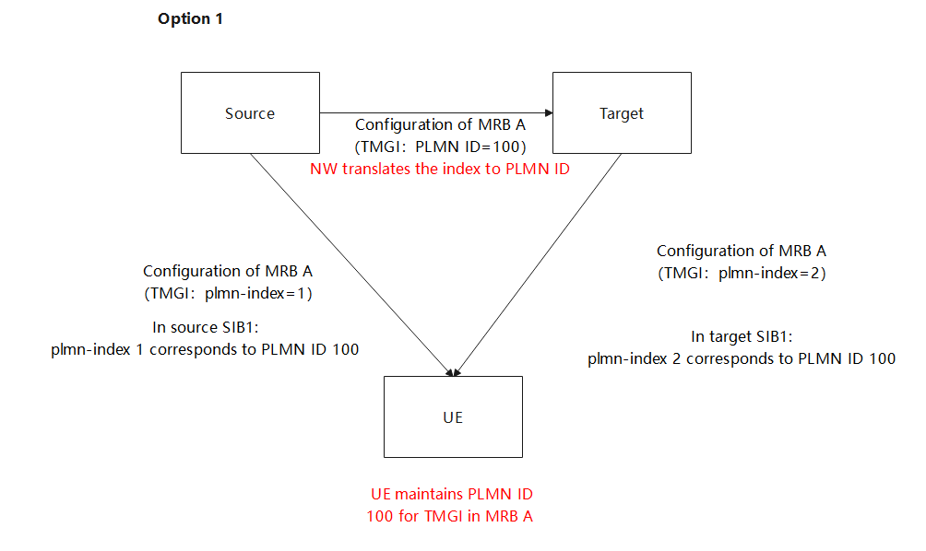

**Option 2:** The plmn-index can be used for multicast and the NW shall reconfigure the MRB with correct plmn-index during the handover.

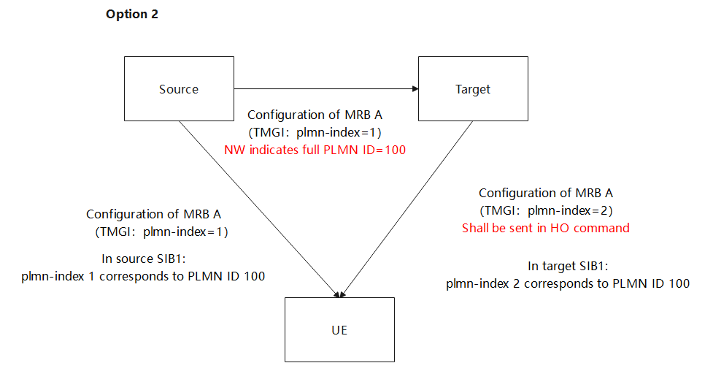

**Option 3:** The plmn-index can be used for multicast and the NW shall reconfigure the MRB with full PLMN IDduring the handover. The NW should translate the index to PLMN ID.

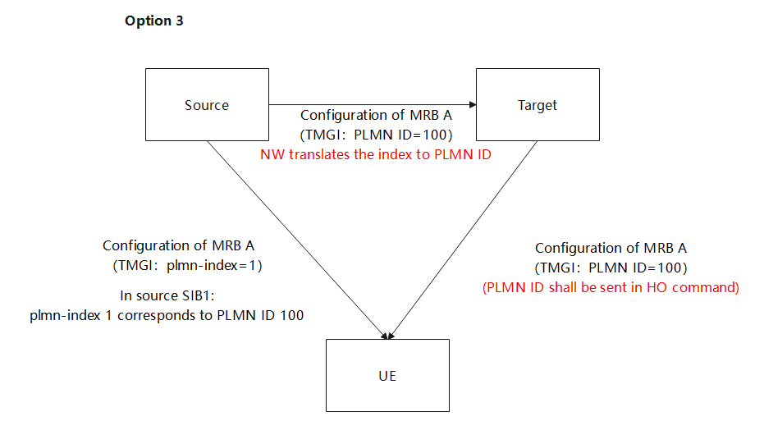

**Option 4:** The plmn-index is not used for multicast configuration.

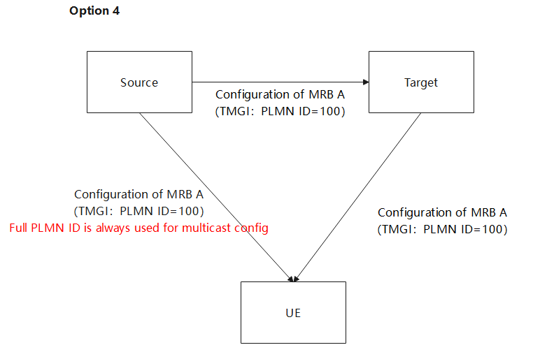

|  |
| --- |
| **Offline agreement: Option 1 is supported for non-NPN case (NPN will be discussed later).**  **The plmn-index can be used for multicast MRB configuration (this doesn’t preclude using explicit PLMN ID), and the UE translates and maintains the explicit PLMN ID when receiving the multicast MRB configuration with plmn-index based on the PLMN list in SIB1.**  **Upon and after handover, if the target doesn’t indicate TMGI in the multicast MRB configuration, the UE continue using the maintained PLMN ID.**  **Upon and after handover, if the target indicates the TMGI with plmn-index in the multicast MRB configuration, the UE will translate the plmn-index to the explicit PLMN ID based on the PLMN list in the target cell SIB1, and maintains the explicit PLMN ID.**  **The source will translate the plmn-index to the explicit PLMN ID and will transfer multicast MRB configuration with the explicit PLMN ID to the target in the inter-node message.** |

**.**

# MBS support in NPN

2.1 MBS support in PNI-NPN

According to SA2 spec (TS 23.247), the MBS session is uniquely identified by the TMGI and NID (in case of SNPN):

|  |
| --- |
| 6.5.2 Temporary Mobile Group Identity TMGI (Temporary Mobile Group Identity) is defined in TS 23.003 [12] and is used to be able to identify a broadcast MBS Session or a multicast MBS session.  In SNPN (Stand-alone Non-Public Network), TMGI is used together with NID (Network Identifier) defined in TS 23.003 [12] to identify an MBS Session. |

We can see that there is no mentioning of using CAG ID to identify the MBS session ID. Therefore, from the MBS supporting perspective, PNI-NPN should be similar with the public network, and in such case, the CAG allowed UEs can naturally receive the MBS multicast in the CAG cell.

**Proposal 1: MBS can be supported in PNI-NPN (i.e., CAG cells) without extra spec effort.**

2.2 MBS support in SNPN

### 2.2.1 MBS Broadcast

Q0: should MBS broadcast reception on non-serving SNPN be supported?

**Option 1: No support of MBS broadcast reception on any non-serving SNPN in Rel-17.**

**Option 2: Support of MBS broadcast reception on non-serving SNPNs in the NPN list broadcast in SIB1 in Rel-17.**

CATT:

Option 2,we understand current spec already support MBS broadcast reception on non-serving SNPNs in the NPN list broadcast in SIB1 in Rel-17. If broadcast service is provided on non-serving SNPNs in the NPN list broadcast in SIB1,It seems nothing prevent UE to receive it.

Q1: when plmn-index is indicated in MII, should the plmn-index be mapped to PLMN ID only, or to (PLMN ID+NID)?

**Option 1 (no support of non-serving SNPN MBS broadcast reception)**: plmn-index in MII is translated into PLMN ID only, and in inter-node message *serving NID* in the *NPN mobility information* is used to indicate the NID.

**Option 2 (support of non-serving SNPN MBS broadcast reception)**: plmn-index in MII is mapped into (PLMN ID+NID), and in inter-node message additional NID is introduced.

CATT:

Option 2, option 2 is necessary according to our answer to Q0.

Q2a: Can the explicit PLMN ID be used in MII in case of SNPN?

CATT: Yes

Q2b: If the explicit PLMN ID is indicated in MII, anything more needed?

**Option 1 (no support of non-serving SNPN MBS broadcast reception)**: No more signalling, in inter-node message *serving NID* in the *NPN mobility information* is used to indicate the NID.

**Option 2 (support of non-serving SNPN MBS broadcast reception)**: the explicit NID is needed in MII which is transmitted on Uu and inter-node message.

CATT: option 2

### 2.2.1 MBS Multicast

Q1: when plmn-index is used in MRB-ToAddMod-r17, should the plmn-index be mapped to PLMN ID only, or to (PLMN ID+NID) at the UE?

**Option 1**: plmn-index is translated into PLMN ID only at the UE, which is used together with the serving NID of the UE.

**Option 2**: plmn-index is translated into (PLMN ID+NID). The NID should be the serving NID of the UE.

CATT: Option 2.UE knows whether it is camping on SNPN, thus it can directly repace the plmn-index in TMGI with the serving SNPN ID(i.e., PLMN ID+NID)..

Q2a: Can the explicit PLMN ID be used in MRB-ToAddMod-r17 in case of SNPN?

CATT:Yes

Q2b: when the explicit PLMN ID is used in MRB-ToAddMod-r17, anything more is needed to indicate NID?

**Option 1**: No more thing needed, and the explicit PLMN ID will be used together with serving NID at the UE.

**Option 2**: The NID (should be the serving NID of the UE) is introduced in MRB-ToAddMod-r17.

CATT: Option 1, UE knows whether it is camping on SNPN, thus it can directly repace the explicit PLMN ID in TMGI with the serving SNPN ID(i.e., PLMN ID+NID).