3GPP TSG-RAN WG2 #113bis-e R2-210xxxx
Electronic meeting, 12th April – 20th April 2021

Agenda Item: 5.4.1.2
Source: Ericsson
Title: Summary of [AT113bis-e][007][NR15] Inter-Node
Document for: Discussion, Decision

1 Introduction
This document is to handle the following email discussion:
- [AT113bis-e][007][NR15] Inter-Node (Ericsson)
Scope: Treat R2-2102768 (start after on-line), R2-2103027 (start after on-line), R2-2102769, R2-2103028, R2-2103029, R2-2103028, R2-2103641, R2-2103642, R2-2103801, R2-2103802
Phase 1, determine agreeable parts, Phase 2, for agreeable parts Work on CRs.
Intended outcome: Report and Agreed-in-principle CRs.
Deadline: Schedule A

Regarding the deadlines, I would like to set the following 2 deadlines:
1) First deadline on Wednesday April 14 1000 UTC to settle scope what is agreeable.
2) Second deadline on Monday April 19 1800 UTC to agree the CRs (where applicable) and final check.

2 Contact information
Company (Name) | Email
Ericsson (Tony) | antonino.orsino@ericsson.com
Docomo (Masato) | masato.taniguchi.mf@nttdocomo.com
ZTE(LiuJing) | liu.jing30@zte.com.cn
Samsung | Himke.vandervelde@samsung.com
Huawei, HiSilicon | david.lecompte@huawei.com
Intel | Sudeep.k.palat@intel.com
Qualcomm | oozturk@qti.qualcomm.com
NEC | hisashi.futaki[at]nec.com

3 Discussion

3.1 MN and SN configurations restrictions

3.1.1 Additional aspects on MN SN config restrictions
R2-2102768 Additional aspects on MN SN config restrictions Nokia, Nokia Shanghai Bell discussion Rel-15

A figure summarizing the proposals is shown here for quick understanding.

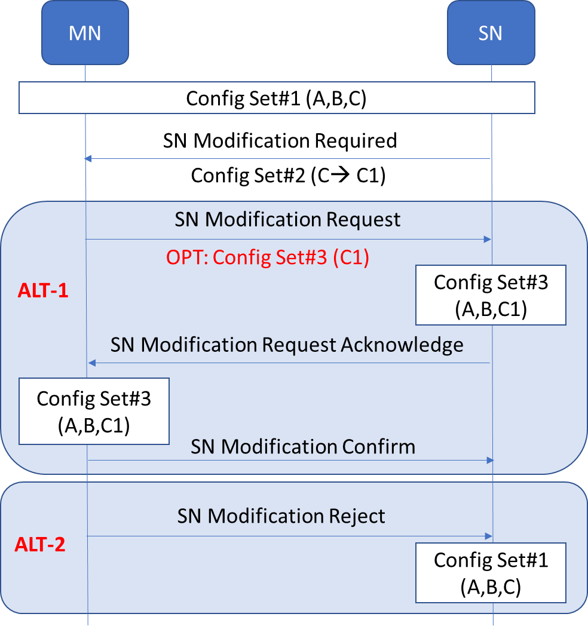
Figure 4-1: Illustrating the discussions with the message sequence

Scenario: MN initiated SN modification in an ongoing SN initiated SN modification procedure. In this scenario the MN needs to send SN Modification Request for other purpose (e.g. transfer new gap config).
Example: A part of configurations in configRestrictInfo (Config set #1) in the last MN-initiated procedure is overridden by configuration in configRestrictModReq (Config set #2) in the SN-initiated procedure. Combination of Config set #1 and Config set #2 is Config set #3 (i.e. Config set #2 overrides some of Config set #1)

Proposal 1: For the given scenario considered along with the example, MN shall assume the Config set #3 as the latest configuration for the SN (and not Config set #1).
Proposal 2: The MN may (i.e. is allowed but not required to) include configRestrictInfo in a SgNB Modification Request procedure during an ongoing SN triggered Modification procedure.
Proposal 3: In the given scenario, the MN shall echo the same values in configRestrictInfo given by Config set #3.
Proposal 4: If the given scenario, the receipt of SN Modification Request without the configRestrictInfo implies the SN also assumes Config set #3 as the latest configuration for the SN.
Proposal 5: In the given scenario, if the MN sends the SN Modification Reject the SN considers Config set #1 as the latest configuration for the SN.

Question 1: Do companies agree with the proposals in R2-2102768?
Company | Proposal x:  Agree (y/n) | Comments
Nokia | Yes | As proponent we would like to find an answer to the discussion from last meeting to avoid IODT issue as at least HW and ZTE had very different interpretations of the specification.
ZTE | Agree to P1, P5  uncertain about P2~4 | We understand the idea is almost aligned with our proposal in R2-2103027. That MN can echo configRestrictInfo to SN if MN accepts the request. But it does not mean MN must trigger SN Modification Request during an ongoing SN triggered Modfication procedure. I.e. MN can do it when it sends first CG-ConfigInfo to SN later on.  But the proposal is a bit unclear to us, for example  - P2 seems to be contradict to P3, one is “may“, the other is “shall“?  - We are not sure whether approval of P4 means we need to update the general principle described in section 11.2.3? We prefer not to modify the principle, as it may cause other unpredicted problems.  In addition, as we pointed out in our paper, for BC coordination, SN can only request one BC in configRestrictModReq, we need to be clear what’s Config set #3 really is when MN accepts the request. (e.g. C->C1, or C-> C+C1).
Samsung | Not sure | We think that at least for the case SN re-negotiates the BC/ feature sets, an explicit response from MN is required as stated in R2-2103027. If we anyhow have cases requiring explicit confirmation, we wonder if we should also have the option of accept without explicit confirm.  Note that although delta signalling is supported, MN has the option to use full signaling (e.g. if needed to resolve potential ambiguity)
Huawei, HiSilicon | Disagree | If the SN includes configRestrictModReq, it is a request to replace the whole configRestrictInfo because there is no delta signalling.  So if the SN accepts the request, the result is that what applies as configRestrictInfo is exactly what was sent by the SN, i.e. Config set 2.  Then, we understand "the values informed via the previous message" as the of configRestrictModReq and we expect this to apply and the MN shall not include configRestrictInfo.
Ericsson | Not sure | We pretty much agree with Samsung and Huawei comments.  Probably to solve this we may need an email discussion to the next meeting to understand what is exactly the issue and if anything more is needed with respect to what we have now in the specification.
Qualcomm | P1, P4, P5 | It would be good to keep this simple. If MN agrees, it stays silent. If MN rejects, both sides revert back to the previous. Not sure the benefit of echoing. P4 seems a logical derivative of P1 and P5.
NEC | Yes for P1,5, need disc for P2-4 | some clarifications are needed for P2-4.  We understand P2-4 are one set of proposals, i.e. P3/4 are under the condition of P2. E.g. „shall“ in P3 is for the case where the MN includes configRestrictInfo as in P2. (if not, need more discussions)  Regarding the delta signaling pointend out by Huawei, we agree. Our understanding of proposals is that if the IE included in both Config set#1 and #2, then the values in Config set#2 shall be used, if MN accepts.  P3: „echo“ may not be entirely correct (although we can understand the intention). Probably that can be „MN shall set the same values ...“.  P4: we assume some updates for text in 11.2.3 is necessary. Otherwise, „MN may“ in P2 should be changed to „MN shall (when SN Modification Request is sent)“. We prefer the latter way (like ZTE propsal below)  P5: this is OK (with Reject->Refuse). Related to this point, a question is when the SN considers the Config Set #3 is as the latest configuration? We assume it is when the SN receives the SN Reconfiguration Complete from the MN. Is this also companies‘ understanding?

3.1.2 Further clarify MN and SN configuration restrictions
R2-2103027 Further clarify MN and SN configuration restrictions ZTE Corporation, Sanechips discussion Rel-15 NR_newRAT-Core
R2-2103028 CR on MN and SN configuration restriction coordination ZTE Corporation, Sanechips CR Rel-15 37.340 15.12.0 0255 - F NR_newRAT-Core
R2-2103029 CR on MN and SN configuration restriction coordination ZTE Corporation, Sanechips CR Rel-16 37.340 16.5.0 0256 - F NR_newRAT-Core

One remaining issue is whether MN can include “ConfigRestrictInfo”, if MN sends SN Modification Request in response to SN Modification Required message. See below figure:

Proposal 1: In case SN triggers configuration negotiation (by sending ConfigRestrictModReqSCG in SN-initiated procedure), MN should:
- Refuse the SN-initiated modification procedure if MN cannot accept the requested value;
- Confirm the SN-initiated modification procedure, and MN is expected to include ConfigRestrictInfo (e.g. with update value) if MN sends SN Modification Request including CG-ConfigInfo (this does not mean MN must trigger SN Modification Request in response to SN Modification Required message).

Question 2: Do you agree with the proposal in R2-2103027?
Company | Proposal x:  Agree (y/n) | Comments
Nokia | No, not essential correction | Honestly, no good reason to capture this in the specification as it seems we are all locking in a specific kind of implementation. The earlier text allows the freedom in Stage 3 and this should be generally enough?  These look normal network behavior and implementation options which are not needed to be captured in the specification.
ZTE | Yes | Proponent. See our answers to Q3 about the necessity of CR.
Samsung | Yes, but | See previous (i.e. we agree that at least for the case SN re-negotiates the BC/ feature sets, an explicit response from MN seems required). Regarding how to provide such explcit response, we see following options:  a) Nested i.e. MN initiates SN modification procedure before completing SN initiated procedure  b) MN initiates SN modification procedure after completing the SN initiated procedure  c) Adding information to SN-Modification-Confirm  We are not entirely clear which option is assumed and whether any clarification regarding this is to be introduced
Huawei, HiSilicon | No | See above
Ericsson | Not sure | See above
Qualcomm | Partially | As above, refuse part is fine. What is the benefit of forcing MN to re-send the same information?
NEC | Yes

Question 3: If the answer to Q2 is yes, do you agree to introduce the changes in stage 2 as proposed in the CRs R2-2103028 and R2-2103029?
Company | Agree (y/n) | Comments
Nokia | No, not essential correction | See Q2 answer
ZTE | Yes | Proponent  The configuration restriction procedure is now described in TS 37.340, but the detailed procedure we are discussing here is not captured in stage 2. Based on the discussion in past several meetings, clearly companies may have different understandings due to the unclear SPEC. So to avoid inter-operability issue in the future, it is better to make the spec clear when companies reach consensus.
Samsung |  | See previous
Huawei, HiSilicon | No | See above
Ericsson |  | See above
NEC | Yes, basically | some wording changes may be necessary, e.g.:  cover sheet (IoT) – „because TS 38.331 specifies UE should maintain the previous received value in this case.“ we guess „UE“ should be „SN“ in this case?  new text – „Otherwise, the MN rejects the request by sending X2/Xn reject message.“ more precisely, „reject“ should be „refuse“.

3.2 Clarification on sCellFrequencies
R2-2102769 Clarification on sCellFrequencies Nokia, Nokia Shanghai Bell discussion Rel-15

Observation 1: It seems that if only the PSCell remains, the scellFrequenciesSN-NR shall be signalled as empty but there is no way to current signal it.
Observation 2: If the scellFrequenciesSN-NR is omitted (ASN.1 optional field) the procedural text in 11.2.3 will be broken as delta signalling applies for this field and MN will wrongly assume that the SN still has the SCell(s).
Observation 3: Same problem exists also for NE-DC, i.e. for the field scellFrequenciesSN-EUTRA.
Solution option | MN impact | SN impact | ASN.1 NBC | Impact
Solution 1 | YES | YES | Partly | Medium (affects other scenarios but simpler?)
Solution 2 | YES | YES | Strictly | Low
Solution 3 | YES | NO | No | Lowest
Solution 4 | YES | YES | Strictly | High  (affects other scenarios?)
Solution 5 | YES | YES | No | Medium (take new fields into account)
Table 1: List of all potential solutions with impact analysis
The solutions proposed are described as follows:
Solution 1: Add a field (starting Rel-15) indicating that all the SCells are released (one field for NE-DC and other for rest of the MR-DC options).
Solution 2: Change the cardinality of the fields to start from 0 rather than 1 (in this case ASN.1 encoding will not change)
Solution 3: Use some other field (e.g. fr-InfoListSCG) and maybe clarify in the field description that this could be used instead.
Solution 4: Remove the fields scellFrequenciesSN-NR and scellFrequenciesSN-EUTRA from delta configuration.
Solution 5: Dummify scellFrequenciesSN-NR and scellFrequenciesSN-EUTRA and add the fields with the correct cardinality i.e. starting from 0.

Question 4: According to the analysis provided in R2-2102769, do companies acknowledge the issue regarding the SCell frequencies fields?
Company | Agree (y/n) | Comments
Ericsson (Tony) | Yes | We agree that when the SN releases all the SCells, according to current signaling, there is no way to signal this to the MN. This has an impact on e.g., the splitting of the measurements identities since the MN will do the calculation assuming that the SN has still SCell(s).
Docomo | Yes | Agree with Ericsson comments
Nokia | Yes | As proponent, we would like to avoid IODT issue and a resolution is much appreciated.
ZTE | Yes | We agree the issue identified is valid.
Samsung | Yes
Huawei, HiSilicon | If the field is used, yes | We note that for (NG)EN-DC the field is optional.
Qualcomm | Yes
NEC | Yes | we agree with the issue.

Question 5: If the answer to Q4 is yes, which solution to you prefer to pursue in order to solve the issue regarding the SCell frequencies fields?
Company | Solution | Comments
Ericsson (Tony) | Solution 4 | Since this change came quite late in Rel-15, we think that a clean solution should be good. For this reason we prefer to remove the fields scellFrequenciesSN-NR and scellFrequenciesSN-EUTRA from the list in 11.2.3.
Docomo | Solution 4 | The fields were added to the exception list by the CR in R2-2006214, and reverting the change (i.e. Solution 4) would be the simplest way to fix this, if this is acceptable for companies. Could Proponent provide some descriptions for “affects other scenarios” in the table?
ZTE | Solution 4 | We are ok with solution 4.
Samsung | Solution 4 | Given this is a late change, a solution involving least changes is preferred
Huawei, HiSilicon | Solution 1 | "solution 4" may not work for (NG)EN-DC because the fied is optional. We think solution 1 works and is clearer.
NEC | Solution 4? | For Rel-15, it is too late unfortunately. So, we are wondering if the solution 3 can work with network implementation. If not, the solution 4 is acceptable

3.3 Clarification on full and delta configuration signalling for inter-MN handover without SN change
R2-2103228 Clarification on full and delta configuration signalling for inter-MN handover without SN change Nokia, Nokia Shanghai Bell discussion Rel-15 NR_newRAT-Core

Observation 1: The presence or absence of IE sourceConfigSCG and scg-RB-Config can be used by target MN to indicate full configuration or delta configuration in target SN in the case of inter-MN Handover with SN change, but not applicable in the case of inter-MN Handover without SN change.
Proposal 1: RAN2 to clarify full/delta configuration indicator(s) in SgNB Addition Request in the scenario of inter-MN handover without SN change, with below two candidate options.
- Option 1: SN UE X2AP ID as full or delta configuration flag
- Inter-MN HO without SN change (delta config is allowed in SN)
  - SN UE X2AP ID present
  - sourceConfigSCG not present
  - scg-RB-Config not present
- Inter-MN HO without SN change (SN must apply full config)
  - SN UE X2AP ID not present
  - sourceConfigSCG not present
  - scg-RB-Config not present

- Option 2: IE sourceConfigSCG and scg-RB-Config as full or delta configuration flag
- Inter-MN HO without SN change (delta config is allowed in SN)
  - SN UE X2AP ID present
  - sourceConfigSCG present
  - scg-RB-Config present
- Inter-MN HO without SN change (SN must apply full config)
  - SN UE X2AP ID present
  - sourceConfigSCG not present
  - scg-RB-Config not present
Proposal 2: If Option1 is agreed, RAN2 to discuss the update of stage2 description. If Option2 is agreed, RAN2 to discuss the field description update of IE sourceConfigSCG and scg-RB-Config.

Question 6: According to the analysis provided in R2-2103228, do companies acknowledge the issue regarding on how to indicate full configuration or delta configuration in target SN in the case of inter-MN Handover without SN change?
Company | Proposal x:  Agree (y/n) | Comments
Ericsson (Tony) | Agree with the proposals | In principle we agree with the issue pointed out
Docomo | Yes
Nokia | Yes | As proponent we think something has been missed out and needs RAN2 to discuss and come up with an answer to our questions.
ZTE | Yes
Samsung | P1: yes | We prefer option 2
Huawei, HiSilicon | See comment | We agree with observation 1 but we understand the specification allows option 1 without any change
Intel | May be | We think option 1 is the right behaviour and it is already clear.
Qualcomm | Yes
NEC | No | we do not see the issue. The corresponding field description use „e.g.“ for SN change case, but can be also applied to some other cases including inter-MN HO without SN change.

Question 7: If the answer to Q6 is yes, which option to you prefer to pursue in order to solve the issue on how to indicate full configuration or delta configuration in target SN in the case of inter-MN Handover without SN change?
Company | Option | Comments
Ericsson (Tony) | Option 2 with comment | We slightly prefer option 2 even if the drawback is that it requires the MN to always fetch the source SN configuration even if the SN is not changed, in order to support delta signalling.  In that way, option 1 is maybe better since it does not have that requirement. However, we are not sure what changes to the spec option 1 would require, since 37.340 already states that “If the target MN decides to keep the SN, the target MN sends SN Addition Request to the SN including the SN UE X2AP ID as a reference to the UE context in the SN that was established by the source MN”.  On the other hand, considering that it is the target MN that decides whether to change or keep the SN, maybe the source MN may anyway needs to provide the source SN configuration.
Docomo | Option 1 | With Option 2, in order to accommodate delta config, SCG configuration query has to be performed prior to MN handover, which delays the handover and could degrade mobility performance of MCG.  However we can follow the majority and would like RAN2 to converge to a single option for interoperability.  As for Ericsson’s comments, we think that the impact of Option 1 should be discussed, but not sure if it is assumed for target MN to “peek” the SCG configuration.
ZTE | Option 2 | We share the similar view as Ericsson.  The target MN decides whether to change or keep the SN, so anyway, source MN needs to fetch source SCG configuration and transmit them to target MN. So there is no additional effort for target MN to forward those configuration to SN.  Solution 1 can be regarded as optimization. But we are not sure we need to change anything to fit this. In addition, it is up to MN and source SN whether to use “SN UE X2AP ID” as a reference. So even if the SN is kept, it is possible SN Addition Request is sent without SN UE X2AP ID. From SN point of view, it always treats it as a new context setup. It is not optimal, but it is allowed.
Samsung | Option 2 | We understand that CR in R2-2103801 is related and should be concluded together. I.e. when adopting solution 2, the CR in R2-2103801 is needed for the case only MN terminated RBs are configured
Huawei, HiSilicon | Option 1
Intel | Option 1 if a change is felt needed
Qualcomm | Other | Both options have drawbacks as commented by others. Since the implementations will have to change anyway, maybe we can go one step further and ask RAN3 add an explicit IE for full configuration request.
NEC | Option 2

3.4 Clean-up of INM procedure text
R2-2103641 Clean-up of INM procedure text Ericsson CR Rel-15 38.331 15.13.0 2515 - F NR_newRAT-Core
R2-2103642 Clean-up of INM procedure text Ericsson CR Rel-16 38.331 16.4.1 2516 - A NR_newRAT-Core, TEI16

Reason for change:
- Existing text on fields in CG-Config and CG-ConfigInfo is organized in three parts
- Fields that convey the UE configuration
- Fields that are always included
- Fields that use a delta signalling variant
But the text is not well organized and well-structured
- The text that covers fields in CG-Config and CG-Configinfo that conveys the UE configuration is incomplete, i.e. CG-Config and CG-ConfigInfo are described differently.
- The list of fields that are subject to the delta signalling variant contains fields sent by both MN and SN, but existing text inticates that the list covers only fields sent by the MN.
- Text on that the fields newUE-Identity and t304 included in ReconfigurationWithSync are not used for delta configuration purpose need to be more clear.

Question 8: Do company agree with the changes proposed in CRs R2-2103641 and R2-2103642?
Company | Agree (y/n) | Comments
Ericsson (Tony) | Yes | Proponent
Docomo | Yes
Nokia | No, Not essential correction | We see little value in clean-up as the existing text is not broken and this is non-essential correction. We cannot rule out something is newly broken by fixing earlier text.  Removing "and in this sub-clause" now (technically) removes delta-signaling applicability - of course that's not the intention but this creates ambiguity. We would also say that "previous message" is VERY ambiguous.  In practice, If there is a desire to improve on the text, let's have an email discussion after May meeting to handle that. This is clearly not urgent, and requires some time.
ZTE | Yes | The update text looks clearer to us.
Samsung | Y | Perhaps it’s good to modify last sentence in CR i.e. as follows:  as indicated in the previous inter-node message
Huawei HiSilicon | No | Same view like Nokia
Intel | May be | While the changes look good to us, we are not sure if it is essential.
NEC |  | we see some benefits to modify the text, while do not see urgency. If necessary, RAN2 can have email discussion until next meeting?

3.5 Clarification of mcg-RB-config field description
R2-2103801 Clarification of mcg-RB-config field description Ericsson CR Rel-15 38.331 15.13.0 2532 - F NR_newRAT-Core
R2-2103802 Clarification of mcg-RB-config field description Ericsson CR Rel-16 38.331 16.4.1 2533 - A NR_newRAT-Core

Reason for change:
During MCG full configuration, MN can use release and add of the SN to ensure the SN provides the full SCG configuration. This was confirmed with RAN3 with LS (R2-1912033):
“RAN3 has discussed the scenarios when MN determines to configure the UE with fullConfig IE, SN may not be aware and can only provide delta configuration to the UE. One solution proposed in RAN3 is by indicating over X2 and Xn signalling so that the SN is able to know full configuration is required for SN modification. RAN3 would ask RAN2 to help confirm such scenarios and whether it is possible to include in an inter-node message once confirmed.”
RAN2 responded in LS (R2-1914228):
“RAN2 would like to thank RAN3 for their LS. RAN2 discussed cases where full configuration of the SN is required and it was observed that the MN can use the release and add procedure in such cases. RAN2 do not see any need to change RAN2 specifications and it is up to RAN3 whether and how to trigger the release and add procedure.”
Thus it was agreed no explicit indicator in INM from MN to SN is needed. Still, there is a need to clarify in the field description of mcg-RB-config, that it is also absent in case MN uses full configuration, i.e. same as is currently mentioned already for scg-RB-config. This since also for SN addition, MN may or may not provide mcg-RB-config, and thus SN may not be aware whether MN uses full config or not. So in effect it means that if mcg-RB-config is absent, SN must provide the full configuration of SN terminated DRBs.
At the same time, the field description of scg-RB-config is updated to cover also other MR-DC options than (NG)EN-DC, by changing “master eNB” to “MN”.

Question 9: Do company agree with the changes proposed in CRs R2-2103801 and R2-2103802?
Company | Agree (y/n) | Comments
Ericsson (Tony) | Yes | Proponent
Docomo | Yes with comments | We agree with the intention.  With the proposed text MN has to omit the field on SN Addition with PDCP duplication and full configuration option (of MN part)? Would it be better to limit the scenario to bearer type change case?
Nokia | No, Not essential correction | We think the proposal is redundant over the already existing field description and hence the CR is not needed.
ZTE | Yes
Samsung | Yes | We think this should be concluded together with R2-2103228. I.e. applies in case we adopt option 2, see comments for that CR.
Intel | y
Qualcomm | Maybe | This can work but an explicit IE in Q8 can also solve this problem as well, instead of yet another hack.
NEC |  | do not see specific need for these, but both (if confirmed) can be in (potentially) Rapporteur CR

Conclusion
Based on the discussion in the previous sections we propose the following:

References

