RAN1#115 Online Schedule
RAN1 Breakout1
(Salon A1)
RAN1 Main
(International Ballroom N)
RAN1 Breakout2
(Salon A2)

 | Monday |  |  | Tuesday |  |  | Wednesday |  |  | Thursday |  |  | Friday
08:15  ~  10:30  (135 min) | RAN1#115 commences at 09:00 (local time)  on Monday  Agenda items 1, 2, 3, 4, 5  Agenda items 6, 7.1 |  |  | AI/ML (135) | CovEnh (45)  Mobility (60)  Pos (30) | UE features (135)  MCE (60)  MIMO (60)  BWP_wor (15) | AI/ML (135) | Sidelink (135) | UE features (135)
Morning coffee break: 10:30 ~ 11:00
11:00  ~  12:45  (105 min) | Agenda item 7.1, 7.2 (105) |  |  | NCR, XR, MC-Enh (105) | Pos (105) | UE features (105)  MCE (45)  CovEnh (60) | MC-Enh (45)  MIMO (60) | Pos (105) | UE features (105)
Lunch break: 12:45 ~ 14:00 |  |  |  |  |  |  |  |  |  |  |  |  | Break for 15 min (12:45 ~ 13:00)  Reconvene joint session at 13:00  . Any open issues  . Session reports (start with 8.16)  RAN1#115 is expected to close at 14:30 (local time)  on Friday
14:00  ~  15:30  (90 min) | MIMO (90) | Pos (90) | UE features (90)  SL (90) | AI 8.17 Others (20)  AI 7.1/7.2 (70) | <5MHz, DSS, RedCap, (70)  Sat Eval (20) | UE features (90)  SL (30)  NES (60) | MIMO (90) | NTN (90) | UE features (90)
Afternoon coffee break: 15:30 ~ 16:00
16:00  ~  18:30  (150 min) | MIMO (60)  NES (90) | NTN (60)  SL (90) | UE features (150)  XR (30)  IoT-NTN (30)  MIMO (90) | AI 7.1/7.2 (60)  NES (90) | NTN (60)  7.2 (90) | UE features (150)  MCE (45)  Mobility (45)  Pos (60) | AI 7.2 (20)  AI 5 LSs (30)  NES (100) | CovEnh (40)  Mobility (60)  7.2 (50) | UE features (150)
All sessions end at 18:45 (at the latest) – no exceptions

RAN1#115 Offline Session Schedule
Buckinghams (42)
Salon C 1-2 (108)
 | Monday |  | Tuesday |  | Wednesday |  | Thursday |  | Friday
08:15  ~  10:30  (135 min) |  |  | Positioning (100)  <5MHz (35) | XR (30)  NES (105) | Positioning (135) | MC-Enh (45)  NES (90) | David (135) | Younsun (135) | David (135) | Younsun (135)
Morning coffee break: 10:30 ~ 11:00
11:00  ~  12:45  (105 min) | AI/ML (105) | Positioning (105) | AI/ML (105) | eRedCap (50)  DSS (20)  Sat Eval (35) | AI/ML (105) | NTN (60)  Mobility (45) | Younsun (105) | David (105)
Lunch break: 12:45 ~ 14:00 |  |  |  |  |  |  |  |  | To be assigned by David
14:00  ~  15:30  (90 min) | NTN (90) | NES (90) | MIMO (90) | NTN (90) | CovEnh (60)  Positioning (30) | NCR (30)  XR (30)  MC-Enh (30) | David (90) | David (90)
Afternoon coffee break: 15:30 ~ 16:00
16:00  ~  18:30  (150 min) | Sidelink (50)  Mobility (50)  CovEnh (50) | NES (30)  NCR (40)  MC-Enh (80) | MIMO (150) | Sidelink (150) | MIMO (150) | Sidelink (90)  eRedCap (40)  <5MHz (20) | Younsun (150) | David (150)
All sessions end at 18:45 – no exceptions

RAN1#115 Detailed Schedule for RAN1 Main Session

 | Monday | Tuesday | Wednesday | Thursday | Friday
08:15  ~  10:30  (135 min) |  | Rel-18 AI/ML  . 8.14.1  . 8.14.2 | Rel-18 AI/ML  . 8.14.3  . 8.14.1  . 8.14.2
Morning coffee break: 10:30 ~ 11:00
11:00  ~  12:45  (105 min) | Agenda item 7.1  Agenda item 7.2  . MIMO  . IIoT & URLLC  . Coverage Enh  . UE power saving  . TR38.901 | Rel-18 NCR, XR, MC-Enh  . NCR XR MC-Enh | Rel-18 MC-Enh  . Both agenda items  Rel-18 MIMO  . TBD
Lunch break: 12:45 ~ 14:00
14:30  ~  16:30  (90 min) | Rel-18 MIMO  . Unified TCI  . Two TA  . CSI  . DMRS  . SRS (if there is time) | Agenda item 8.17  Comebacks for AI 7.1  Comebacks for AI 7.2  . MIMO, IIoT & URLLC | Rel-18 MIMO  . TBD
Afternoon coffee break: 15:30 ~ 16:00
17:00  ~  18:30  (150 min) | Rel-18 MIMO  . SRS  . STxMP  . 8TX  Rel-18 NES  . Both agenda items | Rel-18 NES  . Both agenda items | Comebacks for AI 7.2  . CovEnh, UE power saving  Comebacks for AI 5  Rel-18 NES  . Both agenda items
All sessions end at 18:45 – no exceptions
Meeting Room Locations
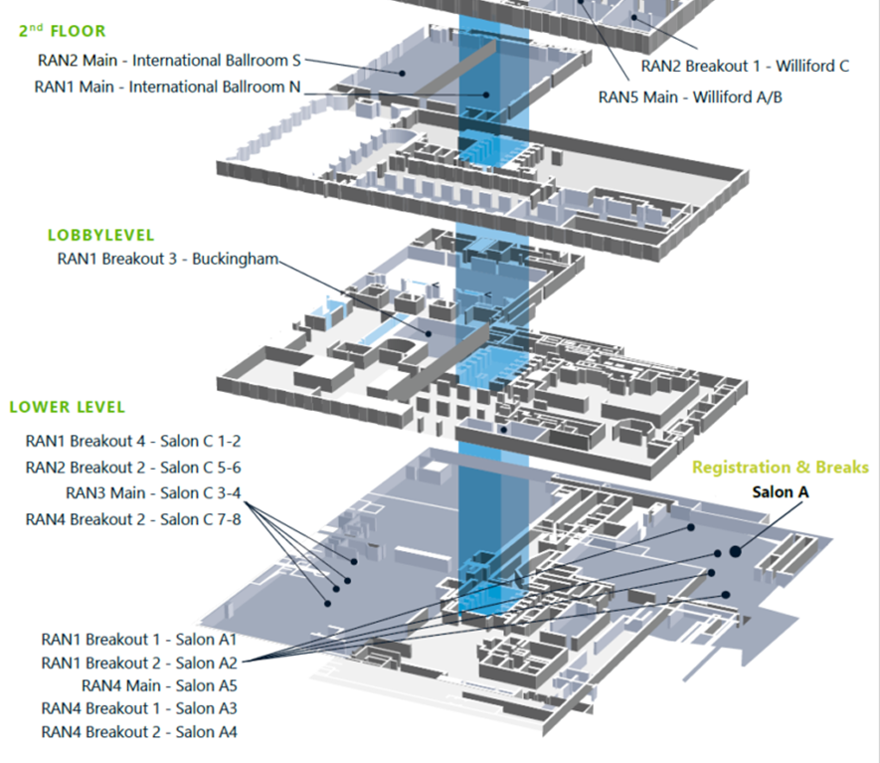

Online session rooms:
International Ballroom N (2nd floor)
Salon A1 (lower level)
Salon A2 (lower level)

Offline session rooms:
Buckingham (lobby level)
Salon C 1-2 (lower level)

