3GPP TSG RAN WG1 Meeting #109-e R1-22xxxxx
e-Meeting, May 9 - 20, 2022

Agenda Item: 8.9
Source: Moderator (Huawei)
Title: Feature lead summary on 109-e-LTE-Rel17-NB-IoT-eMTC-01
Document for: Discussion and Decision

Introduction
This documents provides the proposals and summary of discussions of the following email discussion according to the inputs [2-5]. The detailed discussion in preparation phase can be found in [6].
[109-e-LTE-Rel17-NB-IoT-eMTC-01] Email discussion for Maintenance on support of 16-QAM, including Issue 1 and Issue 2 in FL summary R1-22xxxxx, – Yubo (Huawei)
- Discussion and decision by 5/14

Discussion

Issue 1: On whether and how to use the DwPTS in special subframes for NPDSCH with 16QAM
The proposals are summarized in the following table.
Related contributions | Proposals
[2] | Text proposal to TS 36.211:  - On an NB-IoT carrier for which higher-layer parameter operationModeInfo indicates inband-SamePCI or inband-DifferentPCI, or higher-layer parameter inbandCarrierInfo is present, or on an NB-IoT carrier for SystemInformationBlockType1-NB for which sib1-carrierInfo indicates non-anchor and the value of the higher layer parameter sib-GuardbandInfo is set to sib-GuardbandInbandSamePCI or sib-GuardbandinbandDiffPCI, DwPTS in special subframe configuration 0 and 5 for normal cyclic prefix is not used for NPDCCH and NPDSCH transmission. DwPTS in special subframe configuration 9 for normal cyclic prefix is not used for NPDSCH transmission with 16QAM, when NPDSCH-16QAM-Config-NB is configured.
[4] | Text proposal to TS 36.211:  On an NB-IoT carrier for which higher-layer parameter operationModeInfo indicates inband-SamePCI or inband-DifferentPCI, or higher-layer parameter inbandCarrierInfo is present, or on an NB-IoT carrier for SystemInformationBlockType1-NB for which sib1-carrierInfo indicates non-anchor and the value of the higher layer parameter sib-GuardbandInfo is set to sib-GuardbandInbandSamePCI or sib-GuardbandinbandDiffPCI, DwPTS in special subframe configuration 0 and 5 for normal cyclic prefix is not used for NPDCCH and NPDSCH transmission, and when npdsch-16QAM-Config-r17 is configured then DwPTS in special subframe configuration 9 for normal cyclic prefix is also not used for NPDSCH transmission.
[5] | Proposal 1: It is up to the eNB to ensure that NPDSCH transmission on DwPTS using 16-QAM is self-decodable (e.g. coding rate lower than 0.932) by the UE after rate matching. There is no need for specification change.

As the background, the following was agreed in the last meeting on support of 16QAM for NPDSCH in TDD operation.
Agreement
- FDD/TDD differentiation is needed for FGs 1-1/1-2
  - DwPTS in special subframe configuration 9 for normal cyclic prefix is not used for NPDSCH transmission with 16QAM, when 16QAM is configured.

Please input your comments on whether a CR is needed on the use of DwPTS, and if your answer is yes, your comments to the CR proposed in [2] and [3].
Companies | Comments
Ericsson | Yes. In the previous e-meeting and for illustration purposes when I_{SF} = 0, an analysis was performed across all special subframe configurations (0 to 9) for stand-alone (I_{TBS} indices 14 to 21) and in-band deployments (I_{TBS} indices 11 to 17). From the analysis it was found that on top of the unused legacy special subframe configurations 0 and 5, special subframe configuration 9 cannot be used either since for in all cases for all deployment modes the code-rate goes beyond 1 and that is the reason behind the CR: “DwPTS in special subframe configuration 9 for normal cyclic prefix is not used for NPDSCH transmission with 16QAM, when 16QAM is configured”  For special subframe configurations other than 0, 5 and 9, there are some cases where the code rate is less than 1 and in therefore for those special subframes configurations we can leave it up to the network to handle it.  Having said that, overall, the intention of the TPs in [2] and [4] is ok. It is just that TP in [2] gives the impression that only special subframe configuration 9 is not used, however special subframe configurations 0 and 5 should not be used either (i.e., they are unusable already from legacy specification). Thus, we think TP in [4] is more accurate since it reflects that on top of special subframe configurations 0 and 5, DwPTS in special subframe configuration 9 is not used.
Lenovo | Regarding above agreement. Please clarify that if 16QAM is configured, NPDSCH transmission with 16QAM is not supported for special subframe configuration 9, and PDSCH with QPSK is supported.  If so, we prefer [4] with the above clarification.  and when npdsch-16QAM-Config-r17 is configured, then DwPTS in special subframe configuration 9 for normal cyclic prefix is also not used for NPDSCH transmission with 16QAM.
Qualcomm | Agree with Lenovo
Nokia, NSB | We feel that the CR is not necessary as it should be sufficient to leave it to the eNB to handle this. In our view there are many cases where it’s not feasible to use DwPTS so there is no need to specifically exclude special subframe configuration 9 with 16-QAM.  However, we are fine if it is the majority view to have the CR. In this case, we prefer [4] with clarification by Lenovo.
ZTE, Sanechips | As replied by the email reflector before, the following red entries can not be used.  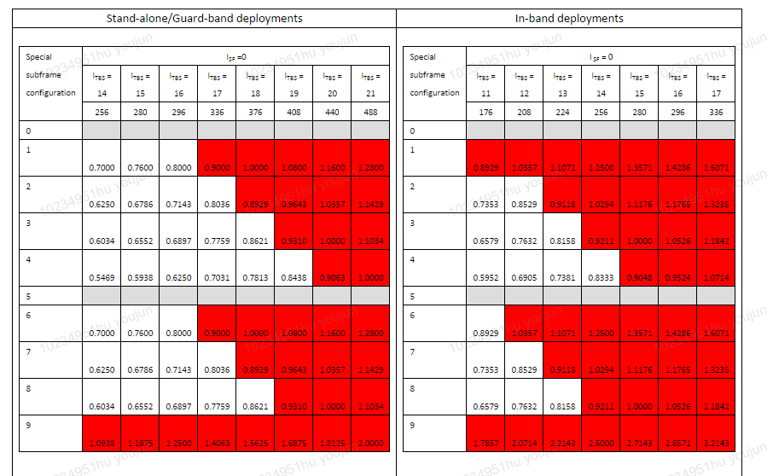  If we only consider excluding special subframe configuration 9 with 16-QAM, is there a misunderstanding that the other entries can be supported?
Ericsson v007 | The reason for considering excluding special subframe configuration 9 is because in all cases for all deployment modes the code-rate goes beyond 1. So, with no exception is completely unusable for transmitting DwPTS as it happens with special subframe configurations 0 and 5 which are explicitly excluded.  For special subframe configurations other than 0, 5, and 9, since there is at least one usable entry we can leave it up to the network to handle it.
Moderator (Huawei) v009 | It seems most companies are fine with the version updated by Lenovo. Therefore, a text proposal is drafted accordingly as in section 1 of R1-22xxxxx text proposals on NB-IoT 16QAM-v01.docx.

Issue 2: On the RRC configuration for NPDSCH 16QAM regarding power allocation in PUR procedure
The proposals are summarized in the following table.
Related contributions | Proposals
[3] | Text proposal to TS 36.213:  If a UE is configured with higher layer parameters npdsch-16QAM-Config or pur-DL-16QAM-Config and nrs-PowerRatio,  - the ratio of NPDSCH EPRE to NRS EPRE among NPDSCH REs in symbols with NRS is given by for a cell with one NRS antenna port and for a cell with two NRS antenna ports, where is given by the parameter nrs-PowerRatio.

In the preparation phase, there was some discussion on whether npdsch-16QAM-Config can refer to both connected mode and idle mode PUR procedure. In current 36.331 V17.0.0, the high layer parameters related to NPDSCH 16QAM are in the following IE:
NPDSCH-16QAM-Config-NB-r17 ::=SEQUENCE{
nrs-PowerRatio-r17 ENUMERATED {dB-6, dB-4dot77, dB-3, dB-1dot77, dB0, dB1, dB2, dB3} OPTIONAL,
nrs-PowerRatioWithCRS-r17 ENUMERATED {dB-6, dB-4dot77, dB-3, dB-1dot77, dB0, dB1, dB2, dB3} OPTIONAL -- Cond InBand
}

And for connected mode, the following configuration is used:
PhysicalConfigDedicated-NB-r13 ::= SEQUENCE {
<unrelated parts omitted>
[[ npusch-ConfigDedicated-v1700 NPUSCH-ConfigDedicated-NB-v1700 OPTIONAL, -- Need ON
npdsch-ConfigDedicated-v1700 SetupRelease {NPDSCH-16QAM-Config-NB-r17} OPTIONAL, -- Need ON
uplinkPowerControlDedicated-v1700 UplinkPowerControlDedicated-NB-v1700 OPTIONAL -- Cond npusch-16QAM
]]
}

And for PUR procedure in idle mode, the following configuration is used:
PUR-Config-NB-r16 ::= SEQUENCE {
<unrelated parts omitted>
[[
pur-PhysicalConfig-v1700 SEQUENCE {
pur-UL-16QAM-Config-r17 SetupRelease {PUR-UL-16QAM-Config-NB-r17} OPTIONAL, -- Need ON
pur-DL-16QAM-Config-r17 SetupRelease {NPDSCH-16QAM-Config-NB-r17} OPTIONAL -- Need ON
} OPTIONAL -- Need ON
]]
}

From the above IE, npdsch-ConfigDedicated-v1700 is used to configure 16QAM for connected mode, and pur-DL-16QAM-Config-r17 is used for PUR procedure, while both refer to NPDSCH-16QAM-Config-NB-r17 as the structure of the parameters. However, with the following field description, npdsch-16QAM-Config is the field identifier to configure 16QAM for connected mode, as that have used in RAN1 specs. It’s also noted that there’s some CR submitted to correct this inconsistency (e.g., R2-2206039).
npdsch-16QAM-Config
Activativation of 16QAM for DL, see TS 36.213 [23].

Based on the above observation, it should be RAN2’s intention to use npdsch-16QAM-Config for connected configuration and pur-DL-16QAM-Config-r17 for PUR procedure in idle mode.
Please input your comments to this issue and the related text proposal.
Companies | Comments
Ericsson | We are ok with clarifying “Issue 2” using “npdsch-16QAM-Config” and “pur-DL-16QAM-Config-r17”.
Lenovo | we can wait for the stable spec of TS36.331 and revisit the issue next meeting.  It is not clear for the relationship npdsch-16QAM-Config, pur-DL-16QAM-Config and nrs-PowerRatio in the current TS36.331 and the following CR. (Note: nrs-PowerRatio-r17 is only configured in NPDSCH-16QAM-Config-NB)  If a UE is configured with higher layer parameters npdsch-16QAM-Config or pur-DL-16QAM-Config and nrs-PowerRatio  NPDSCH-16QAM-Config-NB-r17 ::=SEQUENCE{  nrs-PowerRatio-r17 ENUMERATED {dB-6, dB-4dot77, dB-3, dB-1dot77, dB0, dB1, dB2, dB3} OPTIONAL,  nrs-PowerRatioWithCRS-r17 ENUMERATED {dB-6, dB-4dot77, dB-3, dB-1dot77, dB0, dB1, dB2, dB3} OPTIONAL -- Cond InBand  }
Qualcomm | We are seeing this issue again and again of having to correct the parameters for 16-QAM for PUR and RRC_Connected. Could we just change it to  If a UE is configured with 16-QAM higher layer parameters npdsch-16QAM-Config or pur-DL-16QAM-Config and higher layer parameter nrs-PowerRatio
Nokia, NSB | We are OK with using npdsch-16QAM-Config and pur-DL-16QAM-Config-r17.  We are also fine with the suggestion from Qualcomm as this would eliminate further discussion regarding parameter names but we have slight preference to list the two parameters as this explicitly capture both connected mode and PUR.
ZTE, Sanechips | We prefer to use pur-DL-16QAM-Config for idle mode, which can differentiate with the connected mode. Also, we are OK with a general description, e.g., the version from Qualcomm.
Ericsson v007 | We slightly prefer using “npdsch-16QAM-Config” and “pur-DL-16QAM-Config-r17” as to be consistent with what we have done for UL.
Lenovo | We want to clarify that the nrs-PowerRatio-r17 is configured in npdsch-16QAM-Config and pur-DL-16QAM-Config separately. nrs-PowerRatio-r17 is further configured in npdsch-16QAM-Config or pur-DL-16QAM-Config  So we hope we should make it clear as  If a UE is configured with higher layer parameters npdsch-16QAM-Config or pur-DL-16QAM-Config, and further configured with higher layer parameter nrs-PowerRatio,
Moderator (Huawei) v009 | I have sympathy with the way mentioned by Qualcomm, while most companies prefer to refer to the exact RRC parameter. Regarding the comment of Lenovo, perhaps we can have a more simplified version as below:  If a UE is configured with higher layer parameters nrs-PowerRatio in npdsch-16QAM-Config or pur-DL-16QAM-Config  A text proposal is drafted accordingly in section 2 of R1-22xxxxx text proposals on NB-IoT 16QAM-v01.docx, please provide your comments

Summary
TBD.

References
- RP-211340, “WID revision: Additional enhancements for NB-IoT and LTE-MTC”, Huawei, HiSilicon, RAN#92e, E-meeting, June 2021.
- R1-2203223 On use of DwPTS for 16QAM NPDSCH in NB-IoT Huawei, HiSilicon
- R1-2203631 Clarifications for DL power allocation for 16-QAM ZTE, Sanechips
- R1-2204082 Support of 16-QAM for unicast in UL and DL in NB-IoT Ericsson
- R1-2204878 Support of 16-QAM in NB-IoT TDD Nokia, Nokia Shanghai Bell
- R1-2204878 Preparation phase discussion on 109-e-Prep-AI8.9 NB-IoT-eMTC Moderator (Huawei)

