**3GPP TSG RAN WG1 #108-e R1-22xxxxx**

**e-Meeting, February 21st – March 3rd, 2022**

**Source: Moderator (MediaTek)**

**Title: [108-e-NR-CRs-11] Issue#14 On rate matching pattern of DSS under TDD LTE scenario**

**Agenda item: 7.1**

**Document for:** **Discussion and Decision**

Introduction

In RAN1#108-e meeting, one contribution [1, MTK] is submitted to clarify the rate matching pattern of DSS under TDD LTE scenario.

As guided by the Chairman, this contribution provides summary of the submitted contributions (Section 4), discussion points (Section 2), and possible RAN1 consensus during this meeting (Section 3, TBD).

108-e-NR-CRs-11] Issue#14 On rate matching pattern of DSS under TDD LTE scenario – ??? (MediaTek)

* Relevant tdoc: [R1-2202050](../../Docs/R1-2202050.zip)
* Check point on February 23

Discussion points (phase 1 until 23-Feb)

Based on the submitted contribution [1, MTK], it strives to clarify the rate matching pattern of DSS under TDD LTE scenario and proposes that

* **Proposal 1: RAN1 to draw the following conclusion:**
  + **For DSS application, NR UE assumes the same LTE CRS rate match pattern provided by the IE *lte-CRS-ToMatchAround*, regardless LTE is FDD or TDD, for R15 and R16.**
    - **It can be discussed later whether to do further enhancement on CRS rate match pattern for LTE TDD system, in R17 and later releases.**

The proposal is drawn considering that

* For DSS application, in current NR spec (38.331, 38.211, and 38.214), NR UE obtains the LTE CRS pattern for rate matching by the IE *lte-CRS-ToMatchAround*. UE would assume the same *RateMatchPatternLTE-CRS* under *lte-CRS-ToMatchAround*, regardless LTE is FDD or TDD
* Some operators are investigating DSS for LTE TDD band (e.g. band B40) and it would be good to clarify RAN1’s understanding

In the preparation phase summary for AI 7.1 during RAN1 #107e [2], RAN1 Chairman’s initial assessment is

* + Seems **current specification is written this way** since there is no distinction between LTE FDD and LTE TDD.

In the preparation phase discussion [2], **most companies agree** with RAN1 Chairman’s initial assessment. Besides, some companies (**Nokia**, **ZTE**) mention that if the TDD LTE and TDD NR are DSS, usually they will be configured with the same TDD pattern. However, **to moderator’s understanding**, we do not see different TDD patterns for TDD LTE and TDD NR in DSS scenario are prevented from current NR spec (38.331, 38.211, and 38.214). On the other hand, **Ericsson** mentions an alternative way in current spec to configure different MBSFN pattern (*mbsfn-SubframeConfigList*) for FDD and TDD LTE to solve this issue.

At the same time, in the email reflector, **Vodafone** expresses preference to recognize the existence of the problem and potential further enhancement in R17 or later release.

**Discussion point 1:**

**Do you think different TDD patterns for TDD LTE and TDD NR in DSS scenario are prevented from current NR spec?**

**If your answer is “Yes”, please assist to point out the spec text in the comment for an easier reference**

|  |  |  |
| --- | --- | --- |
| **Company** | **Yes/No** | **Comment** |
| MTK | No | We do not see different TDD patterns for TDD LTE and TDD NR in DSS scenario are prevented from current NR spec (38.331, 38.211, and 38.214) |
|  |  |  |
|  |  |  |
|  |  |  |

**Discussion point 2:**

**According to current NR spec, do you agree that “NR UE assumes the same LTE CRS rate match pattern obtained by the IE *lte-CRS-ToMatchAround*, regardless LTE is FDD or TDD”?**

**If your answer is “No”, please assist to provide your understanding on NR UE’s behavior for LTE FDD/TDD case.**

|  |  |  |
| --- | --- | --- |
| **Company** | **Yes/No** | **Comment** |
| MTK | Yes | There is no distinction between LTE FDD and LTE TDD in current NR spec (38.211, 38.214, 38.331). Hence, it seems NR UE can only assume this way. |
|  |  |  |
|  |  |  |
|  |  |  |

**Discussion point 3:**

**Do you agree with Ericsson’s view that current spec covers the case with different MBSFN pattern for FDD LTE and TDD LTE (through *lte-CRS-ToMatchAround*🡪**[***RateMatchPatternLTE-CRS***](https://www.sqimway.com/rrc_nr.html#RateMatchPatternLTE-CRS)**🡪*mbsfn-SubframeConfigList*)?**

|  |  |  |
| --- | --- | --- |
| **Company** | **Yes/No** | **Comment** |
| MTK | Yes, but … | This is one workaround to mute CRS in some sub-frames using MBSFN configuration under DSS scenario. However, NR UE still does not know it is co-existing with a TDD LTE UE or an FDD LTE UE. Hence, we still think the statement in Discussion Point 2 holds (“NR UE assumes the same LTE CRS rate match pattern obtained by the IE *lte-CRS-ToMatchAround*, regardless LTE is FDD or TDD”). |
|  |  |  |
|  |  |  |
|  |  |  |

**Discussion point 4:**

**Just for clarification, do you agree to draw the following RAN1 conclusion?**

* + **“For DSS application, NR UE assumes the same LTE CRS rate match pattern provided by the IE *lte-CRS-ToMatchAround*, regardless LTE is FDD or TDD, for R15 and R16”**

|  |  |  |
| --- | --- | --- |
| **Company** | **Yes/No** | **Comment** |
| MTK | Yes | We see no harm to draw the conclusion for clarification, considering we are given an email thread to clarify this issue. |
|  |  |  |
|  |  |  |
|  |  |  |

**Discussion point 5:**

**As potential enhancement, do you agree to draw the following RAN1 conclusion?**

* + **“It can be discussed later whether to do further enhancement on CRS rate match pattern for LTE TDD system, for the scenario NR UE and LTE UE are configured with different TDD patterns, in R17 or later releases.”**

|  |  |  |
| --- | --- | --- |
| * **Company** | **Yes/No** | **Comment** |
| MTK | Yes | We are open for further enhancement. On the other hand, if all companies think Ericsson’s view in Discussion point 3 is correct, then maybe the solution is already there. |
|  |  |  |
|  |  |  |
|  |  |  |

Resulted RAN1 conclusion/agreement (phase 2)

TBD based on outcome/situation of phase 1 discussion.

Summary of contribution inputs

**Summary for [1, MTK]:**

In [1], it is mentioned that dynamic spectrum sharing (DSS) provides a useful migration path from LTE (4G) to NR (5G) by allowing LTE and NR to share the same carrier instead of a conventional spectrum re-farming. To enable DSS, NR UE needs to do rate matching around the CRS (4G reference signal) as shown in Figure 1 below.

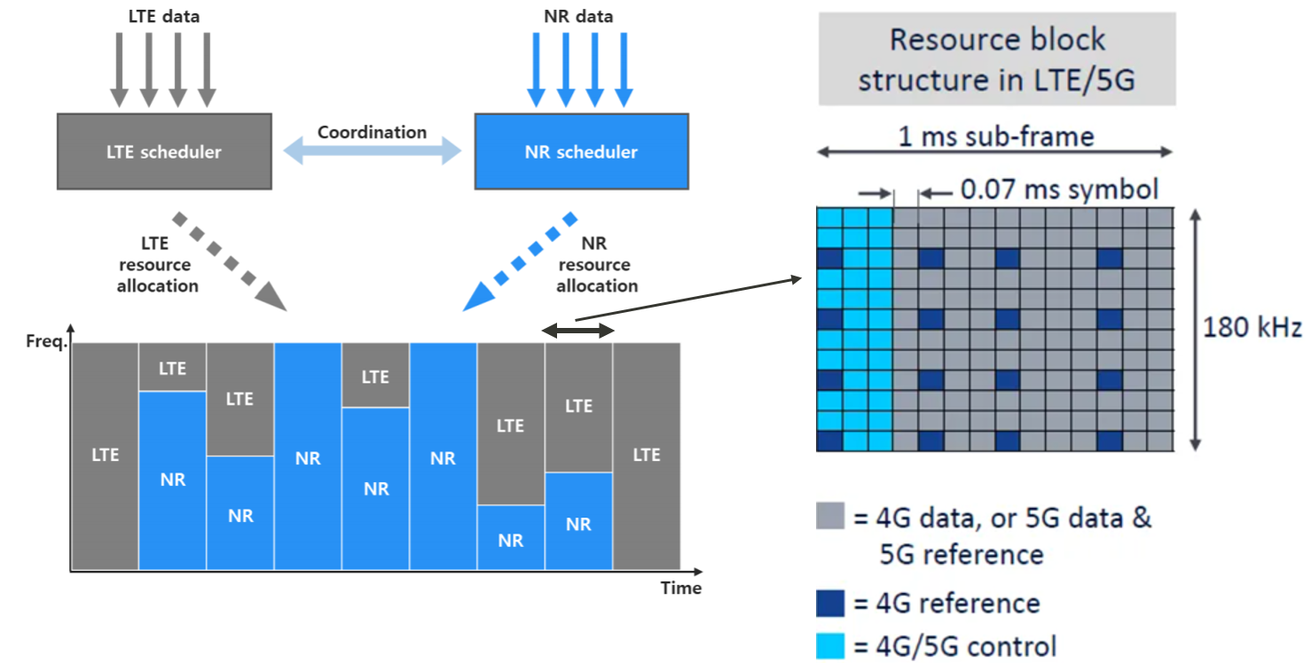

**Figure 1. A DSS example with LTE(4G)/NR(5G) sharing the same carrier**

In current NR spec (38.331), NR UE obtains the LTE CRS pattern for rate matching by the IE *lte-CRS-ToMatchAround*:



UE would assume the same *RateMatchPatternLTE-CRS* for each LTE sub-frame, which is intuitive for LTE FDD scenario, since every sub-frame of a LTE FDD system can be a DL sub-frame. Related spec description can be found in 38.211, 38.214 by searching for *lte-CRS-ToMatchAround*.

**Observation 1: For DSS application, in current NR spec (38.331), NR UE obtains the LTE CRS pattern for rate matching by the IE *lte-CRS-ToMatchAround*. UE would assume the same *RateMatchPatternLTE-CRS* under *lte-CRS-ToMatchAround* for each LTE sub-frame, which is intuitive for LTE FDD scenario, since every sub-frame of a LTE FDD system can be a DL sub-frame. Related spec description can be found in 38.211, 38.214 by searching for *lte-CRS-ToMatchAround*.**

**Observation 2: Technologically speaking, DSS can be applied not only to LTE FDD, but also to LTE TDD system. However, NR UE is not aware of the TDD pattern of LTE UE, and can only assume the same LTE CRS rate match pattern for each sub-frame. In this case, if NW wants to schedule NR PDSCH in LTE TDD UL sub-frame, LTE CRS may be over-rate-matched, but the system still works if gNB and UE have the same understanding that each LTE sub-frame would be rate-matched.**

**Observation 3: India operator is investigating DSS for LTE TDD band (e.g. band B40), and it would be beneficial to confirm the understanding that NR UE assumes the same LTE CRS rate match pattern for each sub-frame, regardless LTE is FDD or TDD, at least for R15 and R16 (commercialized releases).**

Therefore, we have the following proposal:

**Proposal 1: RAN1 to draw the following conclusion:**

* **For DSS application, NR UE assumes the same LTE CRS rate match pattern provided by the IE *lte-CRS-ToMatchAround*, regardless LTE is FDD or TDD, for R15 and R16.**

**It can be discussed later whether to do further enhancement on CRS rate match pattern for LTE TDD system, in R17 and later releases.**

References

[1] R1-2202050 On rate matching pattern of DSS under TDD LTE scenario, MediaTek, RAN1 #108e

[2] R1-22xxxxx RAN1#108-e_NR_CRs_7.1_summary_v18_Ericsson_Moderator.xlsx, [download link](https://www.3gpp.org/ftp/tsg_ran/WG1_RL1/TSGR1_108-e/Inbox/drafts/7.1/Prep%20phase/RAN1%23108-e_NR_CRs_7.1_summary_v18_Ericsson_Moderator.xlsx), RAN1, RAN1 #108e