3GPP TSG-RAN WG1 Meeting #103b-e draft R1- 21NNNNN
e-Meeting, April 12th – 20th, 2021
Source: Moderator (Ericsson)
Title: Output #1 for email discussion [104-be-NR-Pos-02]
Agenda item: 7.2.8
Document for: Discussion and Decision
- Introduction
This contribution documents the output of email discussion [104b-e-NR-Pos-02] triggered by the following Chairman’s decision and based on the feature lead summary for AI 7.2.8[TBD,[3]:

[104b-e-NR-Pos-02] Email discussion/approval on the following until Apr-16 – Florent (Ericsson)
- Aspect #3: Maintaining multiple pathloss estimates
- Aspect #4: Clarification on UE Rx-Tx time difference measurements

- List of Remaining Opens on NR Positioning

Aspect #3: Maintaining multiple pathloss estimates for SRS for positioning

Feature Lead Summary

In [1], it is noticed that specification is not clear with respect to UE capability for support of simultaneous pathloss estimates per serving cell and across all serving cells. It is proposed to address the following points:
- The fact that UE may not indicate the capability (“may” is added in front of “indicates”)
- Maximum number of pathloss estimates per serving cell
- UE behavior/capability for pathloss estimates across all cells
Section 7.3.1 of 38.213
----------------------------------------Start of Text Proposal for 38.213-----------------------------------------

7.3.1 UE behaviour
----------------------------------------------------- unrelated part omitted --------------------------------
The UE may indicate a capability for up to sixteen pathloss estimates that the UE can simultaneously maintain for all SRS resource sets provided by SRS-PosResourceSet per serving cell in addition to the up to four pathloss estimates that the UE maintains per serving cell for PUSCH/PUCCH transmissions and for SRS transmissions configured by SRS-Resource.
The UE may indicate a capability for up to sixteen pathloss estimates that the UE can simultaneously maintain for all SRS resource sets provided by SRS-PosResourceSet across all cells in addition to the up to four pathloss estimates that the UE maintains per serving cell for PUSCH/PUCCH transmissions and for SRS transmissions configured by SRS-Resource.
-------------------------------------------------------End of Text Proposal -------------------------------------------

first round of comments
Companies are encouraged to provide their view on the TP in the table below
Company | Comment
Huawei/HiSilicon | Not necessary for the whole TP.  It is common in the specification that some UE features that are self-explanatory in TS 38.306 introduced by RAN1 do not necessarily have a full description RAN1 specs.
vivo | WE don’t see any confusion or misinterpretation on current specification wording and think no need to have this TP as that would duplicate from UE feature list.
QC | We are OK to change the “indicates” to “may indicate”, and generally the changes in the 1st paragraph.  With regards to the 2nd paragraph, we also tend to believe that 38.306 seems to be good enough, but we are OK to capture it if there is majority view.  From 38.306:  - maxNumberPathLossEstimatePerServing-r16 indicates the maximum number of pathloss estimates that the UE can simultaneously maintain for all the SRS resource sets for positioning per serving cell in addition to the up to four pathloss estimates that the UE maintains per serving cell for the PUSCH/PUCCH/SRS transmissios. The UE shall include this field if the UE supports any of olpc-SRS-PosBasedOnPRS-Serving-r16, olpc-SRS-PosBasedOnSSB-Neigh-r16 and olpc-SRS-PosBasedOnPRS-Neigh-r16. Otherwise, the UE does not include this field.
Nokia/NSB | Same view as Huawei and vivo.
OPPO | This TP Is not needed. The UE capability is clearly defined in TS 37.355. We do not need  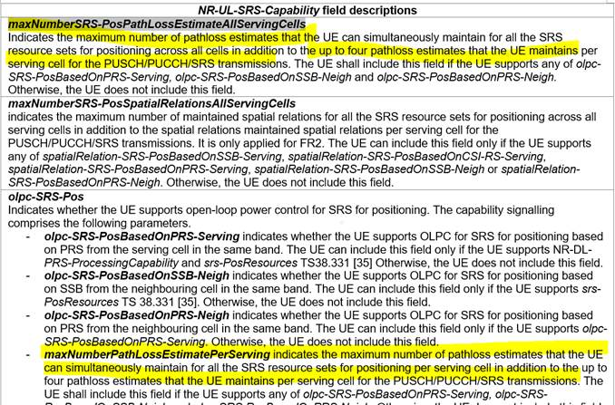
ZTE | Similar view as QC.
CATT | Since majority of companies prefer to keep current specs and don’t want to introduce additional descrptions, we can compromise to change the TP as follows.  In the updated TP, as QC and ZTE suggested, only change the “UE indicates” to “UE may indicate”, to address the issue that this UE capability is optional, and UE may not indicate the capability.
  The UE may indicate a capability for a number of pathloss estimates that the UE can simultaneously maintain for all SRS resource sets provided by SRS-PosResourceSet in addition to the up to four pathloss estimates that the UE maintains per serving cell for PUSCH/PUCCH transmissions and for SRS transmissions configured by SRS-Resource.

Aspect #4: Clarification on UE Rx-Tx time difference measurements

Feature Lead Summary

In [2], it is noticed that agreed UE capabilities are not correctly captured in current specification 38.214 for the following aspects:
- According to FG13-11a, it should be UE’s capability to support measurements derived on one or more DL PRS resource/resource sets which may be in different positioning frequency layers for SRS transmitted in a single CC. However, the current specification in TS 38.214 doesn’t mention that UE should report this capability, and all the measurements should correspond to SRS transmitted in a single CC.
- According to FG 13-11, the following aspects are not captured in the current specification, which may cause ambiguity to understand this FG.
- Different UE Rx–Tx time difference measurements are based on different DL PRS resources or DL PRS resource sets.
- Up to 4 UE Rx–Tx time difference measurements are based on DL PRS resources associated with the same TRP.
- Up to 4 UE Rx–Tx time difference measurements are based on DL PRS resources associated with the same positioning frequency layer.

To address above aspects, the following TP is provided in [2]:
clause 5.1.6.5 of TS 38.214
5.1.6.5 PRS reception procedure
===========================Unchanged parts omitted ============================
The UE may be configured to measure and report, subject to UE capability, up to 4 DL RSTD measurements per pair of dl-PRS-ID with each measurement between a different pair of DL PRS resources or DL PRS resource sets within the DL PRS configured for those dl-PRS-ID. The up to 4 measurements being performed on the same pair of dl-PRS-ID and all DL RSTD measurements in the same report use a single reference timing.
The UE may be configured to measure and report, subject to UE capability, up to 8 DL PRS-RSRP measurements on different DL PRS resources associated with the same dl-PRS-ID. When the UE reports DL PRS-RSRP measurements from one DL PRS resource set, the UE may indicate which DL PRS-RSRP measurements associated with the same higher layer parameter nr-DL-PRS-RxBeamIndex [17, TS 37.355] have been performed using the same spatial domain filter for reception if for each nr-DL-PRS-RxBeamIndex reported there are at least 2 DL PRS-RSRP measurements associated with it within the DL PRS resource set.
The UE may be configured to measure and report, subject to UE capability, up to 4 UE Rx-Tx time difference measurements based on DL PRS resources associated with the same dl-PRS-ID and the same positioning frequency layer, and corresponding to a single configured SRS resource or resource set for positioning. Different measurements correspond to different received DL PRS resources or resource sets, which can be in different positioning frequency layers corresponding to SRS transmitted in a single carrier, subject to UE capability.
========================== Unchanged parts omitted =============================

first round of comments
Companies are encouraged to provide their view on the TP in the table below
Company | Comment
Huawei/HiSilicon | We see the value of clarifying that the 4 UE Rx – Tx time difference are from the same TRP on a positioning frequency layer. However, the second half needs some fine-tuning.  Changes suggested below:  The UE may be configured to measure and report, subject to UE capability, up to 4 UE Rx-Tx time difference measurements based on DL PRS resources associated with the same dl-PRS-ID and the same positioning frequency layer, and corresponding to a single configured SRS resource or resource set for positioning.  The UE may be configured to measurement and report, subject to UE capability, UE Rx – Tx time difference measurements based on DL PRS resources or resource sets in different positioning frequency layers for SRS transmitted in a single CC.
vivo | We don’t see any critical or essential problem of existing specification wording. As we commented toward aspect#3, we prefer not to duplicate from UE feature list.  On the suggested clarification w.r.t. the same PFL, our understanding on the word ‘can’ in “Each measurement corresponds to a single received DL PRS resource or resource set which can be in different positioning frequency layers” covers both same or different PFL.
QC | OK with HW’s revision, with a minor change on top, as shown below with red:  The UE may be configured to measure and report, subject to UE capability, up to 4 UE Rx-Tx time difference measurements based on DL PRS resources associated with the same dl-PRS-ID and the same positioning frequency layer, and corresponding to a single configured SRS resource or resource set for positioning.  The UE may be configured to measurement measure and report, subject to UE capability, UE Rx – Tx time difference measurements based on DL PRS resources or resource sets in different positioning frequency layers for SRS transmitted in a single CC.
Nokia/NSB | We don’t really see how the change suggested by HW/QC above changes the spec. While we agree that the change, if accepted, makes the spec correct we also think it is correct now. Could a proponent explain how the current spec might be misinterpreted?
OPPO | We do not think This TP is needed. There is misunderstanding. Furthermore, the specification in 37.355 does explain that clearly:  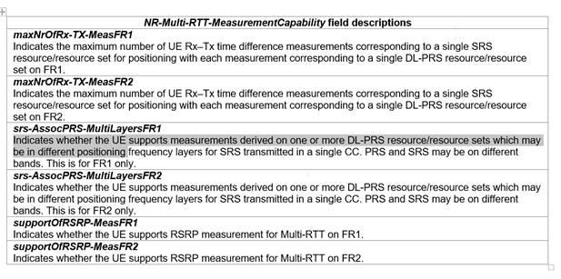
ZTE | We can accept original TP or the TP revised by Huawei and QC. As we described in our tDoc, for your convenience, the justifications are listed and amended as below,  - According to FG13-11a, it should be UE’s capability to support measurements derived on one or more DL PRS resource/resource sets which may be in different positioning frequency layers for SRS transmitted in a single CC. However, the current specification in TS 38.214 doesn’t mention that UE should report this capability, and all the measurements should correspond to SRS transmitted in a single CC.  - According to FG 13-11, the following aspects are not captured in the current specification, which may cause ambiguity to understand this FG.  - Different UE Rx–Tx time difference measurements are based on different DL PRS resources or DL PRS resource sets. For DL-RSTD and DL-AOD, it’s clearly stated in current specification that different measurements are based on different DL PRS resources or DL PRS resource sets, so it would be better to clarify this in Multi-RTT.Otherwise, it’s not clear what the meaning of this capability.  - Up to 4 UE Rx–Tx time difference measurements are based on DL PRS resources associated with the same TRP. The similar descriptions are also stated in current specification for DL-RSTD and DL-AOD,so it would be better to clarify this in Multi-RTT.Otherwise, it’s not clear what the meaning of this capability.  - Up to 4 UE Rx–Tx time difference measurements are based on DL PRS resources associated with the same positioning frequency layer. The note in FG13-11 should be captured to avoid ambiguity.
CATT | We are generally fine with the TP revised by QC, with a minor change on QC’s version, as follows with YELLOW backgroud, since Up to 4 UE Rx–Tx time difference measurements are based on DL PRS resources associated with the same TRP, or based on DL PRS resources associated with the same positioning frequency layer:  The UE may be configured to measure and report, subject to UE capability, up to 4 UE Rx-Tx time difference measurements based on DL PRS resources associated with the same dl-PRS-ID or the same positioning frequency layer, and corresponding to a single configured SRS resource or resource set for positioning.  The UE may be configured to measurement measure and report, subject to UE capability, UE Rx – Tx time difference measurements based on DL PRS resources or resource sets in different positioning frequency layers for SRS transmitted in a single CC.
Huawei/HiSilicon | We support QC’s version, but not CATT’s version.  Replacing “and” with “or” changed the meaning significantly. By saying “or”, it will mean that 4 UE Rx – Tx time difference measurements can be counted from ALL TRPs on a positioning frequency layers, which should not be the intention  Please also refer to the note in the UE feature list  Reply to Nokia/OPPO:  In our understanding, the problem here first lies in the description of FG13-11, where 4 UE Rx – Tx time difference measurements are not restricted to a single TRP, which may be mis-interpreted as the total number across all TRPs.  Another issues is that the current description mixed FG13-11 and FG13-11a. For FG13-11, we are referring to the measurement capability within a TRP, and for FG13-11a, we are referring to single SRS associated with PRS in multiple positioning frequency layers. Those two features should be independent from each other.
  13-11 | UE Rx-Tx Measurement Report for Multi-RTT | - Max number of UE Rx–Tx time difference measurements corresponding to a single SRS resource/resource set for positioning with each measurement corresponding to a single DL PRS resource/resource set.  Value for component 1: {1,2,3,4}  Note: DL PRS resource/sets are on the same frequency layer  Note: the number of UE Rx – Tx time difference measurements refers to the measurements for a single TRP  - Support RSRP measurements. Values = {0, 1}  Note: If the UE reports value 1 for component 2, same number of RSRP measurements supported as UE Rx-Tx measurements for component 1
ZTE2 | Huawei’s explanation makes our intention more clear. We have two minor changes based on QC’s version,  - up to 4 UE Rx-Tx time difference measurements should be based on different DL PRS resources  - the description “CC” should be changed into “carrier”.  The UE may be configured to measure and report, subject to UE capability, up to 4 UE Rx-Tx time difference measurements based on different DL PRS resources associated with the same dl-PRS-ID and the same positioning frequency layer, and corresponding to a single configured SRS resource or resource set for positioning.  The UE may be configured to measurement measure and report, subject to UE capability, UE Rx – Tx time difference measurements based on DL PRS resources or resource sets in different positioning frequency layers for SRS transmitted in a single carrier.

Conclusion
TBD
- References
- R1-2102597 Discussion and TP on remaining issues in NR positioning CATT
- R1-2102659 Maintenance of NR positioning support ZTE
- R1-210zzzz Feature Leads Summary for NR Positioning Maintenance – AI 7.2.8

