Title: Correlation Properties of SCM

File: SCM-127-QCOM-CorrelationProperties

Source: Steven Howard
QUALCOMM Inc.
(781) 276-0904
showard@qualcomm.com

Date: March 28, 2003

Notice

©2002 Third Generation Partnership Project Two (3GPP2). All rights reserved. Permission is granted for copying, reproducing, or duplicating this document only for the legitimate purposes of 3GPP2 and its organizational partners. No other copying, reproduction, or distribution is permitted.

Copyright Notification
No part may be reproduced except as authorized by written permission.
The copyright and the foregoing restriction extend to reproduction in all media.

© 2002, 3GPP Organizational Partners (ARIB, CWTS, ETSI, T1, TTA, TTC).
All rights reserved.

Introduction
The spatial and temporal correlation properties of the spatial channel modeling (SCM) are compared with the theoretical correlation properties of a received signal that is the superposition of waves with a Laplacian Power Azimuth Spectrum (PAS). Omni directional antenna elements are assumed for all the results. An alternative channel model is presented that has correlation properties that are closer to theoretical.

Spatial Correlation
Spatial correlation is the cross-correlation of the signals received at two spatially separated antenna elements that originated at same source. For the SCM, the mean, complex valued, spatial correlation for the nth multipath component is given by:
$$ρ_{\text{SCM}}(d)=E[h_{1,s,n}(t)h_{2,s,n}^{}(t)]=\frac{1}{M}\sum_{m=1}^{M}{\text{exp}(−j2πd\text{sin}(θ_{m})/λ)},$$
where $d$is the receiver antenna element separation in meters, $h_{u,s,n}$ is as defined in the SCM text normalized to unit power, $M$ is the number of subpaths, λ is the wavelength in meters as determined by the carrier frequency, and θ_{m} is the Angle of Arrival (AoA) of the mth subpath that is derived by adding the mean AoA to the mth offset of the desired Angle Spread (AS) given in Table 3.2 of the SCM.
The theoretical spatial correlation of a signal with a Laplacian PAS is given in [1, 2] where the Laplacian distribution is determined by the AoA and the AS.
In Figure 1, the spatial correlation of the SCM is plotted using $ρ_{\text{SCM}}(d)$ for an AS of 35^{ο} and a range of AoA from 0^{ο} to 90^{ο} in 15^{ο} increments. In Figure 2, the spatial correlation of a signal with a Laplacian PAS is plotted for an AS of 35^{ο} and a range of AoA from 0^{ο} to 90^{ο} in 15^{ο} increments. Figure 3 and Figure 5 show the spatial correlation of the SCM for AS of 5^{ο} and 2^{ο} respectively for same range of AoA. Figure 4 and Figure 6 show the spatial correlation of a signal with a Laplacian PAS for an AS of 5^{ο} and 2^{ο} respectively for same range of AoA.
From these figures, it is seen that the spatial correlation of the SCM does not match very well with the theoretical spatial correlation of a signal with a Laplacian PAS.
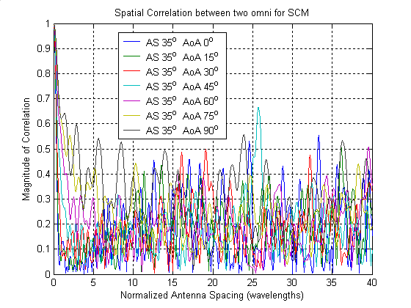
Figure 1 – Spatial Correlation derived from SCM for 35 degree AS and a range of AoA.
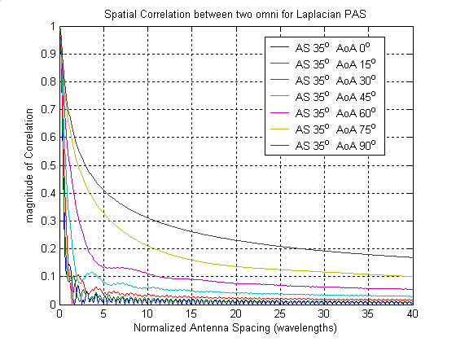
Figure 2 – Theoretical Spatial Correlation for Laplacian PAS with 35 degree AS and a range of AoA.
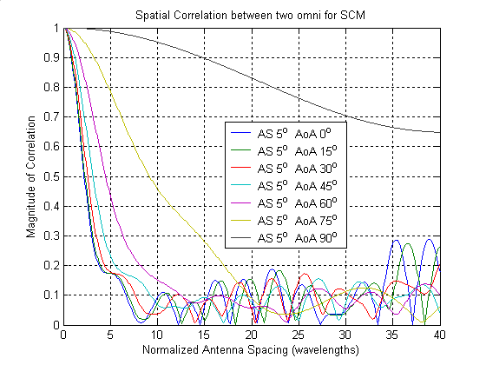
Figure 3 – Spatial Correlation derived from SCM for 5 degree AS and a range of AoA.
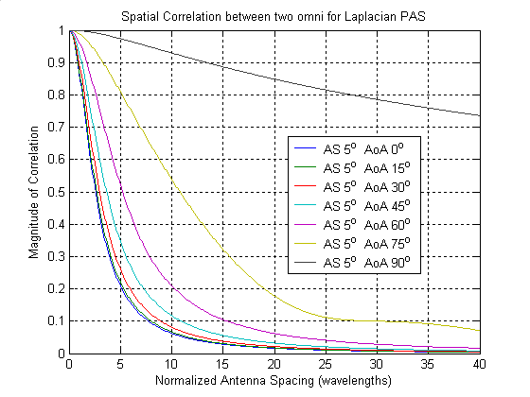
Figure 4 - Theoretical Spatial Correlation for Laplacian PAS with 5 degree AS and a range of AoA.
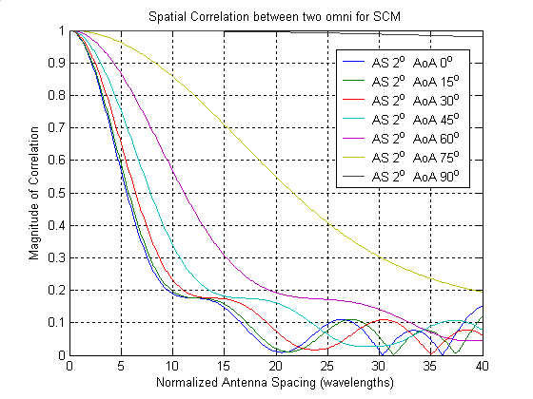
Figure 5 – Spatial Correlation derived from SCM for 2 degree AS and a range of AoA.
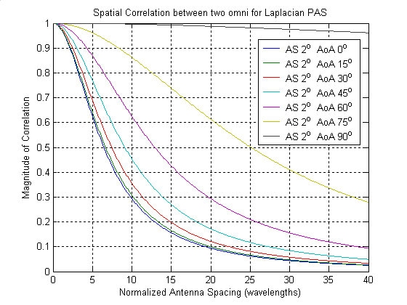
Figure 6 – Theoretical Spatial Correlation for Laplacian PAS with 2 degree AS and a range of AoA.

Temporal Correlation
Temporal correlation is the auto-correlation of the signal received at a single antenna element. For the SCM, the mean, complex valued, temporal correlation for the nth multipath component is given by:
$$ρ_{\text{SCM}}(τ)=E[h_{u,s,n}(t)h_{u,s,n}^{}(t+τ)]=\frac{1}{M}\sum_{m=1}^{M}{\text{exp}(−j2\text{πτ}\left\|v\right\|\text{cos}(θ_{m}−θ_{v})/λ})$$
where $τ$is the time delay in seconds, $h_{u,s,n}(t)$is as defined in the SCM text normalized to unit power, $M$ is the number of subpaths, λ is the wavelength in meters as determined by the carrier frequency, θ_{m} is the Angle of Arrival (AoA) of the mth subpath that is derived by adding the mean AoA to the mth offset of the desired Angle Spread (AS) given in Table 3.2 of the SCM, $\left\|v\right\|$ is the magnitude of the velocity vector in meters per second, and θ_{v} is the angle of the velocity vector. When θ_{v} is 90^{ο} then the SCM temporal correlation at the normalized distance traveled, $τ^{'}=τ{\left\|v\right\|}/λ$, is the same as the SCM spatial correlation at the normalized antenna spacing, $d^{'}=d/λ$.
The theoretical temporal correlation of a signal with a Laplacian PAS is given in [2] where the Laplacian distribution is determined by the AoA and the AS. When θ_{v} is 90^{ο} then the theoretical temporal correlation at the normalized distance traveled, $τ^{'}=τ{\left\|v\right\|}/λ$, is the same as the theoretical spatial correlation at the normalized antenna spacing, $d^{'}=d/λ$.
A 40λ distance is 6 meters at a 2 GHz carrier frequency, so the scale shown on the correlation plots is on the order of a second for mobile applications.
Therefore, the spatial correlations shown in Figures 1-6 are also the temporal correlations when θ_{v} is 90^{ο}. If θ_{v} is 0^{ο}, then the temporal correlation at an AoA of xº is the same as the temporal correlation at an AoA of (x+90)º when θ_{v} is 90^{ο}. This is seen by comparing Figure 7 to Figure 2. As was the case with the spatial correlation, the temporal correlation of the SCM does not match very well with the theoretical temporal correlation of a signal with a Laplacian PAS.
The SCM correlation functions can be derived either as an ensemble average with the expectation w.r.t the uniformly distributed random phase or as a time average. Each channel realization $h_{u,s,n}(t)$ will have its own correlation sequence that deviates from the average behavior. The blue curve of Figure 8 shows the standard deviation of the complex-valued auto-correlation for 100 realizations of $h_{u,s,n}(t)$of length 250λ with a 35^{ο} AS, θ_{v} is 0^{ο}, and AoA is 0^{ο}. The standard deviation starts out low and then levels out around 0.2 after 2 λ. This is consistent with [3, Figure 4] where the 10% and 90% bounds of the correlation sequences were presented.

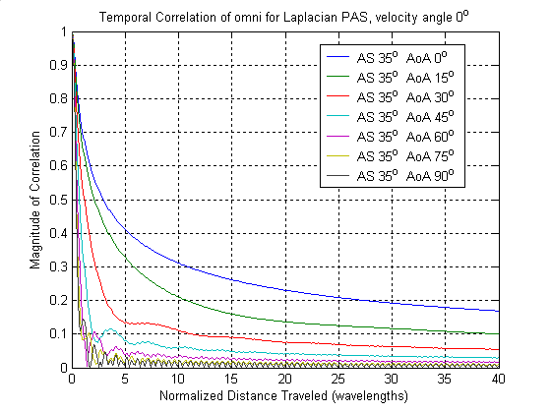
Figure 7 - Theoretical Temporal Correlation for Laplacian PAS with 35 degree AS and a range of AoA for θ_{v} of 0 degrees.

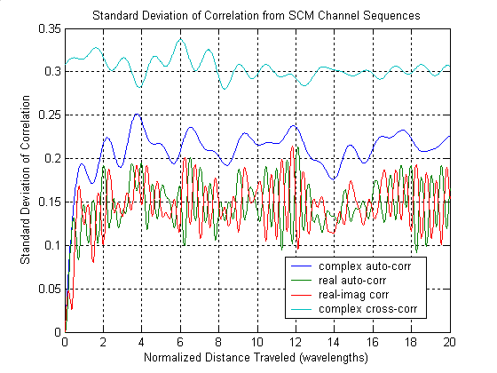
Figure 8 – Standard Deviation of Temporal Correlation for 100 SCM realizations of $h_{u,s,n}(t)$of length 250λ with a 35^{ο} AS, θ_{v} is 0^{ο}, and AoA is 0^{ο}.

Between USER Fading Correlation
The mean correlation between users is zero because each channel realization $h_{u,s,n}(t)$ has a different set of random phases. However, when two users have the same (AoA - θ_{v}) then the fading correlation between the two users can be significant because the frequency of the individual oscillators for each user is the same. The top curve of Figure 8 shows the standard deviation of the complex-valued cross-correlation for 100 independent pairs of realizations of $h_{u,s,n}(t)$of length 250λ with a 35^{ο} AS, θ_{v} is 0^{ο}, and AoA is 0^{ο}. The standard deviation is around 0.3 over the full correlation distance.

Altenative SCM Model
In the current SCM, the frequency of each subpath (oscillator) is fixed by the AS, AoA and the θ_{v} throughout the sampling period. The frequency of the mth subpath is
$$f_{m}=\left\|v\right\|\text{cos}(θ_{m}−θ_{v})/λ$$
where ${\left\|v\right\|}/λ$ is the maximum Doppler frequency.
A different approach would be to have the frequency varying with time (sample number) . Then the form of each oscillator is
$$h_{u,s,n,m}(t)=\text{exp}(j2π\int{f_{m}(v)\text{dv}+θ_{n,m}})$$
since the instantaneous frequency is the derivative of the phase.
To get a Laplacian PAS, $θ_{m}(t)$ is chosen to have a Laplacian distribution over time (this is similar to the Laplacian offsets of the current SCM). Each subpath has a different random sweep period T_{m} during which $θ_{m}(t)$is swept through the full angular range. This is to avoid synchronisms between users. To get a Laplacian angle distribution for $θ_{m}(t)$ let
$F(θ_{m}(t))=x_{m}(t)/{T_{m}}, x_{m}(t)∈[0,T_{m}],$
where F is the Laplacian CDF for a given AS and mean AoA. Then
$θ_{m}(t)=F^{−1}(x_{m}(t)/{T_{m}})\text{.}$
$x_{m}(t)$ is a triangular waveform with a peak of $T_{m}$, a period of 2$T_{m}$, and a random starting value that can be specified as:
$$\begin{aligned}s_{m}(t)=t+S_{m}2T_{m}−\left\lfloor t/2T_{m}\right\rfloor , \\ x_{m}(t)=s_{m}(t), s_{m}(t)∈[0,T_{m}), \\ =2T_{m}−s_{m}(t), s_{m}(t)∈[T_{m},2T_{m}), \\ S_{m}≈U[0,1]\text{.}\end{aligned}$$
To assure that the frequency is sweeping slowly $T_{m}$is chosen to be about 100 times the Doppler period by:
$$T_{m}=\text{100}K_{m}λ/{\left\|v\right\|}, K_{m}≈U[0\text{.}9,1\text{.}1]\text{.}$$
Figure 9 shows the temporal-correlations generated from this swept frequency model for a single fading sequence of length 250λ at each AoA. This should be compared with Figure 7.

Conclusion
In this contribution, an exact expression for the spatial correlation and the temporal correlation of the SCM model was presented. These expressions were used to compare the SCM correlation to the theoretical correlation of a signal with a Laplacian PAS, and it was shown that the SCM does provide a good match to the theoretical. An alternative model was presented that provided a much better match to the theoretical correlations.

References

[1] L. Schumacher, K. I. Pedersen, and P. E. Morgensen, “From antenna spacings to theoretical capacities – guidelines for simulating MIMO systems”, in Proc. PIMRC 2002.
[2] Lucent, “Correlation Computation of SCM”, SCM-096R1, January 8-9, 2003, San Diego CA.
[3] Motorola, “SCM Fading Model”, SCM-101, January 30, 2003, Conference Call.

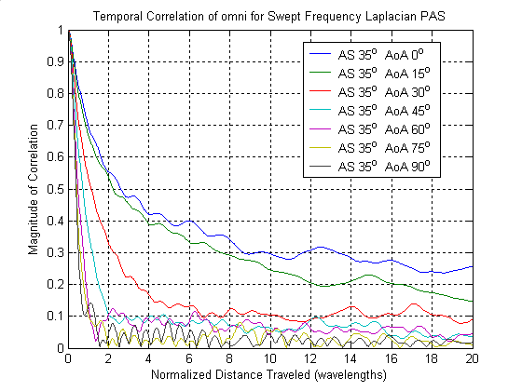
Figure 9 - Temporal Correlation for Swept Frequency Laplacian PAS with 35 degree AS and a range of AoA for θ_{v} of 0 degrees.

