

Has the pleasure of inviting you to 3GPP RAN WGs

13-17 October 2025

In Prague, Czech Republic

TITLE | TYPE | DATES | LOCATION | CTRY
3GPPRAN1#122 bis | OR | 13 – 17 October 2025 | Prague | Czech Republic
3GPPRAN2#131 bis | OR | 13 – 17 October 2025 | Prague | Czech Republic
3GPPRAN3#129 bis | OR | 13 – 17 October 2025 | Prague | Czech Republic
3GPPRAN4#116 bis | OR | 13 – 17 October 2025 | Prague | Czech Republic

Event’s summary

- 3GPP meeting venue: 02 Universum
- Accommodation at the STAGES HOTEL Prague (next door to the conference center, a Tribute Portfolio Hotel of Marriott)
- Book your group rate for 3GPP RAN

Sophia Antipolis, 24 April 2025
3GPP RAN WGs
from Monday 13 to Friday 17 October 2025 in Prague, Czech Republic

Dear Delegate,

ETSI has the pleasure of inviting you to the above-mentioned meetings.
Meeting Venue
02 Universum conference center in Prague
Českomoravská čp. 2345/17a, 190 00 Praha 9 web@bestsport.cz
Stage Hotel Prague (a Tribute Portfolio Hotel of Marriott, next door to meeting venue)
Here's your reservation link your guest can use to make reservations:
Book your group rate for 3GPP RAN
Hotel(s) offering your special group rate:
Stages Hotel Prague, a Tribute Portfolio Hotel
for 3,600 CZK per night

Single room B&B for 3,600 CZK per night, Double room B&B for 3,750 CZK per night
The above rates are net, quoted per room per night. Rates include Buffet Breakfast and VAT; rates do not include local tax.
Rates are subject to 12% VAT. In case of any VAT changes the Hotel reserves the right to charge applicable VAT according to the effective legal regulation.
Guest room check-in time is 15:00 (3:00 p.m.). Guest room check-out time is 12:00 (12:00 p.m.). Requests for early check-in or late check-out to be advised in advance, extra charge may apply, subject to availability.
INDIVIDUAL CANCELLATION CONDITIONS
Cancellation received 48 hours prior arrival – free of charge
Cancellation received less than 48 hours prior arrival – hotel charges amount for the whole stay to the debit/credit card attached with the reservation
ROOMS ATTRITION
The Hotel is relying upon Customer’s use of the Room Night Commitment. Customer agrees to inform the Hotel of a final adjusted number of rooms in the block (the “Adjusted Room Night Commitment”) by 30 days prior to arrival.
The reserved capacity will be released based on sold rooms according to the schedule below:
- 10/07/2025 30% of unsold capacity will be released
- 10/08/2025 50% of unsold capacity will be released
- 10/09/1025 all unsold capacity will be released

Additional reservations after the final release are subject to availability. ETSI rate is not guaranteed after the final release, it is subject to availability.

Alternatives hotels:
Map of hotels
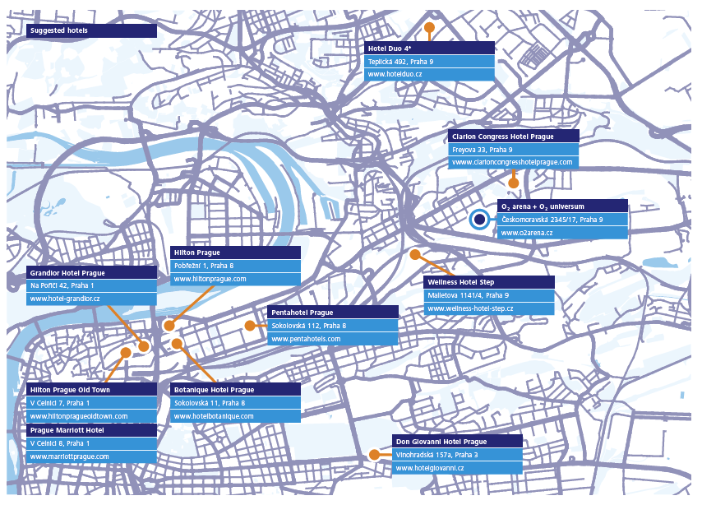

Clarion Congress Hotel Prague****
Freyova 33, Prague 9 – Vysočany, Czechia
https://www.clarioncongresshotelprague.com/en/reservations?preferrate=5058&datein=2025-10-12&dateout=2025-10-18&adults=1
contact person: Eliška Mrázová e.mrazova@clarion-hotels.cz

Wellness Hotel
You can book with their reservation system with a 10% discount from other portals- this is the link- https://www.wellness-hotel-step.cz/en/book-now

Meeting Registration
The registration to the meeting is mandatory. Please register to the meetings at:
TITLE
3GPPRAN1#122 bis
3GPPRAN2#131 bis
3GPPRAN3#129 bis
3GPPRAN4#116 bis

****VISA LETTER****
 Delegates needing a visa in order to attend a meeting hosted by ETSI should make their hotel booking where the meeting will take place. As soon as they book their room please ask the hotel to provide you with a personal letter.
We would like to invite you to fill-in your own invitation letter which contains all your personal information. Please follow these steps:
- Please download the visa application letter template at
http://www.3gpp.org/delegates-corner#outil_sommaire
(Under meeting Delegates FAQs, meeting document template, “visa application letter template”)
- Please update the letter accordingly
- Please send your letter to e3mag@etsi.org for signature

How to reach the meeting venue
Prague Public Transit Company (DPP) plans long-term closure of metro station Českomoravská, which was not refurbished since it´s opening in 1985. They put together all relevant and important information about your accessibility, you will find all details in attached document. O2 universum remains well connected to public transportation network and once the renovation is finished, metro stop will bring higher comfort for guests and visitors.

Instructions for visitors during closure can be found on https://www.o2arena.cz/en/information-on-transport-accessibility-in-2025/, if travelling by metro, easiest way is to leave metro at station Vysocanska and walk 10 minutes

Apart from public transportation, taxis, Uber and Bolt are widely present in Prague.

Host Contacts
For any questions about anything relating to the meeting please contact: e3mag@etsi.org

We look forward to seeing you all in Prague.

Take care, travel safe,

Your ETSI 3GPP Meeting Host @ e3mag@etsi.org

