**RAN1#118 Online Session Schedule**

**Expo Foyer (Lv1)**

**0.4 Brussels (Lv0)**

**2.18/2.19 Mekiong/Madeira (Lv2)**

|  |  |  |  |  |  |  |  |  |  |  |  |  |  |  |  |
| --- | --- | --- | --- | --- | --- | --- | --- | --- | --- | --- | --- | --- | --- | --- | --- |
|  | **Monday** | | | **Tuesday** | | | **Wednesday** | | | **Thursday** | | | **Friday** | | |
| **08:30**  **~**  **10:30**  **(120 min)** | **RAN1#118 commences at 09:00 on Monday**  Agenda items 1, 2, 3, 4, 5  Agenda items 7 | | | R19 LP-WUS (90)  R19 XR (30) | R19 7-24GHz (60)  AI 8.1 (60) . MCE . Mobility | R19 NTN (120) | R19 LP-WUS (90)  AI 8.1 (30) . NES, Others | R19 7-24GHz (75)  R18 UE features (45)  8.2.2 MobEnh (15)  8.2.1 MCE (30) | R19 NTN (120) | AI 5 Incoming LSs (5)  R19 LP-WUS (115) | R19 7-24GHz (75)  R18 UE features (45)  8.2.2 MIMO (45) | R19 NTN (90)  AI 8.1 (30) | R19 NES (90)  TBD (30) | TBD (120) | R19 A-IoT (75)  R19 NTN (45) |
| **Morning coffee break: 10:30 ~ 11:00** | | | | | | | | | | | | | | | |
| **11:00**  **~**  **13:00**  **(120 min)** | Agenda item 7 (30)  Agenda item 8.1 (90) . MIMO, NES, Others | | | R19 Duplex (120) | R19 AI/ML (120) | R19 A-IoT (120) | R19 Duplex (120) | R19 AI/ML (120) | R19 ISAC (75)  AI 8.1 (45) . Pos | R19 XR (45)  AI 7 (45)  AI 8.1 (30) | R19 AI/ML (120) | R19 A-IoT (120) | AI 7 (30)  R19 LP-WUS (90) |  |  |
| **Lunch break: 13:00 ~ 14:30** | | | | | | | | | | | | | | | |
| **14:30**  **~**  **16:30**  **(120 min)** | R19 MIMO (120) | R18 UE features (60)  8.2.2 NES (30)  8.2.2 IoT-NTN (15)  8.2.2 MobEnh (15)  AI 8.1 (60) . MC-Enh | R19 A-IoT (120) | R19 MIMO (90)  R19 Mobility (30) | R18 UE features (60)  8.2.2 Positioning (15)  8.2.2 NES (30)  8.2.2 IoT-NTN (15)  AI 7 (60) | AI 8.1 (120) . MBS(30) . Pos (90) | R19 MIMO (120) | AI 8.1 (60) . MC-Enh . Mobility  AI 7 (60) | R19 A-IoT (120) | R19 MIMO (90)  R19 Mobility (30) | AI 8.1 (60) . MCE . Mobility  AI 7 (60) | R19 A-IoT (120) | Any other issues  Session reports  **RAN1#118 expected to close at 17:00** | | |
| **Afternoon coffee break: 16:30 ~ 17:00** | | | | | | | | | | | | |
| **17:00**  **~**  **19:30**  **(150 min)** | R19 NES (120)  R19 Mobility (30) | R19 AI/ML (150) | R19 ISAC (60)  AI 8.1 (90) . NTN(30) . SL (60) | R19 NES (105)  AI 7 (45) | R19 AI/ML (150) | R19 A-IoT (150) | R19 NES (120)  AI 8.1 (30) . MIMO | R19 AI/ML (150) | R19 A-IoT (150) | R19 Duplex (150) | R19 AI/ML (150) | AI 8.1 (60) . SL  R19 ISAC (90) |
| **All sessions end at 19:45 – no exceptions** | | | | | | | | | | | | | | | |

**RAN1#118 Offline Session Schedule**

**0.8 Rome (Lv0)**

**MECC Suite (Lv1)**

|  |  |  |  |  |  |  |  |  |  |  |
| --- | --- | --- | --- | --- | --- | --- | --- | --- | --- | --- |
|  | **Monday** | | **Tuesday** | | **Wednesday** | | **Thursday** | | **Friday** | |
| **08:30**  **~**  **10:30**  **(120 min)** |  | | R18/R19 Mobility (60)  R19 MIMO (60) | R19 AI/ML (120) | R19 Duplex (90)  R19 MIMO (30) | R19 AI/ML (120) | R19 A-IoT (120) | R19 AI/ML (120) | R19 LP-WUS (120) |  |
| **Morning coffee break: 10:30 ~ 11:00** | | | | | | | | | | |
| **11:00**  **~**  **13:00**  **(120 min)** |  | | R19 NES (120) | R19 ISAC (120) | R19 MIMO (45)  R19 NES (75) | R19 A-IoT (120) | R19 MIMO (120) | R19 Duplex (120) | Younsun (120) |  |
| **Lunch break: 13:00 ~ 14:30** | | | | | | | | | | |
| **14:30**  **~**  **16:30**  **(120 min)** | R19 Duplex (120) | R19 7-24GHz (60)  R19 AI/ML (60) | R19 A-IoT (120) | R19 AI/ML (120) | R19 ISAC (60)  R19 NTN (60) | R19 AI/ML (120) | R19 Duplex (45)  R19 NES (75) | R19 AI/ML (120) | To be assigned by Xiaodong  To be assigned by David | |
| **Afternoon coffee break: 16:30 ~ 17:00** | | | | | | | | |
| **17:00**  **~**  **19:30**  **(150 min)** | R19 MIMO (60)  R19 LP-WUS (90) | A-IoT (90)  NTN (60) | R19 XR (30)  R19 Mobility (30)  R19 LP-WUS (90) | R19 7-24GHz (75)  R19 NTN (75) | R19 LP-WUS (150) | R19 7-24GHz (75)  R19 XR (35)  R19 Mobility (40) | R19 NES (90)  R19 NTN (60) | R19 A-IoT (150) |
| **All sessions end at 19:45 – no exceptions** | | | | | | | | | | |

**RAN1#118 Detailed Schedule for RAN1 Main Session**

|  |  |  |  |  |  |
| --- | --- | --- | --- | --- | --- |
|  | **Monday** | **Tuesday** | **Wednesday** | **Thursday** | **Friday** |
| **08:30**  **~**  **10:30**  **(120 min)** | Agenda items 1, 2, 3, 4, 5  Agenda items 7 | R19 LP-WUS (90) . 9.6.3 . 9.6.1 . 9.6.2  R19 XR (30) | R19 LP-WUS (90) . 9.6.1 . 9.6.2  AI 8.1 (30) . NES, Others | R19 LP-WUS (120) . 9.6.1 . 9.6.2 . 9.6.3 |  |
| **Morning coffee break: 10:30 ~ 11:00** | | | | | |
| **11:00**  **~**  **13:00**  **(120 min)** | Agenda item 7 (30)  Agenda item 8.1 (90) . MIMO, NES, Others | R19 Duplex (120) . 9.3.1 . 9.3.2 . 9.3.3 | R19 Duplex (120) . 9.3.1 . 9.3.2 . 9.3.3 | R19 XR (45)  AI 7 (45)  AI 8.1 (30) |  |
| **Lunch break: 13:00 ~ 14:30** | | | | | |
| **14:30**  **~**  **16:30**  **(120 min)** | R19 MIMO (120) . 9.2.1 . 9.2.2 . 9.2.3 . 9.2.4 | R19 MIMO (90) . 9.2.1 . 9.2.2  R19 Mobility (30) | R19 MIMO (120) . 9.2.3 . 9.2.4 . 9.2.2 . 9.2.1 | R19 MIMO (90)  R19 Mobility (30) |  |
| **Afternoon coffee break: 16:30 ~ 17:00** | | | | |
| **17:00**  **~**  **19:30**  **(150 min)** | R19 NES (120) . 9.5.1 . 9.5.2 . 9.5.3  R19 Mobility (30) | R19 NES (105) . 9.5.1 . 9.5.2 . 9.5.3  AI 7 (45) | R19 NES (120) . 9.5.1 . 9.5.2 . 9.5.3  AI 8.1 (30) . MIMO | R19 Duplex (150) |
| **All sessions end at 19:45 – no exceptions** | | | | | |

**Level 0: RAN1 Breakout#1, Offline#1**

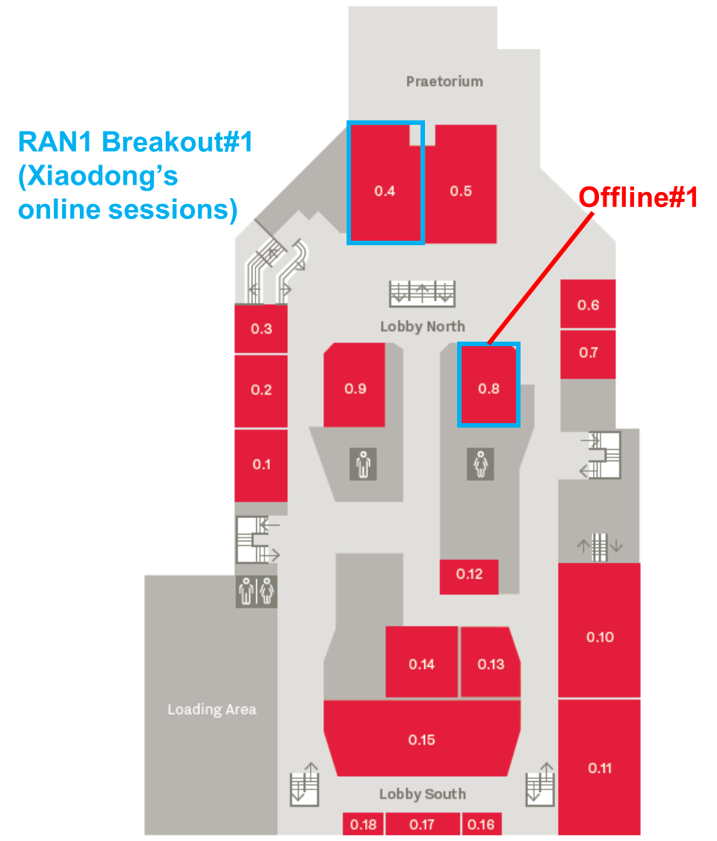

**Level 1: RAN1 Main Session, Offline#2**

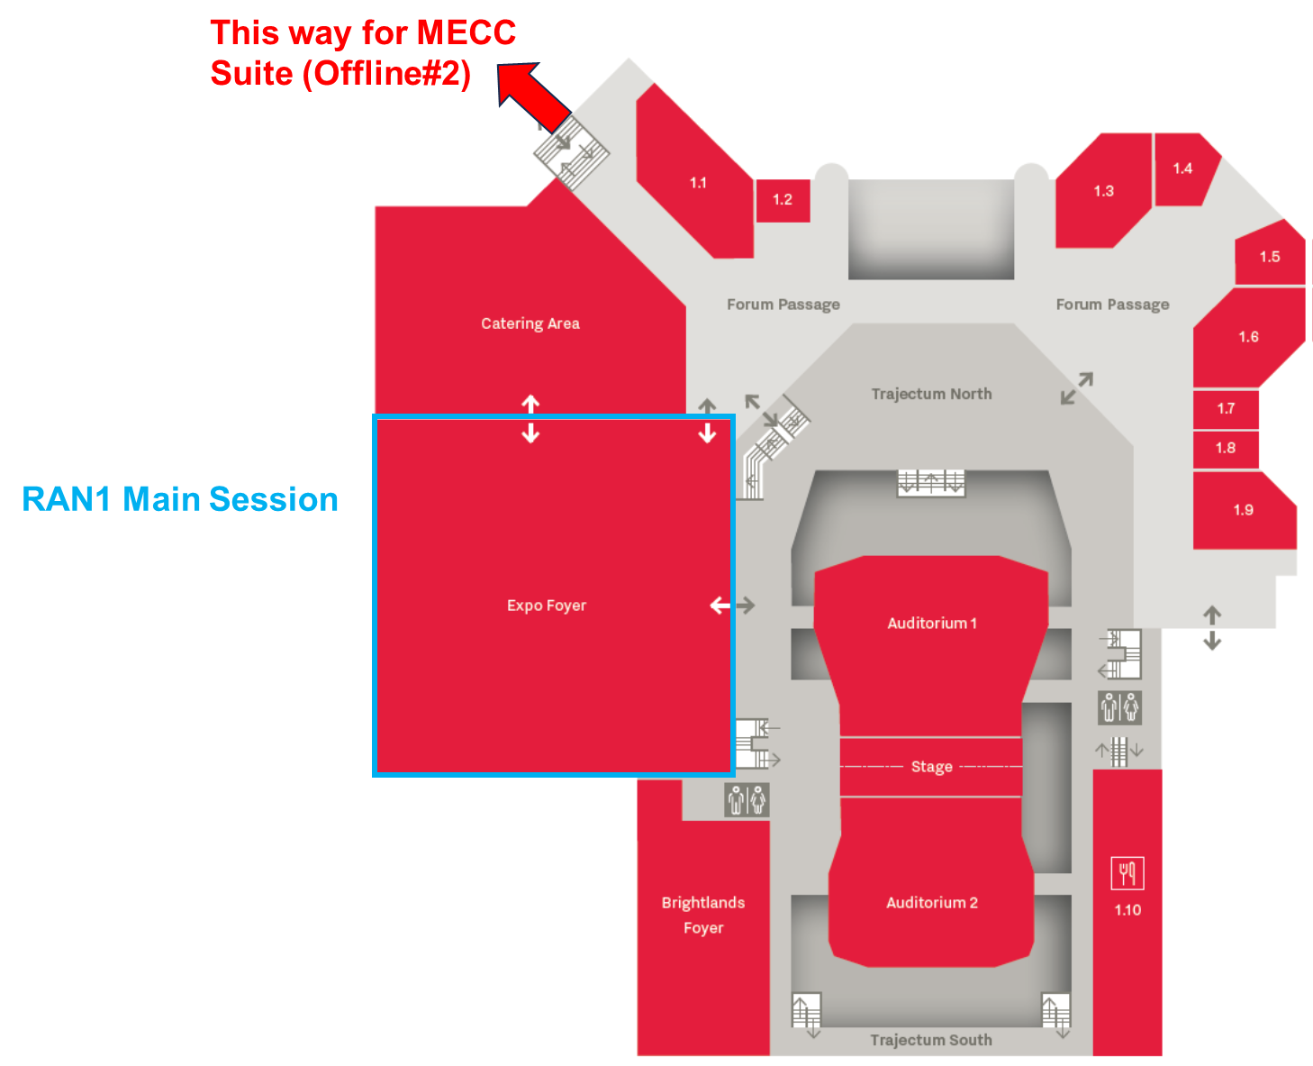

**Level 2: RAN1 Breakout#2**

