**3GPP TSG RAN WG1 #107-e R1-21xxxxx**

**e-Meeting, Nov. 11 – Nov. 19, 2021**

**Source: Moderator (MediaTek)**

**Title: [107-e-NR-7.1CRs-11] Email discussion on Issue#18: Clarification on PUSCH with UCI Only and DMRS Multiplexing**

**Agenda item: 7.1**

**Document for:** **Discussion and Decision**

Introduction

In RAN1#107-e meeting, two contributions [1, DOCOMO] and [2, MTK] are submitted to clarify the UE behavior when a DCI scheduling a PUSCH without UL-SCH indicates FDM between UL-SCH and DM-RS.

As guided by the Chairman, this contribution provides summary of the submitted contributions (Section 4), discussion points (Section 2), and possible RAN1 conclusion during this meeting (Section 3, TBD).

[107-e-NR-7.1CRs-11] Issue#18: Clarification on PUSCH with UCI Only and DMRS Multiplexing by Nov 17 – ??? (MediaTek)

* Only to draw a possible conclusion on Issue#18

Discussion points (phase 1 until 12-Nov)

Based on the submitted contributions [1, DOCOMO] and [2, MTK], both companies strive to clarify the UE behaviour when a DCI scheduling a PUSCH without UL-SCH indicates FDM between UL-SCH and DM-RS and propose that

* ***Proposal 1: UE does not transmit any bits for non-DMRS RE(s) in DMRS symbol(s) when a DCI format 0_1 includes UL-SCH indicator = 0 and an indication of FDM between UL-SCH and DMRS.***

The proposal above corresponds to Interpretation #1 as shown in Figure 1 (a) below:

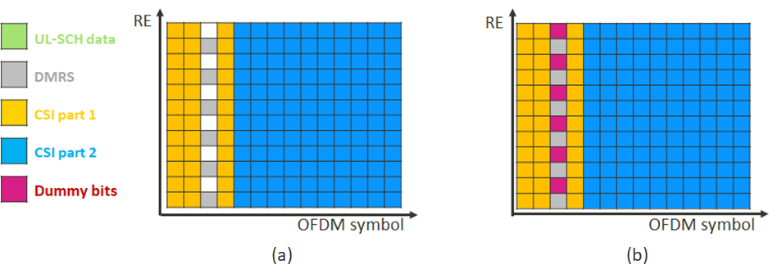

Figure 1. Two possible UE behaviours: Interpretation #1 in (a) and Interpretation #2 in (b)

In the preparation phase summary for AI 7.1 during RAN1 #107e [3], RAN1 Chairman’s initial assessment is

* + Seems the **current specification is written in a way to reflect interpretation1**. Seems no further spec change is necessary

and companies’ stands in [3] are

* + **Interpretation1:** MTK, Nokia, CATT, Samsung, Huawei, Futurewei, vivo, Ericsson, Intel, Apple
  + **Up to UE implementation, this case can be avoided by gNB:** Qualcomm

**Discussion point 1:**

**To draw a possible conclusion in this meeting as guided by Chairman, do you agree to take the following proposal as RAN1 conclusion:**

* ***Proposal 1: UE does not transmit any bits for non-DMRS RE(s) in DMRS symbol(s) when a DCI format 0_1 includes UL-SCH indicator = 0 and an indication of FDM between UL-SCH and DMRS.***

**If your answer is “No”, please try to provide a way forward in comment if possible, to address the concern raised by [1, DOCOMO]**

* **gNB might schedule a PUSCH with UL-SCH indicator = 0 that is indicated to perform FDM between UL-SCH and DMRS, since there is no spec text preventing gNB from doing this. Prohibiting this case will be NBC from gNB’s perspective.**

|  |  |  |
| --- | --- | --- |
| **Company** | **Yes/No** | **Comment** |
| MTK | Yes | We think this conclusion is needed to align behaviour between UE and gNB, and prevent NBC issue for gNB. |
|  |  |  |
|  |  |  |
|  |  |  |

Proposed RAN1 conclusion (phase 2)

TBD, based on outcome of phase 1 discussion.

Summary of contribution inputs

**Summary for [1, DOCOMO]:**

In [1], it mentions that in NR Rel-15/16, when UCI is multiplexed on a PUSCH, the UCI cannot be FDMed with PUSCH DM-RS.

|  |
| --- |
| **38.212 (16.6.0)** 6.2.7 Data and control multiplexing ...  Denote  as the set of resource elements, in ascending order of indices , available for transmission of UCI in OFDM symbol , for . Denote  as the number of elements in set . Denote  as the -th element in . For any OFDM symbol that carriers DMRS of the PUSCH, . For any OFDM symbol that does not carry DMRS of the PUSCH, .  ... |

**Meanwhile, UL-SCH can be FDMed with PUSCH DM-RS**. In current spec, **UE behavior is unclear when a DCI scheduling a PUSCH without UL-SCH indicates FDM between UL-SCH and DM-RS**. Two points should be discussed:

* Point 1: Whether this FDM indication is possible or not
* Point 2: Whether dummy bits are generated on non-DMRS RE(s) in DMRS symbol(s)
  + Note: this aspect would have impacts on signal generation, e.g. PUSCH scrambling

For Point 1, in our understanding, **there is no text to prohibit that gNB indicates the situation**. That is, **gNB might schedule a PUSCH without UL-SCH that is indicated to perform FDM between UL-SCH and DMRS**. **If the prohibition is added, it will be NBC from gNB perspective**. Therefore, we believe that no additional agreement/conclusion on Point 1 is necessary. Regarding Point 2, it seems that there is no text in any specification to generate dummy bits for the non-DMRS RE(s) in this situation. In this sense, the correct UE behavior based on the specifications is not to generate any bits for the non-DMRS(s), and for example PUSCH scrambling specified in clause 6.3.3.1 of 38.211 is applied to the bit sequence without any bit corresponding to the non-DMRS RE(s).

**Observation:**

* *Current specifications do not prohibit a UL grant indicating ‘without UL-SCH’ and ‘FDM between UL-SCH and DM-RS’.*
* *Current specifications do not allow any bits generation for non-DMRS RE(s) in DMRS symbol(s) in the above situation.*

**Proposal for conclusion:**

* *UE does not generate any bits for non-DMRS RE(s) in DMRS symbol(s) when a DCI format 0_1 includes UL-SCH indicator = 0 and an indication of FDM between UL-SCH and DMRS.*

**Summary for [2, MTK]:**

In [2], it is mentioned that in AH #1801 meeting, the following agreement regarding the multiplexing of PUSCH and DMRS when UCI is piggybacked on PUSCH was made.

Agreements:

* It is clarified that based on previous agreements, when UCI is piggybacked on PUSCH, UCI is not FDMed with DMRS
  + This applies to the case regardless of whether UL-SCH is present on PUSCH or not

It indicates that UCI is not FDMed with DMRS no matter when UL-SCH is present on PUSCH or not. However, there is ambiguity on whether PUSCH with UCI only can be FDMed with DMRS or not. If it is possible, then it is not clear in TS 38.212 about what data to be transmitted on non-DMRS RE(s) in the DMRS symbol(s).

Moreover, when UL-SCH is **NOT** present on PUSCH, i.e., ‘UL-SCH indicator’ in DCI format 0_1 is 0, there is ambiguity on what to be transmitted on non-DMRS RE(s) in the DMRS symbol(s) if the network indicates data is FDMed with DMRS. Two possible interpretations on UE behaviour are as follows.

* **Interpretation #1:** UE does not transmit anything on non-DMRS RE(s) in the DMRS symbol(s) – see Figure 1(a)
* **Interpretation #2:** UE generates and transmits dummy bits on non-DMRS RE(s) in the DMRS symbol(s) – see Figure 1(b)



Figure 1. Two possible UE behaviours if PUSCH with UCI only is allowed to be FDMed with DMRS

**Proposal**: **RAN1 to adopt Interpretation #1 since it is more consistent with the spirit of the agreement in AH #1801. Additionally, how to generate the dummy bit(s) as depicted in Interpretation #2 is undefined in current specification.**

References

[1] R1-2112088 Discussion on PUSCH without UL-SCH and with FDM indication, NTT DOCOMO, INC., RAN1 #107e

[2] R1-2112293 Clarification on PUSCH with UCI Only and DMRS Multiplexing, MediaTek, RAN1 #107e

[3] R1-21xxxxx RAN1#107-e_NR_CRs_7.1_summary_v16_Apple_Moderator, [download link](https://www.3gpp.org/ftp/tsg_ran/WG1_RL1/TSGR1_107-e/Inbox/drafts/7.1/Preparation%20Phase/RAN1%23107-e_NR_CRs_7.1_summary_v16_Apple_Moderator.xlsx), RAN1, RAN1 #107e