**3GPP TSG RAN WG1 #107-e R1-211xxxx**

e-Meeting, November 11th – 19th, 2021

Agenda Item: 7.1

Source: Moderator (Apple Inc.)

Title: Summary of [107-e-NR-7.1CRs-10] Issue#17 Discussion and clarification on CSI report during SCell activation

Document for: Discussion/Decision

# Introduction

This document provides summary on the following email discussion;

|  |
| --- |
| [107-e-NR-7.1CRs-10] Issue#17: Discussion and clarification on CSI report during SCell activation by Nov 17 – Haitong (Apple) |

The issue was raised in contribution R1-2111846 [1]. This document is structured as the following

* Section 2 is used to provide background on issues raised for the CSI report during SCell activation
* Section 3 is used to collect companies’ views.
* Section 4 is used to summarize the outcome of the email discussion

Please provide your comments in Section 3 preferably by **12th Nov 23:59 UTC** (1st check point).

# Background

In this email discussion, the purpose is to discuss and collect companies’ understanding regarding the UE CSI report during SCell activation. Figure 1 illustrates the important timeline for SCell activation,

* NW transmits MAC-CE to activate SCell
* UE receives the corresponding MAC-CE and feedbacks HARQ-ACK on UL
* T1: 3ms after UE feedbacks the HARQ-ACK
* T2: UE feedbacks the first valid CQI report which is considered as SCell activation complete

The discussion is regarding the UE CSI report during SCell activation, i.e., between T1 and T2.

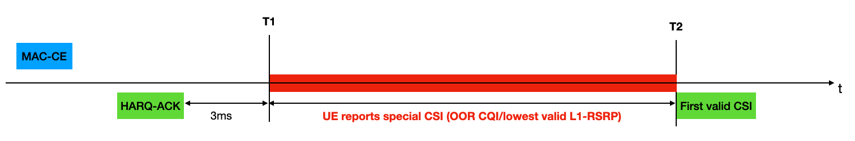

Figure 1 Timeline for SCell Activation

## RAN4 38.133 specification

In RAN4 38.133 [2], it is specified that UE should report OOR (Out of Range) for CQI and lowest valid L1 SS-RSRP range for L1-RSRP for SCell between T1 and T2. The specification reference is as below

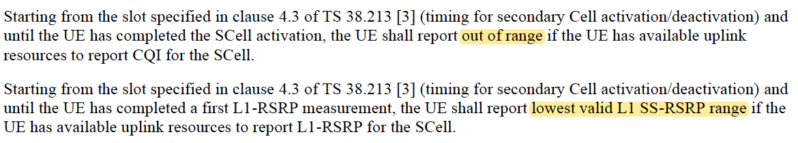

## RAN1 38.214 specification

In RAN1 38.214 [3], there is the following sentence which requires UE to drop the CSI report when there is no valid CSI measurement after the serving cell activation



The interpretation of this paragraph can be ambiguous,

* If the “serving cell activation” refers to time T1, i.e., 3ms after UE sends HARQ-ACK, then the RAN1 specification is in conflict with RAN4 specification
* If the “serving cell activation” refers to time T2, i.e., after UE transmits the valid CQI to complete the SCell activation, then the RAN1 specification is not in conflict with RAN4 specification

# Email Discussion

## First Round

Based on the description of the issues, we have the following two questions to collect companies’ view

**Question #1: Do you agree that we should follow RAN4 specification, i.e., 38.133, in terms of UE CSI reporting during SCell activation**

* **Note: The SCell activation discussed here is the time from the slot specified in clause 4.3 of TS 38.213 to the time when UE completes the SCell activation, i.e., reports a valid CQI**
* **Note: RAN4 specification requires UE to report special CSI, i.e., Out of Range (OOR) for CQI and lowest valid SS-RSRP range for L1-RSRP, as specified in 38.133**

|  |  |
| --- | --- |
| **Company** | **View** |
|  |  |
|  |  |
|  |  |
|  |  |
|  |  |
|  |  |

**Question #2: Companies please provide your view on whether specification change is necessary, if your view is that UE CSI reporting during SCell activation should follow RAN4 specification in 38.133.**

* **Note: the specification change is for 38.214, Clause 5.2.2.5**

|  |  |
| --- | --- |
| **Company** | **View** |
|  |  |
|  |  |
|  |  |
|  |  |
|  |  |
|  |  |

# Outcome of the Email discussion

To be updated

# Reference

1. R1-2111846, "Discussion and clarification on CSI report during SCell activation", 3GPP TSG RAN WG1 #107-e, e-Meeting, November 11th – 19th, 2021
2. 3GPP TS 38.133, Requirements for support of radio resource management (Release 16), V16.8.0, 2021-06
3. 3GPP TS 38.214, Physical layer procedures for data (Release 16), V16.7.0, 2021-09