HST evaluations
Based on the company’s inputs, it is a common understanding that only LLS should be used for HST evaluations. Therefore, it is proposed to limit discussion scope to LLS assumptions only
Proposal #1:
- LLS to be used for Rel-17 HST evaluations
Company | Comment

Frequency range
Companies have provided views on the FR that should be used for HST evaluations. Some companies prefer to prioritize FR1 for HST evaluations (ZTE, CATT, IDC, Lenovo/MotM, CMCC, Nokia), while other companies prefer to treat FR1 and FR2 with equal priority (SS, Intel, E///, vivo), i.e.,
- Alt .1: FR1 + FR2, but FR1 is prioritized
- Alt. 2: FR1 + FR2
From simulation perspective, it is better to define assumptions for both FR1 and FR2 and decide possible FR prioritization later.
Proposal #2:
- Define HST simulation assumptions for both FR1 and FR2
Company | Comment

HST layout
Two HST layout options were proposed by companies based on TR 38.913 supporting FR1 + FR2 (Samsung, Lenovo/Motorola Mobility, Nokia) and TS 36.101 Annex B.3A with Ds=700m, Dmin=150m supporting FR1 (CMCC, Intel, IDC, CATT, Ericsson, LG, FUTUREWAY, Sony), i.e.,
- Alt 1: TR 38.913 (FR1 + FR2)
- Alt 2: TS 36.101 Annex B.3A (FR1: Ds=700m, Dmin=150m, FR2: TBD)
Proposal #3:
- Companies to provide their views on the preferred TRP layout for HST evaluation for both FR1 and FR2
  - Alt 1: TR 38.913 (FR1 + FR2)
  - Alt 2: TS 36.101 Annex B.3A (FR1: Ds=700m, Dmin=150m, FR2: TBD)
Company | Comment

gNB antenna orientation
Two companies provided views on the gNB antenna orientation in HST deployment.
- Alt 1: Bi-directional only
- Alt 2: Unidirectional + Bidirectional
Considering operator’s input on realistic deployment scenario and given RAN4 requirements are only defined for bi-directional model, it seems natural to use bi-direction antenna orientation should mandatory antenna orientation and unidirectional as optional
Proposal #4:
- Use bi-directional as mandatory and uni-directional as optional gNB antenna orientation
Company | Comment

Channel model
Some companies proposed to reuse RAN4 channel models (TS 36.101 / TR 36.878) as much as possible (Samsung, Intel, IDC, CATT, Ericsson, LG, FUTUREWEI, CMCC, Sony, OPPO, Nokia), while other companies proposed by extend RAN4 models by including multi-path components using CDL framework (ZTE, CMCC, Huawei/HiSilicon, Lenovo/Motorola Mobility, vivo),i.e.,
- Alt 1: 4 taps - TS 36.101 (Annex B.3A) / TR 36.878 (RAN4)
- Alt 2: Multi-path extension of TS 36.101 (Annex B.3A) / TR 36.878 (RAN4) + CDL TR 38.901
Considering maturity of the model it is recommended to include RAN4 model as part of simulation assumption and continue discussion to finalize multipath extension of RAN4 model using CDL framework

Proposal #5:
- Adopt RAN4 4-taps model based on TS 36.101 (Annex B.3A) / TR 36.878
- Further discuss CDL based multipath extension from RAN4 model, e.g., using the following proposal (CMCC) as a starting point
CDL based channel model proposal for HST:

Therefore, we think that some combination of the CDL channel model in TR38.901 and the 4-tap channel model in TS36.101 Annex B.3A could be considered. One simple way could be similar to the suggestion of ZTE, as illustrated in figure 3 below, 2-tap channel model for simplicity could be assumed which is similar to RAN4’s 4-tap assumption in order to reflect the characteristic of SFN-based transmission, and for each tap, CDL channel model in TR38.901 could be used to model the effect of the directional antenna of gNB.
  - The delay for k’th TRP is modified as
$$τ_{k,n}=τ_{k}+τ_{n}$$
where is the delay of k’th TRP, which can be derived as
$$τ_{k}=\frac{\left|y(t)-x_{k}\right|}{C}$$
where $τ_{n}$ is the delay of the n’th channel cluster as in Table 7.7.1-1~7.7.1-5 in 38.901, and assume the location of the k’th TRP is xk, and the UE’s location is y(t).
The delay spread for different TRPs could be modeled as different as suggested by Huawei.
  - The normalized power for k’th TRP is modified as
$$P_{k}=10\lg\left(\frac{\frac{1}{{\left|y(t)-x_{k}\right|}^{2}}}{\sum_{i=1,2}{\frac{1}{{\left|y(t)-x_{i}\right|}^{2}}}}\right)(dB)$$
  - To generate the modified angle parameters, the scaling method mentioned in subclause 7.7.5.1 in TS 38.901 is used
$$φ_{n,\text{scaled}}=\frac{\text{A}{\text{S}}_{\text{desired}}}{\text{A}{\text{S}}_{\text{model}}}\left(φ_{n,\text{model}}-μ_{φ,\text{model}}\right)+μ_{φ,\text{desired}}$$
where $\text{A}{\text{S}}_{\text{model}}=\text{A}{\text{S}}_{\text{desired}}$ could be assumed, and $μ_{φ,\text{desired}}$ of the k’th TRP is the AOD, AOA, ZOD and ZOA of LOS direction derived based on the locations and antenna heights of UE and TRPs.
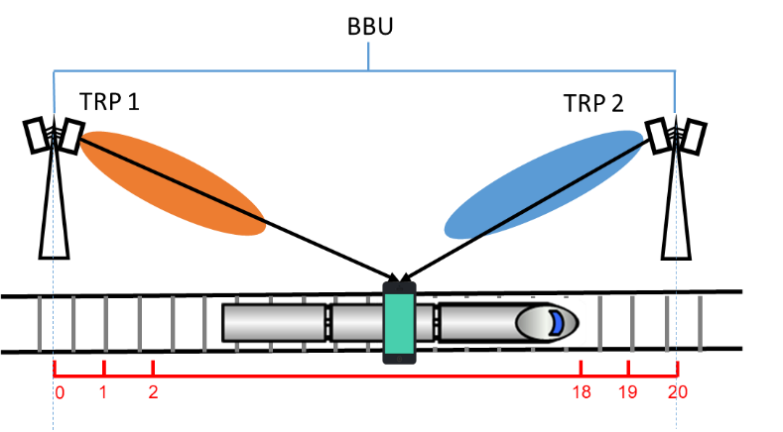
Fig. 3. Simplified and updated HST-SFN channel model for evaluation

Company | Comment

Baseline scheme for comparison
Some companies provided their views on the baseline schemes that should be used for performance comparison, i.e.,
- Alt. 1 Rel-15 SFN
- Alt. 2 Rel-16 URLLC
To avoid lengthy discussion on the baseline scheme, it is recommended that each company to provide details on the baseline scheme used for comparison

Proposal #6:
- Each company to provide baseline scheme used for comparison as part of simulation assumptions
Company | Comment

Companies are also encouraged to provide additional inputs regarding HST simulation assumptions using the following table below.

Detailed simulation assumptions:
Parameter | FR1 |  | FR2
Duplexing | FDD | TDD | TDD
TRP layout (Ds, Dmin, etc)
gNB antenna configuration including number of antennas, pattern, ports, orientation, etc
UE antenna configuration including number of antennas, pattern, ports, orientation, etc
DMRS type
Number of DMRS symbols
TDD pattern | N/A
MCS
Number of scheduled RBs
Propagation condition
TRS configuration, TRS periodicity
PDSCH / PUSCH mapping
Rank
BW
Carrier frequency or maximum Doppler shift
Performance metric
Other assumptions or simulation parameters, e.g., correlation am

