3GPP TSG RAN WG1 email discussion [5G-ACIA] R1-20xxx

E-mail discussion, December 14 - 18, 2020

Source: Qualcomm

Title: Simulation Assumptions and URLLC Performance Evaluations for 5G-ACIA Performance Evaluation Round 1

Document for: Discussion

1 Introduction

Following the agreements discussed during the first week of the 5G ACIA e-meeting in October 2020, a number of simulation assumptions and performance metrics are agreed [1]. The goal is to provide performance evaluations to 5G-ACIA for their LS on 3GPP NR Rel-16 URLLC [2], [3]. The target date for the completion of this activity is TSG RAN Meeting #91e in March 2021.

In the following, Qualcomm’s simulation results obtained with the agreed simulation assumptions are presented. The focus of this paper is FR2.

2 Simulation Parameters

In TR 38.824, detailed simulation parameters were provided for system level and link-level simulation assumptions. Most parameters can be reused from TR 38.824, and what is presented here is the set of parameters that are different from the ones of TR 38.824 and which comply with the 5G-ACIA LS.

## 2.1 Performance Metric

From 5G-ACIA LS, three performance metrics are provided:

1) CSA: single CDF of CSA distribution of all UEs in factory hall

2) Latency: single CDF of latency distribution of all UEs in factory hall

3) Percentage of UEs satisfying re-quirements and

4) resource utilization

What will be used in the results presented below is the performance metric number 3, i.e.

* the percentage of UEs satisfying the BLER target requirement equal to 0.1 %

As specified in TR 38.824, this number corresponds to the so call “URLLC Capacity”, especially when this percentage of UEs satisfying the BLER Target is above 90%.

## 2.1 Simulation Parameters

### 2.1.1 Network Topology

A factory hall of 120m x 50m x 10m, which is then fully covered by 12 service areas of 50m x 10m. BS antenna height is 8m for InF-SH and InF-DH. The number of BS/TRPs is ???.

|  |  |
| --- | --- |
| Inter-BS/TRP distance | 20 m?? as in TR 38.824 (reproduced in Figure 1 below) for the factory automation use case. |
| BS antenna height | 8?? m |
| Channel model | InF-DH |

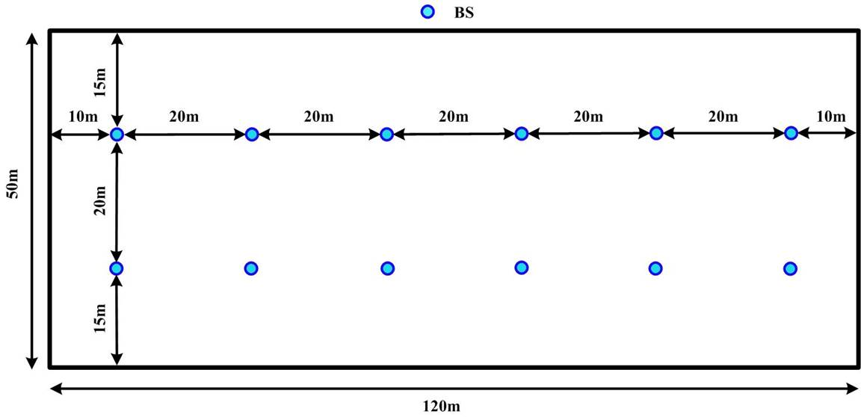

Figure 1. Base station layout for factory automation use case in TR 38.824.

### 2.1.2 Traffic model downlink and uplink

For both downlink and uplink, Option 1 is chosen, hence

*:*

* ***Option-1****: all UEs’ messages both in DL and UL arriving at NG-RAN node in the first transfer interval are uniformly random distributed within the TI time window.*

In addition, *“For DL-UL traffic arrival time relationship”* the option 1 is consdiered*.*

* ***Option-1:*** *DL and UL traffic arrival time instants are independent*

### 2.1.3 Number of UEs per cell

In the 5G-ACIA scenario, the UEs randomly distributed within the respective service area, with up to 50 UEs per service area. Considering that there are a total of 12 service areas, the total number of UEs is up to 12x50=600 UEs.

After fine tuning, the cases of interest are the ones with 20, 28 and 36 UEs per cell

|  |  |
| --- | --- |
| Number of UEs per Cell | {20, 27, 36}  The UEs are randomly distributed in each cell. |

2.1.4 Other assumptions for FR 2

For FR2, only TDD is available. The same parameters are assumed in 5G-ACIA LS and TR 38.824, and summarized below.

|  |  |
| --- | --- |
| Duplex | TDD |
| Carrier frequency | 30 GHz |
| Simulation bandwidth | 160 MHz |
| SCS | 120 kHz |

2.1.4 TDD Frame and slot structure

In order to meet the latency requirements, the slot configuration #50 from the table 11.1.1-1 from 38.213 is selected. It is the slot configuration with the pattern in (symbols) DDFFUUU repeated twice in a 14 symbols slot. The 3rd symbol in the pattern is used as DL symbol and the fourth flexibly symbol is used as gap.



3 URLLC/IIoT Features

## 3.1 Features for FR2

For FR2, SCS of 120 kHz is assumed. This makes it easier to achieve the 1ms latency requirement, even though only TDD is possible for FR2. Due to the limitation of TDD only for FR2, it is even more important to rely on DL SPS and UL CG to support the traffic pattern, thus eliminating the latency caused by PDCCH. Similar to FR1, Rel-15 features appear to be sufficient. We do not see the need to invoke Rel-16 features.

Thus we suggest the following in the simulation study for FR2:

* UL CG with one configuration is assumed to achieve 1 ms latency in UL.
* DL SPS with one configuration is assumed to achieve 1 ms latency in DL.

4 Simulation Results

(to be added)

5 References

1. 3GPP 5G-ACIA, “Agreements on URLLC Features and Simulation Assumptions for 5G-ACIA”,
2. RP‑201279, “LS on 3GPP NR Rel-16 URLLC and IIoT performance evaluation (5G-ACIA-LS-2020-WI042; to: RAN, RAN1; cc: SA1, RAN2; contact: Bosch”, 5GCIA
3. R1-2007186, “RAN1 LS to RAN plenary”
4. RP-202069, “Way forward and RAN work for 5G ACIA requested simulations”, Ericsson
5. RP-202097, “on 3GPP NR Rel-16 URLLC and IIoT performance evaluation” (to: 5G-ACIA; cc: RAN1, RAN2, SA1; contact: Ericsson)
6. TR 38.824.

Appendix 1. Performance requirements in TS 22.104

The services requirements of motion control are copied below from TS 22.104 V17.4.0.

TS 22.104 V17.4.0, Table 5.2-1: Periodic deterministic communication service performance requirements

| Characteristic parameter | | | | Influence quantity | | | | | |  |
| --- | --- | --- | --- | --- | --- | --- | --- | --- | --- | --- |
| Communica­tion service availability: target value (note 1) | Communication service reliability: mean time between failures | End-to-end latency: maximum (note 2) (note 12a) | Service bit rate: user experienced data rate (note 12a) | Message size [byte] (note 12a) | Transfer interval: target value (note 12a) | Survival time (note 12a) | UE  speed (note 13) | # of UEs | Service area  (note 3) | Remarks |
| 99.999 % to 99.999 99 % | ~ 10 years | < transfer interval value | – | 50 | 500 μs | 500 μs | ≤ 75 km/h | ≤ 20 | 50 m x 10 m x 10 m | Motion control (A.2.2.1) |
| 99.999 9 % to 99.999 999 % | ~ 10 years | < transfer interval value | – | 40 | 1 ms | 1 ms | ≤ 75 km/h | ≤ 50 | 50 m x 10 m x 10 m | Motion control (A.2.2.1) |
| 99.999 9 % to 99.999 999 % | ~ 10 years | < transfer interval value | – | 20 | 2 ms | 2 ms | ≤ 75 km/h | ≤ 100 | 50 m x 10 m x 10 m | Motion control (A.2.2.1) |
| NOTE 1: One or more retransmissions of network layer packets may take place in order to satisfy the communication service availability requirement.  NOTE 2: Unless otherwise specified, all communication includes 1 wireless link (UE to network node or network node to UE) rather than two wireless links (UE to UE).  NOTE 3: Length x width (x height).  NOTE 12a: It applies to both UL and DL unless stated otherwise.  NOTE 13: It applies to both linear movement and rotation unless stated otherwise. | | | | | | | | | | |

Appendix 2. Activity plan

As it was agreed in [3]:

* *Discussions are on the RAN1_NR reflector* 
  + *Email activity only during short periods (< week) distributed across the time allocated to the activity*
  + *No email activity in weeks before/during/after RAN1 meetings or RAN defined inactive periods*

Based on statements above, the following activity plan has been proposed:

1. 12-16 October 2020
   * Discussion on which URLLC features to include in the evaluations and simulation assumptions
2. 14-18 December 2020
   * First round of simulation results
3. 22-26 February 2021
   * Second round of simulation results
4. 8-12 March 2021
   * Finalization of the report to RAN#91