3GPP TSG RAN WG1 email discussion [5G-ACIA]

March 8 – 12, 2020

**Source: Qualcomm CDMA Technologies**

**Title: FR1 simulation results for 5G-ACIA performance evaluation**

**Document for: Description of simulation methodology and results**

# Introduction

In response to the following schedule set by the moderator (Ericsson) in the RAN1_NR reflector, we describe in Section 2 our simulation methodology for factory automation under the framework outlined in [1][2][3] and present in Section 3 the corresponding simulation results for FR1.

1. 12-16 October 2020
   * Discussion on which URLLC features to include in the evaluations and simulation assumptions
2. 14-18 December 2020
   * First round of simulation results
3. 22-26 February 2021
   * Second round of simulation results
4. 8-12 March 2021
   * Finalization of the report to RAN#91

# Simulation Assumptions

The simulation parameters for FR1 are summarized as follows:

|  |  |
| --- | --- |
| Parameters | 5G-ACIA |
| Factory hall size | 120 x 50 m |
| Room height | 10 m |
| Inter-BS/TRP distance | 20 m |
| BS / UE antenna height | 8 m / 1.5 m |
| Layout – BS/TRP deployment | 12 BS |
| Channel model | InF-DH |
| Carrier frequency and simulation bandwidth for TDD | 100 MHz for 4 GHz |
| SCS | 30 kHz |
| Number of UEs per service area | 5, 12, 15, 18, 20 |
| UE distribution | Randomly distributed within the respective service area. |
| Message size | 48 bytes |
| DL traffic model | Periodic with random offset; periodicity = 1 ms |
| UL traffic model | UL traffic is symmetric to DL traffic |
| CSA requirements | 99.9999% |
| Performance metrics | 1) CSA: single CDF of CSA distribution of all UEs in factory hall 2) Latency: single CDF of latency distribution of all UEs in factory hall |
| E2E latency | E2E latency: 1 ms |
| UE speed | Linear movement of 75 km/h |
| BS Tx power | 31 dBm (24 dBm per 20 MHz) |
| UE Tx power | 23 dBm |
| BS / UE receiver noise figure | 5 dB / 9 dB |

## Deployment Model

The following deployment model is used with a factory hall layout of 120m x 50m x 10m with the BS locations as shown below. UEs are randomly distributed within the respective service areas, as defined in [1].

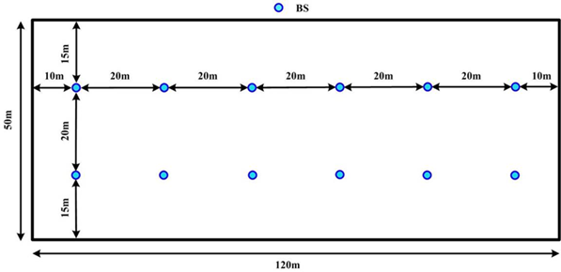

Figure 1: Factory hall layout using the InF-DH model with 12 BS

## Antenna pattern

The following antenna patterns are used:

* UE: 4 antennas; isotropic
* BS: 4 antennas; non-isotropic according to the Table 10 in [4] with mechanical downtilt = 90 0

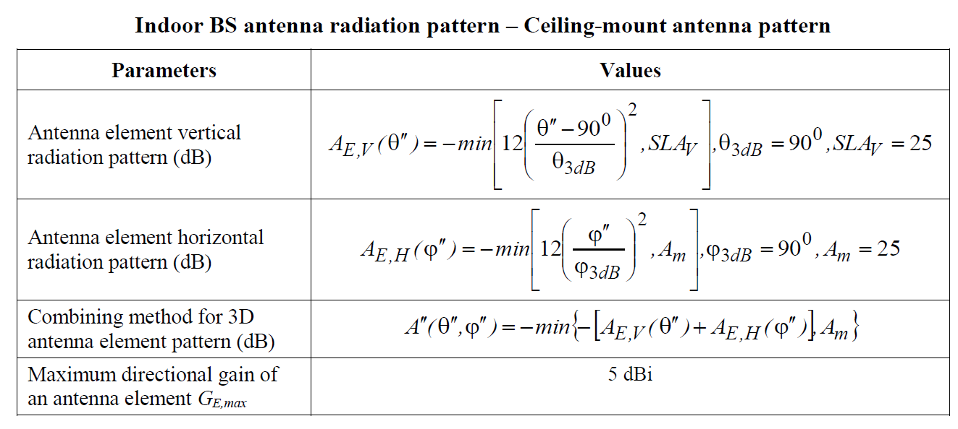

# Simulation Methodology

We consider two approaches for this study: (i) One-shot approach without HARQ retransmissions and (ii) HARQ with up to one retransmission. We evaluate each approach with respect to the packet error rate (PER) and the CSA metric with a survival time of 1 cycle.

## One-shot Approach

### Frame structure

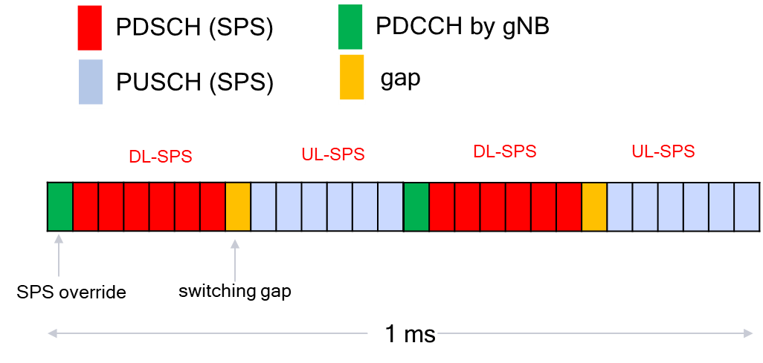

Figure 2: Frame structure for one-shot approach

The frame structure has the format [ D D D D D D D G U U U U U U] as shown in Figure 2. The downlink and uplink data symbols are semi-persistently scheduled (SPS). A PDCCH symbol is provided at the beginning of the frame for possible SPS override. In order to reduce the scheduling latency, the PDSCH transmissions are divided into mini-slots of 2-symbol PDSCH, and the PUSCH transmissions are divided into mini-slots of 2-symbol PUSCH.

### Scheduling delay for different data arrival offsets

For clarity of description, let us index the 14 symbols as shown here 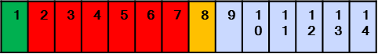 . Every downlink packet is scheduled to transmit at symbols 2, 4 or 6 corresponding to different mini-slot locations with the slot, and the corresponding transmission finishes at symbols 3, 5 or 7 respectively in the same slot. Similarly, every uplink packet is scheduled to transmit at symbols 9, 11 or 13 within the slot, and the corresponding transmission finishes at symbols 10, 12 or 14 respectively in the same slot. If a packet has arrived but is not scheduled (possibly due to limited resources) within 1 ms (i.e., 28 symbols), the packet will be discarded. The minimum latency between the end symbol of packet generation and the end of packet transmission is stated in Table 1:

|  |  |  |  |  |  |  |  |  |  |  |  |  |  |  |
| --- | --- | --- | --- | --- | --- | --- | --- | --- | --- | --- | --- | --- | --- | --- |
| **End symbol of packet generation** | **1** | **2** | **3** | **4** | **5** | **6** | **7** | **8** | **9** | **10** | **11** | **12** | **13** | **14** |
| DL SPS min. latency | 2 | 3 | 2 | 3 | 2 | 11 | 10 | 9 | 8 | 7 | 6 | 5 | 4 | 3 |
| UL SPS min. latency | 9 | 8 | 7 | 6 | 5 | 4 | 3 | 2 | 3 | 2 | 3 | 2 | 11 | 10 |

Table 1 Minimum latency between the end symbol of packet generation and the end of packet transmission

## HARQ approach

### Frame Structure

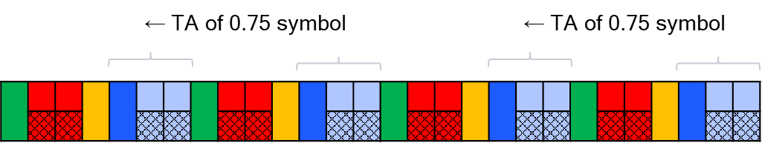

Figure 3 Frame Structure for the HARQ approach

The proposed frame structure shown in Figure 3 consists of periods of 14 symbols. The first seven symbols of each period start with six downlink symbols consisting of combined SPS transmissions and dynamically (PDCCH) scheduled retransmissions followed by a gap symbol. The remaining seven symbols of the period start with six uplink symbols consisting of combined SPS transmissions and dynamically (PDCCH) scheduled retransmissions followed by a gap symbol. The uplink transmissions have timing advance (TA) of 0.75 symbol so that the processing delays between PDSCH 1st Tx and PUCCH, PUCCH and PDCCH ReTx, PUSCH 1st Tx and PDCCH and PDCCH and PUSCH ReTx are sufficient as shown in Figure 4, satisfying the capability-2 UE and BS processing time requirements stated in Table 5.7.1.1.1-1 and Table 5.7.1.1.1-2 of TR 37.910 [5] (the tables are attached in Appendix for reference).

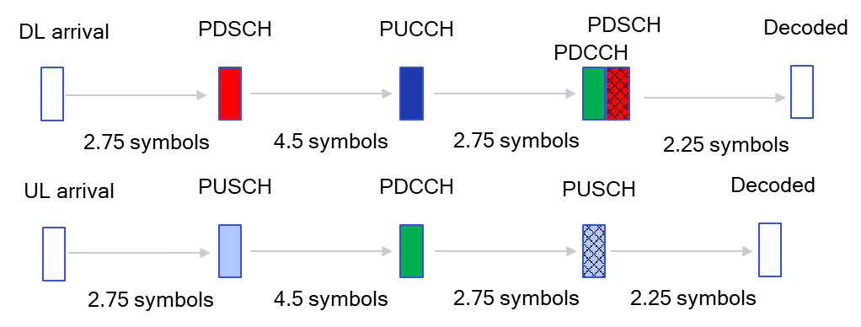

Figure 4 Processing delays

### Scheduling delay for different data arrival offsets

By labelling the 14 symbols as shown here 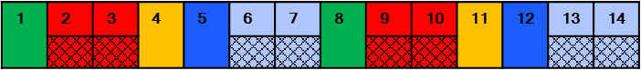, we have the following latency table that characterizes the minimum latencies between the end symbol of packet generation and the end of packet transmission:

|  |  |  |  |  |  |  |  |  |  |  |  |  |  |  |
| --- | --- | --- | --- | --- | --- | --- | --- | --- | --- | --- | --- | --- | --- | --- |
| **Symbol of packet generation** | **1** | **2** | **3** | **4** | **5** | **6** | **7** | **8** | **9** | **10** | **11** | **12** | **13** | **14** |
| DL SPS min. latency | 2 | 8 | 7 | 6 | 5 | 4 | 3 | 2 | 8 | 7 | 6 | 5 | 4 | 3 |
| DL ReTx additional latency | 14 | 14 | 14 | 14 | 14 | 14 | 14 | 14 | 14 | 14 | 14 | 14 | 14 | 14 |
| UL SPS min. latency | 6 | 5 | 4 | 3 | 2 | 8 | 7 | 6 | 5 | 4 | 3 | 2 | 8 | 7 |
| UL ReTx additional latency | 14 | 14 | 14 | 14 | 14 | 14 | 14 | 14 | 14 | 14 | 14 | 14 | 14 | 14 |

Table 2 Minimum latency between the end symbol of packet generation and the end of packet transmission

# Simulation Results

Every plot in this section is generated from 50 random networks. The geometry cdf derived from our simulation is attached below for calibration purpose.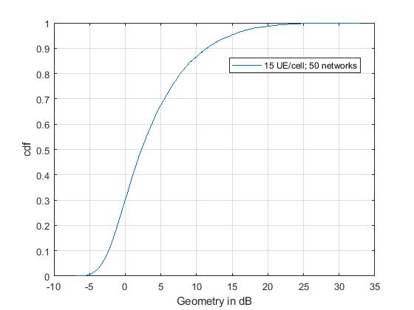

Figure 5

In the rest of this section, we are interested in finding the maximum number of UE/cell that can be supported with respect to each approach such that 100% UL and DL packets satisfy PER or CSA error < 10-6 with latency < 1 ms. The following three categories of network operating modes have been identified in [3]:

* 1. No coordination – no static partitioning or coordination of resources among BS/TRP
  2. Independent/Uncoordinated scheduling – static partitioning of resources among BS/TRP, but with uncoordinated scheduling
  3. Common/centralized scheduling among BS/TRP synchronized within the order of the cyclic prefix

## Category A: No coordination among BS

### One-shot approach with reuse-1 transmissions

#### CSA error metric with packet survival time = 0

Under the one-shot approach, the CSA error metric with zero packet survival time is referred to as packet error rate (PER). The BLER (equal to PER) target is set to 10-6. The percentage of users satisfying the reliability requirement is stated in Table 3, which shows that the corresponding capacity is between 5 UE/cell and 12 UE/cell.

Table 3

|  |  |  |
| --- | --- | --- |
| # of UE/cell | 5 | 12 |
| % of UL packets satisfying PER < 10-6 | 100% | 98% |
| % of DL packets satisfying PER < 10-6 | 100% | 98.75% |

If the network operates at 12 UE/cell which exceeds the capacity, the corresponding complementary cdf of UL and DL PER is shown in Figure 6.

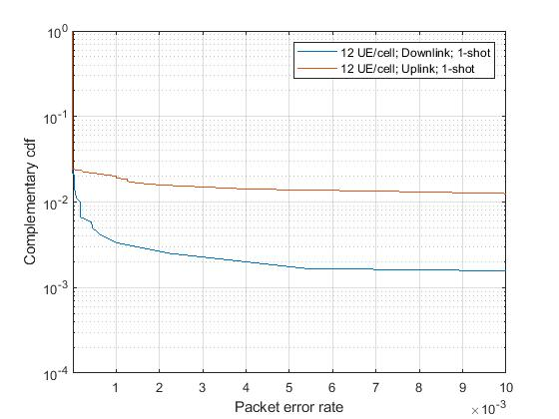

Figure 6

The latency cdf for the achievable 5 UE/cell is shown in Figure 7.

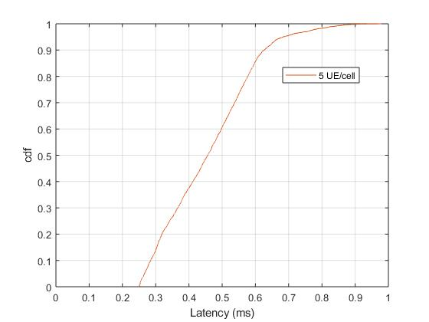

Figure 7

#### CSA error metric with packet survival time = 1

Under the one-shot approach, the CSA error metric with packet survival time = 1 is equivalent to the probability of having two or more consecutive packet errors. The BLER target of each packet is set to 10-4. The percentage of users satisfying the CSA requirement is stated in Table 4, which shows that the corresponding capacity is between 12 and 18.

Table 4

|  |  |  |
| --- | --- | --- |
| # of UE/cell | 12 | 18 |
| % of UL packets satisfying CSA error rate < 10-6 | 100% | 99.75% |
| % of DL packets satisfying CSA error rate < 10-6 | 100% | 100% |

If the network operates at 18 UE/cell which exceeds the capacity, the corresponding complementary cdf of UL CSA error is shown in Figure 8.

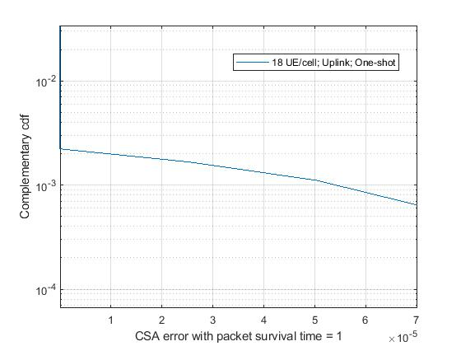

Figure 8

The latency cdf for the achievable 12 UE/cell is shown in Figure 9.

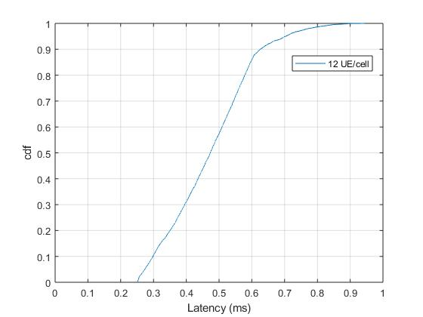

Figure 9

## Category B: Independent/Uncoordinated scheduling

### One-shot approach with reuse-(1/12) transmissions

#### CSA error metric with packet survival time = 0

All the BS operate in orthogonal frequency bands in a static frequency reuse manner where each BS is allocated 21 RBs in every time slot. Our simulations reveal that the minimum downlink and uplink SNRs are very close to 10 dB. In order to achieve 10-6 PER, MCS 18 is chosen for each packet, which implies that 17 RBs are needed for each 48-byte packet transmission. Therefore, each 2-symbol mini-slot can support 2 UE/cell. Consequently, we obtain the following result:

|  |  |
| --- | --- |
| # of UE/cell | 12 |
| % of UL packets satisfying PER < 10-6 | 100% |
| % of DL packets satisfying PER < 10-6 | 100% |

The latency cdf for the achievable 12 UE/cell is almost identical to Figure 9 and therefore omitted.

## Category C: Common/centralized scheduling among BS/TRP

### HARQ approach with reuse-1 SPS transmissions and orthogonal retransmissions

Our HARQ approach consists of reuse-1 SPS transmissions and orthogonal retransmissions where the retransmissions among cells are orthogonalized. The BLER target for each DL SPS packet and each UL SPS packet is set to 10-2. The retransmission BLER target is set to below 10-4. Half of the available frequency band is dedicated to retransmissions during the PDSCH and PUSCH symbols. All the 12 BS coordinate together to schedule orthogonal retransmissions on the dedicated band. A node always transmits at full power if it is performing retransmissions.

During a packet retransmission, the UE remains connected to the same base station in the RSRP sense, and the base stations do not need to share the packet or channel state information among them. The base stations only need to share among themselves how many RBs are needed for retransmissions. Therefore, the backhaul complexity requirement is low compared to full cooperation among the BS.

Since orthogonal retransmission strategy is adopted, interference is removed from the system. The resultant SNR cdf curve over the users is shown in Figure 10 for reference:

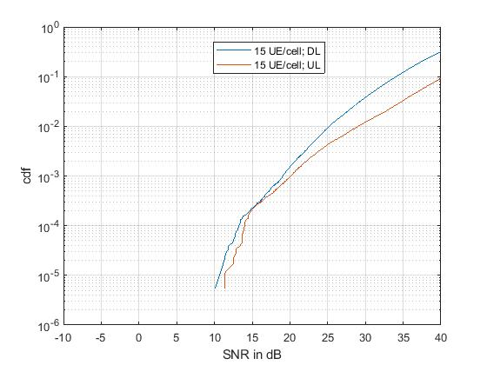

Figure 10

### CSA error metric with packet survival time = 0 (1st Tx BLER = 10-2 and ReTx BLER ≤ 10-4)

The percentage of users satisfying the end-to-end error requirement as stated in Table 7 shows that the corresponding capacity is between 15 and 20.

Table 7

|  |  |  |
| --- | --- | --- |
| # of UE/cell | 15 | 20 |
| % of UL packets satisfying CSA error rate < 10-6 | 100% | 99.2% |
| % of DL packets satisfying CSA error rate < 10-6 | 100% | 100% |

If the network operates at 20 UE/cell which exceeds the capacity, the corresponding complementary cdf of UL CSA error is shown in Figure 11.

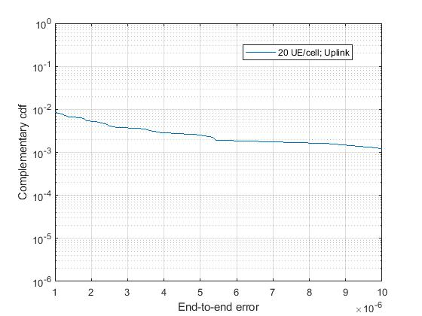

Figure 11

The latency cdf for the achievable 15 UE/cell is shown in Figure 12.

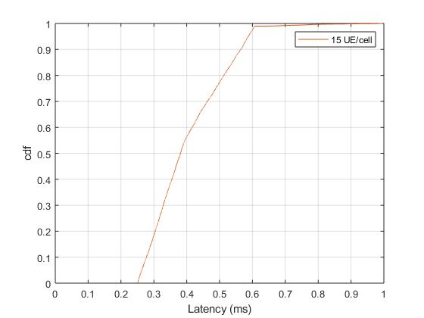

Figure 12

# Conclusion

For the one-shot approach with reuse-1 transmissions, we show that the capacity under the CSA metric with zero survival time is at least 5 UE/cell. If the survival time is relaxed to one, then the capacity is at least 12 UE/cell.

For the one-shot approach with static frequency reuse 1/12, we show that the capacity under the CSA metric with zero survival time is at least 12 UE/cell.

For the HARQ approach with orthogonal retransmissions where the retransmissions are coordinated among base stations to occupy orthogonal resources, we show that the capacity under the CSA metric with zero survival time is at least 15 UE/cell.

# References

1. “Final proposals on URLLC features and simulation assumptions,” Moderator (Ericsson).
2. “Summary of discussions in Week 2,” Moderator (Ericsson).
3. “Summary of discussions in Week 3,” Moderator (Ericsson).
4. “Guidelines for evaluation of radio interface technologies for IMT-2020,” ITU-R M.2412-0, October 2017.
5. “Technical Specification Group Radio Access Network; Study on self-evaluation towards IMT-2020 submission,” 3GPP TR 37.910, September 2019

# Appendix



