3GPP RAN 5G-ACIA Evaluations week 3

February 22nd – 26th 2021

Source: CATT

Title: Simulation Results for 5G-ACIA (Second round)

# Introduction

At RAN#89, it was agreed to provide evaluations for 5G-ACIA [1]. After first round of discussion, a set of simulation assumptions and the URLLC features are agreed to be considered in the evaluation [2]. In this contribution, we provide our calibration results and evaluation results according to agreed assumptions.

# Calibration results

In this section, the coupling loss and geometry SINR for DL are presented in Figure 1 for calibration purpose based on the agreements and the detailed assumption parameters are listed in Table 1.

|  |  |
| --- | --- |
|  |  |
| 1. Geometry | 1. Coupling loss |

Figure 1. The CDF of the coupling loss and geometry SINR for DL

Table 1. Agreements on the simulation assumptions

|  |  |  |
| --- | --- | --- |
| **Parameters** | **Value from Agreement** | **Note** |
| Factory hall size | 120x50 m | As in 5G-ACIA LS |
| Room height | 10 m | As in 5G-ACIA LS |
| Inter-BS/TRP distance | According to proposed layout below | As in 5G-ACIA LS |
| BS/TRP antenna height | 8m for InF-DH | As in 5G-ACIA LS |
| Layout – BS/TRP deployment | 12 TRPs within area with the same 2D placement as in TR 38.901 and TR 38.824. |  |
| Channel model | UC-2: InF-DH | Mandatory: InF-DH  Optional: InD-DL, InF-SH, InF-SL |
| Carrier frequency and simulation bandwidth | TDD 4 GHz: 100 MHz | As in 5G-ACIA LS |
| TDD DL-UL configuration | DUDUD | As in 5G-ACIA LS |
| Number of UEs per service area | 10, 20 | As in 5G-ACIA LS |
| UE distribution | All UEs randomly distributed within the respective service area. | As in 5G-ACIA LS |
| Message size | 48 bytes | As in 5G-ACIA LS |
| DL traffic model | 5G-ACIA Option 1 | As in 5G-ACIA LS |
| UL traffic model | 5G-ACIA Option 1 | As in 5G-ACIA LS |
| CSA requirements | UC-#2: 99.9999% | As in 5G-ACIA LS |
| Performance metrics | 1) CSA: single CDF of CSA distribution of all UEs in factory hall 2) Latency: single CDF of latency distribution of all UEs in factory hall 3) Percentage of UEs satisfying requirements  4) resource utilization | As in 5G-ACIA LS |
| E2E latency & air interface latency | E2E latency: 1 ms for UC#2 | As in 5G-ACIA LS |
| UE speed | Linear movement | As in 5G-ACIA LS |
| BS antenna mount | M,N,P,Mg,Ng,Mp,Np ={1,2,2,1,1,1,2} |  |

Note:

1. In the evaluation, the non-coordination transmission for FR1 is adopted, i.e. the frequency resources are reused among the adjacent cells.

# Evaluation results

In this section, we mainly provide the performance results including the CDF of packet error rate, CDF of Communication Service Availability (CSA) and the percentage of UEs satisfying 1ms latency and 99.9999% reliability/CSA requirement for DL.

As a fundamental performance metric for IIoT use cases with periodic deterministic traffic with strict latency requirements, the CSA can be obtained from BLER for non-zero and zero survival time, respectively. In our evaluation results, we assume that the survival time is larger than zero, in which the consecutive impairments and/or delays are ignored until the respective time has expired. The CSA is calculated according to the formula in the LS from 5G-ACIA, as shown below:

$$CSA=1-\sum_{n=2}^{∞}{P_{E}(n)\frac{nT_{I}-T_{s}}{nT_{I}}}$$

A survival time of one transfer interval, i.e. $T_{s}=T_{I}$ is assumed. Further $P_{E}(n)$ is computed as $P_{E}\left(n\right)=\frac{N_{E}(n)}{N_{T}/n}=\frac{n×N_{E}(n)}{N_{T}}$ with $N_{E}(n)$ denotes the number of occurrences that *n* consecutive packets are wrongly delivered.

Since transport block error rate (BLER) is a typical system level simulation metric and directly affects the CSA, the evaluation results based on the different BLER targets are considered, i.e. BLER=1e-3 and BLER=1e-5 in Section 3.1 and Section 3.2, respectively.

Specifically, the latency for the DL transmission is calculated according to the components from Table 5.7.1.1.1-1 in 37.910, which is provided in Table 2.

Table 2. Latency for DL transmission

|  |  |  |  |
| --- | --- | --- | --- |
| ID | Component | Notations | Value |
| 1 | DL data transfer | *T*1 = (*t*BS,tx + *t*FA,DL) + *t*DL_duration + *t*UE,rx |  |
| 1.1 | BS processing delay | *t*BS,tx  The time interval between the data is arrived, and packet is generated. | Tproc,2/2, with d2,1= d2,2= d2,3=0. |
| 1.2 | DL Frame alignment (transmission alignment) | *t*FA,DL  It includes frame alignment time, and the waiting time for next available DL slot | *T*FA + *T*wait,  *T*FA is the frame alignment time within the current DL slot;  *T*wait is the waiting time for next available DL slot if the current slot is not DL slot. |
| 1.3 | TTI for DL data packet transmission | *t*DL_duration | TTI is of 2OS |
| 1.4 | UE processing delay | *t*UE,rx  The time interval between the PDSCH is received and the data is decoded; | Tproc,1/2 |

## Evaluation results with the target BLER = 1e-3

The evaluation results including the CSA and the percentage of UEs satisfying requirements are listed in Table 3. The CDF of PER and CDF of CSA are omitted since all UEs can achieve a PER smaller than 1e-3 and a CSA larger than 99.9999%. According to the table, the percentage of UEs satisfying the 1ms latency and 99.9999% CSA requirement is 100% for the 10UEs/20UEs per service area.

Table 3. Evaluations results (CSA and percentage of UEs satisfying requirements)   
based on BLER= 1e-3

|  |  |  |  |
| --- | --- | --- | --- |
| Number of UEs per service area | DL/UL | Percentage of UEs satisfying PER= 1e-3 requirement | Percentage of UEs satisfying 99.9999% CSA requirement |
| 10 users | DL | 100% | 100% |
| 20 users | DL | 100% | 100% |

The CDF of latency distribution of all UEs in factory hall is provided in Figure 2. According to the latency distribution for the different UE density, the latency for DL transmission is below 0.81ms for 10UEs/20UEs per service area. It denotes that the one-slot DL transission for 10UEs/20UEs per service area can satisfy the latency requirement, i.e. 1ms. For the 10UEs/20UEs per service area, the latency performance is quite near with the neglectable effect for less resource confliction.

|  |  |
| --- | --- |
|  |  |
| 1. 10 UEs per service area | 1. 20 UEs per service area |

Figure 2. CDF of latency distribution of all UEs in factory hall

***Observation 1: For non-coordination transmission for FR1 DL with the target BLER = 1e-3,***

* ***For the 10UEs/20UEs per service area, the percentage of UEs satisfying the 1ms latency and 99.9999% CSA requirement is 100%.***
* ***For the 10UEs/20UEs per service area, the latency performance is quite near with the neglectable effect.***

## Evaluation results with the BLER = 1e-5

In order to present the different BLER impact on CSA, the evaluation results based on the BLER target BLER=1e-5 are provided in this section. The CDF of packet error rate for 10UEs per service area and the CDF of CSA for the UEs are provided in Figure 3 and Figure 4. The evaluation results including the CSA and the percentage of UEs satisfying requirements are listed in Table 4. According to the table, the percentage of UEs satisfying the 1ms latency and 99.9999% CSA requirement is 85.83% for the 10UEs per service area.

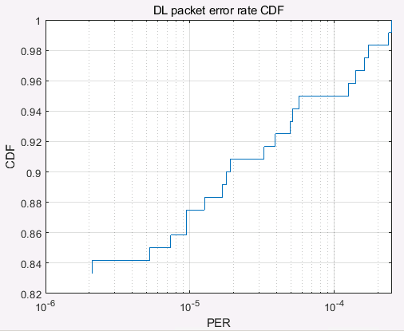

Figure 3. The CDF of PER distribution of all UEs in factory hall

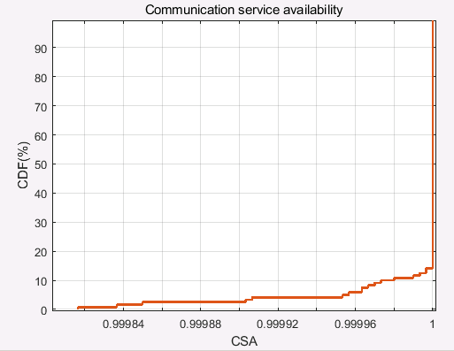 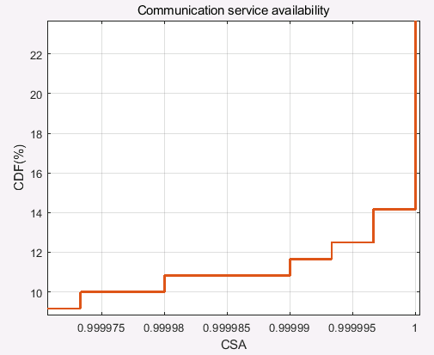

Figure 4. The CDF of CSA distribution of all UEs in factory hall

Table 4. Evaluations results (CSA and percentage of UEs satisfying requirements)   
based on BLER= 1e-5

|  |  |  |
| --- | --- | --- |
| Number of UEs per service area | DL/UL | Percentage of UEs satisfying 99.9999% CSA requirement |
| 10 users | DL | 85.83% |

The CDF of latency distribution of all UEs in factory hall with 10UEs per service area is provided in Figure 5. According to the latency distribution in the figure, the latency for DL transmission is below 0.81ms for 10UEs per service area. It denotes that the one-slot DL transission for 10UEs per service area can satisfy the latency requirement, i.e. 1ms.

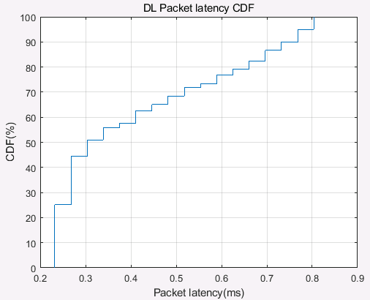

Figure 5. CDF of latency distribution of all UEs in factory hall

***Observation 2: For non-coordination transmission for FR1 DL with the target BLER = 1e-5,***

* ***For the 10UEs per service area, the percentage of UEs satisfying the 1ms latency and 99.9999% CSA requirement is 85.83%***
* ***For the 10UEs per service area, the latency performance for all UEs can satisfied the latency requirement, i.e. 1ms.***

# Conclusion

In this document, we provide the simulation results for 5G-ACIA evaluation results. Based on the simulation results, it could be observed that:

***Observation 1: For non-coordination transmission for FR1 DL with the target BLER = 1e-3,***

* ***For the 10UEs/20UEs per service area, the percentage of UEs satisfying the 1ms latency and 99.9999% CSA requirement is 100%.***
* ***For the 10UEs/20UEs per service area, the latency performance is quite near with the neglectable effect.***

***Observation 2: For non-coordination transmission for FR1 DL with the target BLER = 1e-5,***

* ***For the 10UEs per service area, the percentage of UEs satisfying the 1ms latency and 99.9999% CSA requirement is 85.83%***
* ***For the 10UEs per service area, the latency performance for all UEs can satisfied the latency requirement, i.e. 1ms.***

# References

1. RP-201279, LS on 3GPP NR Rel-16 URLLC and IIoT performance evaluation, 5G-ACIA

1. [Agreements week 1 5G-ACIA](https://www.3gpp.org/ftp/tsg_ran/TSG_RAN/TSGR_90e/Inbox/Drafts/5G-ACIA%20October/Agreements/Agreements%20week%201%205G-ACIA.docx), Moderator (Ericsson)