3GPP TSG-RAN WG5 Meeting #100 R5-235817
Toulouse, France, Aug 21 - 25, 2023

Title: LS on Applicability of the DEMOD and CSI requirements for IoT NTN UE

Response to: -

Release: Rel-18

Work Item: LTE_NBIOT_eMTC_NTN_req-UEConTest

Source: RAN WG5
To: RAN WG4
Cc: -

Contact Person:

Name: Dan Song

E-mail Address: songdan@chinamobile.com

Send any reply LS to: 3GPP Liaisons Coordinator, mailto:3GPPLiaison@etsi.org

Attachments:

1. Overall Description:
In TS 36.102 Table 8.2.1.2-1, it is indicated by Note that “For UE supports NTN access (ntn-Connectivity-EPC-r17), the requirements in TS 36.101 Clause 8 and Clause 9 also applies to UE according to the UE category and capability”.
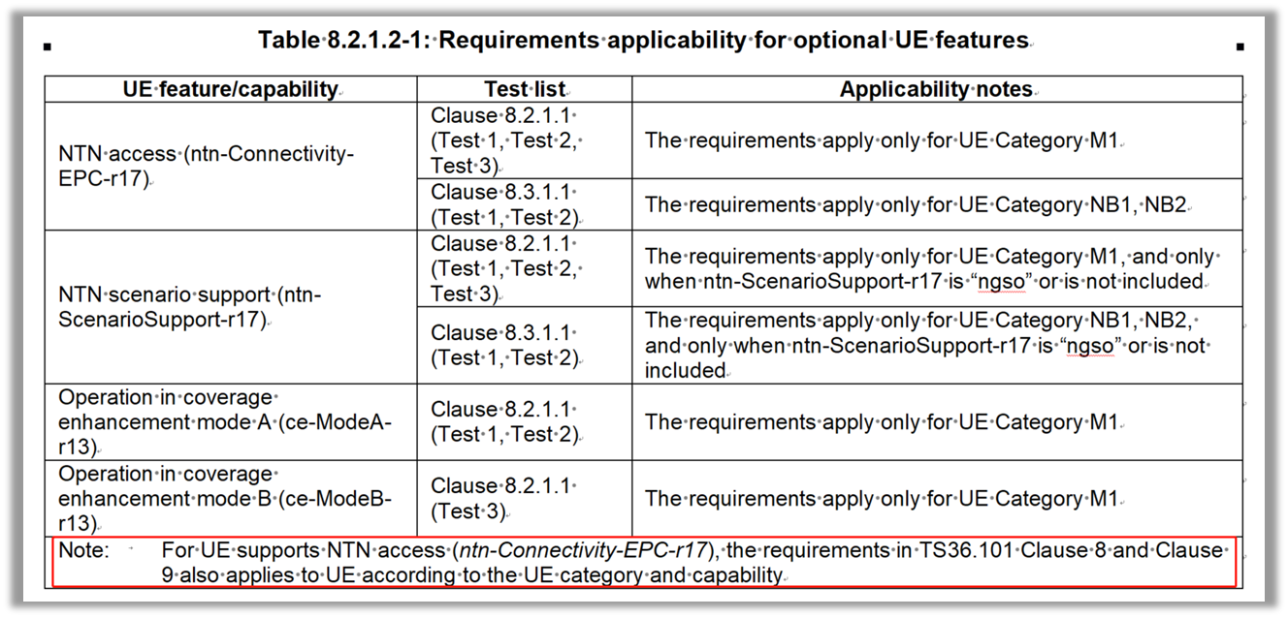
After case-by-case evaluation, RAN5 found concerns in the following aspects (For details, please check R5-234756):

For eMTC NTN requirements in TS 36.101 Clause 8 Performance Requirements:
It is identified that no eMTC requirements can be applied to eMTC NTN UEs due to lack of requirements for “CBW=1.4MHz and Antenna Configuration=1*1” from TS 36.521-1 Clause 9.
Question 1: What is RAN4’s plan to adapt LTE performance requirements for UEs supporting eMTC NTN only (not supporting TN)?

For requirements in TS 36.101 Clause 9 Reporting of Channel State Information:
It is observed that no need to consider CSI reporting for NB-IoT NTN UE or eMTC NTN Mode B UE. Besides, it is identified that no eMTC requirements from TS 36.521-1 Clause 9 can be applied to eMTC NTN Mode A UE due to lack of requirements for “CBW=1.4MHz”.
Question 2: What is RAN4’s plan to define reporting of CSI requirements for UEs supporting eMTC NTN only (not supporting TN)?

For Annex B.2 in TS 36.102:
Table B.2-1 is the only table in Section “B.2 Set-up”. It says “Table B.2-1 describes the downlink Physical Channels that are required for connection set up.” without indicating it is for Category M1 only or it is for both Category M1 and Category NB1/NB2. And it seems that there is no content for Category NB1/NB2 in Table B.2-1 yet.
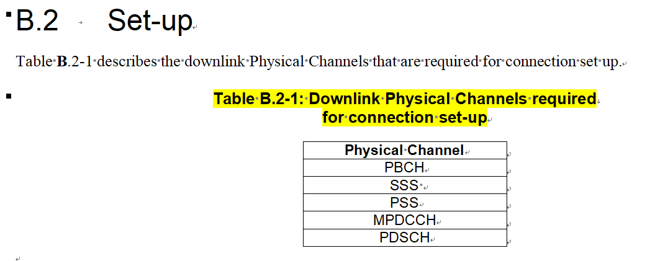
Question 3: What is the RAN4 guidance on how to interpret Table B.2-1? Is it for Category M1 UEs only and there will be additional table to address Category NB1/NB2? Or is it for both Category M1 UEs and Category NB1/NB2 UEs and Table B.2-1 needs updates on Category NB1/NB2?

2. Actions:
To RAN WG4:
ACTION: RAN5 would like to kindly ask RAN4 to provide replies to the 3 questions. Early feedback to any of the questions will unblock IoT NTN conformance test definition in RAN5 specifications.
Question 1: What is RAN4’s plan to adapt LTE performance requirements for UEs supporting eMTC NTN only (not supporting TN)?
Question 2: What is RAN4’s plan to define reporting of CSI requirements for UEs supporting eMTC NTN only (not supporting TN)?
Question 3: What is the RAN4 guidance on how to interpret Table B.2-1? Is it for Category M1 UEs only and there will be additional table to address Category NB1/NB2? Or is it for both Category M1 UEs and Category NB1/NB2 UEs and Table B.2-1 needs updates on Category NB1/NB2?

3. Date of Next RAN WG5 Meetings:
TSG RAN WG5 Meeting #101 November 13th – 17th, 2023 Chicago, US
TSG RAN WG5 Meeting #102 Feb 26th – March 1st, 2024 Athens, GR

