3GPP TSG RAN Meeting #94-e R5-221359r3
Electronic Meeting, 21st Feb – 4th Mar 2022

Agenda item: 5.3.40.1
Source: Apple Portugal
Title: Discussion on Work Plan Structure for FR2 Enhanced Test Methods
Document for: DISCUSSION AND ENDORSEMENT

1 Introduction
3GPP RAN4 has in Rel-17 worked on a Study Item focusing on Enhanced Test Methods for FR2 UEs. The study has identified improvements to current FR2 test methodologies as well as new enhanced FR2 test methods across a range of topics. This includes some issues reported by RAN5 such as:
- Test requirement relaxation due to High DL/Low UL signal power limitations
- Mitigation of polarization basis mismatch
- Extreme Temperature Condition testing methodology.
In addition, several test time reduction topics are included in the RAN4 SID. At RAN5#93 in November 2021, a way forward [1] was agreed to create a work plan to track the progress of this item in the RAN5 WG. A framework for such a work plan is discussed in this paper.

2 Discussion

2.1 Summary of TR 38.884
A detailed view of the test methodology enhancements identified within the RAN4 study item, (which must be reviewed and analyzed for incorporating into RAN5 test specifications) are within the high-level initial scope listed in [1]. The test time reduction techniques recommended are understood to be optional within the RAN5 test specifications and depending on UE vendor declaration.

2.1.1 High-level initial SCOPE of intended RAN5 Work Plan
As agreed, in [1], the proposed RAN5 Work Plan to incorporate TR 38.884 outcomes into RAN5 test specifications will cover the following initial scope and is submitted at this meeting RAN5#94:
- High DL power and low UL power test cases: improvement of current permitted methods (e.g. IFF) has been identified in the relaxation of requirements for the specific tests reported by RAN5.

- High DL power and low UL power test cases: new methodologies based on near-field (i.e. Direct Near Field (DNF), Combined Far-Field/Direct Near Field (CFFDNF), Combined Far-Field/Delta Near Field (CFFdeltaNF) and Combined Far-Field/Near Field (CFFNF)) have been analyzed and the study outcome is included in TR 38.884.
- Enhanced test method for EIRP measurements: adopt the TPMI method defined in TR 38.884 to activate the dual polarization transmission on the UE, removing the need for a specific test function and define the applicability of the method to the EIRP based test procedures and FR2 UE types.
- Enhanced test methods for UL Demodulation Measurements: adopt zero-forcing MIMO receiver architecture based on Method 1 as described in TR 38.884 so that dual-polarization transmissions by the UE can be demodulated by the test equipment receiver.
- Analyze and incorporate testability enhancements to support the verification of RF requirements for inter-band (FR2+FR2) CA
  - An analysis of the impact of AoA offsets in the test setup for inter-band CA with Common Beam Management (CBM) is needed after the scope of CBM requirements and associated agreements are better understood.
- Incorporate any new recommendations in TR 38.884 for testing under extreme temperature conditions for all applicable FR2 UE RF test cases.
- Analyze and incorporate the testability enhancements defined in TR 38.884 to reduce test time. All the recommended test methodology enhancements are understood to be optional.
  - New Measurement grids based on 4x2 antenna pattern assumption, dependent on UE declaration
  - RSRPB-based RX beam peak search
  - Fast Spherical Coverage
  - Single Link Polarization Measurement, dependent on UE declaration
  - Non-uniform TRP measurement grids
- Adopt the recommendations in TR 38.884 and perform further analysis of testability aspects for the introduction of the new band n262
  - Considering the extension of frequency applicability of the permitted methods in TR38.810 from 43.5 GHz up to at least 48.2 GHz
  - Considering the extension of frequency applicability of the test methodology enhancements in Objectives 1 through 7 above
NOTE 1: It should be noted that topics related to ’NR Enhancements for 52-71 GHz’ has just commenced in RAN4 post RAN#93 and is currently not planned to be included in initial scope. Study of item 1 and item 2 (improvements of relaxation) can consider the possibility that test system supports both FR2-1 and FR2-2.
NOTE 2: The work plan initial scope may include MU assessments required in RAN5 specific to the topics listed above.
NOTE 3:
- Significant deviations from TR 38.884 outcomes and/or
- Mapping to known RAN5 testability issues
are intended to be tracked as part of the progress of the proposed RAN5 umbrella work plan

2.1.2 RAN5 Impact
This section lists the anticipated list of test specifications that would need to be updated due to the FR2 Enhanced Test Methods Study

Table 2.1.2-1

TS/TR No. | Description of anticipated changes | Related RAN5 Work Item(s)
TS 38.521-2 | Introduction of enhanced test methods aspects for SA FR2 and any n262 MU assessment as applicable to SA RF tests | 5GS_NR_LTE-UEConTest  NR_RF_FR2_req_enh-UEConTest  NR_eMIMO-UEConTest
TS 38.521-3 | Introduction of enhanced test methods aspects for NSA FR2 and any n262 MU assessment as applicable to NSA RF tests | 5GS_NR_LTE-UEConTest  NR_RF_FR2_req_enh-UEConTest  NR_eMIMO-UEConTest
TS 38.522 | Updated applicability for tests impacted by enhanced FR2 test methods | 5GS_NR_LTE-UEConTest  NR_RF_FR2_req_enh-UEConTest  NR_eMIMO-UEConTest
TS 38.508-1 | Update to FR2 RF test environments | 5GS_NR_LTE-UEConTest  NR_RF_FR2_req_enh-UEConTest
TS 38.508-2 | Introduction of UE declarations for alternate enhanced test methods | 5GS_NR_LTE-UEConTest  NR_RF_FR2_req_enh-UEConTest
TS 38.521-4 | Introduction of n262 MU and enhanced test methods aspects for 5G Demod | 5GS_NR_LTE-UEConTest  NR_RF_FR2_req_enh-UEConTest
TS 38.533 | Introduction of n262 MU and enhanced test methods aspects for 5G RRM | 5GS_NR_LTE-UEConTest  NR_RF_FR2_req_enh-UEConTest  NR_eMIMO-UEConTest
TR 38.903 | Documentation of MU assessment for enhanced test methods | 5GS_NR_LTE-UEConTest  NR_RF_FR2_req_enh-UEConTest

Observation 1: There is significant impact to multiple FR2 RF tests due to the enhanced test methods defined in TR 38.884. The RAN4 SID outcome needs to be evaluated and accordingly incorporated in RAN5 specifications to resolve multiple FR2 RF testability issues, several of which were reported by RAN5.

2.2 Incorporating FR2 Test Methods into RAN5 specifications

2.2.1 Applicability
TR 38.884 provides a set of general guidelines to determine applicability of the proposed enhanced FR2 test methods and this is a useful guide to slot each method into the relevant applicability.

The enhanced test methods defined in the following clauses are not only applicable to current release, the general applicability can be categorized as following:

1. If a test case or requirement was not-testable in an older Release (e.g. Rel-15), and a new test method or procedure unblocks it in Rel-17, then the method can be said to be release-independent and would apply to the older release.
2. If we call one of the enhanced test methodologies as a Rel-17 test equipment feature, then a test equipment setup implementing the earlier release conformance test specification should be allowed to bring in a Rel-17 feature, provided that it meets all of the applicable Rel-17 requirements for that feature.
3. When there is a core requirement change (or modification/relaxation) in, e.g. Rel-17, to enable testing/unblock testability issues, then the requirement change should be applicable only from Rel-17 onwards.
4. When the enhanced test methodology applies to a UE feature supported only from a specific release, the test method becomes applicable only from that release onwards.

Proposal 1: For core requirement changes/modifications or UE feature/capability that is applicable only from Release 17 and onwards, it should be analysed on a case-by-case basis if a better option is to introduce a new test case.

2.2.2 Analysis for Work Plan
A topic-level analysis would help to identify and track the updates needed within the proposed work plan.

2.2.2.1 High DL power and low UL power
The list of test cases impacted by this issue is quite clear as it was provided by RAN5 in an LS to RAN4. Each of the tests can be analyzed for resolution of the testability issues reported earlier.
Table 2.2.2.1-1: Summary of test cases and testability issues
Clause | Requirement | Testability issue | Test Metric
6.3.1 | Minimum output power | Low UL power | EIRP (Link=TX beam peak direction, Meas=Link angle).
6.3.2 | Transmit OFF power | Low UL power | TRP (Link=TX beam peak direction, Meas=TRP grid)
6.5.1 | Occupied bandwidth | Low UL power | OBW (Link=TX beam peak direction, Meas=Link angle)
6.5.2.3 | Adjacent channel leakage ratio | Low UL power | TRP (Link=TX beam peak direction, Meas=TRP grid).
6.5.3.2 | Additional spurious emissions | Low UL power | TRP (Link=TX beam peak direction, Meas=TRP grid).
7.4 | Maximum input power | High DL power | EIS (Link=RX beam peak direction, Meas=Link angle).
7.5 | Adjacent channel selectivity (case 1) | High DL power | EIS (Link=RX beam peak direction, Meas=Link angle)
7.5 | Adjacent channel selectivity (case 2) | High DL power | EIS (Link=RX beam peak direction, Meas=Link angle)
7.6.2 | In-band blocking | High DL power | EIS (Link=RX beam peak direction, Meas=Link angle)
7.9 | Receiver spurious emissions | Low UL power | TRP (Link=TX beam peak direction, Meas=TRP grid).

The RAN4 study has come out with new test methodologies (CFFNF, CFFDNF and CFFdeltaNF) to resolve the testability issues.
Proposal 2: The list of test cases impacting by Low UL Power/High DL Power issue requires additional analysis as additional tests may have to be included (beyond what was identified in initial RAN5 analysis).
Below changes can be planned
- For a given test case, NF based solutions should only be considered if the improvement for current methods is not enough to remove the relaxations determined by RAN5.
[Note: RAN4 has outlined this procedure in TR 38.884 in clause 5.1.6]

For a given test case, NF based solutions should only be considered if the improvement for current methods is not enough to remove the relaxations determined by RAN5.
  - Analyze the suggested methods for inclusion as permitted test methods in Annex of TS 38.521-2/TS 38.521-3
  - Evaluation of MU/TT and update in Annex F of TS 38.521-2/TS 38.521-3 and TS 38.903
  - Updates for individual tests listed in Table 2.2.2.1-1 to incorporate the updated test methods within same test or as new test case and removal of editors notes if it is determined that the testability issues are indeed resolved.
  - Applicability updates in TS 38.522
  - Updates to TS 38.508-2 for the vendor declaration aspects of the “black and white” box approach defined in TR 38.884 for the defined test methodologies.
  - Updates to TS 38.508-1 RF environment section and Annexes to include new test methodology references.

2.2.2.2 Extreme Temperature Testing
TR 38.884 [2] reviewed the feasibility of performing beam peak search and Tx/Rx test procedures under ETC. However since the study began in RAN4, RAN5 has been able to analyze and incorporate ETC test methodology into several FR2 RF tests :
  - Single Carrier: MU impact due to ETC for EIRP, Frequency Error and few tests is being performed and updated
  - Carrier Aggregation: There is general agreement to incorporate ETC for CA into the EIRP. REFSENS and Frequency Error tests. This analysis is ongoing.
There are pending issues with 4 categories of tests (Beam Correspondence, EVM Spectral Flatness, Spherical Coverage, Power Tolerance) which are ongoing discussion in RAN4 and out of scope of the TR 38.884.
[6] brought in the change to update temperature tolerance limit of the ETC test system.
Proposal 3: No changes specific to ETC are planned as part of this proposed work plan as ETC pending items are being discussed as part of other RAN4/RAN5 work items.

2.2.2.3 Test Time Reduction
The RAN4 study proposes alternate test methods/procedures to reduce conformance test time.

2.2.2.3.1 New Measurement grids based on 4x2 antenna pattern
This topic (measurement grid implementation as well as applicability) was already incorporated into the RAN5 test specifications as part of [4].
No changes are planned as part of this proposed work plan and the topic can be considered 100% complete.

2.2.2.3.2 RSRP(B) based Rx Beam Search
RSRP(B)-based RX beam peak search approach is applicable to find the beam peak, the beam peak searching time can be reduced significantly.
The feasibility of this RSRP-B based approach for FR2 RF tests is still FFS. However RAN5 can evaluate addition of this method to the Annex.
  - Analyze the suggested methods for inclusion as Rx Beam Search procedure in Annex of TS 38.521-2/TS 38.521-3
  - Updates for individual tests (Rx Beam Peak Search, EIS measurements, …)

2.2.2.3.3 Single Link Polarization Measurement
As an enhancement to the FR2 2Tx test cases, it has been proposed to adopt a Single link polarization measurement to reduce the test time. Single Pol_{link} can be randomly selected from either theta Pol_{link} or phi Pol_{link}.
For EIRP test, whether single Pol_{link} is adopted or test under 2 link directions, depends on UE declaration.
  - Analyze the suggested methods for inclusion as permitted test methods in Annex of TS 38.521-2/TS 38.521-3
  - Evaluation of MU/TT and update in Annex F of TS 38.521-2/TS 38.521-3 and TS 38.903
  - Updates for individual tests (Tx Beam Peak Search, EIRP measurements, …) as per UE vendor declaration
  - Updates to TS 38.508-2 for the vendor declaration aspects for this alternate enhanced test methodology.

2.2.2.4 Polarization basis mismatch between TE and DUT

2.2.2.4.1 Enhanced Test Methods for EIRP measurements

2.2.2.4.1.1 TPMI Method
In the TPMI method, TPMI side conditions are applicable certain to Rel-15 (Coherent UEs) or Rel-16 (Coherent, Mode1) UEs as described in the TR 38.884 snippet below
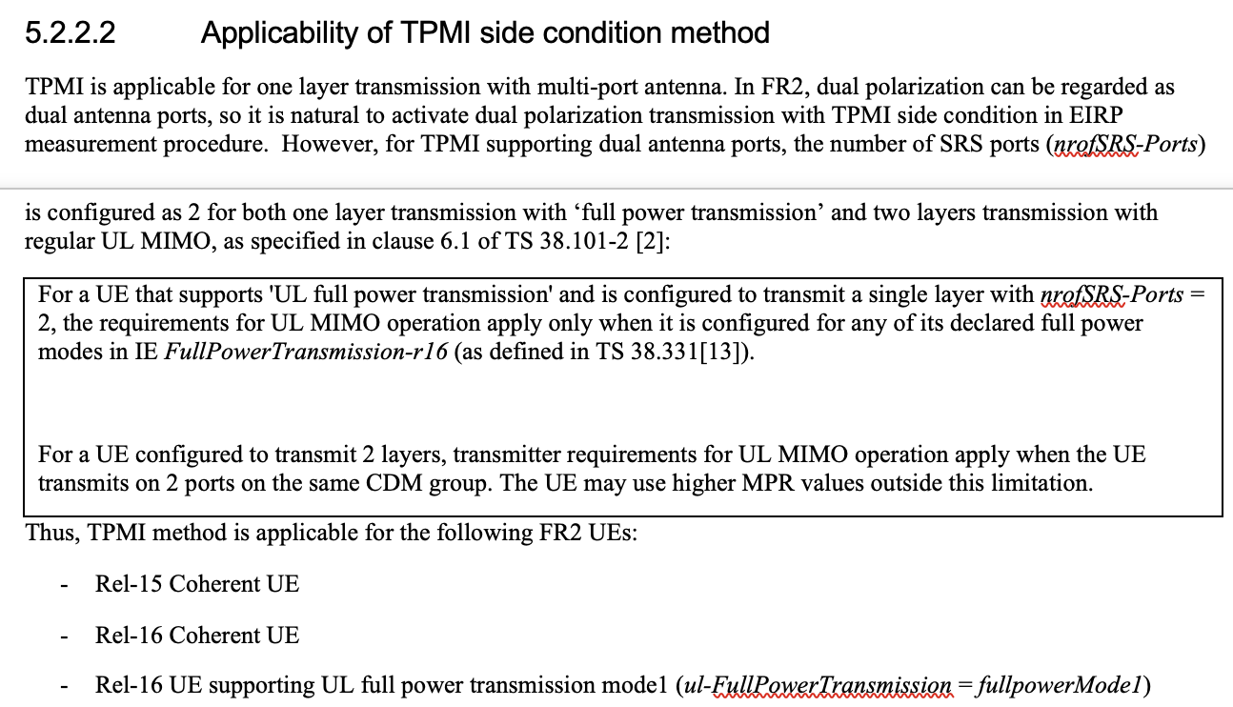
Below is an agreement from RAN4 for the test scenarios where the TPMI based method would apply:

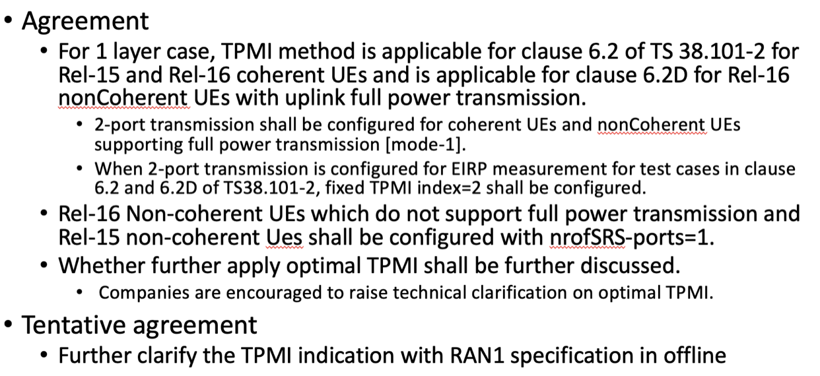

The TPMI method is applicable to UEs supporting Transmit diversity which cannot be currently tested in this mode (current Release 15 tests have specified Tx Diversity should be oFF as per TS 38.521-2 clause 6.1.

The UE under test shall be pre-configured with UL Tx diversity schemes disabled to account for single polarization System Simulator (SS) in the test environment. The UE under test may transmit with dual polarization.

In addition, based on the condition of nrofsrs-ports=2, the method applies to UEs with UL-MIMO capability (specifically fullpowermode1). The UL MIMO enhancements WID is bringing in changes related to this feature. Contributions to update the test cases with TPMI method implemented can be made against that work item but progress is tracked via this work plan.

However the way above forward also refers to non-coherent UEs which shall be configured with nrofSRS_ports=1.

Analysis of TPMI method applicability beyond the above scenarios needs additional analysis.

2.2.2.4.2 Enhanced Test Methods for UL Demodulation Measurement
As an enhancement to the FR2 test equipment topology, TR 38.884 proposes to adopt a zero-forcing MIMO receiver architecture so that dual-polarization transmissions by the UE can be demodulated by the test equipment receiver.
Two methods of demodulation and EVM calculation were discussed, one utilized DMRS-based channel inversion (Method 1), and the other based on inversion of the LSE-estimate of the channel (Method 2).
  - Analyze how to include RAN4’s recommended method 1 as a permitted test method in Annex of TS 38.521-2/TS 38.521-3
  - Evaluation of MU/TT and update in Annex F of TS 38.521-2/TS 38.521-3 and TS 38.903
  - Updates for individual Tx quality tests (Frequency Error, EVM, In-band emissions, EVM equalizer spectrum flatness,…)
  - Updates to TS 38.508-2 for the vendor declaration aspects for this alternate enhanced test methodology.
  - RAN5 to discuss the timeline aspects for enabling the dual receiver, while factoring in the applicability guidelines in clause 4 of TR38.884 e.g., by introducing a grace period for using both legacy and new method at the same time to allow TEV to implement and validate the test method.

2.2.2.4.3 UE RRM and Demod testing methodology enhancements
The changes in this section primarily deal with extension of the test methodology and MU assessments in TR 38.810 to Rel.17 band n262.
Noc levels and Maximum achievable SNR assessment is performed.

- Updates to TS 38.903 and MU/TT evaluation in Annexes of TS 38.533 and TS 38.521-4

2.2.2.4.4 Inter-band CA (FR2+FR2 CA)
The primary dependency of inter-band test set ramifications is the frequency coverage of each antenna in an IFF system with multiple antennae.
  - Analyze the suggested methods for inclusion as permitted test methods in Annex of TS 38.521-2/TS 38.521-3
  - Evaluation of MU due to addition of new MU elements especially for multi-antennae methodology
  - Updates for individual tests (Receiver tests with inter-band CA – EIS, ACS, IBB)

The contributions will be submitted as part of the relevant WIDs.

2.3 Contributions regarding Enhanced FR2 Test Methods
Observation 2: Existing process to adopt TR 38.810 defined test methods into TS 38.521-2 was easy to track due to clear dependency as those methods were needed to define all initial FR2 RF tests in Release 15 via 5GS_NR_LTE-UEConTest Rel.15 WID.

Considering that this is not a RAN5 WID, the task of incorporating FR2 enhanced test methods in TS 38.884 into RAN5 specifications will fall under different active/maintenance RAN5 WIDs over some period. Therefore, it was discussed in RAN5#93 [1] that a contribution structure needs to be defined for contributions to Enhanced FR2 RF methods that will be brought in via the WIDs listed in Table 2.1.2-1

Proposal 4: As discussed in the way forward at RAN5#93, contributions on this subject will be brought in via the associated RAN5 WIDs. To the extent possible, contributions related to measurement uncertainty shall be separated

Proposal 5: The FR2 Enhanced Test Methods RAN5 work plan shall include a column to list the associated RAN5 WID under which contributions may be submitted.

Proposal 6: The FR2 Enhanced Test Methods work plan shall be coordinated with rapporteurs of the other RAN5 RF WIDs, under which contributions will be submitted, to ensure scope/test cases in those work plans are aligned for contributions from FR2 Enhanced Test Methods topic.

2.4 Umbrella Work Plan
Proposal 7: Agree on the proposed RAN5 Work Plan structure to track adoption of TR 38.884 outcomes into RAN5 test specifications. An outline of such a work plan is submitted in associated with this discussion paper.

3 Summary
Observation 1: There is significant impact to multiple FR2 RF tests due to the enhanced test methods defined in TR 38.884. The RAN4 SID outcome needs to be evaluated and accordingly incorporated in RAN5 specifications to resolve multiple FR2 RF testability issues, several of which were reported by RAN5.
Proposal 1: For core requirement changes/modifications or UE feature/capability that is applicable only from Release 17 and onwards, it should be analysed on a case-by-case basis if a better option is to introduce a new test case.
Proposal 2: The list of test cases impacting by Low UL Power/High DL Power issue requires additional analysis as additional tests may have to be included (beyond what was identified in initial RAN5 analysis).
Proposal 3: No changes specific to ETC are planned as part of this proposed work plan as ETC pending items are being discussed as part of other RAN4/RAN5 work items.
Observation 2: Existing process to adopt TR 38.810 defined test methods into TS 38.521-2 was easy to track due to clear dependency as those methods were needed to define all initial FR2 RF tests in Release 15 via 5GS_NR_LTE-UEConTest Rel.15 WID

Proposal 4: As discussed in the way forward at RAN5#93 [1], contributions on this subject will be brought in via the associated RAN5 WIDs. To the extent possible, contributions related to measurement uncertainty shall be separated

Proposal 5: To incorporate feedback from RAN5#93, the work plan shall include a column to list the associated RAN5 WID under which contributions may be submitted.

Proposal 6: The FR2 Enhanced Test Methods work plan shall be coordinated with rapporteurs of the other RAN5 RF WIDs, under which contributions will be submitted, to ensure scope/test cases in those work plans are aligned for contributions from FR2 Enhanced Test Methods topic.

Proposal 7: Agree on the proposed RAN5 Work Plan structure to track adoption of TR 38.884 outcomes into RAN5 test specifications. An outline of such a work plan is submitted in associated with this discussion paper.

4 References
- R5-218202 – Incorporating TR 38.884 outcome in RAN5 Test Specifications,
Apple Portugal, AT&T, China Telecom, Dish Network, DOCOMO Communications Lab, Keysight Technologies, Nokia, Nokia Shanghai Bell, Oppo, Orange, QUALCOMM Europe Inc. - Spain, Rohde & Schwarz, Samsung, Telecom Italia, Verizon Switzerland AG, ZTE Corporation;
3GPP TSG RAN WG5 Meeting #93-e, November 2021
- TR 38.810 - NR: Study on Test Methods
- TR 38.884 - FR2 Enhanced Test Methods for NR UEs
- R5-213839 : CR to 38.521-2 on Optional 4x2 PC3 Antenna Array Configuration, Keysight, 3GPP TSG RAN WG5 Meeting #92-e, August 2021
- TS 38.521-2 – FR2 RF Test Specification
R5-213903 - CR to 38.521-2 on Temperature Tolerance for FR2 Testing, Keysight, 3GPP TSG RAN WG5 meeting #92e, August 2021

Company comments collected at RAN5#94 for contributions on this topic
Summary/Status of Email Discussion

TDoc | Contributor | Proposals | Comments
R5-221359r2 | Apple | Observation 1: There is significant impact to multiple FR2 RF tests due to the enhanced test methods defined in TR 38.884. The RAN4 SID outcome needs to be evaluated and accordingly incorporated in RAN5 specifications to resolve multiple FR2 RF testability issues, several of which were reported by RAN5.  Proposal 1: For core requirement changes/modifications or UE feature/capability that is applicable only from Release 17 and onwards, it should be analysed on a case-by-case basis if a better option is to introduce a new test case.  Proposal 2: The list of test cases impacting by Low UL Power/High DL Power issue requires additional analysis as additional tests may have to be included (beyond what was identified in initial RAN5 analysis).  Proposal 3: No changes specific to ETC are planned as part of this proposed work plan as ETC pending items are being discussed as part of other RAN4/RAN5 work items.  Observation 2: Existing process to adopt TR 38.810 defined test methods into TS 38.521-2 was easy to track due to clear dependency as those methods were needed to define all initial FR2 RF tests in Release 15 via 5GS_NR_LTE-UEConTest Rel.15 WID  Proposal 4: As discussed in the way forward at RAN5#93 [1], contributions on this subject will be brought in via the associated RAN5 WIDs. To the extent possible, contributions related to measurement uncertainty shall be separated  Proposal 5: To incorporate feedback from RAN5#93, the work plan shall include a column to list the associated RAN5 WID under which contributions may be submitted.  Proposal 6: The FR2 Enhanced Test Methods work plan shall be coordinated with rapporteurs of the other RAN5 RF WIDs, under which contributions will be submitted, to ensure scope/test cases in those work plans are aligned for contributions from FR2 Enhanced Test Methods topic.  Proposal 7: Agree on the proposed RAN5 Work Plan structure to track adoption of TR 38.884 outcomes into RAN5 test specifications. An outline of such a work plan is submitted in associated with this discussion paper. | [Apple] r2 uploaded to address further comments from R&S and Keysight (no change to proposals, wording changes across sections to align applicability and work plan scope)  Feb 24: Draftr3 uploaded to modify statement under Method 1 as per Keysight feedback.
R5-221360r1 | Apple | Associated Draft Work Plan as per R5-221359 | No comments to r1
R5-221260 | Keysight | Observation 1: Additional test cases might need to be added to the list of test cases that require relaxations.  Observation 2: The new permitted methodologies would have to be added in TS38.508-1.  Observation 3: The new black&white-box approach would have to be added in TS38.508-1 and likely TS38.521-2.  Observation 4: The new black&white-box vendor declaration would have to be added in TS38.508-2.  Observation 5: When the origin of the spur is unknown (black box), spurious emissions test cases performed in the NF due to free-space path loss reduction would see a moderate improvement.  Observation 6: The new permitted NF methodologies would have to be added in TS38.508-1.  Observation 7: The new test procedures would have to be added in TS38.521-2.  Observation 8: While many simulations can be re-used from RAN4, some new simulations will be required.  Observation 9: For each of the low UL/high-DL power test cases addressed by the new NF methodologies, MUs would be captured in TR38.903 and MTSUs in TS38.521-2.  Proposal 1: RAN5 to determine whether the ~14dB improvement in relaxations is sufficient before integrating and further researching the new NF methodologies in test specifications and technical reports.  Proposal 2: Feedback from industry (chipset vendors and OEMs) is requested whether the origin of the spurious emission regardless of frequency is always co-located with the antenna array responsible for the radiation of the in-band beam peak. | [Anritsu]  Prop 1: we believe that it is difficult to achieve the 14dB improvement by the actual future TE for the reasons in the next paragraph. We think that it is the maximum improvement value that can be theoretically possible with NF and is given as just a reference  - Consider the below  a) QZ expansion to 40cm (Keysight agree that for larger QZ NF probe measurement distance needs to be adjusted…this was not part of scope earlier)  b) ETC enclosure (Keysight suggest removal of ETC enclosure for this analysis)  [R&S]  - Agree with Anritsu comment on 14 dB improvement.  - Following what it’s presented in clause 5.1.6 of TR 38.884, there must be first an assessment on the improvements to IFF before deciding on NF methods:  [Ericsson]: Without an overall picture on current testability problems (relaxation values per affected test case) it is hard to decide whether 14 dB improvement is enough. It may be sufficient for some test cases but not all. Just picking one example in Max input level. Here we have 34 dB relaxation for FR2b, and an improvement to 20 dB relaxation does not seem very useful. Are there also other improvements for IFF possible on top of this?
R5-220882 | Anritsu | Proposal 1 : Clarify common assumptions of FR2 enhanced test methods before the study on improvement of the relaxation of requirements in the current IFF system and new NF approach.  Proposal 2 : Adopt ETC environment for the common assumption of FR2 enhanced test methods.  Proposal 3 : Adopt TE that can test both of PC1 and PC3 for the common assumption of FR2 enhanced test methods.  Proposal 4 : Adopt TE that considers inter-band CA and blocking TC for the common assumption of FR2 enhanced test methods.  Proposal 5 : Postpone the discussion on the common assumption for frequency range until RAN4 reaches a conclusion for feasibility of extending existing test systems supporting FR2-1 to full FR2 range. | [Apple] Prop1 provides a general overview, but this is included in the work plan scope already and Prop1 of R5-221359r1 and Prop1 of R5-221260 provide detailed view of the same.  Prop2 - ETC environment was included in RAN4 SID to study feasibility of 3D Scan in the ETC setup and enclosure. RAN5 has already proceeded since then with ETC testing enablement. Pending ETC topics can be discussed as part of other ongoing RAN5 WIDs (with dependencies on RAN4 tracked there already). Hence plan was not to perform any additional work under this FR2 RF Enhanced Test Methods topic.  Prop 3 - PC3 is likely to be focus based on historical FR2 work  Prop4 - FR2 CA and blocking are part of the work plan scope and discussed in R5-221359r1 already with additional details. Can be merged with that discussion  Prop5 - As already endorsed in WF at RAN5#93, FR2-2 is not in current scope of the RAN5 WP as it is still ongoing discussion in RAN4.  [Keysight]:  P1: A lot of the simulation assumptions for the NF methodologies have been documented in TR38.884. While we generally agree to align on common assumptions, we believe this proposal is too generic and more specific guidance on which assumptions needs to be provided.  P2: If a low UL/high DL power test case requires ETC, e.g., Min Output, it should certainly be considered. For test cases that currently do not require ETC, it is not clear yet whether the ETC environment should be considered as common assumption. We prefer to defer this decision  P3: We believe that this proposal is too restrictive. If a vendor wants to optimize the relaxations for PC3, this should be permissible.  P4: As outlined in our contribution with Observation 1, we believe that we need to evaluate a revised list of low-UL/high-DL power test cases with relaxations; thus, this proposal should be deferred.  P5: As FR2-2 is currently not part of the RAN5 efforts, we do not believe that discussions/investigations on NF methodologies should be deferred based on feasibility analyses in RAN4.

