3GPP RAN5 PRD 21 Draft v0.1.0 (2022-2)
Permanent Reference Document
3rd Generation Partnership Project;
Technical Specification Group RAN WG5;
Permanent Reference Document (PRD);
NR bands and 5G NR CADC configuration handling in RAN5
(Release 15 and later releases)

The present document has been developed within the 3rd Generation Partnership Project (3GPP TM) and may be further elaborated for the purposes of 3GPP.
The present document has not been subject to any approval process by the 3GPP Organizational Partners and shall not be implemented.
This Specification is provided for future development work within 3GPP only. The Organizational Partners accept no liability for any use of this Specification.
Specifications and Reports for implementation of the 3GPP TM system should be obtained via the 3GPP Organizational Partners' Publications Offices.

3GPP
Postal address

3GPP support office address
650 Route des Lucioles - Sophia Antipolis
Valbonne - FRANCE
Tel.: +33 4 92 94 42 00 Fax: +33 4 93 65 47 16
Internet
http://www.3gpp.org

Copyright Notification
No part may be reproduced except as authorized by written permission.
The copyright and the foregoing restriction extend to reproduction in all media.

© 2021, 3GPP Organizational Partners (ARIB, ATIS, CCSA, ETSI, TSDSI, TTA, TTC).
All rights reserved.

UMTS™ is a Trade Mark of ETSI registered for the benefit of its members
3GPP™ is a Trade Mark of ETSI registered for the benefit of its Members and of the 3GPP Organizational Partners
LTE™ is a Trade Mark of ETSI registered for the benefit of its Members and of the 3GPP Organizational Partners
GSM® and the GSM logo are registered and owned by the GSM Association

Contents
Foreword 4
Introduction 5
1 Scope 5
2 References 6
3 Definitions of terms, symbols and abbreviations 7
3.1 Terms 7
3.2 Symbols 7
3.3 Abbreviations 7
4 Guidelines to handle the RAN5 work items covered by PRD21 7
4.1 Guidelines to handle the 5G NR configuration specific WIs 7
4.2 Guidelines to handle the New NR bands and extension of existing NR bands WIs impacting 5G NR CADC configurations 9
4.3 Guidelines to handle the 5G NR feature specific WIs impacting 5G NR CADC configurations 9
4.4 Guidelines to handle the 5G NR High Power WIs impacting 5G NR CADC configurations 10
4.5 Guidelines to handle the 5G NR CADC fallback configurations without Interested Operator 10
5 5G NR bands and CADC configurations list 10
5.1 General 10
5.2 Introduction worksheet 11
5.3 NR bands worksheet 11
5.3.1 Overview 11
5.3.2 Requesting assignment of NR bands and NR band CBW extensions 12
5.4 5G NR CADC Configurations worksheet 15
5.4.1 Overview 15
5.4.2 Requesting assignment of 5G NR CADC configurations 18
6 Responsible Company guidelines 21
6.1 General 21
6.2 Creating a WP/Checklist 22
6.3 Maintaining the WP 23
6.4 Reporting a NR bands, NR band CBW extensions and 5G NR CADC configuration as completed 25
7 CR author guideline for selecting WI code for CRs 25
8 PRD rapporteur guidelines 25
8.1 PRD21 rapportuer and WI rapporteur responsibilities 25
8.2 Handling assignment requests 26
8.3 Update the PRD21 5G NR CADC list when new version of TS 38.101-X is published 26
8.3.1 Update of the "5G NR CADC Configurations" worksheet 26
8.3.2 Update of the "Support data" worksheet 26
8.4 Update the PRD21 after end of RAN5 meetings 27
8.4.1 Update status of NR bands, NR band CBW Extensions and 5G NR CADC Configurations 27
8.4.2 Update when a RAN5 NR bands, NR band CBW Extensions or 5G NR CADC basket WI is closed 27
8.5 Update the WP templates 27
8.6 Update when PRD21 rapporteur is changed 27
Annex A (informative): Change history 27

Foreword
This Permanent Reference Document (PRD) has been produced by the 3rd Generation Partnership Project (3GPP) TSG RAN Working Group 5 (RAN WG5 = RAN5).
The contents of the present document are subject to continuing work within the TSG and may change following formal TSG approval. Should the TSG modify the contents of the present document, it will be re-released by the TSG with an identifying change of release date and an increase in version number as follows:
Version x.y.z
where:
x the first digit:
1 presented to TSG for information;
2 presented to TSG for approval;
3 or greater indicates TSG approved document under change control.
y the second digit is incremented for all changes of substance, i.e. technical enhancements, corrections, updates, etc.
z the third digit is incremented when editorial only changes have been incorporated in the document.

Introduction
PRD21 describes handling and tracks completion status of RAN5 work items introducing new NR bands, new channel bandwidth extensions of existing NR bands and 5G NR CADC configurations. This also covers handling and tracking of RAN5 work items for introducing new power classes for NR bands and 5G NR CADC configurations.
PRD21 is based on the RAN5 agreements in [1-10]. In case of any deviations between PRD21 and the agreements in [1-10], PRD21 takes precedence.
Clause 4 provides RAN5 agreed guidelines for the different areas covered by PRD21:
- 5G NR CADC configurations (sub-clasue 4.1)
- New NR bands and CBW extensions (sub-clasue 4.2)
- 5G NR feature specific WIs impacting 5G NR CADC configurations (sub-clasue 4.3)
- 5G NR High Power WIs impacting 5G NR CADC configurations (sub-clasue 4.4)
- 5G NR CADC fallback configurations without Interested Operator (sub-clasue 4.5)
The tracking of completion status, industry priorities and responsibility of NR bands and 5G NR CADC configurations is provided by the PRD21 attached Excel document "5G NR bands and CADC configurations list". Clause 5 gives an overview of the different work sheets in the Excel document.
For 5G NR CADC configuration work items the handling in RAN5 is based on the following principles endorsed by RAN5 at RAN5#94-e in [10]:
- RAN5 5G NR CADC configuration work items should focus on updating existing test cases and/or adding new test cases for the new type of 5G NR CADC configurations introduced by the work items. The status of the new 5G NR CADC configurations introduced by the work items shall be tracked in the 5G NR CADC configuration list, including "Interested Operator" and the status of “Pending”, “Ongoing” and “Completed”.
- The minimum criteria for closing a RAN5 5G NR CADC work item is that the associated RAN4 core work item(s) are completed; that all required new or existing test cases have been completed for at least one representative 5G NR CADC configuration; and that PRD21 includes all the 5G NR CADC configurations introduced by the associated RAN4 core work items.
- PRD21 is used to keep track of TS 38.101-1 [11], TS 38.101-2 [12] and TS 38.101-3 [13] 5G NR CADC configurations and the status of the configurations in RAN5 conformance test specifications.

1 Scope
The scope of present document is to track status of for NR bands, NR band CBW extensions and 5G NR CADC configurations and its power classes covered by RAN5 work items and to provide a tool and guideline for companies volunteering to take responsibility to introduce new NR bands, NR band CBW extensions and 5G NR CADC configurations in 3GPP RAN5 test specifications.
The RAN5 work items covered by RAN5 PRD21 are:
Release | UIC | 3GPP Work Item Name | 3GPP Work Item Acronym | Status
Rel-15 | 760087 | UE Conformance Test Aspects - 5G system with NR and LTE  Sub-WI: Rel-15 NR bands, NR CA/DC and EN-DC configurations | 5GS_NR_LTE-UEConTest | Ongoing
Rel-16 | 870062 | UE Conformance Test Aspects - High power UE (power class 2) for EN-DC (1 LTE TDD band + 1 NR TDD band) | ENDC_UE_PC2_TDD_TDD-UEConTest | Completed
 | 830083 | UE Conformance Test Aspects - Rel-16 NR CA and DC; and NR and LTE DC Configurations | NR_CADC_NR_LTE_DC_R16-UEConTest | Ongoing
 | 850062 | UE Conformance Test Aspects - New Rel-16 NR bands and extension of existing NR bands | NR_bands_BW_R16-UEConTest | Ongoing
 | 870061 | UE Conformance Test Aspects - RF requirements for NR frequency range 1 (FR1) | NR_RF_FR1-UEConTest | Ongoing
 | 910098 | UE Conformance Test Aspects - NR RF requirement enhancements for frequency range 2 (FR2) | NR_RF_FR2_req_enh-UEConTest | Ongoing
 | 911004 | UE Conformance Test Aspects - LTE-NR & NR-NR Dual Connectivity and NR CA enhancements | LTE_NR_DC_CA_enh-UEConTest | Ongoing
Rel-17 | 900056 | UE Conformance - Rel-17 NR CA and DC; and NR and LTE DC Configurations | NR_CADC_NR_LTE_DC_R17-UEConTest | Ongoing
 | 900055 | UE Conformance - New Rel-17 NR licensed bands and extension of existing NR bands | NR_lic_bands_BW_R17-UEConTest | Ongoing
 | 911000 | UE Conformance - High power UE (power class 2) for EN-DC with 1 LTE band + 1 NR TDD band | ENDC_UE_PC2_R17_NR_TDD-UEConTest | Ongoing
 | 920065 | UE Conformance - SAR schemes for UE power class 2 (PC2) for NR inter-band Carrier Aggregation and supplemental uplink (SUL) configurations with 2 bands UL | NR_SAR_PC2_interB_SUL_2BUL-UEConTest | Ongoing
 | 920066 | UE Conformance - Rel-17 High power UE for NR inter-band Carrier Aggregation with 2 bands downlink and x bands uplink (x=1,2) | NR_PC2_CA_R17_2BDL_2BUL-UEConTest | Ongoing
 | 930051 | UE Conformance - Power Class 2 for EN-DC with x LTE bands + y NR band(s) in DL and with 1 LTE band +1 TDD NR band in UL (either x= 2, 3, y=1 or x=1, 2, y=2) | ENDC_PC2_R17_xLTE_yNR-UEConTest | Ongoing

2 References
[1] R5-195406: "WF update for Rel-16 NR CADC band combinations WI".
[2] R5-197600: "WF update for Rel-16 NR CADC band combinations WI".
[3] R5-198048: "Discussion on how to update Rel-16 NR CA/DC band combinations WI".
[4] R5-201917: "Discussion on how to introduce Rel-16/15 NR CADC band combinations/new bands/new BWs into TS 38.521-1/-2/-3".
[5] R5-212566: "Way forward on how to bring contributions to "NR_CADC_NR_LTE_DC_R16-UEConTest" WI and "NR_CADC_NR_LTE_DC_R17-UEConTest" WI".
[6] R5-215709: "Handling of CA/DC basket WIs and HP (high power) WIs".
[7] R5-217504: "Way forward on how to bring contributions to "NR_CADC_NR_LTE_DC_R16-UEConTest" WI and "NR_CADC_NR_LTE_DC_R17-UEConTest" WI".
[8] R5-217767: "Checklist - NR CA; NR-DC and EN-DC configurations for RAN5#93-e".
[9] R5-217498: "Checklist - Rel-17 NR CA; NR-DC and EN-DC configurations for RAN5#93-e"
[10] R5-220140: "Discussion on 5G NR CADC configuration handling in RAN5".
[11] 3GPP TS 38.101-1: "NR; User Equipment (UE) radio transmission and reception; Part 1: Range 1 Standalone".
[12] 3GPP TS 38.101-2: "NR; User Equipment (UE) radio transmission and reception; Part 2: Range 2 Standalone".
[13] 3GPP TS 38.101-3: "NR; User Equipment (UE) radio transmission and reception; Part 3: Range 1 and Range 2 Interworking operation with other radios".
[14] 3GPP TS 38.521-1: "NR; User Equipment (UE) conformance specification; Radio transmission and reception; Part 1: Range 1 Standalone".
[15] 3GPP TS 38.521-2: "NR; User Equipment (UE) conformance specification; Radio transmission and reception; Part 2: Range 2 Standalone".
[16] 3GPP TS 38.521-3: “NR; User Equipment (UE) conformance specification; Radio transmission and reception; Part 3: Range 1 and Range 2 Interworking operation with other radios”.
[17] 3GPP TS 38.508-2: "5GS; User Equipment (UE) conformance specification; Part 2: Common Implementation Conformance Statement (ICS) proforma"

3 Definitions of terms, symbols and abbreviations

3.1 Terms
5G NR CADC configuration: A NR CA, NR-DC, NR SUL, NE-DC or EN-DC configuration as specified in TS 38.101-1 [11], TS 38.101-2 [12] and TS 38.101-3 [13].
Pending configuration: A 5G NR CADC configuration that has not been interested by any operator yet in RAN5.
Ongoing configuration: A 5G NR CADC configuration that has been interested by at least one operator and is open for assignment or contributions in RAN5. As long as a 5G NR CADC configuration has been interested by at least one operator in RAN5, it can be regarded as an Ongoing configuration no matter it has been assigned to a volunteering company or not.
Assigned configuration: A 5G NR CADC Ongoing configuration is assigned to a company volunteering to take responsibility to make sure that the necessary contributions to include the configuration into RAN5 conformance test specifications are prepared, submitted and agreed in RAN5.
Completed configuration: All CRs required to make the 5G NR CADC configuration completed have been agreed by RAN5 for inclusion in next version of impacted RAN5 conformance test specifications.
Configuration specific WIs: A work item is to introduce new configurations into RAN5 test specifications.
Feature specific WIs: A work item is to introduce new features into RAN5 test specifications.
Feature specific configuration: A configuration is to introduce new features into RAN4 technical specifications.

3.2 Symbols
None

3.3 Abbreviations
For the purposes of the present document, the abbreviations given in 3GPP TR 21.905 [1] and the following apply. An abbreviation defined in the present document takes precedence over the definition of the same abbreviation, if any, in 3GPP TR 21.905 [1].
BCS Bandwidth Combination Set
CBW Channel Bandwidth
HP High Power
N/A Not Applicable
PC2 Power Class 2
PC3 Power Class 3
WI Work Item
WP Work Plan

4 Guidelines to handle the RAN5 work items covered by PRD21

4.1 Guidelines to handle the 5G NR configuration specific WIs
The existing 5G NR configuration specific WIs are list in the table below:
Release | UIC | 3GPP Work Item Name | 3GPP Work Item Acronym
Rel-15 | 760087 | UE Conformance Test Aspects - 5G system with NR and LTE  Sub-WI: Rel-15 NR bands, NR CA/DC and EN-DC configurations | 5GS_NR_LTE-UEConTest
Rel-16 | 830083 | UE Conformance Test Aspects - Rel-16 NR CA and DC; and NR and LTE DC Configurations | NR_CADC_NR_LTE_DC_R16-UEConTest
Rel-17 | 900056 | UE Conformance - Rel-17 NR CA and DC; and NR and LTE DC Configurations | NR_CADC_NR_LTE_DC_R17-UEConTest

- There is column of “Status” in the PRD21 5G NR CADC list. Only the assigned configurations, as well as the ready-to-be assigned configurations due to operators’ interest, can be set as “Ongoing” or “Completed”, and all the other configurations shall be set as “Pending” as default.
- There is column of “Interested Operator” in the PRD21 5G NR CADC list. For an unassigned configuration, only when there is at least one operator expressing its “interest” in this configuration, it can be set as “Ongoing” which is ready to be assigned. Otherwise, this configuration shall stay in the “Pending” state as default.
- Operators are requested to take up "Pending" status configurations from the PRD21 5G NR CADC list before "3GU opening" to allow for contributions and progress at the upcoming meeting. Once a configuration has been taken up by operators, the configuration will be tagged with "Interested Operator" and the status will be changed into "Ongoing" in the PRD21 5G NR CADC list.
- Updated draft WPs of the 5G NR configuration specific WIs shall be sent out to the RAN5 reflector prior to "3GU Opening" for each RAN5 meeting.
- Only the contributions for the configurations tagged with "Interested Operator" in the draft WPs sent out prior to "3GU Opening" can be accepted by the corresponding RAN5 meeting.
- As an exception, if the updated draft WP cannot be available before the "3GU Opening", the deadline for operators' tagging the configurations with "Interested Operator" shall be extended pending on the rapporteurs' decision.
- For the operator that doesn’t attend RAN5 in person, its name could also be filled in the column of “Interested Operator” by its agent vendor to show the industry needs. And the agent vendor shall also fill its names in the column of “Company” to indicate that the agent vendor will be in charge of facilitating the completion of the test cases for the corresponding configurations in RAN5. Any exceptions shall get the approval from RAN5 with justification before any corresponding contributions can be brought to RAN5.
- In the PRD21 5G NR CADC list, the “Interested Operator” and “Company” could be filled in and the “Status” could be changed between the RAN5 meetings as well as during the meetings.
- For an “Ongoing” 5G NR CADC configuration, if there is no “Interested Operator” standing for it any more as industry develops, it is allowed for the WI rapporteurs to set it back to “Pending” with justification.
- When RAN4 corresponding 5G NR CADC basket WI closes and there are no RAN5 “Ongoing” 5G NR CADC configurations anymore, the RAN5 5G NR CADC WIs can be regarded as “Closed”.
- After a RAN5 5G NR CADC WI closes, if any RAN5 “Pending” 5G NR CADC configuration gains an “Interested Operator”, this configuration could be implemented in the forward release 5G NR CADC configuration WI pending on RAN5’s decision. E.g., After RAN5 Rel-16 5G NR CADC WI close, if any RAN5 “Pending” Rel-16 5G NR CADC configuration gains an “Interested Operator”, this configuration could be implemented in the Rel-17 or forward 5G NR CADC configuration WI pending on RAN5’s decision.
- Considering the meeting efficiency, it is strongly suggested that all the configuration specific changes to Chapter 5 to be covered in a Jumbo CR submitted by Chapter 5 owner. Any other individual configuration specific change request to Chapter 5 is suggested to be merged into the Jumbo CR and the corresponding company will be added as a co-source company. Additional change requests not related to configuration specific changes can be submitted under feature specific WIs
- No new configurations/new bands/new BWs shall be introduced into Chapter 5 of TS 38.521-1 [14], TS 38.521-2 [15] and TS 38.521-3 [16], unless the new configurations/new bands/new BWs have been completed in RAN4.
- To avoid missing configuration specific changes to the test cases in Chapter 6/7 of TS 38.521-1 [14], TS 38.521-2 [15] and TS 38.521-3 [16] for any new configurations/new bands/new BWs,
- If it is thought there are no configuration specific changes needed for Chapter 6/7 or only the changes to ΔTIB,c and ΔRIB,c are needed in Chapter 6/7, an paper shall be submitted to justify why no such changes to Chapter 6/7 are needed or why only the changes to ΔTIB,c and ΔRIB,c are needed in Chapter 6/7. Otherwise, any configuration specific change requests to Chapter 5 shall NOT be accepted by RAN5 and there shall be no changes to Chapter 5.
- If there are already new configurations/new bands/new BWs related test cases in Chapter 6/7 which are just incomplete yet, change requests to Chapter 5 are acceptable.
- Considering Chapter 5 is necessary for the corresponding test case validation, any change requests to test cases of Chapter 6/7 without any new/existing corresponding changes to Chapter 5 shall not be accepted by RAN5.

4.2 Guidelines to handle the New NR bands and extension of existing NR bands WIs impacting 5G NR CADC configurations
The existing New NR bands and extension of existing NR bands WIs are list in the table below:
Release | UIC | 3GPP Work Item Name | 3GPP Work Item Acronym
Rel-16 | 850062 | UE Conformance Test Aspects - New Rel-16 NR bands and extension of existing NR bands | NR_bands_BW_R16-UEConTest
Rel-17 | 900055 | UE Conformance - New Rel-17 NR licensed bands and extension of existing NR bands | NR_lic_bands_BW_R17-UEConTest

If there are any new NR bands and extension of the existing NR bands to be involved in the 5G NR CADC configuration WIs, the corresponding 5G NR CADC configuration(s) cannot be considered as completed before the involved new NR bands and the extended NR bands to be confirmed as completed.

4.3 Guidelines to handle the 5G NR feature specific WIs impacting 5G NR CADC configurations
The existing 5G NR feature specific WIs are list in the table below:
Release | UIC | 3GPP Work Item Name | 3GPP Work Item Acronym
Rel-15 | 760087 | UE Conformance Test Aspects - 5G system with NR and LTE  Except for Sub-WI “Rel-15 NR bands, NR CA/DC and EN-DC configurations” | 5GS_NR_LTE-UEConTest
Rel-16 | 870061 | UE Conformance Test Aspects - RF requirements for NR frequency range 1 (FR1) | NR_RF_FR1-UEConTest
 | 910098 | UE Conformance Test Aspects - NR RF requirement enhancements for frequency range 2 (FR2) | NR_RF_FR2_req_enh-UEConTest
 | 911004 | UE Conformance Test Aspects - LTE-NR & NR-NR Dual Connectivity and NR CA enhancements | LTE_NR_DC_CA_enh-UEConTest
 | 870062 | UE Conformance Test Aspects - High power UE (power class 2) for EN-DC (1 LTE TDD band + 1 NR TDD band) | ENDC_UE_PC2_TDD_TDD-UEConTest
Rel-17 | 911000 | UE Conformance - High power UE (power class 2) for EN-DC with 1 LTE band + 1 NR TDD band | ENDC_UE_PC2_R17_NR_TDD-UEConTest
 | 920065 | UE Conformance - SAR schemes for UE power class 2 (PC2) for NR inter-band Carrier Aggregation and supplemental uplink (SUL) configurations with 2 bands UL | NR_SAR_PC2_interB_SUL_2BUL-UEConTest
 | 920066 | UE Conformance - Rel-17 High power UE for NR inter-band Carrier Aggregation with 2 bands downlink and x bands uplink (x=1,2) | NR_PC2_CA_R17_2BDL_2BUL-UEConTest
 | 930051 | UE Conformance - Power Class 2 for EN-DC with x LTE bands + y NR band(s) in DL and with 1 LTE band +1 TDD NR band in UL (either x= 2, 3, y=1 or x=1, 2, y=2) | ENDC_PC2_R17_xLTE_yNR-UEConTest

- When specific Rel-16 configurations are needed to be used to complete test cases introduced by Rel-16 feature specific WIs, the specific Rel-16 configurations shall be picked out among the “Ongoing” or “Completed” configurations in Rel-16 configuration specific WI. If there is no "Ongoing" or "Completed" configuration in Rel-16 configuration specific WI can be used to complete the test cases introduced by some Rel-16 feature specific WI, one specific “Ongoing” or “Completed” configuration in Rel-17 and forward configuration specific WIs shall be used to complete the test cases introduced by the Rel-16 feature specific WI, and shall be picked out by the Rel-16 feature specific WI rapporteur and the Rel-17 and forward configuration specific WI rapporteur together. The corresponding progress shall be reflected both in the Rel-16 feature specific WI WP and the PRD21 5G NR bands and CADC configurations list.
- When specific Rel-17 configurations are needed to be used to complete test cases introduced by Rel-17 feature specific WIs, the specific Rel-17 configurations shall be picked out among the “Ongoing” or “Completed” configurations in Rel-17 configuration specific WI. If there is no "Ongoing" or "Completed" configuration in Rel-17 configuration specific WI can be used to complete the test cases introduced by some Rel-17 feature specific WI, one specific “Ongoing” or “Completed” configuration in Rel-18 and forward configuration specific WIs shall be used to complete the test cases introduced by the Rel-17 feature specific WI, and shall be picked out by the Rel-17 feature specific WI rapporteur and the Rel-18 and forward configuration specific WI rapporteur together. The corresponding progress shall be reflected both in the Rel-17 feature specific WI WP and the PRD21 5G NR bands and CADC configurations list.
- Only the feature specific configurations can be introduced into RAN5 specifications under the feature specific WIs. All the other configurations shall be introduced into RAN5 specifications under the configuration specific WIs.

4.4 Guidelines to handle the 5G NR High Power WIs impacting 5G NR CADC configurations
The 5G NR High Power WIs have also been included in the existing 5G NR feature specific WIs in RAN5.
The existing 5G NR High Power WIs in RAN5 are list in the table below:
Release | UIC | 3GPP Work Item Name | 3GPP Work Item Acronym
Rel-16 | 870062 | UE Conformance Test Aspects - High power UE (power class 2) for EN-DC (1 LTE TDD band + 1 NR TDD band) | ENDC_UE_PC2_TDD_TDD-UEConTest
Rel-17 | 911000 | UE Conformance - High power UE (power class 2) for EN-DC with 1 LTE band + 1 NR TDD band | ENDC_UE_PC2_R17_NR_TDD-UEConTest
 | 920065 | UE Conformance - SAR schemes for UE power class 2 (PC2) for NR inter-band Carrier Aggregation and supplemental uplink (SUL) configurations with 2 bands UL | NR_SAR_PC2_interB_SUL_2BUL-UEConTest
 | 920066 | UE Conformance - Rel-17 High power UE for NR inter-band Carrier Aggregation with 2 bands downlink and x bands uplink (x=1,2) | NR_PC2_CA_R17_2BDL_2BUL-UEConTest
 | 930051 | UE Conformance - Power Class 2 for EN-DC with x LTE bands + y NR band(s) in DL and with 1 LTE band +1 TDD NR band in UL (either x= 2, 3, y=1 or x=1, 2, y=2) | ENDC_PC2_R17_xLTE_yNR-UEConTest

- All the general requirements shall be introduced by 5G NR feature specific WIs. Regarding the power class dependent requirements, i.e. MOP, MPR, A-MPR, SEM, ACLR, A-SEM, A-SE and REFSENS, the PC3 requirements shall be introduced by 5G NR configuration specific WIs, and the HP requirements shall be introduced by HP WIs.
- For each HP configuration, High Power WI rapporteurs capture the progress of corresponding PC3 configurations in the HP WP.
- The HP configuration owner shall provide the completion level of HP configurations to HP WI rapporteurs after each RAN5 meeting, along with the completion level of corresponding PC3 configurations to HP WI rapporteurs.
- HP configuration can’t be set as 100% until the corresponding PC3 configuration is confirmed as 100% completed.
- It’s encouraged that the same company take responsibility of HP configuration and corresponding PC3 configuration. If different companies share the work, efficient coordination and co-operation would be required.

4.5 Guidelines to handle the 5G NR CADC fallback configurations without Interested Operator
There are 5G NR CADC fallback configurations without “Interested Operator”. However, as defined in Section 5.3A UE channel bandwidth for CA in TS 38.101-1 [11] and TS 38.101-2 [12], these fallback configurations still need to be completed as long as they are in the same fallback group of the configuration with “Interested Operator”.
For these 5G NR CADC fallback configurations without “Interested Operator”, as long as they are in the same fallback group of the configuration with “Interested Operator”, they shall be tagged as “Ongoing (FB)” in the “Status” Column of the RAN5 PRD21 5G NR CADC list and are ready for accepting contributions. They also shall be tagged as “Completed (FB)” in the “Status” Column of the RAN5 PRD21 5G NR CADC list when they are 100% completed in the 5G NR CADC configuration WIs.

5 5G NR bands and CADC configurations list

5.1 General
The RAN5 PRD21 5G NR bands and CADC configurations list attached to PRD21 is an macro enabled Excel file named "PRD21 5G NR bands and CADC configurations list vx.y.z" where vx.y.z is the same version number as the version number of this PRD.
The PRD21 5G NR bands and CADC configurations list includes the worksheets as listed in Table 5.1-1. Sub-clauses 5.2 to 5.4 describes the purpose and how to use the different worksheets.
Table 5.1-1: Work sheets in PRD21 5G NR bands and CADC configurations list.
Worksheet name | Description
Introduction | Description of PRD21 NR bands and 5G NR CADC configurations list and statistics of number of NR bands, NR band extension items and 5G NR CADC configurations.
NR bands | List of NR bands and NR band CBW extension items and their status
5G NR CADC configurations | List of 5G NR CADC configurations and their status

5.2 Introduction worksheet
The worksheet "Introduction" contains a short description of the PRD21 NR bands and 5G NR CADC configurations lists and includes a table showing the overall status of the NR bands and 5G NR CADC Configurations vs TS 38.101-1 [11], TS 38.101-2 [12] and TS 38.101-3 [13] NR bands and 5G NR CADC configuration tables. By selecting a specific release or "All Releases" current RAN5 status of completed, assigned and pending NR bands and 5G NR CADC configurations is shown.
Picture 5.2-1 shows a snapshot of the table with overall status of NR bands and RAN5 5G NR CADC configurations for the case "Rel-15" has been selected. The data in Picture 5.2-1 reflect the status after RAN5#94-e (February 2022).
For the actual status see worksheet "Introduction" in the attached version of the attached PRD21 NR bands and 5G NR CADC list.

Picture 5.2-1: Overall status of RAN5 5G NR CADC configurations for the case "Rel-15" selected.
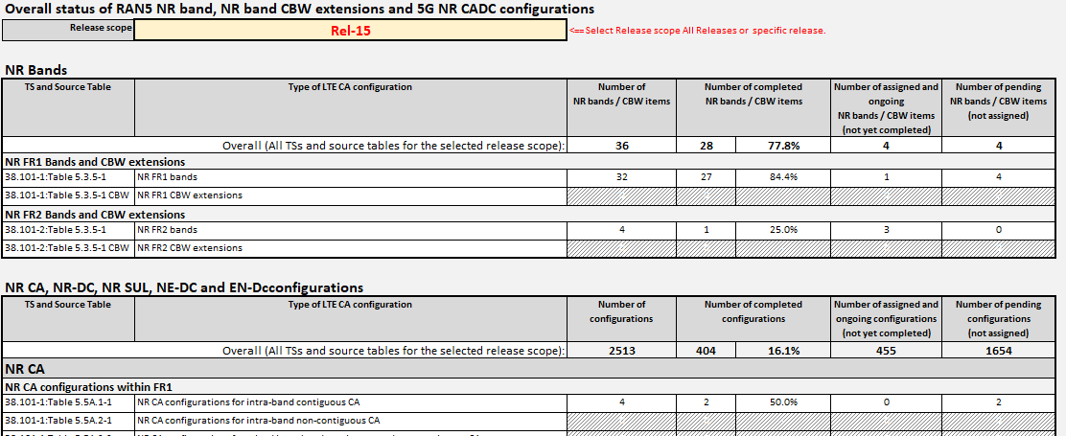

5.3 NR bands worksheet

5.3.1 Overview
Picture 5.3-1 shows a snapshot of the worksheet "NR bands". The list covers all NR bands and CBW extensions within the scope of RAN5 5G NR work items and based on the TS 38.101-1 (FR1) and TS 38.101-2 (FR2) versions as indicated in the top f the worksheet (see item 1 in Picture 5.3-1).
The purpose of the columns in the list are:
Column | Description
Marked config | Indicates if the NR band/CBW extension is selected/marked as input to an assignment request or to create workplan/checklist for.
Release introduced in TS 38.101-x | The release the NR band/CBW extension was introduced in TS 38.101-1 [11] or TS 38.101-2 [12].
Type of band | Indicates if the NR band/CBW extension is a FDD FR1, TDD FR1, SUL FR1, SDL FR1 or TDD FR2 band.
TS and Source Table | Indiates the source TS and Table number the NR band/CBW extension is specified in.
NR band | NR band/CBW extension label in format "nX" for NR bands and "nX CBW (<list of added CBWs>)"
CBWs SCS[kHz]:[MHz]+...+[MHz] | List the covered CBWs for each SCS, 15 kHz, 30 kHz and 60kz for FR1 and for SCS 60kHz and 120 kHz for FR2.
PC3 Status | Status of RAN5 process ("Pending", "Ongoing" or "Completed") to introduce introducing PC3 details for the NR band/CBW extension in RAN5 TSs and TRs. See clause 5.2 for the purpose of the differnet status indication in the RAN5 process to introduce NR bands/CBW extensions.
PC2 completed? | "Yes" indicates that Power Class 2 has been completed in RAN5 TSs and TRs. No value indicates that PC2 is not completed or not applicable for the NR band/CBW extension.
RAN5 Completion Meeting (PC3) | Indicates the RAN5 meeting the NR band/CBW extension was completed in RAN5 TSs and TRs.
Completion Reference (PC3) | Reference RAN5 TDOC declaring the completion of the NR band/CBW extension. Typically, it is the CR to TS 38.508-2 adding the Physical Layer Baseline Implementation Capabilities for the NR bands/CBW extension in Annex A.5.3.1. See clause 6.6 for details.
Interested operator (PC3) | Indicate the interested operator of the NR band/CBW extension for PC3. See clause 5.2 for the purpose of "Interested operator" in the RAN5 process to introduce NR bands/CBW extensions.
Responsible Company (contact) (PC3) | Indicate the company name(s) and the contact name(s) for the company acting as responsible company to coordinate the contributions to secure all aspects for the NR band/CBW extension has been taken into account before the NR band/CBW extension is declared as completed. The workplans/checklists provided by PRD21 give guidance to the responsible company. See clause 5.2 for the purpose of "Responsible Company" in the RAN5 process to introduce NR bands/CBW extensions.
Assignment [RAN5 meeting] (PC3) | Indicates the RAN5 meeting the NR band/CBW extension for PC3 was assigned to interested operator and responible company.
Applicable RAN5 WI code(s) for CRs | Indcates 3GPP WI code to be used in CRs for the NR band/CBW extension.

The colour labelling of 5G NR bands and CBW extensions rows is:
Completed: Green row indicates that the 5G NR band / NR band CBW Extension item is complete in the RAN5 test specifications. Available for testing.
Ongoing: Yellow row indicates that the 5G NR band / NR band CBW Extension item is ongoing and assigned to at least one "Interested Operator" and at least one "Responsible Company assignment". CRs can be submitted to RAN5 test specifications.
Ongoing: White row with black text indicates that the 5G NR band / NR band CBW Extension item is ongoing but pending assignment to a "Responsible Company". No CRs shall be submitted to the RAN5 specifications unless the company volunteers to be assigned as "Responsible Company".
Pending: White row with red text indicates that the 5G NR band / NR band CBW Extension item is pending assignment to "Interested Operator". No CRs shall be submitted to the RAN5 specifications.

The column "Applicable RAN5 WI code(s) for CRs" shows the RAN5 WI code(s) to be specified on the CR coversheet for CRs to the 5G NR CADC configurations. See Picture 5.3-1.
Picture 5.3-1: Indication of source of TS 38.101-X [11,12,13].

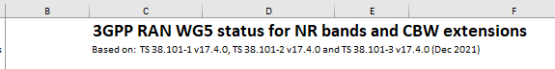

5.3.2 Requesting assignment of NR bands and NR band CBW extensions
See picture 5.3-2 showing location of the different buttons referenced in the text below.
To submit an assignment request for "Interested Operator" and/or "Responsible Company" for one or more NR bands and/or NR band CBW extensions do:
Step 1: Select the "NR bands" worksheet.
Step 2: Mark NR bands and NR band CBW extension items to be included in the assignment request:
- Individual items can be marked/un-marked by double-clicking on the row with the item.
- Multiple items can be marked by first selecting multiple rows followed by pressing the "Mark selected items" button.
- All marked items can be un-marked by pressing the "Clear" button.
Step 3: Press the "Request assignment for marked items" button.
Step 4: In the pop-up window (see picture 5.3-3) select type of assignment request: "Interested operator", "Responsible company" or "Interested Operator and Responsible Company". Depending on selected type of assignment fill in interested operator, responsible company or both. If the assignment request includes responsible company, then fill in the company contact name.
Step 5: Press the "Request Assignment" button (see picture 5.3-3).
Step 6: An email is created including the assignment request (see picture 5.3-4) including an Excel file with the requested configurations (see picture 5.3-5). Press the "Send" button to send the assignment request to the PRD rapporteur.
Step 7: The requested assignment is confirmed by the PRD rapporteur responding to the assignment request email.
When a responsible company has been assigned for a NR band or NR band CBW extension should the responsible company create a work plan as described in clause 6.2.

Picture 5.3-2: NR band worksheet overview.

WI code to be used for CRs

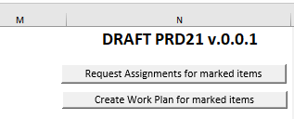

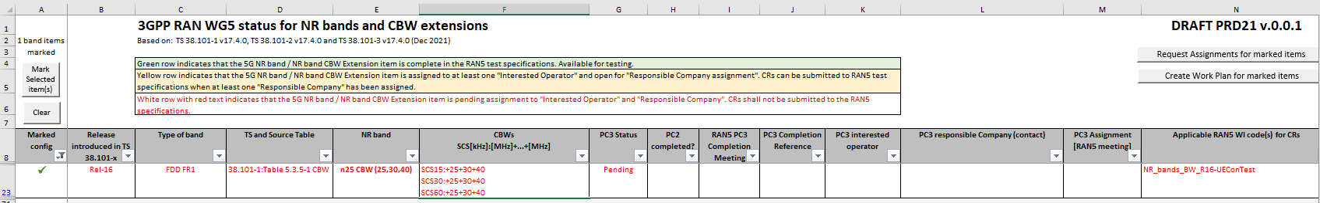

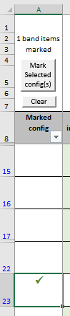

Picture 5.3-3: Assignment request form for NR bands and CBW extensions.
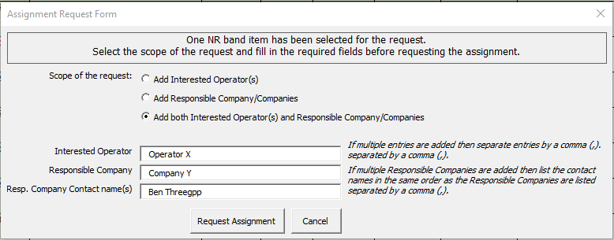
Picture 5.3-4: Example of an assignment request email.
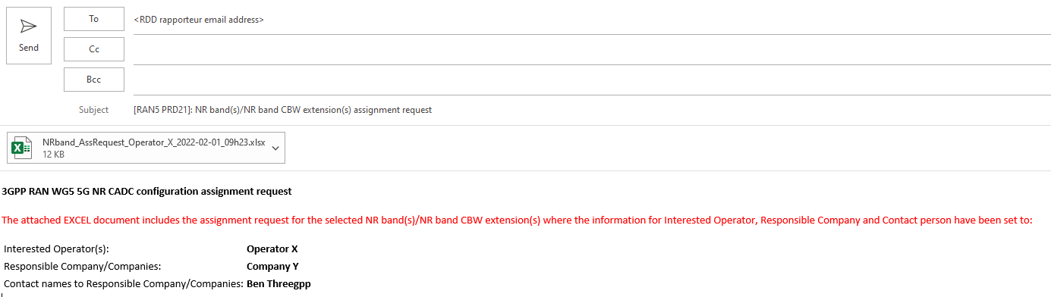

Picture 5.3-5: Example of attached EXCEL file attachment for an assignment request of a NR band CBW extension.
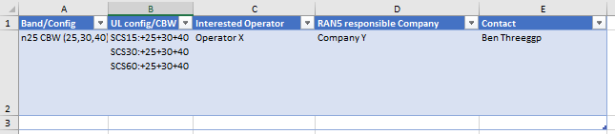

5.4 5G NR CADC Configurations worksheet

5.4.1 Overview
Picture 5.4-1 shows a snapshot of the worksheet "5G NR CADC Configurations". The list covers all NR CA, NR-DC, NR SUL, NE-DC and EN-DC configurations within the scope of RAN5 5G NR work items and based on the TS 38.101-1,-2,-3 [11,12,13] versions as indicated in the top of the worksheet (see item 1 in Picture 5.4-1).
The purpose of the columns in the list are:
Column | Description
Marked config | Indicates if the configuration is selected/marked as input to an assignment request or to create workplan/checklist for.
Release introduced in TS 38.101-x | The release the configuration was introduced in TS 38.101-1 [11], TS 38.101-2 [12] or TS 38.101-3 [13]
Type of configuration | Indicates if the configuration is a NR CA, NR-DC, NR SUL, NE-DC or EN-DC configuration.
TS and Source Table | Indicates the source TS and Table number the configuration is specified in. The format used is TS:Table <Table number>, e.g. " 38.101-3:Table 5.5A.1-1" for TS 38.101-3 and Table 5.5A.1-1.
Configuration | Indicates the DL configuration for NR CA, NR-DC, NE-DC and EN-DC configurations. For NR SUL it indicates the SUL band combination if the TS and Source Table is "38.101-1:Table 5.5C-1" else it indicates the SUL band combination with CA.
Uplink configuration | Indicates the UL configuration for the configuration for NR CA, NR-DC, NE-DC and EN-DC configurations. For NR SUL it is not applicable if the TS and Source Table is "38.101-1:Table 5.5C-1" else it indicates the SUL configuration for the SUL band combination with CA indicated in column "Configuration".
PC3 Status | Status of RAN5 process ("Pending", "Ongoing" or "Completed") to introduce PC3 details for the configuration (and its UL configuration when applicable) in RAN5 TSs and TRs. See clause 5.1 for the purpose of the different status indication in the RAN5 process to introduce 5G NR CADC configurations.
PC2 completed? | "Yes" indicates if Power Class 2 has been completed for the configuration in RAN5 TSs and TRs. No value indicates that PC2 details are not cmpleted or nor applciable for the configuration.
RAN5 Completion Meeting (PC3) | Indicates the RAN5 meeting the configuration was declared completed in RAN5 TSs and TRs. See clause 6.6 for details.
Completion Reference (PC3) | Reference RAN5 TDOC declaring the completion of the configuration. Typically, it is the CR to TS 38.508-2 adding the Physical Layer Baseline Implementation Capabilities for one or more NR bands, NR band extensions and 5G NR CADC configurations in Annex A.4.3.1. See clause 6.6 for details.
Interested operator (PC3) | Indicate the interested operator(s) of the configuration and PC3. See clause 5.1 for the use of "Interested operator" in the RAN5 process to introduce 5G NR CADC configurations.
Responsible Company (contact) (PC3) | Indicate the company (or companies) acting as responsible company to coordinate the contributions to secure all aspects for the configuration has been taken into account before the configuration is declared as completed. The workplans/checklists provided by PRD21 give guidance to the responsible company. See clause 5.1 for the use of "Interested operator" in the RAN5 process to introduce 5G NR CADC configurations.
Assignment [RAN5 meeting] (PC3) | Indicates the RAN5 meeting the configuration for PC3 was assigned to interested operator and responsible company.
Applicable RAN5 WI code(s) for CRs | Indicates 3GPP WI code to be used in CRs for the configuration.

The colour labelling of 5G NR CADC configurations in the list reflects the current status of the configurations:
Completed: Green row indicates that the 5G NR CADC configuration is complete in the RAN5 test specifications. Available for testing.
Ongoing: Yellow row indicates that the 5G NR CADC configuration is assigned to at least one "Interested Operator" and at least one "Responsible Company". CRs can be submitted to RAN5 test specifications.
Ongoing: White row with black text indicates that the 5G NR CADC configuration is ongoing but not yet assigned to any "Responsible Company". No CRs shall be submitted to the RAN5 specifications unless the company volunteers to be assigned as “Responsible Company”.
Pending: White row with red text indicates that the 5G NR CADC configuration is is pending assignment to "Interested Operator". No CRs shall be submitted to the RAN5 specifications.

Item 2 and Item 3 in Picture 5.4-1 shows controls for marking configurations to request assignments as "Interested Operator" and "Responsible Company", and to create workplans/checklists for the marked configurations. See clause 6.1 for more details.
Item 4 in Picture 5.4-1 shows options buttons for pre-defined sort options of the list.
The column "Applicable RAN5 WI code(s) for CRs" (see item 5 in Picture 5.4-1) shows the RAN5 WI code(s) to be specified on the CR coversheet for CRs to the 5G NR CADC configuration.

Picture 5.4-1: 5G NR CADC configuration worksheet overview.
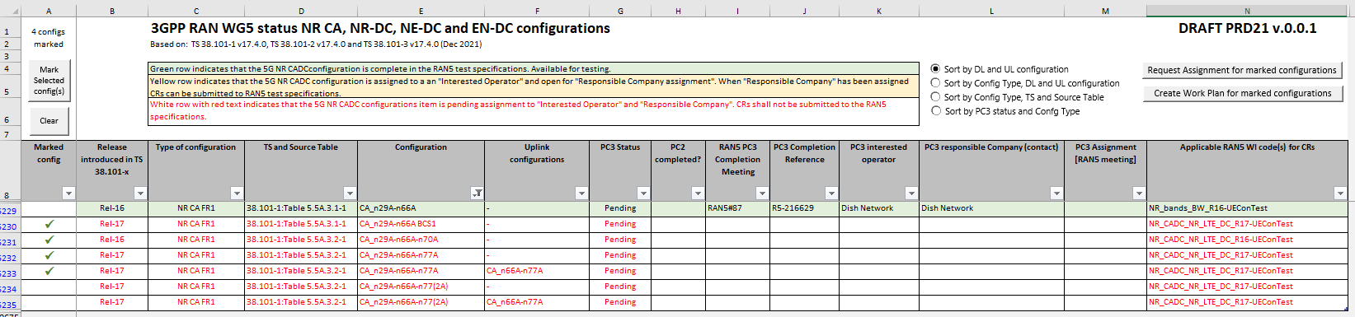
3
41
1

2

2
2
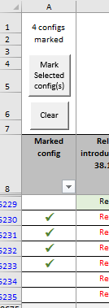
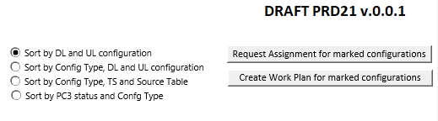

A 5G NR CADC configurations in 38.101-x [11,12,13] clause 5.6A having UL CA and/or more than one BCS will in the PRD21 5G NR CADC list be split into multiple rows where each row is limited to without UL CA or with one UL CA configuration and one BCS.
The purpose of the splitting of the 38.101-x [11,12,13] 5G NR CADC configurations into multiple configurations is to allow progress of individual configurations dependent on industry interest.

5.4.2 Requesting assignment of 5G NR CADC configurations
See picture 5.4.2-1 showing location of the different buttons referenced in the text below.
To submit an assignment request for "Interested Operator" and/or "Responsible Company" for one or more 5G NR CADC configurations do:
Step 1: Select the "5G NR CADC Configurations" worksheet.
Step 2: Mark the 5G NR CADC configurations to be included in the assignment request:
- Individual items can be marked/un-marked by double-clicking on the row with the item.
- Multiple items can be marked by first selecting multiple rows followed by pressing the "Mark selected items" button.
- All marked items can be un-marked by pressing the "Clear" button.
Step 3: Press the "Request assignment for marked items" button.
Step 4: In the pop-up window (see picture 5.4.2-2) select type of assignment request: "Interested operator", "Responsible company" or "Interested Operator and Responsible Company". Depending on selected type of assignment fill in interested operator, responsible company, or both. If the assignment request includes responsible company, then fill in the company contact name.
Step 5: Press the "Request Assignment" button (see picture 5.4.2-2).
Step 6: An email is created including the assignment request (see picture 5.4.2-3) including an Excel file with the requested configurations (see picture 5.4.2-4). Press the "Send" button to send the request to the PRD rapporteur.
Step 7: The requested assignment is confirmed by the PRD rapporteur responding to the assignment request email.
When a responsible company has been assigned for a 5G NR CADC configuration should the responsible company create a work plan as described in clause 6.2.

Picture 5.4.2-1: 5G NR CA DC configuration worksheet overview.

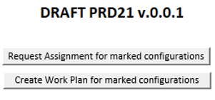
Picture 5.4.2-2: Assignment request form for 5G NR CADC configurations.
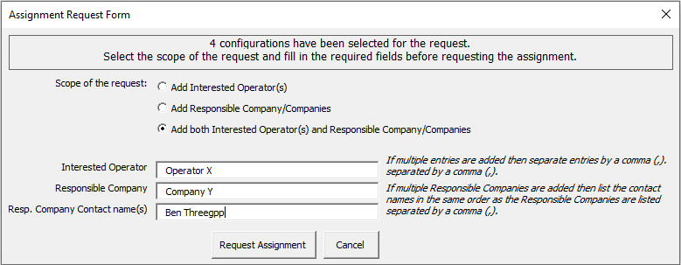
Picture 5.4.2-3: Example assignment request email.
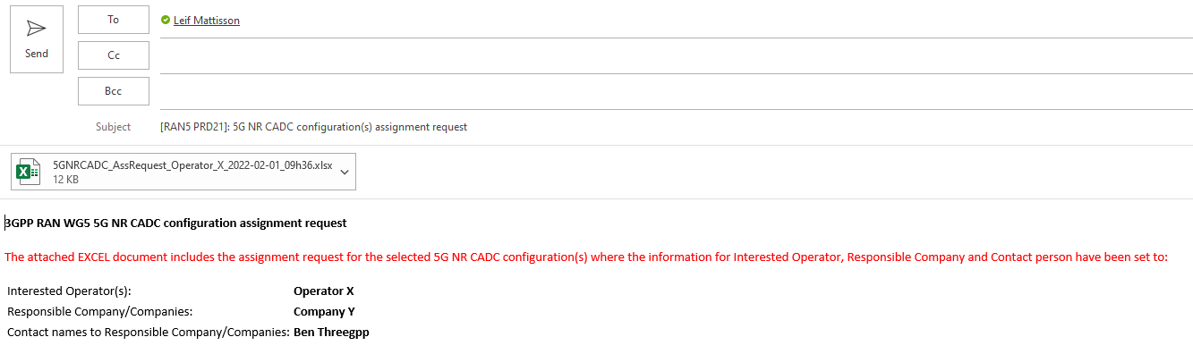

Picture 5.4.2-4: Example of attached EXCEL file attachment for an assignment request of four 5G NR CADC configurations.
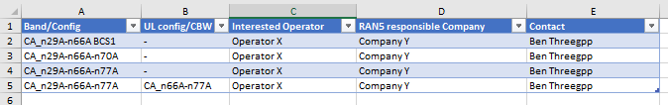

6 Responsible Company guidelines

6.1 General
PRD21 includes a zip-file with workplan/checklist templates (WP templates) as listed in Table 6.1-1. The WP templates are divided by type of configuration (NR Band, NR CBW, NR CA, NR-DC, NR SUL, NE-DC and EN-DC), power class (PC2, PC3) and frequency range (FR1, FR2 and FR1+FR2).
Table 6.1-1: WP templates in the PRD21 “WP templates” zip-fil.
WP template name | Description
NR band and NR band CBW extensions
NR band FR1 | WP template/checklist for introducing one or more NR bands into RAN5 TSs and TRs depending on if the band is for FR1 or FR2.
NR band FR2
NR band FR1 CBW | WP template/checklist for introducing one or more new channel bandwidth into RAN5 TSs and TRs depending on if the band is for FR1 or FR2.
NR band FR2 CBW
Power Class 3
WP NR CA PC3 FR1 | WP template/checklist for introducing one or more NR CA Power Class 3 configuration(s) into RAN5 TSs and TRs depending on if the configuration(s) are within FR1, within FR2 or between FR1 and FR2.
WP NR CA PC3 FR2
WP NR CA PC3 FR1+FR2
WP NR-DC PC3 FR1 | WP template/checklist for introducing one or more NR-DC Power Class 3 configuration(s) into RAN5 TSs and TRs depending on if the configuration(s) are within FR1 or between FR1 and FR2.
WP NR-DC PC3 FR1+FR2
WP NR SUL PC3 FR1 | WP template/checklist for introducing one or more NR SUL Power Class 3 configuration(s) into RAN5 TSs and TRs for FR1.
WP NE-DC PC3 FR1 | WP template/checklist for introducing one or more NE-DC Power Class 3 configuration(s) into RAN5 TSs and TRs depending on if the configuration(s) are within FR1 or within FR2.
WP NE-DC PC3 FR2
WP EN-DC PC3 FR1 | WP template/checklist for introducing one or more EN-DC Power Class 3 configuration(s) into RAN5 TSs and TRs depending on if the configuration(s) are within FR1, within FR2 or between FR1 and FR2.
WP EN-DC PC3 FR2
WP EN-DC PC3 FR1+FR2
Power Class 2
WP NR SUL PC2 FR1 | WP template/checklist for introducing one or more NR SUL Power Class 2 configuration(s) into RAN5 TSs and TRs for FR1.
WP EN-DC PC2 FR1 | WP template/checklist for introducing one or more EN-DC Power Class 2 configuration(s) into RAN5 TSs and TRs for FR1.
WP NR CA PC2 FR1 | WP template/checklist for introducing one or more NR CA Power Class 2 configuration(s) into RAN5 TSs and TRs for FR1.

The WP templates are used by the responsible company as a guideline and checklist how to introduce and document the introduction of the NR bands, NR band CBW Extensions and 5G NR CADC configurations into the relevant RAN5 technical specifications and technical reports.

A WP/Checklist is also used in the final step to confirm completion of NR bands, NR CBW extensions and 5G NR CADC configurations by attaching the WP/Checklist worksheet to the CR to TS 38.508-2 [17], sub-clause 5.6.4.
A WP/Checklist may include one or more NR bands, NR CBW extensions or 5G NR CADC configurations.
The WP/Checklist has three outline levels:
Outline Level 1: Showing overview of recommended workflow steps to introduce the 5G NR CADC configurations
Outline Level 2: Showing all WP items under each workflow step.
Outline Level 3: Showing all details of the WP (as Outline Level 2 + details of WP scope and overall status).
The outline level is selected in the upper left corner of the WP by selecting 1, 2 or 3:
The WP is structured in the recommended workflow steps to introduce the new NR band(s), NR CBW Extension(s) or 5G NR CADC configuration(s) in RAN5 technical specifications and technical reports. The overall completion and the completion of each workflow step is shown in section 2 of the WP, see Picture 6.1-1. The completion status is calculated based on the reported status for each WP item in section 3 of the WP.
Picture 6.1-1: WP workflow steps and WP overall status information (NR CA WP).
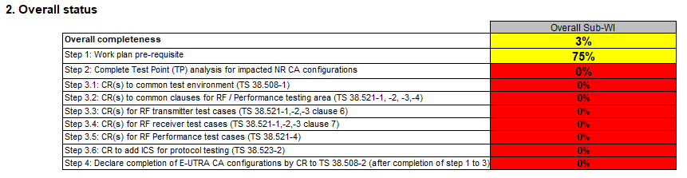

For each workflow step the WP includes a number of WP item rows with status columns to indicate progress and completion of the WP item tasks, see Picture 6.1-2 for an example of WP item rows for work flow step 1.
Picture 6.1-2: Example of a workflow step and its WP item rows (NR CA WP).
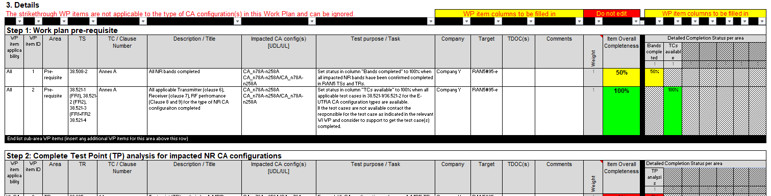
The applicable WP item rows are dependent on the type of NR band, NR CBW extension or 5G NR CADC configurations covered by the WP.

6.2 Creating a WP/Checklist
Note: The guideline in this clause uses a set of NR CA PC3 FR1 configurations as an example to create a NR CA PC3 FR1 workplan. Creating work plans for other type of target configurations follwos the same principles.
To create a WP/Checklist do:
1. Select the relevant WP template in the PRD21 WP templates zip-file and save it on Your computer using the following name convention:
WP filename: <WP template name>-<Company>-<WP scope label>, where
<WP template name> is the name of the WP template as picked from the WP templates zip-file,
<Company> is name of Your company (use short abbreviation if possible), and
<WP scope label> is a suitable short label of the scope of the WP
Example:
<WP template name> = "WP EN-DC PC3 FR1"
<Company> = "Ericsson"
<WP scope label> = "2bSet1" (two bands, configuration set 1)
=> WP file name = "WP EN-DC PC3 FR1-Ericsson-2bSet1"
2. Open the saved WP.

3. Select the "WP scope" worksheet and do:
- Fill in the Work Plan scope information (rows 5 to 8). See Picture 6.2-1 for an example.
- Select the target NR bands, NR band CBW extensions or 5G NR CADC configurations from the PRD21 "5G NR bands and CADC configurations" list as described in the WP scope worksheet (step 1). See Picture 6.2-2 for an example.
- Paste the selected target configurations in the table as described in the WP scope worksheet (steps 2 to 3). See Picture 6.2-3 for an example.
4. Save the workplan.
5. The work plan is ready for use. See sub-clause 6.3 for guideline of maintaining the WP.

Picture 6.2-1: Example Workplan scope filled in for a NR CA PC3 FR1 workplan.
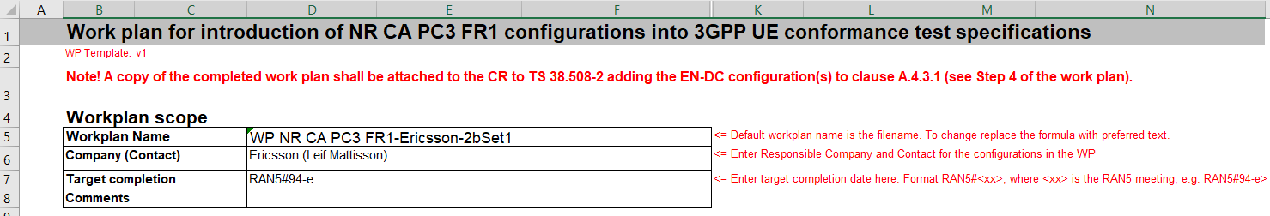

Picture 6.2-2: Example: Selecting target configurations CA_n5A-n7A, CA_n5A-n78A and CA_7A-n78A in the PRD21 "5G NR bands and CADC configurations" list.
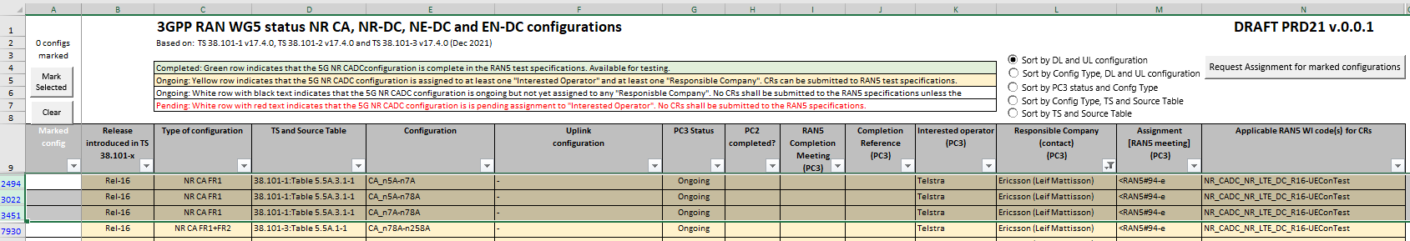

Picture 6.2-3: Example: Target configurations added to the NR CA PC3 FR1 workplan.
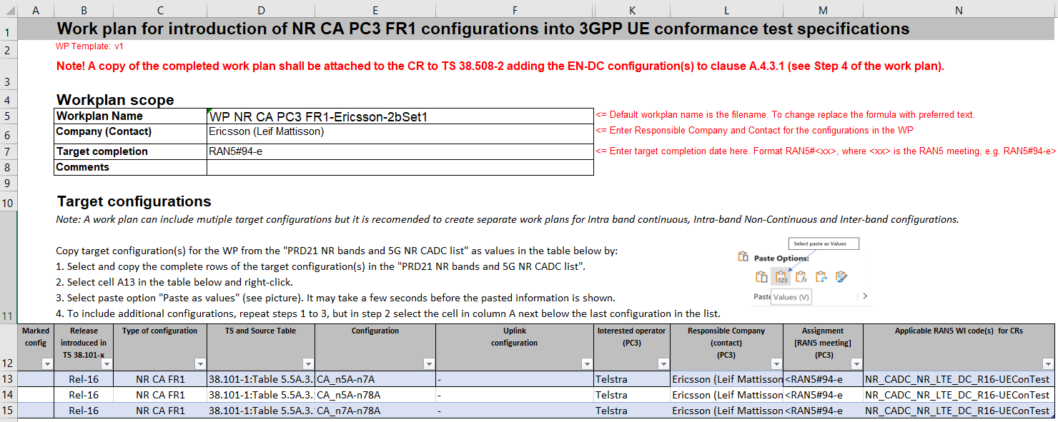

6.3 Maintaining the WP
The columns marked as "WP item columns to be filled in" shall be filled in showing what have been done to complete the WP items. The purpose of the different columns is (see Picture 6.3-1):
- The "Company" column is used to track company responsibility for the WP item in case more companies than the assigned company of the 5G NR CADC configurations have contributed.
- The "Target" column is by default linked to the values of the target completion date specified in the WP header. If needed specific target for a WP item can be added by replacing the current formula in the target column with specific target information for the WP item.
- The "TDOC(s)" column is used to track RAN5 contributions (CRs) progressing and completing the WP items.
- The "Comments" column can be used to add additional comments as needed for the WP items. E.g., for the case no changes were needed for the WP item then it is useful to add a comment "No changes needed" as justification for setting the WP item as completed (100%).
- WP item status columns are used to state the current status (0% to 100%) for the different areas covered by the status columns. As default the WP template have the applicable status columns set to "0%". In case a WP item is not applicable for the specific type of configurations then need all the status column be cleared (delete content of the status columns for the WP item). See Picture 6.3-2 for an example of a WP item changed to be made not applicable for the target configurations.

Picture 6.3-1: Example: WP overall status and WP item columns (WP based on NR CA PC3 FR1 workplan template).
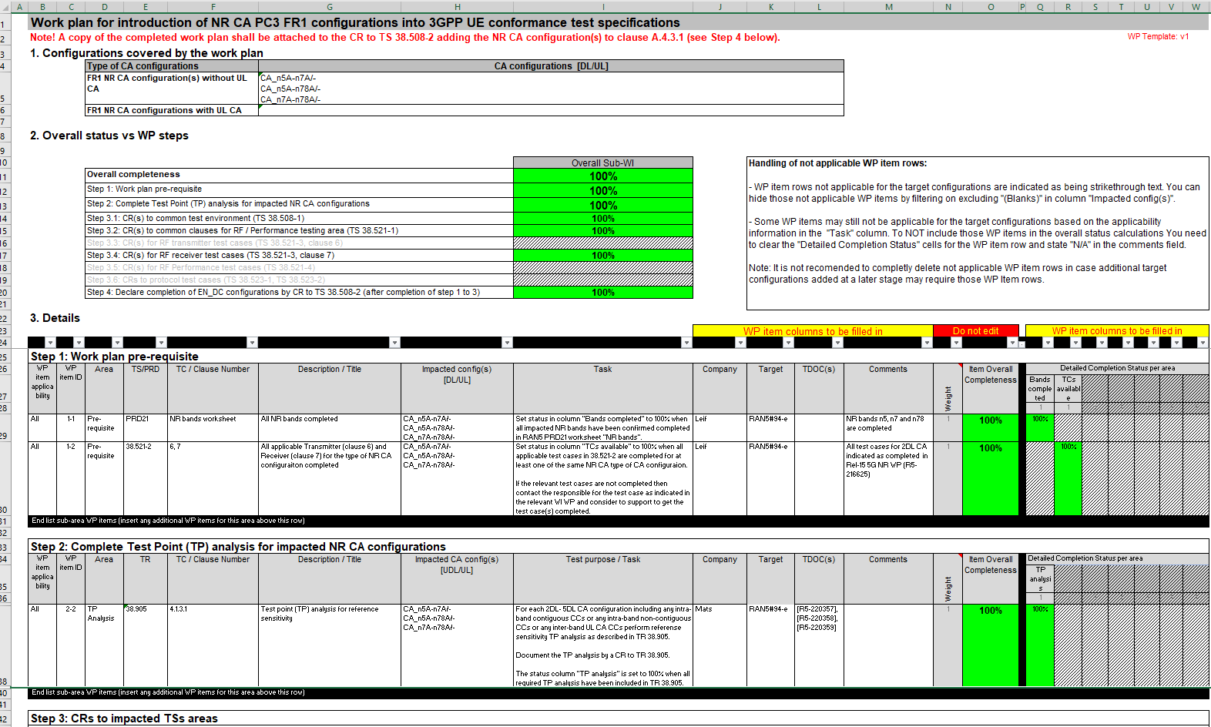

Picture 6.3-2: Example of WP item (WP item ID "3.5-2"not applicable for target configurations (WP based on NR CA PC3 FR1 workplan template).
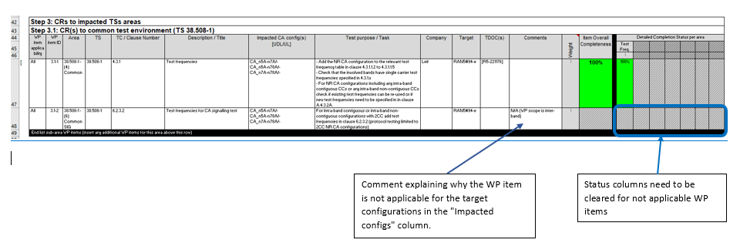

6.4 Reporting a NR bands, NR band CBW extensions and 5G NR CADC configuration as completed
Editor's note: This clause is pending updated of formats of the Physical Layer Baseline Implementation Capability tables in TS 38.508-2 [17], Annex A.4.3.1 to enable declration of completion of DL and UL configurations individually.
The final workflow step in the WP, step 4, covers the actions to declare that a NR band, NR band extension or 5G NR CADC configuration is completed by RAN5 specifications.
All the involved bands in a 5G NR CADC configuration shall be confirmed as completed before the NR band, NR band extension or 5G NR CADC configuration can be considered as completed. For EN-DC and NE-DC shall also be confirmed that all the involved E-UTRA CA and NR CA configuration(s) in the configuration are completed before the EN-DC and NE-DC configuration can be considered completed. The confirmation that bands and the embedded configurations have been completed is declared as part of step 1 of the WP ("Work plan requisite", see Picture 6.1-1),
The configuration completion declaration is done by a CR to TS 38.508-2 [17] adding the Physical Layer Baseline Implementation Capabilities for one or more NR bands, NR band extensions and 5G NR CADC configurations in Annex A.4.3.1.
The CR shall add the completed NR bands, NR band extensions and 5G NR CADC configurations in the relevant Physical Layer Baseline Implementation Capabilities in Annex A.4.3.1.
For 5G NR CADC configurations the table format where each row shall cover one DL and UL 5G NR CADC configuration. The covered BCSs and the introduction release of the initial BCS0 shall also be specified in the CR. See example below for the format to be used in TS 38.508-2 [17].
Any exceptions for not completed parts need to be stated in the CR cover sheet and as a note in the CR body text for the entry of the NR band, NR CBW extension or5G NR CADC configuration in the impacted Physical Layer Baseline Implementation Capability table.
A copy of the work plan shall be attached to the CR to TS 38.508-2 [17] in the TDOC zip-file.

7 CR author guideline for selecting WI code for CRs
Any CR submitted to RAN5 to introduce or update details for a NR band, NR band CBW extension or 5G NR CADC configuration in RAN5 technical specifications and technical reports shall use the WI code as indicated in the PRD21 NR bands and 5G NR CADC configurations list in worksheet "NR bands" and "5G NR CADC Configurations" respectively.

8 PRD rapporteur guidelines

8.1 PRD21 rapportuer and WI rapporteur responsibilities
The PRD21 rapporteur together with the RAN5 rapporteurs for NR bands, NR band CBW extensions and 5G NR CADC configuration work items are responsible for:
- Keeping the NR band and 5G NR CADC configuration list up to date with latest version of TS 38.101-1 [11], TS 38.101-2 [12] and TS 38.101-3 [13] within the scope of RAN5 work items.
- Handling assignment of Interested Operator and volunteering companies for NR bands, NR band CBW extensions and 5G NR CADC configurations.
- Maintaining the status of completed NR bands, NR band CBW extensions and 5G NR CADC configurations in RAN5 conformance test specifications.

8.2 Handling assignment requests
When receiving an assignment request email do:
- Add the interested operator, responsible company and responsible company contact person to the "NR bands" worksheet for the requested NR bands and NR Band CBW extensions; and to the "5G NR CADC Configurations " worksheet for the request 5G NR CADC configurations.
- Add the RAN5 meeting the request was received in column "RAN5 Assignment [RAN5 meeting]".
- Confirm the assignment by responding to the request email.

8.3 Update the PRD21 5G NR CADC list when new version of TS 38.101-x is published

8.3.1 Update of the "5G NR CADC Configurations" worksheet
Add any new or changed NR bands, NR bands CBW extensions and 5G NR CADC configurations (and its bandwidth combination set, BCS) in accordance to the latest version of 38.101-x [11,12,13] up to the release covered by the RAN5 NR bands, NR band CBW extensions and 5G NR CADC work items listed in clause 1.
The column "Applicable RAN5 WI code(s) for CRs" is set in accordance to the current applicable WI codes as listed in clause 1 depending on the current status of the RAN5 WI the configuration belongs to.
Example: 2D/2UL 5G NR CADC configuration CA_1A-n3A
38.101-x [11,12,13] v17.4.0, Table 5.5A.3.1-1 specifies the NR CA configuration CA_1A-3A as:
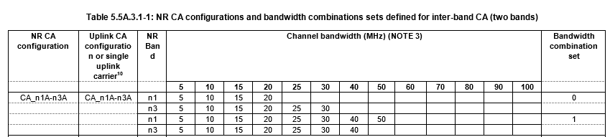
BCS0 was introduced in Rel-16 and BCS1 in Rel-16 of TS 38.101-1 [11].
For PRD21 CA list this configuration and its UL CA configurations are split into separate rows for each BCS and for each UL CA configuration as well as one row each for each BCS for the case without UL CA:
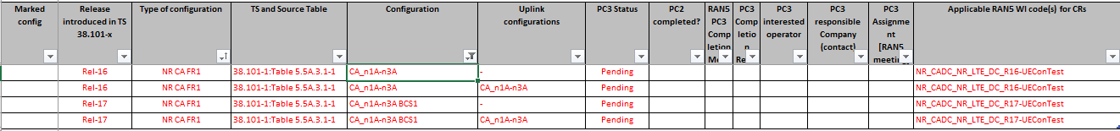

8.3.2 Update of the "Support data" worksheet
The support data Excel worksheet is hidden in the published version of PRD21 5G NR CADC list. Unhide the worksheet and do:
- Unhide the worksheet "Support data" in the Excel file attached to PRD21.
- Update the version of TS 38.101-x [11,12,13] in the cell next to "Source of PRD21 support data".
- Check if any changes are needed in the support data tables due to the new version of 38.101-x [11,12,13].
- Hide the worksheet "Support data".

8.4 Update the PRD21 after end of RAN5 meetings

8.4.1 Update status of NR bands, NR band CBW Extensions and 5G NR CADC Configurations
Update the status of completed NR bands, NR band extensions and 5G NR CADC Configurations by adding the RAN5 meeting to column "RAN5 Completion" and add the reference to the agreed CR to TS 38.508-2 [17] confirming the completion of the 5G NR CADC configuration(s).

8.4.2 Update when a RAN5 NR bands, NR band CBW Extensions or 5G NR CADC basket WI is closed
When a NR bands, NR band extension and RAN5 5G NR CADC basket work item has been closed, the following need to be updated:
- Update the "Status" column in the scope table in clause 1 of this document for the WI.
- If all the 5G NR CADC configurations have been completed, set the status to "Completed"; else
- If the WI is closed but not all 5G NR CADC configurations have been completed, set the status to "WI closed but not all configurations specified".
- For each NR band, NR Band extension or 5G NR CADC configuration of the closed WI add "TEIx_Text," before the existing WI code in column "Applicable RAN5 WI code(s) for CRs" where x is the number of the release, e.g. 15 for Rel-15, etc.

8.5 Update the WP templates
When a WP template need to be updated pay attention to not overwrite cells with formulas.
Add new WP items by copying an existing WP item row and inserting above the relevant black row under each WP step area and modifying as needed.

8.6 Update when PRD21 rapporteur is changed
When a new rapporteur is assigned to PRD21 do:
- Unhide the worksheet "Support data" in the Excel file attached to PRD21.
- In the "Support data" worksheet, update the PRD21 contact person details, including Name, Company and email address. It is important that the email address is correct as it will be used in the assignment request emails.
- Hide the worksheet "Support data".

Annex A (informative):
Change history
Change history
Date | Meeting | TDoc | CR | Rev | Cat | Subject/Comment | New version
2022-2 | RAN5#94-e | [R5-220661] | - | - | - | First version | 1.0.0

