In TS38.521-3 spec following changes are pertinent to be done for NE-DC

1. For all ***non-anchor agnostic tests/clauses*** add below step-6 in initial condition with an indication that step-6 is to be followed if UE does not support EN-DC. Yellow highlighted is new text

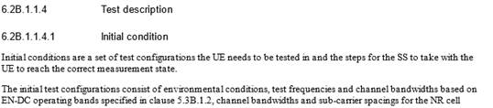

…..

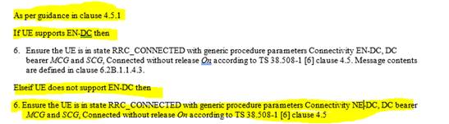

1. If there are NE-DC exceptional requirements in -3 core spec then introduce separate clauses in TS38.521-3 and have ***Step6 in the initial conditions*** as below  i.e. these tests are only for option4 UE’s



1. For ***all Anchor agnostic tests*** no need of  any changes since they all point back to option2 test spec and as we have confirmed option2 is mandatory to be supported for option 4 UE’s.  For these clauses the change you are bringing to replace NSA with MR-DC in clause 4.5.1 suffices. If desired you could point

to clause 4.5.1 in each of these test purpose as follows , yellow highlighted text is new

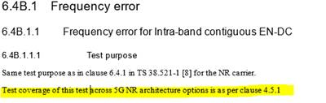

All tests in 521-4 and .533 are anchor agnostic so the above anchor agnostic way fwd can be extended.