3GPP TSG-RAN5 Meeting #92-e R5-215809_Draft_r2
Electronic Meeting, 16th – 27th August 2021

Title: LS on AMPR edge RB allocation for NS
Response to:
Release: Release 15
Work Item: 5GS_NR_LTE-UEConTest

Source: TSG RAN WG5
To: TSG RAN WG4
Cc: N/A

Contact Person:

Name: Mohammad Omar Farooq
Tel. Number:

E-mail Address: mohammad_farooq@apple.com

Send any reply LS to: 3GPP Liaisons Coordinator, mailto:3GPPLiaison@etsi.org

Attachments:

1. Overall Description:
In TS 38.101-1 specification, it is observed that for edge RB, A-MPR value is not explicitly mentioned for several NS values. However, A-MPR values for “Outer” and “Inner” RB allocations are indicated for different regions but edge RB allocation is omitted. These tables from TS 38.101 are used in related sections in TS 38.521-1 specification for A-MPR test cases.
We can take an example of NS_21 table in TS 38.521-1 section 6.2.3.3.14. A-MPR values for different regions (Regions A1a, A1b, A2, A3b and A3a) are specified. Interpreting regions A1a and A3a based on formula stated covers outermost allocations at the channel edges.

If we consider 1RB@0 (edge RB allocation) test point which falls in Region A1a (RB_{start} ≤ 8, L_{CRB} ≤ 3), since edge allocation is excluded in the table [ refer below red circled text in Table 6.2.3.3.14-1, “Outer” and “Inner” are indicated , “edge” is not indicated,], A-MPR is interpreted as 0 dB , resulting in different test requirement compared to test requirement with A-MPR of 6dB
It is not clear whether phrases like “Outer/Inner” and “Outer” is redundant information and not to be considered in the A-MPR table for NS_21.

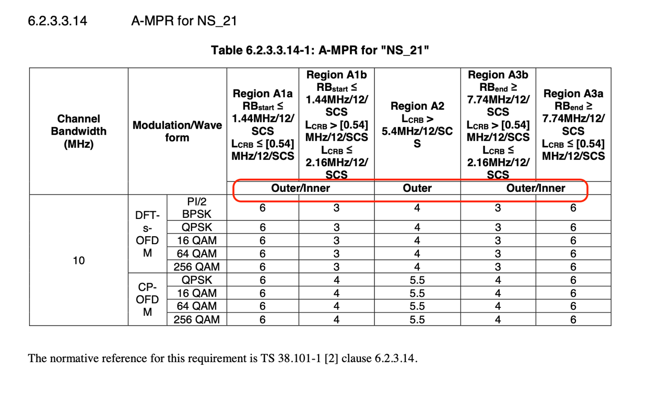

Similar observations are found in A-MPR tables for other NS values (example: NS_24, NS_27, NS_46 etc.)..

2. Actions:
To RAN4 group.
ACTION: RAN5 respectfully asks RAN4 to clarify "edge" RB allocation A-MPR requirements in NS_21 and other NS value A-MPR tables defined with "outer" , “Outer/Inner” RB allocations.
3. Date of Next TSG-RAN WG5 Meetings:
TSG-RAN5 Meeting#93e 8th – 19th November 2021 Electronic Meeting
TSG-RAN5 Meeting#94 21st – 25th February 2022 Athens, GR

--- END ---

