3GPP TSG-RAN WG4 Meeting #99-e R4- 2111xxx
Online, 19 – 27 May 2021

Source: Huawei, HiSilicon
Title: A-MPR for n39 NS_50 PC2
Agenda Item: 8.34.2
Document for: Information

1 Introduction
According to the WF [1] some preliminary simulation results are provided for the discussion on n39 PC2 A-MPR. New A-MPR may be needed for PC2 UEs to meet the additional emission requirements as signalled by NS_50 [2].

6.5.3.3.16 Requirement for network signalling value "NS_50"
When "NS_50" is indicated in the cell, the power of any UE emission shall not exceed the levels specified in Table 6.5.3.3.16-1. This requirement also applies for the frequency ranges that are less than F_{OOB} (MHz) in Table 6.5.3.1-1 from the edge of the channel bandwidth.
Table 6.5.3.3.16-1: Additional requirements for "NS_50"
Protected band | Frequency range (MHz) |  |  | Maximum Level (dBm) | MBW (MHz) | NOTE
Frequency range | 1805 | - | 1855 | -40 | 1 | 1
Frequency range | 1855 | - | 1880 | -15.5 | 5 | 1, 2, 3
NOTE 1: This requirement is applicable for carriers with aggregated channel bandwidths confined in 1885-1920 MHz for 25MHz and 30MHz channel BWs and confined in 1880-1920 MHz for 40MHz channel BW.
NOTE 2: The requirement also applies for the frequency ranges that are less than F_{OOB} (MHz) in Table 6.6.3.1-1 and Table 6.6.3.1A-1 from the edge of the channel bandwidth.
NOTE 3: For these adjacent bands, the emission limit could imply risk of harmful interference to UE(s) operating in the protected operating band.

2 Discussion
The PC2 A-MPR simulation results for NS_50 are presented in Table 1.

Table 1: A-MPR Simulation Results for NS_50
Channel Bandwidth | DFT-s-OFDM | CP-OFDM
25 MHz | 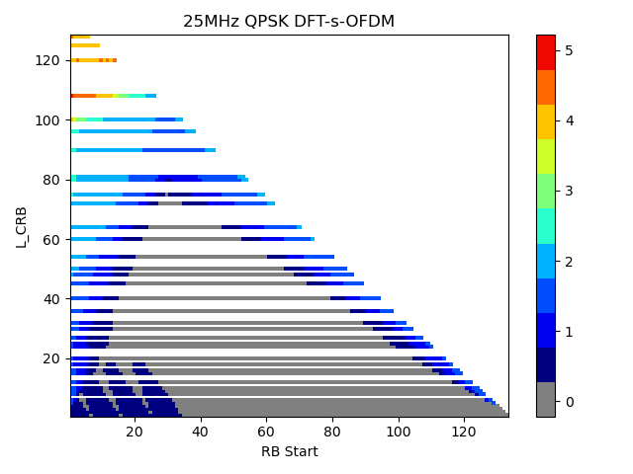 | 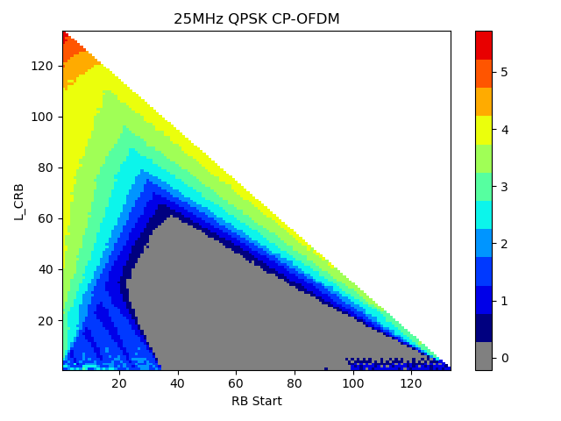
30 MHz | 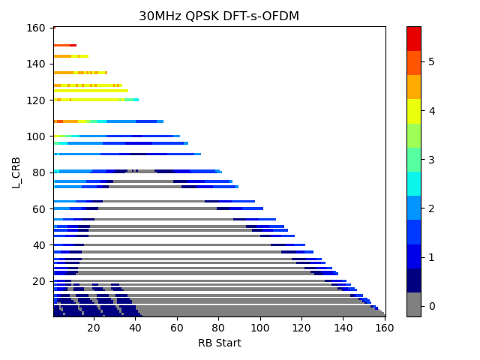 | 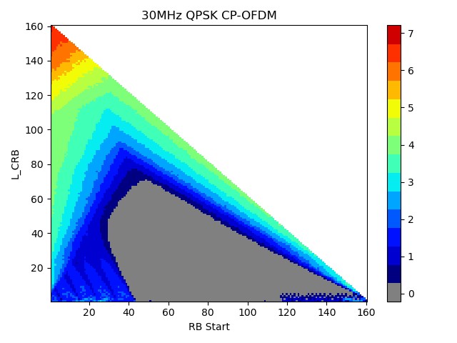
40 MHz | 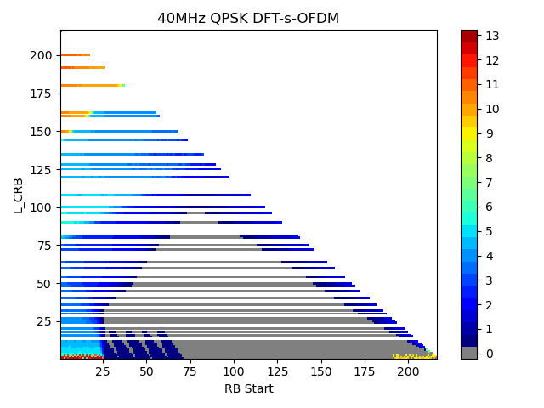 | 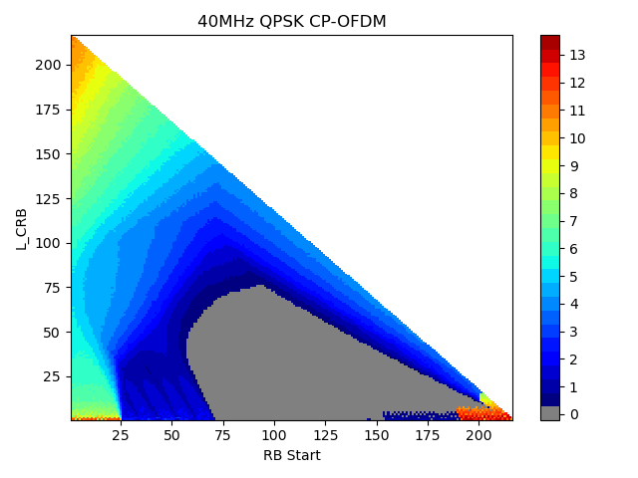

References
[1] R4-2105386, “WF on PC2 n34 and n39 for NR”, CMCC, 3GPP TSG RAN4#98bis-e
[2] 3GPP TS 38.101-1 v16.6.0

