3GPP TSG-RAN WG4 Meeting # 99-e R4-210XXXX
Electronic Meeting, 19th – 27th May 2021

Agenda item: 6.7.1
Source: Moderator (vivo)
Title: Email discussion summary for [99-e][109] NR_TxD
Document for: Information

Introduction
Briefly introduce background, the scope of this email discussion (e.g. list of treated agenda items) and provide some guidelines for email discussion if necessary.
List of candidate target of email discussion for 1st round and 2nd round
The TxD and power class ambiguity problem had been on for some time. Based on latest RAN2 LS and evaluation, see if this issue could be closed.
- 1st round:
  - Discuss remaining issues for TxD, including reply LS to RAN2
  - Discuss power class ambiguity issue, converge on the treatment
- 2nd round:
  - Agree reply LS to RAN2
  - Update the endorsed TxD CR, see if agreeable
  - Agree CR for power class if possible
  - See if other output is needed or possible (LS/WF/CR, etc…)

Topic #1: TxD
Main technical topic overview. The structure can be done based on sub-agenda basis.

Companies’ contributions summary
T-doc number | Company | Proposals / Observations
R4-2107616 | RAN2 | Reply LS to RAN4 on the capability of transparent TxD  RAN2 thanks RAN4 for the LS on signalling scheme of transparent TxD.  Regarding the new per-band capability signaling in Rel-16 for FR1 UEs supporting transparent TxD, RAN2 can add the corresponding capability in corresponding specification (TS 38.331 and TS 38.306).  RAN2 has discussed whether to enable release-independent support of this new capability from Rel-15, and the following agreements have been achieved:  - RAN2 can support release independent capability of transparent TxD for Rel-15, by allowing early implementation of the Rel-16 CRs.  - It is possible to only apply the change for this new capability for PC2 UEs for Rel-15, but RAN2 would like to understand whether the Rel-16 capability signalling applies for all PCs, while Rel-15 capability signalling applies for just PC2 (as this difference in Rel-15 and Rel-16 capability might impact the signalling design)?  - RAN2 would also like to confirm whether this new capability has any dependencies with other capabilities that should be captured by RAN2 (since the capability is intended as release independent, RAN2 may need to capture such pre-requisites explicitly).  To RAN WG4  RAN2 kindly request RAN4 to take the above information into account during the following work, and provide feedback, if any.
R4-2108793 | Qualcomm Incorporated | SRS switching and spectral flatness with TX diversity  Proposal: Specification changes to accommodate Tx Diversity are proposed as follows  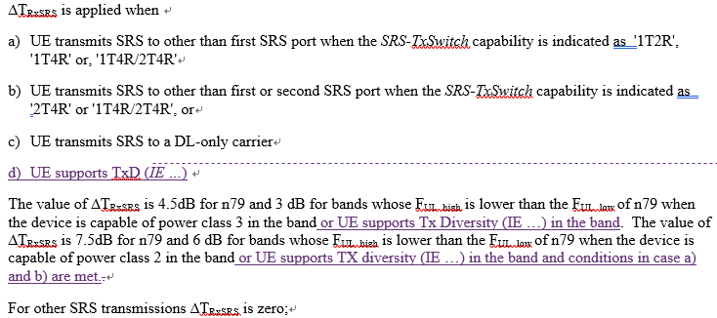  Proposal 2: The draft CR [1] is changed according to following changes  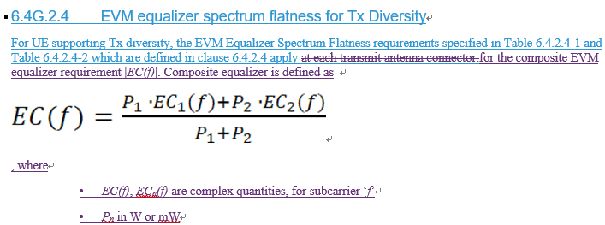  Observation: The draft CR is not using agreed text format “requirement is defined as sum”
R4-2108794 | Qualcomm Incorporated | MPR for 2Tx devices  Observation 1: The proposed MPR relaxations in [2] seem to enable use of PC3 PA’s for PC2 with TxD.  Observation 2: If reference design is targeted for PC2 from the beginning, same MPR could be met as what is specified for PC2 now in the spec  Observation 3: -41 dBc RIMD level for the PA is the correct value  Observation 4: Edge RBs do not need additional MPR compared to the PC2 MPRs not in specification  Observation 5: Keeping the agreement of applying same MPR for UL MIMO and Tx Diversity and approving proposed [2] MPR’s would mean UL MIMO AMPR need to be revisited too  Proposal: 256 QAM DFT-s waveforms need 1 dB more MPR and CP-OFDM 2 dB more MPR for Tx diversity UEs
R4-2108909 | Nokia, Nokia Shanghai Bell | Relation between TxD and ul-FullPwrModes & TxD and SRS antenna switching  Observations  Observation 1: If PC2 TxD PA configuration is 26dBm + 23dBm, the below current requirement can cover the extra 3 dB relaxation due to non-full-rated-PA usage for 1TyR if we follow a principle of the past.  The value of ∆T_{RxSRS} is 7.5dB for n79 and 6 dB for bands whose F_{UL_high} is lower than the F_{UL_low} of n79 when the device is capable of power class 2 in the band.  Observation 2: If PC2 TxD PA configuration is 26dBm + 26dBm, no extra 3 dB relaxation due to non-full-rated PA usage for 1TyR is needed.  Observation 3: If PC2 TxD PA configuration is 23dBm + 23dBm, the power transmitted via each antenna is lower than the PC2 for 1TyR by 3dB if Tx antenna virtualization is not used and this is not covered by the current specification.  Observation 4: If PC2 PA configuration is 23dBm + 23dBm and if Tx antenna virtualization is used, the situation becomes similar to Case 1(part of antennas is virtualized) or 2(all the antennas are virtualized).  Observation 5: If UE is assumed to virtualize Tx ports for the purpose of SRS antenna switching while NOT assumed to virtualize Rx ports for it in the same manner, the gain is not maximized.  Observation 6: If the above observations 1 - 4 are valid, the option 1a is at least not wrong if we follow the principle of the past for PC2 extra relaxation.  Observation 7: Without supporting UL MIMO in a given band, a UE supporting TxD cannot report any ul-FullPwrMode related capabilities.  Observation 8: How to achieve full power with two Tx chains is not specified. Hence it is up to UE implementation as far as the UEs meet all the requirements for TxD.  Proposals  Proposal 1: At least UE performance requirements related to SRS for DL CIS acquisition should be established based on the assumption that a UE uses the same antenna virtualization configuration between Tx and Rx.  Proposal 2: In case extra relaxation due to non-full-rated PA is introduced, specification must be clear that it applies to only 1TyR case.  Proposal 3: Regardless of PA configurations(two full-rated, two non-full-rated, partially full-rated ), the UE supporting TxD should meet all the requirements for TxD.
R4-2109420 | ZTE Wistron Telecom AB | On remaining issues on NR TxD  Observation 1: In transparent TxD, spatial copies of information are transmitted without intervention from BS.  Observation 2: In one-layer-two port configuration with full power transmission, spatial copies of information are transmitted in full power which is controlled by BS.  Observation 3: TxD and full power capability are two independent features with some overlappings.  Proposal 2: RAN4 take Option 2 regarding the relationship between TxD and full power capability.  Proposal 1: RAN4 reach a consensus on tentative understanding.  Proposal 3: No more discussion on transparent TxD antenna and channel models.
R4-2109678 | vivo | Remaining issues in Transparent Tx Diversity  Observation 1: RAN2 confirmed there will be a new capability in Rel-16 specification for transparent TxD.  Observation 2: Regarding the capability for Rel-15 UEs, RAN2 have agreed to support release independent capability of transparent TxD for Rel-15 UEs.  Observation 3: RAN2 is not clear the power class restriction for transparent TxD for different releases, and ask RAN4 to feedback this information.  Proposal 1: For Rel-16, confirm RAN2 there is no restriction for the power class of transparent TxD. For Rel-15, discuss whether PC2 restriction is necessary for release independency.  Proposal 2: Confirm RAN2 that there is no dependency with other capabilities for this transparent TxD capability.  Proposal 3: Introduce certain MPR relaxations for 2Tx compared to 1Tx. The detailed number can be based on evaluation.  Proposal 4: It is proposed to postpone the discussion, possibly leave to RAN5, after feature CR can be approved.  Proposal 5: A testing mode can only be the last resort and should be avoided wherever possible.  Proposal 6: Further clarify the SRS antenna switching requirements, possibly into ∆TRxSRS based on the scheme in [6].  Proposal 7: No inter-dependency with transparent TxD capability with full power capability.  Proposal 8: Reply RAN5’s LS after RAN4 CR is stable and release independence applicability is confirmed.
R4-2109703 | LG Electronics Polska | MPR of transmit diversity for power class2  Proposal 1: Define MPR for power class 2 with Tx diversity with Table 2.1.  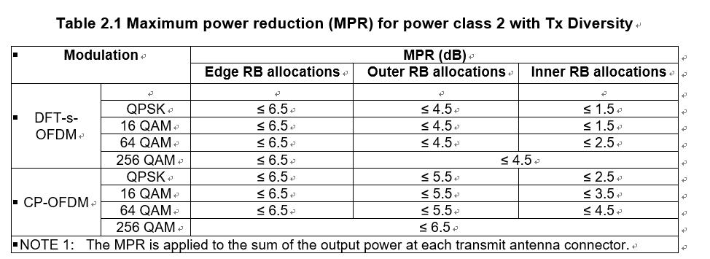
R4-2109974 | Ericsson | More on transparent TxD and a Draft Reply LS to RAN2  Observation 1:  - Transparent TxD can be substantially worse than single antenna operation under severe conditions  - When the channel is highly correlated, transparent TxD can be multiple dB worse when an inappropriate amount of CDD delay is used for PUSCH transmission  - Transparent TxD is sensitive to proper choice of CDD delay even under conditions favorable to TxD  - Improper choice of CDD delay can result in roughly a dB loss for uncorrelated antennas  - Transparent TxD can provide notable gain over single antenna operation in conditions favorable to diversity  - Gains of roughly 1 dB can be observed with appropriate CDD delay and when frequency hopping is used with uncorrelated antennas.  Proposal 1: further discuss the relevant antenna and channel models and their impact as part of, and prior to, concluding on conformance testing methodologies and reference receivers for TxD with conducted measurements.$EVM$  Observation 2: Given the support for a wide variety of PA architectures, full configurability, and specified behavior of full-power UL MIMO, additional support for a transparent TxD capability is redundant and may lead to potential behavior ambiguity where UEs support full power operation.  the consequence of which is that  Proposal 2: UEs can support only one of full power capability and transparent TxD capability in a given band.  Observation 3: A UE that supports 1T2R antenna switching SRS should have at least one full power PA, which is inconsistent with the half power assumption driving the transparent TxD design.  Observation 4: Non-codebook based UEs required full power PAs per Tx chain for power efficient operation, which is incompatible with the half power assumption driving the transparent TxD design.  Proposal 3: Except for full power UL MIMO, a TxD capable UE can indicate support for a feature only if UE behavior and performance for the feature is unaffected by TxD capability; otherwise the combination is precluded by specification.  Proposal 4: RAN4 to confirm which multi-antenna features have UE behavior and performance that is unaffected by TxD capability.  Observation 5: according to the current Rel-16 version of the 38.101-1, a UE configured with full-power UL-MIMO must meet the power-class requirement per TX connector when DCI 0_0 or 0_1 with single-port is scheduled.  Observation 6: why not use the full-power Mode 1 with two half-power PAs instead of the TxD capability?  We propose that RAN2 informed on the dependencies between capabilities as per the LS below.
R4-2110815 | OPPO | R16 TxD testing issues and draft LS to RAN5  Observation 1: Testing procedure and test mode signaling are falling into RAN5 scope should not be decided in RAN4. What RAN4 can discuss and decide is the UE behavior related to testing.  Observation 2: Only Option 1 (UE will keep the tx diversity status unchanged in conformance testing) is within RAN4 scope.  Proposal 1: It is proposed to agree that UE will keep the tx diversity status unchanged in conformance testing or leave it to RAN5.  Observation 3: Same logic can be applied for UL MIMO and TxD in power splitting between antenna connectors. The necessity of this discussion is unclear.  Observation 4: It is less likely the power split is always equal in implementation, and RAN5 tests should accommodate equal and unequal power splits, however, this testing specific issue shall be decided by RAN5 rather than RAN4.  Proposal 2: It is proposed to allow any power split between connectors, and it is up to RAN5 decide the test case design.  Proposal 3: It is proposed to inform RAN5 about the TxD requirement progress in RAN4 and also the testing related conclusions to facilitate test case design.
R4-2111495 | Lenovo, Motorola Mobility | On Defining EVM for Transmit Diversity using the Pseudo-Inverse  Observation 1: If the pseudo-inverse is used to define and measure EVM, the resulting EVM definition  will depend on the channel between the transmitter and receiver.  Observation 2: With worst-case correlation of the transmitter noise, the EVM measured using the  pseudo-inverse may underestimate the EVM by a factor as large as 1.4.  Observation 3: The EVM definition agreed in RAN4#98-e-bis does not depend on the channel between  the transmitter and receiver.  Observation 4: The EVM definition agreed in RAN4 #98-e-bis assumes the maximum possible  correlation of the transmitter noise with worst-case phase. Thus, the definition will not  underestimate the EVM even though it is based on conductive measurements.  Because defining EVM using the pseudo-inverse will yield an EVM definition which is fundamentally depends on the propagation channel, and because the pseudo-inverse does not address the correlation of the transmitter noise that may not be present in conductive measurements but will be present when the UE transmits through its antennas, we have the following proposal.  Proposal: Keep the existing agreement in which the EVM for transparent transmit diversity is defined as  $$EVM=\frac{P_{1}{ ∙EVM}_{1}+{P_{2} ∙EVM}_{2}}{P_{1}+P_{2}}$$  where EVM₁ and EVM₂ denote the EVM measured at the first and second antenna connectors and P₁ and P₂ denote the power measured at the first and second antenna connectors.
R4-2111011 | Skyworks Solutions Inc. | MPR evaluation for PC2 transparent Tx diversity  Observation summary:  - The effect of RIMD is noticeable but this may be more significant for ET PAs and cases with large MPR.  - The RIMD effect will not be present in the conducted measurements as the antenna coupling will be removed, but needs to be accounted for in the MPR specification as the issue will exist in the field for regulated emissions  - As expected the PC2+PC2 PA calibration case needs limited to no back-off due to the intrinsic 3dB headroom  - For the PC3+PC3 PA calibration case, additional back off compared to PC2 single PA to account for RIMD and recovering from the 30dB ACLR linearity compared to 31dB.  Proposal on PC2 TxDiv MPR:  - MPR assessment must account for RIMD and its different behavior for different PA architectures like ET and APT  - MPR is different for different PA architectures thus it is proposed that:  - PC3+PC2 PA calibration case is not pursued  - PC2+PC2 case is covered in the specification and could at least claim an MPR derived from the PC2 single Tx case or the PC1.5 2Tx case with a delta MPR.  - PC2 2Tx PC3+PC3 case has a slightly larger MPR than PC2 1Tx to account for the CDD and RIMD impacts and linearity recovery for the different ACLR capability. Whether this MPR can be the same as for UL MIMO is FFS but could be logical due to the similarities with single stream UL MIMO  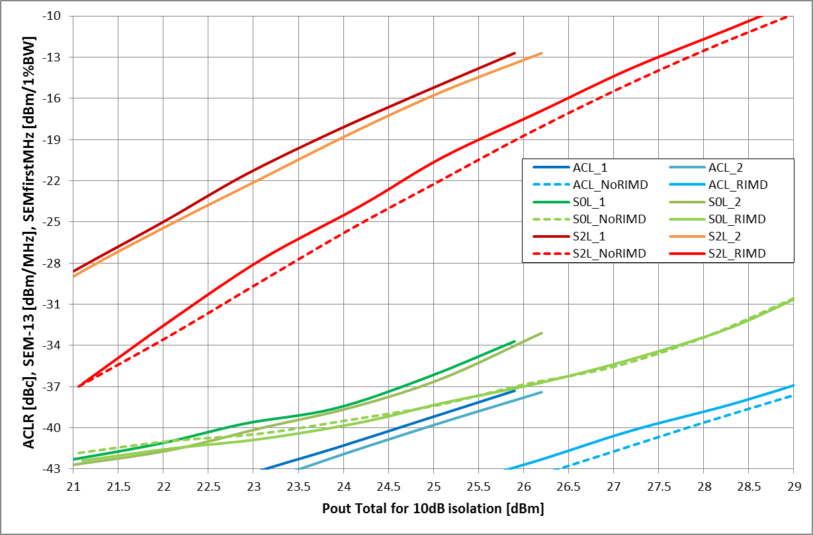  Figure 5: ACLR, first MHz SEM, -13dBm/MHz SEM for P1 and PA2 wo RIMD, PA1+PA2 wo RIMD, PA1+PA2 w RIMD at 10dB antenna isolation
R4-2111440 | Huawei,HiSilicon, vivo, OPPO | CR for TS 38.101-1 Tx diversity requirements
R4-2111502 | Huawei,HiSilicon, vivo, OPPO | CR for TS 38.101-1 Tx diversity requirements
R4-2110816 | OPPO | R16 SRS IL update  Observation 1: For 1T4R or t1r4-t2r4 SRS switch with TxD capability, 6dB/7.5dB additional IL as PC2 case is needed.  Observation 2: For 2T4R SRS switch with TxD capability, 3dB/4.5dB additional IL is needed.  Observation 3: For PC2 with TxD, if larger IL value is used then it will be covered by current PC2 wording in the spec.  Observation 4: For PC3, current spec is enough and no need to mention TxD.  Observation 5: For PC1.5, it needs to be added to spec like PC2 does and no need to mention TxD.  Proposal 1: It is proposed to add PC1.5 to the ∆T_{RxSRS} specification and no need to specify TxD.  Proposal 2: It is proposed to change ∆T_{RxSRS} specification as below from Rel-16.
R4-2110935 | OPPO | R16 CR on SRS IL  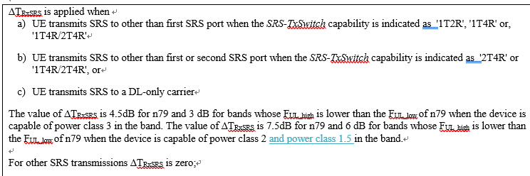
R4-2110936 | OPPO | R17 mirror CR on SRS IL

Open issues summary and discussion
Before e-Meeting, moderators shall summarize list of open issues, candidate options and possible WF (if applicable) based on companies’ contributions.

Sub-topic 1-1 RAN2 Reply LS related
Sub-topic description:
Open issues and candidate options before e-meeting:

Issue 1-1-1: Applicable power class for capability signaling in different releases
- Proposals
  - Option 1: Applies for all Power Classes for both Rel-15 and Rel-16
  - Option 2: Applies for only PC2 for Rel-15, and for all power classes in Rel-16;
  - Option 3: Others
- Recommended WF
  - [Option 1]

Views’ collection for 1st round:
Company | Comments
Qualcomm | Option 1. This simplifies ran2 as clarified offline by the LS proponent.
YYY

Status summary for 1st round:
Status summary
Tentative agreements:
Candidate options:
Recommendations for 2nd round:

Issue 1-1-2: Architecture assumption
Currently there are different understandings of Transparent TxD capable UE’s architecture:
- Proposals
  - Option 1: Full-power PA(s) implementation, compared to UE power class, is not precluded for UE with transparent TxD capability;
  - Option 2: UE with transparent TxD capability can only have half-power PAs compared to UE power class.
  - Option 3: Others
- Recommended WF
  - [Option 1]

Views’ collection for 1st round:
Company | Comments
XXX
YYY

Status summary for 1st round:
Status summary
Tentative agreements:
Candidate options:
Recommendations for 2nd round:

Issue 1-1-3: Relation with full power capability
Clarify the relationship between transparent TxD capability signalling and full Tx power capability
- Proposals
  - Option 1: No dependency
  - Option 2: A UE can support only one of the two capabilities
- Recommended WF
  - TBA

Views’ collection for 1st round:
Company | Comments
Qualcomm | Option 1. No dependency
YYY

Status summary for 1st round:
Status summary
Tentative agreements:
Candidate options:
Recommendations for 2nd round:

Issue 1-1-4: Antenna virtualization for different purpose of SRS
In order to understand the relationship between transparent TxD and SRS antenna switching, and provide a basis for the requirements. Discuss whether the following proposals can be assumed.
- Proposals
  - Proposal 1: Antenna virtualization cannot be assumed for SRS antenna switching which is targeting DL CSI.
    - This is discussed in R4-2108793 and is the basis for the requirements proposal
  - Proposal 2: Antenna virtualization can be assumed for the SRS intended for UL PUSCH scheduling.

- Recommended WF
  - [Both Proposal 1 and Proposal 2]

Views’ collection for 1st round:
Company | Comments
Qualcomm | How UE virtualizes is up to implementation but since the virtualization or lack of it is transparent to the networks as long as UE is not changing it, only specification impact is the max power capability for the SRS in case UE does not virtualize RX ports.
YYY

Status summary for 1st round:
Status summary
Tentative agreements:
Candidate options:
Recommendations for 2nd round:

Issue 1-1-5: Relation with SRS antenna switching
Clarify the relationship between transparent TxD capability signalling and SRS antenna switching
- Proposals
  - Option 1: No dependency
  - Option 2: A UE that supports 1T2R antenna switching SRS should have at least one full power PA
    - In another word, transparent TxD UE capable UE with an architecture of 23+23 for PC2, are not allowed to be 1T2R antenna switching capable
  - Option 3: Others

- Recommended WF
  - TBA

Views’ collection for 1st round:
Company | Comments
Qualcomm | Option 2 is interesting proposal. If accepted, then the relaxation to the max power would not be needed. However, then PC1.5 UE would not be able to support SRS antenna switching.
YYY

Status summary for 1st round:
Status summary
Tentative agreements:
Candidate options:
Recommendations for 2nd round:

Issue 1-1-6: Relation with Non-codebook based transmission
Clarify the relationship between transparent TxD capability signalling and non-codebook based transmission
- Proposals
  - Option 1: No dependency
  - Option 2: Non-codebook based UEs required full power PAs per Tx chain for power efficient operation.
  - Option 3: Others

- Recommended WF
  - TBA

Views’ collection for 1st round:
Company | Comments
Qualcomm | If option 2 is selected, the e.g. FPULTx mode 1 non-codebook behavior needs to be clarified since it can not meet full power according to 6.2.1 what the spec now demands.
YYY

Status summary for 1st round:
Status summary
Tentative agreements:
Candidate options:
Recommendations for 2nd round:

Issue 1-1-7: Relation with other multi-antenna features
Clarify the relationship between transparent TxD capability signalling and other multi-antenna features
- Proposals
  - Option 1: No dependency
  - Option 2: A TxD capable UE can indicate support for a feature only if UE behavior and performance for the feature is unaffected by TxD capability.
  - Option 3: Others

- Recommended WF
  - TBA

Views’ collection for 1st round:
Company | Comments
Qualcomm | Agree w option 2 given that the outout power generation with two antenna connectors is allowed.
YYY

Status summary for 1st round:
Status summary
Tentative agreements:
Candidate options:
Recommendations for 2nd round:

Sub-topic 1-2 Other Remaing issues
Sub-topic description
Open issues and candidate options before e-meeting:

Issue 1-2-1: MPR
The following evaluation and tentative suggestion had been provided:
- R4-2111011 (Skyworks):
- R4-2108794 (Qualcomm)
- R4-2109703 (LG)
- R4-2111440 (Huawei CR)
- Proposals
  - Companies can encourage to comment on the respective evaluation results
- Recommended WF
  - TBA

Views’ collection for 1st round:
Company | Comments
XXX
YYY

Status summary for 1st round:
Status summary
Tentative agreements:
Candidate options:
Recommendations for 2nd round:

Issue 1-2-2: A-MPR Related
- Proposals
  - Option 1: A-MPR as band specific requirements could be decoupled from the general TxD requirements
  - Option 2: Keeping the agreement of applying same MPR for UL MIMO and Tx Diversity would mean changed to the UL MIMO AMPR, too.
- Recommended WF
  - TBA

Views’ collection for 1st round:
Company | Comments
Qualcomm | Does option 1 mean there will be a list of bands where TxD is enabled? Or how is this decoupling stated in the specification? For option2,
YYY

Status summary for 1st round:
Status summary
Tentative agreements:
Candidate options:
Recommendations for 2nd round:

Issue 1-2-3: SRS switching requirements
- Proposals
  - Option 1: Based on R4-2108793
    - The ∆TRxSRS needs to be increased by 3 dB overall except for the PC2 case which accommodates the use of PA with 3 dB lower power for SRS antenna switching.
  - Option 2: Based on R4-2110816: Add PC1.5 to the ∆TRxSRS specification and no need to specify TxD
  - Option 3: Others
- Recommended WF
  - TBA

Views’ collection for 1st round:
Company | Comments
Qualcomm | Option 2 does not allow 23+23 dBm implementation without virtualization of the Rx port. We can only agree to Option 1 unless issue 1-1-5 option 2 is agreed.
YYY

Status summary for 1st round:
Status summary
Tentative agreements:
Candidate options:
Recommendations for 2nd round:

Issue 1-2-4: TxD EVM spectrum flatness
- Proposals
  - Option 1: Based on R4-2108793:
  - Option 2: Others
- Recommended WF
  - TBA

Views’ collection for 1st round:
Company | Comments
XXX
YYY

Status summary for 1st round:
Status summary
Tentative agreements:
Candidate options:
Recommendations for 2nd round:

Issue 1-2-5: Testing related issues
There are still two testing related issues following concept:
- UE behaviour under conformance testing
- Power splitting behaviour
- Proposals
  - Option 1: Leave these discussions to RAN5 and not pursue them before agreement of RAN4 CR.
  - Option 2: Continue discussion in RAN4.
- Recommended WF
  - [Option 1]

Views’ collection for 1st round:
Company | Comments
Qualcomm | Option 1 and 2 are both feasible in parallel. The actions towards specification and/or test procedure should be taken in ran5 but ran4 could instruct ran5 what is the expected UE behavior.
YYY

Status summary for 1st round:
Status summary
Tentative agreements:
Candidate options:
Recommendations for 2nd round:

Issue 1-2-6: TxD antenna and channel models
- Proposals
  - Option 1: No more discussion on these issues.
  - Option 2: Further discuss the relevant antenna and channel models and their impact as part of, and prior to, concluding on conformance testing methodologies and reference receivers for TxD with conducted measurements.
- Recommended WF
  - [Option 1]

Views’ collection for 1st round:
Company | Comments
XXX
YYY

Status summary for 1st round:
Status summary
Tentative agreements:
Candidate options:
Recommendations for 2nd round:

Sub-topic 1-3 CRs/TPs
For close-to-finalize WIs and maintenance work, comments collections can be arranged for TPs and CRs. For ongoing WIs, suggest to focus on open issues discussion on 1st round.
CR/TP number | Comments collection
R4-2111440  (Huawei) | Qualcomm: 6.2G.1 says “is defined as the sum of the maximum output power from both” but 6.2G.2 and also 6.2G.3 says “power is measured as the sum of the maximum”.  Could we put Table 6.2.2-2a in to 6.2G.2? or is there is a reason to keep it in the 6.2.1?  We should include the SRS IL part here too and spectral flatness before agreeing.
 | Company B
R4-2110935  (OPPO) | Qualcomm: As in issue 1-2-3, this change is not sufficient.
 | Company B

Status summary for 1st round:
Status summary
Tentative agreements:
Candidate options:
Recommendations for 2nd round:

Topic #2: Power Class related
Main technical topic overview. The structure can be done based on sub-agenda basis.

Companies’ contributions summary
T-doc number | Company | Proposals / Observations
R4-2108859 | Qualcomm Incorporated | Handling power class ambiguity  Observation: Rel-15 UE can rely on dedicated txd capability based on LS [1]  Proposal 1: Solve EN-DC power class ambiguity between SA and NSA by referring to TxD capability and allowing the relaxation to the power class for EN-DC mode only for UE that declare TxD capability for that band.  Proposal 2: Reply to RAN2 [1] that TxD capability is applicable to all power classes for all applicable releases.
R4-2109679 | vivo | Remaining issues in Power class & UL MIMO related requirments  Observation 1: With transparent TxD capability release independency from Rel-15 is confirmed by RAN2 at least for PC2, the meaning of current description of multiple possibilities of power class in NR part of NSA mode is also confirmed.  Proposal 1: For Rel-15 UE without the TxD capability, the current behaviour of multiple power class possibilities for NR part of NSA can be removed.  Proposal 2: For Rel-15 UE with the TxD capability, the current behaviour of multiple power class possibilities for NR part of NSA need to be kept, and further refinements targeting more precise PHR reporting can also be considered.  Proposal 3: Revise the power class part according to previous proposals and the general part can as the Annex.  Proposal 4: With the release independency of TxD capability to Rel-15, ue-PowerClass should always be supported for 1-port transmission fall back mode for SA.  Proposal 5: Reply GCF when all the related CRs are approved.  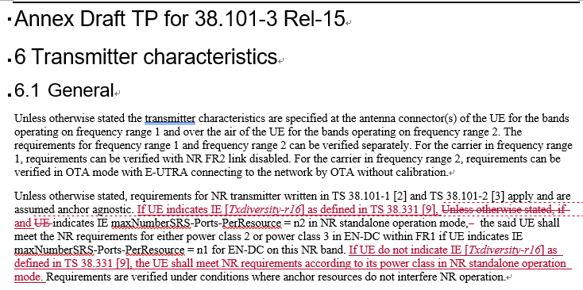
R4-2111441 | Huawei,HiSilicon | Discussion and draft reply LS on EN-DC power class  Observation 1: Without a power class to indicate the difference between SA and NSA for the NR band, it’s ambiguous which power class would be used for P_{CMAX_L,f,c,,NR} , consequently, UE may fail the Pcmax test for the NR part in an EN-DC band combination.  Observation 2: The main issue of Pcmax identified by RAN5 is to address the measurement problem.  Proposal: It is proposed to adopt the method to set a lower bound for P_{CMAX_L,f,c,,NR} if P_{PowerClass,NR} is indicated as a higher power class rather than the default power class.
R4-2111442 | Huawei,HiSilicon | CR for TS 38.101-3 correction of power class for EN-DC

Open issues summary and discussion
Before e-Meeting, moderators shall summarize list of open issues, candidate options and possible WF (if applicable) based on companies’ contributions.

Sub-topic 2-1 Power Class ambigulity
Sub-topic description:
Open issues and candidate options before e-meeting:

Issue 2-1-1: How to treat the ”famous sentence” for Rel-15
Regarding the description of multiple power class possibilities for NR part of NSA in Rel-15:
Unless otherwise stated, if UE indicates IE maxNumberSRS-Ports-PerResource = n2 in NR standalone operation mode, the said UE shall meet the NR requirements for either power class 2 or power class 3 in EN-DC within FR1 if UE indicates IE maxNumberSRS-Ports-PerResource = n1 for EN-DC on this NR band.
further differentiation can be made based on whether TxD is supported or not, the following proposals are provided:

- Proposals
  - Proposal 1: For Rel-15 UE without the TxD capability, the current behaviour of multiple power class possibilities for NR part of NSA can be removed.
    - At least one full-power chain has to be equipped
  - Proposal 2: For Rel-15 UE with the TxD capability, the current behaviour of multiple power class possibilities for NR part of NSA need to be kept;
    - The two RF chains may all be half-power and reach total SA power class by TxD
- Recommended WF
  - [Both Proposal 1 and Proposal 2]

Views’ collection for 1st round:
Company | Comments
Qualcomm | Agree with both proposals
YYY

Status summary for 1st round:
Status summary
Tentative agreements:
Candidate options:
Recommendations for 2nd round:

Issue 2-1-2: The Pcmax for NR for Rel-15 EN-DC
- Proposals
  - Option 1: The Pcmax for NR is modified to use the lower possible power class to decide the lower bound of the configured power. (Huawei)
  - Option 2: The Pcmax for NR is modified according to the declared NR power capability for NSA so that the PHR becomes correct. (Ericsson)
  - Option 3:Do not consider further refinements of Pcmax for NR.
  - Option 5: Others
- Recommended WF
  - TBA

Views’ collection for 1st round:
Company | Comments
Qualcomm | Option 2 sounds right (Where is Ericsson proposal in detail?)
YYY

Status summary for 1st round:
Status summary
Tentative agreements:
Candidate options:
Recommendations for 2nd round:

Issue 2-1-3: Fallback to 1-port Tx for SA in Rel-15
- Proposals
  - Option 1: Confirm ue-PowerClass should always be supported for 1-port transmission fall back mode for SA in Rel-15.
    - UE do not support TxD capability would equip a full power chain
    - For UE support TxD capability, when falls back to 1-port transmission, it is also reasonable to suppose it would use TxD to achieve ue-PowerClass in standalone mode
  - Option 2: Others
- Recommended WF
  - TBA

Views’ collection for 1st round:
Company | Comments
Qualcomm | Option 1.
YYY

Status summary for 1st round:
Status summary
Tentative agreements:
Candidate options:
Recommendations for 2nd round:

Sub-topic 2-2 CRs/TPs
Major close to finalize WIs and Rel-15 maintenance, comments collections can be arranged for TPs and CRs. For Rel-16 on-going WIs, suggest to focus on open issues discussion on 1st round.
CR/TP number | Comments collection
R4-2111442  (Huawei) | Qualcomm; To us it seems this should have a reference to Txd capability and if it is indicated. This grants too broad relaxation.
 | Company B
 | Qualcomm: This looks ok since it uses the txd capability.
 | Company B
 | Company A
 | Company B

Status summary for 1st round:
Status summary
Tentative agreements:
Candidate options:
Recommendations for 2nd round:

Recommendations for Tdocs

1st round
New tdocs
Title | Source | Comments
WF on … | YYY
LS on … | ZZZ | To: RAN_X; Cc: RAN_Y

Existing tdocs
Tdoc number | Title | Source | Recommendation | Comments
R4-210xxxx | CR on … | XXX | Agreeable, Revised, Merged, Postponed, Not Pursued

Notes:
- Please include the summary of recommendations for all tdocs across all sub-topics incl. existing and new tdocs.
- For the Recommendation column please include one of the following:
  - CRs/TPs: Agreeable, Revised, Merged, Postponed, Not Pursued
  - Other documents: Agreeable, Revised, Noted
- For new LS documents, please include information on To/Cc WGs in the comments column
- Do not include hyper-links in the documents

2nd round

Tdoc number | Title | Source | Recommendation | Comments
R4-210xxxx | CR on … | XXX | Agreeable, Revised, Merged, Postponed, Not Pursued
R4-210xxxx | WF on … | YYY | Agreeable, Revised, Noted
R4-210xxxx | LS on … | ZZZ | Agreeable, Revised, Noted

Notes:
- Please include the summary of recommendations for all tdocs across all sub-topics.
- For the Recommendation column please include one of the following:
  - CRs/TPs: Agreeable, Revised, Merged, Postponed, Not Pursued
  - Other documents: Agreeable, Revised, Noted
- Do not include hyper-links in the documents

