3GPP TSG-RAN WG4 Meeting # 99-e R4-2107743
Electronic Meeting, May. 19-27, 2021

CR-Form-v12.1
CHANGE REQUEST
 | 38.101-3 | CR | 0525 | rev | 1 | Current version: | 16.7.0
For HELPon using this form: comprehensive instructions can be found at
http://www.3gpp.org/Change-Requests.

Proposed change affects: | UICC apps |  | ME | X | Radio Access Network |  | Core Network

Title: | CR for TS 38.101-3, Time mask for NR V2X and LTE V2X switching in ITS band
Source to WG: | CATT, Xiaomi
Source to TSG: | RAN4
Work item code: | 5G_V2X_NRSL-Core |  |  |  |  |  | Date: |  |  | 2021-05-10
Category: | F |  |  |  |  |  | Release: |  |  | Rel-16
 | Use one of the following categories:  F (correction)  A (mirror corresponding to a change in an earlier release)  B (addition of feature),  C (functional modification of feature)  D (editorial modification)  Detailed explanations of the above categories can  be found in 3GPP TR 21.900. |  |  |  |  |  |  |  | Use one of the following releases:  Rel-8 (Release 8)  Rel-9 (Release 9)  Rel-10 (Release 10)  Rel-11 (Release 11)  Rel-12 (Release 12)  Rel-13 (Release 13)  Rel-14 (Release 14)  Rel-15 (Release 15)  Rel-16 (Release 16)
Reason for change: |  | The output power dynamics requirements for NR V2X should be introduced in TS 38.101-3.
Summary of change: |  | Add the output power dynamics requirements for NR V2X in clause 6.3E.
Consequences if not approved: |  | The output power dynamics requirements for NR V2X would be missing.
Clauses affected: |  | 6.3E
 |  | Y | N
Other specs |  |  | X | Other core specifications |  |  |  | TS/TR ... CR ...
affected: |  | X |  | Test specifications |  |  |  | TS 38.521-3
(show related CRs) |  |  | X | O&M Specifications |  |  |  | TS/TR ... CR ...
Other comments:
This CR's revision history: |  | Revision of R4-2109045

<Start of Change 1>

6.3E Output power dynamics for V2X

6.3E.1 General
The E-UTRA SL and NR SL switching time mask defines the observation period between E-UTRA subframe and NR slot/mini-slot boundary. Both E-UTRA subframe and NR slot/mini-slot have ON power transmissions. The ON power is defined as the mean power over the symbol duration excluding any transient period. For E-UTRA subframe or NR slot/mini-slot having OFF power transmission, the general time mask for E-UTRA or NR shall apply.

6.3E.2 Output power dynamics for intra-band V2X operation
For intra-band V2X operation bands specified in subclause 5.3E.1 and 5.3E.2, the SL switching time masks in Figure 6.3E.2-1 shall apply.
The switching time shall be located on the RAT of lower priority when NR SL and LTE SL have different priorities based on priority information specified in TS 38.213. It is up to UE implementation when NR SL and LTE SL have the same priority based on priority information specified in TS 38.213.
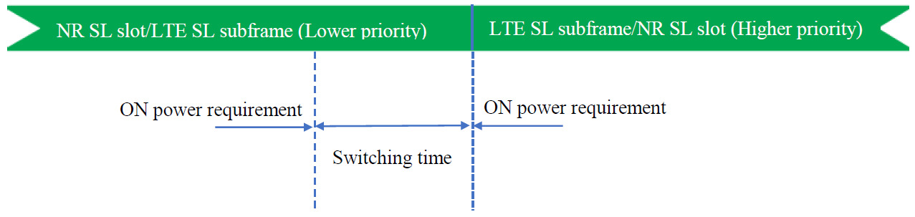
Figure 6.3E.2-1: Time mask for switching between NR SL and E-UTRA SL

6.3E.3 Output power dynamics for inter-band V2X con-current operation
For inter-band con-current NR V2X operation, the output power dynamics requirement shall be applied per each component carrier. The output dynamic requirements specified in clause 6.3 of TS 36.101 [4] apply for E-UTRA UL transmission and the requirements specified in clause 6.3E of TS 38.101-1 [2] apply for NR SL transmission. The output dynamic requirements specified in clause 6.3.2G, 6.3.3G, 6.3.4G of TS 36.104 [4] apply for E-UTRA SL transmission and the requirements specified in clause 6.3 of TS 38.101-1 [2] apply for NR UL transmission.

<End of Change 1>

