Guidance for GotoWebinar sessions for TSG-RAN4#98-bis-e
1. Preparations:
- For better audio quality it is recommended that you use an external head set (speakers and microphones of laptops are less appropriate and may produce background noise).
- Make sure you use the desktop app of GoToWebinar because IOS and Android versions of the app have several glitches and do not operate reliably.
- Make sure you use the audio connection of the app (instead of a separate phone dial-in) to ensure best audio quality.
- Make sure you turn off video and only operate audio.
- Make sure that you register for RAN4#98-bis-e via 3GU before the deadlines (see 2.):
log in into 3GU, find the meeting RAN4#98-bis-e, click on and fill out the requested data;
you can click on of RAN4#98-bis-e to check whether you are successfully registered.
Note: Invitations for GotoWebinar sessions are only distributed directly to people registered for RAN4#98-bis-e (and will NOT be distributed via the RAN4 reflector).
2. GotoWebinar schedules:
- during RAN4#98-bis-e:
GotoWebinar 13 – 15 April: 3:00 UTC – 6:00 UTC
GotoWebinar19-20 April: 12:00 UTC – 15:00 UTC
Note: the session on 16 April (3:00 – 6:00 UTC) is at session Chair’s discretion. Currently not planned for main session because of the time needed to work on the updated report after first round.
- all 3 with registration deadline: 9 April, 2021 Fri 22:00 UTC
- The GotoWebinar session will be started by MCC (at least for main session) usually ~10min before the official start of the meeting to allow people to connect.
3. How to join the GotoWebinar session:
- Assuming that you are registered for RAN4#98-bis-e before the deadline (see 2.) indicated, then you will receive one invitation email for GotoWebinar sessions from carolyn.taylor@etsi.org between this registration deadline and the start of the first GotoWebinar session. This email will include a "Register now" link. for each GotoWebinar session:
- When you click on this "Register now" button, then you register for this specific GotoWebinar by filling in:
  - first name: Please enter here <represented company, first name>
Note: Putting the represented company first will allow the chairman to sort the participants by company.
  - last name
  - email address
Participants with missing “represented company” will be ignored.
Duplicated registrations may be kicked out from the GotoWebinar.
(Note: If you miss to put your represented company first, then you have to leave the GotoWebinar, cancel the GotoWebinar registration (see *** below) and register for the GotoWebinar again.)
- Your browser will then tell you that "You're registered" and offers to add a corresponding entry to your calendar. Alternatively, you could also copy/store the link that is behind "join the webinar".
You will also receive an email with the subject "<Meeting name> Confirmation" with the "Join Webinar" link (***: This email includes also a link "cancel your registration".)
- 10min before the start of the GotoWebinar, MCC will launch the session so that everyone can join the GotoWebinar, please click on the Join Webinar link to do so.
Note: GotoWebinar distinguishes between attendees and staff/organizers (usually only the chairman and MCC are in this category). This guidance document focusses only on the attendee functionality.
- The window you will get as attendee looks as follows:

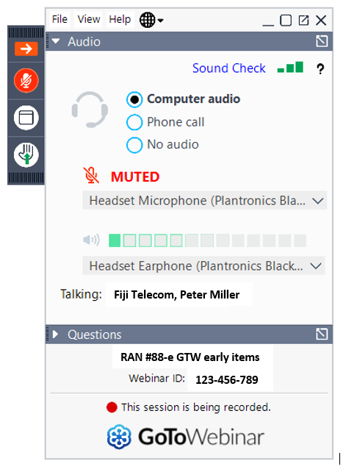
questions
name of the GotoWebinar
in order to request the floor to speak:
- we will NOT use
- we will use: TOHRU
who is speaking
your speaker
your microphone status
mute/unmute yourself

4. GotoWebinar operation principles:
- The chairman/organizer can speak/unmute himself at any time.
The organizer also has a "mute all" button and and an "unmute all" button ("unmute all" does not mean that the micros of attendees are switched on directly but that an additional unmute done by an attendee will immediately give the attendee the possibility to speak; this of course requires sufficient discipline by all participants so that they mute themself when they do not speak and that they only unmute themself when the chairman has given them the floor).
- An attendee has an own button to mute/unmute herself/himself.
But there is a 2nd mute/unmute function under control of the organizer.
In order to get the floor to speak, an attendee has to "raise hand" and the chairman has to unmute the attendee (if the attendee can still not speak, then the attendee has to press also its own unmute button).
- Questions window of GotoWebinar: The usage of this functionality will be limited to organisational questions and meeting logistics raised by delegates/attendees and leadership will monitor them.
Note 1: Delegates can normally not see the questions from other delegates. Only organizers can see them and answer them which then makes also the question visible for all delegates.
Note 2: It is recommended to drag out the Questions window from the control window of GotoWebinar in order to adjust the size of the Questions window.
Note 3: The Questions window is not intended to be a technical chat with the chairman because the chairman has to conduct the meeting.
- As the built-in hand raising functionality has the disadvantages:
- for the chairman that the sequence of raised hands can not be tracked properly
- for delegates that they can not see who else raised their hand
we will use a 2nd tool called TOHRU (Trace Online Hand Raising Utility).

- Together with the invitation for the GotoWebinar MCC will provide you with a
"TOHRU Meeting ID". This "TOHRU Meeting ID" has to be entered on the web page https://tohru.raisingthefloor.org/ and in addition under "Your Name:" you have to provide:
<represented company>, <first name> <family name>
e.g.: XY Telecom, Peter Mustermann
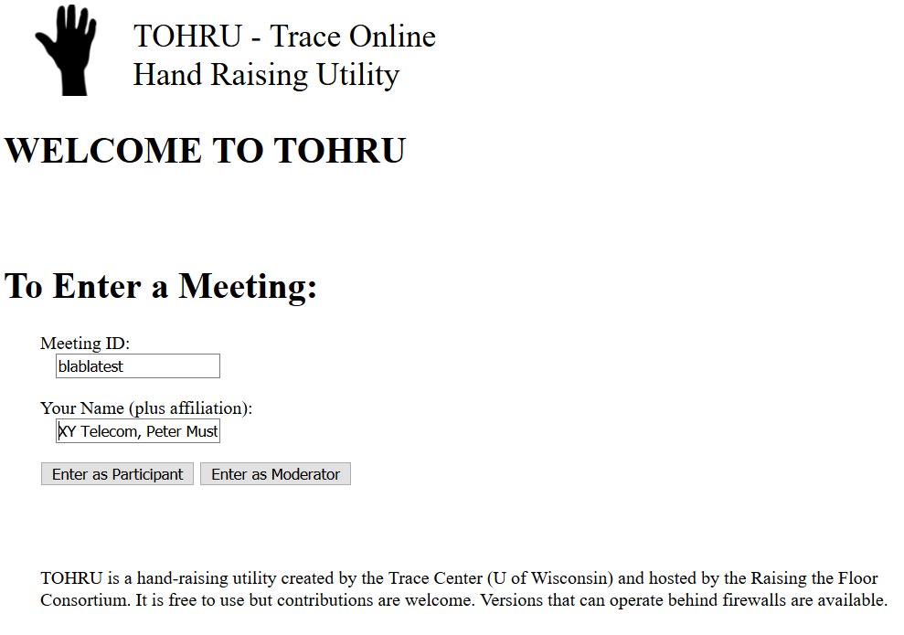
Clicking on "Enter as Participant" will connect you to the Hand Raising tool TOHRU for the corresponding meeting. And in case you raise your hand by clicking on "Same Topic" it will look as follows:
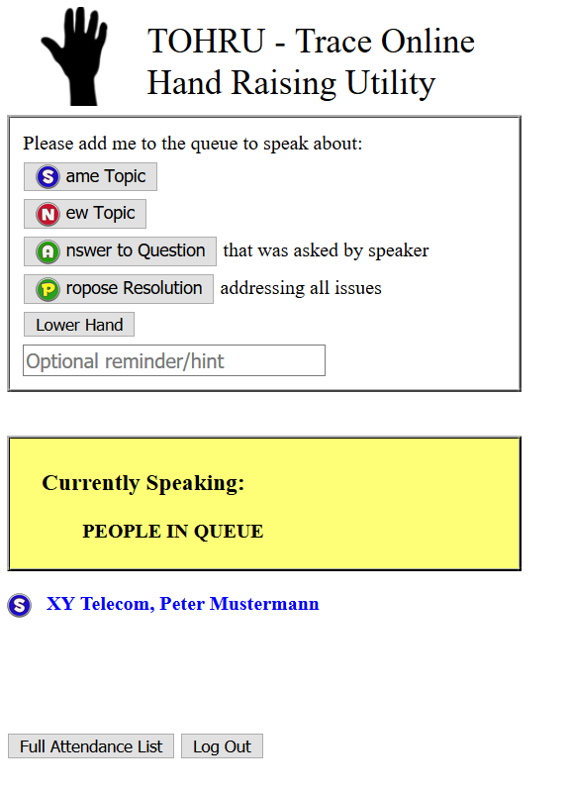
You have there also the options:
- to raise your hand for a new topic
- to raise your hand to answer a question
- to raise your hand to propose a resolution
- to add an additional "Optional reminder/hint" which will be displayed after your name when raising the hand
- to lower your hand
All delegates can then see who is speaking and who is in the queue of raised hands.
Like in a F2F meeting it is up to the discretion of the chairman who gets the floor and becomes next speaker (just do not forget to unmute yourself before speaking and to mute yourself after speaking).
Some further recommendations/hints regarding TOHRU:
- a meeting ID is deleted after two months of inactivity
- at the end you must log out of a TOHRU session; if you just close the browser without logging out, then the next time you go to the TOHRU web page you have no choice to enter a Meeting ID but you are still connected to the previous TOHRU session

