|  |  |
| --- | --- |
| 3GPP TR 38.884 V0.2.0 (2021-02) | |
| Technical Report | |
| 3rd Generation Partnership Project;  Technical Specification Group Radio Access Network;  NR;  Study on enhanced test methods for FR2 NR UEs;  (Release 17) | |
|  | |
| *5G-logo_175px* | 3GPP-logo_web |
|  | |
| The present document has been developed within the 3rd Generation Partnership Project (3GPP TM) and may be further elaborated for the purposes of 3GPP. The present document has not been subject to any approval process by the 3GPPOrganizational Partners and shall not be implemented. This Specification is provided for future development work within 3GPPonly. The Organizational Partners accept no liability for any use of this Specification. Specifications and Reports for implementation of the 3GPP TM system should be obtained via the 3GPP Organizational Partners' Publications Offices. | |

|  |
| --- |
|  |
| ***3GPP***  Postal address  3GPP support office address  650 Route des Lucioles - Sophia Antipolis  Valbonne - FRANCE  Tel.: +33 4 92 94 42 00 Fax: +33 4 93 65 47 16  Internet  http://www.3gpp.org |
| ***Copyright Notification***  No part may be reproduced except as authorized by written permission. The copyright and the foregoing restriction extend to reproduction in all media.  © 2019, 3GPP Organizational Partners (ARIB, ATIS, CCSA, ETSI, TSDSI, TTA, TTC).  All rights reserved.  UMTS™ is a Trade Mark of ETSI registered for the benefit of its members  3GPP™ is a Trade Mark of ETSI registered for the benefit of its Members and of the 3GPP Organizational Partners LTE™ is a Trade Mark of ETSI registered for the benefit of its Members and of the 3GPP Organizational Partners  GSM® and the GSM logo are registered and owned by the GSM Association |

Contents

Foreword 5

1 Scope 7

2 References 8

3 Definitions of terms, symbols and abbreviations 9

3.1 Terms 9

3.2 Symbols 9

3.3 Abbreviations 9

4 General 10

5 UE RF testing methodology enhancements 11

5.1 High DL power and low UL power 11

5.1.1 General 11

5.1.2 Beam management sensitivity study of NF based solutions 12

5.1.2.1 Simulation assumptions 12

5.1.2.2 Simulation results 13

5.1.3 Manufacturer declarations 16

5.1.4 Applicability of NF methodologies 23

5.1.5 Improvement of permitted methods 25

5.2 Polarization basis mismatch between the TE and DUT 27

5.2.1 General 27

5.2.2 Enhanced test method for EIRP measurement 28

5.2.2.1 TPMI method 28

5.2.2.2 Applicability of TPMI side condition method 28

5.2.2.3 Alternative test method 29

5.2.3 Enhanced test method for UL demodulation measurement 29

5.2.3.1 Test equipment Zero-forcing MIMO receiver 29

5.3 Inter-band (FR2+FR2) CA 29

5.3.1 General 29

5.3.2 Impact of multiple test antennae 30

5.3.2.1 PSD imbalance with DL signals from test equipment 30

5.3.2.1.1 DL PSD towards UE supporting independent beam management (IBM) 30

5.3.2.1.2 DL PSD towards UE supporting common beam management (CBM) 31

5.3.2.2 Impact of off-focus test system antennae 32

5.3.2.2.1 Quality of quiet zone (QoQZ) 32

5.3.2.2.2 Rx beam profiles with an independent beam management (IBM) UE 38

5.3.2.2.3 Propensity to trigger incorrect beam in CBM UE 40

5.3.2.2.4 Spherical coverage measurement simulation with common beam management (CBM) UE 41

5.3.2.3 Summary on applicability of offset antenna test system 42

5.3.3 Inter-band testing ramifications 43

5.3.3.1 Single antenna 43

5.3.3.2 Multiple antennae 43

5.4 Extreme temperature conditions 43

5.5 FR2 DL 256QAM 43

5.6 Extension of frequency applicability for band n262 43

6 UE RRM testing methodology enhancements 44

6.1 Extension of frequency applicability for band n262 44

7 UE demodulation testing methodology enhancements 45

7.1 Extension of frequency applicability for band n262 45

8 Test time reduction 46

Annex A: Environment conditions 47

A.1 Operating voltage 47

A.2 Temperature 47

Annex B: Measurement uncertainty 48

B.1 Measurement uncertainty budget for UE RF testing methodology 48

Annex <X>: Change history 49

For definitive guidance on drafting 3GPP TSs and TRs, see [3GPP TS 21.801](http://www.3gpp.org/DynaReport/21801.htm) supplemented by the 3GPP web page <http://www.3gpp.org/specifications-groups/delegates-corner/writing-a-new-spec>.

Ensure all blue guidance text is removed before submitting the TS/TR to the TSG for approval.

# Foreword

This Technical Report has been produced by the 3rd Generation Partnership Project (3GPP).

The contents of the present document are subject to continuing work within the TSG and may change following formal TSG approval. Should the TSG modify the contents of the present document, it will be re-released by the TSG with an identifying change of release date and an increase in version number as follows:

Version x.y.z

where:

x the first digit:

1 presented to TSG for information;

2 presented to TSG for approval;

3 or greater indicates TSG approved document under change control.

y the second digit is incremented for all changes of substance, i.e. technical enhancements, corrections, updates, etc.

z the third digit is incremented when editorial only changes have been incorporated in the document.

In drafting the TS/TR, pay particular attention to the use of modal auxiliary verbs! TRs shall not contain any normative provisions.

In the present document, modal verbs have the following meanings:

**shall** indicates a mandatory requirement to do something

**shall not** indicates an interdiction (prohibition) to do something

The constructions "shall" and "shall not" are confined to the context of normative provisions, and do not appear in Technical Reports.

The constructions "must" and "must not" are not used as substitutes for "shall" and "shall not". Their use is avoided insofar as possible, and they are not used in a normative context except in a direct citation from an external, referenced, non-3GPP document, or so as to maintain continuity of style when extending or modifying the provisions of such a referenced document.

**should** indicates a recommendation to do something

**should not** indicates a recommendation not to do something

**may** indicates permission to do something

**need not** indicates permission not to do something

The construction "may not" is ambiguous and is not used in normative elements. The unambiguous constructions "might not" or "shall not" are used instead, depending upon the meaning intended.

**can** indicates that something is possible

**cannot** indicates that something is impossible

The constructions "can" and "cannot" are not substitutes for "may" and "need not".

**will** indicates that something is certain or expected to happen as a result of action taken by an agency the behaviour of which is outside the scope of the present document

**will not** indicates that something is certain or expected not to happen as a result of action taken by an agency the behaviour of which is outside the scope of the present document

**might** indicates a likelihood that something will happen as a result of action taken by some agency the behaviour of which is outside the scope of the present document

**might not** indicates a likelihood that something will not happen as a result of action taken by some agency the behaviour of which is outside the scope of the present document

In addition:

**is** (or any other verb in the indicative mood) indicates a statement of fact

**is not** (or any other negative verb in the indicative mood) indicates a statement of fact

The constructions "is" and "is not" do not indicate requirements.

# 1 Scope

The objectives of this study are to enhance the FR2 RF testing methodology and to quantify the impact of the enhancements on the UE performance, as related to the polarization basis mismatch between the test equipment and UE and to add support for testing under extreme temperature conditions.

The development of testing methodology enhancements proceeds within the following scope:

- In general

- Target the testing and calibration aspects of the permitted methods for FR2 UE RF testing and the preliminary assessment of measurement uncertainty (Clause 5.2 and Annex B of TR38.810)

- The test methodologies and procedures shall be applicable for different device types and power classes with DUT size defined in the TR 38.810. Prioritize the study to PC3 for aspects related to DUT size, and limit the study to free space conditions

- The study item outcomes shall capture the efficacy of the enhancements

- Objectives related to regulatory test cases shall be prioritized

The detailed objectives are:

1. Define test methodology for high DL power and low UL power test cases

- Considering path loss reduction, measurement antenna gain improvement, DUT positioning improvement, and MU improvement

- Considering NFTF (defined in Clause 5.2 of TR38.810) and direct near field test methodologies as possible alternative methods

- Other approaches are not precluded

- Study preliminary assessment of measurement uncertainty of new alternative methods

2. Define solutions to minimize the impact of polarization basis mismatch between the TE and DUT on the RF testing

- Considering polarization basis mismatch between the test equipment and UE and UE implementations which may be impacted by this mismatch

- Study EIS test metric which can apply to different UE RF implementations considering downlink polarization sweep enhancement

- Limit the study of this objective to the permitted UE RF methods defined in Clause 5.2 of TR38.810

- Possible enhancements may be described as

- Downlink polarization sweeping by the test equipment (i.e. introducing an additional degree of freedom for polarization alignment of the measurement antenna)

- The use of circular polarization to perform measurements

- Coherent combining and demodulation of orthogonally polarized received signals in the test equipment

- Uplink polarization sweeping by the test equipment to search for the optimal polarization angle to receive and demodulate the signal transmitted by the UE

- Considering NFTF (defined in Clause 5.2 of TR38.810) test methodology for EIS measurement

- TPMI side condition method, where TPMI side conditions are applicable to Rel-16 (and higher) UEs

- Test mode to trigger TX diversity

- Other approaches are not precluded

3. Study testability enhancements to support the verification of RF requirements for inter-band (FR2+FR2) CA

- Work on inter-band DL CA is prioritized

- Whether the test setup shall be restricted to emulating the signal from the same direction for the aggregated bands shall be aligned with the UE RF architecture assumption taken in the work item on NR RF Requirement Enhancements for FR2 [UID 830189]

4. Support extreme temperature conditions for all applicable FR2 UE RF test cases

- Considering beam peak search, spherical coverage, and total radiated power procedures

- Limit the study of this objective to the permitted UE RF methods defined in Clause 5.2 of TR38.810

- Study preliminary impacts on system measurement uncertainty under extreme temperature conditions

5. Study testability enhancements to support the verification of RF requirements for FR2 DL 256QAM

6. Study testability enhancements to reduce test time

- Including RF test method enhancement with reduced test time, and possible test time saving approach for UE Demodulation test and RRM test

7. Study testability aspects for the introduction of the new band n262

- Considering the extension of frequency applicability of the permitted methods in TR38.810 from 43.5 GHz up to at least 48.2 GHz

- Considering the extension of frequency applicability of the test methodology enhancements in Objectives 1 through 6 above

# 2 References

The following documents contain provisions which, through reference in this text, constitute provisions of the present document.

- References are either specific (identified by date of publication, edition number, version number, etc.) or non‑specific.

- For a specific reference, subsequent revisions do not apply.

- For a non-specific reference, the latest version applies. In the case of a reference to a 3GPP document (including a GSM document), a non-specific reference implicitly refers to the latest version of that document *in the same Release as the present document*.

[1] 3GPP TR 21.905: "Vocabulary for 3GPP Specifications".

[2] 3GPP TS 38.101-2: "User Equipment (UE) radio transmission and reception; Part 2: Range 2 Standalone".

[3] 3GPP TR 38.810: " Study on test methods ".

[4] 3GPP TS 38.211: "NR; Physical channels and modulation".

[5] 3GPP TS 38.212: "NR; Multiplexing and channel coding".

…

[x] <doctype> <#>[ ([up to and including]{yyyy[-mm]|V<a[.b[.c]]>}[onwards])]: "<Title>".

# 3 Definitions of terms, symbols and abbreviations

This clause and its three subclauses are mandatory. The contents shall be shown as "void" if the TS/TR does not define any terms, symbols, or abbreviations.

## 3.1 Terms

For the purposes of the present document, the terms given in 3GPP TR 21.905 [1] and the following apply. A term defined in the present document takes precedence over the definition of the same term, if any, in 3GPP TR 21.905 [1].

Definition format (Normal)

**<defined term>:** <definition>.

**example:** text used to clarify abstract rules by applying them literally.

## 3.2 Symbols

For the purposes of the present document, the following symbols apply:

Symbol format (EW)

<symbol> <Explanation>

## 3.3 Abbreviations

For the purposes of the present document, the abbreviations given in 3GPP TR 21.905 [1] and the following apply. An abbreviation defined in the present document takes precedence over the definition of the same abbreviation, if any, in 3GPP TR 21.905 [1].

Abbreviation format (EW)

<ABBREVIATION> <Expansion>

# 4 General

Editor’s note: general aspects related to the scope of the study or common study outcomes can be captured in this clause.

# 5 UE RF testing methodology enhancements

Editor’s note: testing and calibration aspects of the permitted methods for FR2 UE RF testing and the preliminary assessment of measurement uncertainty (Clause 5.2 and Annex B of TR38.810) define the baseline UE RF methodology for the purpose of this study.

## 5.1 High DL power and low UL power

### 5.1.1 General

The investigation of high DL power and low UL power enhancements to the FR2 test methodology includes the following aspects: scope of test cases with high DL power and low UL power issues, enhanced test systems, including the investigation of non-permitted systems, enhancements to permitted methods, manufacturer declarations, beam management sensitivity of the DUT in near-field test system environments, and path loss comparison across system types.

Table 5.1.1-1 below provides a summary of the test cases and testability issues.

Table 5.1.1-1: Summary of test cases and testability issues

|  |  |  |  |
| --- | --- | --- | --- |
| Clause | Requirement | Testability issue | Test Metric |
| 6.3.1 | Minimum output power | Low UL power | EIRP (Link=TX beam peak direction, Meas=Link angle). |
| 6.3.2 | Transmit OFF power | Low UL power | TRP (Link=TX beam peak direction, Meas=TRP grid) |
| 6.5.1 | Occupied bandwidth | Low UL power | OBW (Link=TX beam peak direction, Meas=Link angle) |
| 6.5.2.3 | Adjacent channel leakage ratio | Low UL power | TRP (Link=TX beam peak direction, Meas=TRP grid). |
| 6.5.3.2 | Additional spurious emissions | Low UL power | TRP (Link=TX beam peak direction, Meas=TRP grid). |
| 7.4 | Maximum input power | Hidh DL power | EIS (Link=RX beam peak direction, Meas=Link angle). |
| 7.5 | Adjacent channel selectivity (case 1) | High DL power | EIS (Link=RX beam peak direction, Meas=Link angle) |
| 7.5 | Adjacent channel selectivity (case 2) | High DL power | EIS (Link=RX beam peak direction, Meas=Link angle) |
| 7.6.2 | In-band blocking | High DL power | EIS (Link=RX beam peak direction, Meas=Link angle) |
| 7.9 | Receiver spurious emissions | Low UL power | TRP (Link=TX beam peak direction, Meas=TRP grid). |

The investigation of test methodology enhancements to strive to reduce the testability issues which were identified includes study of the feasibility of enhancing test systems which are permitted in TR38.810 [reference TBD] as well as test systems which are not permitted. Non-permitted test systems according to TR38.810 [reference TBD] are not required to verify all requirements in TS38.101-2 [reference TBD]. The candidate test systems are limited to near-field (NF) based solutions and include the following solutions:

- The Direct near-field (DNF) system assumes that all measurements and call setups are performed with a measurement probe in the NF of the DUT.

- The Combined far-field/near-field (CFFNF) system utilizing a transform-based approach assumes that the UE beamlock function (UBF) activation is performed towards the FF beam peak direction based on the far-field method and then test case procedures are performed with measurement probe(s) in the NF of the DUT.

- Combined far-field/direct-near-field (CFFDNF) system assumes that the UE beamlock function (UBF) activation is performed towards the FF beam peak direction based on the far-field method and then test case procedures are performed based on the direct near-field method.

The applicability of these NF methodologies is further outlined in Clause 5.1.4.

### 5.1.2 Beam management sensitivity study of NF based solutions

#### 5.1.2.1 Simulation assumptions

For NF based solutions, where beam peak search is necessary to perform all applicable test case procedures, an evaluation of UE beam management sensitivity to magnitude/phase variation of the DL signal is needed. Two assumptions are made about the NF based system:

- Beam peak search is performed in the NF (i.e. DNF system); OR

- Beam peak search is first performed in the FF/IFF and test case is executed in the NF (i.e. CFFNF system).

Using the spherical coverage measurement grid assumptions shown in Table 5.1.2.1-1, evaluations were performed of the UE beam management sensitivity in terms of simulated radiated performance metrics for each of the assumptions.

Table 5.1.2.1-1: Beam management sensitivity simulation assumptions

|  |  |  |
| --- | --- | --- |
| Parameter | Value | Notes |
| Spherical coverage Measurement Grids baseline assumption | Annex G.1.1 in TR38.810 |  |
| Antenna array | - 8x2 and 4x1  - Antenna element HPBW: {260/130, 90/90} deg | Element near-field assumption is implementation specific |
| Simulated DUT | Two antenna arrays are integrated in the UE for the spherical coverage analyses  - Antenna panels are studied with Nz x Ny with Nz>Ny, e.g., 8x2 corresponds to Nz = 8 and Ny = 2  - The implementation loss for the antenna near the front is 0dB less than that for the antenna near the back  - The antenna in the back is on the opposite side of the UE (mirrored around (0,0,0)). | See Figure 5.1.2.1-1 for example positions of two antenna arrays |
| Beam steering | - In the xy plane, assume 45º beam steering granularity (AZ from -45º to +45º)  - In the xz plane, assume 22.5o beam steering granularity (EL from -90º to 90º) |  |
| Offsets | - Various antenna offsets (yoffset, zoffset) beyond 7.5cm in radius (12.5cm max)  - For TRP analysis, model random antenna offsets anywhere within the 30cm spherical QZ | Offset is defined with respect to the center of antenna array |
| Range Lengths | - 30cm, 20m (more range lengths are not precluded)  - Goal is to eventually determine min. range length and MU for performing spherical coverage tests in DNF | Defined as distance between centre of QZ/positioning axes and measurement probe |
| Test methodology | - CFFDNF/DNF (while taking path loss offsets into account)  - CFFNF |  |
| Sampling grid | Study finer than 7.5deg step size for constant-step size grids | Parametric studies to show convergence for the selected assumption |

Figure 5.1.2.1-1 below illustrates example positions of two antenna arrays in the simulated DUT.

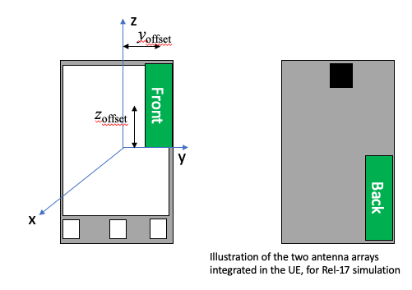

Figure 5.1.2.1-1: Simulated DUT antenna assumptions for beam management sensitivity study

#### 5.1.2.2 Simulation results

Table 5.1.2.2-1 below summarizes the results from simulations of beam management sensitivity of a DNF system (i.e. beam peak search is performed in the NF).

Table 5.1.2.2-1: Beam management sensitivity results of a DNF system

|  |  |  |  |  |  |
| --- | --- | --- | --- | --- | --- |
| Company label | Swept parameters | Beam management performance maximum ∆ relative to reference (dB) | | | Notes |
| Beam peak | 50% CDF | TRP |
| Company A | Array: 8x2  Range: {0.2, 0.4, 0.8} m  Offset: {0, 0.05, 0.10} m  HPBW: {90/90} | 2.5 | Not analysed | Not analysed | There is approximately 2.5 dB of BP error when range length is reduced to 0.2m in presence of the module offset mentioned above. There is also significant perturbation of the CDF curve. CDF statistics start to converge when the range length is at least 4 times the offset. |
| Company B | Array: 8x2, 4x1  Range: {0.25, 0.3, 0.45, 20} m  Offset: {0.125 in y, 0.125 in z, 0.09 in y & z} m  HPBW: {260/130} | 7.0 | 1.0 | TRP analysed separately | The EIRP beam peak (100%-ile EIRP) and direction cannot be measured accurately with the direct NF methodology |
| Company B | Array: 8x2  Range: 0.2 m  Offset: 0.15 m in x, y, z  HPBW: {260/130} |  |  | 0.66 dB systematic  0.46 dB RSS’ed | Large uncertainties can be observed for TRP for measurements performed in the NF utilizing the black back box approach |
| Company C | Array: 4x1  Range: {100, 4.2, 0.9, 0.45, 0.3} m  Offsets: not specified  Full phone model (including the PCB and phone house) has been considered | 0.3 | 0 | Not clear whether 0.1 or 0.4 | Figure of merits such as EIRP, TRP, and Spherical Coverage are not influenced dramatically from range length |
| Company B | Array: {4x1, 8x2}  Range: 0.25 m  Offset: {0, 0.125, 0.9} m in y, z  HPBW: {90/90} | 4.2 |  |  | UE selected different beam between NF beam peak direction and FF beam peak direction |
| Company B | Array: {4x1, 8x2}  Range: 0.25 m  Offset: {0, 0.53, 0.75} m in x, y, z  HPBW: {90/90} | 10.4 |  |  | UE select the same beam in the NF as in the FF more often, we still see concerning trends with the peak EIRP deltas |
| Company B | Reuse assumptions used by Company A:  Array: 8x2  Range: {0.2, 0.4, 0.8} m  Offset: {0, 0.05, 0.10} m  HPBW: {90/90} | 2.5 | 1.2 |  | Simulations were performed to establish alignment with another company |

Table 5.1.2.2-2 below summarizes the results from simulations of beam management sensitivity of a CFFNF system (i.e. beam peak search is first performed in the FF/IFF and test case is executed in the NF).

Table 5.1.2.2-2: Beam management sensitivity results of a CFFNF system

|  |  |  |  |  |  |
| --- | --- | --- | --- | --- | --- |
| Company and reference | Swept parameters | Beam management performance maximum ∆ relative to reference (dB) | | | Notes |
| Beam peak | 50% CDF | TRP |
| Company B (“Black box with transform approach”) | Array: 8x2, 4x1  Range: {0.22 – 0.30} m  Offset: {0, 0.50, 0.10, 0.125} m | Max µ = 0.2  Max σ = 0.3 | Not analysed | Not analysed | These results were obtained using a transform-based approach to correct the incurred path loss. Feedback from industry is requested whether to continue efforts in terms of simulations and empirical investigations on this enhanced NF methodology with transform utilizing black-box approach |
| Company B (“Black & White box with transform approach”) | Array: 8x2, 4x1  Range: {0.22 – 0.30} m  Offset: {0, 0.50, 0.10, 0.125} m | Max µ = 0.1  Max σ = 0.3 | Not analysed | TRP analysed separately | These results were obtained using a transform-based approach to correct the incurred path loss. Feedback from industry is requested whether to continue efforts in terms of simulations and empirical investigations on this enhanced NF methodology with transform utilizing the white&black-box approach |
| Company B (“TRP with compensation for antenna offset”) | Array: 8x2  Range: 0.2 m  Offset: 0.15 m in x, y, z  HPBW: {260/130} |  |  | 0.02 dB systematic  0.21 dB RSS’ed | These results were obtained using the DNF methodology with declared offset; alternatively, these results could be obtained using a transform based approach to estimate the phase centre offset. With the offset of the antenna array known, e.g., estimated with the enhanced NF methodology introduced in this contribution, very accurate TRP measurements in the NF can be made with a TRP offset compensation approach |
| Company C | Array: 4x1  Range: {100, 4.2, 0.9, 0.45, 0.3} m  Offsets: not specified  Full phone model (including the PCB and phone house) has been considered | 0.3 | 1.0 | 0.8 | These results were obtained using the DNF methodology. Figure of merits such as EIRP, TRP, and Spherical Coverage are not influenced dramatically from range length  Full phone model (including the PCB and phone house) has been considered |

While it has always been argued that TRP can be tested in the near-field due to conservation of power, no clear measurement uncertainty analyses have been presented to quantify the errors. In this section, we briefly present our findings for measurement uncertainties when testing TRP in the near field.

An analysis of the impact on measurement uncertainty by testing TRP in the NF was performed according to the assumption for TRP offsets in Table 5.1.2.1-1. In this analysis, near-field effects of the antenna pattern were taken into account. Figure 5.1.2.2-1 below illustrates the differences in the 8x2 antenna pattern at the 2D2/λ distance (a) and at 1/8th of that distance (b).

a)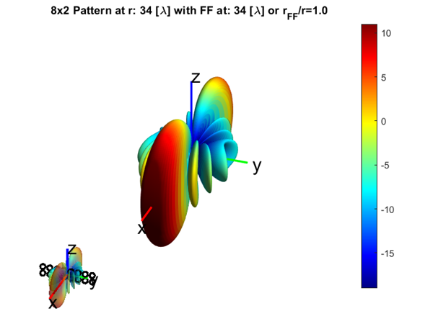b)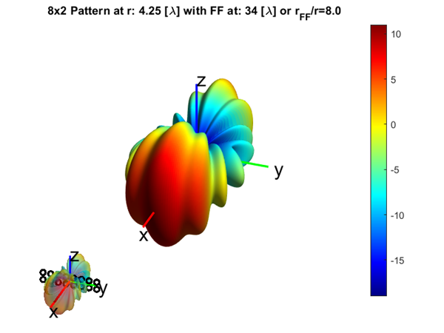

Figure 5.1.2.2-1: Radiation pattern of the 8x2 antenna array at 2D2/λ FF distance (a) and in NF at 1/8th of FF distance (b)

Table 5.1.2.2-3 below summarizes the impact of the approaches with and without offset correction on TRP MU.

Table 5.1.2.2-3: Impact of TRP measurement with and without offset correction on MU

|  |  |  |  |  |
| --- | --- | --- | --- | --- |
| Range Length (cm) | With Offset Correction | | Without Offset Correction | |
| Mean TRP Error (dB) | TRP Std. Dev. (dB) | Mean TRP Error (dB) | TRP Std. Dev. (dB) |
| 20 | 0.02 | 0.13 | 0.40 | 0.26 |
| 25 | 0.03 | 0.06 | 0.24 | 0.15 |
| 28 | 0.03 | 0.04 | 0.19 | 0.11 |
| 32 | 0.03 | 0.02 | 0.14 | 0.08 |
| 43 | 0.03 | 0.02 | 0.08 | 0.04 |
| 100 | 0.04 | 0.02 | 0.01 | 0.01 |

Additionally, CDF curves for the various simulation results are presented in Figure 5.1.2.2-2 below.

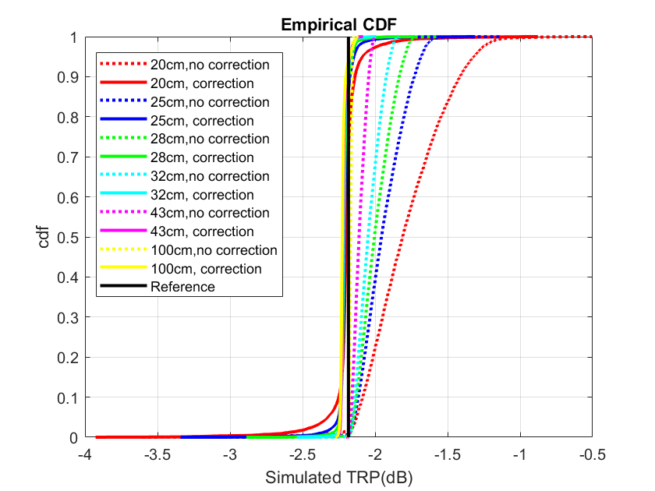

Figure 5.1.2.2-2: Distribution of simulated TRP measurements with and without offset correction

Clause 5.1.4 summarizes the study’s conclusions based on the submitted simulation results.

### 5.1.3 Manufacturer declarations

If a manufacturer declaration is used to inform or optimize a test system parameter, and the DUT is positioned in the test system according to parameters which are informed by this declaration, then the DUT is measured assuming a “white box” configuration. If no manufacturer declaration is used, and the DUT is positioned in the test system according to common procedures, then the DUT is measured assuming a “black box” configuration.

Black box testing requires no knowledge which antenna panel is active at any given time and the detailed location of the active panel within the DUT. In this test configuration, the geometric centre of the DUT is aligned with the centre of the quiet zone as illustrated in Figure 5.1.3-1.

 

Figure 5.1.3-1: Illustration of black box approach

White box testing on the other hand requires the manufacturer declaration of detailed locations of all antenna panels and which antenna panel is active in any UL/DL test direction In this test configuration, the centre of the radiating aperture (of the active panel) is aligned with the centre of the quiet zone as illustrated in Figure 5.1.3-2.

 

Figure 5.1.3-2: Illustration of white box approach

The black&white-box approach combines the advantages of both the black and white-box approaches where the antenna phase centre offset(s) are declared, i.e., white-box approach, but the geometric centre of the DUT is aligned with the centre of the QZ, i.e., black-box approach.

The following paragraphs provide further information on the need for the various vendor declarations with the help of sample illustrations. Here, a DUT with three antenna panels is considered shown schematically in Figure 5.1.3-3 on the left. The right side shows coverage sectors and the corresponding antenna panels the DUT would select if the DL was presented from within those sectors. In this example, the red antenna panel would yield the TX beam peak in the horizontal direction; this direction would be identified following the TX beam peak search. For simplicity, most of the arguments in the next few paragraphs are applied to testing in the FF but they can be applied to testing in the NF as well.

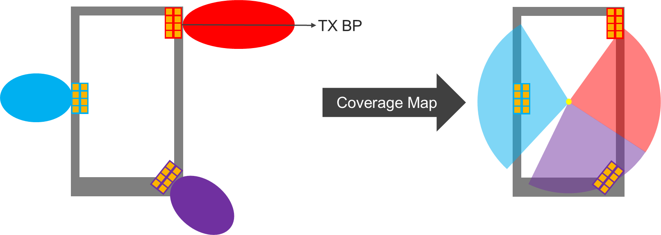

Figure 5.1.3-3: Illustration of Sample DUT with three antenna panels

The beam peak search or spherical coverage test case of the DUT utilizing the black-box approach, i.e., none of the antenna offsets are known/declared, is illustrated in Figure 5.1.3-4. Here, the geometric centre of the DUT is aligned with the centre of the QZ (yellow circle). The (green) beam peak search grid points sample the EIRP around the DUT.

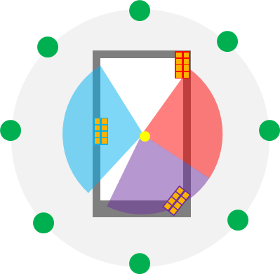

Figure 5.1.3-4: Illustration of beam peak search of sample DUT utilizing black-box approach.

Test cases without a 3D scan, e.g., EIRP/EIS test case towards the known TX/RX beam peak direction, utilizing the black-box approach are illustrated in Figure 5.1.3-5. Here, the geometric centre of the DUT is aligned with the centre of the QZ (yellow circle) and the TX beam peak direction is known from a previous beam peak search measurement, e.g., from an IFF system. Hence, the single (green) FF grid point is aligned with the FF TX beam peak direction.

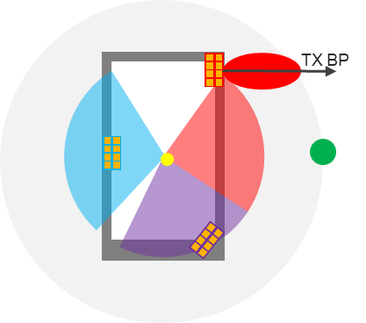

Figure 5.1.3-5: Illustration low UL power test case along TX BP direction of sample DUT utilizing black-box approach.

For the white-box measurement approach, the level of information provided in vendor declarations largely depends on the purpose of test case coverage. If the white-box approach is leveraged for all conformance test cases including the beam peak searches, the total number of panels and the phase centre offsets of each panel need to be declared. Additionally, vendors would have to declare which antenna panel is active for each grid point or test sectors so that the respective antenna panel is aligned with the centre of the QZ during testing. This approach is further illustrated in Figure 5.1.3-6. To sample EIRPs on all beam peak search grid points, three different device positions have to be applied, i.e., for the angular range covering the

- red grid points (declared by OEM), the red antenna panel (location declared by OEM) has to be aligned with the centre of QZ (yellow circle)

- purple grid points (declared by OEM), the purple antenna panel (location declared by OEM) has to be aligned with the centre of QZ (yellow circle)

- blue grid points (declared by OEM), the blue antenna panel (location declared by OEM) has to be aligned with the centre of QZ (yellow circle)

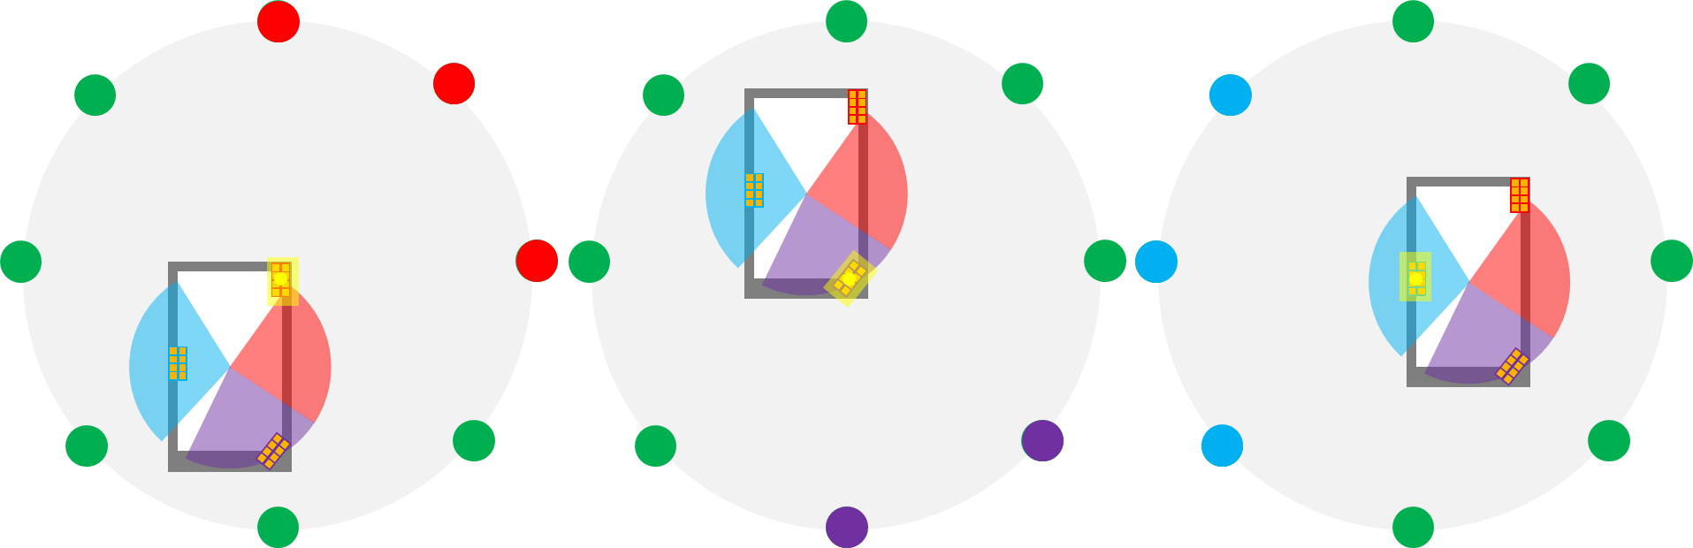

Figure 5.1.3-6: Illustration of beam peak search of sample DUT utilizing white-box approach.

In summary, the information that would have to be declared by the OEMs if the white-box approach is utilized for all conformance test cases is tabulated in Table 5.1.3-1.

Table 5.1.3-1: Sample Vendor Declaration for white box approach supporting all conformance test cases

|  |  |  |
| --- | --- | --- |
| Number of Antenna  Panels in DUT | # | |
| Antenna Panel # | Phase-centre offset from geometric centre of DUT | Range of Angles covered by Antenna Panel |
| 1 | (*x*off1, *y*off1, *z*off1) | (start1 to end1, start1 to end1) |
| 2 | (*x*off2, *y*off2, *z*off2) | (start2 to end2, start2 to end2) |
| … | … | … |
| N | (*x*offN, *y*offN, *z*offN) | (startN to endN, startN to endN) |

Assuming the enhanced test methodology needs to perform beam peak searches and a white box approach was selected, the DUT should be measured in several positions inside the test volume, where two options could be considered:

a. DUT is placed manually in the corresponding off-center positions. This will likely result in significant test time increase and additional MU due to inaccuracies in the alignment of the DUT.

b. x-y-z positioning systems are needed to fully automate testing based on the knowledge of which antenna panel is active in any given UL/DL test direction, as outlined in Figure 5.1.3-6. This will in effect likely result in significant signal ripple and near field coupling effects which is expected to degrade the quality of QZ MU which could offset the offset MU a white box approach eliminates. Such positioning system will furthermore increase test system complexity from a SW and HW perspective as well as test time.

Test cases without a 3D scan, e.g., EIRP/EIS test case towards the known TX/RX beam peak direction, utilizing the white-box approach is illustrated in Figure 5.1.3-7. Here, the phase centre of the red panel (yielding beam peak radiation) of the DUT is aligned with the centre of the QZ (yellow circle) and the TX beam peak direction is known from a previous beam peak search measurement; thus the single (green) grid point is aligned with the FF TX beam peak direction. In this case, only the location of the one antenna panel that yields the beam peak radiation would have to be declared. A sample declaration is shown in Table 5.1.3-2.

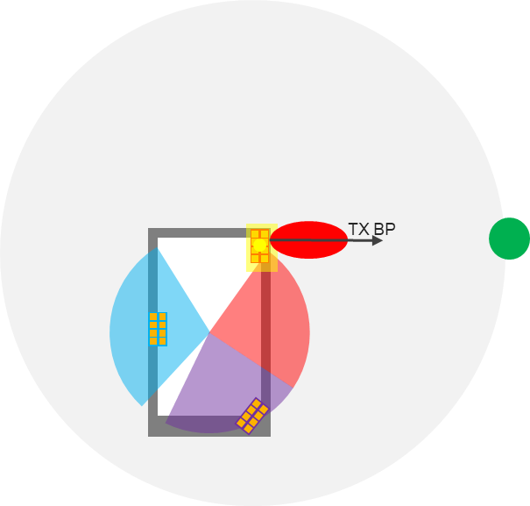

Figure 5.1.3-7: Illustration of low UL power test case along TX BP direction of sample DUT utilizing white-box approach.

Table 5.1.3-2: Sample Vendor Declaration for white-box approach supporting low UL power test cases

|  |  |
| --- | --- |
| Antenna Panel (yielding TX beam peak radiation) | Phase-centre offset from geometric centre of DUT |
|  | (*x*off, *y*off, *z*off) |

Two different black&white-box approaches could be further considered, i.e.,

- Extensive Black&white-box approach: When the NF methodology is used for spherical coverage test cases and for beam peak searches, all active antenna locations are declared together with the angular ranges (theta, phi) each active antenna performs best (when compared to the remaining antenna panels, i.e., the vendor declaration is as outlined in Table 5.1.3-1. Very much similar to the white-box approach with the only difference that the geometric centre of DUT is aligned with the centre of QZ.

- Black&white box: When the NF methodology is used only for EIS based high DL power or EIRP/TRP based low UL power test cases, only the antenna location of the antenna that yields the beam peak needs to be declared, i.e., the vendor declaration is as outlined in Table 5.1.3-2. The geometric centre of DUT is aligned with the centre of QZ.

For test cases focused only on the for EIS based high DL power or EIRP/TRP based low UL power test cases, the key differences are illustrated in Figure 5.1.3-8 for the black-box approach (left), black&white-box approach (centre), and the white-box approach (right). While the black-box approach requires local searches to determine the NF test direction, the need for local searches for the black&white-box approach is FFS. No local search is necessary for the white-box approach.

For the spherical coverage test cases or the beam peak searches, the extensive black&white-box approach is further outlined in Figure 5.1.3-9. On the other hand, the black-box approach is outlined in Figure 5.1.3-4 while the white-box approach is outlined in Figure 5.1.3-6.

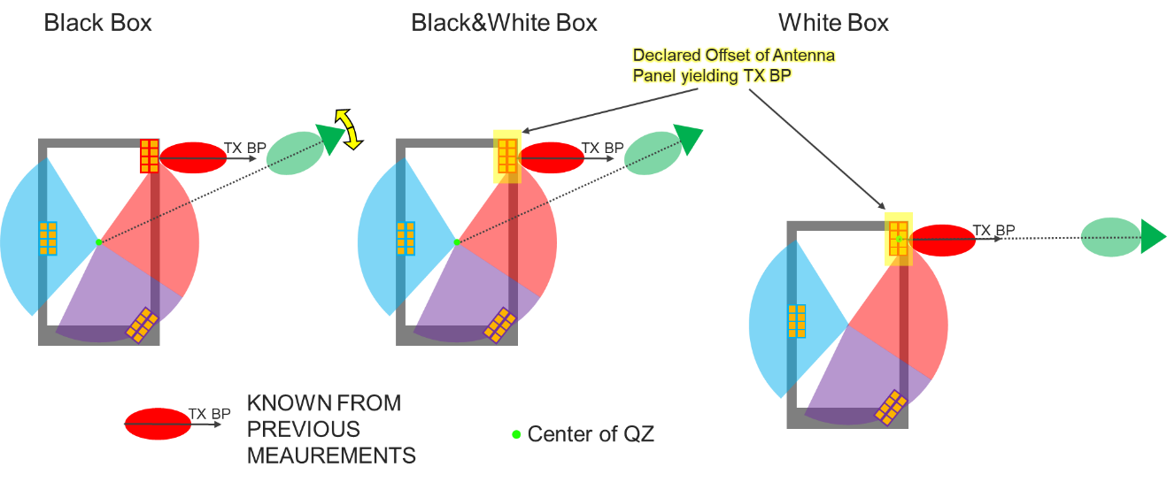

Figure 5.1.3-8: Illustration of black-box approach (left), black&white-box approach (centre), and the white-box approach (right) for the low-UL power test case.

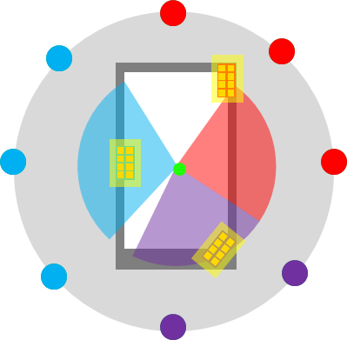

Figure 5.1.3-9: Illustration of beam peak search or beam peak search of sample DUT utilizing extensive black&white-box approach

For white box testing, the minimum radius of the NF probe antenna from the centre of the quiet zone generally must exceed the maximum diameter of the device, as illustrated in Figure 5.1.3-10, to prevent interference of the near field scanning probe with the DUT. While this requirement of the NF range length having to exceed the maximum diameter of the DUT is generally applicable to TRP where the NF Probe antenna needs to perform a full 3D scan around the DUT, this could very well be applicable to single-directional measurements as well, as illustrated in Figure 5.1.3-10 using a PC1 CPE as an example. Similar restrictions apply when testing using ETC enclosures surrounding the DUT.

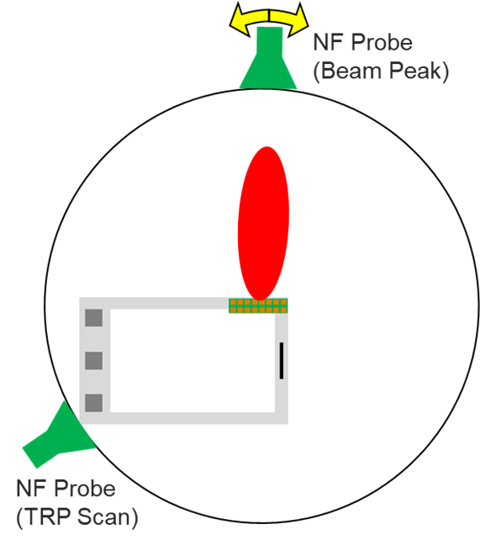

Figure 5.1.3-10: Illustration of min. Range length of NF Systems when applying white box testing

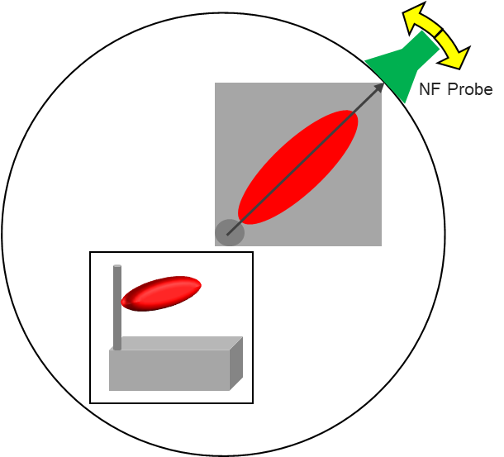

Figure 5.1.3-11: Illustration of min. Range length for NF Systems using PC1 CPE as example.

The corresponding FF and NF min. range lengths are tabulated for selected FR2 frequencies in Table 5.1.3-3 for PC3 devices with fixed D=5cm.

Table 5.1.3-3: Minimum FF and NF Range Lengths for black box and white box conditions for PC3 devices

|  |  |  |  |  |
| --- | --- | --- | --- | --- |
| ***f* [GHz]** | **Antenna Config. 1 and 2 - BLACK BOX -  (PC3 Devices: D=5cm)** | | **Antenna Config. 1 and 2 - WHITE BOX -  (PC3 Devices: D=5cm)** | |
| **Min. FF Range Length [m]** | **Min. NF Range Length [m]** | **Min. FF Range Length [m]** | **Min. NF Range Length  [m]** |
| **24.25** | 0.53 | 0.19 | 0.40 | 0.28 |
| **30** | 0.63 | 0.19 | 0.50 | 0.28 |
| **40** | 0.79 | 0.21 | 0.67 | 0.28 |
| **43.5** | 0.85 | 0.21 | 0.73 | 0.28 |
| **52.6** | 1.00 | 0.22 | 0.88 | 0.28 |

Table 5.1.3-4 summarizes the path loss comparison between “white box” and “black box” configuration across IFF/DFF and NF system types.

Table 5.1.3-4: Path loss comparison between “white box” and “black box” configuration

|  |  |  |  |  |
| --- | --- | --- | --- | --- |
| f (GHz) | Antenna Config. 1, 2, and 3 - BLACK BOX -  (PC3 Devices: D=5cm) | | Antenna Config. 1 and 2 - WHITE BOX -  (PC3 Devices: D=5cm) | |
| IFF/DFF | NF | DFF | NF |
| Path Loss with 1m range length | Path Loss with 0.22m range length | Path Loss with 0.88m range length | Path Loss with 0.28m range length |
| 24.25 | 60.16 | 46.86 | 59.01 | 48.93 |
| 30 | 62.01 | 48.71 | 60.85 | 50.78 |
| 40 | 64.51 | 51.21 | 63.35 | 53.28 |
| 43.5 | 65.24 | 51.94 | 64.08 | 54.00 |
| 52.6 | 66.89 | 53.59 | 65.73 | 55.65 |

Based on the analysis shown in Table 5.1.3-4, it can be concluded that a “white box” is not deemed a feasible enhancement of the methodology.

Additionally, since the beam peak searches and the spherical coverage test cases are not part of the low UL/high DL power test cases and given the complexity of the vendor declaration of the extensive black&white-box approach, it can be concluded that the extensive black&white-box approach is not deemed a feasible enhancement of the methodology.

In a NF system, the NF TX beam peak (BP) direction for an offset antenna is not necessarily the same as the FF TX BP direction; however, the knowledge of the antenna phase centre offset can be leveraged to measure at the NF BP direction as illustrated in Figure 5.1.3-12 below.

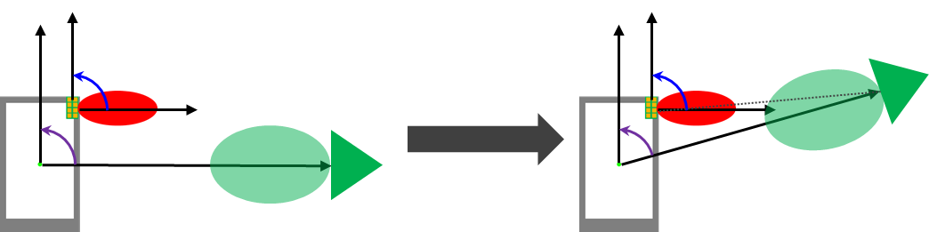

Figure 5.1.3-12: Illustration of NF Testing utilizing the “black&white box” approach

### 5.1.4 Applicability of NF methodologies

Here, the applicability of the NF methodologies considered, i.e., direct Near Field (DNF), Combined Far-Field/Direct Near Field (CFFDNF), and Combined Far-Field/Near Field (CFFNF), are further analysed.

The CFFNF with transform (e.g. asymptotic expansion transform) has the following applicability:

- Beam peak searches and spherical coverage test cases are performed with black box approach using the FF probe. Performing these tests with the NF measurement probe would require the extensive black&white-box approach which is not deemed a feasible enhancement of the methodology.

- The low UL power/high DL power EIRP/EIS test cases in known FF BP direction are applicable to the black-box approach using transform techniques:

- Three radii approach (i.e. local search on radius r1 and very localized searches at r2 and r3) can be used.

- EIRP/EIS can be approximated very accurately with the NF probe at very close distances (~22cm for PC3, ~27cm for PC1) with optimized improvements in relaxations.

- The unknown antenna location can be estimated accurately which allows very accurate TRP measurements at very close distances with large improvement in relaxations.

- The low UL power/high DL power EIRP/EIS test cases in known FF BP direction are applicable to the black&white-box approach.

- Two radii approach without local searches can be used.

- EIRP/EIS can be approximated very accurately with the NF probe at very close distances (~21cm for PC3, ~26cm for PC1) with optimized improvements in relaxations.

- The low UL power TRP test cases are not applicable to transform approach (CFFNF) since that approach would be test time prohibitive. However, the known offset (empirical evaluation with black box approach or declared with black&white-box approach) can be compensated using CFFDNF approach to obtain very accurate TRP results at very close distances.

The CFFDNF has the following applicability:

- Beam peak searches and spherical coverage test cases are performed with black box approach using the FF probe. Performing these tests with the NF measurement probe would require the extensive black&white-box approach which is not deemed a feasible enhancement of the methodology..

- The low UL power/high DL power EIRP/EIS test cases in the known FF BP direction are applicable to the black&white-box approach.

- Whether a local search to determine the NF test direction and/or optimize EIRP/EIS is FFS.

- EIRP/EIS can be approximated in the NF (min. range lengths for PC1 and PC3 are FFS)

- TRP test cases at very close distances require offset compensation while range lengths beyond 32cm for PC3 do not necessarily require offset compensations. At those range lengths, the relaxations are minimized by up to 10dB.

DNF has the following applicability:

- Beam peak searches and spherical coverage test cases are not applicable for the black-box approach. An extensive black&white-box approach would be required to perform these tests with the NF measurement probe. Given the complexities of the extensive black&white-box approach, DNF is not deemed a feasible enhancement of the methodology for conformance testing but it might be suitable during UE development phase.

- The low UL power/high DL power EIRP/EIS test cases in the known FF BP direction are not applicable to the black box approach.

- The applicability of the low UL power/high DL power EIRP/TRP/EIS test cases in the known BP direction and with the black&white-box approach is FFS.

The assumption for this “black & white box” testing approach is that the antenna phase centre offset for the antenna panel that corresponds to the FF beam peak is known and declared, i.e., following the “white box” approach discussed earlier. On the other hand, however, it is assumed that the geometric centre of the DUT is aligned with the centre of the QZ, i.e., following the “black box” approach. This approach would have the same advantages as the “black box” approach over the “white box” approach in terms of complexity, test time, MU, and improvements of the relaxations and is summarized in Table 5.1.4-1 below.

Table 5.1.4-1: Comparison between the “black box” and “black & white box” approaches

|  |  |  |  |  |  |  |  |
| --- | --- | --- | --- | --- | --- | --- | --- |
| Approach | Knowledge of FF BP Direction (from Meas.) | Declaration of Antenna Phase Centre Offset of Antenna yielding BP | Need for FF probes and UBF | Need for local searches around NF BP | Meas. at different Radii | Test Time Impact | Estimated maximum Improvement of Relaxation (NOTE 1) |
| CFFNF for EIRP/EIS using Black Box | Yes | No | Yes | Yes | Yes (x3) | Medium (local searches & 3 different radii) | ~14dB (for 20cm range length). |
| CFFNF for EIRP/EIS using Black & White Box | Yes | Yes | Yes | No | Yes (x2) | Low (2 different radii in fixed NF BP Direction) | ~14dB (for 20cm range length) |
| CFFDNF for TRP using Black Box | Yes | Yes | Yes | No | No | None | Without offset correction: ~10dB (for 32cm range length) |
| CFFDNF for TRP using Black &White Box | Yes | Yes | Yes | No | No | None | With offset correction: ~14dB (for 20cm range length) |
| CFFDNF for EIRP/EIS using Black &White Box | Yes | Yes | Yes | FFS | No | Depends on local search | With pathloss correction: ~14dB (for 20cm range length) |
| NOTE 1: Improvement of relaxation is only considering Free Space Path Loss | | | | | | | |

### 5.1.5 Improvement of permitted methods

Tables 5.1.5-1 and 5.1.5-2 below provide a preliminary list of potential improvement of permitted methods based on the analysis provided by one company and are applicable to the frequency range of 24.25 – 43.5 GHz.

Table 5.1.5-1: Summary of potential improvement of permitted methods by Tx test case (24.25 – 43.5 GHz)

|  |  |  |  |  |  |  |
| --- | --- | --- | --- | --- | --- | --- |
| Clause | Requirement | Testability issue | Test Metric | Regulatory related | TS 38.521-2 Test Requirements | Potential improvement |
| 6.3.1 | Minimum output power | Low UL power | EIRP (Link=TX beam peak direction, Meas=Link angle). | No | No relaxation for PC1. For other power classes, relaxation varies from 0dB to 13.5dB depending on the operating band and channel bandwidth. | ~ 10dB for FR2a and FR2b  FR2a requirements testable without relaxations |
| 6.3.2 | Transmit OFF power | Low UL power | TRP (Link=TX beam peak direction, Meas=TRP grid) | Yes | Relaxations for n257: 21.4dB @ 50MHz, 24.4dB @ 100MHz, 27.4dB @ 200MHz and 30.4dB @ 400MHz.  Relaxations for n258 and n261: [21.4]dB @ 50MHz, [24.4]dB @ 100MHz, [27.4]dB @ 200MHz and [30.4]dB @ 400MHz.  Relaxations for n260: [24.1]dB @ 50MHz, [27.1]dB @ 100MHz, [30.1]dB @ 200MHz and [33.1]dB @ 400MHz. | ~ 10dB for FR2a and FR2b |
| 6.5.1 | Occupied bandwidth | Low UL power | OBW (Link=TX beam peak direction, Meas=Link angle) | Yes | TBD | TBD |
| 6.5.2.3 | Adjacent channel leakage ratio | Low UL power | TRP (Link=TX beam peak direction, Meas=TRP grid). | Yes | Relaxation for n257, n258 and n261: 0dB, except for 200Mhz (0.5dB in one test ID) and 400MHz (between 1.5 and 3.5dB) | Improvements remove required relaxations from TC |
| 6.5.3.2 | Additional spurious emissions | Low UL power | TRP (Link=TX beam peak direction, Meas=TRP grid). | Yes | Between 3.3dB and 6dB relaxation depending on the combination of NR Band and Protected band. | TBD |



Table 5.1.5-2: Summary of potential improvement of permitted methods by Rx test case (24.25 – 43.5 GHz)

|  |  |  |  |  |  |  |
| --- | --- | --- | --- | --- | --- | --- |
| Clause | Requirement | Testability issue | Test Metric | Regulatory related | TS 38.521-2 Test Requirements | Potential improvement |
| 7.4 | Maximum input power | High DL power | EIS (Link=RX beam peak direction, Meas=Link angle). | No | 26dB relaxation for 24.25 ~ 29.5 GHz and 34 dB relaxation for 37 ~ 40 GHz with respect to minimun requirements. | ~ 6dB for FR2a  ~10dB for FR2b |
| 7.5 | Adjacent channel selectivity (case 1) | High DL power | EIS (Link=RX beam peak direction, Meas=Link angle) | Yes | 50MHz: 1.8dB relaxation for power in transmission BW and interferer for band n260.  100MHz: 4.8dB relaxation for power in transmission BW and interferer for band n260.  200MHz and 400MHz are deemed not testable. | Similar improvements as for TC 7.4  Single carrier bandwidth could be testable 400 MHz, without relaxations up to 200 MHz |
| 7.5 | Adjacent channel selectivity (case 2) | High DL power | EIS (Link=RX beam peak direction, Meas=Link angle) | No | Decision not test ACS case 2. | - |
| 7.6.2 | In-band blocking | High DL power | EIS (Link=RX beam peak direction, Meas=Link angle) | Yes | 50MHz: 1.8dB relaxation for power in transmission BW and interferer for band n260.  100MHz: 4.8dB relaxation for power in transmission BW and interferer for band n260.  200MHz and 400MHz are deemed not testable. | Similar improvements as for TC 7.4  Single carrier bandwidth could be testable 400 MHz, without relaxations up to 200 MHz |
| 7.9 | Receiver spurious emissions | Low UL power | TRP (Link=TX beam peak direction, Meas=TRP grid). | Yes | Relaxations for n257: 10.2dB between 6-20GHz, 17.2dB between 20-40GHz and 33.1dB between 40GHz and the 2nd harmonic.  Relaxations for other bands are still TBD. | TBD |

For a given test case, NF based solutions should only be considered if the improvement for current methods is not enough to remove the relaxations determined by RAN5.

## 5.2 Polarization basis mismatch between the TE and DUT

### 5.2.1 General

The investigation of polarization basis mismatch enhancements to the FR2 test methodology includes the following aspects: scope of test cases with polarization basis mismatch between the TE and DUT issues, enhanced test methods, applicability of the enhanced test methods.

The initial testing methodology for FR2 UE RF requirement verification is defined in [3] and features a measurement antenna capable of

- transmitting and receiving on two orthogonal polarizations

- introducing linearly polarized downlink signals at the centre of the quiet zone one polarization at a time

- measuring the total uplink signal power by combining the power measured by two orthogonally polarized antennas sequentially or

- demodulating the signal received by a single polarization at a time.

Regarding polarization basis mismatch between the UE TE and DUT, there are two main issues:

- DL polarization basis mismatch for EIRP measurement. The mismatch between the TE and UE may lead such UEs to disable a Tx chain associated with one DL polarization and may result in an EIRP measurement which fails to include the polarization gain at some test points;

- UL polarization basis mismatch for demodulation. Some UE implementations may support uplink transmission diversity schemes which, although transparent to the specification, impact the demodulation performance when the UL signal is demodulated on just a single polarization.

Therefore, these two issues are addressed separated with different approach. The potential solutions to minimize the impact of polarization basis mismatch address two distinct goals: to enhance the EIRP measurement of UEs with various capabilities, and to enhance the test equipment demodulation performance in the uplink, such that a test mode to disable Tx diversity at the UE is no longer necessary for the UE to perform conformance testing.

### 5.2.2 Enhanced test method for EIRP measurement

#### 5.2.2.1 TPMI method

Transmitted Matrix Precoding Indicator (TPMI) is the basis of codebook based transmission enabling multi-port antenna transmission. TPMI method is identified as applicable method to enhance EIRP measurement, which is able to activate dual polarization transmission in EIRP measurement. The applicability of this method is defined in Clause 5.2.2.2.

For FR2 UEs support the TPMI method, the precoding matrix is given by Table 5.2.2.1-1 (same as Table 6.3.1.5-1 in TS 38.211 [4]). 2Tx TPMI index 2-5 can force UE single-layer transmission using two antenna ports. Among them, only one proper precoding matrix is selected for EIRP measurement.

Table 5.2.2.1-1: Precoding matrix  for single-layer transmission using two antenna ports.

|  |  |  |  |  |  |  |  |  |
| --- | --- | --- | --- | --- | --- | --- | --- | --- |
| TPMI index | (ordered from left to right in increasing order of TPMI index) | | | | | | | |
| 0 – 5 |  |  |  |  |  |  | - | - |

The permitted test methods (i.e. DFF, IFF and NFTF) in [3] are all applicable for TPMI method with the additional procedure that the UE should be configured with TPMI index and working at single-layer transmission using two antenna ports, before performing EIRP-based test procedures in Clause 5.2.1.3 in TR38.810 [3].:

- Peak EIRP Measurement Procedure

- TRP Measurement Procedure

- TX Beam Peak direction search and EIRP Spherical Coverage

#### 5.2.2.2 Applicability of TPMI side condition method

TPMI is applicable for one layer transmission with multi-port antenna. In FR2, dual polarization can be regarded as dual antenna ports, so it is natural to activate dual polarization transmission with TPMI side condition in EIRP measurement procedure. However, for TPMI supporting dual antenna ports, the number of SRS ports (nrofSRS-Ports) is configured as 2 for both one layer transmission with ‘full power transmission’ and two layers transmission with regular UL MIMO, as specified in clause 6.1 of TS 38.101-2 [2]:

|  |
| --- |
| For a UE that supports 'UL full power transmission' and is configured to transmit a single layer with nrofSRS-Ports = 2, the requirements for UL MIMO operation apply only when it is configured for any of its declared full power modes in IE FullPowerTransmission-r16 (as defined in TS 38.331[13]).  For a UE configured to transmit 2 layers, transmitter requirements for UL MIMO operation apply when the UE transmits on 2 ports on the same CDM group. The UE may use higher MPR values outside this limitation. |

Thus, TPMI method is applicable for the following FR2 UEs:

- Rel-15 Coherent UE

- Rel-16 Coherent UE

- Rel-16 UE supporting UL full power transmission mode1 (ul-FullPowerTransmission = fullpowerMode1)

Other UEs are not applicable for TPMI based test method.

#### 5.2.2.3 Alternative test method

A number of open issues have been identified with the configuration of 2-port CSI-RS method, and a conclusion whether this method is a feasible enhancement is TBD.

### 5.2.3 Enhanced test method for UL demodulation measurement

#### 5.2.3.1 Test equipment Zero-forcing MIMO receiver

As an enhancement to the FR2 test equipment topology, it has been proposed to adopt a zero-forcing MIMO receiver architecture so that dual-polarization transmissions by the UE can be demodulated by the test equipment receiver. Further details of the implementation are FFS.

## 5.3 Inter-band (FR2+FR2) CA

### 5.3.1 General

In this sub-clause, following analyses with an in-direct far field (IFF) OTA test systems are introduced in achieving RF measurements of an inter-band CA UE in FR2.

a) Impact of multiple test antennae

1) PSD imbalance with DL signals from test equipment

DL PSD towards UE supporting independent beam management (IBM)

DL PSD towards UE supporting common beam management (CBM)

2) Impact of off-focus test system antennae

Quality of quiet zone (QoQZ)

Rx beam profiles with an independent beam management (IBM) UE

Propensity to trigger incorrect beam in CBM UE

Spherical coverage measurement simulation with common beam management (CBM) UE

3) Summary on applicability of offset antenna test system

b) Inter-band testing ramifications

### 5.3.2 Impact of multiple test antennae

#### 5.3.2.1 PSD imbalance with DL signals from test equipment

##### 5.3.2.1.1 DL PSD towards UE supporting independent beam management (IBM)

An impact of an AoA offset ranging from 0 to 7 degrees was analyzed for UE supporting independent beam management. The gain difference between the CCs is a test case parameter informed by the recent agreement on the PSD difference in the REFSENS and EIS spherical coverage requirement for DL inter-band CA within FR2 [2]. The simulation assumptions are shown in Table 5.3.2.1.1-1 below.

Table 5.3.2.1.1-1: Simulation assumptions for PSD imbalance

|  |  |
| --- | --- |
| Simulation Parameters | |
| Antenna array size | 4x1 |
| Element spacing | 5mm |
| Element pattern | See TR38.803 |
| Antenna impairments | Not considered |
| Phase shifter impairments | See TR38.817-01 |
| Transmission line impairments | Modeled TL length and loss per element |
| AoA offset | {0, 2, 5, 7} deg |
| Beam management assumptions | Independent beam management on each CC |
| Center frequencies of component carriers | f1 = 27.9 GHz, f2 = 38.5 GHz |
| Gain difference between CC1 and CC2 | 15.2 dB |

For each AoA offset the PSD difference between CC1 and CC2 was calculated after spatially filtering the signal with the array response pattern corresponding to each CC. Figure 5.3.2.1.1-1 below illustrates the simulation results.



Figure 5.3.2.1.1-1: Spatially filtered PSD difference vs. angular separation between CCs

Table 5.3.2.1.1-2 below summarizes the simulation results.

Table 5.3.2.1.1-2: Simulation results for spatially filtered PSD difference vs. angular separation between CCs

|  |  |
| --- | --- |
| Max excess PSD difference due to AoA offset (dB) | |
| AoA offset (º) | PSD diff (dB) |
| 2 | 0.4 |
| 5 | 1.1 |
| 7 | 1.7 |

The requirement for inter-band CA between bands n261 and n260 is defined assuming a non-zero PSD difference between the component carriers. This assumption holds for the class of inter-band CA configurations to which the independent beam management (IBM) type is applicable. It is observed that at least for IBM inter-band CA requirements, AoA offsets of up to 7 degrees between two FR2 CA component carriers do not significantly impact the PSD difference assumption taken for the core requirement. This observation should be double-checked after the band n262 requirements are finalized and the scope of CA configurations with n262 are understood.

Further note that as part of the Rel-17 FR2 RF enhancement work item, RAN4 is discussing the potential definition of requirements assuming common beam management (CBM) for combination of certain band groups, such as 28+28 GHz. An analysis of the impact of AoA offsets in the test setup for inter-band CA with CBM is needed after the scope of CBM requirements and associated agreements are better understood.

##### 5.3.2.1.2 DL PSD towards UE supporting common beam management (CBM)

Following a similar simulation methodology as described in 5.3.2.1.1, an analysis of the impact of an AoA offset ranging from 0 to 7 degrees was analyzed for UE supporting common beam management. The gain difference between the CCs is a test case parameter informed by the recent agreement on the PSD difference in the REFSENS and EIS spherical coverage requirement for DL inter-band CA within FR2 [2]. The simulation assumptions are shown in Table 5.3.2.1.2-1 below.

Table 5.3.2.1.2-1: Simulation assumptions for PSD imbalance with CBM

|  |  |
| --- | --- |
| Simulation Parameters | |
| Antenna array size | 4x1 |
| Element spacing | 5mm |
| Element pattern | See TR38.803 |
| Antenna impairments | Not considered |
| Phase shifter impairments | See TR38.817-01 |
| Transmission line impairments | Modeled TL length and loss per element |
| AoA offset | {0, 2, 5, 7} deg |
| Beam management assumptions | Common beam management between CC1 and CC2 (codebook optimized for f1) |
| Center frequencies of component carriers | Case 1: f1 = 24.25 GHz, f2 = 29.5 GHz  Case 2: f1 = 37.0 GHz, f2 = 43.5 GHz |
| Gain difference between CC1 and CC2 | Case 1: 0.0 dB  Case 2: 1.2 dB (difference in EIS spherical coverage between n260 and n259) |

For each AoA offset the PSD difference between CC1 and CC2 was calculated after spatially filtering the signal with the array response pattern corresponding to each CC. Figure 5.3.2.1.2-1 below illustrates the simulation results.

a)  b) 

Figure 5.3.2.1.2-1: Spatially filtered PSD difference vs. angular separation between CCs; a) Case 1 (24.25 + 29.5 GHz); b) Case 2 (37.0 + 43.5 GHz)

Table 5.3.2.1.2-2 below summarizes the simulation results.

Table 5.3.2.1.2-2: Simulation results for spatially filtered PSD difference vs. angular separation between CCs

|  |  |  |
| --- | --- | --- |
| Max excess PSD difference due to AoA offset (dB) | | |
| AoA offset (º) | PSD diff (dB) | |
| Case 1 | Case 2 |
| 2 | 0.3 | -0.2 |
| 5 | 0.8 | 0.3 |
| 7 | 1.7 | 1.2 |

Because RAN4 is still discussing the potential introduction of requirements for CBM CA between bands within the same band group (as of #98-e meeting 2021 Jan.), the PSD difference analysis in this subclause assumes a convergence toward 0 dB PSD difference or, in the case of bands with different spherical coverage requirements, for the difference to be bounded by the difference in spherical coverage EIS values.

We note that because the CBM CA architecture is, in essence, an optimization, the UE receiver is more sensitive to PSD differences beyond those assumed for the core requirement. Although Table 5.3.2.1.2-2 indicates that the maximum excess PSD difference due to AoA offset ≤ 1.7 dB which is applicable only to PC3 UE, this effect compounds with the beam squint impairment.

Again noting that the core requirement work on CBM CA is still ongoing, it is not possible to use the results to disqualify the proposed AoA offset method from applicability to CBM CA test cases. However, the impact of AoA offset on PSD difference assumptions made in the core requirement definition should be taken into account.

#### 5.3.2.2 Impact of off-focus test system antennae

##### 5.3.2.2.1 Quality of quiet zone (QoQZ)

The IFF system for FR2 UE OTA testing is constructed around an offset parabolic mirror to collimate beams from a test antenna towards the UE. The architecture allows for a quiet zone (QZ) roughly the size of the spot on the mirror illuminated by the source. The key to this architecture is locating the source at the focus of the parabola that describers the mirror.

The burgeoning number of FR2 bands place increasing demands on both, the antenna, as well as the RFFE in test equipment.

The effect of off-focus test system antenna in IFF systems was studied before listing ramifications to inter-band test requirements. The components of the IFF are much larger than the wavelength of signals under test. The primary effect of the EM solution to the IFF problem can hence be determined by an equivalent optics problem.

From the geometry of a parabola, there is a unique location (the focus) that allows a test antenna to appear as a far-field antenna after reflection off the mirror. The far-field characteristic comes from the wavefront geometry that is transformed by the mirror from spherical to planar. The planar wavefront is normal to the optical axis of the mirror. Unfortunately, the favorable characteristics of the parabolic mirror are limited to proper placement of the source, and optical aberration is expected outside the geometry demands specific to the mirror in use. For example, in astronomy, the ‘coma’ aberration has long been associated with telescopes when wavefronts of incoming light are not normal to the optical axis.

To simplify the problem, the following assumptions were made about the IFF system, which was modelled with a 2D ray tracer:

1. The TE antenna was modelled as a point light source with uniform illumination in the hemisphere facing the mirror, and no illumination facing the source.

2. Light not incident on the mirror was modelled as being perfectly absorbed by the background

3. Edge effects of the mirror were not considered

4. The primary focal length was chosen to be 0.65m, for an effective focal length with the offset mirror of ~ 0.7m. The mirror offset was such that the mirror extended from y = 0.2 m to y = 0.5 m off the optical axis.

5. QZ plane was placed orthogonal to the optical axis 1.5 m away from the point where the axis intersects the parabola.

6. Source-to-source interaction, in case of multiple sources, are neglected

7. EM field perturbation due to presence of positioner or DUT fixturing is neglected by virtue of choosing an optic method

8. Light source locations considered (d,h defined in figure 5.3.2.2.1-1):

Note that assumption #1 is not valid for typical horn antennae, but the uniform illumination assumption serves as a good reference point for studying power variation across the QZ when the source is moved off-focus.

Table 5.3.2.2.1-1: TBD

|  |  |  |
| --- | --- | --- |
| Location id | d (m) | h (m) |
| 1 (focus) | 0 | 0 |
| 2 | 0 | 0.05 |
| 3 | 0 | 0.10 |
| 4 | -0.05 | 0.10 |
| 5 | +0.05 | 0.10 |

Figures 5.3.2.2.1-1 shows the position of the mirror relative to the sources, as well as the illumination levels at the QZ (sub figure 1b). The blue curve in the sub-figure 1b indicates 2 things about a source at the focus (location1). The first observation is that the nominal QZ is located between y = 0.2 and y=0.5, which coincides with the mirror extents in the y-dimension. This detail is expected. The second observation is that an isotropic source gets transformed to a non-uniform illumination at the QZ.

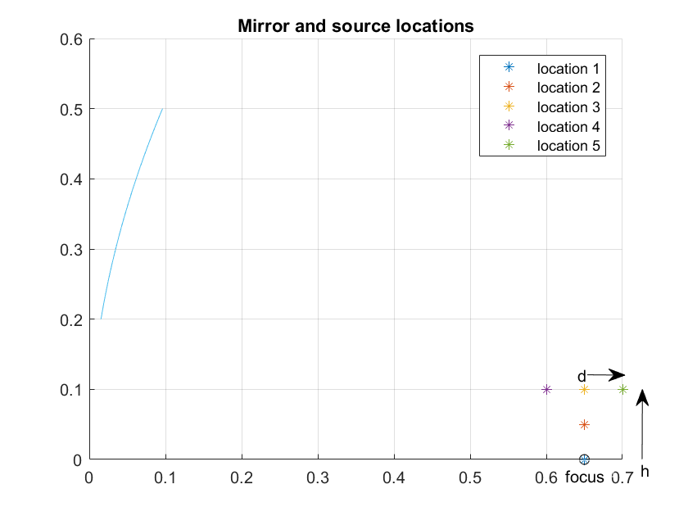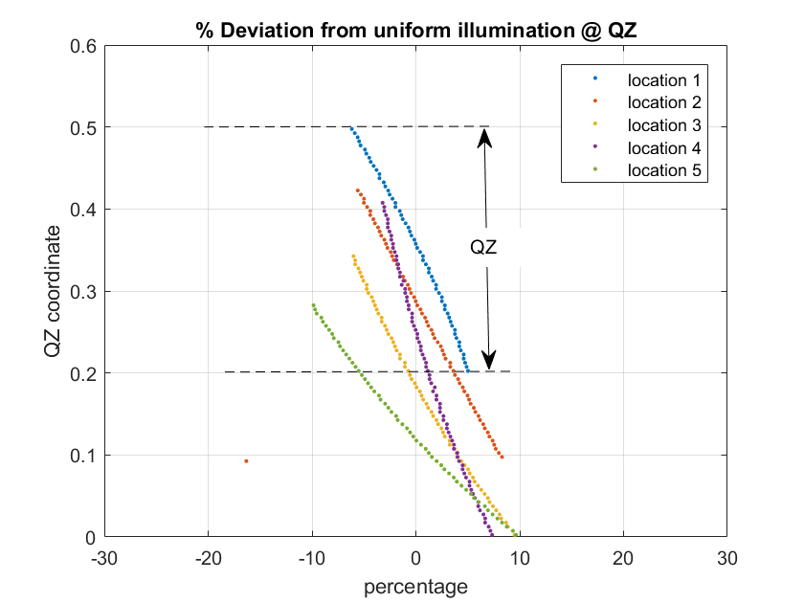

Figure 5.3.2.2.1-1: a: Mirror and source locations; b : Source to QZ power density distortion

Furthermore, the illumination intensity curves corresponding to other source locations inform that the collimated beam moves progressively off the QZ as the source is moved away from focus. In the example locations studied, the beam develops a down tilt, but an up tilt is also possible if the source is moved to a location, say, below and to the left of the focus in figure 1a.

In figure 5.3.2.2.1-2, it is observed that the wavefront also starts to deviate from being purely orthogonal to the optical axis. The wavefront shape is consistent with the ‘beam tilt’ observation made earlier.

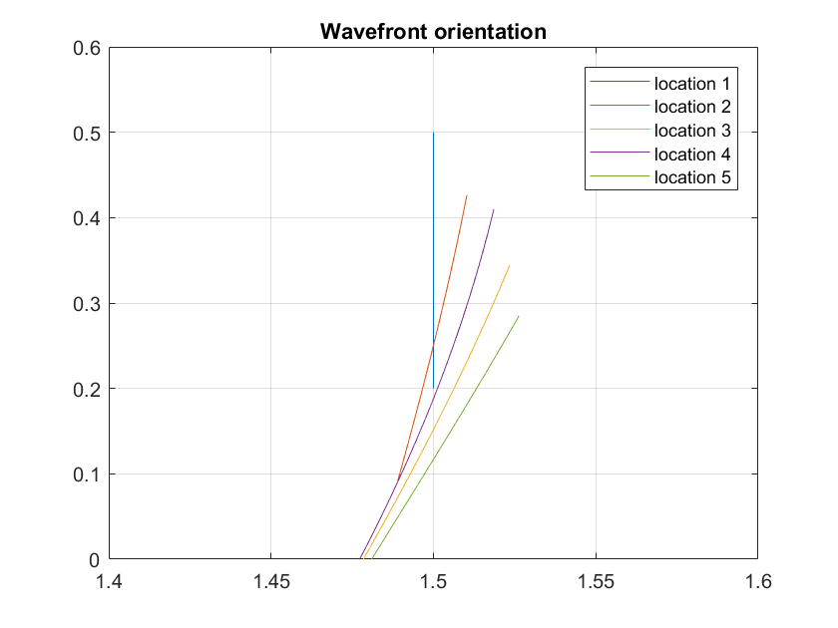

Figure 5.3.2.2.1-2: Wavefront orientation at QZ due to off-focus source

For a UE’s perspective on off-focus sources, candidate source locations were characterized by their angular locations relative to mirror normal. Note that the focus is off the mirror normal due to ‘offset mirror’ geometry, so it has a non-zero value. In the example studied, the focus is 15.4 degrees below mirror normal, and the other off-focus source locations studied all have lower angular offsets than the focus. In figure 5.3.2.2.1-3 we show that the rate of increase beam tilt and the rate of increase in angular offset of the source are very similar, i.e close to 1:1 for the geometry studied.

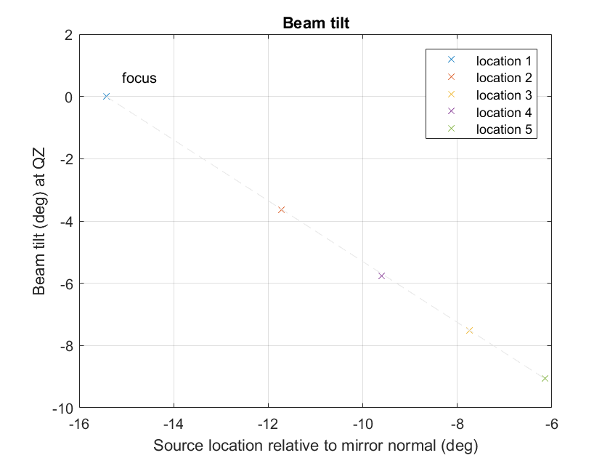

Figure 5.3.2.2.1-3: Beam tilt due to off-focus source

Recall that the nominal QZ location is the illuminated spot in the plane of the QZ when the source is located at the focus of the mirror. In case of our example, the nominal QZ extends from (x=1.5, y= 0.2) to (x=1.5, y= 0.5). Beam tilt causes the illuminated spot in the plane of the QZ to move off the nominal QZ location. When multiple sources illuminate the mirror, the effective QZ size reduces to the common area across the beams from all sources. Beam tilt consequently has the effect of reducing the effective QZ size. See figure 5.3.2.2.1-4. The reduction in size is a function of both, the angular offset between source and focus, and the distance of the QZ from the mirror.

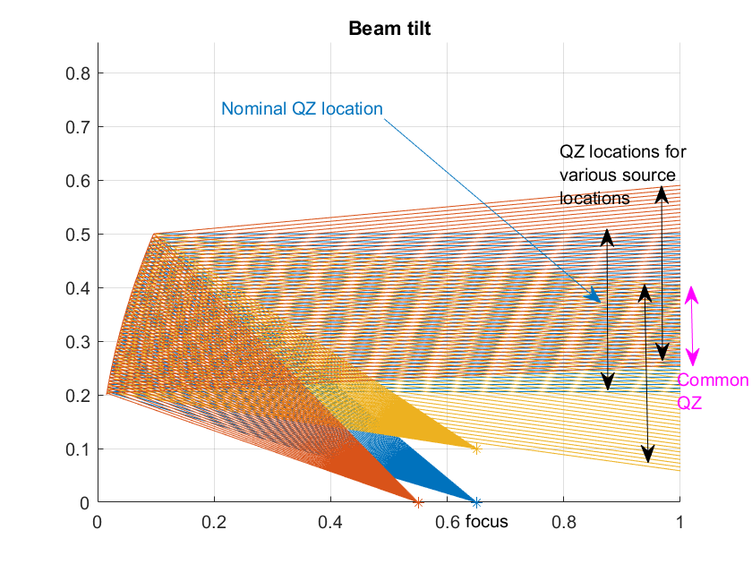

Figure 5.3.2.2.1-4: Beam tilt causes QZ size reduction

Now, different UE power classes have different beam shapes, and different beam packing densities. For power class 1, 3dB beam widths are expected to be between 5 and 10 degrees as an extreme example. A beam tilt in the range of a few degrees could cause a PC1 UE to select a different beam for an off-focus source, relative to a source at the focus.

UE size also limits how close to the mirror the QZ plane can be moved. The radiating face of PC1 device can measure in the 10s of cm in each dimension, which would force the QZ far away from the mirror. This restriction would, in turn, cause much greater reduction in QZ size for a given beam tilt angle, when using multiple sources. These problems would be less serious for PC3 devices.

In a case a test antenna is located simply off the position from a focal point (normally at a position of a main test antenna) in the IFF test system, a centre of a beam from the offset feed antenna would shift depending on a distance of focal length (f), a distance between the reflector and a centre of a quiet zone (r), and a distance of the antenna offset (δ). Figure 5.3.2.2.1-5 depicts the relationship of this shift (δ’).



Figure 5.3.2.2.1-5: Offset of antenna beam peak from centre of QZ (Top view of IFF test system)

Here the shift (δ’) can be calculated geometrically by the following equation, and it may cause an increase of QoQZ measurement uncertainty in a 30 cm quiet zone.

From our experience to date, an electric field intensity in a quiet zone when a feed antenna is located near a focal point is decided by two factors, an antenna pattern of the feed antenna for a test equipment and a shape of the reflector. Especially the antenna pattern can be assumed as the main factor to decide this characteristic, which is directly connected also to the QoQZ.

Based on this observation an estimation was made with an impact of the offset antenna to QoQZ from an experimental data which was obtained by measuring the electric field intensity of a feed antenna via a reflector. Figure 5.3.2.2.1-6 shows one of the experimental data obtained by scanning the field intensity in a range of +/- 200 mm from a centre of the quiet zone. Here a 40.8 GHz vertical polarization beam was scanned along with theta (x) direction.

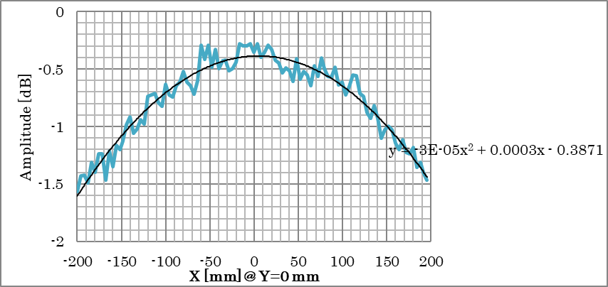

Figure 5.3.2.2.1-6: Electric field intensity of feed antenna scanned along with theta direction (40.8 GHz, V-pol)

Table 5.3.2.2.1-2 and Figure 5.3.2.2.1-7 show the estimation of difference between the QoQZ of main antenna and of the offset antenna. Note that these values are specific to the feed antenna (amplitude taper) in this experiment and thus they may vary depending on an antenna pattern used by each test equipment vendor.

Table 5.3.2.2.1-2: Estimation of QoQZ difference between main and offset antenna

|  |  |  |  |
| --- | --- | --- | --- |
|  | Estimation of QoQZ difference (EIRP) [dB] | | |
| δ [mm] | 23.45 GHz | 32.125 GHz | 40.8 GHz |
| 0 | 0.00 | 0.00 | 0.00 |
| 15 | 0.02 | 0.02 | 0.01 |
| 30 | 0.04 | 0.05 | 0.03 |
| 45 | 0.08 | 0.08 | 0.06 |
| 60 | 0.11 | 0.11 | 0.09 |
| 75 | 0.14 | 0.15 | 0.11 |

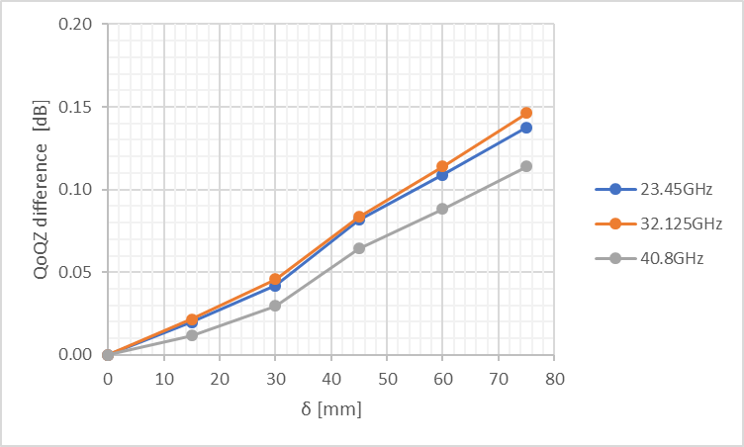

Figure 5.3.2.2.1-7: Plot of QoQZ difference

Though these differences may vary depending on an antenna pattern (amplitude taper) of a feed antenna, as can be seen from above, there is a chance that the difference of QoQZ due to the offset antenna can be limited within an acceptable level by optimizing an arrangement of antennas.

As described above, these QoQZ differences are estimated based on the antenna configuration with which the offset antenna is simply off the position from a focal point. And there is a way to mitigate the impact of the offset antenna to the actual QoQZ.

One of major factors to decide QoQZ is the electric field intensity in the quiet zone. Figure 5.3.2.2.1-8 depicts a 2D-image of the electric field intensity (amplitude taper) in the quiet zone when the offset antenna is used. As shown in the figure, due to the shift of beam centre from the main antenna, distribution of the field intensity becomes asymmetric in the quiet zone and thus it causes the increase of the QoQZ MU value. However it is possible to shift the beam peak position by tilting the offset antenna and make the distribution of the field intensity close to symmetric in the quiet zone like the one from the main antenna, allowing us to mitigate the impact of beam centre shift to the QoQZ value. Figure 5.3.2.2.1-9 depicts the image of the improvement with the offset antenna placement. At the same time, there might be diffraction and/or scattering effects created by the reflector’s paraboloid edges and the size of the paraboloid that impact the QoQZ characteristics. Thus, there should be some limitations with antenna offset ranges and angles to tilt the offset antenna that depend on a relationship between reflector size, measurement antenna offset and range length. All these factors should be considered during the design of the test system.



Figure 5.3.2.2.1-8: 2D image of the electric field intensity (amplitude taper) in the quiet zone from an offset antenna



Figure 5.3.2.2.1-9: 2D image of the electric field intensity in the quiet zone from a tilted offset antenna

There is another way of recovering desired QZ illumination. In Figure 5.3.2.2.1-4, it is shown that beam tilt causes reduction in size of QZ that is common to all source locations. This mechanism is intuitive and can be pre-compensated during design of the test system.

The matter of QZ quality however involves more complexity. As a first approximation, QZ quality can be quantified by the illumination distribution from a hypothetical constant density source illuminating the mirror. Here it becomes evident that angular offset of the antenna alone is not enough to determine illumination distribution. See figure 5.3.2.2.1-10. Locations 2, 3 and 4 all have approximately the same angular offset (<0.5 degree difference), but their QZ illumination can be made better or worse than that of the on-focus source by adjusting mirror to source distance. In the graphic example, the source location closest to the mirror has the least variation QZ illumination.

It is therefore possible to recover desired QZ illumination by adjusting the source location distance from mirror in concert with angular offset. A discussion regarding whether the different QoQZ MU needs to be applied compared to the single carrier case can be left to RAN5.

As shown later in the discussion of wavefront shapes however (see sub-clause 5.3.2.2.3), there are other constraints governing offset source to mirror distance.

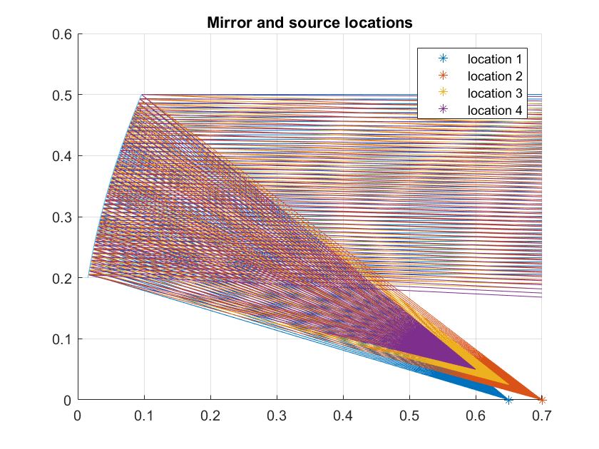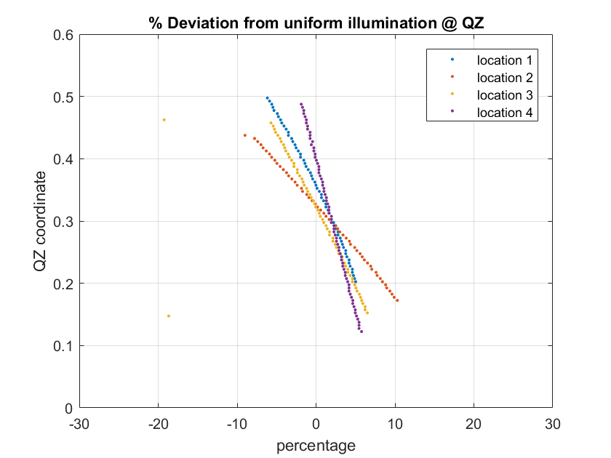

Figure 5.3.2.2.1-10: a: Mirror and source locations. Locations 2, 3 and 4 have similar offset; b: Locations 2, 3 and 4 cause different illumination distribution at QZ

##### 5.3.2.2.2 Rx beam profiles with an independent beam management (IBM) UE

In this sub-clause, an explanation is shown that it is possible to measure the appropriate EIS spherical coverage beam profiles by the test system which equips the non co-located (offset) antenna even with the inter-band 2 DL CA cases as long as the UE is supporting the independent beam management (IBM).

First we consider a single carrier Rx spherical coverage beam profile which we can obtain by two kinds of antennae. If we compare Rx beam profiles of two different cases, one which has been measured by main antenna of the OTA test system, or the other with which the DL beam frequency is same but has been measured from the offset antenna, both beam profiles can be assumed identical as far as following conditions are satisfied.

- Two measurement antennae (main and offset) are arranged along with the θ rotation of the positioner

- DL power of the offset antenna is calibrated and capable of transmitting same power level with the main measurement antenna.

For the rotation angles of positioner, refer to Annex D.2.6 in TS 38.810 [3].

Figure 5.3.2.2.2-1 depicts the image of two beam profiles obtained by different antennae. Note that the profiles are obtained one by one since the link has to be maintained with either of antennae during the measurement.



Figure 5.3.2.2.2-1: 2D image of beam profile obtained by two antennae

If we compare the two measurements, a difference between them are just a point of sight from the UE, in other words a boresight of UE is slightly rotated depending on the arrangement of measured antennae.

There is an angular offset between the two measurement antennae such as 2.5 to 7 degrees. Therefore to compare the two obtained beam profiles, rotation of either one of profiles in accordance with the actual antenna alignment is necessary. Also the adjustment of the start/ stop coordinates to measure is necessary with a case of the offset antenna.

Now we consider beam profiles which are obtained by the test system that transmits two DL signals from single antenna (system A), and the system which has one additional offset antenna to transmit two DL signals - one DL from the main antenna and the other from the offset antenna (system B). For inter-band 2 DL CA case for example with band n260 and n261, suppose only system B transmits n261 from the offset antenna, properties of each beam profile are summarized in Table 5.3.2.2.2-1. Note that 2 measurement antennae of system B are assumed to be arranged along with the θ rotation of the positioner again just as mentioned above.

Table 5.3.2.2.2-1: Beam profiles obtained by system A and system B in a case with IBM antennae in a UE

|  |  |  |
| --- | --- | --- |
|  | System A (2 DL from main antenna, 1 AoA) | System B (2 DL from slightly offset 2 AoA antennae) |
| Beam profile of n260 | Obtained by main antenna | Obtained by main antenna. Thus completely identical with system A. |
| Beam profile of n261 | Obtained by main antenna | Obtained by the offset antenna. The shape of profile should be same but rotated in accordance with the angular offset between two test antennae. |

Taking all explanations above into consideration, system B requires a post processing of the obtained data in accordance with the slightly rotated coordinate system. But the obtained beam profiles can be assumed as identical with ones obtained by system A as far as the UE is supporting the IBM. i.e. There is a way to make IBM UEs to choose same relative beam direction and conduct spherical coverage tests properly like a single test antenna system.

Choice of the beam by UEs with common beam management (CBM) is studied at the next sub-clause.

##### 5.3.2.2.3 Propensity to trigger incorrect beam in CBM UE

The primary mechanism that can mislead CBM UEs is band-specific beam tilt in the test setup. As shown in sub-clause 5.3.2.2.1, beam tilt at the QZ is roughly 1:1 with source angular offset. In the spherical coverage space of a UE, beam tilt becomes a significant problem for beam management at beam boundaries. The impact to measured performance is directly related to probability of finding a beam boundary during 3D search. Beam tilt therefore penalizes UEs with dense beam packing (i.e more beam boundaries).

Dense beam packing is often associated with UEs with good spherical coverage. It can be reasonably argued that the impact of beam tilt in this context is worse for UEs with better spherical coverage. This problem does not have a systematic effect across all UE designs and therefore difficult to overcome.

Another important characteristic of a far field scenario is a nearly planar wavefront. Figures 5.3.2.2.3-1 shows the deviation from planar wavefront at the QZ when the source is moved off-focus. As before, in the figures below, locations 2,3 and 4 have similar angular offset, but differ in mirror to source distance. The figures show that there is an optimal distance from the mirror for any angular offset of the source, for the wavefront to appear planar at the QZ.

**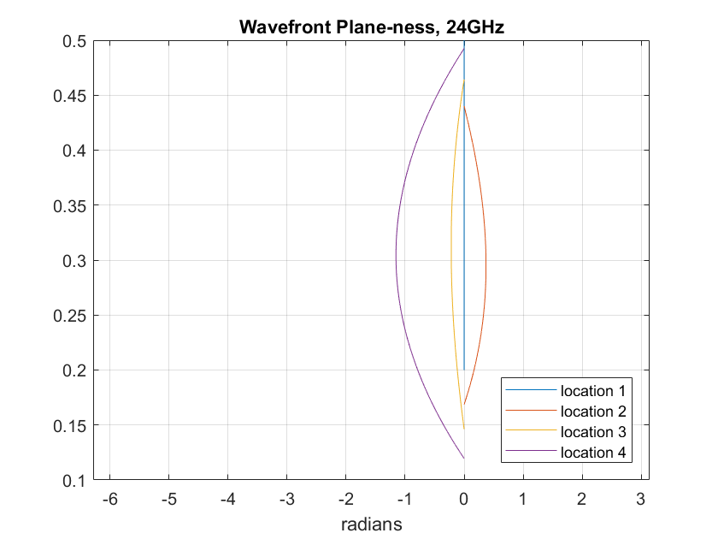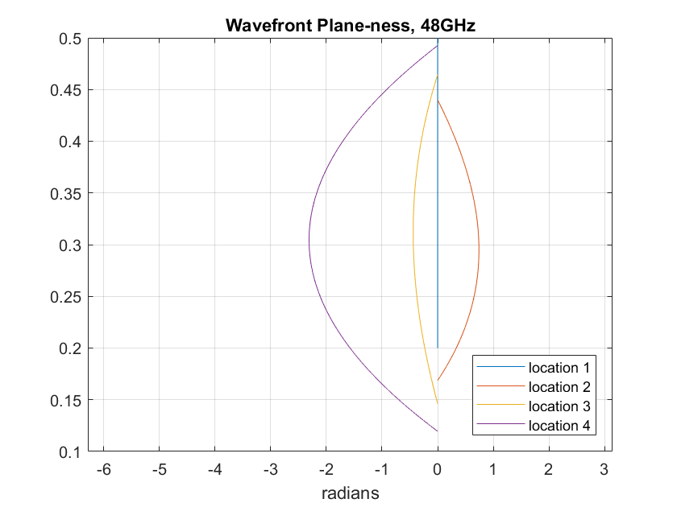**

Figure 5.3.2.2.3-1: Wavefront orientation at QZ due to off-focus source

Also note that positioning an offset source at the optimal distance may not result in optimal illumination density of the QZ. From a beam management standpoint however, it is more important to ensure quality of the wavefront given that the deviation in illumination density seems minor. (Explanation: Position 3 is close to the optimal point, as witnessed by its nearly flat wavefront in figures 5.3.2.2.3-1. In figure 5.3.2.2.3-1, illumination density curves of location 3 and location 1, the focus or ‘ideal location’, track closely)

The figures 5.3.2.2.3-1 also reasonably predict that the non-linear phase variation varies with frequency. Ergo, it is advantageous to reserve the ideal location (focus) for the antenna serving the highest frequencies and use offset locations for antennae serving lower frequencies.

##### 5.3.2.2.4 Spherical coverage measurement simulation with common beam management (CBM) UE

For inter-band CA requirements within 28 GHz range (L + L) or 39 GHz range (H + H) which has a possibility of transmissions by CBM, a simulation was made on the influence of the offset antenna measurement for inter-band CA case with CBM UE. From this simulation we tried to clarify a difference with the measurement of 2 DL by 1 AoA at a frequency range from 37 GHz and 43.5 GHz.

**Assumption of the UE antenna inter-element distance**

It is difficult for us to expect an actual inter-element distance (D) of an antenna in the current UE since it is implementation dependent. But as a starting point, during this simulation we put an assumption that an optimization of the inter-element distance is made at the centre frequency between the lower edge of band n258 (24.25 GHz) and higher edge of n259 (43.5 GHz), i.e. 33.875 GHz where D/λ becomes 0.5.

Table 5.3.2.2.4-1: Optimized frequency and corresponding ratio (D/l) for simulation frequencies

|  |  |  |
| --- | --- | --- |
| Optimized frequency (D/ = 0.5) | Frequency 1 (f1) for simulation | Frequency 2 (f2) for simulation |
| 33.875 GHz (0.5) | 37.0 GHz (0.55) | 43.5 GHz (0.64) |

**Assumption of phase shifter in a UE**

For a beam forming method of the UE, following two methods were applied in the simulation.

i) A fixed phase shift to the antenna regardless with the carrier frequencies, which we assume this method is causing the beam squint.

ii) A different phase shift which is proportional to the carrier frequencies so called true time delay (TTD).

**Simulation procedures for spherical coverage**

The simulation of the spherical coverage measurement was carried out by the following steps.

Step 1) Decide a code book to obtain the maximum sensitivity at frequency 1 (37.0 GHz) with a measurement grid placed randomly against a DUT.

Step 2) Keep the identified code book at step 1) and calculate gain profiles at frequency 2 (43.5 GHz). Then compare the following two cases.

Case 1) Gain profile at frequency 2 measured by the main antenna

- Only the difference of the ratio (D/λ) can be monitored as the difference from the frequency 1. This result can be assumed as a baseline when comparing the influence of the offset antenna measurement.

Case 2) Gain profile at frequency 2 measured by the offset antenna

- In addition to the difference of the ratio (D/λ), influence of the offset antenna is included in this result. (e.g. influence to the measurement grid due to the offset of the antenna.)

**Simulation parameter**

Simulation parameters are summarized in Table 5.3.2.2.4-2.

Table 5.3.2.2.4-2: Simulation parameter for spherical coverage gain profile

|  |  |
| --- | --- |
| Item | Parameter |
| Grid | Constant Density 200 pt, 1000 random orientations against a DUT. |
| Antenna offset | ❑ = 4.0 degrees |
| Array antenna | 1 x 4. Inter-element distance is optimized at 33.875 GHz. |
| Phase shifter | Non TTD (Constant Phase), TTD (True Time Delay) |
| Carrier frequency | 37.0 GHz, 43.5 GHz |

**Spherical coverage simulation result**

Simulation results of the spherical coverage are summarized in Table 5.3.2.2.4-3 and 5.3.2.2.4-4.

Table 5.3.2.2.4-3: Simulation result of spherical coverage – Mean 50%-ile error (against 1deg uniform grid as a reference)

|  |  |  |  |  |
| --- | --- | --- | --- | --- |
| D/ Test frequency) | Non-TTD | | TTD | |
| Main antenna | Offset antenna | Main antenna | Offset antenna |
| 0.55 (37.0 GHz) | 0.024 | - | Same as Non-TTD | - |
| 0.64 (43.5 GHz) | 0.016 | 0.101 | 0.019 | 0.135 |

Table 5.3.2.2.4-4: Simulation result of spherical coverage – Standard deviation of 50%-ile value

|  |  |  |  |  |
| --- | --- | --- | --- | --- |
| D/ Test frequency) | Non-TTD | | TTD | |
| Main antenna | Offset antenna | Main antenna | Offset antenna |
| 0.55 (37.0 GHz) | 0.059 | - | Same as Non-TTD | - |
| 0.64 (43.5 GHz) | 0.096 | 0.102 | 0.111 | 0.168 |

Comparing the results between the main antenna and offset antenna, we observed that the mean error by measuring from the offset antenna increases slightly with both non-TTD and TTD type phase shifter (0.085 dB with non-TTD and 0.116 dB with TTD at 43.5 GHz.). This means that the total measurement uncertainty by measuring from offset antenna will increase approximately 0.1 dB as the systematic uncertainty.

For the standard deviation, only the result with TTD phase shifter showed the slight increase of measurement uncertainty (0.057 at 43.5 GHz.). However this increase of random uncertainty should be a negligible level compared to the other uncertainty contribution.

Therefore for both mean error (systematic error) and standard deviation (random error) with offset antenna, these values are within the acceptable level because the simulation assumptions in this paper are chosen as one of the severest conditions from the viewpoint of the frequency point to optimize inter-element distance, test frequencies, basic frequency point of phase shift, etc. And since the optimization of the inter-element distance was assumed at 33.875 GHz, if this optimization is made at a higher frequency such as at the middle of 37 GHz and 43.5 GHz, the observed uncertainty should be decreased.

Considering all the observations above, we assume that the FR2 OTA test system with the offset test antenna has a feasibility of measuring inter-band DL CA test cases for both CBM and IBM UEs under some limitations.

For cases with UEs which supports wider frequencies (such as n262 in addition) or higher power such as PC1 need a further study.

#### 5.3.2.3 Summary on applicability of offset antenna test system

Taking into consideration of study results in sub-clause 5.3.2.1 and 5.3.2.2, an applicability of the offset antenna test system to the spherical coverage test with an inter-band CA UE is summarized as follows.

IBM UE:

On a test for UEs supporting inter-band CA with IBM, there is a way to make IBM UEs to choose same relative beam direction and conduct spherical coverage tests properly like a single test antenna system. It is recommended that a design of the test system is optimized to mitigate an impact of the offset antenna to the QoQZ measurement uncertainty, including the diffraction and/or scattering effects created by the reflector’s paraboloid edges and the size of the paraboloid.

CBM UE:

On a test for UEs supporting inter-band CA with CBM, there might be a limitation with the feasibility by the offset antenna test system. But this relates also to the on-going WI discussion on the necessity of spherical coverage requirements with CBM UEs supporting a same band group e.g. 28 GHz + 28 GHz.

### 5.3.3 Inter-band testing ramifications

The primary dependency of inter-band test set ramifications is the frequency coverage of each antenna in an IFF system with multiple antennae.

#### 5.3.3.1 Single antenna

For bands that can be supported by a single antenna, the condition to evaluate is if the antenna is not at the focus of the mirror. On-focus single antenna IFF systems have already been studied and their MU quantified, and do not need to be considered again in this context. Non-ideal (off-focus) location causes the following problems:

- A shifted QZ due to beam tilt. Note however that all bands have the same AoA at the UE.

- Beam tilt causes the AoA to no longer be parallel to the optical axis. This aspect must be properly considered during system calibration; for example, a directional calibration antenna placed at the QZ must be pointed accurately along the arrival direction for an accurate path loss estimate.

Provided the problems above are accounted for, UEs with either CBM or IBM can tolerate an IFF system with an off-focus source.

#### 5.3.3.2 Multiple antennae

The assumption for inter-band testing in this context is that the bands are supported through multiple non-co-located test system antennae. For this set up, the considerations listed in the single antenna case get further complicated.

- A reduction in QZ size due to different beam tilt experienced by different bands.

- Beam tilt causes different AoA for different bands. There are two problems associated with this aspect:

- Calibration for each band will require adjustment of a directional calibration antenna so it is pointed along arrival direction of band being calibrated.

- This set up can be perceived as ‘non-co-located’ gNBs by some UEs.

The calibration step complication, and the QZ size reduction may be surmountable, but the non-co-located gNB implication can cause significant problems for UEs with CBM limitation.

A special note is warranted for ACS and IBB requirements – the standard requires that the interferer share the same AoA as the DL band being tested. Fortunately, ACS and IBB interferers are expected to be in the same band as the DL being tested, so it would be natural for the test equipment to use the same antenna for both. If such is not the case, additional MU would be introduced into the system, which is not preferred.

## 5.4 Extreme temperature conditions

Editor’s note: outcome of SI Objective 4 is captured in this clause

## 5.5 FR2 DL 256QAM

Editor’s note: outcome of SI Objective 5 is captured in this clause

## 5.6 Extension of frequency applicability for band n262

Editor’s note: outcome of SI Objective 7 related to the extension of frequency applicability of the permitted methods is captured in this clause

# 6 UE RRM testing methodology enhancements

Editor’s note: testing and calibration aspects of the permitted methods for FR2 UE RRM testing and the preliminary assessment of measurement uncertainty (Clause 6.2 and Annex B.2 of TR38.810) define the baseline UE RRM methodology for the purpose of this study.

## 6.1 Extension of frequency applicability for band n262

Editor’s note: outcome of SI Objective 7 related to the extension of frequency applicability of the permitted methods is captured in this clause

# 7 UE demodulation testing methodology enhancements

Editor’s note: testing and calibration aspects of the permitted methods for FR2 UE demodulation testing and the preliminary assessment of measurement uncertainty (Clause 7.2 and Annex B.2 of TR38.810) define the baseline UE demodulation methodology for the purpose of this study.

## 7.1 Extension of frequency applicability for band n262

Editor’s note: outcome of SI Objective 7 related to the extension of frequency applicability of the permitted methods is captured in this clause

# 8 Test time reduction

Editor’s note: outcome of SI Objective 6 is captured in this clause. This objective may potentially impact RF, RRM, and demodulation test setups.

Annex A:  
Environment conditions

# A.1 Operating voltage

# A.2 Temperature

Annex B:  
Measurement uncertainty

# B.1 Measurement uncertainty budget for UE RF testing methodology

Editor’s note: collect the MU elements which are impacted by the enhancements in Clauses 5 and 6 in this clause; if impact on the MU budget of the RRM and/or demodulation setups is identified, the corresponding clauses can be added. Organize the Annex to mirror the TR38.810 structure

Annex <X>:  
Change history

This is the last annex for TS/TSs which details the change history using the following table.  
This table is to be used for recording progress during the WG drafting process till TSG approval of this TS/TR.  
For TRs under change control, use one line per approved Change Request  
Date: use format YYYY-MM  
CR: four digits, leading zeros as necessary  
Rev: blank, or number (max two digits)  
Cat: use one of the letters A, B, C, D, F  
Subject/Comment: for TSs under change control, include full text of the subject field of the Change Request cover  
New vers: use format [n]n.[n]n.[n]n

|  |  |  |  |  |  |  |  |
| --- | --- | --- | --- | --- | --- | --- | --- |
| **Change history** | | | | | | | |
| **Date** | **Meeting** | **TDoc** | **CR** | **Rev** | **Cat** | **Subject/Comment** | **New version** |
| 2019-10 | R4#92bis | R4-1913071 |  |  |  | Initial skeleton | 0.0.1 |
| 2020-11 | R4#97e | R4-2017663 |  |  |  | Implemented the following text proposal:  R4-2017598 TP to TR38.884 on High DL and Low UL power test cases | 0.1.0 |
| 2020-02 | R4#98e | R4-2103985 |  |  |  | Implemented the following text proposals:  R4-2100530 TP to TR38.884 on structure updates related to band n262  R4-2103966 TP to TR 38.884 on Low UL Power/High DL Power Test Cases  R4-2103967 TP to TR38.884 v0.1.0 on polarization basis mismatch  R4-2103968 TP to TR 38.884 on Inter-band DL CA in FR2 | 0.2.0 |