**3GPP TSG-RAN4 #98-e *R4-2100097r1***

**Electronic Meeting, 25th Jan – 5th Feb. 2021**

**Title:** TP to TR 38.884 on Inter-band DL CA in FR2

**Source:** Anritsu Corporation

**Agenda Item:** 12.1.4

**Document for:** Approval

**1. Introduction**

This contribution is created to capture contents of company contributions [1] to [6], which analysed a feasibility of an offset test antenna for inter-band DL CA in FR2, in TR 38.884 [7].

***Proposal 1: It is proposed to approve the text proposal related to the feasibility of inter-band DL CA (FR2 + FR2).***

**4. References**

[1] R4-2014921, “Impact of AoA offset on inter-band CA PSD difference”, Apple Inc., RAN4 #97-e, Electronic meeting

[2] R4-2014687, “Testability of FR2 inter-band DL 2CA EIS by non co-located antenna”, Anritsu, RAN4 #97-e, Electronic meeting

[3] R4-2014265, “On impact of non-co-located test antennae for FR2 inter-band testing”, Qualcomm Inc., RAN4 #97-e, Electronic meeting

[4] R4-2100096, “Impact of offset antenna to quiet zone in FR2 OTA chamber”, Anritsu, RAN4 #98-e, Electronic meeting

[5] R4-2100527, “Impact of AoA offset on inter-band CA PSD difference”, Apple Inc., RAN4 #98-e, Electronic meeting

[6] R4-2102673, “On impact of non-co-located test antennae for FR2 inter-band testing”, Qualcomm Inc., RAN4 #98-e, Electronic meeting

[7] TR 38.884, “Study on enhanced test methods for FR2 NR UEs”, v0.1.0 (Rel-17), 2020-11

# Text Proposal

<<Start of text proposal>>

## 5.3 Inter-band (FR2+FR2) CA

### 5.3.1 General

In this sub-clause, following analyses with an in-direct far field (IFF) OTA test systems are introduced in achieving RF measurements of an inter-band CA UE in FR2.

1. Impact of multiple test antennae
2. PSD imbalance with DL signals from test equipment

DL PSD towards UE supporting independent beam management (IBM)

DL PSD towards UE supporting common beam management (CBM)

1. Impact of off-focus test system antennae

Quality of quiet zone (QoQZ)

Rx beam profiles with an independent beam management (IBM) UE

Propensity to trigger incorrect beam in CBM UE

1. Spherical coverage measurement simulation with common beam management (CBM) UESummary on applicability of offset antenna test system
2. Inter-band testing ramifications

### 5.3.2 Impact of multiple test antennae

#### 5.3.2.1 PSD imbalance with DL signals from test equipment

5.3.2.1.1 DL PSD towards UE supporting independent beam management (IBM)

An impact of an AoA offset ranging from 0 to 7 degrees was analyzed for UE supporting independent beam management. The gain difference between the CCs is a test case parameter informed by the recent agreement on the PSD difference in the REFSENS and EIS spherical coverage requirement for DL inter-band CA within FR2 [2]. The simulation assumptions are shown in Table 5.3.2.1.1-1 below.

Table 5.3.2.1.1-1: Simulation assumptions for PSD imbalance

|  |  |
| --- | --- |
| Simulation Parameters | |
| Antenna array size | 4x1 |
| Element spacing | 5mm |
| Element pattern | See TR38.803 |
| Antenna impairments | Not considered |
| Phase shifter impairments | See TR38.817-01 |
| Transmission line impairments | Modeled TL length and loss per element |
| AoA offset | {0, 2, 5, 7} deg |
| Beam management assumptions | Independent beam management on each CC |
| Center frequencies of component carriers | f1 = 27.9 GHz, f2 = 38.5 GHz |
| Gain difference between CC1 and CC2 | 15.2 dB |

For each AoA offset the PSD difference between CC1 and CC2 was calculated after spatially filtering the signal with the array response pattern corresponding to each CC. Figure 5.3.2.1.1-1 below illustrates the simulation results.



Figure 5.3.2.1.1-1: Spatially filtered PSD difference vs. angular separation between CCs

Table 5.3.2.1.1-2 below summarizes the simulation results.

Table 5.3.2.1.1-2: Simulation results for spatially filtered PSD difference vs. angular separation between CCs

|  |  |
| --- | --- |
| Max excess PSD difference due to AoA offset (dB) | |
| AoA offset (º) | PSD diff (dB) |
| 2 | 0.4 |
| 5 | 1.1 |
| 7 | 1.7 |

The requirement for inter-band CA between bands n261 and n260 is defined assuming a non-zero PSD difference between the component carriers. This assumption holds for the class of inter-band CA configurations to which the independent beam management (IBM) type is applicable. It is observed that at least for IBM inter-band CA requirements, AoA offsets of up to 7 degrees between two FR2 CA component carriers do not significantly impact the PSD difference assumption taken for the core requirement. This observation should be double-checked after the band n262 requirements are finalized and the scope of CA configurations with n262 are understood.

Further note that as part of the Rel-17 FR2 RF enhancement work item, RAN4 is discussing the potential definition of requirements assuming common beam management (CBM) for combination of certain band groups, such as 28+28 GHz. An analysis of the impact of AoA offsets in the test setup for inter-band CA with CBM is needed after the scope of CBM requirements and associated agreements are better understood.

5.3.2.1.2 DL PSD towards UE supporting common beam management (CBM)

Following a similar simulation methodology as described in 5.3.2.1.1, an analysis of the impact of an AoA offset ranging from 0 to 7 degrees was analyzed for UE supporting common beam management. The gain difference between the CCs is a test case parameter informed by the recent agreement on the PSD difference in the REFSENS and EIS spherical coverage requirement for DL inter-band CA within FR2 [2]. The simulation assumptions are shown in Table 5.3.2.1.2-1 below.

Table 5.3.2.1.2-1: Simulation assumptions for PSD imbalance with CBM

|  |  |
| --- | --- |
| Simulation Parameters | |
| Antenna array size | 4x1 |
| Element spacing | 5mm |
| Element pattern | See TR38.803 |
| Antenna impairments | Not considered |
| Phase shifter impairments | See TR38.817-01 |
| Transmission line impairments | Modeled TL length and loss per element |
| AoA offset | {0, 2, 5, 7} deg |
| Beam management assumptions | Common beam management between CC1 and CC2 (codebook optimized for f1) |
| Center frequencies of component carriers | Case 1: f1 = 24.25 GHz, f2 = 29.5 GHz  Case 2: f1 = 37.0 GHz, f2 = 43.5 GHz |
| Gain difference between CC1 and CC2 | Case 1: 0.0 dB  Case 2: 1.2 dB (difference in EIS spherical coverage between n260 and n259) |

For each AoA offset the PSD difference between CC1 and CC2 was calculated after spatially filtering the signal with the array response pattern corresponding to each CC. Figure 5.3.2.1.2-1 below illustrates the simulation results.

a)  b) 

Figure 5.3.2.1.2-1: Spatially filtered PSD difference vs. angular separation between CCs; a) Case 1 (24.25 + 29.5 GHz); b) Case 2 (37.0 + 43.5 GHz)

Table 5.3.2.1.2-2 below summarizes the simulation results.

Table 5.3.2.1.2-2: Simulation results for spatially filtered PSD difference vs. angular separation between CCs

|  |  |  |
| --- | --- | --- |
| Max excess PSD difference due to AoA offset (dB) | | |
| AoA offset (º) | PSD diff (dB) | |
| Case 1 | Case 2 |
| 2 | 0.3 | -0.2 |
| 5 | 0.8 | 0.3 |
| 7 | 1.7 | 1.2 |

Because RAN4 is still discussing the potential introduction of requirements for CBM CA between bands within the same band group (as of #98-e meeting 2021 Jan.), the PSD difference analysis in this subclause ~~contribution~~ assumes a convergence toward 0 dB PSD difference or, in the case of bands with different spherical coverage requirements, for the difference to be bounded by the difference in spherical coverage EIS values.

We note that because the CBM CA architecture is, in essence, an optimization, the UE receiver is more sensitive to PSD differences beyond those assumed for the core requirement. Although Table 5.3.2.1.2-2 indicates that the maximum excess PSD difference due to AoA offset ≤ 1.7 dB which is applicable only to PC3 UE, this effect compounds with the beam squint impairment.

Again noting that the core requirement work on CBM CA is still ongoing, it is not possible to use the results to disqualify the proposed AoA offset method from applicability to CBM CA test cases. However, the impact of AoA offset on PSD difference assumptions made in the core requirement definition should be taken into account.

#### 5.3.2.2 Impact of off-focus test system antennae

5.3.2.2.1 Quality of quiet zone (QoQZ)

The IFF system for FR2 UE OTA testing is constructed around an offset parabolic mirror to collimate beams from a test antenna towards the UE. The architecture allows for a quiet zone (QZ) roughly the size of the spot on the mirror illuminated by the source. The key to this architecture is locating the source at the focus of the parabola that describers the mirror.

The burgeoning number of FR2 bands place increasing demands on both, the antenna, as well as the RFFE in test equipment.

The effect of off-focus test system antenna in IFF systems was studied before listing ramifications to inter-band test requirements. The components of the IFF are much larger than the wavelength of signals under test. The primary effect of the EM solution to the IFF problem can hence be determined by an equivalent optics problem.

From the geometry of a parabola, there is a unique location (the focus) that allows a test antenna to appear as a far-field antenna after reflection off the mirror. The far-field characteristic comes from the wavefront geometry that is transformed by the mirror from spherical to planar. The planar wavefront is normal to the optical axis of the mirror. Unfortunately, the favorable characteristics of the parabolic mirror are limited to proper placement of the source, and optical aberration is expected outside the geometry demands specific to the mirror in use. For example, in astronomy, the ‘coma’ aberration has long been associated with telescopes when wavefronts of incoming light are not normal to the optical axis.

To simplify the problem, the following assumptions were made about the IFF system, which was modelled with a 2D ray tracer:

1. The TE antenna was modelled as a point light source with uniform illumination in the hemisphere facing the mirror, and no illumination facing the source.
2. Light not incident on the mirror was modelled as being perfectly absorbed by the background
3. Edge effects of the mirror were not considered
4. The primary focal length was chosen to be 0.65m, for an effective focal length with the offset mirror of ~ 0.7m. The mirror offset was such that the mirror extended from y = 0.2 m to y = 0.5 m off the optical axis.
5. QZ plane was placed orthogonal to the optical axis 1.5 m away from the point where the axis intersects the parabola.
6. Source-to-source interaction, in case of multiple sources, are neglected
7. EM field perturbation due to presence of positioner or DUT fixturing is neglected by virtue of choosing an optic method

|  |  |  |
| --- | --- | --- |
| Location id | d (m) | h (m) |
| 1 (focus) | 0 | 0 |
| 2 | 0 | 0.05 |
| 3 | 0 | 0.10 |
| 4 | -0.05 | 0.10 |
| 5 | +0.05 | 0.10 |

1. Light source locations considered (d,h defined in figure 5.3.2.2.1-1):

Note that assumption #1 is not valid for typical horn antennae, but the uniform illumination assumption serves as a good reference point for studying power variation across the QZ when the source is moved off-focus.

Figures 5.3.2.2.1-1 shows the position of the mirror relative to the sources, as well as the illumination levels at the QZ (sub figure 1b). The blue curve in the sub-figure 1b indicates 2 things about a source at the focus (location1). The first observation is that the nominal QZ is located between y = 0.2 and y=0.5, which coincides with the mirror extents in the y-dimension. This detail is expected. The second observation is that an isotropic source gets transformed to a non-uniform illumination at the QZ.

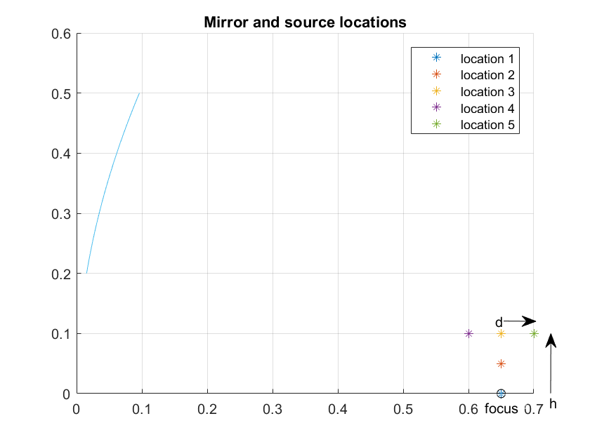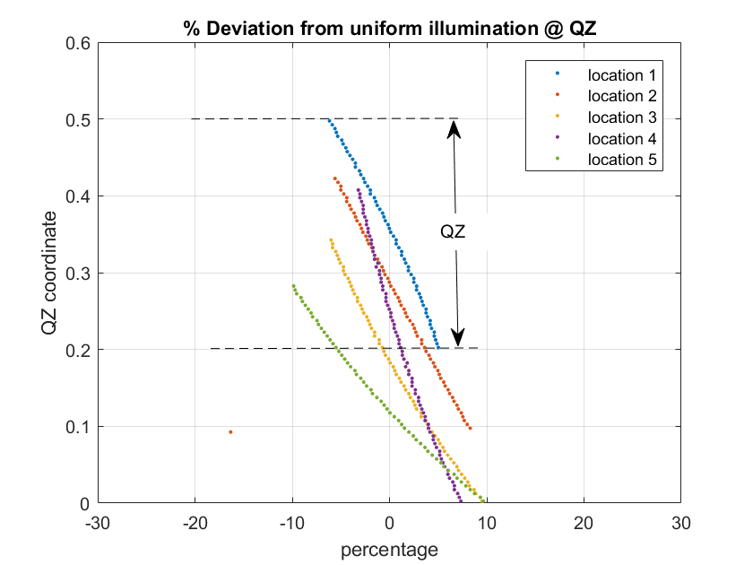

**Figure 5.3.2.2.1-1:**

**a: Mirror and source locations**

**b: Source to QZ power density distortion**

Furthermore, the illumination intensity curves corresponding to other source locations inform that the collimated beam moves progressively off the QZ as the source is moved away from focus. In the example locations studied, the beam develops a down tilt, but an up tilt is also possible if the source is moved to a location, say, below and to the left of the focus in figure 1a.

In figure 5.3.2.2.1-2, it is observed that the wavefront also starts to deviate from being purely orthogonal to the optical axis. The wavefront shape is consistent with the ‘beam tilt’ observation made earlier.

 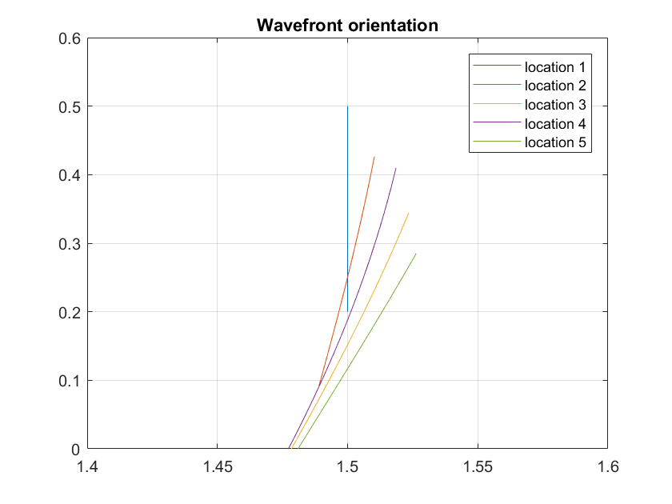

**Figure 5.3.2.2.1-2: Wavefront orientation at QZ due to off-focus source**

For a UE’s perspective on off-focus sources, candidate source locations were characterized by their angular locations relative to mirror normal. Note that the focus is off the mirror normal due to ‘offset mirror’ geometry, so it has a non-zero value. In the example studied, the focus is 15.4 degrees below mirror normal, and the other off-focus source locations studied all have lower angular offsets than the focus. In figure 5.3.2.2.1-3 we show that the rate of increase beam tilt and the rate of increase in angular offset of the source are very similar, i.e close to 1:1 for the geometry studied.

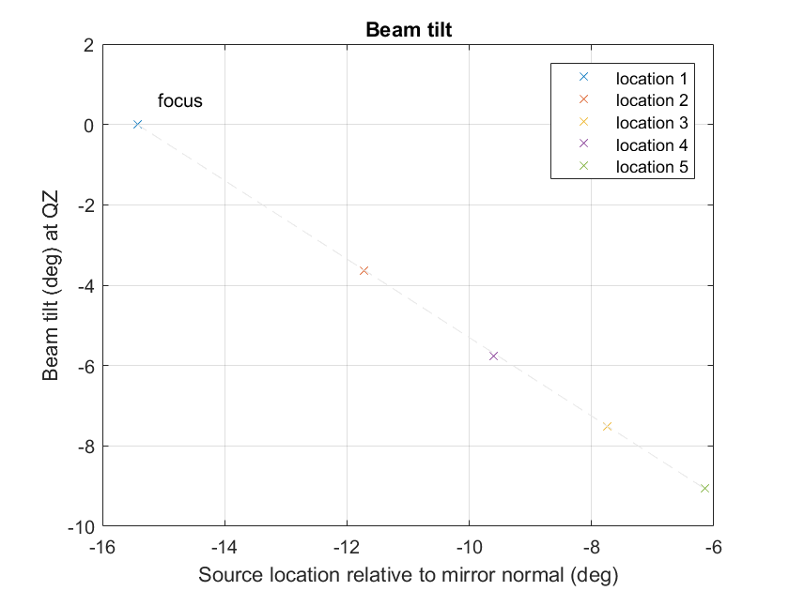

**Figure 5.3.2.2.1-3: Beam tilt due to off-focus source**

Recall that the nominal QZ location is the illuminated spot in the plane of the QZ when the source is located at the focus of the mirror. In case of our example, the nominal QZ extends from (x=1.5, y= 0.2) to (x=1.5, y= 0.5). Beam tilt causes the illuminated spot in the plane of the QZ to move off the nominal QZ location. When multiple sources illuminate the mirror, the effective QZ size reduces to the common area across the beams from all sources. Beam tilt consequently has the effect of reducing the effective QZ size. See figure 5.3.2.2.1-4. The reduction in size is a function of both, the angular offset between source and focus, and the distance of the QZ from the mirror.

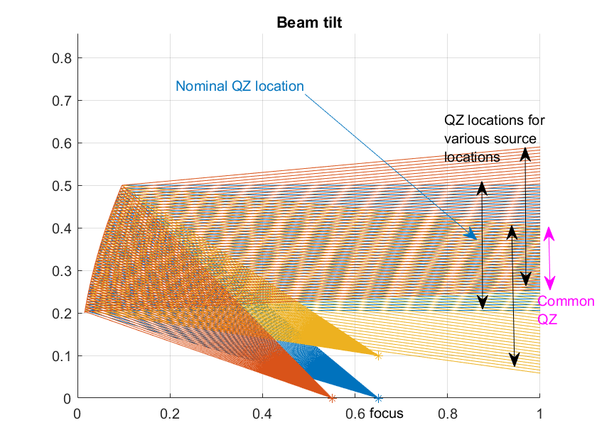

**Figure 5.3.2.2.1-4: Beam tilt causes QZ size reduction**

Now, different UE power classes have different beam shapes, and different beam packing densities. For power class 1, 3dB beam widths are expected to be between 5 and 10 degrees as an extreme example. A beam tilt in the range of a few degrees could cause a PC1 UE to select a different beam for an off-focus source, relative to a source at the focus.

UE size also limits how close to the mirror the QZ plane can be moved. The radiating face of PC1 device can measure in the 10s of cm in each dimension, which would force the QZ far away from the mirror. This restriction would, in turn, cause much greater reduction in QZ size for a given beam tilt angle, when using multiple sources. These problems would be less serious for PC3 devices.

In a case a test antenna is located simply off the position from a focal point (normally at a position of a main test antenna) in the IFF test system, a centre of a beam from the offset feed antenna would shift depending on a distance of focal length (f), a distance between the reflector and a centre of a quiet zone (r), and a distance of the antenna offset (d). Figure 5.3.2.2.1-5 depicts the relationship of this shift (d’).

Reflector

d

f

r

Focal point  
(= Main antenna position)

Offset antenna

Centre of QZ

Centre of beam from the offset antenna

q

d’

z

x

d

**Figure 5.3.2.2.1-5: Offset of antenna beam peak from centre of QZ (Top view of IFF test system)**

Here the shift (d’) can be calculated geometrically by the following equation, and it may cause an increase of QoQZ measurement uncertainty in a 30 cm quiet zone.

From our experience to date, an electric field intensity in a quiet zone when a feed antenna is located near a focal point is decided by two factors, an antenna pattern of the feed antenna for a test equipment and a shape of the reflector. Especially the antenna pattern can be assumed as the main factor to decide this characteristic, which is directly connected also to the QoQZ.

Based on this observation an estimation was made with an impact of the offset antenna to QoQZ from an experimental data which was obtained by measuring the electric field intensity of a feed antenna via a reflector. Figure 5.3.2.2.1-6 shows one of the experimental data obtained by scanning the field intensity in a range of +/- 200 mm from a centre of the quiet zone. Here a 40.8 GHz vertical polarization beam was scanned along with theta (x) direction.

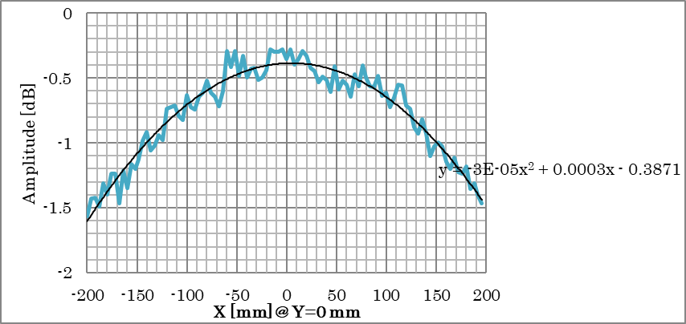

**Figure 5.3.2.2.1-6: Electric field intensity of feed antenna scanned along with theta direction (40.8 GHz, V-pol)**

Table 5.3.2.2.1-1 and Figure 5.3.2.2.1-7 show the estimation of difference between the QoQZ of main antenna and of the offset antenna. Note that these values are specific to the feed antenna (amplitude taper) in this experiment and thus they may vary depending on an antenna pattern used by each test equipment vendor.

**Table 5.3.2.2.1-1: Estimation of QoQZ difference between main and offset antenna**

|  |  |  |  |
| --- | --- | --- | --- |
|  | Estimation of QoQZ difference (EIRP) [dB] | | |
| δ [mm] | 23.45 GHz | 32.125 GHz | 40.8 GHz |
| 0 | 0.00 | 0.00 | 0.00 |
| 15 | 0.02 | 0.02 | 0.01 |
| 30 | 0.04 | 0.05 | 0.03 |
| 45 | 0.08 | 0.08 | 0.06 |
| 60 | 0.11 | 0.11 | 0.09 |
| 75 | 0.14 | 0.15 | 0.11 |

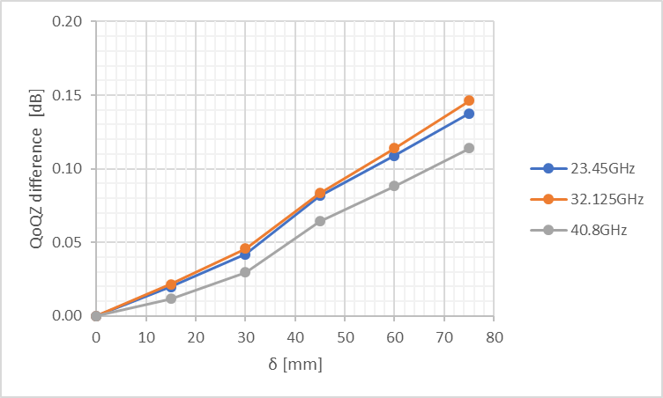

**Figure 5.3.2.2.1-7: Plot of QoQZ difference**

Though these differences may vary depending on an antenna pattern (amplitude taper) of a feed antenna, as can be seen from above, there is a chance that the difference of QoQZ due to the offset antenna can be limited within an acceptable level by optimizing an arrangement of antennas.

As described above, these QoQZ differences are estimated based on the antenna configuration with which the offset antenna is simply off the position from a focal point. And there is a way to mitigate the impact of the offset antenna to the actual QoQZ.

One of major factors to decide QoQZ is the electric field intensity in the quiet zone. Figure 5.3.2.2.1-8 depicts a 2D-image of the electric field intensity (amplitude taper) in the quiet zone when the offset antenna is used. As shown in the figure, due to the shift of beam centre from the main antenna, distribution of the field intensity becomes asymmetric in the quiet zone and thus it causes the increase of the QoQZ MU value. However it is possible to shift the beam peak position by tilting the offset antenna and make the distribution of the field intensity close to symmetric in the quiet zone like the one from the main antenna, allowing us to mitigate the impact of beam centre shift to the QoQZ value. Figure 5.3.2.2.1-9 depicts the image of the improvement with the offset antenna placement. At the same time an impact of roll edge around a reflector and a diffraction created by the edges becomes another factor to decide the QoQZ characteristics. Thus there should be some limitations with antenna offset ranges and angles to tilt the offset antenna. And this optimization should depend on a relationship between reflector size, measurement antenna offset and range length, and should be considered during a design of the test system.

d

QZ

Focal point

Offset antenna

Amplitude taper

Reflector

Beam peak

**Top view**

x

z

**Figure 5.3.2.2.1-8: 2D image of the electric field intensity (amplitude taper) in the quiet zone from an offset antenna**

Beam peak

d

QZ

Focal point

Offset antenna

Amplitude taper

Reflector

**Top view**

x

z

**Figure 5.3.2.2.1-9: 2D image of the electric field intensity in the quiet zone from a tilted offset antenna**

There is another way of recovering desired QZ illumination. In Figure 5.3.2.2.1-4, it is shown that beam tilt causes reduction in size of QZ that is common to all source locations. This mechanism is intuitive and can be pre-compensated during design of the test system.

The matter of QZ quality however involves more complexity. As a first approximation, QZ quality can be quantified by the illumination distribution from a hypothetical constant density source illuminating the mirror. Here it becomes evident that angular offset of the antenna alone is not enough to determine illumination distribution. See figure 5.3.2.2.1-10. Locations 2, 3 and 4 all have approximately the same angular offset (<0.5 degree difference), but their QZ illumination can be made better or worse than that of the on-focus source by adjusting mirror to source distance. In the graphic example, the source location closest to the mirror has the least variation QZ illumination.

It is therefore possible to recover desired QZ illumination by adjusting the source location distance from mirror in concert with angular offset. A discussion regarding whether the different QoQZ MU needs to be applied compared to the single carrier case can be left to RAN5.

As shown later in the discussion of wavefront shapes however (see sub-clause 5.3.2.2.3), there are other constraints governing offset source to mirror distance.

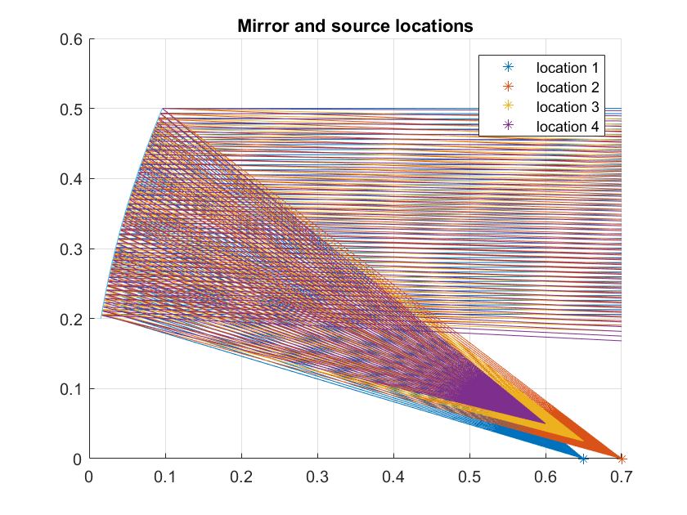 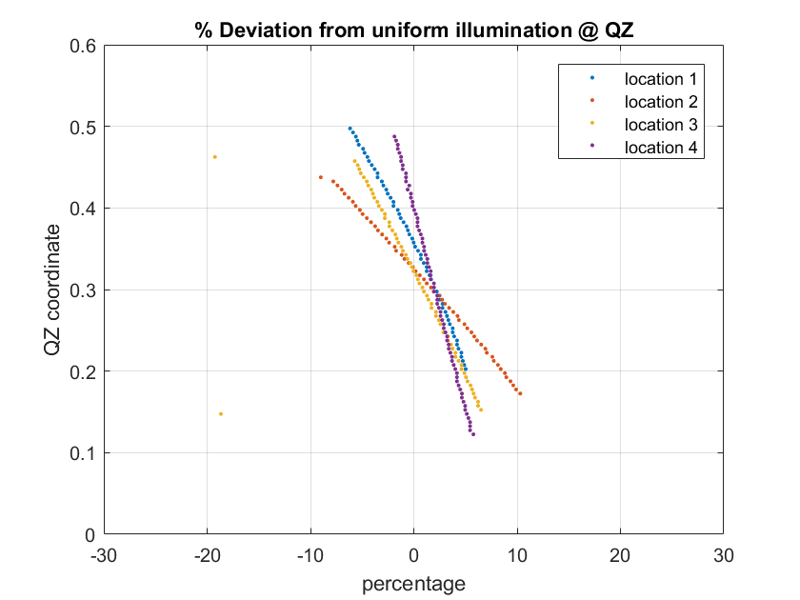

**Figure 5.3.2.2.1-10a: Mirror and source locations. Locations 2, 3 and 4 have similar offset**

**Figure 5.3.2.2.1-10b: Locations 2, 3 and 4 cause different illumination distribution at QZ**

5.3.2.2.2 Rx beam profiles with an independent beam management (IBM) UE

In this sub-clause, an explanation is shown that it is possible to measure the appropriate EIS spherical coverage beam profiles by the test system which equips the non co-located (offset) antenna even with the inter-band 2 DL CA cases as long as the UE is supporting the independent beam management (IBM).

First we consider a single carrier Rx spherical coverage beam profile which we can obtain by two kinds of antennae. If we compare Rx beam profiles of two different cases, one which has been measured by main antenna of the OTA test system, or the other with which the DL beam frequency is same but has been measured from the offset antenna, both beam profiles can be assumed identical as far as following conditions are satisfied.

* Two measurement antennae (main and offset) are arranged along with the q rotation of the positioner
* DL power of the offset antenna is calibrated and capable of transmitting same power level with the main measurement antenna.

For the rotation angles of positioner, refer to Annex D.2.6 in TS 38.810 [3].

Figure 5.3.2.2.2-1 depicts the image of two beam profiles obtained by different antennae. Note that the profiles are obtained one by one since the link has to be maintained with either of antennae during the measurement.



Main  
Antenna

Offset  
Antenna

Beam profile obtained by  
offset antenna. Rotated 2.5 to 7 degrees from the one obtained by the main antenna.

Beam profile obtained by  
main antenna

**Figure 5.3.2.2.2-1: 2D image of beam profile obtained by two antennae**

If we compare the two measurements, a difference between them are just a point of sight from the UE, in other words a boresight of UE is slightly rotated depending on the arrangement of measured antennae.

There is an angular offset between the two measurement antennae such as 2.5 to 7 degrees. Therefore to compare the two obtained beam profiles, rotation of either one of profiles in accordance with the actual antenna alignment is necessary. Also the adjustment of the start/ stop coordinates to measure is necessary with a case of the offset antenna.

Now we consider beam profiles which are obtained by the test system that transmits two DL signals from single antenna (system A), and the system which has one additional offset antenna to transmit two DL signals - one DL from the main antenna and the other from the offset antenna (system B). For inter-band 2 DL CA case for example with band n260 and n261, suppose only system B transmits n261 from the offset antenna, properties of each beam profile are summarized in Table 2.2-1. Note that 2 measurement antennae of system B are assumed to be arranged along with the q rotation of the positioner again just as mentioned above.

**Table 5.3.2.2.2-1: Beam profiles obtained by system A and system B in a case with IBM antennae in a UE**

|  |  |  |
| --- | --- | --- |
|  | **System A** (2 DL from main antenna, 1 AoA) | **System B** (2 DL from slightly offset 2 AoA antennae) |
| Beam profile of n260 | Obtained by main antenna | Obtained by main antenna. Thus completely identical with system A. |
| Beam profile of n261 | Obtained by main antenna | Obtained by the offset antenna. The shape of profile should be same but rotated in accordance with the angular offset between two test antennae. |

Taking all explanations above into consideration, system B requires a post processing of the obtained data in accordance with the slightly rotated coordinate system. But the obtained beam profiles can be assumed as identical with ones obtained by system A as far as the UE is supporting the IBM. And at least for measurement with IBM UEs. i.e. There is a way to make IBM UEs to choose same relative beam direction and conduct spherical coverage tests properly like a single test antenna system.

Choice of the beam by UEs with common beam management (CBM) isstudied at the next sub-clause.

5.3.2.2.3 Propensity to trigger incorrect beam in CBM UE

The primary mechanism that can mislead CBM UEs is band-specific beam tilt in the test setup. As shown in sub-clause 5.3.2.2.1, beam tilt at the QZ is roughly 1:1 with source angular offset. In the spherical coverage space of a UE, beam tilt becomes a significant problem for beam management at beam boundaries. The impact to measured performance is directly related to probability of finding a beam boundary during 3D search. Beam tilt therefore penalizes UEs with dense beam packing (i.e more beam boundaries).

Dense beam packing is often associated with UEs with good spherical coverage. It can be reasonably argued that the impact of beam tilt in this context is worse for UEs with better spherical coverage. This problem does not have a systematic effect across all UE designs and therefore difficult to overcome.

Another important characteristic of a far field scenario is a nearly planar wavefront. Figures 5.3.2.2.3-1 shows the deviation from planar wavefront at the QZ when the source is moved off-focus. As before, in the figures below, locations 2,3 and 4 have similar angular offset, but differ in mirror to source distance. The figures show that there is an optimal distance from the mirror for any angular offset of the source, for the wavefront to appear planar at the QZ.

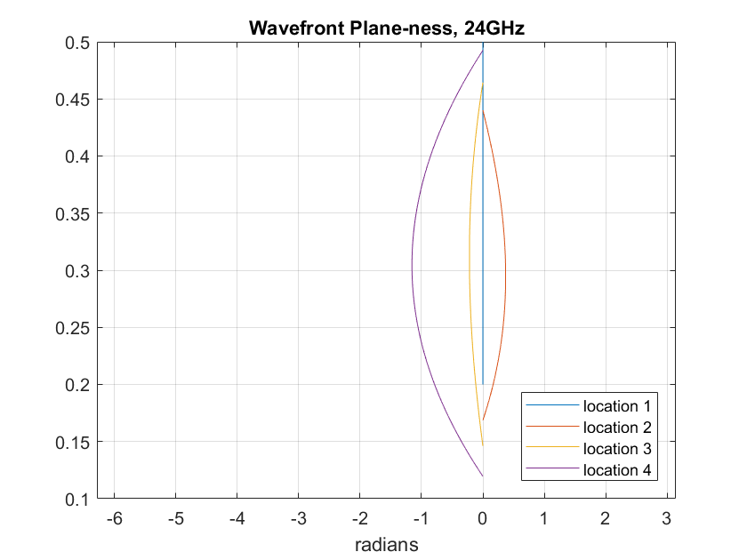 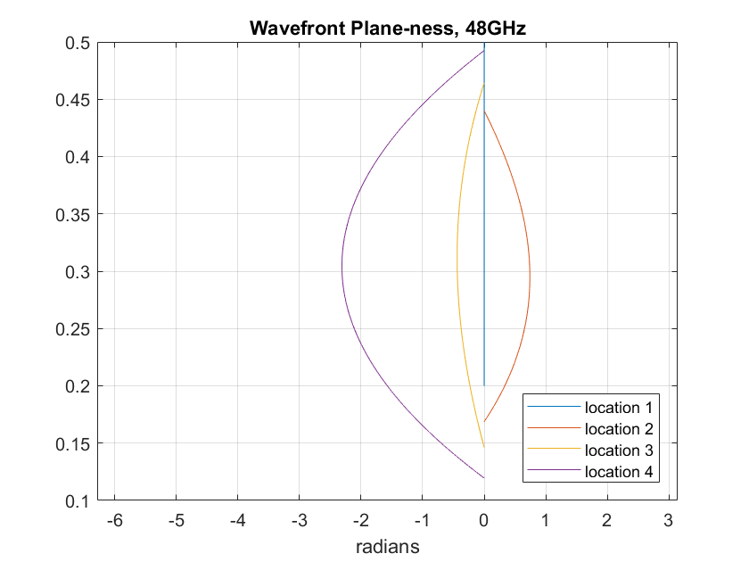

**Figure 5.3.2.2.3-1: Wavefront orientation at QZ due to off-focus source**

Also note that positioning an offset source at the optimal distance may not result in optimal illumination density of the QZ. From a beam management standpoint however, it is more important to ensure quality of the wavefront given that the deviation in illumination density seems minor. (Explanation: Position 3 is close to the optimal point, as witnessed by its nearly flat wavefront in figures 5.3.2.2.3-1. In figure 5.3.2.2.3-1, illumination density curves of location 3 and location 1, the focus or ‘ideal location’, track closely)

The figures 5.3.2.2.3-1 also reasonably predict that the non-linear phase variation varies with frequency. Ergo, it is advantageous to reserve the ideal location (focus) for the antenna serving the highest frequencies and use offset locations for antennae serving lower frequencies.

5.3.2.2.4 Spherical coverage measurement simulation with common beam management (CBM) UE

For inter-band CA requirements within 28 GHz range (L + L) or 39 GHz range (H + H) which has a possibility of transmissions by CBM, a simulation was made on the influence of the offset antenna measurement for inter-band CA case with CBM UE. From this simulation we tried to clarify a difference with the measurement of 2 DL by 1 AoA at a frequency range from 37 GHz and 43.5 GHz.

**Assumption of the UE antenna inter-element distance**

It is difficult for us to expect an actual inter-element distance (D) of an antenna in the current UE since it is implementation dependent. But as a starting point, during this simulation we put an assumption that an optimization of the inter-element distance is made at the centre frequency between the lower edge of band n258 (24.25 GHz) and higher edge of n259 (43.5 GHz), i.e. 33.875 GHz where D/l becomes 0.5.

**Table 5.3.2.2.4-1: Optimized frequency and corresponding ratio (D/l) for simulation frequencies**

|  |  |  |
| --- | --- | --- |
| Optimized frequency (D/l = 0.5) | Frequency 1 (f1) for simulation | Frequency 2 (f2) for simulation |
| 33.875 GHz (0.5) | 37.0 GHz (0.55) | 43.5 GHz (0.64) |

**Assumption of phase shifter in a UE**

For a beam forming method of the UE, following two methods were applied in the simulation.

1. A fixed phase shift to the antenna regardless with the carrier frequencies, which we assume this method is causing the beam squint.
2. A different phase shift which is proportional to the carrier frequencies so called true time delay (TTD).

**Simulation procedures for spherical coverage**

The simulation of the spherical coverage measurement was carried out by the following steps.

Step 1) Decide a code book to obtain the maximum sensitivity at frequency 1 (37.0 GHz) with a measurement grid placed randomly against a DUT.

Step 2) Keep the identified code book at step 1) and calculate gain profiles at frequency 2 (43.5 GHz). Then compare the following two cases.

Case 1) Gain profile at frequency 2 measured by the main antenna

* Only the difference of the ratio (D/l) can be monitored as the difference from the frequency 1. This result can be assumed as a baseline when comparing the influence of the offset antenna measurement.

Case 2) Gain profile at frequency 2 measured by the offset antenna

* In addition to the difference of the ratio (D/l), influence of the offset antenna is included in this result. (e.g. influence to the measurement grid due to the offset of the antenna.)

**Simulation parameter**

Simulation parameters are summarized in Table 5.3.2.2.4-2.

**Table 5.3.2.2.4-2: Simulation parameter for spherical coverage gain profile**

|  |  |
| --- | --- |
| **Item** | **Parameter** |
| Grid | Constant Density 200 pt, 1000 random orientations against a DUT. |
| Antenna offset | q = 4.0 degrees |
| Array antenna | 1 x 4. Inter-element distance is optimized at 33.875 GHz. |
| Phase shifter | Non TTD (Constant Phase), TTD (True Time Delay) |
| Carrier frequency | 37.0 GHz, 43.5 GHz |

**Spherical coverage simulation result**

Simulation results of the spherical coverage are summarized in Table 5.3.2.2.4-3 and 5.3.2.2.4-4.

**Table 5.3.2.2.4-3: Simulation result of spherical coverage – Mean 50%-ile error (against 1deg uniform grid as a reference)**

|  |  |  |  |  |
| --- | --- | --- | --- | --- |
| D/ l (Test frequency) | Non-TTD | | TTD | |
| Main antenna | Offset antenna | Main antenna | Offset antenna |
| 0.55 (37.0 GHz) | 0.024 | - | Same as Non-TTD | - |
| 0.64 (43.5 GHz) | 0.016 | 0.101 | 0.019 | 0.135 |

**Table 5.3.2.2.4-4: Simulation result of spherical coverage – Standard deviation of 50%-ile value**

|  |  |  |  |  |
| --- | --- | --- | --- | --- |
| D/ l (Test frequency) | Non-TTD | | TTD | |
| Main antenna | Offset antenna | Main antenna | Offset antenna |
| 0.55 (37.0 GHz) | 0.059 | - | Same as Non-TTD | - |
| 0.64 (43.5 GHz) | 0.096 | 0.102 | 0.111 | 0.168 |

Comparing the results between the main antenna and offset antenna, we observed that the mean error by measuring from the offset antenna increases slightly with both non-TTD and TTD type phase shifter (0.085 dB with non-TTD and 0.116 dB with TTD at 43.5 GHz.). This means that the total measurement uncertainty by measuring from offset antenna will increase approximately 0.1 dB as the systematic uncertainty.

For the standard deviation, only the result with TTD phase shifter showed the slight increase of measurement uncertainty (0.057 at 43.5 GHz.). However this increase of random uncertainty should be a negligible level compared to the other uncertainty contribution.

Therefore for both mean error (systematic error) and standard deviation (random error) with offset antenna, these values are within the acceptable level because the simulation assumptions in this paper are chosen as one of the severest conditions from the viewpoint of the frequency point to optimize inter-element distance, test frequencies, basic frequency point of phase shift, etc. And since the optimization of the inter-element distance was assumed at 33.875 GHz, if this optimization is made at a higher frequency such as at the middle of 37 GHz and 43.5 GHz, the observed uncertainty should be decreased.

Considering all the observations above, we assume that the FR2 OTA test system with the offset test antenna has a feasibility of measuring inter-band DL CA test cases for both CBM and IBM UEs under some limitations.

For cases with UEs which supports wider frequencies (such as n262 in addition) or higher power such as PC1 need a further study.

#### 5.3.2.3 Summary on applicability of offset antenna test system

Taking into consideration of study results in sub-clause 5.3.2.1 and 5.3.2.2, an applicability of the offset antenna test system to the spherical coverage test with an inter-band CA UE is summarized as follows.

IBM UE:

On a test for UEs supporting inter-band CA with IBM, there is a way to make IBM UEs to choose same relative beam direction and conduct spherical coverage tests properly like a single test antenna system. It is recommended that a design of the test system is optimized to mitigate an impact of the offset antenna to the QoQZ measurement uncertainty. At the same time an impact of roll edge around a reflector and a diffraction created by the edges needs to be taken into consideration during the optimization of the system design.

CBM UE:

On a test for UEs supporting inter-band CA with CBM, there might be a limitation with the feasibility by the offset antenna test system. But this relates also to the on-going WI discussion on the necessity of spherical coverage requirements with CBM UEs supporting a same band group e.g. 28 GHz + 28 GHz.

### 5.3.3 Inter-band testing ramifications

The primary dependency of inter-band test set ramifications is the frequency coverage of each antenna in an IFF system with multiple antennae.

#### 5.3.3.1 Single antenna

For bands that can be supported by a single antenna, the condition to evaluate is if the antenna is not at the focus of the mirror. On-focus single antenna IFF systems have already been studied and their MU quantified, and do not need to be considered again in this context. Non-ideal (off-focus) location causes the following problems:

* A shifted QZ due to beam tilt. Note however that all bands have the same AoA at the UE.
* Beam tilt causes the AoA to no longer be parallel to the optical axis. This aspect must be properly considered during system calibration; for example, a directional calibration antenna placed at the QZ must be pointed accurately along the arrival direction for an accurate path loss estimate.

Provided the problems above are accounted for, UEs with either CBM or IBM can tolerate an IFF system with an off-focus source.

#### 5.3.3.2 Multiple antennae

The assumption for inter-band testing in this context is that the bands are supported through multiple non-co-located test system antennae. For this set up, the considerations listed in the single antenna case get further complicated.

* A reduction in QZ size due to different beam tilt experienced by different bands.
* Beam tilt causes different AoA for different bands. There are two problems associated with this aspect:
  + Calibration for each band will require adjustment of a directional calibration antenna so it is pointed along arrival direction of band being calibrated.
  + This set up can be perceived as ‘non-co-located’ gNBs by some UEs.

The calibration step complication, and the QZ size reduction may be surmountable, but the non-co-located gNB implication can cause significant problems for UEs with CBM limitation.

A special note is warranted for ACS and IBB requirements – the standard requires that the interferer share the same AoA as the DL band being tested. Fortunately, ACS and IBB interferers are expected to be in the same band as the DL being tested, so it would be natural for the test equipment to use the same antenna for both. If such is not the case, additional MU would be introduced into the system, which is not preferred.