3GPP TSG-RAN WG4 Meeting # 98-e R4-210XXXX

Electronic Meeting, 25 January - 5 February 2021

**Agenda item:** 12.1.2

**Source:** Keysight Technologies, Rohde & Schwarz

**Title:** TP to TR 38.884 on Low UL Power/High DL Power Test Cases

**Document for:** Approval

# Introduction

This contribution captures the new contents related to low-UL power and high-DL power test cases in TR 38.884.

***Proposal 1: It is proposed to approve the text proposal related to low-UL power and high-DL power test cases***

# 5 UE RF testing methodology enhancements

Editor’s note: testing and calibration aspects of the permitted methods for FR2 UE RF testing and the preliminary assessment of measurement uncertainty (Clause 5.2 and Annex B of TR38.810) define the baseline UE RF methodology for the purpose of this study.

## 5.1 High DL power and low UL power

### 5.1.1 General

The investigation of high DL power and low UL power enhancements to the FR2 test methodology includes the following aspects: scope of test cases with high DL power and low UL power issues, enhanced test systems, including the investigation of non-permitted systems, enhancements to permitted methods, manufacturer declarations, beam management sensitivity of the DUT in near-field test system environments, and path loss comparison across system types.

Table 5.1.1-1 below provides a summary of the test cases and testability issues.

Table 5.1.1-1: Summary of test cases and testability issues

|  |  |  |  |
| --- | --- | --- | --- |
| Clause | Requirement | Testability issue | Test Metric |
| 6.3.1 | Minimum output power | Low UL power | EIRP (Link=TX beam peak direction, Meas=Link angle). |
| 6.3.2 | Transmit OFF power | Low UL power | TRP (Link=TX beam peak direction, Meas=TRP grid) |
| 6.5.1 | Occupied bandwidth | Low UL power | OBW (Link=TX beam peak direction, Meas=Link angle) |
| 6.5.2.3 | Adjacent channel leakage ratio | Low UL power | TRP (Link=TX beam peak direction, Meas=TRP grid). |
| 6.5.3.2 | Additional spurious emissions | Low UL power | TRP (Link=TX beam peak direction, Meas=TRP grid). |
| 7.4 | Maximum input power | Hidh DL power | EIS (Link=RX beam peak direction, Meas=Link angle). |
| 7.5 | Adjacent channel selectivity (case 1) | High DL power | EIS (Link=RX beam peak direction, Meas=Link angle) |
| 7.5 | Adjacent channel selectivity (case 2) | High DL power | EIS (Link=RX beam peak direction, Meas=Link angle) |
| 7.6.2 | In-band blocking | High DL power | EIS (Link=RX beam peak direction, Meas=Link angle) |
| 7.9 | Receiver spurious emissions | Low UL power | TRP (Link=TX beam peak direction, Meas=TRP grid). |

The investigation of test methodology enhancements to strive to reduce the testability issues which were identified includes study of the feasibility of enhancing test systems which are permitted in TR38.810 [reference TBD] as well as test systems which are not permitted. Non-permitted test systems according to TR38.810 [reference TBD] are not required to verify all requirements in TS38.101-2 [reference TBD]. The candidate test systems are limited to near-field (NF) based solutions and include the following solutions:

- The Direct near-field (DNF) system assumes that all measurements and call setups are performed with a measurement probe in the NF of the DUT.

- The Combined far-field/near-field (CFFNF) system utilizing a transform-based approach assumes that theUE beamlock function (UBF) activation is performed towards the FF beam peak direction based on the far-field method and then test case procedures are performed with measurement probe(s) in the NF of the DUT.

- Combined far-field/direct-near-field (CFFDNF) system assumes that the UE beamlock function (UBF) activation is performed towards the FF beam peak direction based on the far-field method and then test case procedures are performed based on the direct near-field method.

The applicability of these NF methodologies is further outlined in Clause 5.1.4.

### 5.1.2 Beam management sensitivity study of NF based solutions

#### 5.1.2.1 Simulation assumptions

For NF based solutions, where beam peak search is necessary to perform all applicable test case procedures, an evaluation of UE beam management sensitivity to magnitude/phase variation of the DL signal is needed. Two assumptions are made about the NF based system:

- Beam peak search is performed in the NF (i.e. DNF system); OR

- Beam peak search is first performed in the FF/IFF and test case is executed in the NF (i.e. CFFNF system).

Using the spherical coverage measurement grid assumptions shown in Table 5.1.2.1-1, evaluations were performed of the UE beam management sensitivity in terms of simulated radiated performance metrics for each of the assumptions.

Table 5.1.2.1-1: Beam management sensitivity simulation assumptions

|  |  |  |
| --- | --- | --- |
| Parameter | Value | Notes |
| Spherical coverage Measurement Grids baseline assumption | Annex G.1.1 in TR38.810 |  |
| Antenna array | - 8x2 and 4x1  - Antenna element HPBW: {260/130, 90/90} deg | Element near-field assumption is implementation specific |
| Simulated DUT | Two antenna arrays are integrated in the UE for the spherical coverage analyses  - Antenna panels are studied with Nz x Ny with Nz>Ny, e.g., 8x2 corresponds to Nz = 8 and Ny = 2  - The implementation loss for the antenna near the front is 0dB less than that for the antenna near the back  - The antenna in the back is on the opposite side of the UE (mirrored around (0,0,0)). | See Figure 5.1.2.1-1 for example positions of two antenna arrays |
| Beam steering | - In the xy plane, assume 45º beam steering granularity (AZ from -45º to +45º)  - In the xz plane, assume 22.5o beam steering granularity (EL from -90º to 90º) |  |
| Offsets | - Various antenna offsets (yoffset, zoffset) beyond 7.5cm in radius (12.5cm max)  - For TRP analysis, model random antenna offsets anywhere within the 30cm spherical QZ | Offset is defined with respect to the center of antenna array |
| Range Lengths | - 30cm, 20m (more range lengths are not precluded)  - Goal is to eventually determine min. range length and MU for performing spherical coverage tests in DNF | Defined as distance between centre of QZ/positioning axes and measurement probe |
| Test methodology | - CFFDNF/DNF (while taking path loss offsets into account)  - CFFNF |  |
| Sampling grid | Study finer than 7.5deg step size for constant-step size grids | Parametric studies to show convergence for the selected assumption |

Figure 5.1.2.1-1 below illustrates example positions of two antenna arrays in the simulated DUT.

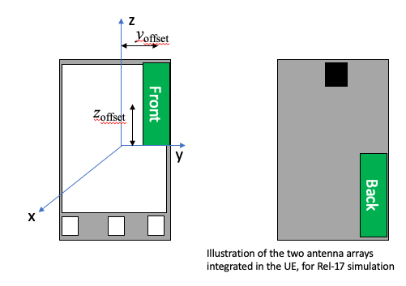

Figure 5.1.2.1-1: Simulated DUT antenna assumptions for beam management sensitivity study

#### 5.1.2.2 Simulation results

Table 5.1.2.2-1 below summarizes the results from simulations of beam management sensitivity of a DNF system (i.e. beam peak search is performed in the NF).

Table 5.1.2.2-1: Beam management sensitivity results of a DNF system

|  |  |  |  |  |  |
| --- | --- | --- | --- | --- | --- |
| Company label | Swept parameters | Beam management performance maximum ∆ relative to reference (dB) | | | Notes |
| Beam peak | 50% CDF | TRP |
| Company A | Array: 8x2  Range: {0.2, 0.4, 0.8} m  Offset: {0, 0.05, 0.10} m  HPBW: {90/90} | 2.5 | Not analyzed | Not analyzed | There is approximately 2.5 dB of BP error when range length is reduced to 0.2m in presence of the module offset mentioned above. There is also significant perturbation of the CDF curve. CDF statistics start to converge when the range length is at least 4 times the offset. |
| Company B | Array: 8x2, 4x1  Range: {0.25, 0.3, 0.45, 20} m  Offset: {0.125 in y, 0.125 in z, 0.09 in y & z} m  HPBW: {260/130} | 7.0 | 1.0 | TRP analyzed separately | The EIRP beam peak (100%-ile EIRP) and direction cannot be measured accurately with the direct NF methodology |
| Company B | Array: 8x2  Range: 0.2 m  Offset: 0.15 m in x, y, z  HPBW: {260/130} |  |  | 0.66 dB systematic  0.46 dB RSS’ed | Large uncertainties can be observed for TRP for measurements performed in the NF utilizing the black back box approach |
| Company C | Array: 4x1  Range: {100, 4.2, 0.9, 0.45, 0.3} m  Offsets: not specified  Full phone model (including the PCB and phone house) has been considered | 0.3 | 0 | Not clear whether 0.1 or 0.4 | Figure of merits such as EIRP, TRP, and Spherical Coverage are not influenced dramatically from range length |
| Company B | Array: {4x1, 8x2}  Range: 0.25 m  Offset: {0, 0.125, 0.9} m in y, z  HPBW: {90/90} | 4.2 |  |  | UE selected different beam between NF beam peak direction and FF beam peak direction |
| Company B | Array: {4x1, 8x2}  Range: 0.25 m  Offset: {0, 0.53, 0.75} m in x, y, z  HPBW: {90/90} | 10.4 |  |  | UE select the same beam in the NF as in the FF more often, we still see concerning trends with the peak EIRP deltas |
| Company B | Reuse assumptions used by Company A:  Array: 8x2  Range: {0.2, 0.4, 0.8} m  Offset: {0, 0.05, 0.10} m  HPBW: {90/90} | 2.5 | 1.2 |  | Simulations were performed to establish alignment with another company |

Table 5.1.2.2-2 below summarizes the results from simulations of beam management sensitivity of a CFFNF system (i.e. beam peak search is first performed in the FF/IFF and test case is executed in the NF).

Table 5.1.2.2-2: Beam management sensitivity results of a CFFNF system

|  |  |  |  |  |  |
| --- | --- | --- | --- | --- | --- |
| Company and reference | Swept parameters | Beam management performance maximum ∆ relative to reference (dB) | | | Notes |
| Beam peak | 50% CDF | TRP |
| Company B (“Black box with transform approach”) | Array: 8x2, 4x1  Range: {0.22 – 0.30} m  Offset: {0, 0.50, 0.10, 0.125} m | Max µ = 0.2  Max σ = 0.3 | Not analysed | Not analysed | These results were obtained using a transform-based approach to correct the incurred path loss. Feedback from industry is requested whether to continue efforts in terms of simulations and empirical investigations on this enhanced NF methodology with transform utilizing black-box approach |
| Company B (“Black & White box with transform approach”) | Array: 8x2, 4x1  Range: {0.22 – 0.30} m  Offset: {0, 0.50, 0.10, 0.125} m | Max µ = 0.1  Max σ = 0.3 | Not analysed | TRP analysed separately | These results were obtained using a transform-based approach to correct the incurred path loss. Feedback from industry is requested whether to continue efforts in terms of simulations and empirical investigations on this enhanced NF methodology with transform utilizing the white&black-box approach |
| Company B (“TRP with compensation for antenna offset”) | Array: 8x2  Range: 0.2 m  Offset: 0.15 m in x, y, z  HPBW: {260/130} |  |  | 0.02 dB systematic  0.21 dB RSS’ed | These results were obtained using the DNF methodology with declared offset; alternatively, these results could be obtained using a transform based approach to estimate the phase centre offset. With the offset of the antenna array known, e.g., estimated with the enhanced NF methodology introduced in this contribution, very accurate TRP measurements in the NF can be made with a TRP offset compensation approach |
| Company C | Array: 4x1  Range: {100, 4.2, 0.9, 0.45, 0.3} m  Offsets: not specified  Full phone model (including the PCB and phone house) has been considered | 0.3 | 1.0 | 0.8 | These results were obtained using the DNF methodology. Figure of merits such as EIRP, TRP, and Spherical Coverage are not influenced dramatically from range length  Full phone model (including the PCB and phone house) has been considered |

While it has always been argued that TRP can be tested in the near-field due to conservation of power, no clear measurement uncertainty analyses have been presented to quantify the errors. In this section, we briefly present our findings for measurement uncertainties when testing TRP in the near field.

An analysis of the impact on measurement uncertainty by testing TRP in the NF was performed according to the assumption for TRP offsets in Table 5.1.2.1-1. In this analysis, near-field effects of the antenna pattern were taken into account. Figure 5.1.2.2-1 below illustrates the differences in the 8x2 antenna pattern at the 2D2/λ distance (a) and at 1/8th of that distance (b).

a)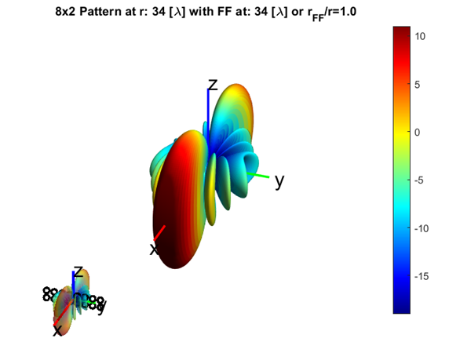b)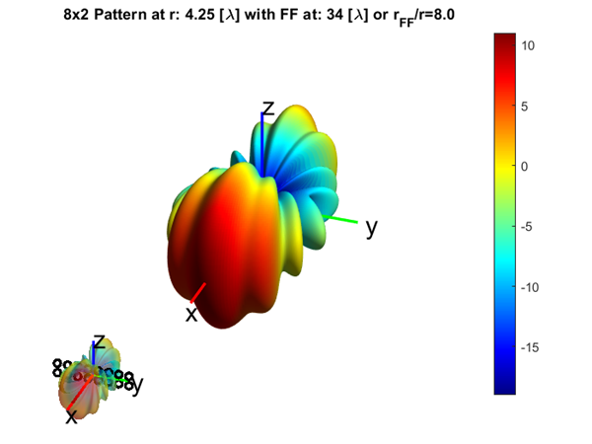

Figure 5.1.2.2-1: Radiation pattern of the 8x2 antenna array at 2D2/λ FF distance (a) and in NF at 1/8th of FF distance (b)

Table 5.1.2.2-3 below summarizes the impact of the approaches with and without offset correction on TRP MU.

Table 5.1.2.2-3: Impact of TRP measurement with and without offset correction on MU

|  |  |  |  |  |
| --- | --- | --- | --- | --- |
| Range Length (cm) | With Offset Correction | | Without Offset Correction | |
| Mean TRP Error (dB) | TRP Std. Dev. (dB) | Mean TRP Error (dB) | TRP Std. Dev. (dB) |
| 20 | 0.02 | 0.13 | 0.40 | 0.26 |
| 25 | 0.03 | 0.06 | 0.24 | 0.15 |
| 28 | 0.03 | 0.04 | 0.19 | 0.11 |
| 32 | 0.03 | 0.02 | 0.14 | 0.08 |
| 43 | 0.03 | 0.02 | 0.08 | 0.04 |
| 100 | 0.04 | 0.02 | 0.01 | 0.01 |

Additionally, CDF curves for the various simulation results are presented in Figure 5.1.2.2-2 below.

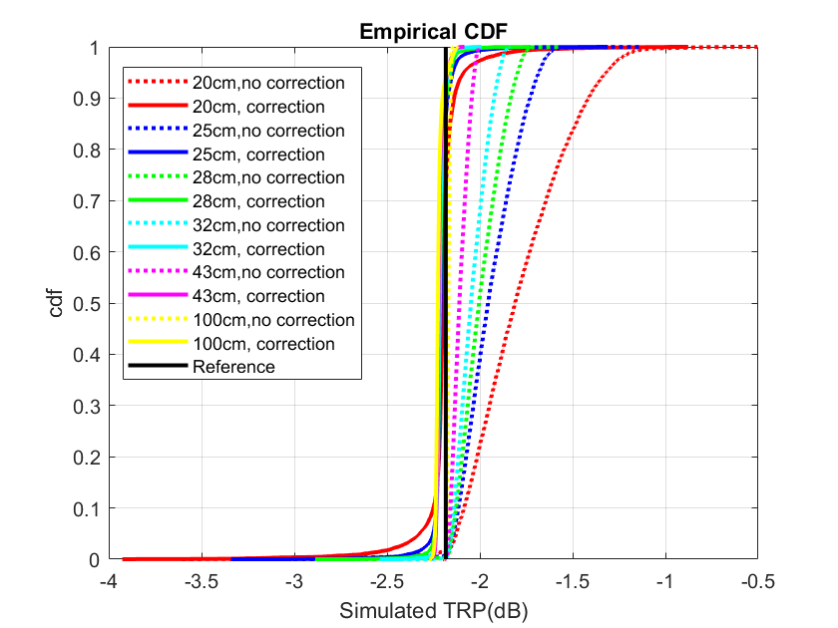

Figure 5.1.2.2-1: Distribution of simulated TRP measurements with and without offset correction

Based on the submitted simulation results, the following conclusions can be drawn:

- TBD

### 5.1.3 Manufacturer declarations

If a manufacturer declaration is used to inform or optimize a test system parameter, and the DUT is positioned in the test system according to parameters which are informed by this declaration, then the DUT is measured assuming a “white box” configuration. If no manufacturer declaration is used, and the DUT is positioned in the test system according to common procedures, then the DUT is measured assuming a “black box” configuration.

Black box testing requires no knowledge which antenna panel is active at any given time and the detailed location of the active panel within the DUT. In this test configuration, the geometric centre of the DUT is aligned with the centre of the quiet zone as illustrated in Figure 5.1.3-1.

 

Figure 5.1.3-1: Illustration of black box approach

White box testing on the other hand requires the manufacturer declaration of detailed locations of all antenna panels and which antenna panel is active in any UL/DL test direction In this test configuration, the centre of the radiating aperture (of the active panel) is aligned with the centre of the quiet zone as illustrated in Figure 5.1.3-2.

 

Figure 5.1.3-2: Illustration of white box approach

The black&white-box approach combines the advantages of both the black and white-box approaches where the antenna phase centre offset(s) are declared, i.e., white-box approach, but the geometric centre of the DUT is aligned with the centre of the QZ, i.e., black-box approach.

The following paragraphs provide further information on the need for the various vendor declarations with the help of sample illustrations. Here, a DUT with three antenna panels is considered shown schematically in Figure 5.1.3-3 on the left. The right side shows coverage sectors and the corresponding antenna panels the DUT would select if the DL was presented from within those sectors. In this example, the red antenna panel would yield the TX beam peak in the horizontal direction; this direction would be identified following the TX beam peak search. For simplicity, most of the arguments in the next few paragraphs are applied to testing in the FF but they can be applied to testing in the NF as well.

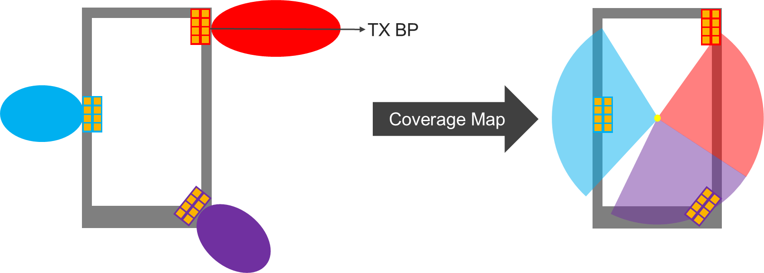

Figure 5.1.3-3: Illustration of Sample DUT with three antenna panels

The beam peak search or spherical coverage test case of the DUT utilizing the black-box approach, i.e., none of the antenna offsets are known/declared, is illustrated in Figure 5.1.3-4. Here, the geometric centre of the DUT is aligned with the centre of the QZ (yellow circle). The (green) beam peak search grid points sample the EIRP around the DUT.

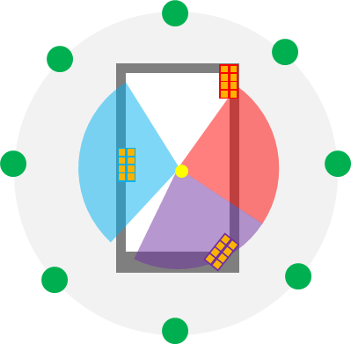

Figure 5.1.3-4: Illustration of beam peak search of sample DUT utilizing black-box approach.

Test cases without a 3D scan, e.g., EIRP/EIS test case towards the known TX/RX beam peak direction, utilizing the black-box approach are illustrated in Figure 5.1.3-5. Here, the geometric centre of the DUT is aligned with the centre of the QZ (yellow circle) and the TX beam peak direction is known from a previous beam peak search measurement, e.g., from an FF system. Hence, the single (green) FF grid point is aligned with the FF TX beam peak direction.

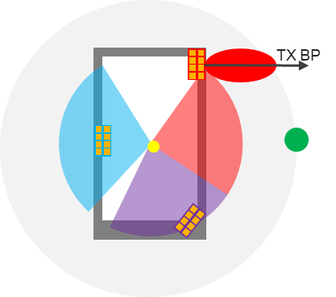

Figure 5.1.3-5: Illustration low UL power test case along TX BP direction of sample DUT utilizing black-box approach.

For the white-box measurement approach, the level of information provided in vendor declarations largely depends on the purpose of test case coverage. If the white-box approach is leveraged for all conformance test cases including the beam peak searches, the total number of panels and the phase centre offsets of each panel need to be declared. Additionally, vendors would have to declare which antenna panel is active for each grid point or test sectors so that the respective antenna panel is aligned with the centre of the QZ during testing. This approach is further illustrated in Figure 5.1.3-6. To sample EIRPs on all beam peak search grid points, three different device positions have to be applied, i.e., for the angular range covering the

* red grid points (declared by OEM), the red antenna panel (location declared by OEM) has to be aligned with the centre of QZ (yellow circle)
* purple grid points (declared by OEM), the purple antenna panel (location declared by OEM) has to be aligned with the centre of QZ (yellow circle)
* blue grid points (declared by OEM), the blue antenna panel (location declared by OEM) has to be aligned with the centre of QZ (yellow circle)

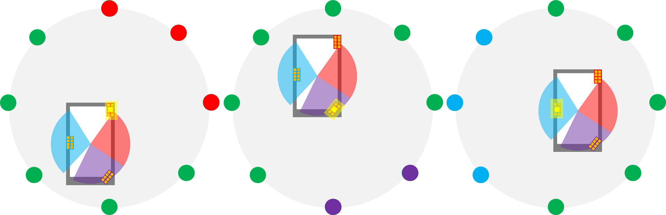

Figure 5.1.3-6: Illustration of beam peak search of sample DUT utilizing white-box approach.

In summary, the information that would have to be declared by the OEMs if the white-box approach is utilized for all conformance test cases is tabulated in Table 5.1.3-1.

Table 5.1.3-1: Sample Vendor Declaration for white box approach supporting all conformance test cases

|  |  |  |
| --- | --- | --- |
| **Number of Antenna  Panels in DUT** | # | |
| **Antenna Panel #** | **Phase-centre offset from geometric centre of DUT:** | **Range of Angles covered by Antenna Panel** |
| 1 | (*x*off1, *y*off1, *z*off1) | (start1 to end1, start1 to end1) |
| 2 | (*x*off2, *y*off2, *z*off2) | (start2 to end2, start2 to end2) |
| … | … | … |
| N | (*x*offN, *y*offN, *z*offN) | (startN to endN, startN to endN) |

Assuming the enhanced test methodology needs to perform beam peak searches and a white box approach was selected, the DUT should be measured in several positions inside the test volume, where two options could be considered:

1. DUT is placed manually in the corresponding off-center positions. This will likely result in significant test time increase and additional MU due to inaccuracies in the alignment of the DUT.
2. x-y-z positioning systems are needed to fully automate testing based on the knowledge of which antenna panel is active in any given UL/DL test direction, as outlined in Figure 5.1.3-6. This will in effect likely result in significant signal ripple and near field coupling effects which is expected to degrade the quality of QZ MU which could offset the offset MU a white box approach eliminates. Such positioning system will furthermore increase test system complexity from a SW and HW perspective as well as test time.

Test cases without a 3D scan, e.g., EIRP/EIS test case towards the known TX/RX beam peak direction, utilizing the white-box approach is illustrated in Figure 5.1.3-7. Here, the phase centre of the red panel (yielding beam peak radiation) of the DUT is aligned with the centre of the QZ (yellow circle) and the TX beam peak direction is known from a previous beam peak search measurement; thus the single (green) grid point is aligned with the FF TX beam peak direction. In this case, only the location of the one antenna panel that yields the beam peak radiation would have to be declared. A sample declaration is shown in Table 5.1.3-2.

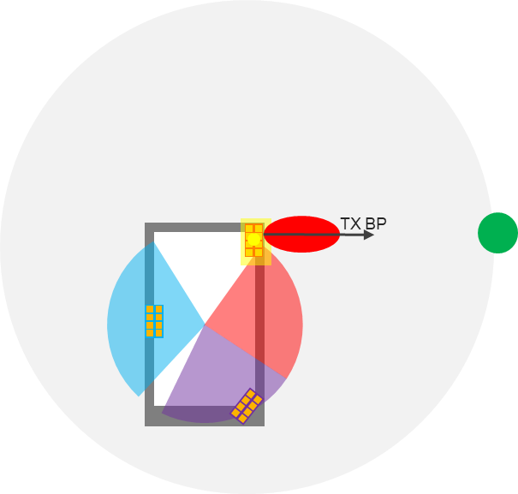

Figure 5.1.3-7: Illustration of low UL power test case along TX BP direction of sample DUT utilizing white-box approach.

Table 5.1.3-2: Sample Vendor Declaration for white-box approach supporting low UL power test cases

|  |  |
| --- | --- |
| **Antenna Panel (yielding TX beam peak radiation** | **Phase-centre offset from geometric centre of DUT:** |
|  | (*x*off, *y*off, *z*off) |

Two different black&white-box approaches could be further considered, i.e.,

* Extensive Black&white-box approach: When the NF methodology is used for spherical coverage test cases and for beam peak searches, all active antenna locations are declared together with the angular ranges (theta, phi) each active antenna performs best (when compared to the remaining antenna panels, i.e., the vendor declaration is as outlined in Table 5.1.3-1. Very much similar to the white-box approach with the only difference that the geometric centre of DUT is aligned with the centre of QZ.
* Black&white box: When the NF methodology is used only for EIS based high DL power or EIRP/TRP based low UL power test cases, only the antenna location of the antenna that yields the beam peak needs to be declared, i.e., the vendor declaration is as outlined in Table 5.1.3-2. The geometric centre of DUT is aligned with the centre of QZ.

For test cases focused only on the for EIS based high DL power or EIRP/TRP based low UL power test cases, the key differences are illustrated in Figure 5.1.3-8 for the black-box approach (left), black&white-box approach (centre), and the white-box approach (right). While the black-box approach requires local searches to determine the NF test direction, the need for local searches for the black&white-box approach is FFS. No local search is necessary for the white-box approach.

For the spherical coverage test cases or the beam peak searches, the extensive black&white-box approach is further outlined in Figure 5.1.3-9. On the other hand, the black-box approach is outlined in Figure 5.1.3-4 while the white-box approach is outlined in Figure 5.1.3-6.

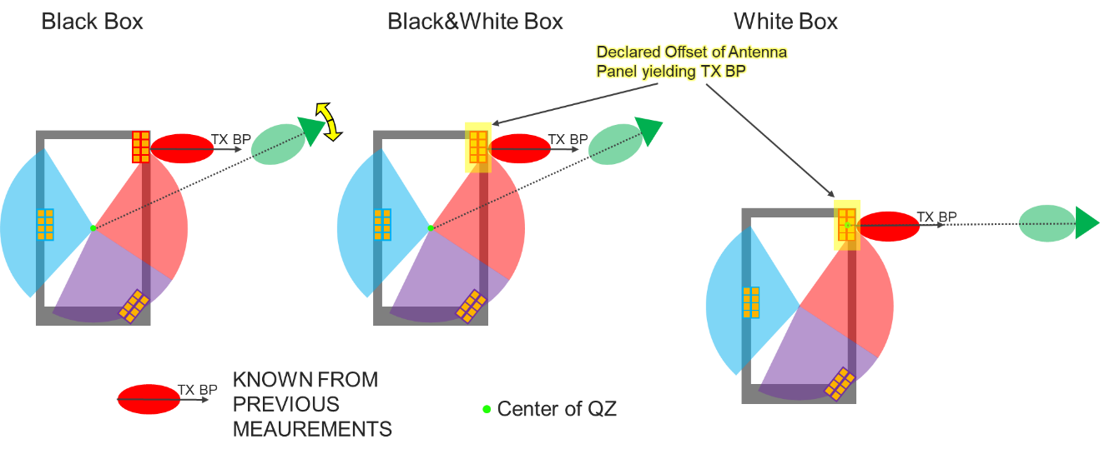

Figure 5.1.3-8: Illustration of black-box approach (left), black&white-box approach (centre), and the white-box approach (right) for the low-UL power test case.

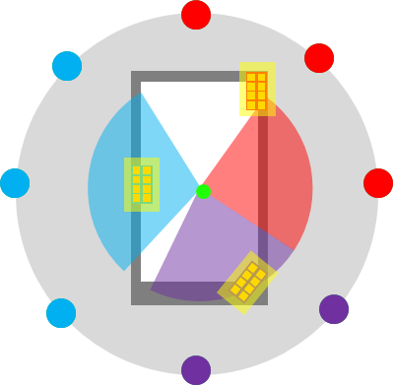

**Figure 5.1.3-9: Illustration of beam peak search or beam peak search of sample DUT utilizing extensive black&white-box approach**

For white box testing, the minimum radius of the NF probe antenna from the centre of the quiet zone generally must exceed the maximum diameter of the device, as illustrated in Figure 5.1.3-10, to prevent interference of the near field scanning probe with the DUT. While this requirement of the NF range length having to exceed the maximum diameter of the DUT is generally applicable to TRP where the NF Probe antenna needs to perform a full 3D scan around the DUT, this could very well be applicable to single-directional measurements as well, as illustrated in Figure 5.1.3-10 using a PC1 CPE as an example. Similar restrictions apply when testing using ETC enclosures surrounding the DUT.

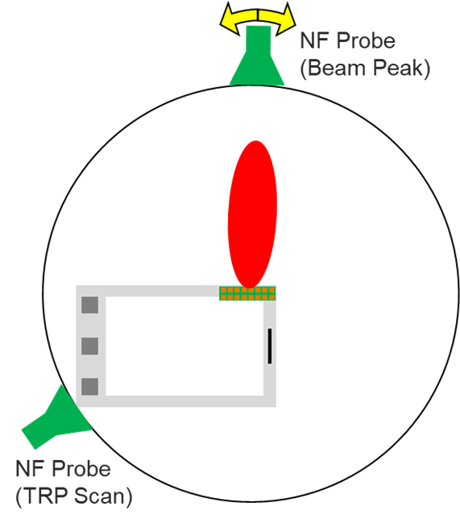

Figure 5.1.3-10: Illustration of min. Range length of NF Systems when applying white box testing

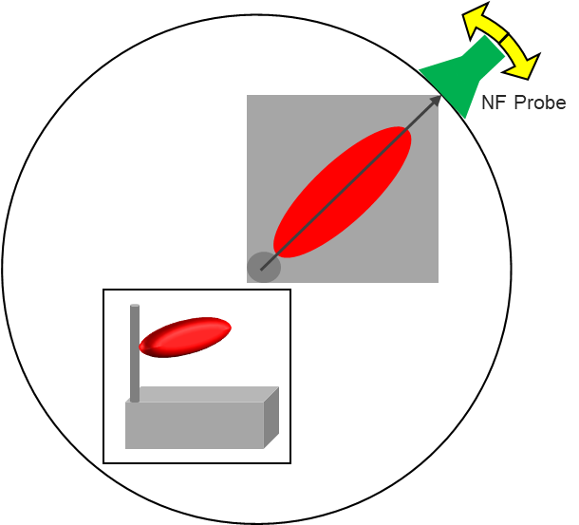

Figure 5.1.3-11: Illustration of min. Range length for NF Systems using PC1 CPE as example.

The corresponding FF and NF min. range lengths are tabulated for selected FR2 frequencies in Table 3 for PC3 devices with fixed D=5cm.

Table 5.1.3-3: Minimum FF and NF Range Lengths for black box and white box conditions for PC3 devices



Table 5.1.3-4 summarizes the path loss comparison between “white box” and “black box” configuration across IFF/DFF and NF system types.

Table 5.1.3-4: Path loss comparison between “white box” and “black box” configuration

|  |  |  |  |  |
| --- | --- | --- | --- | --- |
| f (GHz) | Antenna Config. 1, 2, and 3 - BLACK BOX -  (PC3 Devices: D=5cm) | | Antenna Config. 1 and 2 - WHITE BOX -  (PC3 Devices: D=5cm) | |
| IFF/DFF | NF | DFF | NF |
| Path Loss with 1m range length | Path Loss with 0.22m range length | Path Loss with 0.88m range length | Path Loss with 0.28m range length |
| 24.25 | 60.16 | 46.86 | 59.01 | 48.93 |
| 30 | 62.01 | 48.71 | 60.85 | 50.78 |
| 40 | 64.51 | 51.21 | 63.35 | 53.28 |
| 43.5 | 65.24 | 51.94 | 64.08 | 54.00 |
| 52.6 | 66.89 | 53.59 | 65.73 | 55.65 |

Based on the analysis shown in Table 5.1.3-4, it can be concluded that a “white box” is not deemed a feasible enhancement of the methodology.

Additionally, since the beam peak searches and the spherical coverage test cases are not part of the low UL/high DL power test cases and given the complexity of the vendor declaration of the extensive black&white-box approach, it can be concluded that the extensive black&white-box approach is not deemed a feasible enhancement of the methodology.

In a NF system, the NF TX beam peak (BP) direction for an offset antenna is not necessarily the same as the FF TX BP direction; however, the knowledge of the antenna phase centre offset can be leveraged to measure at the NF BP direction as illustrated in Figure 5.1.3-12 below. .

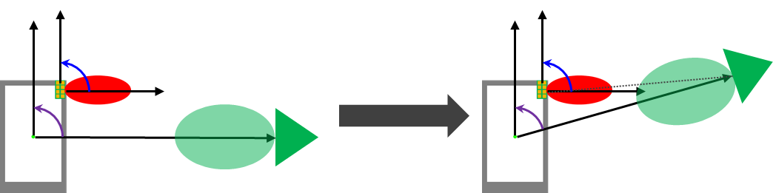

Figure 5.1.3-12: Illustration of NF Testing utilizing the “black&white box” approach

### 5.1.4 Applicability of NF methodologies

Here, the applicability of the NF methodologies considered, i.e., direct Near Field (DNF), Combined Far-Field/Direct Near Field (CFFDNF), and Combined Far-Field/Near Field (CFFNF), are further analysed.

The CFFNF with transform (e.g. asymptotic expansion transform) has the following applicability:

* Beam peak searches and spherical coverage test cases are performed with black box approach using the FF probe. Performing these tests with the NF measurement probe would require the extensive black&white-box approach which is not deemed a feasible enhancement of the methodology.
* The low UL power/high DL power EIRP/EIS test cases in known FF BP direction are applicable to the black-box approach using transform techniques:
  + Three radii approach (i.e. local search on radius r1 and very localized searches at r2 and r3) can be used.
  + EIRP/EIS can be approximated very accurately with the NF probe at very close distances (~22cm for PC3, ~27cm for PC1) with optimized improvements in relaxations.
  + The unknown antenna location can be estimated accurately which allows very accurate TRP measurements at very close distances with large improvement in relaxations.
* The low UL power/high DL power EIRP/EIS test cases in known FF BP direction are applicable to the black&white-box approach.
  + Two radii approach without local searches can be used.
  + EIRP/EIS can be approximated very accurately with the NF probe at very close distances (~21cm for PC3, ~26cm for PC1) with optimized improvements in relaxations.
* The low UL power TRP test cases are not applicable to transform approach (CFFNF) since that approach would be test time prohibitive. However, the known offset (empirical evaluation with black box approach or declared with black&white-box approach) can be compensated using CFFDNF approach to obtain very accurate TRP results at very close distances.

The CFFDNF has the following applicability:

* Beam peak searches and spherical coverage test cases are performed with black box approach using the FF probe. Performing these tests with the NF measurement probe would require the extensive black&white-box approach which is not deemed a feasible enhancement of the methodology.
* The low UL power/high DL power EIRP/EIS test cases in the known FF BP direction are applicable to the black&white-box approach.
  + Whether a local search to determine the NF test direction and/or optimize EIRP/EIS is FFS.
  + EIRP/EIS can be approximated in the NF (min. range lengths for PC1 and PC3 are FFS)
* TRP test cases at very close distances require offset compensation while range lengths beyond 32cm for PC3 do not necessarily require offset compensations. At those range lengths the relaxations are minimized by up to 10dB.

DNF has the following applicability:

* Beam peak searches and spherical coverage test cases are not applicable regardless of black-box or black&white-box approach. Performing these tests with the NF measurement probe would require the extensive black&white-box approach which is not deemed a feasible enhancement of the methodology.
* The low UL power/high DL power EIRP/EIS test cases in the known FF BP direction are not applicable to the black box approach.
* The applicability of the low UL power/high DL power EIRP/TRP/EIS test cases in the known BP direction and with the black&white-box approach is FFS.

The assumption for this “black & white box” testing approach is that the antenna phase centre offset for the antenna panel that corresponds to the FF beam peak is known and declared, i.e., following the “white box” approach discussed earlier. On the other hand, however, it is assumed that the geometric centre of the DUT is aligned with the centre of the QZ, i.e., following the “black box” approach. This approach would have the same advantages as the “black box” approach over the “white box” approach in terms of complexity, test time, MU, and improvements of the relaxations and is summarized in Table 5.1.4-1 below.

Table 5.1.4-1: Comparison between the “black box” and “black & white box” approaches

|  |  |  |  |  |  |  |  |  |
| --- | --- | --- | --- | --- | --- | --- | --- | --- |
| Approach | Knowledge of FF BP Direction (from Meas.) | Declaration of Antenna Phase Centre Offset of Antenna yielding BP | Need for FF probes and UBF | Need for local searches around NF BP | Meas. at different Radii | Test Time Impact | Estimated maximum Improvement of Relaxation (Note 1) | |
| CFFNF for EIRP/EIS using Black Box | Yes | No | Yes | Yes | Yes (x3) | Medium (local searches & 3 different radii) | ~14dB (for 20cm range length). | |
| CFFNF for EIRP/EIS using Black & White Box | Yes | Yes | Yes | No | Yes (x2) | Low (2 different radii in fixed NF BP Direction) | ~14dB (for 20cm range length | |
| CFFDNF for TRP using Black Box | Yes | Yes | Yes | No | No | None | Without offset correction: ~10dB (for 32cm range length) | |
| CFFDNF for TRP using Black &White Box | Yes | Yes | Yes | No | No | None | With offset correction: ~14dB (for 20cm range length) | |
| CFFDNF for EIRP/EIS using Black &White Box | Yes | Yes | Yes | FFS | No | Depends on local search | With pathloss correction: ~14dB (for 20cm range length) | |
| Note 1: Improvement of relaxation is only considering Free Space Path Loss | | | | | | | |

### 5.1.5 Improvement of permitted methods

Table 5.1.5-1 below provides a preliminary list of potential improvement of permitted methods based on the analysis provided by one company and are applicable to the frequency range of 24.25 – 43.5 GHz.

Table 5.1.5-1: Summary of potential improvement of permitted methods by Tx test case (24.25 – 43.5 GHz)

|  |  |  |  |  |  |  |
| --- | --- | --- | --- | --- | --- | --- |
| Clause | Requirement | Testability issue | Test Metric | Regulatory related | TS 38.521-2 Test Requirements | Potential improvement |
| 6.3.1 | Minimum output power | Low UL power | EIRP (Link=TX beam peak direction, Meas=Link angle). | No | No relaxation for PC1. For other power classes, relaxation varies from 0dB to 13.5dB depending on the operating band and channel bandwidth. | ~ 10dB for FR2a and FR2b  FR2a requirements testable without relaxations |
| 6.3.2 | Transmit OFF power | Low UL power | TRP (Link=TX beam peak direction, Meas=TRP grid) | Yes | Relaxations for n257: 21.4dB @ 50MHz, 24.4dB @ 100MHz, 27.4dB @ 200MHz and 30.4dB @ 400MHz.  Relaxations for n258 and n261: [21.4]dB @ 50MHz, [24.4]dB @ 100MHz, [27.4]dB @ 200MHz and [30.4]dB @ 400MHz.  Relaxations for n260: [24.1]dB @ 50MHz, [27.1]dB @ 100MHz, [30.1]dB @ 200MHz and [33.1]dB @ 400MHz. | ~ 10dB for FR2a and FR2b |
| 6.5.1 | Occupied bandwidth | Low UL power | OBW (Link=TX beam peak direction, Meas=Link angle) | Yes | [TBD] | [TBD] |
| 6.5.2.3 | Adjacent channel leakage ratio | Low UL power | TRP (Link=TX beam peak direction, Meas=TRP grid). | Yes | Relaxation for n257, n258 and n261: 0dB, except for 200Mhz (0.5dB in one test ID) and 400MHz (between 1.5 and 3.5dB) | Improvements remove required relaxations from TC |
| 6.5.3.2 | Additional spurious emissions | Low UL power | TRP (Link=TX beam peak direction, Meas=TRP grid). | Yes | Between 3.3dB and 6dB relaxation depending on the combination of NR Band and Protected band. | [TBD] |

Table 5.1.5-2: Summary of potential improvement of permitted methods by Rx test case (24.25 – 43.5 GHz)

|  |  |  |  |  |  |  |
| --- | --- | --- | --- | --- | --- | --- |
| Clause | Requirement | Testability issue | Test Metric | Regulatory related | TS 38.521-2 Test Requirements | Potential improvement |
| 7.4 | Maximum input power | High DL power | EIS (Link=RX beam peak direction, Meas=Link angle). | No | 26dB relaxation for 24.25 ~ 29.5 GHz and 34 dB relaxation for 37 ~ 40 GHz with respect to minimun requirements. | ~ 6dB for FR2a  ~10dB for FR2b |
| 7.5 | Adjacent channel selectivity (case 1) | High DL power | EIS (Link=RX beam peak direction, Meas=Link angle) | Yes | 50MHz: 1.8dB relaxation for power in transmission BW and interferer for band n260.  100MHz: 4.8dB relaxation for power in transmission BW and interferer for band n260.  200MHz and 400MHz are deemed not testable. | Similar improvements as for TC 7.4  Single carrier bandwidth could be testable 400 MHz, without relaxations up to 200 MHz |
| 7.5 | Adjacent channel selectivity (case 2) | High DL power | EIS (Link=RX beam peak direction, Meas=Link angle) | No | Decision not test ACS case 2. | - |
| 7.6.2 | In-band blocking | High DL power | EIS (Link=RX beam peak direction, Meas=Link angle) | Yes | 50MHz: 1.8dB relaxation for power in transmission BW and interferer for band n260.  100MHz: 4.8dB relaxation for power in transmission BW and interferer for band n260.  200MHz and 400MHz are deemed not testable. | Similar improvements as for TC 7.4  Single carrier bandwidth could be testable 400 MHz, without relaxations up to 200 MHz |
| 7.9 | Receiver spurious emissions | Low UL power | TRP (Link=TX beam peak direction, Meas=TRP grid). | Yes | Relaxations for n257: 10.2dB between 6-20GHz, 17.2dB between 20-40GHz and 33.1dB between 40GHz and the 2nd harmonic.  Relaxations for other bands are still TBD. | [TBD] |



For a given test case, NF based solutions should only be considered if the improvement for current methods is not enough to remove the relaxations determined by RAN5.