3GPP TSG-RAN WG4 Meeting #98-e R4-2103544
Electronic Meeting, Jan.25 - Feb.5, 2021

CR-Form-v12.1
CHANGE REQUEST
 | 38.174 | CR | draftCR | rev | - | Current version: | 16.1.0
For HELP on using this form: comprehensive instructions can be found at
http://www.3gpp.org/Change-Requests.

Proposed change affects: | UICC apps |  | ME | X | Radio Access Network |  | Core Network

Title: | Test cases for IAB-MT RLM requirements in TS 38.174
Source to WG: | Nokia, Nokia Shanghai Bell
Source to TSG: | R4
Work item code: | NR_IAB-Perf |  |  |  |  |  | Date: |  |  | 2021-02-02
Category: | B |  |  |  |  |  | Release: |  |  | Rel-16
 | Use one of the following categories:  F (correction)  A (mirror corresponding to a change in an earlier release)  B (addition of feature),  C (functional modification of feature)  D (editorial modification)  Detailed explanations of the above categories can  be found in 3GPP TR 21.900. |  |  |  |  |  |  |  | Use one of the following releases:  Rel-8 (Release 8)  Rel-9 (Release 9)  Rel-10 (Release 10)  Rel-11 (Release 11)  …  Rel-15 (Release 15)  Rel-16 (Release 16)  Rel-17 (Release 17)  Rel-18 (Release 18)
Reason for change: |  | New test cases for IAB-MT radio link monitoring requirements.
Summary of change: |  | - Add test cases for IAB-MT radio link monitoring  - Based on the agreed specification structure in R4-2017117 in RAN4#97e meeting.
Consequences if not approved: |  | The test cases for IAB-MT radio link monitoring requirements is missing.
Clauses affected: |  | G.2.3.1.1, G.2.3.1.2, G.2.3.1.3, G.2.3.1.4
 |  | Y | N
Other specs |  |  | X | Other core specifications |  |  |  | TS/TR ... CR ...
affected: |  |  | X | Test specifications |  |  |  | TS/TR ... CR ...
(show related CRs) |  |  | X | O&M Specifications |  |  |  | TS/TR ... CR ...
Other comments:
This CR's revision history:

< Start of change 1>

G.2.3.1.1 Radio Link Monitoring Out-of-sync Test for FR1 PCell configured with SSB-based RLM RS in non-DRX mode

G.2.3.1.1.1 Test Purpose and Environment
The purpose of this test is to verify that the IAB-MT properly detects the out of sync and in sync for the purpose of monitoring downlink radio link quality of the PCell. This test will partly verify the FR1 radio link monitoring requirements in clause 12.3.1.
In the test, IAB-MT is configured to perform RLM on SSB, with detectionResource included in RadioLinkMonitoringRS set to SSB#0 and SSB#1, and purpose set to ‘rlf’. Supported test configurations are shown in table G.2.3.1.1.1-1. The test parameters are given in Tables G.2.3.1.1-2 and G.2.3.1.1.1-3 below. There is one cell (Cell 1), which is the active NR cell, in the test. The test consists of three successive time periods, with time duration of T1, T2 and T3 respectively. Figure G.2.3.1.1.1-1 shows the variation of the downlink SNR in the active cell to emulate out-of-sync and in-sync states. Prior to the start of the time duration T1, the IAB-MT shall be fully synchronized to Cell 1. The IAB-MT shall be configured for periodic CSI reporting with a reporting periodicity of 5 ms.
Table G.2.3.1.1.1-1: Supported test configurations for FR1 PCell
Configuration | Description
1 | TDD, SSB SCS 15 kHz, data SCS 15 kHz, BW 10 MHz
2 | TDD, SSB SCS 30 kHz, data SCS 30 kHz, BW 40 MHz
Note: The IAB-MT is only required to pass in one of the supported test configurations in FR1

Table G.2.3.1.1.1-2: General test parameters for FR1 out-of-sync testing in non-DRX mode
Parameter |  |  | Unit | Value
 |  |  |  | Test 1
Active PCell |  |  |  | Cell 1
RF Channel Number |  |  |  | 1
Duplex mode |  | Config 1,2 |  | TDD
BW_{channel} |  | Config 1 | MHz | 10: N_{RB,c} = 52
 |  | Config 2 |  | 40: N_{RB,c} = 106
DL initial BWP configuration |  | Config 1, 2 |  | DLBWP.0.1
DL dedicated BWP configuration |  | Config 1, 2 |  | DLBWP.1.1
UL initial BWP configuration |  | Config 1, 2 |  | ULBWP.0.1
UL dedicated BWP configuration |  | Config 1, 2 |  | ULBWP.1.1
TDD Configuration |  | Config 1 |  | TDDConf.1.1
 |  | Config 2 |  | TDDConf.2.1
CORESET Reference Channel |  | Config 1 |  | CR.1.1 TDD
 |  | Config 2 |  | CR.2.1 TDD
SSB Configuration |  | Config 1 |  | SSB.1 FR1
 |  | Config 2 |  | SSB.2 FR1
SMTC Configuration |  | Config 1 |  | SMTC.1
 |  | Config 2 |  | SMTC.1
PDSCH/PDCCH subcarrier spacing |  | Config 1 |  | 15 kHz
 |  | Config 2 |  | 30 kHz
PRACH Configuration |  | Config 1 |  | TBD
 |  | Config 2 |  | TBD
SSB index assigned as RLM RS |  |  |  | 0
OCNG parameters |  |  |  | OP.1
CP length |  |  |  | Normal
Correlation Matrix and Antenna Configuration |  |  |  | 2x2 Low
Out of sync transmission parameters | DCI format |  |  | 1-0
 | Number of Control OFDM symbols |  |  | 2
 | Aggregation level |  | CCE | 8
 | Ratio of hypothetical PDCCH RE energy to average SSS RE energy |  | dB | 4
 | Ratio of hypothetical PDCCH DMRS energy to average SSS RE energy |  | dB | 4
 | DMRS precoder granularity |  |  | REG bundle size
 | REG bundle size |  |  | 6
DRX |  |  |  | OFF
Layer 3 filtering |  |  |  | Enabled
T310 timer |  |  | ms | 0
T311 timer |  |  | ms | 1000
N310 |  |  |  | 1
N311 |  |  |  | 1
CSI-RS configuration for CSI reporting |  | Config 1 |  | CSI-RS.1.1 TDD
 |  | Config 2 |  | CSI-RS.2.1 TDD
CSI-RS for tracking |  | Config 1 |  | TRS.1.1 TDD
 |  | Config 2 |  | TRS.1.2 TDD
T1 |  |  | s | 0.2
T2 |  |  | s | 1.08
T3 |  |  | s | 1.08
D1 |  |  | s | 1.04
Note 1: All configurations are assigned to the IAB-MT prior to the start of time period T1.
Note 2: IAB-MT-specific PDCCH is not transmitted after T1 starts.

Table G.2.3.1.1.1-3: Cell specific test parameters for FR1 (Cell 1) for out-of-sync radio link monitoring tests in non-DRX mode
Parameter |  | Unit | Test 1
 |  |  | T1 | T2 | T3
EPRE ratio of PDCCH DMRS to SSS |  | dB | 4
EPRE ratio of PDCCH to PDCCH DMRS |  | dB | 0
EPRE ratio of PBCH DMRS to SSS |  | dB | 0
EPRE ratio of PBCH to PBCH DMRS |  | dB
EPRE ratio of PSS to SSS |  | dB
EPRE ratio of PDSCH DMRS to SSS |  | dB
EPRE ratio of PDSCH to PDSCH DMRS |  | dB
EPRE ratio of OCNG DMRS to SSS |  | dB
EPRE ratio of OCNG to OCNG DMRS |  | dB
SNR on RLM-RS | Config 1 | dB | 1 | -7 | -15
 | Config 2 |  | 1 | -7 | -15
 | Config 3 |  | 1 | -7 | -15
SNR on other channels and signals | Config 1, 2, 3 | dB | 1
 | Config 1 | dBm/SCS | -98
 | Config 2 |  | -95
Propagation condition |  |  | TDL-C 300ns 100Hz
Note 1: OCNG shall be used such that the resources in Cell 1 are fully allocated and a constant total transmitted power spectral density is achieved for all OFDM symbols.
Note 2: The signal contains PDCCH for IAB-MTs other than the device under test as part of OCNG.
Note 3: SNR levels correspond to the signal to noise ratio over the SSS REs.
Note 4: The SNR in time periods T1, T2 and T3 is denoted as SNR1, SNR2 and SNR3 respectively in Figure G.2.3.1.1.1-1.
Note 5: The SNR values are specified for testing an IAB-MT which supports 2RX on at least one band. For testing of an IAB-MT which supports 4RX on all bands, the SNR during T3 is A.3.6 [6].

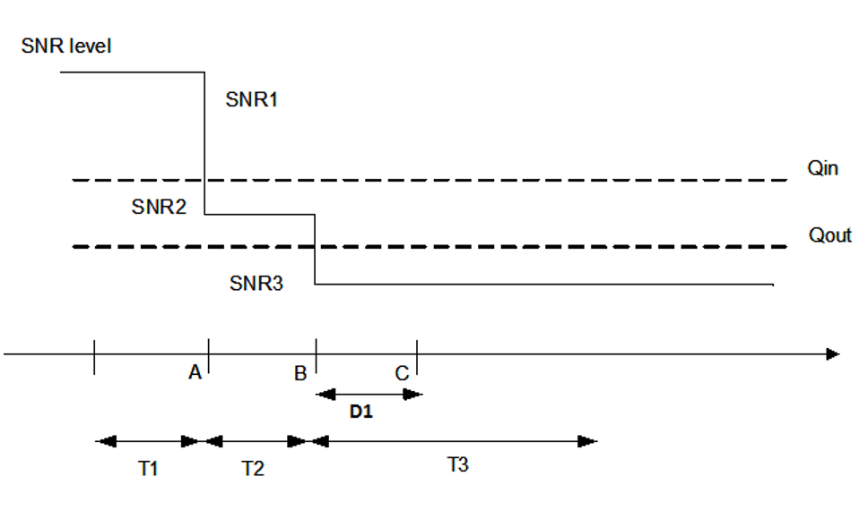
Figure G.2.3.1.1.1-1: SNR variation for out-of-sync testing

G.2.3.1.1.2 Test Requirements
The IAB-MT behaviour in each test during time durations T1, T2 and T3 shall be as follows:
During the period from time point A to time point B the IAB-MT shall transmit uplink signal at least in all uplink slots configured for CSI transmission according to the configured periodic CSI reporting.
The IAB-MT shall stop transmitting uplink signal no later than time point C (D1 second after the start of the time duration T3).
The rate of correct events observed during repeated tests shall be at least 90%.

G.2.3.1.2 Radio Link Monitoring In-sync Test for FR1 PCell configured with SSB-based RLM RS in non-DRX mode

G.2.3.1.2.1 Test Purpose and Environment
The purpose of this test is to verify that the IAB-MT properly detects the out of sync and in sync for the purpose of monitoring downlink radio link quality of the PCell. This test will partly verify the FR1 radio link monitoring requirements in clause 12.3.1.
In the test, IAB-MT is configured to perform RLM on SSB, with detectionResource included in RadioLinkMonitoringRS set to SSB#0 and SSB#1, and purpose set to ‘rlf’. Supported test configurations are shown in table G.2.3.1.2.1-1. The test parameters are given in Tables G.2.3.1.2.1-2, and G.2.3.1.2.1-3 below. There is one cell (Cell 1), which is the active cell, in the test. The test consists of five successive time periods, with time duration of T1, T2, T3, T4 and T5 respectively. Figure G.2.3.1.2.1-1 shows the variation of the downlink SNR in the active cell to emulate out-of-sync and in-sync states. Prior to the start of the time duration T1, the IAB-MT shall be fully synchronized to Cell 1. Prior to the start of the time duration T1, the IAB-MT shall be fully synchronized to Cell 1. The IAB-MT shall be configured for periodic CSI reporting with a reporting periodicity of 5 ms.
Table G.2.3.1.2.1-1: Supported test configurations for FR1 PCell
Configuration | Description
1 | TDD, SSB SCS 15 kHz, data SCS 15 kHz, BW 10 MHz
2 | TDD, SSB SCS 30 kHz, data SCS 30 kHz, BW 40 MHz
Note: The IAB-MT is only required to pass in one of the supported test configurations in FR1

Table G.2.3.1.2.1-2: General test parameters for FR1 in-sync testing in non-DRX mode
Parameter |  |  |  | Unit | Value
 |  |  |  |  | Test 1
Active PCell |  |  |  |  | Cell 1
RF Channel Number |  |  |  |  | 1
Duplex mode |  |  | Config 1, 2 |  | TDD
BW_{channel} |  |  | Config 1 | MHz | 10: N_{RB,c} = 52
 |  |  | Config 2 |  | 40: N_{RB,c} = 106
DL initial BWP configuration |  |  | Config 1, 2 |  | DLBWP.0.1
DL dedicated BWP configuration |  |  | Config 1, 2 |  | DLBWP.1.1
UL initial BWP configuration |  |  | Config 1, 2 |  | ULBWP.0.1
UL dedicated BWP configuration |  |  | Config 1, 2 |  | ULBWP.1.1
TDD Configuration |  |  | Config 1 |  | TDDConf.1.1
 |  |  | Config 2 |  | TDDConf.2.1
CORESET Reference Channel |  |  | Config 1 |  | CR.1.1 TDD
 |  |  | Config 2 |  | CR.2.1 TDD
SSB Configuration |  |  | Config 1 |  | SSB.1 FR1
 |  |  | Config 2 |  | SSB.2 FR1
SMTC Configuration |  |  | Config 1,2 |  | SMTC.1
PDSCH/PDCCH subcarrier spacing |  |  | Config 1 |  | 15 kHz
 |  |  | Config 2 |  | 30 kHz
PRACH Configuration |  |  | Config 1 |  | TBD
 |  |  | Config 2 |  | TBD
SSB index assigned as RLM RS |  |  |  |  | 0
OCNG parameters |  |  |  |  | OP.1
CP length |  |  |  |  | Normal
Correlation Matrix and Antenna Configuration |  |  |  |  | 2x2 Low
In sync transmission parameters | DCI format |  |  |  | 1-0
 | Number of Control OFDM symbols |  |  |  | 2
 | Aggregation level |  |  | CCE | 4
 | Ratio of hypothetical PDCCH RE energy to average SSS RE energy |  |  | dB | 0
 | Ratio of hypothetical PDCCH DMRS energy to average SSS RE energy |  |  | dB | 0
 | DMRS precoder granularity |  |  |  | REG bundle size
 | REG bundle size |  |  |  | 6
Out of sync transmission parameters | DCI format |  |  |  | 1-0
 | Number of Control OFDM symbols |  |  |  | 2
 | Aggregation level |  |  | CCE | 8
 | Ratio of hypothetical PDCCH RE energy to average SSS RE energy |  |  | dB | 4
 | Ratio of hypothetical PDCCH DMRS energy to average SSS RE energy |  |  | dB | 4
 | DMRS precoder granularity |  |  |  | REG bundle size
 | REG bundle size |  |  |  | 6
DRX |  |  |  |  | OFF
Layer 3 filtering |  |  |  |  | Enabled
T310 timer |  |  |  | ms | 1000
T311 timer |  |  |  | ms | 1000
N310 |  |  |  |  | 1
N311 |  |  |  |  | 1
CSI-RS configuration for CSI reporting |  | Config 1 |  |  | CSI-RS.1.1 TDD
 |  | Config 2 |  |  | CSI-RS.2.1 TDD
CSI-RS for tracking |  | Config 1 |  |  | TRS.1.1 TDD
 |  | Config 2 |  |  | TRS.1.2 TDD
T1 |  |  |  | s | 0.2
T2 |  |  |  | s | 0.2
T3 |  |  |  | s | 1.04
T4 |  |  |  | s | 0.2
T5 |  |  |  | s | 2.02
D1 |  |  |  | s | 1.98
Note 1: All configurations are assigned to the IAB-MT prior to the start of time period T1.
Note 2: IAB-MT-specific PDCCH is not transmitted after T1 starts.

Table G.2.3.1.2.1-3: Cell specific test parameters for FR1 (Cell 1) for in-sync radio link monitoring tests in non-DRX mode
Parameter |  | Unit | Test 1
 |  |  | T1 | T2 | T3 | T4 | T5
EPRE ratio of PDCCH DMRS to SSS |  | dB | 4
EPRE ratio of PDCCH to PDCCH DMRS |  | dB | 0
EPRE ratio of PBCH DMRS to SSS |  | dB | 0
EPRE ratio of PBCH to PBCH DMRS |  | dB
EPRE ratio of PSS to SSS |  | dB
EPRE ratio of PDSCH DMRS to SSS |  | dB
EPRE ratio of PDSCH to PDSCH DMRS |  | dB
EPRE ratio of OCNG DMRS to SSS |  | dB
EPRE ratio of OCNG to OCNG DMRS |  | dB
SNR on RLM-RS | Config 1 | dB | 1 | -7 | -15 | -4.5 | 1
 | Config 2 |  | 1 | -7 | -15 | -4.5 | 1
 | Config 3 |  | 1 | -7 | -15 | -4.5 | 1
SNR on other channels and signals | Config 1, 2, 3 | dB | 1
 | Config 1 | dBm/SCS | -98
 | Config 2 |  | -95
Propagation condition |  |  | TDL-C 300ns 100Hz
Note 1: OCNG shall be used such that the resources in Cell 1 are fully allocated and a constant total transmitted power spectral density is achieved for all OFDM symbols.
Note 2: The signal contains PDCCH for IAB-MTs other than the device under test as part of OCNG.
Note 3: SNR levels correspond to the signal to noise ratio over the SSS REs.
Note 4: The SNR in time periods T1, T2, T3, T4 and T5 is denoted as SNR1, SNR2, SNR3, SNR4 and SNR5 respectively in Figure G.2.3.1.2.1-1.
Note 5: The SNR values are specified for testing an IAB-MT which supports 2RX on at least one band. For testing of an IAB-MT which supports 4RX on all bands, the SNR during T3 and T4 is modified as specified in clause A.3.6 [6].

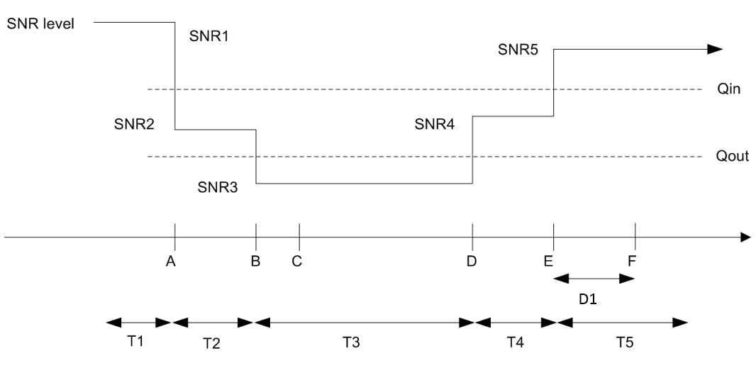
Figure G.2.3.1.2.1-1: SNR variation for in-sync testing

G.2.3.1.2.2 Test Requirements
The IAB-MT behaviour in each test during time durations T1, T2, T3, T4 and T5 shall be as follows:
During the period from time point A to time point F (D1 second after the start of time duration T5) the IAB-MT shall transmit uplink signal at least in all uplink slots configured for CSI transmission according to the configured periodic CSI reporting.
The rate of correct events observed during repeated tests shall be at least 90%.

G.2.3.1.3 Radio Link Monitoring Out-of-sync Test for FR2 PCell configured with SSB-based RLM RS in non-DRX mode

G.2.3.1.3.1 Test Purpose and Environment
The purpose of this test is to verify that the IAB-MT properly detects the out of sync and in sync for the purpose of monitoring downlink radio link quality of the PCell. This test will partly verify the FR2 radio link monitoring requirements in clause 12.3.1.
In the test, IAB-MT is configured to perform RLM on SSB, with detectionResource included in RadioLinkMonitoringRS set to SSB#0 and SSB#1, and purpose set to ‘rlf’. Supported test configurations are shown in table G.2.3.1.3.1-1. The test parameters are given in Tables G.2.3.1.3.1-2 and G.2.3.1.3.1-3 below. There is one cell (Cell 1), which is the active NR cell, in the test. The test consists of three successive time periods, with time duration of T1, T2 and T3 respectively. Figure G.2.3.1.3.1-1 shows the variation of the downlink SNR in the active cell to emulate out-of-sync and in-sync states, and Figure G.2.3.1.3.1-2 shows the Time multiplexed downlink transmissions from each Angle of Arrival. Prior to the start of the time duration T1, the IAB-MT shall be fully synchronized to Cell 1. The IAB-MT shall be configured for periodic CSI reporting with a reporting periodicity of 5 ms.
Table G.2.3.1.3.1-1: Supported test configurations for FR2 PCell
Configuration | Description
1 | TDD, SSB SCS 120 KHz, data SCS 120KHz, BW 100 MHz

Table G.2.3.1.3.1-2: General test parameters for FR2 out-of-sync testing in non-DRX mode
Parameter |  |  | Unit | Value
 |  |  |  | Test 1
Active PCell |  |  |  | Cell 1
RF Channel Number |  |  |  | 1
Duplex mode |  | Config 1 |  | TDD
BW_{channel} |  | Config 1 |  | 100: N_{RB,c} = 66
DL initial BWP configuration |  | Config 1 |  | DLBWP.0.1
DL dedicated BWP configuration |  | Config 1 |  | DLBWP.1.1
UL initial BWP configuration |  | Config 1 |  | ULBWP.0.1
UL dedicated BWP configuration |  | Config 1 |  | ULBWP.1.1
TDD Configuration |  | Config 1 |  | TDDConf.3.1
CORESET Reference Channel |  | Config 1 |  | CR.3.1 TDD
SSB Configuration |  | Config 1 |  | SSB.1 FR2
SMTC Configuration |  | Config 1 |  | SMTC.1
PDSCH/PDCCH subcarrier spacing |  | Config 1 |  | 120 KHz
PRACH Configuration |  | Config 1 |  | TBD
SSB index assigned as RLM RS |  | Config 1 |  | 0,1
OCNG parameters |  |  |  | OP.2
CP length |  |  |  | Normal
Out of sync transmission parameters | DCI format |  |  | 1-0
 | Number of Control OFDM symbols |  |  | 2
 | Aggregation level |  | CCE | 8
 | Ratio of hypothetical PDCCH RE energy to average SSS RE energy |  | dB | 4
 | Ratio of hypothetical PDCCH DMRS energy to average SSS RE energy |  | dB | 4
 | DMRS precoder granularity |  |  | REG bundle size
 | REG bundle size |  |  | 6
DRX |  |  |  | OFF
Layer 3 filtering |  |  |  | Enabled
T310 timer |  |  | ms | 0
T311 timer |  |  | ms | 1000
N310 |  |  |  | 1
N311 |  |  |  | 1
CSI-RS for CSI reporting |  | Config 1 |  | CSI-RS.3.1 TDD
TCI states for PDCCH/PDSCH |  |  |  | TCI.State.2
CSI-RS for tracking |  | Config 1 |  | TRS.2.1 TDD
T1 |  |  | s | 0.2
T2 |  |  | s | 4.88
T3 |  |  | s | 4.88
D1 |  |  | s | 4.84
Note 1: All configurations are assigned to the IAB-MT prior to the start of time period T1.
Note 2: IAB-MT-specific PDCCH is not transmitted after T1 starts.

Table G.2.3.1.3.1-3: OTA related cell specific test parameters for FR2 (Cell 1) for out-of-sync radio link monitoring tests in non-DRX mode
Parameter |  | Unit | Test 1
 |  |  | T1 | T2 | T3 | T1 | T2 | T3
AoA setup |  |  | Setup 2 as specified in clause G.1.8.2
 |  |  | AoA1 |  |  | AoA2
Assumption for IAB-MT beams ^{Note 5} |  |  | Rough |  |  | Rough
EPRE ratio of PDCCH DMRS to SSS |  | dB | 4 |  |  | Not sent
EPRE ratio of PDCCH to PDCCH DMRS |  | dB | 0
EPRE ratio of PBCH DMRS to SSS |  | dB
EPRE ratio of PBCH to PBCH DMRS |  | dB
EPRE ratio of PSS to SSS |  | dB
EPRE ratio of PDSCH DMRS to SSS |  | dB
EPRE ratio of PDSCH to PDSCH DMRS |  | dB
EPRE ratio of OCNG DMRS to SSS |  | dB
EPRE ratio of OCNG to OCNG DMRS |  | dB
ssb-Index 0 SNR | Config 1 | dB | 2^{Note 6} | -6^{Note 6} | -15
ssb-Index 1 SNR | Config 1 |  | Not sent |  |  | 2^{Note 6} | -15 | -15
SNR on other channels and signals | Config 1 | dB | 2^{Note 6} |  |  | N/A
 | Config 1 | dBm/  15kHz | -92.1 |  |  | -92.1
Time multiplexing of the downlink transmissions from each AoA |  |  | Defined in Figure G.2.3.1.3.1-2
Propagation condition |  |  | TDL-A 30ns 75Hz |  |  | TDL-A 30ns 75Hz
Note 1: OCNG shall be used such that the resources in Cell 1 are fully allocated and a constant total transmitted power spectral density is achieved for all OFDM symbols.
Note 2: The signal contains PDCCH for IAB-MTs other than the device under test as part of OCNG.
Note 3: SNR levels correspond to the signal to noise ratio over the SSS REs.
Note 4: The SNR values are specified for testing an IAB-MT which supports 2RX on at least one band. For testing of a IAB-MT which supports 4RX on all bands, the SNR during T3 is A.3.6 [6].
Note 5: Information about types of IAB-MT beam is given in B.2.1.3 [6] and does not limit IAB-MT implementation or test system implementation.
Note 6: This value allows up to 1dB degradation from applied SNR to IAB-MT baseband

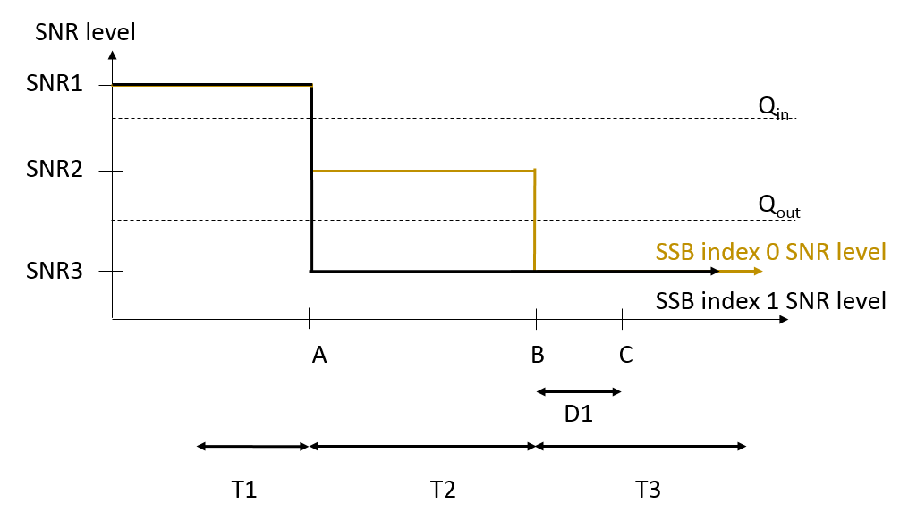
Figure G.2.3.1.3.1-1: SNR variation for out-of-sync testing
Figure G.2.3.1.3.1-2: Time multiplexed downlink transmissions

G.2.3.1.3.2 Test Requirements
The IAB-MT behavior in each test during time durations T1, T2 and T3 shall be as follows:
During the period from time point A to time point B the IAB-MT shall transmit uplink signal at least in all uplink slots configured for CSI transmission according to the configured periodic CSI reporting.
The IAB-MT shall stop transmitting uplink signal no later than time point C (D1 second after the start of the time duration T3).
The rate of correct events observed during repeated tests shall be at least 90%.

G.2.3.1.4 Radio Link Monitoring In-sync Test for FR2 PCell configured with SSB-based RLM RS in non-DRX mode

G.2.3.1.4.1 Test Purpose and Environment
The purpose of this test is to verify that the IAB-MT properly detects the out of sync and in sync for the purpose of monitoring downlink radio link quality of the PCell. This test will partly verify the FR2 radio link monitoring requirements in clause 12.3.1.
In the test, IAB-MT is configured to perform RLM on SSB, with detectionResource included in RadioLinkMonitoringRS set to SSB#0 and SSB#1, and purpose set to ‘rlf’. Supported test configurations are shown in table G.2.3.1.4.1-1. The test parameters are given in Tables G.2.3.1.4.1-2, and G.2.3.1.4.1-3 below. There is one cell (Cell 1), which is the active cell, in the test. The test consists of five successive time periods, with time duration of T1, T2, T3, T4 and T5 respectively. Figure G.2.3.1.4.1-1 shows the variation of the downlink SNR in the active cell to emulate out-of-sync and in-sync states, and Figure G.2.3.1.4.1-2 shows the Time multiplexed downlink transmissions from each Angle of Arrival. Prior to the start of the time duration T1, the IAB-MT shall be fully synchronized to Cell 1. Prior to the start of the time duration T1, the IAB-MT shall be fully synchronized to Cell 1. The IAB-MT shall be configured for periodic CSI reporting with a reporting periodicity of 5 ms.
Table G.2.3.1.4.1-1: Supported test configurations for FR2 PCell
Configuration | Description
1 | TDD, SSB SCS 120 KHz, data SCS 120KHz, BW 100 MHz

Table G.2.3.1.4.1-2: General test parameters for FR2 in-sync testing in non-DRX mode
Parameter |  |  | Unit | Value
 |  |  |  | Test 1
Active PCell |  |  |  | Cell 1
RF Channel Number |  |  |  | 1
Duplex mode |  | Config 1 |  | TDD
BW_{channel} |  | Config 1 |  | 100: N_{RB,c} = 66
DL initial BWP configuration |  | Config 1 |  | DLBWP.0.1
DL dedicated BWP configuration |  | Config 1 |  | DLBWP.1.1
UL initial BWP configuration |  | Config 1 |  | ULBWP.0.1
UL dedicated BWP configuration |  | Config 1 |  | ULBWP.1.1
TDD Configuration |  | Config 1 |  | TDDConf.3.1
CORESET Reference Channel |  | Config 1 |  | CR.3.1 TDD
SSB Configuration |  | Config 1 |  | SSB.1 FR2
SMTC Configuration |  | Config 1 |  | SMTC.3
PDSCH/PDCCH subcarrier spacing |  | Config 1 |  | 120 KHz
PRACH Configuration |  | Config 1 |  | TBD
SSB index assigned as RLM RS |  | Config 1 |  | 0,1
OCNG parameters |  |  |  | OP.2
CP length |  |  |  | Normal
In sync transmission parameters | DCI format |  |  | 1-0
 | Number of Control OFDM symbols |  |  | 2
 | Aggregation level |  | CCE | 4
 | Ratio of hypothetical PDCCH RE energy to average SSS RE energy |  | dB | 0
 | Ratio of hypothetical PDCCH DMRS energy to average SSS RE energy |  | dB | 0
 | DMRS precoder granularity |  |  | REG bundle size
 | REG bundle size |  |  | 6
Out of sync transmission parameters | DCI format |  |  | 1-0
 | Number of Control OFDM symbols |  |  | 2
 | Aggregation level |  | CCE | 8
 | Ratio of hypothetical PDCCH RE energy to average SSS RE energy |  | dB | 4
 | Ratio of hypothetical PDCCH DMRS energy to average SSS RE energy |  | dB | 4
 | DMRS precoder granularity |  |  | REG bundle size
 | REG bundle size |  |  | 6
DRX |  |  |  | OFF
Layer 3 filtering |  |  |  | Enabled
T310 timer |  |  | ms | 4000
T311 timer |  |  | ms | 1000
N310 |  |  |  | 1
N311 |  |  |  | 1
CSI-RS for CSI reporting |  | Config 1 |  | CSI-RS.3.1 TDD
TCI states for PDCCH/PDSCH |  |  |  | TCI.State.2
CSI-RS for tracking |  | Config 1 |  | TRS.2.1 TDD
T1 |  |  | s | 0.2
T2 |  |  | s | 0.2
T3 |  |  | s | 4.84
T4 |  |  | s | 0.2
T5 |  |  | s | 7.84
D1 |  |  | s | 7.8
Note 1: All configurations are assigned to the IAB-MT prior to the start of time period T1.
Note 2: IAB-MT-specific PDCCH is not transmitted after T1 starts.

Table G.2.3.1.4.1-3: OTA related cell specific test parameters for FR2 (Cell 1) for in-sync radio link monitoring tests in non-DRX mode
Parameter |  | Unit | Test 1
 |  |  | T1 | T2 |  | T3 |  | T4 |  | T5 |  | T1 |  | T2 |  | T3 |  | T4 |  | T5
AoA setup |  |  | Setup 2 as specified in clause G.1.8.2
 |  |  | AoA1 |  |  |  |  |  |  |  |  |  | AoA2
Assumption for IAB-MT beams ^{Note 5} |  |  | Rough |  |  |  |  |  |  |  |  |  | Rough
EPRE ratio of PDCCH DMRS to SSS |  | dB | 4 |  |  |  |  |  |  |  |  |  | Not sent
EPRE ratio of PDCCH to PDCCH DMRS |  | dB | 0
EPRE ratio of PBCH DMRS to SSS |  | dB
EPRE ratio of PBCH to PBCH DMRS |  | dB
EPRE ratio of PSS to SSS |  | dB
EPRE ratio of PDSCH DMRS to SSS |  | dB
EPRE ratio of PDSCH to PDSCH DMRS |  | dB
EPRE ratio of OCNG DMRS to SSS |  | dB
EPRE ratio of OCNG to OCNG DMRS |  | dB
ssb-Index 0 SNR | Config 1 | dB | 2^{Note 6} |  | -6^{Note 6} |  | -15 |  | -4.5 |  | 2^{Note 6}
ssb-Index 1 SNR | Config 1 |  | Not sent |  |  |  |  |  |  |  |  |  | 2^{Note 6} |  | -15 |  | -15 |  | -15 |  | -15
SNR on other channels and signals | Config 1 | dB | 2^{Note 6} |  |  |  |  |  |  |  |  |  | N/A
 | Config 1 | dBm/  15kHz | -92.1 |  |  |  |  |  |  |  |  |  | -92.1
Time multiplexing of the downlink transmissions from each AoA |  |  | Defined in Figure G.2.3.1.4.1-2
Propagation condition |  |  | TDL-A 30ns 75Hz |  |  |  |  |  |  |  |  |  | TDL-A 30ns 75Hz
Note 1: OCNG shall be used such that the resources in Cell 1 are fully allocated and a constant total transmitted power spectral density is achieved for all OFDM symbols.
Note 2: The signal contains PDCCH for IAB-MTs other than the device under test as part of OCNG.
Note 3: SNR levels correspond to the signal to noise ratio over the SSS REs.
Note 4: The SNR values are specified for testing an IAB-MT which supports 2RX on at least one band. For testing of a IAB-MT which supports 4RX on all bands, the SNR during T3 is A.3.6 [6].
Note 5: Information about types of IAB-MT beam is given in B.2.1.3 [6] and does not limit IAB-MT implementation or test system implementation.
Note 6: This value allows up to 1dB degradation from applied SNR to IAB-MT baseband

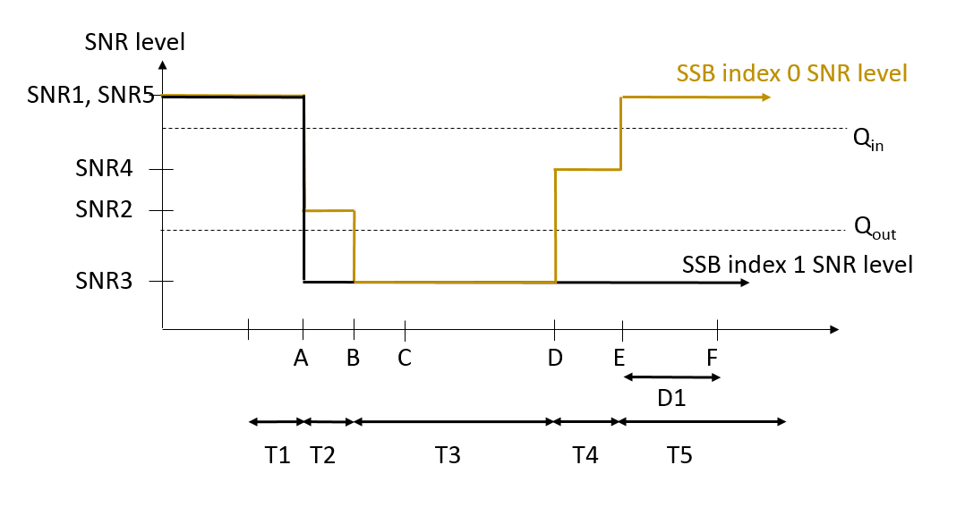
Figure G.2.3.1.4.1-1: SNR variation for in-sync testing
Figure G.2.3.1.4.1-2: Time multiplexed downlink transmissions

G.2.3.1.4.2 Test Requirements
The IAB-MT behaviour in each test during time durations T1, T2, T3, T4 and T5 shall be as follows:
During the period from time point A to time point F (D1 second after the start of time duration T5) the IAB-MT shall transmit uplink signal at least in all uplink slots configured for CSI transmission according to the configured periodic CSI reporting.
The rate of correct events observed during repeated tests shall be at least 90%.

< End of change 1>

