3GPP TSG-RAN WG4 Meeting # 98-e-Bis R4-200XXXX
Electronic Meeting, Jan. 25 – Feb. 5, 2021

Agenda item: 4.7
Source: Moderator (Huawei, HiSilicon)
Title: Email discussion summary for [98e Bis][201] NR_NewRAT_RRM_Core
Document for: Information

Introduction
In this email thread for Rel-15 NR RRM core requirement, we will treat the following topics:
- RRM measurements:
  - CSSF calculation for inter-RAT measurement in EN-DC,
  - MO merging,
  - SMTC1 and SMTC2 differentiation,
  - deactivated SCell measurement requirement for intra-frequency measurement with MG
- SCell activation:
  - Maintenance for SCell activation requirements
  - SSB-less SCell activation
- Beam management: correction of filter for beam failure detection
- BWP switching: Applicability of RRC based BWP switch delay requirement in Rel-15
- Active TCI state switching
- Interruption due to measurement on SCC
- Maintenance for intra-frequency E-CID
- Maintenance for idle mode requirements

Topic #1: RRM measurement

Companies’ contributions summary
T-doc number | Company | Proposals / Observations
R4-2100172 | Apple | Further discussion on CSSF for R15 EN-DC  Proposal 1: When inter-RAT MO is not on any NR serving CC, inter-RAT measurement is always performed within MG.  Proposal 2: for R15 we propose an implementation #2 for EN-DC, that is,  When inter-RAT MO is on a NR serving CC, inter-RAT measurements are performed in the same way as NR intra-frequency measurement, i.e., it can be within or outside MG depending on whether SSB is contained in the active BWP, and whether SMTC is fully overlapping with MG.  Proposal 3: RAN4 further discuss in R16 that whether the implementation 2 could be used for inter-RAT measurement on NR non-serving CC.  Proposal 4: adopt Option 2a: count the NR inter-RAT MO on NR serving CC configured by LTE MN that can be measured without MG in CSSF outside MG and remove the inter-RAT MOs counted in CSSF outside MG from CSSF within MG. One note could be added into R15 spec that, “longer delays for cell identification and measurement periods derived based on CSSFwithin_gap,i can be expected, if the UE is configured with inter-RAT MO on NR serving CC by E-UTRAN PCell in EN-DC mode”.  Proposal 5: for calculation of CSSF outside MG, adopt Option 1a:  to consider merging of intra-frequency MO configured by NR SN and inter-RAT MO configured by LTE MN on the same serving frequency that are measured without MG, based on MO merging conditions in clause 9.1.3.2 of 38.133.  Proposal 6: for calculation of CSSF within MG, adopt Option 1a:  to consider merging of two MOs configured by LTE MN and NR SN on the same frequency that are measured within MG, based on MO merging conditions in clause 9.1.3.2 of 38.133.
R4-2100173 | Apple | CR on CSSF for EN-DC R15 (38.133 Section 9.1.5.1, 9.1.5.2)  The CSSF requirement has been updated for EN-DC to consider the MOs configured from both LTE MN and NR SN in EN-DC.  (Tdoc numbers of Rel-16, Rel-17 CRs are missing)
R4-2102536 | Ericsson | On correction to inter-RAT CSSF  Observation 1: Double counting in both CSSFwithin_gap and CSS_outside_gap is not acceptable.  Observation 2: From the Rel-15 reporting criteria requirements, it is clear that regardless of the configuring node the measurements on serving NR carriers are NR intra-frequency measurements, not inter-RAT measurements.  Proposal 1: RAN4 should initially discuss the technical solution for CSSF scaling of interRAT measurement objects configured by the LTE PCell.  Observation 3: The discussion in [1] does not consider (intra-frequency) measurements on NR serving carriers, which are configured by LTE PCell and require measurement gaps.  Proposal 2: Reject Option 1.  Proposal 3: Reject Option 2b.  Proposal 4 : RAN4 should agree Option 2a (i.e., count in CSSF outside MG the NR inter-RAT MO on NR serving CC configured by LTE MN that can be measured without MG and remove from CSSF within MG the inter-RAT MOs counted in CSSF outside MG.  o NOTE: This option applies in the case that it is possible to make non-gap based measurements, i.e. SSB is contained within the active BWP and the SMTC is not fully overlapping with the active BWP.  Proposal 5: Implementations which are certified prior to RAN#95 are allowed to include inter-RAT MOs counted in CSSF outside MG also in CSSF within MG.  Proposal 6: In calculation of CSSF outside MG: if MOs configured by MN and SN are merged from a capabilities perspective they are also counted only once in CSSF outside MG.  Proposal 7: In calculation of CSSF within MG: if MOs configured by MN and SN are merged from a capabilities perspective they are also counted only once in CSSF outside MG.
R4-2102827 | Ericsson | Correction to inter-RAT CSSF (38.133, Section 9.1.5.1)  Add to the definition of CSSFoutside_gap to explicitly exclude a single merged MO which is both an LTE interRAT MO and an NR intrafrequency MO:  If an NR intra-frequency measurement object configured by PSCell and a NR inter-RAT measurement objects configured by E-UTRA PCell are for the same NR carrier frequency layer and all measurement object merging conditions defined in clause 9.1.3.2 are satisfied, it shall be counted in CSSF_{within_gap,I} as specified in clause 9.1.5.2.1 and shall not be counted in CSSF_{outside_gap} as specified in this clause. Editors note : Implementations certified prior to RAN#95 may count such measurement objects in either CSSF_{outside_gap} or CSSF_{within_gap,I}.  Add to the definition of CSSFwithin_gap for EN-DC : For synchronous intra-band EN-DC, if an NR inter-frequency measurement object configured by PSCell and a NR inter-RAT measurement objects configured by E-UTRA PCell are for the same NR carrier frequency layer and all measurement object merging conditions defined in clause 9.1.3.2 are satisfied, they shall be counted only once in M_{inter,i,j}.  Add similar text to the definition of M_{groupBi,j}. in NE-DC requirements.
R4-2102537 | Ericsson | Correction to inter-RAT CSSF  Cat A CR
R4-2102538 | Ericsson | Correction to inter-RAT CSSF  Cat A CR
R4-2101051 | MediaTek inc. | CR on R15 remaining issues (38.133 Section 8.1.2.2)  1. Clarify that the SSB-ToMeasure indications shall be the union of all MOs which can be merged.  2. Define the minimum requirement when both SSB and CSI-RS for L1-RSRP measurement are configured.  3. Clarify SFTD measurement reporting delay including measurement period plus the RRC procedure delay  4. Some editorial changes.
R4-2101052 | MediaTek inc. | CR on R15 remaining issues  Cat A CR
R4-2101053 | MediaTek inc. | CR on R15 remaining issues  Cat A CR
R4-2102737 | Huawei, HiSilicon | Discussion on CSSF for inter-RAT measurement, SCell activation delay and cell identification requirements on deactivated SCell in Rel-15  Proposal 5: For scenarios where UE is not assumed to perform cell detection on the target SCell, the SCell activation requirements apply provided that SSB offset is same on the target SCell and the active serving cell.  Proposal 6: Scaling factor Kp shall be added for deactivated SCell measurement requirements without gap in R15.  Proposal 7: The measurement requirements for deactivated SCell with gap shall be added in R15.  Proposal 8: For R15, it is left to UE implementation whether to perform NR inter-RAT measurements on NR serving carrier within MG or outside MG. However, this measurement can only be counted once either in calculation of CSSF_within_MG or CSSF_outside_MG. And for R16 and later release, UE shall perform NR inter-RAT measurements on NR serving carrier outside MG.  Proposal 9: For calculation of CSSF_within_MG and CSSF_outside_MG, measurements configured by LTE PCell and NR PSCell on the same NR carrier are counted as one candidates if they satisfy MO merging condition.
R4-2101050 | MediaTek inc. | Remaining issues on RRM in R15  Proposal 4: In EN-DC, the NR Inter-RAT MOs of measurements without MG configured by LTE MN shall be moved to the CSSF outside MG from CSSF within MG.  Proposal 5: The same MO merging condition shall be applied for the Inter-RAT MO configured by LTE MN and intra-frequency MO configured by NR SN.
R4-2100178 | Apple | CR on smtc1 and smtc2 differentiation in intra-frequency measurement with MG R15 (38.133 Section 9.2.6)  Add condition of smtc1 and smtc2 differentiation in intra-frequency measurement with MG.
R4-2100179 | Apple | CR on smtc1 and smtc2 differentiation in intra-frequency measurement with MG R16  Cat A CR
R4-2100180 | Apple | CR on smtc1 and smtc2 differentiation in intra-frequency measurement with MG R17  Cat A CR
R4-2100851 | CMCC | Discussion on deactivated SCell measurement for intra-frequency measurement with measurement gap  Observation 1: for intra-f measurement without MG, TS38.133 explicitly specify the time period for PSS/SSS detection, time period for time index detection, measurement period for deactivated SCell  Observation 2: for intra-f measurement with MG, it seems that the time period for PSS/SSS detection, time period for time index detection, measurement period for deactivated SCell are not specified.  Proposal 1: for the scenario of intra-f measurement with MG, it is necessary to specify the requirements for PSS/SSS detection, time index detection and measurement period for deactivated SCell.
R4-2100852 | CMCC | CR on deactivated SCell measurement for intra-frequency measurement with measurement gap (38.133, Section 9.2.5, 9.2.6)  1. Correct the caption for the time period for PSS/SSS detection, deactivated SCell (FR2) for intra-frequency measurement without MG  2. Specify the requirements on PSS/SSS detection, time index detection and measurement for deactivated SCell for intra-frequency measurement with MG.
R4-2100853 | CMCC | CR on deactivated SCell measurement for intra-frequency measurement with measurement gap  Cat A CR (Tdoc number for Rel-17 Cat CR)
R4-2102738 | Huawei, HiSilicon | CR on SCell activation delay, cell idenfication requirements on deactivated SCell and inter-RAT ECID requirements for NE-DC R15 (38.133, Section 8.3.2, 9.4.1, 9.4.5, 9.2.5, 9.2.6)  1. Update the SCell activation requriements  a) Clarifiy that current activation requirements do not apply when SCellSSB is outside frist active BWP  b) Clarify the condition for FR2 SSB-less SCell activation requirements  c) Add FR1 SSB-less SCell activation requirements  d) Clarifythe meaning of SCell measurement cycle” in FR1 known SCell activation requirements  e) Clarify that for scenarios where UE is not assumed to perform cell detection on the target SCell, requirements apply provided that SSB offset is same on the target SCell and the active or known serving cell.  2. Update the applicable requriements for NR – LTE inter-RAT E-CID measurement on LTE serving frequencies in NE-DC, such that the LTE SA intra-frequency requirements apply.  3. For deactivated SCell measurement:  -Adding scaling factor Kp for deactivated SCell measurement requirements without gap;  -Adding measurement requirements for deactivated SCell with gap
R4-2102739 | Huawei, HiSilicon | CR on SCell activation delay, cell idenfication requirements on deactivated SCell and inter-RAT ECID requirements for NE-DC R16  Cat A CR
R4-2102740 | Huawei, HiSilicon | CR on SCell activation delay, cell idenfication requirements on deactivated SCell and inter-RAT ECID requirements for NE-DC R17  Cat A CR

Open issues summary

Sub-topic 1-1 CSSF calcualtion for Inter-RAT measurement objective in EN-DC
Issue 1-1-1: How to treat the issue whether to count inter-RAT MO in CSSF outside MG or CSSF within MG?
- Proposals
  - Option 1 (Apple R4-2100172):
    - When inter-RAT MO is not on any NR serving CC, inter-RAT measurement is always performed within MG.
    - for R15 we propose an implementation #2 for EN-DC, that is,
When inter-RAT MO is on a NR serving CC, inter-RAT measurements are performed in the same way as NR intra-frequency measurement, i.e., it can be within or outside MG depending on whether SSB is contained in the active BWP, and whether SMTC is fully overlapping with MG.
    - RAN4 further discuss in R16 that whether the implementation 2 could be used for inter-RAT measurement on NR non-serving CC.
  - Option 2 (Huawei R4-2102737):
    - For R15, it is left to UE implementation whether to perform NR inter-RAT measurements on NR serving carrier within MG or outside MG. However, this measurement can only be counted once either in calculation of CSSF_within_MG or CSSF_outside_MG. And for R16 and later release, UE shall perform NR inter-RAT measurements on NR serving carrier outside MG.
  - Option 3 (Ericsson R4-2102536):
    - RAN4 should initially discuss the technical solution for CSSF scaling of interRAT measurement objects configured by the LTE PCell.
- Recommended WF
  - TBA

Issue 1-1-2: Whether/how to count CSSF outside MG and CSSF within MG
- Proposals
  - Alternative 1(Apple R4-2100172):
    - Adopt Option 2a: count the NR inter-RAT MO on NR serving CC configured by LTE MN that can be measured without MG in CSSF outside MG and remove the inter-RAT MOs counted in CSSF outside MG from CSSF within MG. One note could be added into R15 spec that, “longer delays for cell identification and measurement periods derived based on CSSFwithin_gap,i can be expected, if the UE is configured with inter-RAT MO on NR serving CC by E-UTRAN PCell in EN-DC mode”.
    - for calculation of CSSF outside MG, adopt Option 1a:
to consider merging of intra-frequency MO configured by NR SN and inter-RAT MO configured by LTE MN on the same serving frequency that are measured without MG, based on MO merging conditions in clause 9.1.3.2 of 38.133.
    - for calculation of CSSF within MG, adopt Option 1a:
to consider merging of two MOs configured by LTE MN and NR SN on the same frequency that are measured within MG, based on MO merging conditions in clause 9.1.3.2 of 38.133.
  - Alternative 2 (Ericsson R4-2102536):
    - RAN4 should agree Option 2a (i.e., count in CSSF outside MG the NR inter-RAT MO on NR serving CC configured by LTE MN that can be measured without MG and remove from CSSF within MG the inter-RAT MOs counted in CSSF outside MG.
NOTE: This option applies in the case that it is possible to make non-gap based measurements, i.e. SSB is contained within the active BWP and the SMTC is not fully overlapping with the active BWP.
    - Implementations which are certified prior to RAN#95 are allowed to include inter-RAT MOs counted in CSSF outside MG also in CSSF within MG.
    - In calculation of CSSF outside MG: if MOs configured by MN and SN are merged from a capabilities perspective they are also counted only once in CSSF outside MG.
    - In calculation of CSSF within MG: if MOs configured by MN and SN are merged from a capabilities perspective they are also counted only once in CSSF outside MG.
  - Alternative 3 (Huawei R4-2102737):
    - However, this measurement can only be counted once either in calculation of CSSF_within_MG or CSSF_outside_MG. And for R16 and later release, UE shall perform NR inter-RAT measurements on NR serving carrier outside MG.
    - For calculation of CSSF_within_MG and CSSF_outside_MG, measurements configured by LTE PCell and NR PSCell on the same NR carrier are counted as one candidates if they satisfy MO merging condition.
  - Alternative 4 (Mediatek R4-2101050)
    - In EN-DC, the NR Inter-RAT MOs of measurements without MG configured by LTE MN shall be moved to the CSSF outside MG from CSSF within MG.
    - The same MO merging condition shall be applied for the Inter-RAT MO configured by LTE MN and intra-frequency MO configured by NR SN.
- Recommended WF
  - Seems Option 2a in previous meeting is acceptable.
  - It seems agreeable that in both CSSF outside MG band CSSF within MG, if MOs configured by MN and SN can satisfy MO merging condition, the measurements should be counted once.

Sub-topic 1-2 MO merging related to SSB-ToMeasurement indications
Issue 1-2: MO merging related to SSB-ToMeasurement indications
- Proposals (Mediatek RP-2101051)
  - Clarify that the SSB-ToMeasure indications shall be the union of all MOs which can be merged.
  - The following changes are proposed for Section 8.1.2.2, 8.1.3.2, 8.5.2.2, 8.5.3.2, 8.5.5.2, 8.5.6.2, 9.5.4.1, 9.5.4.2
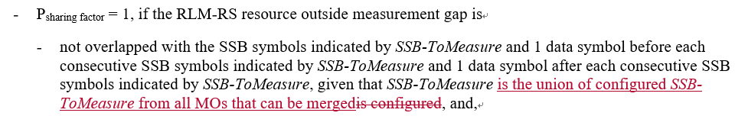
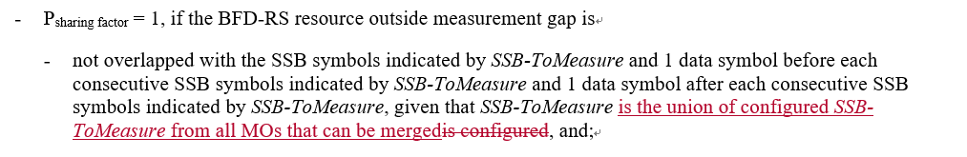
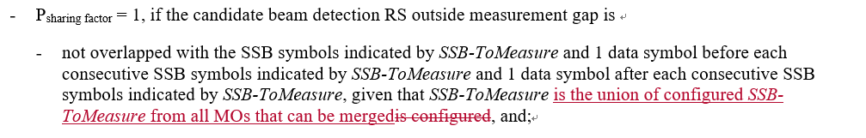
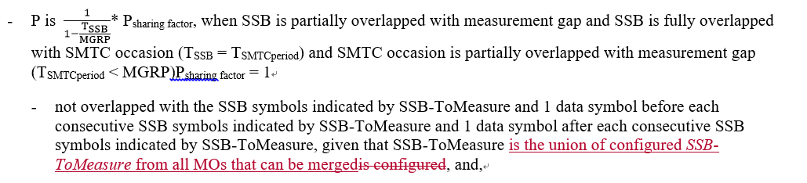
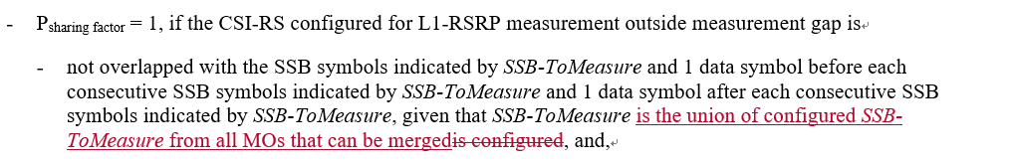
- Recommended WF
  - TBA

Sub-topic 1-3 SMTC1 and SMTC2 differentiation
Issue 1-3: SMTC1 and SMTC2 differentiation in intra-frequency measurement with MG
- Proposals (Apple R4-2100178)
  - Add condition of smtc1 and smtc2 differentiation in intra-frequency measurement with MG.
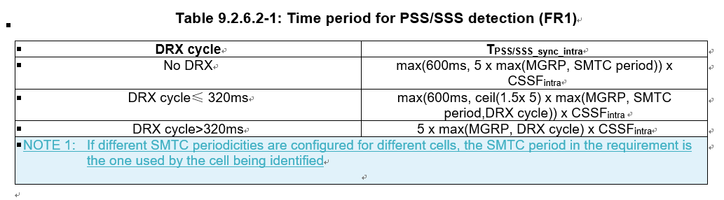
- Conclusion:
  - According to Chair (Andrey) guidance, this CR is postponed. So there is no need to discuss the topic in this meeting.

Sub-topic 1-4 deactivated SCell measurement for intra-frequency measurement with measurement gap
Issue 1-4: deactivated SCell measurement for intra-frequency measurement with MG
- Proposals
  - Option 1 (CMCC R4-21200851/2/3): for the scenario of intra-f measurement with MG, it is necessary to specify the requirements for PSS/SSS detection, time index detection and measurement period for deactivated SCell.
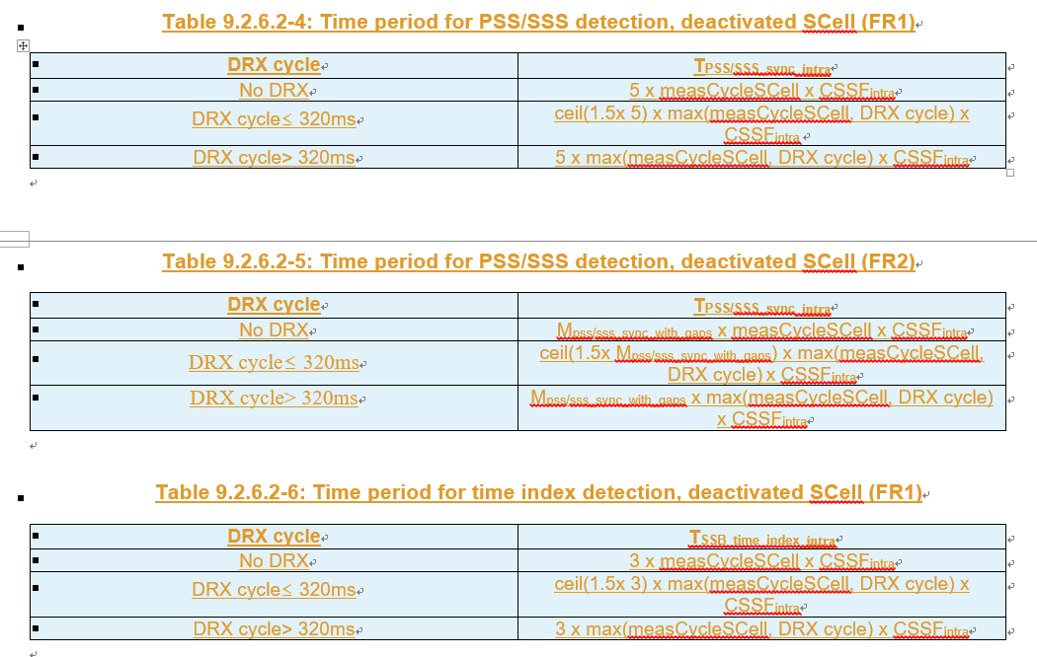
  - Option 2 (Huawei R4-2002737/38/39/40:
    - Scaling factor Kp shall be added for deactivated SCell measurement requirements without gap in R15.
    - The measurement requirements for deactivated SCell with gap shall be added in R15.
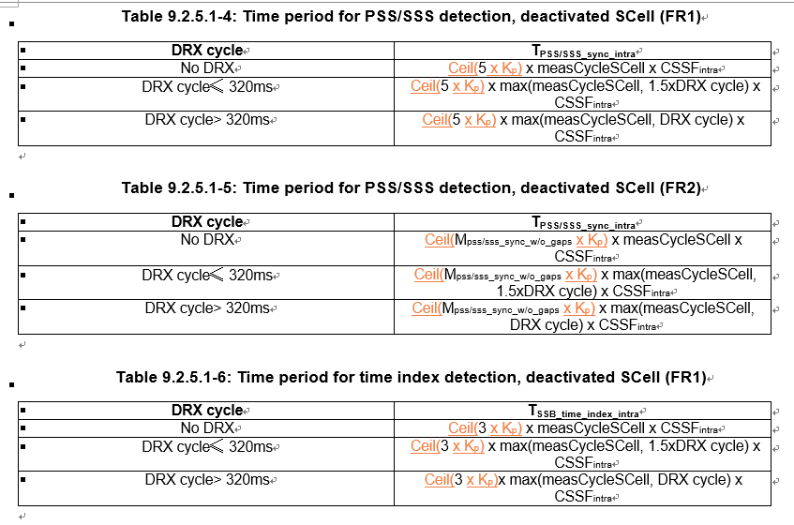
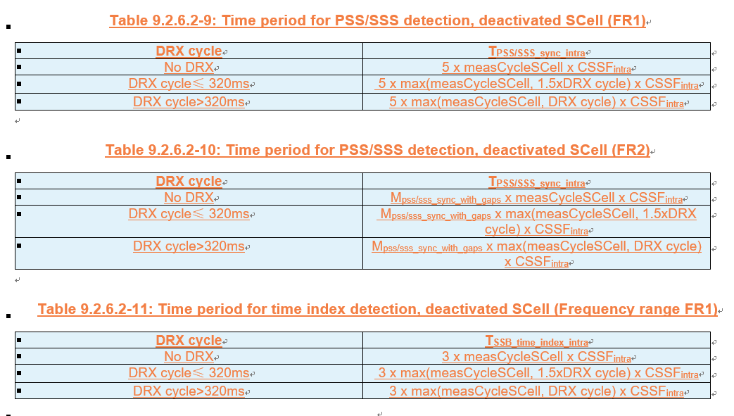
- Recommended WF
  - TBA

Companies views’ collection for 1st round

Open issues
Company | Comments
Apple | Sub topic 1-1:  Issue 1-1-1: we proposed option 1. We think it’s better to capture a clear UE behavior in spec, but for earlier R15 UE we could add a note in spec to allow some requirement relaxation.  Issue 1-1-2: alt 1 and alt 2 is quite similar, and we support alt1/2. We can further discuss the wording in the CR. We also support recommended WF.  Sub topic 1-2:  Issue 1-2: we are fine with MTK proposals.  ….  Sub topic 1-4:  Issue 1-4: We think deactivated SCell measurement does not belong to intra-frequency measurement with MG, since deactivated SCell does not have active BWP and the measurement of deactivated SCell would only cause possible interruption rather than using MG.  We think deactivated SCell measurement is still one kind of intra-frequency measurement without MG. So, we think it’s not necessary to introduce new requirement tables for deactivated SCell measurement into the section of “intra-frequency measurement with MG”.  Others:
Ericsson | Issue 1-1-1: How to treat the issue whether to count inter-RAT MO in CSSF outside MG or CSSF within MG?  Options 1 and 2 are incorrect as a measurement on a serving carrier is an inter-frequency measurements, not an inter-RAT measurement.This is clear already from the Rel-15 reporting criteria requirements and it applies regardless of which node is configuring the measurements on serving NR carriers.  Issue 1-1-2: Whether/how to count CSSF outside MG and CSSF within MG  We support Option 2a, with additional comditions:  - In calculation of CSSF outside MG: if MOs configured by MN and SN are merged from a capabilities perspective they are also counted only once in CSSF outside MG.  - In calculation of CSSF within MG: if MOs configured by MN and SN are merged from a capabilities perspective they are also counted only once in CSSF outside MG.  If the additional conditions are also the intention in the recommended WF, we support the recommended WF (unclear about whether counted only once in CSSF outside MG).  Issue 1-2: MO merging related to SSB-ToMeasurement indications  The intention is clear but the wording is not. Better make it clearer that this applies for DC scenarios.  Issue 1-3: SMTC1 and SMTC2 differentiation in intra-frequency measurement with MG  We are OK with the proposal.  Issue 1-4: deactivated SCell measurement for intra-frequency measurement with MG  Baseline for deactivated SCell measurements is measurements without gaps. Agree that in case MGs used by UE for other measurements would collide with SMTC for deactivated SCell, it will impact the cell identification time on the SCC due to the assumed searcher limitation. In case SMTC and MG collide occasionally, scaling by Kp may be adequate. If they collide all the time, scaling by CSSF may be adequate since the deactivated SCell measurement then would be fully competing with the other, gap-based, measurements for the resources during the measurement gap. We are OK with Option 2.

CRs/TPs comments collection
Please provide additional comments, if any, on CRs below for the issues in Sub-topic 1-1 CSSF calculation
CR/TP number | Comments collection
R4-2100173 | Moderator: No Tdoc numbers are reserved for Rel-16 and Rel-17 Cat A CRs.
 | Apple: clarify to moderator: the R16 CR would be quite different from R15 since we have CSI-RS L3 MO and inter-frequency without MG MO in R16. Perhaps we would have discussion paper and cat-F CR for R16 case in next meeting.
 | Ericsson: Suggest to wait until sub-topic 1-1 has been settled.
R4-2102827  R4-2102537  R4-2102538 | Ericsson: Suggest to wait until sub-topic 1-1 has been settled.
 | Company B

Please provide additional comments, if any, on CRs below for the issues for sub-topic 1-2. Please focus on MO merging.
CR/TP number | Comments collection
R4-2101050  R4-2101051  R4-2101052 | Apple: fine with the CR
 | Ericsson: Please see our comment for sub-topic 1-2. We think that the wording needs to be improved to make it clearer.

Please provide additional comments on CRs below for the issues for sub-topic 1-4. Please focus on deactivated SCell requirements.
CR/TP number | Comments collection
R4-2100852  R4-2100853 | Moderator: No Tdoc number is reserved for Rel-17 Cat A CRs.
 | Apple: same comment as to issue 1-4
 | Ericsson: It seems to us that Huawei’s proposal is more adequately addressing the issue, but let us not forego the discussion for sub-topic 1-4; let us wait with the CRs until the discussion has been settled.
R4-2102738  R4-2102739  R4-2102740 | Apple: same comment as to issue 1-4
 | Ericsson: Please see our comment above.

Summary for 1st round

Open issues
Moderator tries to summarize discussion status for 1st round, list all the identified open issues and tentative agreements or candidate options and suggestion for 2nd round i.e. WF assignment.
 | Status summary
Sub-topic#1 | Tentative agreements:  Candidate options:  Recommendations for 2nd round:

Recommendations on WF/LS assignment
 | WF/LS t-doc Title | Assigned Company,  WF or LS lead
#1

CRs/TPs
Moderator tries to summarize discussion status for 1st round and provides recommendation on CRs/TPs Status update
CR/TP number | CRs/TPs Status update recommendation
XXX | Based on 1st round of comments collection, moderator can recommend the next steps such as “agreeable”, “to be revised”

Discussion on 2nd round (if applicable)

Summary on 2nd round (if applicable)
Moderator tries to summarize discussion status for 2nd round and provided recommendation on CRs/TPs/WFs/LSs Status update suggestion
CR/TP/LS/WF number | T-doc Status update recommendation
XXX | Based on 2nd round of comments collection, moderator can recommend the next steps such as “agreeable”, “to be revised”

Topic #2: Scell activation

Companies’ contributions summary
T-doc number | Company | Proposals / Observations
R4-2101006 | Apple | CR on Scell activation delay maintenance (R15) (38.133, Section 8.3)  1. Update the condition in SCell activation delay requirements for known target cell in FR1
R4-2101007 | Apple | CR on Scell activation delay maintenance (R16)  Cat A CR
R4-2101008 | Apple | CR on Scell activation delay maintenance (R17)  Cat A CR
R4-2102737 | Huawei, HiSilicon | Discussion on CSSF for inter-RAT measurement, SCell activation delay and cell identification requirements on deactivated SCell in Rel-15  Proposal 1: The current SCell activation requirements, except those for SSB-less SCell, apply provided that the SSB of the to-be-activated SCell is within the first active DL BWP of the SCell.  Proposal 2: RAN4 to clarify that the condition “is not provided with any SMTC for the target SCell” means UE is not provided with SSB configuration for the SCell (absoluteFrequencySSB is absent).  Proposal 3: If UE is not provided with SSB configuration for the SCell in FR1, Tactivation_time is 3 ms provided  - The target SCell is contiguous to an active serving cell in the same band, and  - The TypeA QCL for the target SCell is configured to the active serving cell, and  - The RTD between the target SCell and the active serving cell is <= CP/2  Proposal 4: Clarify that  “SCell measurement cycle is equal to or smaller than 160ms”  in FR1 known SCell activation requirements means  “the SCell has been measured within the last 160ms according to the measurement requirements defined for deactivated SCell in clause 9.2”.  Proposal 5: For scenarios where UE is not assumed to perform cell detection on the target SCell, the SCell activation requirements apply provided that SSB offset is same on the target SCell and the active serving cell.
R4-2102738 | Huawei, HiSilicon | CR on SCell activation delay, cell idenfication requirements on deactivated SCell and inter-RAT ECID requirements for NE-DC R15 (38.133, Section 8.3.2, 9.4.1, 9.4.5, 9.2.5, 9.2.6)  1. Update the SCell activation requriements  a) Clarifiy that current activation requirements do not apply when SCellSSB is outside frist active BWP  b) Clarify the condition for FR2 SSB-less SCell activation requirements  c) Add FR1 SSB-less SCell activation requirements  d) Clarifythe meaning of SCell measurement cycle” in FR1 known SCell activation requirements  e) Clarify that for scenarios where UE is not assumed to perform cell detection on the target SCell, requirements apply provided that SSB offset is same on the target SCell and the active or known serving cell.  2. Update the applicable requriements for NR – LTE inter-RAT E-CID measurement on LTE serving frequencies in NE-DC, such that the LTE SA intra-frequency requirements apply.  3. For deactivated SCell measurement:  -Adding scaling factor Kp for deactivated SCell measurement requirements without gap;  -Adding measurement requirements for deactivated SCell with gap
R4-2102739 | Huawei, HiSilicon | CR on SCell activation delay, cell idenfication requirements on deactivated SCell and inter-RAT ECID requirements for NE-DC R16  Cat A CR
R4-2102740 | Huawei, HiSilicon | CR on SCell activation delay, cell idenfication requirements on deactivated SCell and inter-RAT ECID requirements for NE-DC R17  Cat A CR
R4-2100174 | Apple | On SSB-less SCell activation  Proposal 1: If RAN4 agrees to introduce the requirement for FR1 SSB-less SCell activation in R15, only the intra-band contiguous case shall be considered.  Proposal 2: if RAN4 agrees to introduce the FR1 SSB-less SCell activation for intra-band NC case in R16, the 3ms activation delay requirement only applies when time difference between active serving cell and intra-band NC to-be-activated SCell is less than 260ns.  Proposal 3: the FR2 SCell activation without SMTC shall be revised as,  If the SCell being activated belongs to FR2 and if there is at least one active serving cell on that FR2 band, if the UE supporting scellWithoutSSB is not provided with any SMTC for the target SCell, T_{activation_time} is 3 ms, provided  - the RS (s) of SCell being activated is (are) QCL-TypeD with RS (s) of one active serving cell on that FR2 band.
R4-2100175 | Apple | CR on FR2 SCell activation requirement R15 (38.133, Section 8.3.2)  Revision the wording for current FR2 SCell activation for the case when UE supporting scellWithoutSSB is not provided with any SMTC for the target SCell
R4-2100176 | Apple | CR on FR2 SCell activation requirement R16  Cat A CR
R4-2100177 | Apple | CR on FR2 SCell activation requirement R17  Cat A CR
R4-2101071 | NEC | CR on SSB less SCell activation for FR1 for Rel-15 (38.133 Section 8.3.2, 8.3.3)  SCells are assumed to be co-located for intra-band contiguous CA in FR1. SCell can be activated without SSB provided the timing of SCell can be obtained. For a SCell operating without SSB, timing of SCell for PDCCH/PDSCH reception can be obtained from the already activated serving cell for the intra-band contiguos CA in FR1.
R4-2101072 | NEC | CR on SSB less SCell activation for FR1 for Rel-16  SCells are assumed to be co-located for intra-band contiguous CA in FR1. SCell can be activated without SSB provided the timing of SCell can be obtained. For a SCell operating without SSB, timing of SCell for PDCCH/PDSCH and CSI-RS reception can be obtained from the already activated serving cell for the intra-band contiguos CA in FR1.  (Tdoc number for Rel-17 CR is missing. Should this CR be Cat A?)
R4-2102872 | Qualcomm Incorporated | Cat-F CR to SSB-less SCell activation delay requirement for deactivated FR1 SCell in Rel-15 (38.133, Section 8.3.2)  Added an SSB-less SCell activation delay requirement for deactivated FR1 SCell and included QCL relations between refernce signals across cells in the same FR1 band in accordance with allowed QCL relations specified by the current spec.
R4-2102873 | Qualcomm Incorporated | Cat-A CR to SSB-less SCell activation delay requirement for deactivated FR1 SCell in Rel-16  Cat A CR
R4-2102874 | Qualcomm Incorporated | Cat-A CR to SSB-less SCell activation delay requirement for deactivated FR1 SCell in Rel-17  Cat A CR
R4-2101050 | MediaTek inc. | Remaining issues on RRM in R15  Proposal 1: When TCI of to-be-activated SSB-less SCell is QCLed to a RS of FR1 active serving cell which isn’t a contiguous intra-band cell, there is no requirement for SCell activation.  Proposal 2: When the TCI state of to-be-activated SSB-less SCell is indicates the QCL to a RS of FR1 active serving cell which is a contiguous intra-band cell and this active serving cell fulfill the following conditions,  - The RTD to the to-be-activated SCell is no larger than 260ns, and  - The RPD to the to-be-activated SCell is no larger than 6dB.  The T_{activation_time} time can be 3ms.  Otherwise, there is no requirement for this SSB-less SCell.

Open issues summary

Sub-topic 2-1 Scell activation requirement
Issue 2-1-1: SSB non in the first active BWP
- Proposals (Huawei R4-2102737):
  - The current SCell activation requirements, except those for SSB-less SCell, apply provided that the SSB of the to-be-activated SCell is within the first active DL BWP of the SCell.
- Recommended WF
  - TBA

Issue 2-1-2: Update conditions for SCell activation delay for the case where SCell is known
- Proposal 1 (Huawei R4-2102737):
  - Regarding SCell measurement cycle and AGC, clarify that
“SCell measurement cycle is equal to or smaller than 160ms”
in FR1 known SCell activation requirements means
“the SCell has been measured within the last 160ms according to the measurement requirements defined for deactivated SCell in clause 9.2”.
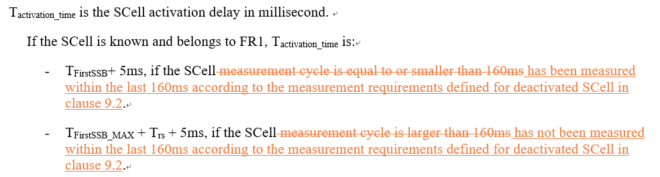
- Proposal 2 (Apple R4-2101006):
  - Update the condition in SCell activation delay requirements for known target cell in FR1
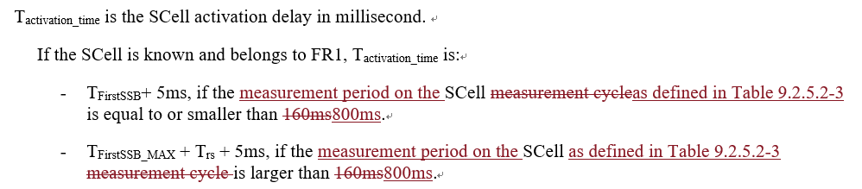
- Recommended WF
  - TBA

Issue 2-1-3: Determination of SSB offset
- Proposals (Huawei R4-2102737):
  - For scenarios where UE is not assumed to perform cell detection on the target SCell, the SCell activation requirements apply provided that SSB offset is same on the target SCell and the active serving cell.
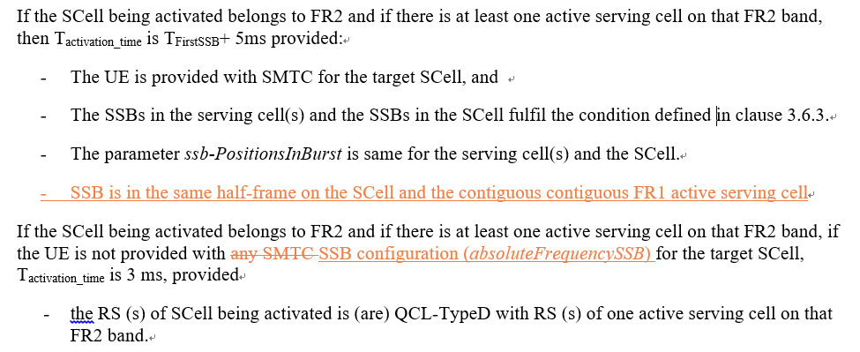
- Recommended WF
  - TBA

Issue 2-1-4: Determination of SSB offset
- Proposals (Huawei R4-2102737):
  - For scenarios where UE is not assumed to perform cell detection on the target SCell, the SCell activation requirements apply provided that SSB offset is same on the target SCell and the active serving cell.

Sub-topic 2-2 SSB-less Scell activation
Issue 2-2-1: Condition and requirements for SSB-less SCell activation for FR1
- Proposals
  - Option 1 (Huawei R4-2102737/38/39/40):
    - RAN4 to clarify that the condition “is not provided with any SMTC for the target SCell” means UE is not provided with SSB configuration for the SCell (absoluteFrequencySSB is absent).
    - If UE is not provided with SSB configuration for the SCell in FR1, Tactivation_time is 3 ms provided
      - The target SCell is contiguous to an active serving cell in the same band, and
      - The TypeA QCL for the target SCell is configured to the active serving cell, and
      - The RTD between the target SCell and the active serving cell is <= CP/2
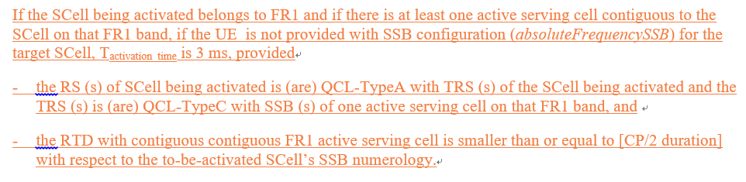
  - Option 2 (Qualcomm R4-2102872):
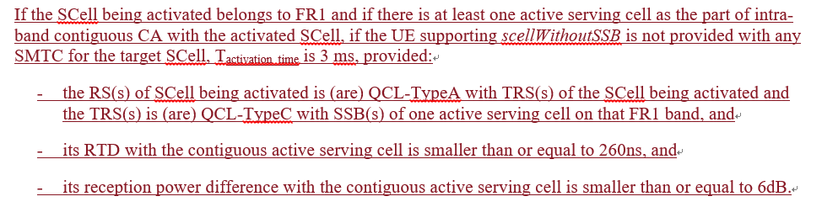
  - Option 3 (Apple R4-2100174/5):
    - If RAN4 agrees to introduce the requirement for FR1 SSB-less SCell activation in R15, only the intra-band contiguous case shall be considered.
    - if RAN4 agrees to introduce the FR1 SSB-less SCell activation for intra-band NC case in R16, the 3ms activation delay requirement only applies when time difference between active serving cell and intra-band NC to-be-activated SCell is less than 260ns.
  - Option 4 (Mediatek R4-2101050/1/2/3):
    - When TCI of to-be-activated SSB-less SCell is QCLed to a RS of FR1 active serving cell which isn’t a contiguous intra-band cell, there is no requirement for SCell activation.
    - When the TCI state of to-be-activated SSB-less SCell is indicates the QCL to a RS of FR1 active serving cell which is a contiguous intra-band cell and this active serving cell fulfill the following conditions,
      - The RTD to the to-be-activated SCell is no larger than 260ns, and
      - The RPD to the to-be-activated SCell is no larger than 6dB.
The T_{activation_time} time can be 3ms.
    - Otherwise, there is no requirement for this SSB-less SCell.
  - Option 5 (NEC R4-2001071): for Rel-15
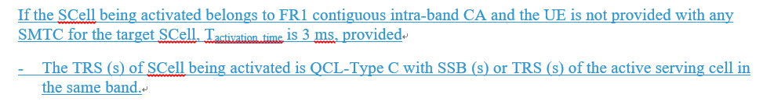
  - Option 5a (NEC R4-2001072): for Rel-16
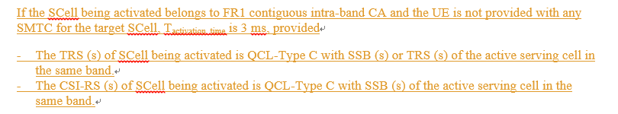
- Recommended WF
  - Can we try to use Option 1 and Option 2 as starting point to converge?

Issue 2-2-2: Condition and requirements for SSB-less SCell activation for FR2
- Proposals
  - Option 1 (Apple R4-2100174/5):
    - the FR2 SCell activation without SMTC shall be revised as,
If the SCell being activated belongs to FR2 and if there is at least one active serving cell on that FR2 band, if the UE supporting scellWithoutSSB is not provided with any SMTC for the target SCell, Tactivation_time is 3 ms, provided
- the RS (s) of SCell being activated is (are) QCL-TypeD with RS (s) of one active serving cell on that FR2 band.
- Recommended WF
  - TBA
  - If agreeable, this part should be merged into the other CR.

Companies views’ collection for 1st round

Open issues
Company | Comments
Apple | Issue 2-1-1: SSB non in the first active BWP  Fine with proposal from Huawei.  Issue 2-1-2: Update conditions for SCell activation delay for the case where SCell is known  We think fundamentally both proposal 1 and 2 are targeting the same issue: measCycleSCell doesn’t represent the actual sample interval. In proposal 1, actually network may have no idea if the target cell has been measured within the last 160ms, since on which carrier UE should perform measurement within certain SMTC is up to UE implementation. Thus if there is no measurement report within 160ms, NW has to assume additional time for AGC is needed. To avoid this, NW may configure periodic report on target deactivated SCell, which is unnecessary and resource and power would be wasted. A simple way to focus on total measurement period. Since 5 samples is assumed for each measurement period, assuming UE can hold AGC for 160ms, as long as the actual measurement period no longer than 800ms, UE doesn’t additional time for AGC.  Therefore, we prefer proposal 2.  Issue 2-1-3: Determination of SSB offset  Fine with additional condition proposed by Huawei. Seems there is some typo:  - SSB is in the same half-frame on the SCell and the contiguous contiguous FR12 active serving cell  Issue 2-1-4: Determination of SSB offset  Fine with additional condition proposed by Huawei.  Sub topic 2-1:  Issue 2-2-1: support 3/4 with RTD≤260ns. In option 2 first sub-bullet, the active serving cell on that FR1 band shall be the one contiguous to the to-be-activated SCell. The wording could be revised as,  “- the RS(s) of SCell being activated is (are) QCL-TypeA with TRS(s) of the SCell being activated and the TRS(s) is (are) QCL-TypeC with SSB(s) of one active serving cell contiguous to the being activated SCell on that FR1 band, and”  Sub topic 2-2:  Issue 2-2-2:  We proposed option 1. No SMTC case shall only apply for the UE supporting scellWithoutSSB like FR1 case.  ….  Others:
Ericsson | Issue 2-1-1: SSB non in the first active BWP  From the discussions previous meeting it became clear that if UE is applying a “wide enough” bandwidth (regardless of BWP configuration), there would potentially be an interrupt later after the SCell activation for adjusting to the BW to the BWP. Hence there was concern on applying other BW than dictated by the BWP during the SCell activation. However, in case SSB is outside the BW of the BWP, the UE would anyways handle this on a periodic basis after the SCell is activated for the purpose of serving cell measurements and intra-frequency measurements. Hence the UE could switch back to the BW associated to the BWP at the first such occasion. It shall also be noted that there are UE configurations that are overridden during SCell activation, e.g. DRX. Therefore we do not see the proposed condition as absolutely necessary. If there is a consensus among other companies on that it is needed, we can accept it.  Issue 2-1-2: Update conditions for SCell activation delay for the case where SCell is known  Regarding Proposal 1: While we agree on that it is more suitable to consider how recently the cell has been measured than to consider the periodicity, we do not agree that one can reuse 160ms when changing to the former. The measurement period is 5 x measCycleSCell x CSSF_{intra.} If just re-using measCycleSCell when instead looking at how recently the SCell was measured, one would miss that the existing condition also is accounting for that CSSF_{intra} may be larger than one, etc. Hence we think that if changing the condition, the time needs to be larger than 160ms. Potentially the time in Proposal 2 can be used.  Regarding Proposal 2: We think it makes sense to use the measurement period rather than measCycleSCell. However we also think Proposal 1 makes sense. Merge?  Issue 2-1-3: Determination of SSB offset  This proposal needs to be updated. It talks about SCell in FR2 being activated, and the new condition proposed to be added concerns “SSB is in the same half frame on the SCell and the contiguous contiguous FR1 active serving cell.” An active serving cell in FR1 cannot be contiguous to an SCell in FR2. “Contiguous” is repeated twice.  Issue 2-1-4: Determination of SSB offset  Seems this issue is replicating parts of the 2-1-3. Editing mistake?  Issue 2-2-1: Condition and requirements for SSB-less SCell activation for FR1  We support the recommended WF. We have a slight preference for Option 2.  Issue 2-2-2: Condition and requirements for SSB-less SCell activation for FR2

CRs/TPs comments collection
Please provide the additional comments on the CRs below, if any, for the issues in sub-topic 2-1. Please focus on SCell activation
CR/TP number | Comments collection
R4-2101006  R4-2101007  R4-2101008 | Ericsson: Please see our comments above. Would potentially consider a merge between this CR and R4-2102738.
 | Company B
R4-2102738  R4-2102739  R4-2102740 | Ericsson: Please see our comments above. Would potentially consider a merge between this CR and R4-2101006. Some of the changes may not be agreeable, hence need to settle the discussion first.

Please provide the additional comments on the CRs below, if any, for the issues in sub-topic 2-2. Please focus on SSB-less activation requirements
CR/TP number | Comments collection
R4-2101071  R4-2101072 | Moderator: Tdoc number for Rel-17 CR is missing.
 | Ericsson: Need to settle the discussion first.
R4-2102738  R4-2102739  R4-2102740 | Ericsson: Need to settle the discussion first.
R4-2102872  R4-2102873  R4-2102874 | Apple: the first sub-bullet of the SSB-less activation requirement needs to be reworded as:  “- the RS(s) of SCell being activated is (are) QCL-TypeA with TRS(s) of the SCell being activated and the TRS(s) is (are) QCL-TypeC with SSB(s) of one active serving cell contiguous to the being activated SCell on that FR1 band, and”
 | Ericsson: We are in principle fine with this CR. However, need to settle the discussion first.

Summary for 1st round

Open issues
Moderator tries to summarize discussion status for 1st round, list all the identified open issues and tentative agreements or candidate options and suggestion for 2nd round i.e. WF assignment.
 | Status summary
Sub-topic#1 | Tentative agreements:  Candidate options:  Recommendations for 2nd round:

Suggestion on WF/LS assignment
 | WF/LS t-doc Title | Assigned Company,  WF or LS lead
#1

CRs/TPs
Moderator tries to summarize discussion status for 1st round and provided recommendation on CRs/TPs Status update suggestion
CR/TP number | CRs/TPs Status update recommendation
XXX | Based on 1st round of comments collection, moderator can recommend the next steps such as “agreeable”, “to be revised”

Discussion on 2nd round (if applicable)

Summary on 2nd round (if applicable)
Moderator tries to summarize discussion status for 2nd round and provided recommendation on CRs/TPs/WFs/LSs Status update suggestion
CR/TP/LS/WF number | T-doc Status update recommendation
XXX | Based on 2nd round of comments collection, moderator can recommend the next steps such as “agreeable”, “to be revised”

Topic #3: Beam management

Companies’ contributions summary
T-doc number | Company | Proposals / Observations
R4-2101464 | vivo | CR on the filter for beam failure indications in 38.133 (38.133 Section 8.5.4)  1. Clarify that the filter for beam failure indication should be Layer-2 filter  2. Clarify that such filter is not specified in TS 38.331.
R4-2101465 | vivo | CR on the filter for beam failure indications in 38.133  Cat A CR
R4-2101466 | vivo | CR on the filter for beam failure indications in 38.133  Cat A CR

Open issues summary

Sub-topic 3-1 Correction of layer X filter for beam failure detection
Issue 3-1: Correction of layer X filter for beam failure detection
- Proposals (Vivo R4-2101464/5/6):
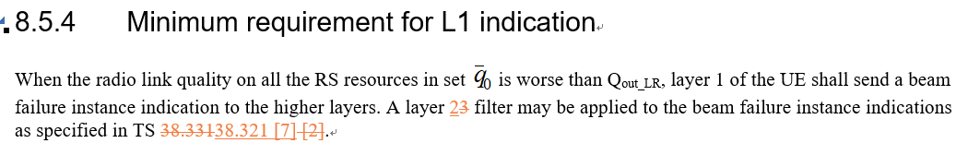
- Recommended WF
  - TBA

Companies views’ collection for 1st round

Open issues
Company | Comments
Apple | Sub topic 3-1:  Issue 3-1: fine with vivo CR.  Others:
Ericsson | Issue 3-1: Correction of layer X filter for beam failure detection  It is correct that there is no L3 filtering. On the other hand, there is no L2 filtering either, so we propose to remove the concerned sentence completely. Hence we think the proposal and the CR needs to be updated.

Summary for 1st round

Open issues
Moderator tries to summarize discussion status for 1st round, list all the identified open issues and tentative agreements or candidate options and suggestion for 2nd round i.e. WF assignment.
 | Status summary
Sub-topic#1 | Tentative agreements:  Candidate options:  Recommendations for 2nd round:

Suggestion on WF/LS assignment
 | WF/LS t-doc Title | Assigned Company,  WF or LS lead
#1

CRs/TPs
Moderator tries to summarize discussion status for 1st round and provided recommendation on CRs/TPs Status update suggestion
CR/TP number | CRs/TPs Status update recommendation
XXX | Based on 1st round of comments collection, moderator can recommend the next steps such as “agreeable”, “to be revised”

Discussion on 2nd round (if applicable)

Summary on 2nd round (if applicable)
Moderator tries to summarize discussion status for 2nd round and provided recommendation on CRs/TPs/WFs/LSs Status update suggestion
CR/TP/LS/WF number | T-doc Status update recommendation
XXX | Based on 2nd round of comments collection, moderator can recommend the next steps such as “agreeable”, “to be revised”

Topic #4: BWP switching

Companies’ contributions summary
T-doc number | Company | Proposals / Observations
R4-2101407 | Intel Corporation | Discussion on RRC based BWP switching  Proposal 1: Clarify that requirement for RRC based BWP switching on a single CC apply for SpCell only.

Open issues summary
In previous meeting the agreements are as follows:
- Agreements
  - Send LS to RAN2 clarifying applicability of RRC based switch to SCell
  - Update Editor’s note as:
    - FFS if RRC based BWP switch is applicable to SCell
  - RRC based BWP switch requirements for SCell defined in Rel-15 can be updated based on RAN2 response, if needed
  - Requirements for RRC based BWP switch for SCell (Rel-16 onwards)
    - Can be updated to follow RAN2’s agreements in Rel-16, if needed
Accordingly the CR R4-2017342 was agreed.
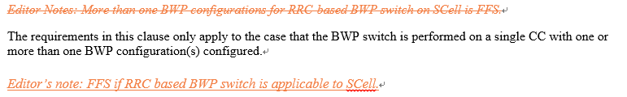

Sub-topic 4-1 Applicability of RRC based BWP switch delay requirement in Rel-15
Issue 4-1: Applicability of RRC based BWP switch delay requirement in Rel-15
- Proposal (Intel R4-2101407)
  - Clarify that requirement for RRC based BWP switching on a single CC apply for SpCell only.
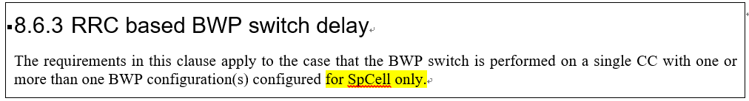
- Recommended WF
  - TBA

Companies views’ collection for 1st round

Open issues
Company | Comments
Apple | Sub topic 4-1: Applicability of RRC based BWP switch delay requirement in Rel-15  We recommend waiting for RAN2 LS reply before making any further changes to core requirements.  Others:
Ericsson | Issue 4-1: Applicability of RRC based BWP switch delay requirement in Rel-15  RAN4 has not yet received RAN2 LS response so it is too early to conclude that RRC based BWP switching does not cover Scell

Summary for 1st round

Open issues
Moderator tries to summarize discussion status for 1st round, list all the identified open issues and tentative agreements or candidate options and suggestion for 2nd round i.e. WF assignment.
 | Status summary
Sub-topic#1 | Tentative agreements:  Candidate options:  Recommendations for 2nd round:

Suggestion on WF/LS assignment
 | WF/LS t-doc Title | Assigned Company,  WF or LS lead
#1

CRs/TPs
Moderator tries to summarize discussion status for 1st round and provided recommendation on CRs/TPs Status update suggestion
CR/TP number | CRs/TPs Status update recommendation
XXX | Based on 1st round of comments collection, moderator can recommend the next steps such as “agreeable”, “to be revised”

Discussion on 2nd round (if applicable)

Summary on 2nd round (if applicable)
Moderator tries to summarize discussion status for 2nd round and provided recommendation on CRs/TPs/WFs/LSs Status update suggestion
CR/TP/LS/WF number | T-doc Status update recommendation
XXX | Based on 2nd round of comments collection, moderator can recommend the next steps such as “agreeable”, “to be revised”

Topic #5: TCI state switching

Companies’ contributions summary
T-doc number | Company | Proposals / Observations
R4-2101050 | MediaTek inc. | Remaining issues on RRM in R15  Proposal 3: Define L1-RSRP delay requirement as max(T_{L1-RSPR_Measurement_Period_SSB}, TL1-RSRP_Measurement_Period_CSI-RS) when both SSB and CSI-RS are configured for L1-RSRP measurement.
R4-2101051 | MediaTek inc. | CR on R15 remaining issues (38.133 Section 8.1.2.2)  2. Define the minimum requirement when both SSB and CSI-RS for L1-RSRP measurement are configured.
R4-2101052 | MediaTek inc. | CR on R15 remaining issues  Cat A CR
R4-2101053 | MediaTek inc. | CR on R15 remaining issues  Cat A CR

Open issues summary

Sub-topic 5-1 Active TCI state switching
Issue 5-1: L1-RSRP delay requirement
- Proposal (Mediatek R4-2101050/1/2/3)
  - Define L1-RSRP delay requirement as max(T_{L1-RSPR_Measurement_Period_SSB}, TL1-RSRP_Measurement_Period_CSI-RS) when both SSB and CSI-RS are configured for L1-RSRP measurement.
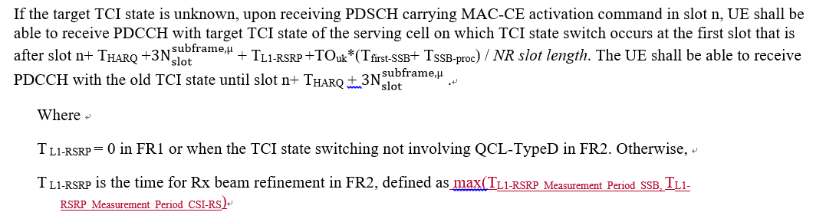
- Recommended WF
  - TBA

Companies views’ collection for 1st round

Open issues
Company | Comments
Apple | Sub topic 5-1: L1-RSRP delay requirement  We agree with adding the clarification that max would apply if both CSI-RS and SSB are configured, but wording needs to be clarified when max is applicable, otherwise it might be mis-leading.  ….  Others:
Ericsson | Issue 5-1: L1-RSRP delay requirement  The purpose of the L1-RSRP measurement is to identify the currently unknown target TCI state. For the target TCI state, it is known whether the associated RS is an SSB or a CSI-RS. The measurement period shall depend on whether it is SSB or CSI-RS. We do not see a reason to define it as maximum over the two periods.

Summary for 1st round

Open issues
Moderator tries to summarize discussion status for 1st round, list all the identified open issues and tentative agreements or candidate options and suggestion for 2nd round i.e. WF assignment.
 | Status summary
Sub-topic#1 | Tentative agreements:  Candidate options:  Recommendations for 2nd round:

Suggestion on WF/LS assignment
 | WF/LS t-doc Title | Assigned Company,  WF or LS lead
#1

CRs/TPs
Moderator tries to summarize discussion status for 1st round and provided recommendation on CRs/TPs Status update suggestion
CR/TP number | CRs/TPs Status update recommendation
XXX | Based on 1st round of comments collection, moderator can recommend the next steps such as “agreeable”, “to be revised”

Discussion on 2nd round (if applicable)

Summary on 2nd round (if applicable)
Moderator tries to summarize discussion status for 2nd round and provided recommendation on CRs/TPs/WFs/LSs Status update suggestion
CR/TP/LS/WF number | T-doc Status update recommendation
XXX | Based on 2nd round of comments collection, moderator can recommend the next steps such as “agreeable”, “to be revised”

Topic #6: Interruption

Companies’ contributions summary
T-doc number | Company | Proposals / Observations
R4-2100233 | Apple | Interruption requirements due to measurement on SCC in NR-DC (R15) (38.133 Section 8.2.4.2.3)  Requirements for interruption due to measurement on SCC in NR-DC are defined in TS38.133 clause 8.2.4.2.3, which has same content as that defined in SA in clause 8.2.2.2.2. However, only interruption on PCell and other activated SCells are covered. Interruption on PSCell is missing.  Introduce interruption on PSCell due to measurement on SCC in NR-DC.  (Tdoc numbers for Rel-16, Rel-17 CRs are missing)

Open issues summary

Sub-topic 6-1 Interruption due to measurement on SCC in NR-DC
Issue 6-1: interruption requirement due to measurement on SCC in NR-DC
- Proposal (Apple, R4-2100233)
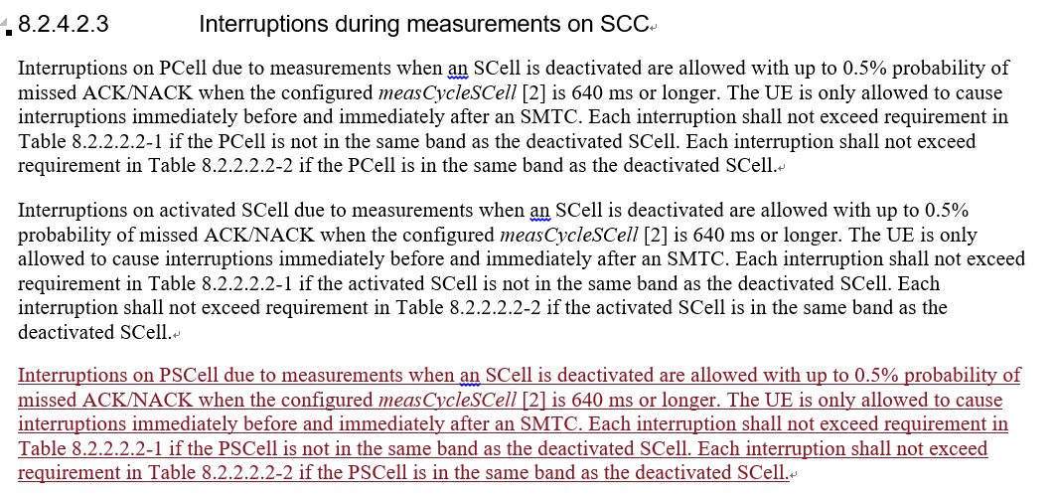
- Conclusion
  - According to Chair guidance (This CR is postponed). So there will be no discussion in this meeting.

Topic #7: Intra-frequency ECID

Companies’ contributions summary
T-doc number | Company | Proposals / Observations
R4-2102731 | Huawei, HiSilicon | CR to remove intra-frequency ECID requirements for NE-DC 36133 R15 (36.133 Section 8.19.5)  Remove the Intra-frequency E-CID measurement requirements for NE-DC.
R4-2102732 | Huawei, HiSilicon | CR to remove intra-frequency ECID requirements for NE-DC 36133 R16  Cat A CR
R4-2102733 | Huawei, HiSilicon | CR to remove intra-frequency ECID requirements for NE-DC 36133 R17  Cat A CR
R4-2102738 | Huawei, HiSilicon | CR on SCell activation delay, cell idenfication requirements on deactivated SCell and inter-RAT ECID requirements for NE-DC R15 (38.133, Section 8.3.2, 9.4.1, 9.4.5, 9.2.5, 9.2.6)  1. Update the SCell activation requriements  a) Clarifiy that current activation requirements do not apply when SCellSSB is outside frist active BWP  b) Clarify the condition for FR2 SSB-less SCell activation requirements  c) Add FR1 SSB-less SCell activation requirements  d) Clarifythe meaning of SCell measurement cycle” in FR1 known SCell activation requirements  e) Clarify that for scenarios where UE is not assumed to perform cell detection on the target SCell, requirements apply provided that SSB offset is same on the target SCell and the active or known serving cell.  2. Update the applicable requriements for NR – LTE inter-RAT E-CID measurement on LTE serving frequencies in NE-DC, such that the LTE SA intra-frequency requirements apply.  3. For deactivated SCell measurement:  -Adding scaling factor Kp for deactivated SCell measurement requirements without gap;  -Adding measurement requirements for deactivated SCell with gap
R4-2102739 | Huawei, HiSilicon | CR on SCell activation delay, cell idenfication requirements on deactivated SCell and inter-RAT ECID requirements for NE-DC R16  Cat A CR
R4-2102740 | Huawei, HiSilicon | CR on SCell activation delay, cell idenfication requirements on deactivated SCell and inter-RAT ECID requirements for NE-DC R17  Cat A CR

Open issues summary

Sub-topic 7-1 Correction for E-CID requirements
Issue 7-1-1: Remove intra-frequency E-CID measurement requirement for NE-DC
- Proposal (Huawei R4-2102731/2/3)
  - Remove 8.19.5 in 36.133
- Recommended WF
  - TBA

Issue 7-1-2: Correction of E-CID requirements
- Proposal (Huawei R4-2102738/39/40)
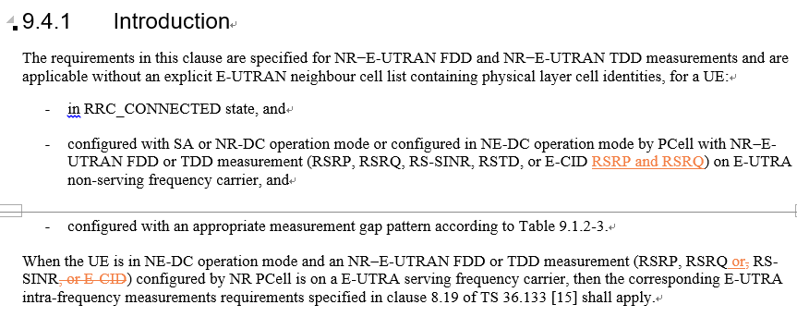
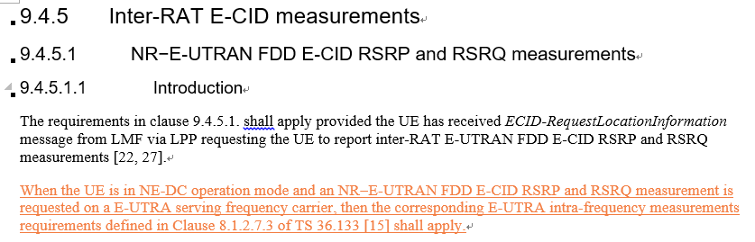
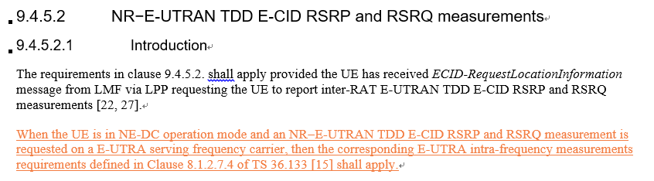
- Recommended WF
  - TBA

Companies views’ collection for 1st round

Open issues
Company | Comments
Ericsson | Issue 7-1-1: Remove intra-frequency E-CID measurement requirement for NE-DC  We do not think this CR is needed as it seems to be based on incorrect assumptions. Regardless of which cell is configuring, a measurement on a serving carrier frequency is intra-frequency – this is true even for Rel-15 CR. Furthermore, from Rel-16, we even have LPP in the Pcell, so the argument about LPP is not correct for CRs from Rel-16 and up, i.e., CRs for Rel-16 and Rel-17 should not even be submitted.  Issue 7-1-2: Correction of E-CID requirements  We do not agree to the proposal, as it is incorrect. The addition under “9.4.5. Inter-RAT E-CID measurements” states:  When the UE is in NE-DC operation mode and an NR−E-UTRAN FDD E-CID RSRP and RSRQ measurement is requested on a E-UTRA serving frequency carrier, then the corresponding E-UTRA intra-frequency measurements requirements defined in Clause 8.1.2.7.3 of TS 36.133 [15] shall apply.  We have highlighted the part that is problematic for the CR. The measurement is carried out on a serving carrier. A serving carrier is always an intra-frequency carrier, not an inter-RAT carrier.
XXX | Sub topic 7-1:  ….  Others:

Summary for 1st round

Open issues
Moderator tries to summarize discussion status for 1st round, list all the identified open issues and tentative agreements or candidate options and suggestion for 2nd round i.e. WF assignment.
 | Status summary
Sub-topic#1 | Tentative agreements:  Candidate options:  Recommendations for 2nd round:

Suggestion on WF/LS assignment
 | WF/LS t-doc Title | Assigned Company,  WF or LS lead
#1

CRs/TPs
Moderator tries to summarize discussion status for 1st round and provided recommendation on CRs/TPs Status update suggestion
CR/TP number | CRs/TPs Status update recommendation
XXX | Based on 1st round of comments collection, moderator can recommend the next steps such as “agreeable”, “to be revised”

Discussion on 2nd round (if applicable)

Summary on 2nd round (if applicable)
Moderator tries to summarize discussion status for 2nd round and provided recommendation on CRs/TPs/WFs/LSs Status update suggestion
CR/TP/LS/WF number | T-doc Status update recommendation
XXX | Based on 2nd round of comments collection, moderator can recommend the next steps such as “agreeable”, “to be revised”

Topic #8: Idle mode

Companies’ contributions summary
T-doc number | Company | Proposals / Observations
R4-2102734 | Huawei, HiSilicon | CR to idle more requirements in 36133 R15 (36.133 Section 4.2.2)  Add NR as one of the inter-RAT targets for high priority carrier seach when UE is in LTE Idle mode.
R4-2102735 | Huawei, HiSilicon | CR to idle more requirements in 36133 R16  Cat A CR
R4-2102736 | Huawei, HiSilicon | CR to idle more requirements in 36133 R17  Cat A CR

Open issues summary

Sub-topic 8-1 Correction for idle mode requirements
Issue 8-1: Correction for idle mode requirements
- Proposal (Huawei R4-2102734/5/6)
  - Add NR as one of the inter-RAT targets for high priority carrier seach when UE is in LTE Idle mode.
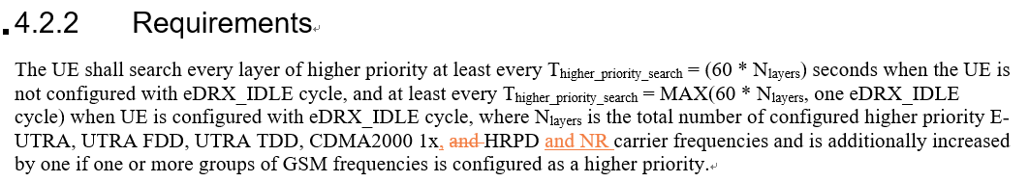
- Recommended WF
  - TBA

Companies views’ collection for 1st round

Open issues
Company | Comments
Apple | Sub topic 8-1:  Issue 8-1: fine with Huawei proposal  Others:
Ericsson | Issue 8-1: Correction for idle mode requirements  We are fine with the proposal.

Summary for 1st round

Open issues
Moderator tries to summarize discussion status for 1st round, list all the identified open issues and tentative agreements or candidate options and suggestion for 2nd round i.e. WF assignment.
 | Status summary
Sub-topic#1 | Tentative agreements:  Candidate options:  Recommendations for 2nd round:

Suggestion on WF/LS assignment
 | WF/LS t-doc Title | Assigned Company,  WF or LS lead
#1

CRs/TPs
Moderator tries to summarize discussion status for 1st round and provided recommendation on CRs/TPs Status update suggestion
CR/TP number | CRs/TPs Status update recommendation
XXX | Based on 1st round of comments collection, moderator can recommend the next steps such as “agreeable”, “to be revised”

Discussion on 2nd round (if applicable)

Summary on 2nd round (if applicable)
Moderator tries to summarize discussion status for 2nd round and provided recommendation on CRs/TPs/WFs/LSs Status update suggestion
CR/TP/LS/WF number | T-doc Status update recommendation
XXX | Based on 2nd round of comments collection, moderator can recommend the next steps such as “agreeable”, “to be revised”

Topic #9: SFTD and other editorial maintenance

Companies’ contributions summary
T-doc number | Company | Proposals / Observations
R4-2101051 | MediaTek inc. | CR on R15 remaining issues (38.133 Section 8.1.2.2)  3. SFTD(9.3.8.3)  SFTD measurement reporting delay doesn’t include RRC procedure delay.
R4-2101052 | MediaTek inc. | CR on R15 remaining issues  Cat A CR
R4-2101053 | MediaTek inc. | CR on R15 remaining issues  Cat A CR

Open issues summary

Sub-topic 9-1 Correction for SFTD requirements
Issue 9-1: Correction for SFTD requirements
- Proposal (Mediatek R4-2101051/2/3)
  - Clarify SFTD measurement reporting delay including measurement period plus the RRC procedure delay
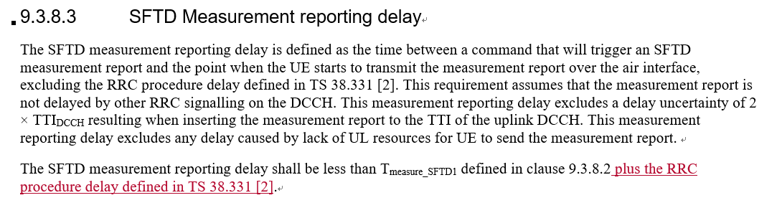
- Recommended WF
  - TBA

Sub-topic 9-2 others
Issue 9-2: Other editorial changes in R4-2101051/2/3
- Proposals
  - Changes in Section 9.2.5.1, 9.2.5.3
- Recommended WF
  - TBA

Companies views’ collection for 1st round

Open issues
Company | Comments
Apple | Sub topic 9-1:  Issue 9-1: fine with the changed proposed by MTK.  Sub topic 9-2:  ….  Others:
Ericsson | Issue 9-1: Correction for SFTD requirements  We disagree with the proposal. It is already clear that RRC delay is excluded from SFTD measurement reporting delay, and hence that the time will be the sum of the two. Please see the highlighted text:  9.3.8.3 SFTD Measurement reporting delay  The SFTD measurement reporting delay is defined as the time between a command that will trigger an SFTD measurement report and the point when the UE starts to transmit the measurement report over the air interface, excluding the RRC procedure delay defined in TS 38.331 [2]. This requirement assumes that the measurement report is not delayed by other RRC signalling on the DCCH. This measurement reporting delay excludes a delay uncertainty of 2 × TTI_{DCCH} resulting when inserting the measurement report to the TTI of the uplink DCCH. This measurement reporting delay excludes any delay caused by lack of UL resources for UE to send the measurement report.  The SFTD measurement reporting delay shall be less than T_{measure_SFTD1} defined in clause 9.3.8.2  Issue 9-2: Other editorial changes in R4-2101051/2/3  These changes concern changing font colour to “automatic”. I have no issue with this being addressed in the same CR as addressing other things, but I think maybe next time we do not need to add such changes as an issue for companies to comment on.

Summary for 1st round

Open issues
Moderator tries to summarize discussion status for 1st round, list all the identified open issues and tentative agreements or candidate options and suggestion for 2nd round i.e. WF assignment.
 | Status summary
Sub-topic#1 | Tentative agreements:  Candidate options:  Recommendations for 2nd round:

Suggestion on WF/LS assignment
 | WF/LS t-doc Title | Assigned Company,  WF or LS lead
#1

CRs/TPs
Moderator tries to summarize discussion status for 1st round and provided recommendation on CRs/TPs Status update suggestion
CR/TP number | CRs/TPs Status update recommendation
XXX | Based on 1st round of comments collection, moderator can recommend the next steps such as “agreeable”, “to be revised”

Discussion on 2nd round (if applicable)

Summary on 2nd round (if applicable)
Moderator tries to summarize discussion status for 2nd round and provided recommendation on CRs/TPs/WFs/LSs Status update suggestion
CR/TP/LS/WF number | T-doc Status update recommendation
XXX | Based on 2nd round of comments collection, moderator can recommend the next steps such as “agreeable”, “to be revised”

