3GPP TSG-RAN WG4 Meeting # 98-e-Bis R4-200XXXX
Electronic Meeting, Jan. 25 – Feb. 5, 2021

Agenda item: 4.7
Source: Moderator (Huawei, HiSilicon)
Title: Email discussion summary for [98e Bis][201] NR_NewRAT_RRM_Core
Document for: Information

Introduction
In this email thread for Rel-15 NR RRM core requirement, we will treat the following topics:
- RRM measurements:
  - CSSF calculation for inter-RAT measurement in EN-DC,
  - MO merging,
  - SMTC1 and SMTC2 differentiation,
  - deactivated SCell measurement requirement for intra-frequency measurement with MG
- SCell activation:
  - Maintenance for SCell activation requirements
  - SSB-less SCell activation
- Beam management: correction of filter for beam failure detection
- BWP switching: Applicability of RRC based BWP switch delay requirement in Rel-15
- Active TCI state switching
- Interruption due to measurement on SCC
- Maintenance for intra-frequency E-CID
- Maintenance for idle mode requirements
For the GTW session after the first round, the following topics are suggested for discussion.
First priority
 | Status summary
Sub-topic#1-1-2 | Issue 1-1-2: Whether/how to count CSSF outside MG and CSSF within MG  7 companies made comments. All the companies can accept the recommended WF, i.e., Option 2a in the previous meeting and the merging condition. Ericsson proposed to make modification on Option 2a. But could Ericsson clarify whether it should be “counted only once in CSSF” within MG rather than “outside MG” in the second bullet of the proposed additional conditions.  There would be two issues for further discussion:  - How to resolve the compatibility issue with existing Rel-15 UEs  - Whether and how to add the conditions for inter-RAT measurements on the NR serving carrier configured by LTE MN.  Tentative agreements:  - In principle the Option 2a is agreed, i.e.,  - Remove the inter-RAT MOs counted in CSSF outside MG from CSSF within MG, and further discuss allowing existing implementations not to meet the updated requirements.  Candidate options:  There are three issues for further discussions:  - Is there any significant difference between Alternative 2 and other alternatives? Which one does the group agree on?  - Alternative 1:  - For calculation of CSSF outside MG, Option 1a in last meeting’s WF.  - For calculation of CSSF within MG, Option 1a in last meeting’s WF.  - Alternative 2:  - In calculation of CSSF outside MG: if MOs configured by MN and SN are merged from a capabilities perspective they are also counted only once in CSSF outside MG.  - In calculation of CSSF within MG: if MOs configured by MN and SN are merged from a capabilities perspective they are also counted only once in CSSF outside MG.  - To resolve the compatibility issue with existing Rel-15 UEs, can we agree on the proposed relaxation in Alternative 1, which is aligned also with other companies’ proposal.  - One note could be added into R15 spec that, “longer delays for cell identification and measurement periods derived based on CSSFwithin_gap,i can be expected, if the UE is configured with inter-RAT MO on NR serving CC by E-UTRAN PCell in EN-DC mode”.  - Can we agree on conditions to be added for inter-RAT measurements on the NR serving carrier configured by LTE MN?  - The conditions for performing inter-RAT measurement on the NR serving carrier outside MG shall be  - SSB is contained in the active BWP  - SMTC is not fully overlapping with MG.  Recommendations for 2nd round:  Further discussion on the above three issues.  More comment needs be collected on which CRs should be used to capture the agreement after the technique issue is addressed.
Sub-topic#1-2 | Issue 1-2: MO merging related to SSB-ToMeasurement indications  5 companies made the comments. It seems in principle the proposal is agreeable. One company suggested to make it clear that the proposal applies for DC scenarios. One company asked for the clarification about “the union”. The response is provided.  Tentative agreements:  N/A  Candidate options:  Recommendations for 2nd round:  Further discussion is needed:  - Need response from Nokia whether the response from Mediatek on Nokia’s comment is acceptable.  - Whether the wording should apply for DC only or for DC and CA.
Sub-topic#1-4 | Issue 1-4: deactivated SCell measurement for intra-frequency measurement with MG  Companies made comments. 3 companies opposed the proposal. After the discussion, it seems agreeable not to specify the intra-frequency de-activated SCell measurement requirements with MG. But for the intra-frequency de-activated SCell measurement requirements without MG, more discussion on scaling factor is needed.  Tentative agreements:  Not to introduce the intra-frequency de-activated SCell measurement requirement with MG.  Candidate options:  Further discussion on  - Whether Kp is introduced for intra-frequency deactivated SCell measurement requirements without gap when SMTC is partially overlapping with MG.  - Yes  - No  Recommendations for 2nd round:  Further discuss the above open issues.
Sub-topic#2-1-1 | Issue 2-1-1: SSB non in the first active BWP  4 companies supported the proposal. 1 company is neutral. 2 companies still had the questions.  One question from NEC is how AGC is conducted if SSB is outside the first active BWP. The other comment from Qualcomm is that SSB outside BWP is an optional feature. But both comments seems to be aligned with the intention of Huawei’s proposal “SSB of the to-be-activated SCell is within BWP. But the companies who had question seemed to mean that SSB should be within first active BWP but there is no need for explicitly clarification of such condition. Please companies further clarify whether it is the correct understanding.  The other question is why the condition is needed since there is no additional interruption defined for SSB-outside-BWP for PCell currently. In my view, it implies that there will be no additional interruption even for the configuration of SSB outside the active DL BWP. Can the group agree with such observation?  Tentative agreements:  N/A  Candidate options:  According to the comments, there are two comments which need response and two questions need further discussion:  - NEC: How is AGC conducted if SSB is outside the first active BWP? Does the question imply that SSB should be within the first active BWP?  - Qualcomm: SSB outside BWP is an optional feature. There is no additional interruption defined for SSB-outside-BWP for PCell currently and so there is no need to have proposed condition.  - Does the group agree that there is no additional interruption needed for SSB-outside-BWP for both PCell and SCell?  - Should the condition that SSB of the to-be-activated SCell is within the first active DL BWP of the SCell be added in the spec?  - Yes (Huawei, Apple, MTK, Vivo, Nokia, Ericsson (acceptable))  - No (Qualcomm, NEC(have question))  Recommendations for 2nd round:  Further discuss the above comments and questions.
Sub-topic#2-1-2 | Issue 2-1-2: Update conditions for SCell activation delay for the case where SCell is known  6 companies made comments. The key issue is that some companies think the wording “measurement cycle” is unclear and proposed two alternatives for modifications.  Regarding the proposal from Huawei, i.e., “SCell has been measured within the last 160ms…”, the comments were that the measurement is up to UE and cannot be controlled or measured by network and the time should be larger than 160ms if “measurement cycle” was changed.  Regarding the proposal from Apple, i.e., “measurement period … equal to or smaller than 800ms, the comments were that it cannot be ensured that SCell is measured within 160ms following such conditions.  The other alternative from Nokia and supported by NEC is to change “measurement cycle” to “if the activation command is received within 160ms of an SSB from the SCell”.  Tentative agreements:  N/A  Candidate options:  The key issue is whether measurement cycle is unclear and if so how to change it. There are follow alternative solutions:  - Alternative 1: Change “measurement cycle is equal to or smaller than 160ms” to “SCell has been measured within the last 160ms…” (Huawei)  - Alternative 2: Change “measurement cycle is equal to or smaller than 160ms” to “the measurement period on the SCell … is equal to or smaller than 800ms. (Apple)  - Alternative 3: Change “measurement cycle is equal to or smaller than 160ms” to “if the activation command is received within 160ms of an SSB from the SCell” (Nokia, NEC)  - Alternative 4: No change (Mediatek)  Recommendations for 2nd round:  Further discuss the above alternative solutions.
Sub-topic#2-1-1 | Issue 2-1-1: Condition and requirements for SSB-less SCell activation for FR1  6 companies made the comments. It seemed that we can down-select to Option 1 and Option 2. There are a few of questions to be answered and issues to be addressed.  Tentative agreements:  - Further discuss the solution based on Option 1 and Option 2.  Candidate options:  A number of questions and issues need be addressed:  - Should we change the wording for Option 1 as proposed by Apple?  - “- the RS(s) of SCell being activated is (are) QCL-TypeA with TRS(s) of the SCell being activated and the TRS(s) is (are) QCL-TypeC with SSB(s) of one active serving cell contiguous to the being activated SCell on that FR1 band, and”  - Should and what the reception power difference with the contiguous active serving cell need be captured?  - Alternative 1: smaller than or equal to 6dB  - The condition “UE is not provided with any SMTC for the target Cell” needs be clarified (Huawei)  - Alternative 1: The condition “UE is not provided with any SMTC for the target SCell” means UE is not provided with SSB configuration for the SCell (absoluteFrequencySSB is absent)  - Can we explicitly clarify RS (s) in the first condition, since they may be different for Rel-15 and Rel-16? Since they can be different for Rel-15 and Rel-16, do we need to have separate conditions for Rel-15 and Rel-16? (NEC)  - The condition of RTD:  - Alternative 1: Explicitly clarify that RTD is smaller than or equal to 260ns. (Qualcomm, Apple, Mediatek, Huawei)  - Alternative 2: Since the QCL relation and intra-band contiguous CA condition is already specified, do we need to explicitly specify 260ns as RTD. Isn’t it straight forward from the BS TAE for this scenario? (NEC)  - Converge on the solution based on Option 1 and Option 2:  - Option 1:  If the SCell being activated belongs to FR1 and if there is at least one active serving cell contiguous to the SCell on that FR1 band, if the UE is not provided with SSB configuration (absoluteFrequencySSB) for the target SCell, T_{activation_time} is 3 ms, provided  - the RS (s) of SCell being activated is (are) QCL-TypeA with TRS (s) of the SCell being activated and the TRS (s) is (are) QCL-TypeC with SSB (s) of one active serving cell on that FR1 band, and  - the RTD with contiguous contiguous FR1 active serving cell is smaller than or equal to [CP/2 duration] with respect to the to-be-activated SCell’s SSB numerology.  - Option 2:  If the SCell being activated belongs to FR1 and if there is at least one active serving cell as the part of intra-band contiguous CA with the activated SCell, if the UE supporting scellWithoutSSB is not provided with any SMTC for the target SCell, T_{activation_time} is 3 ms, provided:  - the RS(s) of SCell being activated is (are) QCL-TypeA with TRS(s) of the SCell being activated and the TRS(s) is (are) QCL-TypeC with SSB(s) of one active serving cell on that FR1 band, and  - its RTD with the contiguous active serving cell is smaller than or equal to 260ns, and  - its reception power difference with the contiguous active serving cell is smaller than or equal to 6dB.  Recommendations for 2nd round:  Further discuss the above issues.

Second priority
Sub-topic#5-1 | Issue 5-1: L1-RSRP delay requirement  4 companies made comments. 1 company supported it. 2 companies opposed it. 1 companies can accept the scenario under consideration but proposed to change the requirement from max to min. More discussion is needed.  Tentative agreements:  Candidate options:  The requirement of L1-RSRP delay for scenario where network configures both SSB and CSI-RS is discussed, the question is:  - Should and how the additional requirements covering the scenario where network configures both SSB and CSI-RS be specified?  - No. TCI state is detected based on either SSB or CSI-RS. (Ericsson, Huawei)  - Yes, the requirement is based on min(SSB measurement period, CSI-RS measurement period) (Nokia)  - Yes, the requirement is based on max(SSB measurement period, CSI-RS measurement period) (Mediatek)  Recommendations for 2nd round:
Sub-topic#7-1-1 | Issue 7-1-1: Remove intra-frequency E-CID measurement requirement for NE-DC  2 companies made comments. Both of them opposed the changes. The key issue is whether E-CID measurement should be intra-frequency measurement or inter-RAT. More discussion is needed.  It seems that Nokia may be OK with Rel-15 CR. It is needed for Nokia to clarify their comments.  Tentative agreements:  N/A  Candidate options:  Further discussion on  - Is E-CID measurement on serving cell an intra-frequency measurement or inter-RAT measurement?  - Intra-frequency (Ericsson)  - Inter-RAT (Huawei)  Recommendations for 2nd round:  Further discuss the above question.
Sub-topic#9-1 | Issue 9-1: Correction for SFTD requirements  3 companies made comments. 2 companies supported the change. 1 company opposed it, who commented that it is already clear that RRC delay is excluded from SFTD measurement reporting delay.  Tentative agreements:  N/A  Candidate options:  Further discussion on  - Whether RRC delay is excluded from SFTD measurement reporting  - Yes (Ericsson)  - No (Mediatek, [Huawei], [Apple])  Recommendations for 2nd round:  Further discussion is needed.

Topic #1: RRM measurement

Companies’ contributions summary
T-doc number | Company | Proposals / Observations
R4-2100172 | Apple | Further discussion on CSSF for R15 EN-DC  Proposal 1: When inter-RAT MO is not on any NR serving CC, inter-RAT measurement is always performed within MG.  Proposal 2: for R15 we propose an implementation #2 for EN-DC, that is,  When inter-RAT MO is on a NR serving CC, inter-RAT measurements are performed in the same way as NR intra-frequency measurement, i.e., it can be within or outside MG depending on whether SSB is contained in the active BWP, and whether SMTC is fully overlapping with MG.  Proposal 3: RAN4 further discuss in R16 that whether the implementation 2 could be used for inter-RAT measurement on NR non-serving CC.  Proposal 4: adopt Option 2a: count the NR inter-RAT MO on NR serving CC configured by LTE MN that can be measured without MG in CSSF outside MG and remove the inter-RAT MOs counted in CSSF outside MG from CSSF within MG. One note could be added into R15 spec that, “longer delays for cell identification and measurement periods derived based on CSSFwithin_gap,i can be expected, if the UE is configured with inter-RAT MO on NR serving CC by E-UTRAN PCell in EN-DC mode”.  Proposal 5: for calculation of CSSF outside MG, adopt Option 1a:  to consider merging of intra-frequency MO configured by NR SN and inter-RAT MO configured by LTE MN on the same serving frequency that are measured without MG, based on MO merging conditions in clause 9.1.3.2 of 38.133.  Proposal 6: for calculation of CSSF within MG, adopt Option 1a:  to consider merging of two MOs configured by LTE MN and NR SN on the same frequency that are measured within MG, based on MO merging conditions in clause 9.1.3.2 of 38.133.
R4-2100173 | Apple | CR on CSSF for EN-DC R15 (38.133 Section 9.1.5.1, 9.1.5.2)  The CSSF requirement has been updated for EN-DC to consider the MOs configured from both LTE MN and NR SN in EN-DC.  (Tdoc numbers of Rel-16, Rel-17 CRs are missing)
R4-2102536 | Ericsson | On correction to inter-RAT CSSF  Observation 1: Double counting in both CSSFwithin_gap and CSS_outside_gap is not acceptable.  Observation 2: From the Rel-15 reporting criteria requirements, it is clear that regardless of the configuring node the measurements on serving NR carriers are NR intra-frequency measurements, not inter-RAT measurements.  Proposal 1: RAN4 should initially discuss the technical solution for CSSF scaling of interRAT measurement objects configured by the LTE PCell.  Observation 3: The discussion in [1] does not consider (intra-frequency) measurements on NR serving carriers, which are configured by LTE PCell and require measurement gaps.  Proposal 2: Reject Option 1.  Proposal 3: Reject Option 2b.  Proposal 4 : RAN4 should agree Option 2a (i.e., count in CSSF outside MG the NR inter-RAT MO on NR serving CC configured by LTE MN that can be measured without MG and remove from CSSF within MG the inter-RAT MOs counted in CSSF outside MG.  o NOTE: This option applies in the case that it is possible to make non-gap based measurements, i.e. SSB is contained within the active BWP and the SMTC is not fully overlapping with the active BWP.  Proposal 5: Implementations which are certified prior to RAN#95 are allowed to include inter-RAT MOs counted in CSSF outside MG also in CSSF within MG.  Proposal 6: In calculation of CSSF outside MG: if MOs configured by MN and SN are merged from a capabilities perspective they are also counted only once in CSSF outside MG.  Proposal 7: In calculation of CSSF within MG: if MOs configured by MN and SN are merged from a capabilities perspective they are also counted only once in CSSF outside MG.
R4-2102827 | Ericsson | Correction to inter-RAT CSSF (38.133, Section 9.1.5.1)  Add to the definition of CSSFoutside_gap to explicitly exclude a single merged MO which is both an LTE interRAT MO and an NR intrafrequency MO:  If an NR intra-frequency measurement object configured by PSCell and a NR inter-RAT measurement objects configured by E-UTRA PCell are for the same NR carrier frequency layer and all measurement object merging conditions defined in clause 9.1.3.2 are satisfied, it shall be counted in CSSF_{within_gap,I} as specified in clause 9.1.5.2.1 and shall not be counted in CSSF_{outside_gap} as specified in this clause. Editors note : Implementations certified prior to RAN#95 may count such measurement objects in either CSSF_{outside_gap} or CSSF_{within_gap,I}.  Add to the definition of CSSFwithin_gap for EN-DC : For synchronous intra-band EN-DC, if an NR inter-frequency measurement object configured by PSCell and a NR inter-RAT measurement objects configured by E-UTRA PCell are for the same NR carrier frequency layer and all measurement object merging conditions defined in clause 9.1.3.2 are satisfied, they shall be counted only once in M_{inter,i,j}.  Add similar text to the definition of M_{groupBi,j}. in NE-DC requirements.
R4-2102537 | Ericsson | Correction to inter-RAT CSSF  Cat A CR
R4-2102538 | Ericsson | Correction to inter-RAT CSSF  Cat A CR
R4-2101051 | MediaTek inc. | CR on R15 remaining issues (38.133 Section 8.1.2.2)  1. Clarify that the SSB-ToMeasure indications shall be the union of all MOs which can be merged.  2. Define the minimum requirement when both SSB and CSI-RS for L1-RSRP measurement are configured.  3. Clarify SFTD measurement reporting delay including measurement period plus the RRC procedure delay  4. Some editorial changes.
R4-2101052 | MediaTek inc. | CR on R15 remaining issues  Cat A CR
R4-2101053 | MediaTek inc. | CR on R15 remaining issues  Cat A CR
R4-2102737 | Huawei, HiSilicon | Discussion on CSSF for inter-RAT measurement, SCell activation delay and cell identification requirements on deactivated SCell in Rel-15  Proposal 5: For scenarios where UE is not assumed to perform cell detection on the target SCell, the SCell activation requirements apply provided that SSB offset is same on the target SCell and the active serving cell.  Proposal 6: Scaling factor Kp shall be added for deactivated SCell measurement requirements without gap in R15.  Proposal 7: The measurement requirements for deactivated SCell with gap shall be added in R15.  Proposal 8: For R15, it is left to UE implementation whether to perform NR inter-RAT measurements on NR serving carrier within MG or outside MG. However, this measurement can only be counted once either in calculation of CSSF_within_MG or CSSF_outside_MG. And for R16 and later release, UE shall perform NR inter-RAT measurements on NR serving carrier outside MG.  Proposal 9: For calculation of CSSF_within_MG and CSSF_outside_MG, measurements configured by LTE PCell and NR PSCell on the same NR carrier are counted as one candidates if they satisfy MO merging condition.
R4-2101050 | MediaTek inc. | Remaining issues on RRM in R15  Proposal 4: In EN-DC, the NR Inter-RAT MOs of measurements without MG configured by LTE MN shall be moved to the CSSF outside MG from CSSF within MG.  Proposal 5: The same MO merging condition shall be applied for the Inter-RAT MO configured by LTE MN and intra-frequency MO configured by NR SN.
R4-2100178 | Apple | CR on smtc1 and smtc2 differentiation in intra-frequency measurement with MG R15 (38.133 Section 9.2.6)  Add condition of smtc1 and smtc2 differentiation in intra-frequency measurement with MG.
R4-2100179 | Apple | CR on smtc1 and smtc2 differentiation in intra-frequency measurement with MG R16  Cat A CR
R4-2100180 | Apple | CR on smtc1 and smtc2 differentiation in intra-frequency measurement with MG R17  Cat A CR
R4-2100851 | CMCC | Discussion on deactivated SCell measurement for intra-frequency measurement with measurement gap  Observation 1: for intra-f measurement without MG, TS38.133 explicitly specify the time period for PSS/SSS detection, time period for time index detection, measurement period for deactivated SCell  Observation 2: for intra-f measurement with MG, it seems that the time period for PSS/SSS detection, time period for time index detection, measurement period for deactivated SCell are not specified.  Proposal 1: for the scenario of intra-f measurement with MG, it is necessary to specify the requirements for PSS/SSS detection, time index detection and measurement period for deactivated SCell.
R4-2100852 | CMCC | CR on deactivated SCell measurement for intra-frequency measurement with measurement gap (38.133, Section 9.2.5, 9.2.6)  1. Correct the caption for the time period for PSS/SSS detection, deactivated SCell (FR2) for intra-frequency measurement without MG  2. Specify the requirements on PSS/SSS detection, time index detection and measurement for deactivated SCell for intra-frequency measurement with MG.
R4-2100853 | CMCC | CR on deactivated SCell measurement for intra-frequency measurement with measurement gap  Cat A CR (Tdoc number for Rel-17 Cat CR)
R4-2102738 | Huawei, HiSilicon | CR on SCell activation delay, cell idenfication requirements on deactivated SCell and inter-RAT ECID requirements for NE-DC R15 (38.133, Section 8.3.2, 9.4.1, 9.4.5, 9.2.5, 9.2.6)  1. Update the SCell activation requriements  a) Clarifiy that current activation requirements do not apply when SCellSSB is outside frist active BWP  b) Clarify the condition for FR2 SSB-less SCell activation requirements  c) Add FR1 SSB-less SCell activation requirements  d) Clarifythe meaning of SCell measurement cycle” in FR1 known SCell activation requirements  e) Clarify that for scenarios where UE is not assumed to perform cell detection on the target SCell, requirements apply provided that SSB offset is same on the target SCell and the active or known serving cell.  2. Update the applicable requriements for NR – LTE inter-RAT E-CID measurement on LTE serving frequencies in NE-DC, such that the LTE SA intra-frequency requirements apply.  3. For deactivated SCell measurement:  -Adding scaling factor Kp for deactivated SCell measurement requirements without gap;  -Adding measurement requirements for deactivated SCell with gap
R4-2102739 | Huawei, HiSilicon | CR on SCell activation delay, cell idenfication requirements on deactivated SCell and inter-RAT ECID requirements for NE-DC R16  Cat A CR
R4-2102740 | Huawei, HiSilicon | CR on SCell activation delay, cell idenfication requirements on deactivated SCell and inter-RAT ECID requirements for NE-DC R17  Cat A CR

Open issues summary

Sub-topic 1-1 CSSF calcualtion for Inter-RAT measurement objective in EN-DC
Issue 1-1-1: How to treat the issue whether to count inter-RAT MO in CSSF outside MG or CSSF within MG?
- Proposals
  - Option 1 (Apple R4-2100172):
    - When inter-RAT MO is not on any NR serving CC, inter-RAT measurement is always performed within MG.
    - for R15 we propose an implementation #2 for EN-DC, that is,
When inter-RAT MO is on a NR serving CC, inter-RAT measurements are performed in the same way as NR intra-frequency measurement, i.e., it can be within or outside MG depending on whether SSB is contained in the active BWP, and whether SMTC is fully overlapping with MG.
    - RAN4 further discuss in R16 that whether the implementation 2 could be used for inter-RAT measurement on NR non-serving CC.
  - Option 2 (Huawei R4-2102737):
    - For R15, it is left to UE implementation whether to perform NR inter-RAT measurements on NR serving carrier within MG or outside MG. However, this measurement can only be counted once either in calculation of CSSF_within_MG or CSSF_outside_MG. And for R16 and later release, UE shall perform NR inter-RAT measurements on NR serving carrier outside MG.
  - Option 3 (Ericsson R4-2102536):
    - RAN4 should initially discuss the technical solution for CSSF scaling of interRAT measurement objects configured by the LTE PCell.
- Recommended WF
  - TBA

Issue 1-1-2: Whether/how to count CSSF outside MG and CSSF within MG
- Proposals
  - Alternative 1(Apple R4-2100172):
    - Adopt Option 2a: count the NR inter-RAT MO on NR serving CC configured by LTE MN that can be measured without MG in CSSF outside MG and remove the inter-RAT MOs counted in CSSF outside MG from CSSF within MG. One note could be added into R15 spec that, “longer delays for cell identification and measurement periods derived based on CSSFwithin_gap,i can be expected, if the UE is configured with inter-RAT MO on NR serving CC by E-UTRAN PCell in EN-DC mode”.
    - for calculation of CSSF outside MG, adopt Option 1a:
to consider merging of intra-frequency MO configured by NR SN and inter-RAT MO configured by LTE MN on the same serving frequency that are measured without MG, based on MO merging conditions in clause 9.1.3.2 of 38.133.
    - for calculation of CSSF within MG, adopt Option 1a:
to consider merging of two MOs configured by LTE MN and NR SN on the same frequency that are measured within MG, based on MO merging conditions in clause 9.1.3.2 of 38.133.
  - Alternative 2 (Ericsson R4-2102536):
    - RAN4 should agree Option 2a (i.e., count in CSSF outside MG the NR inter-RAT MO on NR serving CC configured by LTE MN that can be measured without MG and remove from CSSF within MG the inter-RAT MOs counted in CSSF outside MG.
NOTE: This option applies in the case that it is possible to make non-gap based measurements, i.e. SSB is contained within the active BWP and the SMTC is not fully overlapping with the active BWP.
    - Implementations which are certified prior to RAN#95 are allowed to include inter-RAT MOs counted in CSSF outside MG also in CSSF within MG.
    - In calculation of CSSF outside MG: if MOs configured by MN and SN are merged from a capabilities perspective they are also counted only once in CSSF outside MG.
    - In calculation of CSSF within MG: if MOs configured by MN and SN are merged from a capabilities perspective they are also counted only once in CSSF outside MG.
  - Alternative 3 (Huawei R4-2102737):
    - However, this measurement can only be counted once either in calculation of CSSF_within_MG or CSSF_outside_MG. And for R16 and later release, UE shall perform NR inter-RAT measurements on NR serving carrier outside MG.
    - For calculation of CSSF_within_MG and CSSF_outside_MG, measurements configured by LTE PCell and NR PSCell on the same NR carrier are counted as one candidates if they satisfy MO merging condition.
  - Alternative 4 (Mediatek R4-2101050)
    - In EN-DC, the NR Inter-RAT MOs of measurements without MG configured by LTE MN shall be moved to the CSSF outside MG from CSSF within MG.
    - The same MO merging condition shall be applied for the Inter-RAT MO configured by LTE MN and intra-frequency MO configured by NR SN.
- Recommended WF
  - Seems Option 2a in previous meeting is acceptable.
  - It seems agreeable that in both CSSF outside MG band CSSF within MG, if MOs configured by MN and SN can satisfy MO merging condition, the measurements should be counted once.

Sub-topic 1-2 MO merging related to SSB-ToMeasurement indications
Issue 1-2: MO merging related to SSB-ToMeasurement indications
- Proposals (Mediatek RP-2101051)
  - Clarify that the SSB-ToMeasure indications shall be the union of all MOs which can be merged.
  - The following changes are proposed for Section 8.1.2.2, 8.1.3.2, 8.5.2.2, 8.5.3.2, 8.5.5.2, 8.5.6.2, 9.5.4.1, 9.5.4.2
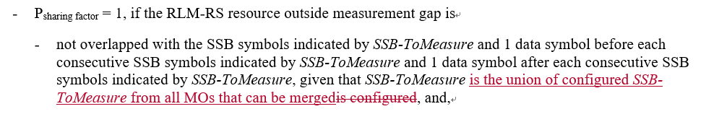
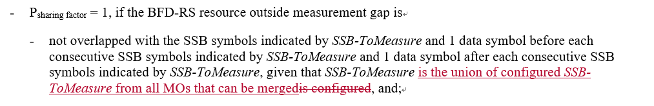
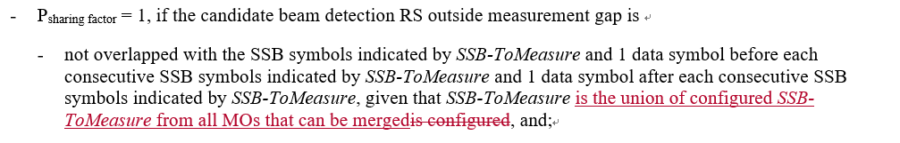
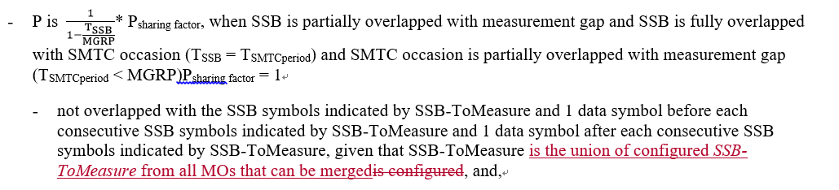
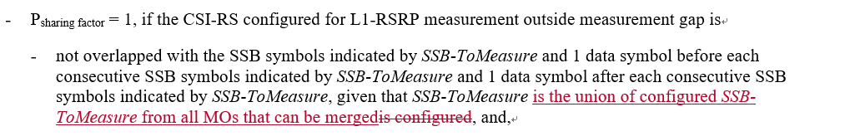
- Recommended WF
  - TBA

Sub-topic 1-3 SMTC1 and SMTC2 differentiation
Issue 1-3: SMTC1 and SMTC2 differentiation in intra-frequency measurement with MG
- Proposals (Apple R4-2100178)
  - Add condition of smtc1 and smtc2 differentiation in intra-frequency measurement with MG.
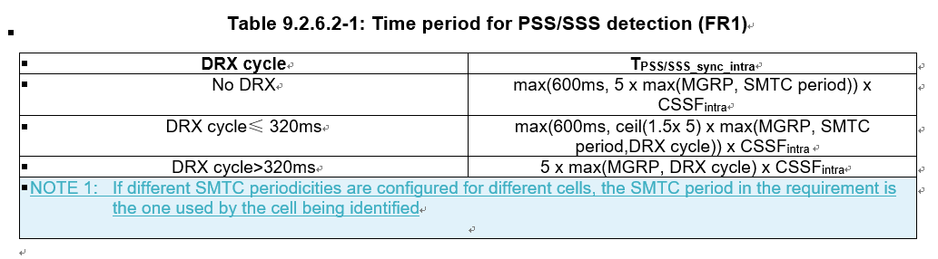
- Conclusion:
  - According to Chair (Andrey) guidance, this CR is postponed. So there is no need to discuss the topic in this meeting.

Sub-topic 1-4 deactivated SCell measurement for intra-frequency measurement with measurement gap
Issue 1-4: deactivated SCell measurement for intra-frequency measurement with MG
- Proposals
  - Option 1 (CMCC R4-21200851/2/3): for the scenario of intra-f measurement with MG, it is necessary to specify the requirements for PSS/SSS detection, time index detection and measurement period for deactivated SCell.
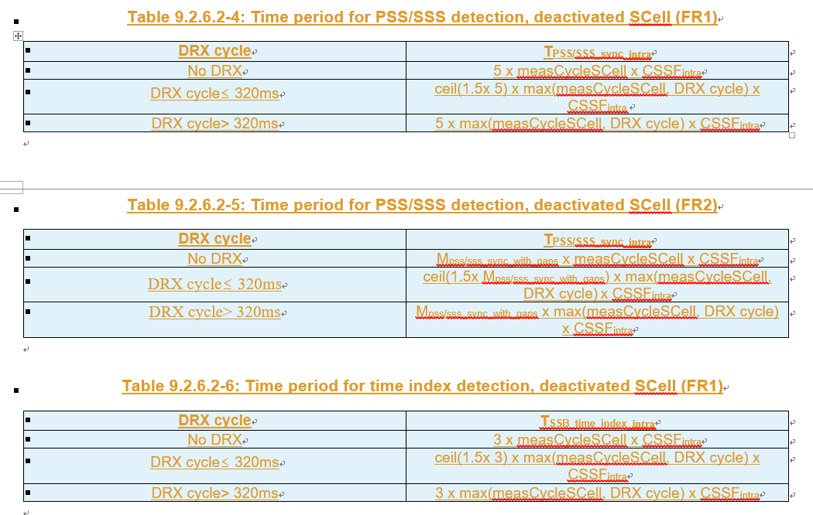
  - Option 2 (Huawei R4-2002737/38/39/40:
    - Scaling factor Kp shall be added for deactivated SCell measurement requirements without gap in R15.
    - The measurement requirements for deactivated SCell with gap shall be added in R15.
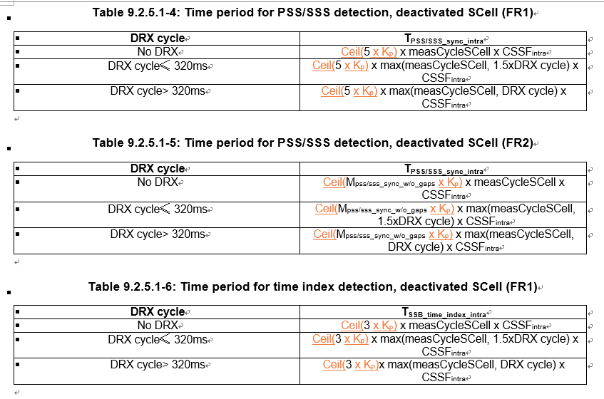
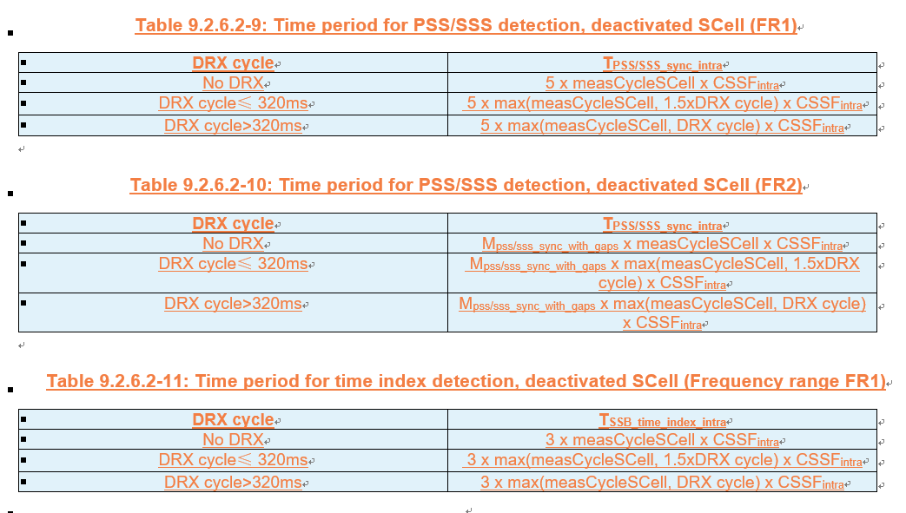
- Recommended WF
  - TBA

Companies views’ collection for 1st round

Open issues
Company | Comments
Apple | Sub topic 1-1:  Issue 1-1-1: we proposed option 1. We think it’s better to capture a clear UE behavior in spec, but for earlier R15 UE we could add a note in spec to allow some requirement relaxation.  Issue 1-1-2: alt 1 and alt 2 is quite similar, and we support alt1/2. We can further discuss the wording in the CR. We also support recommended WF.  Sub topic 1-2:  Issue 1-2: we are fine with MTK proposals.  ….  Sub topic 1-4:  Issue 1-4: We think deactivated SCell measurement does not belong to intra-frequency measurement with MG, since deactivated SCell does not have active BWP and the measurement of deactivated SCell would only cause possible interruption rather than using MG.  We think deactivated SCell measurement is still one kind of intra-frequency measurement without MG. So, we think it’s not necessary to introduce new requirement tables for deactivated SCell measurement into the section of “intra-frequency measurement with MG”.  Others:
Ericsson | Issue 1-1-1: How to treat the issue whether to count inter-RAT MO in CSSF outside MG or CSSF within MG?  Options 1 and 2 are incorrect as a measurement on a serving carrier is an inter-frequency measurements, not an inter-RAT measurement.This is clear already from the Rel-15 reporting criteria requirements and it applies regardless of which node is configuring the measurements on serving NR carriers.  Issue 1-1-2: Whether/how to count CSSF outside MG and CSSF within MG  We support Option 2a, with additional comditions:  - In calculation of CSSF outside MG: if MOs configured by MN and SN are merged from a capabilities perspective they are also counted only once in CSSF outside MG.  - In calculation of CSSF within MG: if MOs configured by MN and SN are merged from a capabilities perspective they are also counted only once in CSSF outside MG.  If the additional conditions are also the intention in the recommended WF, we support the recommended WF (unclear about whether counted only once in CSSF outside MG).  Issue 1-2: MO merging related to SSB-ToMeasurement indications  The intention is clear but the wording is not. Better make it clearer that this applies for DC scenarios.  Issue 1-3: SMTC1 and SMTC2 differentiation in intra-frequency measurement with MG  We are OK with the proposal.  Issue 1-4: deactivated SCell measurement for intra-frequency measurement with MG  Baseline for deactivated SCell measurements is measurements without gaps. Agree that in case MGs used by UE for other measurements would collide with SMTC for deactivated SCell, it will impact the cell identification time on the SCC due to the assumed searcher limitation. In case SMTC and MG collide occasionally, scaling by Kp may be adequate. If they collide all the time, scaling by CSSF may be adequate since the deactivated SCell measurement then would be fully competing with the other, gap-based, measurements for the resources during the measurement gap. We are OK with Option 2.
MTK | Issue 1-1-1:  Option 2.  We’re fine with the proposal for R16 and later release, UE shall perform NR inter-RAT measurements on NR serving carrier outside MG.  Issue 1-1-2:  We’re fine with Option 2a in last meeting’s WF: count the NR inter-RAT MO on NR serving CC configured by LTE MN that can be measured without MG in CSSF outside MG and remove the inter-RAT MOs counted in CSSF outside MG from CSSF within MG.  For calculation of CSSF outside MG, we’re fine with Option 1a in last meeting’s WF.  For calculation of CSSF within MG, we’re fine with Option 1a in last meeting’s WF.  Sub topic 1-2:  This issue had already agreed in last meeting with CR R4-2017336.  Just updating the spec. follows the same rule.  We accept Ericsson’s suggestion and revise it later.  Sub topic 1-3:  We’re fine.  Sub topic 1-4:  Do not need to define the requirement for deactivated SCell for intra-frequency measurement with MG.  When deactivated SCell’s SMTC is fully overlapping with MG, the requirement has already captured in section 9.2.5.1 with CSSF_{intra} determined by CSSFwithin_gap,i.  The reason to introduce the intra-frequency with MG requirement is the active BWP may not contain the SSB for the intra-frequency. However, there is no active BWP for deactivated SCell. Thus, we don’t define the deactivated SCell with MG requirement in Rel-15.  For Kp value, we think UE had already met current requirement in Rel-15. Thus, we don’t need to update to a loose requirement.
vivo | Issue 1-1-1:  Option 2  Issue 1-1-2:  Fine with option 2a of previous meeting WF.  Sub topic 1-2:  Sub topic 1-3:  Sub topic 1-4:  Agree with MTK’s view on this issue
Nokia | Issue 1-1-1: How to treat the issue whether to count inter-RAT MO in CSSF outside MG or CSSF within MG?  We believe RAN 4 should adopt similar rules as when RAN4 discussed the UE reporting capabilities. Hence, if an NR inter-RAT carrier configured by LTE is on a serving NR carrier, this carrier is measured as NR intra-frequency carrier.  This also means that if the NR inter-RAT carrier configured by LTE is not on a serving NR carrier, this LTE configured NR carrier is measured as an inter-RAT carrier.  The rules considering whether the carrier is measured within or outside MGs can follow the existing rules based on above classification (configured on serving carrier or not).  We do understand that we have Rel-15 devices in the field. Whether the agreements reached can apply for Rel-15 or from Rel-16 can be discussed once we have agreement on the how to address the ambiguity.  Issue 1-1-2: Whether/how to count CSSF outside MG and CSSF within MG  We prefer option 2a. When considering the actual physical measurement, the UE is only measuring the NR inter-RAT carrier configured by LTE on an NR serving carrier, once. And hence it shall only count once, and it should be measured as an intra-frequency carrier.  If we follow this approach any inter-RAT NR carriers on serving NR carriers should follow the current rules for measurements outside gaps in 9.1.5.1 or measurements inside gaps in 9.1.5.2.  In CSSF calculation and merging we are not sure the rule in 9.1.3.2 can be readily applied. Although we see that the carriers (the serving carrier and the NR inter-RAT carrier on the same serving NR carrier) shall only count once and use the merging rule of 9.1.3.2, this does not address how the measurements are to be performed within MGs or outside MGs. For other carriers (non-serving NR carrier and NR inter-RAT carrier on same carrier as a non-serving NR carrier) the rules of 9.1.3.2 should work and such carrier will be measured according to a non-serving NR carrier (inter-frequency carrier).  Anyway, we see using option 2a and same principles as applied for reporting capability, the existing CSSF rules should be readily applicable with some additional notes in section 9.1.5.1  Note: SSB-based intra-frequency measurement include measurement objects configured by E-UTRA PCell on an NR serving frequency carrier  and 9.1.5.2  Note: NR Inter-RAT measurement object configured by the E-UTRAN PCell and not configured on serving carriers by the E-UTRAN PCell  Issue 1-2: MO merging related to SSB-ToMeasurement indications  We would like to understand what ‘the union’ is a union of? This is for serving cell measurements it is not clear what ‘all MO’s that can be merge’ covers. Can MTK clarify?  Issue 1-4: deactivated SCell measurement for intra-frequency measurement with MG  We are wondering if additional scaling is needed for deactivated SCell measurements. Such measurements would be performed according to the configured measCycleScell and current requirements already include the CSSF factor. Is it correct to assume that the proposed Kp scaling factor for intra-f measurements with gaps would defined in a similar way as intra-frequency measurements without gaps?
MTK | To Ericsson,  We agree this issue is for DC, but the wording should apply for both DC and CA.  We don’t think it should further clarify the detail definitions in both DC and CA scenarios.  If possible, could Ericsson suggest the update wording?  To Nokia,  This is an issue related to MO-merge agreed in last meeting (CR R4-2017336). When both MN and SN configures two different SSB-ToMeasure, UE needs to merge the SSB-ToMeasure set from both side.  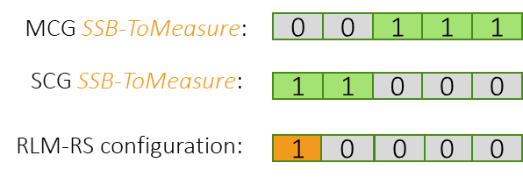
CMCC | Issue 1-4: for deactivated SCell measurement with MG, thanks companies for the clarification that the reason not specifying the requirements for the case is that there is no active BWP for deactivated SCell. If companies share the same understanding, we are also fine to only specify the deactivated SCell measurement related requirements for the case without MG.
Huawei | Issue 1-1-1: How to treat the issue whether to count inter-RAT MO in CSSF outside MG or CSSF within MG?  We support both option 1 and option 2.  To Ericsson/Nokia, we understand the measurement on an NR serving carrier configured by LTE PCell is still an inter-RAT measurement, but the requirements should follow NR intra-frequency. This is reflected in clause 8.17.4 of 36.133, which is for LTE-NR inter-RAT measurement, as copied below.  8.17.4.1 E-UTRAN FDD – NR measurements when configured with E-UTRA-NR Dual connectivity  Requirements in this clause apply for the NR capable UE configured with inter-RAT measurement on NR. For UE supporting EN-DC operation, the requirements in this clause shall apply when NR PSCell is configured. When the UE is not configured with E-UTRA-NR dual connectivity mode then the E-UTRAN FDD - NR measurement requirements defined in section 8.1.2.4.21 shall apply. When the E-UTRAN FDD-NR measurement object configured by E-UTRA PCell is on an NR serving frequency carrier, then the NR intra-frequency measurements requirements defined in clause 9.2 of TS 38.133 [50] shall apply. The requirements in this section shall also apply, when the UE is configured to perform NR SRS carrier based switching and using measurement gaps.  In this sense, whether the inter-RAT measurement on NR serving carrier should be performed within MG or outside MG should follow NR intra-frequency. However, the issue is that this is not clear in the current spec as mentioned in WF R4-2017331, and some companies raised the concern that there are already Rel-15 UE in the field which performs the measurement within MG.  Both option 1 and option 2 can clarify the spec and address the concern of legacy UE. A problem with option 1 is that there would be no requirement for measurement within MG once LTE PCell configured inter-RAT measurement on NR serving carrier, but we can discuss the wording when working on CR.  Issue 1-1-2: Whether/how to count CSSF outside MG and CSSF within MG  We are fine with option 2a from the WF last meeting, i.e. remove the inter-RAT MOs from the CSSF within MG, but we need to discuss how to address the legacy UE as we mentioned for Issue 1-1-1.  On whether the inter-RAT MO and intra- or inter-frequency MO can be merged, either within MG or outside MG, we understand all alternatives are same, i.e. they can merged as long the MO merging conditions are met, which we also support.  Issue 1-2: MO merging related to SSB-ToMeasurement indications  We are fine with MTK proposal.  Issue 1-3: SMTC1 and SMTC2 differentiation in intra-frequency measurement with MG  We are fine with Apple proposal.  Issue 1-4: deactivated SCell measurement for intra-frequency measurement with MG  There are two issues in Issue1-4.  - The first issue is whether adding deactivated SCell measurement within gap when SMTC is fully overlapping with MG.  - The second issue is whether Kp is introduced for deactivated SCell measurement requirements without gap when SMTC is partially overlapping with MG.  For the first issue, after the discussion, we can agree not introducing additional requirements since CSSFintra can be CSSFwithgap. Thanks for the clarification from companies.  For the secondary issue, we think it shall be addressed. Let us provide a bit explanation on this issue.  Although UE performs measurements on deactivated SCell without gap, the SMTC occasion may be partial overlapped with gap as well. For the partial overlapping case, it is reasonable to scale Kp, where Kp is 1/(1- (SMTC period /MGRP)).  One can argue that as measCycleSCell is larger or equal to 160ms, there is other opportunity for measurement on deactivated SCell during measCycleSCell. However the motivation of introducing measCycleSCell is to slowdown the measurement on deactivated SCC compared with activated cells. The measurement delay on deactivated SCell without scaling Kp may be smaller than that of activated cells, which is contradictory with the motivation.  According to the comments from company “UE had already met current requirement in Rel-15”, it can not ensure whether UE already meet the current requirement, as no test cases are verified. We suggest to fix the issue.
Qualcomm | Issue 1-1-1: How to treat the issue whether to count inter-RAT MO in CSSF outside MG or CSSF within MG?  Option1 is fine, but it is controversial due to compatibility with existing R15 UEs.  Option2 is agreeable but for R16 and later, the conditions of performing L2NR IRAT MOs on the NR serving carrier outside MG shall be clearly regulated, i.e.  1. whether SSB is contained in the active BWP  2. whether SMTC is fully overlapping with MG.  Issue 1-4: deactivated SCell measurement for intra-frequency measurement with MG  Deactivated Scell intra-frequency with gap may not be a valid scenario, since gap is required for intra-frequency measurement only when SSB is outside of active BWP, but deactivated Scell doesn’t have an “active BWP”, therefore this scenario is not valid.

CRs/TPs comments collection
Please provide additional comments, if any, on CRs below for the issues in Sub-topic 1-1 CSSF calculation
CR/TP number | Comments collection
R4-2100173 | Moderator: No Tdoc numbers are reserved for Rel-16 and Rel-17 Cat A CRs.
 | Apple: clarify to moderator: the R16 CR would be quite different from R15 since we have CSI-RS L3 MO and inter-frequency without MG MO in R16. Perhaps we would have discussion paper and cat-F CR for R16 case in next meeting.
 | Ericsson: Suggest to wait until sub-topic 1-1 has been settled.
 | MTK: suggest to at least update the CSSF table to make it readable
 | Nokia: suggest agreeing on solution and then discuss which CR can capture the changes.
 | Huawei: need more discussion on the wording as we commented for Issue 1-1-1.
R4-2102827  R4-2102537  R4-2102538 | Ericsson: Suggest to wait until sub-topic 1-1 has been settled.
 | MTK: suggest to merge all the CRs about CSSF.
 | Nokia: Focus on agreement and the allocate a CR for the agreed changes.
 | Huawei: need more discussion on the wording as we commented for Issue 1-1-1.

Please provide additional comments, if any, on CRs below for the issues for sub-topic 1-2. Please focus on MO merging.
CR/TP number | Comments collection
R4-2101050  R4-2101051  R4-2101052 | Apple: fine with the CR
 | Ericsson: Please see our comment for sub-topic 1-2. We think that the wording needs to be improved to make it clearer.
 | MTK: accept.
 | Nokia: please see our question in the discussion.
 | Huawei: changes related to SSB-ToMeasure with MO merging are agreeable. For other changes we will provide separate comments.

Please provide additional comments on CRs below for the issues for sub-topic 1-4. Please focus on deactivated SCell requirements.
CR/TP number | Comments collection
R4-2100852  R4-2100853 | Moderator: No Tdoc number is reserved for Rel-17 Cat A CRs.
 | Apple: same comment as to issue 1-4
 | Ericsson: It seems to us that Huawei’s proposal is more adequately addressing the issue, but let us not forego the discussion for sub-topic 1-4; let us wait with the CRs until the discussion has been settled.
 | MTK: Not support.
 | Nokia: Depends on the outcome of Issue 1-4.
 | Qualcomm: MGRP should be added to the table, as max(MGRP, measCycleSCell, DRX cycle)
R4-2102738  R4-2102739  R4-2102740 | Apple: same comment as to issue 1-4
 | Ericsson: Please see our comment above.
 | MTK: Not support the CR for deactivated SCell with MG requirement.
 | Nokia: Depends on the outcome of Issue 1-4.
 | Huawei: this CR only keep within gap part and remove the with gap part.

Summary for 1st round

Open issues
Moderator tries to summarize discussion status for 1st round, list all the identified open issues and tentative agreements or candidate options and suggestion for 2nd round i.e. WF assignment.
 | Status summary
Sub-topic#1-1-1 | Issue 1-1-1: How to treat the issue whether to count inter-RAT MO in CSSF outside MG or CSSF within MG?  7 companies made comments. In Ericsson’s comment, there seems a typo and it should be “Option 1 and Option 2 are incorrect as a measurement on a serving carrier is an intra-frequency….  Although one company commented that such measurement is not an inter-RAT measurement, all companies shared the same understanding that intra-frequency measurement requirements shall apply for the concerned case. Thus there would be no need to further discuss sub-topic#1-1-1. In the second round, we should focus on addressing the key issue, i.e., count CSSF outside MG and CSSF within MG, for the topic 1-1.  Tentative agreements:  No new agreement.  Companies share the same understanding as specified in Section 8.17.4.1 of TS 36.133 that “when the E-UTRAN FDD-NR measurement object configured by E-UTRA PCell is on an NR serving frequency carrier, then the NR intra-frequency measurement requirements defined in clause 9.2 of TS38.133 [50] shall apply.  Candidate options:  Recommendations for 2nd round:  No need for further discussion on the sub-topic#1-1-1.
Sub-topic#1-1-2 | Issue 1-1-2: Whether/how to count CSSF outside MG and CSSF within MG  7 companies made comments. All the companies can accept the recommended WF, i.e., Option 2a in the previous meeting and the merging condition. Ericsson proposed to make modification on Option 2a. But could Ericsson clarify whether it should be “counted only once in CSSF” within MG rather than “outside MG” in the second bullet of the proposed additional conditions.  There would be two issues for further discussion:  - How to resolve the compatibility issue with existing Rel-15 UEs  - Whether and how to add the conditions for inter-RAT measurements on the NR serving carrier configured by LTE MN.  Tentative agreements:  - In principle the Option 2a is agreed, i.e.,  - Remove the inter-RAT MOs counted in CSSF outside MG from CSSF within MG, and further discuss allowing existing implementations not to meet the updated requirements.  Candidate options:  There are three issues for further discussions:  - Is there any significant difference between Alternative 2 and other alternatives? Which one does the group agree on?  - Alternative 1:  - For calculation of CSSF outside MG, Option 1a in last meeting’s WF.  - For calculation of CSSF within MG, Option 1a in last meeting’s WF.  - Alternative 2:  - In calculation of CSSF outside MG: if MOs configured by MN and SN are merged from a capabilities perspective they are also counted only once in CSSF outside MG.  - In calculation of CSSF within MG: if MOs configured by MN and SN are merged from a capabilities perspective they are also counted only once in CSSF outside MG.  - To resolve the compatibility issue with existing Rel-15 UEs, can we agree on the proposed relaxation in Alternative 1, which is aligned also with other companies’ proposal.  - One note could be added into R15 spec that, “longer delays for cell identification and measurement periods derived based on CSSFwithin_gap,i can be expected, if the UE is configured with inter-RAT MO on NR serving CC by E-UTRAN PCell in EN-DC mode”.  - Can we agree on conditions to be added for inter-RAT measurements on the NR serving carrier configured by LTE MN?  - The conditions for performing inter-RAT measurement on the NR serving carrier outside MG shall be  - SSB is contained in the active BWP  - SMTC is not fully overlapping with MG.  Recommendations for 2nd round:  Further discussion on the above three issues.  More comment needs be collected on which CRs should be used to capture the agreement after the technique issue is addressed.
Sub-topic#1-2 | Issue 1-2: MO merging related to SSB-ToMeasurement indications  5 companies made the comments. It seems in principle the proposal is agreeable. One company suggested to make it clear that the proposal applies for DC scenarios. One company asked for the clarification about “the union”. The response is provided.  Tentative agreements:  N/A  Candidate options:  Recommendations for 2nd round:  Further discussion is needed:  - Need response from Nokia whether the response from Mediatek on Nokia’s comment is acceptable.  - Whether the wording should apply for DC only or for DC and CA.
Sub-topic#1-3 | Issue 1-3: SMTC1 and SMTC2 differentiation in intra-frequency measurement with MG  3 companies made the comments. The proposal is agreeable for them. But according to Chair guidance, the CR should be postponed. So we can come back in the next meeting.  Tentative agreements:  N/A  Candidate options:  Recommendations for 2nd round:  No discussion in the second round.
Sub-topic#1-4 | Issue 1-4: deactivated SCell measurement for intra-frequency measurement with MG  Companies made comments. 3 companies opposed the proposal. After the discussion, it seems agreeable not to specify the intra-frequency de-activated SCell measurement requirements with MG. But for the intra-frequency de-activated SCell measurement requirements without MG, more discussion on scaling factor is needed.  Tentative agreements:  Not to introduce the intra-frequency de-activated SCell measurement requirement with MG.  Candidate options:  Further discussion on  - Whether Kp is introduced for intra-frequency deactivated SCell measurement requirements without gap when SMTC is partially overlapping with MG.  - Yes  - No  Recommendations for 2nd round:  Further discuss the above open issues.

Recommendations on WF/LS assignment
 | WF/LS t-doc Title | Assigned Company,  WF or LS lead
#1

CRs/TPs
Moderator tries to summarize discussion status for 1st round and provides recommendation on CRs/TPs Status update
CR/TP number | CRs/TPs Status update recommendation
R4-2100173 | Return to
R4-2102827 | Return to
R4-2102537 | Return to
R4-2102538 | Return to
R4-2101051 | To be revised
R4-2101052 | Return to (Cat A CR for R4-2101051)
R4-2101053 | Return to (Cat A CR for R4-2101051)
R4-2100852 | Merged into the revised R4-2102738
R4-2100853 | Withdrawn
R4-2102738 | To be revised
R4-2102739 | Return to
R4-2102740 | Return to

Discussion on 2nd round (if applicable)
In the second round the CRs R4-2100173/R4-2102827/R4-2102537/R4-2102538, CRs R4-2101051/R4-2101052/R4-2101053, and CRs R4-2102738/R4-2102739/R4-2102740 need further discussion. Since the CRs R4-2101051/R4-2101052/R4-2101053, and CRs R4-2102738/R4-2102739/R4-2102740 cover multiple topics, we merge the corresponding multiple topics into one email thread in the 2nd round.
- Please Apple trigger the email discussion for sub-topic #1-1, and if the agreements were reached, please decide which CRs among R4-2100173/R4-2102827/R4-2102537/R4-2102538 should be used as baseline and revise them to capture the agreements.
  - With subject of [98e][201] NR_NewRAT_RRM_Core-CSSF calculation
- Please Mediatek trigger the email discussion for R4-2101051/R4-2101052/R4-2101053 to cover sub-topic #1-2, #5-1, #9-1, and #9-2.
  - With subject of [98e][201] NR_NewRAT_RRM_Core-MO merging-Active TCI-SFTD
- Please Huawei trigger the email discussion for R4-2102738/R4-2102739/R4-2102740 to cover sub-topic #1-4, #2-1, and #7-1 together with CRs R4-2102731/R4-2102732/R4-2102733.
  - With subject of [98e][201] NR_NewRAT_RRM_Core-SCell-E-CID

Summary on 2nd round (if applicable)
Moderator tries to summarize discussion status for 2nd round and provided recommendation on CRs/TPs/WFs/LSs Status update suggestion
CR/TP/LS/WF number | T-doc Status update recommendation
XXX | Based on 2nd round of comments collection, moderator can recommend the next steps such as “agreeable”, “to be revised”

Topic #2: Scell activation

Companies’ contributions summary
T-doc number | Company | Proposals / Observations
R4-2101006 | Apple | CR on Scell activation delay maintenance (R15) (38.133, Section 8.3)  1. Update the condition in SCell activation delay requirements for known target cell in FR1
R4-2101007 | Apple | CR on Scell activation delay maintenance (R16)  Cat A CR
R4-2101008 | Apple | CR on Scell activation delay maintenance (R17)  Cat A CR
R4-2102737 | Huawei, HiSilicon | Discussion on CSSF for inter-RAT measurement, SCell activation delay and cell identification requirements on deactivated SCell in Rel-15  Proposal 1: The current SCell activation requirements, except those for SSB-less SCell, apply provided that the SSB of the to-be-activated SCell is within the first active DL BWP of the SCell.  Proposal 2: RAN4 to clarify that the condition “is not provided with any SMTC for the target SCell” means UE is not provided with SSB configuration for the SCell (absoluteFrequencySSB is absent).  Proposal 3: If UE is not provided with SSB configuration for the SCell in FR1, Tactivation_time is 3 ms provided  - The target SCell is contiguous to an active serving cell in the same band, and  - The TypeA QCL for the target SCell is configured to the active serving cell, and  - The RTD between the target SCell and the active serving cell is <= CP/2  Proposal 4: Clarify that  “SCell measurement cycle is equal to or smaller than 160ms”  in FR1 known SCell activation requirements means  “the SCell has been measured within the last 160ms according to the measurement requirements defined for deactivated SCell in clause 9.2”.  Proposal 5: For scenarios where UE is not assumed to perform cell detection on the target SCell, the SCell activation requirements apply provided that SSB offset is same on the target SCell and the active serving cell.
R4-2102738 | Huawei, HiSilicon | CR on SCell activation delay, cell idenfication requirements on deactivated SCell and inter-RAT ECID requirements for NE-DC R15 (38.133, Section 8.3.2, 9.4.1, 9.4.5, 9.2.5, 9.2.6)  1. Update the SCell activation requriements  a) Clarifiy that current activation requirements do not apply when SCellSSB is outside frist active BWP  b) Clarify the condition for FR2 SSB-less SCell activation requirements  c) Add FR1 SSB-less SCell activation requirements  d) Clarifythe meaning of SCell measurement cycle” in FR1 known SCell activation requirements  e) Clarify that for scenarios where UE is not assumed to perform cell detection on the target SCell, requirements apply provided that SSB offset is same on the target SCell and the active or known serving cell.  2. Update the applicable requriements for NR – LTE inter-RAT E-CID measurement on LTE serving frequencies in NE-DC, such that the LTE SA intra-frequency requirements apply.  3. For deactivated SCell measurement:  -Adding scaling factor Kp for deactivated SCell measurement requirements without gap;  -Adding measurement requirements for deactivated SCell with gap
R4-2102739 | Huawei, HiSilicon | CR on SCell activation delay, cell idenfication requirements on deactivated SCell and inter-RAT ECID requirements for NE-DC R16  Cat A CR
R4-2102740 | Huawei, HiSilicon | CR on SCell activation delay, cell idenfication requirements on deactivated SCell and inter-RAT ECID requirements for NE-DC R17  Cat A CR
R4-2100174 | Apple | On SSB-less SCell activation  Proposal 1: If RAN4 agrees to introduce the requirement for FR1 SSB-less Scell activation in R15, only the intra-band contiguous case shall be considered.  Proposal 2: if RAN4 agrees to introduce the FR1 SSB-less Scell activation for intra-band NC case in R16, the 3ms activation delay requirement only applies when time difference between active serving cell and intra-band NC to-be-activated Scell is less than 260ns.  Proposal 3: the FR2 Scell activation without SMTC shall be revised as,  If the Scell being activated belongs to FR2 and if there is at least one active serving cell on that FR2 band, if the UE supporting scellWithoutSSB is not provided with any SMTC for the target Scell, T_{activation_time} is 3 ms, provided  - the RS (s) of Scell being activated is (are) QCL-TypeD with RS (s) of one active serving cell on that FR2 band.
R4-2100175 | Apple | CR on FR2 SCell activation requirement R15 (38.133, Section 8.3.2)  Revision the wording for current FR2 SCell activation for the case when UE supporting scellWithoutSSB is not provided with any SMTC for the target SCell
R4-2100176 | Apple | CR on FR2 SCell activation requirement R16  Cat A CR
R4-2100177 | Apple | CR on FR2 SCell activation requirement R17  Cat A CR
R4-2101071 | NEC | CR on SSB less SCell activation for FR1 for Rel-15 (38.133 Section 8.3.2, 8.3.3)  SCells are assumed to be co-located for intra-band contiguous CA in FR1. SCell can be activated without SSB provided the timing of SCell can be obtained. For a SCell operating without SSB, timing of SCell for PDCCH/PDSCH reception can be obtained from the already activated serving cell for the intra-band ulfilous CA in FR1.
R4-2101072 | NEC | CR on SSB less SCell activation for FR1 for Rel-16  SCells are assumed to be co-located for intra-band contiguous CA in FR1. SCell can be activated without SSB provided the timing of SCell can be obtained. For a SCell operating without SSB, timing of SCell for PDCCH/PDSCH and CSI-RS reception can be obtained from the already activated serving cell for the intra-band ulfilous CA in FR1.  (Tdoc number for Rel-17 CR is missing. Should this CR be Cat A?)
R4-2102872 | Qualcomm Incorporated | Cat-F CR to SSB-less SCell activation delay requirement for deactivated FR1 SCell in Rel-15 (38.133, Section 8.3.2)  Added an SSB-less SCell activation delay requirement for deactivated FR1 SCell and included QCL relations between refernce signals across cells in the same FR1 band in accordance with allowed QCL relations specified by the current spec.
R4-2102873 | Qualcomm Incorporated | Cat-A CR to SSB-less SCell activation delay requirement for deactivated FR1 SCell in Rel-16  Cat A CR
R4-2102874 | Qualcomm Incorporated | Cat-A CR to SSB-less SCell activation delay requirement for deactivated FR1 SCell in Rel-17  Cat A CR
R4-2101050 | MediaTek inc. | Remaining issues on RRM in R15  Proposal 1: When TCI of to-be-activated SSB-less SCell is QCLed to a RS of FR1 active serving cell which isn’t a contiguous intra-band cell, there is no requirement for SCell activation.  Proposal 2: When the TCI state of to-be-activated SSB-less SCell is indicates the QCL to a RS of FR1 active serving cell which is a contiguous intra-band cell and this active serving cell ulfil the following conditions,  - The RTD to the to-be-activated SCell is no larger than 260ns, and  - The RPD to the to-be-activated SCell is no larger than 6dB.  The T_{activation_time} time can be 3ms.  Otherwise, there is no requirement for this SSB-less SCell.

Open issues summary

Sub-topic 2-1 Scell activation requirement
Issue 2-1-1: SSB non in the first active BWP
- Proposals (Huawei R4-2102737):
  - The current SCell activation requirements, except those for SSB-less SCell, apply provided that the SSB of the to-be-activated SCell is within the first active DL BWP of the SCell.
- Recommended WF
  - TBA

Issue 2-1-2: Update conditions for SCell activation delay for the case where SCell is known
- Proposal 1 (Huawei R4-2102737):
  - Regarding SCell measurement cycle and AGC, clarify that
“SCell measurement cycle is equal to or smaller than 160ms”
in FR1 known SCell activation requirements means
“the SCell has been measured within the last 160ms according to the measurement requirements defined for deactivated SCell in clause 9.2”.
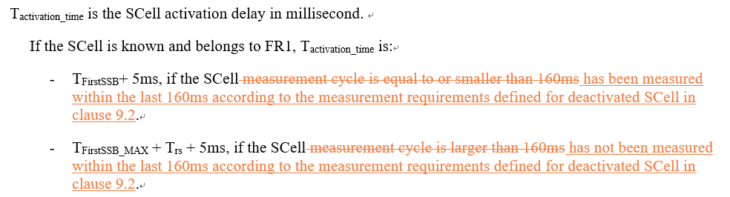
- Proposal 2 (Apple R4-2101006):
  - Update the condition in SCell activation delay requirements for known target cell in FR1
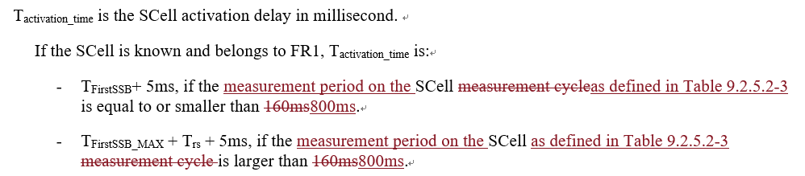
- Recommended WF
  - TBA

Issue 2-1-3: Determination of SSB offset
- Proposals (Huawei R4-2102737):
  - For scenarios where UE is not assumed to perform cell detection on the target SCell, the SCell activation requirements apply provided that SSB offset is same on the target SCell and the active serving cell.
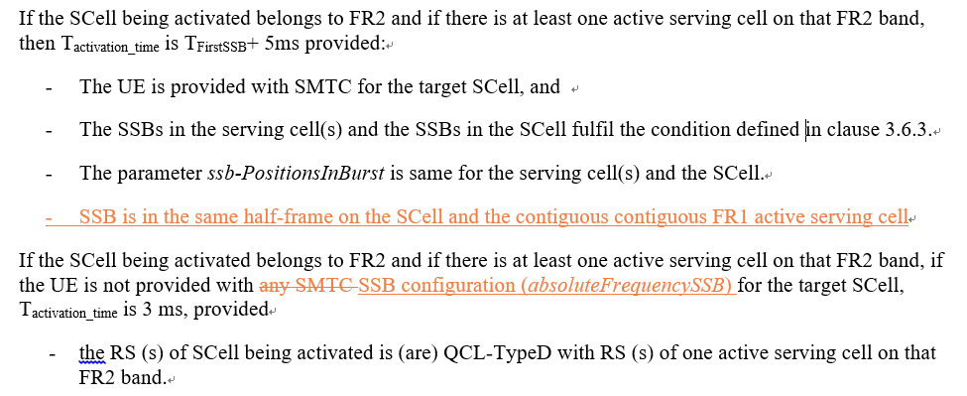
- Recommended WF
  - TBA

Sub-topic 2-2 SSB-less Scell activation
Issue 2-2-1: Condition and requirements for SSB-less SCell activation for FR1
- Proposals
  - Option 1 (Huawei R4-2102737/38/39/40):
    - RAN4 to clarify that the condition “is not provided with any SMTC for the target SCell” means UE is not provided with SSB configuration for the SCell (absoluteFrequencySSB is absent).
    - If UE is not provided with SSB configuration for the SCell in FR1, Tactivation_time is 3 ms provided
      - The target SCell is contiguous to an active serving cell in the same band, and
      - The TypeA QCL for the target SCell is configured to the active serving cell, and
      - The RTD between the target SCell and the active serving cell is <= CP/2
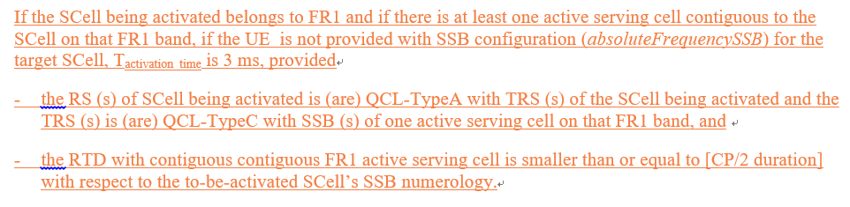
  - Option 2 (Qualcomm R4-2102872):
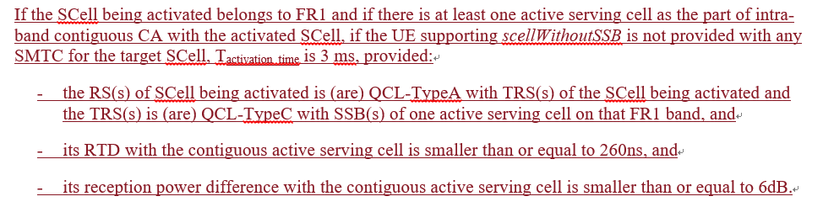
  - Option 3 (Apple R4-2100174/5):
    - If RAN4 agrees to introduce the requirement for FR1 SSB-less SCell activation in R15, only the intra-band contiguous case shall be considered.
    - if RAN4 agrees to introduce the FR1 SSB-less SCell activation for intra-band NC case in R16, the 3ms activation delay requirement only applies when time difference between active serving cell and intra-band NC to-be-activated SCell is less than 260ns.
  - Option 4 (Mediatek R4-2101050/1/2/3):
    - When TCI of to-be-activated SSB-less SCell is QCLed to a RS of FR1 active serving cell which isn’t a contiguous intra-band cell, there is no requirement for SCell activation.
    - When the TCI state of to-be-activated SSB-less SCell is indicates the QCL to a RS of FR1 active serving cell which is a contiguous intra-band cell and this active serving cell ulfil the following conditions,
      - The RTD to the to-be-activated SCell is no larger than 260ns, and
      - The RPD to the to-be-activated SCell is no larger than 6dB.
The T_{activation_time} time can be 3ms.
    - Otherwise, there is no requirement for this SSB-less SCell.
  - Option 5 (NEC R4-2001071): for Rel-15
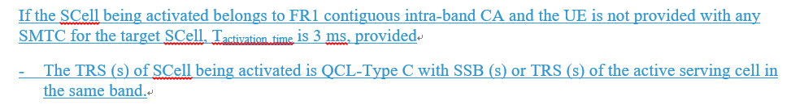
  - Option 5a (NEC R4-2001072): for Rel-16
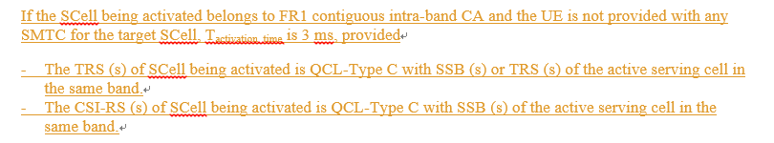
- Recommended WF
  - Can we try to use Option 1 and Option 2 as starting point to converge?

Issue 2-2-2: Condition and requirements for SSB-less SCell activation for FR2
- Proposals
  - Option 1 (Apple R4-2100174/5):
    - the FR2 SCell activation without SMTC shall be revised as,
If the SCell being activated belongs to FR2 and if there is at least one active serving cell on that FR2 band, if the UE supporting scellWithoutSSB is not provided with any SMTC for the target SCell, Tactivation_time is 3 ms, provided
- the RS (s) of SCell being activated is (are) QCL-TypeD with RS (s) of one active serving cell on that FR2 band.
- Recommended WF
  - TBA
  - If agreeable, this part should be merged into the other CR.

Companies views’ collection for 1st round

Open issues
Company | Comments
Apple | Issue 2-1-1: SSB non in the first active BWP  Fine with proposal from Huawei.  Issue 2-1-2: Update conditions for SCell activation delay for the case where SCell is known  We think fundamentally both proposal 1 and 2 are targeting the same issue: measCycleSCell doesn’t represent the actual sample interval. In proposal 1, actually network may have no idea if the target cell has been measured within the last 160ms, since on which carrier UE should perform measurement within certain SMTC is up to UE implementation. Thus if there is no measurement report within 160ms, NW has to assume additional time for AGC is needed. To avoid this, NW may configure periodic report on target deactivated SCell, which is unnecessary and resource and power would be wasted. A simple way to focus on total measurement period. Since 5 samples is assumed for each measurement period, assuming UE can hold AGC for 160ms, as long as the actual measurement period no longer than 800ms, UE doesn’t additional time for AGC.  Therefore, we prefer proposal 2.  Issue 2-1-3: Determination of SSB offset  Fine with additional condition proposed by Huawei. Seems there is some typo:  - SSB is in the same half-frame on the SCell and the contiguous contiguous FR12 active serving cell  Issue 2-1-4: Determination of SSB offset  Fine with additional condition proposed by Huawei.  Sub topic 2-1:  Issue 2-2-1: support ¾ with RTD≤260ns. In option 2 first sub-bullet, the active serving cell on that FR1 band shall be the one contiguous to the to-be-activated Scell. The wording could be revised as,  “- the RS(s) of SCell being activated is (are) QCL-TypeA with TRS(s) of the SCell being activated and the TRS(s) is (are) QCL-TypeC with SSB(s) of one active serving cell contiguous to the being activated SCell on that FR1 band, and”  Sub topic 2-2:  Issue 2-2-2:  We proposed option 1. No SMTC case shall only apply for the UE supporting scellWithoutSSB like FR1 case.  ….  Others:
Ericsson | Issue 2-1-1: SSB non in the first active BWP  From the discussions previous meeting it became clear that if UE is applying a “wide enough” bandwidth (regardless of BWP configuration), there would potentially be an interrupt later after the SCell activation for adjusting to the BW to the BWP. Hence there was concern on applying other BW than dictated by the BWP during the SCell activation. However, in case SSB is outside the BW of the BWP, the UE would anyways handle this on a periodic basis after the SCell is activated for the purpose of serving cell measurements and intra-frequency measurements. Hence the UE could switch back to the BW associated to the BWP at the first such occasion. It shall also be noted that there are UE configurations that are overridden during SCell activation, e.g. DRX. Therefore we do not see the proposed condition as absolutely necessary. If there is a consensus among other companies on that it is needed, we can accept it.  Issue 2-1-2: Update conditions for SCell activation delay for the case where SCell is known  Regarding Proposal 1: While we agree on that it is more suitable to consider how recently the cell has been measured than to consider the periodicity, we do not agree that one can reuse 160ms when changing to the former. The measurement period is 5 x measCycleSCell x CSSF_{intra.} If just re-using measCycleSCell when instead looking at how recently the SCell was measured, one would miss that the existing condition also is accounting for that CSSF_{intra} may be larger than one, etc. Hence we think that if changing the condition, the time needs to be larger than 160ms. Potentially the time in Proposal 2 can be used.  Regarding Proposal 2: We think it makes sense to use the measurement period rather than measCycleSCell. However we also think Proposal 1 makes sense. Merge?  Issue 2-1-3: Determination of SSB offset  This proposal needs to be updated. It talks about SCell in FR2 being activated, and the new condition proposed to be added concerns “SSB is in the same half frame on the SCell and the contiguous contiguous FR1 active serving cell.” An active serving cell in FR1 cannot be contiguous to an SCell in FR2. “Contiguous” is repeated twice.  Issue 2-1-4: Determination of SSB offset  Seems this issue is replicating parts of the 2-1-3. Editing mistake?  Issue 2-2-1: Condition and requirements for SSB-less SCell activation for FR1  We support the recommended WF. We have a slight preference for Option 2.  Issue 2-2-2: Condition and requirements for SSB-less SCell activation for FR2
MTK | Issue 2-1-1: Support the proposal.  Issue 2-1-2: Not support.  We think the condition ‘SCell measurement cycle is equal to or smaller than 160ms’ is clearly to both NW and UE side.  For proposal 1,  When SCell measurement cycle is smaller 160ms, UE can easily schedule the measurement within 160ms before SCell activation. However, whether UE will be measured the SCell less than 160ms is up to UE implementation.  At the same time, when change the condition to ‘the SCell has been measured within the last 160ms’, NW doesn’t have idea on whether UE finished the measurement within last 160ms.  For proposal 2,  The key issue here is UE needs to track the AGC other than UE had to finish the overall measurement period.  Issue 2-1-3:  Support the proposal with the update:  If the SCell being activated belongs to FR2 and if there is at least one active serving cell on that FR2 band, then T_{activation_time} is T_{FirstSSB}+ 5ms provided:  - The UE is provided with SMTC for the target SCell, and  - The SSBs in the serving cell(s) and the SSBs in the SCell fulfil the condition defined in clause 3.6.3.  - The parameter ssb-PositionsInBurst is same for the serving cell(s) and the SCell.  - SSB is in the same half-frame on the SCell and the contiguous FR2 active serving cell  Issue 2-1-4: the same as Issue 2-1-3.  Sub topic 2-2:  We’re fine with CR change in option 2. It’s the same meaning with option 4.  This proposal is to capture the assumption that NW will use the same Tx beam at a given time for intra-band contiguous CCs. If these FR1 cells have the same Tx beams direction, the propagation delay difference shall be 0ns. At the same time, the TAE for intra-band contiguous FR1 cell is 260ns. Thus, the overall delay shall be no larger than 260ns.  On the contrary, if NW cannot guarantee to use the same Tx beam direction for intra-band contiguous CCs. The overall RTD will depend on the propagation delay difference which is uncertain in the real field. As mentioned in our paper, when SSB-less SCell directly refer on the timing of the active intra-band contiguous serving cell, the larger RTD will result in the additional interference and performance degradation.  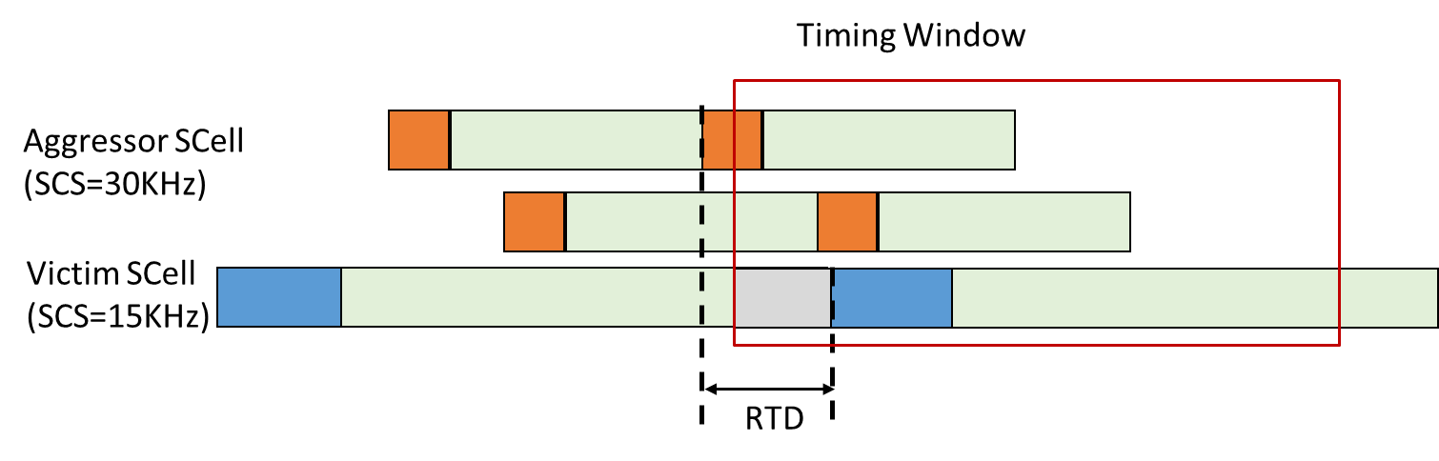  Issue 2-2-2: support the proposal.
vivo | Issue 2-1-1: OK with the proposal.
Nokia | Issue 2-1-1: SSB non in the first active BWP  We are fine with the addition.  Issue 2-1-2: Update conditions for SCell activation delay for the case where SCell is known  Proposal 1: We cannot agree to this change. It is changed to a condition which is not measurable or testable: ‘has been measured’. This is under UE control and cannot be known. We assume what is important is that the RS needed for performing the measurement is available for the UE to measure within 160ms. Hence, if ‘measurement cycle’ is unclear we could suggest ‘if the activation command is received within 160ms of an SSB from the SCell’. We are open to discuss but conditions would need to be measurable.  Proposal 2: We cannot agree to this change either. This change uses measurement period while it would be the actual RS and measurement opportunity that would be important? We are open to discuss how to capture a suitable wording.  Issue 2-1-3: Determination of SSB offset  With the updates to the wording pointed out by other companies this change should be agreeable (pending final text)  Issue 2-1-4: Determination of SSB offset  Same comment as other companies (same/copy?)  Issue 2-2-1: Condition and requirements for SSB-less SCell activation for FR1  We are fine with the proposed WF. Option 2 and the condition related to power imbalance needs to be aligned with RF session.
Huawei | Issue 2-1-1: SSB non in the first active BWP  We support the proposal.  Response to Ericsson comments, when SCell is active and SSB is not within active BWP the measurement would be based on MG which allows UE to re-tune the RF with periodic interruptions, but for SCell activation, only one interruption at the beginning of the activation process is allowed.  Issue 2-1-2: Update conditions for SCell activation delay for the case where SCell is known  We get the point from Apple/MTK/Nokia on Proposal 1 that it is hard to determine if the SCell has been measured within 160ms, but our concern with Proposal 2 is that overall measurement period being <=800ms does not mean the SCell is measured within 160ms, and we need more time to check if it is a valid condition to determine the need for AGC in known SCell activation.  We need more time to check and maybe can come back in 2nd round.  Issue 2-1-3: Determination of SSB offset  We can fix the errors in the CR as pointed by Apple/MTK/Ericsson/Nokia.  Issue 2-1-4: Determination of SSB offset  It seems to be identical to Issue 2-1-3  Issue 2-2-1: Condition and requirements for SSB-less SCell activation for FR1  We suggest to combine option 1 and option 2.  One different between optino1 and the other options is that the condition “UE is not provided with any SMTC for the target SCell” means UE is not provided with SSB configuration for the SCell (absoluteFrequencySSB is absent), and this needs to clarified.  We are fine to use 260ns as RTD condition and also include condition on support of scellWithoutSSB as well as the power imbalance as in option 2.  Issue 2-2-2: Condition and requirements for SSB-less SCell activation for FR2  We are fine with Apple’s proposal.
NEC | Issue 2-1-1: SSB not in the first active BWP  May be a clarification question to Huawei. If UE selects the RF BW as the first active BWP of the to-be-activated SCell, when SSB is not contained in the first active BWP, how does UE perform AGC when UE switches to other BW (this is not target BW for AGC) to measure SSB? May be I missed something. Can you please clarify?  Issue 2-1-2: Update conditions for SCell activation delay for the case where SCell is known  We share similar view as Nokia. We could change w.r.t RS reception instance, SCell activation command.  Issue 2-2-1: Condition and requirements for SSB-less SCell activation for FR1  May be couple of clarification questions to companies.  Question 1: Can we explicitly clarify RS (s) in the first condition, since they may be different for Rel-15 and Rel-16? Since they can be different for Rel-15 and Rel-16, do we need to have separate conditions for Rel-15 and Rel-16?  Question 2: Since the QCL relation and intra-band contiguous CA condition is already specified, do we need to explicitly specify 260ns as RTD. Isn’t it straight forward from the BS TAE for this scenario?  Issue 2-2-2: Condition and requirements for SSB-less SCell activation for FR2  OK with the proposal
Qualcomm | Issue 2-1-1: SSB non in the first active BWP  SSB outside BWP is an optional feature (6-1a) indicated in the “BWP-withoutRestriction” IE. Currently even for PCell there is no additional interruption defined for SSB-outside-BWP, so it is unclear why this would be needed for SCell.  Issue 2-1-2: Update conditions for SCell activation delay for the case where SCell is known  We agree to the observation and motivation for the change. We slightly prefer Proposal 2.  Issue 2-1-3: Determination of SSB offset  Does “SSB offset” in the main bullet refer to the half-frame offset? If so, it will be better to refine the wording of “SSB offset”. And we believe this should also apply to FR1 cases. If so, can we also try to reflect the same update to relevant FR1 requirements?  Issue 2-1-4: Determination of SSB offset  The same comment as Issue 2-1-3.  Issue 2-2-1: Condition and requirements for SSB-less SCell activation for FR1  We can consider the suggestion from Apple “contiguous to the being activated SCell”. Just to provide the rationale behind the wording in our proposal, we wanted to avoid the case where NW needs to sequentially activate SCell to apply the proposed requirement if cells in the same band are placed, e.g. “Cell1 (PCell) | SCell1 (deactivated) | SCell2 (to-be-activated)”. If companies do not see a technical issue with this scenario, we would like to go with our original version.  For Option 1, “The TypeA QCL for the target SCell is configured to the active serving cell” is not allowed by the spec, in our understanding.  Regarding “absoluteFrequencySSB”, if it is okay with Huawei, we want to discuss it separately. The change here is to add SSB-less FR1 SCell activation requirement which currently is missing as opposed to FR2. As the issue with “absoluteFrequencySSB” applies to both FR1 and FR2, it’ll be better to discuss it in another place.

CRs/TPs comments collection
Please provide the additional comments on the CRs below, if any, for the issues in sub-topic 2-1. Please focus on SCell activation
CR/TP number | Comments collection
R4-2101006  R4-2101007  R4-2101008 | Ericsson: Please see our comments above. Would potentially consider a merge between this CR and R4-2102738.
 | MTK: Needs update based on the discussion.
 | Nokia: Need to agree on a suitable wording.
 | Huawei: pending on issue 1-1-2.
R4-2102738  R4-2102739  R4-2102740 | Ericsson: Please see our comments above. Would potentially consider a merge between this CR and R4-2101006. Some of the changes may not be agreeable, hence need to settle the discussion first.
 | MTK: Needs update based on the discussion.
 | Nokia: need to agree on a suitable wording.

Please provide the additional comments on the CRs below, if any, for the issues in sub-topic 2-2. Please focus on SSB-less activation requirements
CR/TP number | Comments collection
R4-2101071  R4-2101072 | Moderator: Tdoc number for Rel-17 CR is missing.
 | Ericsson: Need to settle the discussion first.
 | MTK: suggest to use QC’s CR 2872 as the baseline.
 | Nokia: need to agree wording based on the discussion
R4-2102738  R4-2102739  R4-2102740 | Ericsson: Need to settle the discussion first.
 | MTK: Needs update based on the discussion.
 | Nokia: need to agree wording based on the discussion
R4-2102872  R4-2102873  R4-2102874 | Apple: the first sub-bullet of the SSB-less activation requirement needs to be reworded as:  “- the RS(s) of SCell being activated is (are) QCL-TypeA with TRS(s) of the SCell being activated and the TRS(s) is (are) QCL-TypeC with SSB(s) of one active serving cell contiguous to the being activated SCell on that FR1 band, and”
 | Ericsson: We are in principle fine with this CR. However, need to settle the discussion first.
 | MTK: support the CR. Also fine with Apple’s update.
Nokia: Regarding the Apple proposal, which in general looks fine. we would move the two words:
the RS(s) of SCell being activated is (are) QCL-TypeA with TRS(s) of the SCell being activated and the TRS(s) is (are) QCL-TypeC with SSB(s) of one active serving cell contiguous to the being activated SCell being activated on that FR1 band, and
Regarding the CR, there are two conditions:
- its RTD with the contiguous active serving cell is smaller than or equal to 260ns, and
- its reception power difference with the contiguous active serving cell is smaller than or equal to 6dB.
Power imbalance is likely already agreed in RF session and we should just make sure we are aligned (f they have such common understanding or even captured). The same with the RTD – we are wondering if this is to be understood similar as MRTD?
 | Huawei: please find our commented on Issue 2-1-1.

Summary for 1st round

Open issues
Moderator tries to summarize discussion status for 1st round, list all the identified open issues and tentative agreements or candidate options and suggestion for 2nd round i.e. WF assignment.
 | Status summary
Sub-topic#2-1-1 | Issue 2-1-1: SSB non in the first active BWP  4 companies supported the proposal. 1 company is neutral. 2 companies still had the questions.  One question from NEC is how AGC is conducted if SSB is outside the first active BWP. The other comment from Qualcomm is that SSB outside BWP is an optional feature. But both comments seems to be aligned with the intention of Huawei’s proposal “SSB of the to-be-activated SCell is within BWP. But the companies who had question seemed to mean that SSB should be within first active BWP but there is no need for explicitly clarification of such condition. Please companies further clarify whether it is the correct understanding.  The other question is why the condition is needed since there is no additional interruption defined for SSB-outside-BWP for PCell currently. In my view, it implies that there will be no additional interruption even for the configuration of SSB outside the active DL BWP. Can the group agree with such observation?  Tentative agreements:  N/A  Candidate options:  According to the comments, there are two comments which need response and two questions need further discussion:  - NEC: How is AGC conducted if SSB is outside the first active BWP? Does the question imply that SSB should be within the first active BWP?  - Qualcomm: SSB outside BWP is an optional feature. There is no additional interruption defined for SSB-outside-BWP for PCell currently and so there is no need to have proposed condition.  - Does the group agree that there is no additional interruption needed for SSB-outside-BWP for both PCell and SCell?  - Should the condition that SSB of the to-be-activated SCell is within the first active DL BWP of the SCell be added in the spec?  - Yes (Huawei, Apple, MTK, Vivo, Nokia, Ericsson (acceptable))  - No (Qualcomm, NEC(have question))  Recommendations for 2nd round:  Further discuss the above comments and questions.
Sub-topic#2-1-2 | Issue 2-1-2: Update conditions for SCell activation delay for the case where SCell is known  6 companies made comments. The key issue is that some companies think the wording “measurement cycle” is unclear and proposed two alternatives for modifications.  Regarding the proposal from Huawei, i.e., “SCell has been measured within the last 160ms…”, the comments were that the measurement is up to UE and cannot be controlled or measured by network and the time should be larger than 160ms if “measurement cycle” was changed.  Regarding the proposal from Apple, i.e., “measurement period … equal to or smaller than 800ms, the comments were that it cannot be ensured that SCell is measured within 160ms following such conditions.  The other alternative from Nokia and supported by NEC is to change “measurement cycle” to “if the activation command is received within 160ms of an SSB from the SCell”.  Tentative agreements:  N/A  Candidate options:  The key issue is whether measurement cycle is unclear and if so how to change it. There are follow alternative solutions:  - Alternative 1: Change “measurement cycle is equal to or smaller than 160ms” to “SCell has been measured within the last 160ms…” (Huawei)  - Alternative 2: Change “measurement cycle is equal to or smaller than 160ms” to “the measurement period on the SCell … is equal to or smaller than 800ms. (Apple)  - Alternative 3: Change “measurement cycle is equal to or smaller than 160ms” to “if the activation command is received within 160ms of an SSB from the SCell” (Nokia, NEC)  - Alternative 4: No change (Mediatek)  Recommendations for 2nd round:  Further discuss the above alternative solutions.
Sub-topic#2-1-3 | Issue 2-1-3: Determination of SSB offset  4 companies made the comments. In principle the proposal is agreeable. The typo of “FR1” needs be changed to FR2.  Tentative agreements:  It is agreeable to add the following condition for SCell activation requirements for FR2  - SSB is in the same half-frame on the SCell and the contiguous FR2 active serving cell  Candidate options:  Recommendations for 2nd round:  The typo of FR1 needs be changed and the redundant “contiguous” needs be removed.  NOTE: sorry for mistakenly reduplicate sub-topic 2-1-3 in 2-1-4.
Sub-topic#2-1-1 | Issue 2-1-1: Condition and requirements for SSB-less SCell activation for FR1  6 companies made the comments. It seemed that we can down-select to Option 1 and Option 2. There are a few of questions to be answered and issues to be addressed.  Tentative agreements:  - Further discuss the solution based on Option 1 and Option 2.  Candidate options:  A number of questions and issues need be addressed:  - Should we change the wording for Option 1 as proposed by Apple?  - “- the RS(s) of SCell being activated is (are) QCL-TypeA with TRS(s) of the SCell being activated and the TRS(s) is (are) QCL-TypeC with SSB(s) of one active serving cell contiguous to the being activated SCell on that FR1 band, and”  - Should and what the reception power difference with the contiguous active serving cell need be captured?  - Alternative 1: smaller than or equal to 6dB  - The condition “UE is not provided with any SMTC for the target Cell” needs be clarified (Huawei)  - Alternative 1: The condition “UE is not provided with any SMTC for the target SCell” means UE is not provided with SSB configuration for the SCell (absoluteFrequencySSB is absent)  - Can we explicitly clarify RS (s) in the first condition, since they may be different for Rel-15 and Rel-16? Since they can be different for Rel-15 and Rel-16, do we need to have separate conditions for Rel-15 and Rel-16? (NEC)  - The condition of RTD:  - Alternative 1: Explicitly clarify that RTD is smaller than or equal to 260ns. (Qualcomm, Apple, Mediatek, Huawei)  - Alternative 2: Since the QCL relation and intra-band contiguous CA condition is already specified, do we need to explicitly specify 260ns as RTD. Isn’t it straight forward from the BS TAE for this scenario? (NEC)  - Converge on the solution based on Option 1 and Option 2:  - Option 1:  If the SCell being activated belongs to FR1 and if there is at least one active serving cell contiguous to the SCell on that FR1 band, if the UE is not provided with SSB configuration (absoluteFrequencySSB) for the target SCell, T_{activation_time} is 3 ms, provided  - the RS (s) of SCell being activated is (are) QCL-TypeA with TRS (s) of the SCell being activated and the TRS (s) is (are) QCL-TypeC with SSB (s) of one active serving cell on that FR1 band, and  - the RTD with contiguous contiguous FR1 active serving cell is smaller than or equal to [CP/2 duration] with respect to the to-be-activated SCell’s SSB numerology.  - Option 2:  If the SCell being activated belongs to FR1 and if there is at least one active serving cell as the part of intra-band contiguous CA with the activated SCell, if the UE supporting scellWithoutSSB is not provided with any SMTC for the target SCell, T_{activation_time} is 3 ms, provided:  - the RS(s) of SCell being activated is (are) QCL-TypeA with TRS(s) of the SCell being activated and the TRS(s) is (are) QCL-TypeC with SSB(s) of one active serving cell on that FR1 band, and  - its RTD with the contiguous active serving cell is smaller than or equal to 260ns, and  - its reception power difference with the contiguous active serving cell is smaller than or equal to 6dB.  Recommendations for 2nd round:  Further discuss the above issues.
Sub-topic#2-1-2 | Issue 2-1-2: Condition and requirements for SSB-less SCell activation for FR2  4 companies made comments. The proposal seems agreeable.  Tentative agreements:  The following change is agreeable  - If the SCell being activated belongs to FR2 and if there is at least one active serving cell on that FR2 band, if the UE supporting scellWithoutSSB is not provided with any SMTC for the target SCell, T_{activation_time} is 3 ms, provided  Candidate options:  Recommendations for 2nd round:  Decide how to capture it in the CR. It is suggested to capture it in other CR.

Suggestion on WF/LS assignment
 | WF/LS t-doc Title | Assigned Company,  WF or LS lead
#1

CRs/TPs
Moderator tries to summarize discussion status for 1st round and provided recommendation on CRs/TPs Status update suggestion
CR/TP number | CRs/TPs Status update recommendation
R4-2101006 | Merged into potential revised R4-2102738.
R4-2101007 | Withdrawn
R4-2101008 | Withdrawn
R4-2101071 | Merged into potential revised R4-2102872.
R4-2101072 | Merged into potential revised R4-2102873
R4-2102872 | To be revised
R4-2102873 | Return to (Cat A to R4-2102872)
R4-2102874 | Return to (Cat A to R4-2102872)

Discussion on 2nd round (if applicable)
In the second round the CRs R4-2102872/R4-2102873/R4-2102874 need further discussion.
- Please Qualcomm trigger the email discussion to cover sub-topic #2-2.
  - With subject of [98e][201] NR_NewRAT_RRM_Core-SSB-less

Summary on 2nd round (if applicable)
Moderator tries to summarize discussion status for 2nd round and provided recommendation on CRs/TPs/WFs/LSs Status update suggestion
CR/TP/LS/WF number | T-doc Status update recommendation
XXX | Based on 2nd round of comments collection, moderator can recommend the next steps such as “agreeable”, “to be revised”

Topic #3: Beam management

Companies’ contributions summary
T-doc number | Company | Proposals / Observations
R4-2101464 | vivo | CR on the filter for beam failure indications in 38.133 (38.133 Section 8.5.4)  1. Clarify that the filter for beam failure indication should be Layer-2 filter  2. Clarify that such filter is not specified in TS 38.331.
R4-2101465 | vivo | CR on the filter for beam failure indications in 38.133  Cat A CR
R4-2101466 | vivo | CR on the filter for beam failure indications in 38.133  Cat A CR

Open issues summary

Sub-topic 3-1 Correction of layer X filter for beam failure detection
Issue 3-1: Correction of layer X filter for beam failure detection
- Proposals (Vivo R4-2101464/5/6):
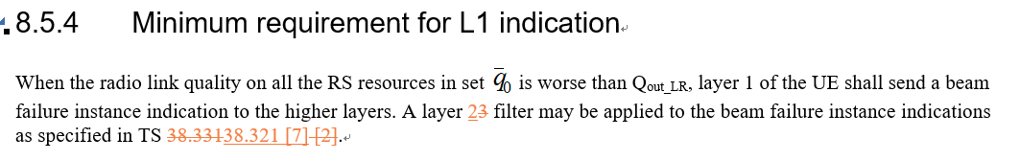
- Recommended WF
  - TBA

Companies views’ collection for 1st round

Open issues
Company | Comments
Apple | Sub topic 3-1:  Issue 3-1: fine with vivo CR.  Others:
Ericsson | Issue 3-1: Correction of layer X filter for beam failure detection  It is correct that there is no L3 filtering. On the other hand, there is no L2 filtering either, so we propose to remove the concerned sentence completely. Hence we think the proposal and the CR needs to be updated.
MTK | Support E///’s comments.  There is no L2 filter also.  Suggest to just delete the sentence.
vivo | The previous understanding from our side is that such filter is the counter for beam failure instances. But we are also fine to remove the sentence if companies’ understanding is aligned.
Nokia | There is a MAC timer which is started once the UE indicates BF instance the ‘upper layers’ in the UE start the timer and increments the BFI_COUNTER. Only if the BFI_COUNTER reaches Max, link recovery starts. One can regard this as ‘a filter’. If we want to clarify we can say that there may be a counter/filter in use in upper layers.
Huawei | Prefer to remove the sentence.

Summary for 1st round

Open issues
Moderator tries to summarize discussion status for 1st round, list all the identified open issues and tentative agreements or candidate options and suggestion for 2nd round i.e. WF assignment.
 | Status summary
Sub-topic#3-1 | Issue 3-1: Correction of layer X filter for beam failure detection  6 companies made comments. 4 out of them suggested to remove the concerned sentence, which seems acceptable for the group.  Tentative agreements:  Remove the concerned sentence about the filter.  Candidate options:  Recommendations for 2nd round:

Suggestion on WF/LS assignment
 | WF/LS t-doc Title | Assigned Company,  WF or LS lead
#1

CRs/TPs
Moderator tries to summarize discussion status for 1st round and provided recommendation on CRs/TPs Status update suggestion
CR/TP number | CRs/TPs Status update recommendation
R4-2101464 | To be revised
R4-2101465 | Return to (Cat A to R4-2101464)
R4-2101466 | Return to (Cat A to R4-2101464)

Discussion on 2nd round (if applicable)
In the second round the CRs R4-2101464/R4-2101465/ R4-2101466 need further discussion.
- Please Vivo trigger the email discussion for sub-topic #3-1.
  - With subject of [97e][201] NR_NewRAT_RRM_Core-Layer X filter

Summary on 2nd round (if applicable)
Moderator tries to summarize discussion status for 2nd round and provided recommendation on CRs/TPs/WFs/LSs Status update suggestion
CR/TP/LS/WF number | T-doc Status update recommendation
XXX | Based on 2nd round of comments collection, moderator can recommend the next steps such as “agreeable”, “to be revised”

Topic #4: BWP switching

Companies’ contributions summary
T-doc number | Company | Proposals / Observations
R4-2101407 | Intel Corporation | Discussion on RRC based BWP switching  Proposal 1: Clarify that requirement for RRC based BWP switching on a single CC apply for SpCell only.

Open issues summary
In previous meeting the agreements are as follows:
- Agreements
  - Send LS to RAN2 clarifying applicability of RRC based switch to Scell
  - Update Editor’s note as:
    - FFS if RRC based BWP switch is applicable to Scell
  - RRC based BWP switch requirements for Scell defined in Rel-15 can be updated based on RAN2 response, if needed
  - Requirements for RRC based BWP switch for Scell (Rel-16 onwards)
    - Can be updated to follow RAN2’s agreements in Rel-16, if needed
Accordingly the CR R4-2017342 was agreed.
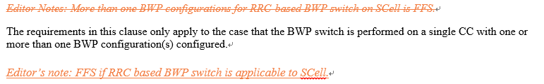

Sub-topic 4-1 Applicability of RRC based BWP switch delay requirement in Rel-15
Issue 4-1: Applicability of RRC based BWP switch delay requirement in Rel-15
- Proposal (Intel R4-2101407)
  - Clarify that requirement for RRC based BWP switching on a single CC apply for SpCell only.
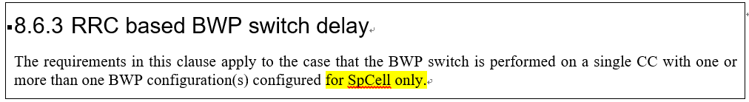
- Recommended WF
  - TBA

Companies views’ collection for 1st round

Open issues
Company | Comments
Apple | Sub topic 4-1: Applicability of RRC based BWP switch delay requirement in Rel-15  We recommend waiting for RAN2 LS reply before making any further changes to core requirements.  Others:
Ericsson | Issue 4-1: Applicability of RRC based BWP switch delay requirement in Rel-15  RAN4 has not yet received RAN2 LS response so it is too early to conclude that RRC based BWP switching does not cover Scell
Intel | Issue 4-1:  Since the feature has impact on Rel-16 RRM enhancement performance part (RRC based BWP switch on multiple CCs), which is assumed to be finished in this meeting. That’s why we propose it. we are also fine to wait for the reply of RAN2.
MTK | Agree with Apple, Ericsson.  This issue is pending on the LS from RAN2.
vivo | Wait for RAN2’s response
Nokia | Agree with other companies that we should wait the RAN2 reply.
Huawei | We prefer to wait for the LS reply from RAN2 before making the change.
NEC | Same view as other companies, we can wait for Reply LS from RAN2
Qualcomm | Pending on RAN2 progress.

Summary for 1st round

Open issues
Moderator tries to summarize discussion status for 1st round, list all the identified open issues and tentative agreements or candidate options and suggestion for 2nd round i.e. WF assignment.
 | Status summary
Sub-topic#1 | Issue 4-1: Applicability of RRC based BWP switch delay requirement in Rel-15  9 companies made comments. Most companies suggested to wait for RAN2 reply LS.  Tentative agreements:  For the issue of applicability of RRC based BWP switch delay requirement in Rel-15, RAN4 needs wait for RAN2 reply LS.  Candidate options:  Recommendations for 2nd round:  No further discussion in 2nd round.

Suggestion on WF/LS assignment
 | WF/LS t-doc Title | Assigned Company,  WF or LS lead
#1

CRs/TPs
Moderator tries to summarize discussion status for 1st round and provided recommendation on CRs/TPs Status update suggestion
CR/TP number | CRs/TPs Status update recommendation
R4-2101407 | Postponed

Topic #5: TCI state switching

Companies’ contributions summary
T-doc number | Company | Proposals / Observations
R4-2101050 | MediaTek inc. | Remaining issues on RRM in R15  Proposal 3: Define L1-RSRP delay requirement as max(T_{L1-RSPR_Measurement_Period_SSB}, TL1-RSRP_Measurement_Period_CSI-RS) when both SSB and CSI-RS are configured for L1-RSRP measurement.
R4-2101051 | MediaTek inc. | CR on R15 remaining issues (38.133 Section 8.1.2.2)  2. Define the minimum requirement when both SSB and CSI-RS for L1-RSRP measurement are configured.
R4-2101052 | MediaTek inc. | CR on R15 remaining issues  Cat A CR
R4-2101053 | MediaTek inc. | CR on R15 remaining issues  Cat A CR

Open issues summary

Sub-topic 5-1 Active TCI state switching
Issue 5-1: L1-RSRP delay requirement
- Proposal (Mediatek R4-2101050/1/2/3)
  - Define L1-RSRP delay requirement as max(T_{L1-RSPR_Measurement_Period_SSB}, TL1-RSRP_Measurement_Period_CSI-RS) when both SSB and CSI-RS are configured for L1-RSRP measurement.
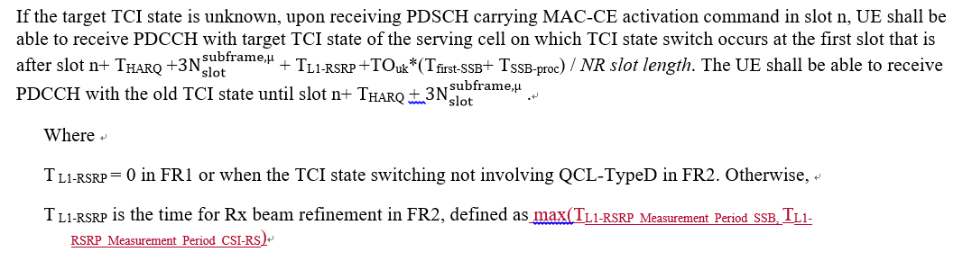
- Recommended WF
  - TBA

Companies views’ collection for 1st round

Open issues
Company | Comments
Apple | Sub topic 5-1: L1-RSRP delay requirement  We agree with adding the clarification that max would apply if both CSI-RS and SSB are configured, but wording needs to be clarified when max is applicable, otherwise it might be mis-leading.  ….  Others:
Ericsson | Issue 5-1: L1-RSRP delay requirement  The purpose of the L1-RSRP measurement is to identify the currently unknown target TCI state. For the target TCI state, it is known whether the associated RS is an SSB or a CSI-RS. The measurement period shall depend on whether it is SSB or CSI-RS. We do not see a reason to define it as maximum over the two periods.
MTK | To Ericsson,  The issue we want to identify is how to handle the requirement once NW configures both SSB and CSI-RS for measurement. There are totally three scenarios as follow:  - NW configures SSB only  - NW configures CSI-RS only  - NW configures both SSB and CSI-RS  The requirement for last scenario is missing.  To Apple,  Yes, the wording here is unclear. We can update the wording based on the suggestion.
Nokia | We are fine with a clarification. However, we cannot agree the proposal that this should be based on Max(). Instead it should be based on Min().  It is true RAN4 defines minimum requirements. But that is also given by allowing UE the time it needs to perform the necessary measurements. There should of course be a system benefit from providing UE with a more dense/often RS for measuring L1-RSRP otherwise there is no gain from network to provide such additional RS (e.g. for reducing latencies). This will also negatively impact the UE.  We even have an ongoing discussion related to similar topic concerning providing additional RS for speeding up SCell activation.  Hence, we agree with Ericsson.
MTK | To Nokia,  We agree with your observation, but this is a R15 remaining issue. RAN4 should be careful that Rel-15 devices had already in the field. If we use min() to define the requirement in R15, it implies a new UE behavior will be defined.  Our intention here is just to define a minimum requirement in R15, otherwise, there is no requirement when NW configures both SSB and CSI-RS.  RAN4 can further discuss the optimization in later release.
Huawei | Even with the clarification from MTK, we are still confused about the scenario.  As specified in RAN1, there is only one QCL-D in one TCI-state. The QCL-D resource is CSI-RS or SSB, and it is not possible to have both. In this case, L1-RSRP delay is based on its corresponding RS.  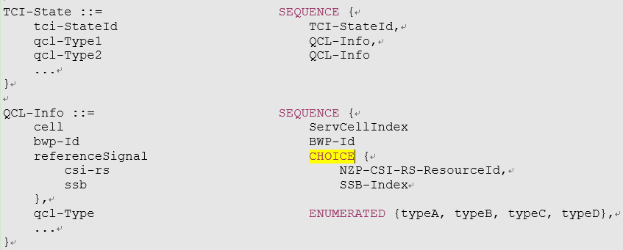  There is another scenario that one TCI state includes QCL-A and QCL-D, and the associated RS is CSI-RS and SSB. If it is this case, L1-RSRP delay is based on configured type-D RS, where UE sweeping TX beam. After that the Rx beam for type-A RS is obtained as well in the current specification 1Tssb is enough for fine timing.

Summary for 1st round

Open issues
Moderator tries to summarize discussion status for 1st round, list all the identified open issues and tentative agreements or candidate options and suggestion for 2nd round i.e. WF assignment.
 | Status summary
Sub-topic#5-1 | Issue 5-1: L1-RSRP delay requirement  4 companies made comments. 1 company supported it. 2 companies opposed it. 1 companies can accept the scenario under consideration but proposed to change the requirement from max to min. More discussion is needed.  Tentative agreements:  Candidate options:  The requirement of L1-RSRP delay for scenario where network configures both SSB and CSI-RS is discussed, the question is:  - Should and how the additional requirements covering the scenario where network configures both SSB and CSI-RS be specified?  - No. TCI state is detected based on either SSB or CSI-RS. (Ericsson, Huawei)  - Yes, the requirement is based on min(SSB measurement period, CSI-RS measurement period) (Nokia)  - Yes, the requirement is based on max(SSB measurement period, CSI-RS measurement period) (Mediatek)  Recommendations for 2nd round:

Suggestion on WF/LS assignment
 | WF/LS t-doc Title | Assigned Company,  WF or LS lead
#1

CRs/TPs
Moderator tries to summarize discussion status for 1st round and provided recommendation on CRs/TPs Status update suggestion

See section 1.4.2

Discussion on 2nd round (if applicable)
See Section 1.5.

Summary on 2nd round (if applicable)
Moderator tries to summarize discussion status for 2nd round and provided recommendation on CRs/TPs/WFs/LSs Status update suggestion
CR/TP/LS/WF number | T-doc Status update recommendation
XXX | Based on 2nd round of comments collection, moderator can recommend the next steps such as “agreeable”, “to be revised”

Topic #6: Interruption

Companies’ contributions summary
T-doc number | Company | Proposals / Observations
R4-2100233 | Apple | Interruption requirements due to measurement on SCC in NR-DC (R15) (38.133 Section 8.2.4.2.3)  Requirements for interruption due to measurement on SCC in NR-DC are defined in TS38.133 clause 8.2.4.2.3, which has same content as that defined in SA in clause 8.2.2.2.2. However, only interruption on PCell and other activated SCells are covered. Interruption on PSCell is missing.  Introduce interruption on PSCell due to measurement on SCC in NR-DC.  (Tdoc numbers for Rel-16, Rel-17 CRs are missing)

Open issues summary

Sub-topic 6-1 Interruption due to measurement on SCC in NR-DC
Issue 6-1: interruption requirement due to measurement on SCC in NR-DC
- Proposal (Apple, R4-2100233)
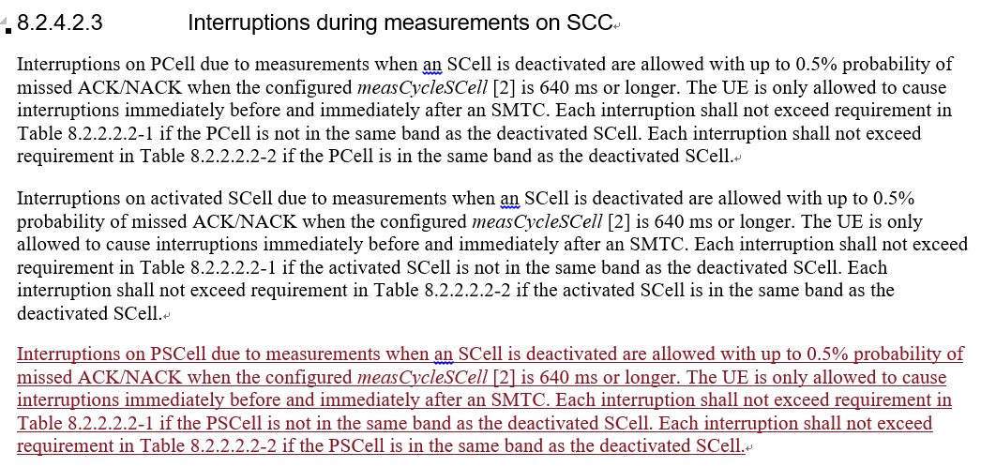
- Conclusion
  - According to Chair guidance (This CR is postponed). So there will be no discussion in this meeting.

Topic #7: Intra-frequency ECID

Companies’ contributions summary
T-doc number | Company | Proposals / Observations
R4-2102731 | Huawei, HiSilicon | CR to remove intra-frequency ECID requirements for NE-DC 36133 R15 (36.133 Section 8.19.5)  Remove the Intra-frequency E-CID measurement requirements for NE-DC.
R4-2102732 | Huawei, HiSilicon | CR to remove intra-frequency ECID requirements for NE-DC 36133 R16  Cat A CR
R4-2102733 | Huawei, HiSilicon | CR to remove intra-frequency ECID requirements for NE-DC 36133 R17  Cat A CR
R4-2102738 | Huawei, HiSilicon | CR on SCell activation delay, cell idenfication requirements on deactivated SCell and inter-RAT ECID requirements for NE-DC R15 (38.133, Section 8.3.2, 9.4.1, 9.4.5, 9.2.5, 9.2.6)  1. Update the SCell activation requriements  a) Clarifiy that current activation requirements do not apply when SCellSSB is outside frist active BWP  b) Clarify the condition for FR2 SSB-less SCell activation requirements  c) Add FR1 SSB-less SCell activation requirements  d) Clarifythe meaning of SCell measurement cycle” in FR1 known SCell activation requirements  e) Clarify that for scenarios where UE is not assumed to perform cell detection on the target SCell, requirements apply provided that SSB offset is same on the target SCell and the active or known serving cell.  2. Update the applicable requriements for NR – LTE inter-RAT E-CID measurement on LTE serving frequencies in NE-DC, such that the LTE SA intra-frequency requirements apply.  3. For deactivated SCell measurement:  -Adding scaling factor Kp for deactivated SCell measurement requirements without gap;  -Adding measurement requirements for deactivated SCell with gap
R4-2102739 | Huawei, HiSilicon | CR on SCell activation delay, cell idenfication requirements on deactivated SCell and inter-RAT ECID requirements for NE-DC R16  Cat A CR
R4-2102740 | Huawei, HiSilicon | CR on SCell activation delay, cell idenfication requirements on deactivated SCell and inter-RAT ECID requirements for NE-DC R17  Cat A CR

Open issues summary

Sub-topic 7-1 Correction for E-CID requirements
Issue 7-1-1: Remove intra-frequency E-CID measurement requirement for NE-DC
- Proposal (Huawei R4-2102731/2/3)
  - Remove 8.19.5 in 36.133
- Recommended WF
  - TBA

Issue 7-1-2: Correction of E-CID requirements
- Proposal (Huawei R4-2102738/39/40)
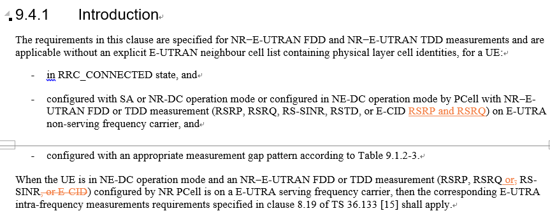
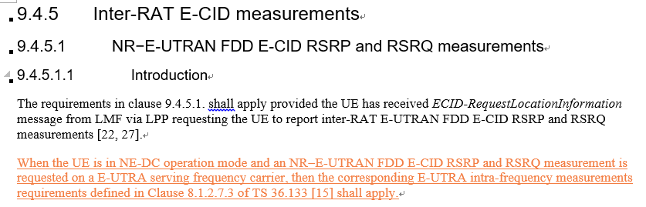
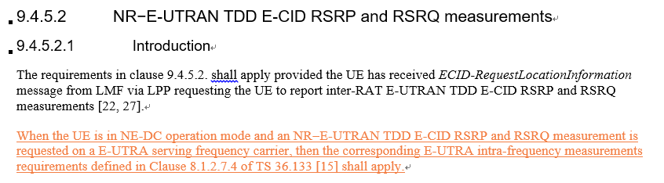
- Recommended WF
  - TBA

Companies views’ collection for 1st round

Open issues
Company | Comments
Ericsson | Issue 7-1-1: Remove intra-frequency E-CID measurement requirement for NE-DC  We do not think this CR is needed as it seems to be based on incorrect assumptions. Regardless of which cell is configuring, a measurement on a serving carrier frequency is intra-frequency – this is true even for Rel-15 CR. Furthermore, from Rel-16, we even have LPP in the Pcell, so the argument about LPP is not correct for CRs from Rel-16 and up, i.e., CRs for Rel-16 and Rel-17 should not even be submitted.  Issue 7-1-2: Correction of E-CID requirements  We do not agree to the proposal, as it is incorrect. The addition under “9.4.5. Inter-RAT E-CID measurements” states:  When the UE is in NE-DC operation mode and an NR−E-UTRAN FDD E-CID RSRP and RSRQ measurement is requested on a E-UTRA serving frequency carrier, then the corresponding E-UTRA intra-frequency measurements requirements defined in Clause 8.1.2.7.3 of TS 36.133 [15] shall apply.  We have highlighted the part that is problematic for the CR. The measurement is carried out on a serving carrier. A serving carrier is always an intra-frequency carrier, not an inter-RAT carrier.
Nokia | Issue 7-1-1: Remove intra-frequency E-CID measurement requirement for NE-DC  The Rel-16 and Rel-17 mirror CRs are not agreeable. For these releases it is our understanding that the measurements can be performed.  :
Huawei | Issue 7-1-1: Remove intra-frequency E-CID measurement requirement for NE-DC  On the definition of intra-frequency and inter-RAT, we have different understanding from Ericson. In NE-DC the measurement configured by NR PCell on LTE serving carriers are inter-RAT carriers, but the requirements are based on LTE intra-frequency case. This is clearly captured in clause 9.4.1 of 38.133 (see the highlighted sentence).  9.4 Inter-RAT measurements  9.4.1 Introduction  The requirements in this clause are specified for NR−E-UTRAN FDD and NR−E-UTRAN TDD measurements and are applicable without an explicit E-UTRAN neighbour cell list containing physical layer cell identities, for a UE:  - in RRC_CONNECTED state, and  - configured  - with SA or NR-DC operation mode or configured in NE-DC operation mode by PCell with NR-E-UTRAN FDD or TDD measurement (RSRP, RSRQ, RS-SINR, RSTD, or E-CID) on E-UTRA non-serving frequency carrier, or  - with SA operation mode on NR carrier frequencies with CCA by PCell with NR-E-UTRAN FDD or TDD measurement (RSRP, RSRQ, RS-SINR) on E-UTRA non-serving frequency carrier, and  - configured with an appropriate measurement gap pattern according to Table 9.1.2-3.  When the UE is in NE-DC operation mode and an NR-E-UTRAN FDD or TDD measurement (RSRP, RSRQ, RS-SINR, or E-CID) configured by NR PCell is on a E-UTRA serving frequency carrier, then the corresponding E-UTRA intra-frequency measurements requirements specified in clause 8.19 of TS 36.133 [15] shall apply.  In NE-DC, NGC is connected to NR MN, and there is no LPP or NRPPa between NGC and LTE SN, so the E-CID measurement can only be configured by NR PCell, so the measurement as in current 8.19.5 of 36.133 should be inter-RAT measurement. We therefore suggest to remove those requirements from 36.133 and add requirements for NR inter-RAT measurement in 38.133.  There is another concern raised by Ericsson and Nokia on Rel-16/17, we understand that in Rel-16 NR E-CID is supported, but the LTE measurement still can only be configured via NR PCell, so they should still be considered as inter-RAT measurement. Maybe Ericsson or Nokia can clarify what is different in Rel-16 that will make the CR incorrect?  Issue 7-1-2: Correction of E-CID requirements  This is also about the definition of intra-frequency and inter-RAT, and same comment as for Issue 7-1-1.
Qualcomm | Issue 7-1-2: Correction of E-CID requirements  There seems a discrepancy between what needs to be included in the section and what is added by the CR, e.g. the requirements in 9.4 are for measurements on “E-UTRA non-serving frequency carrier.”, whereas the text added by the CR mentions requirements for measurements on “E-UTRA serving frequency carrier.”
Ericsson2 | Response to Huawei:  The paragraph you are referring to is providing even further support that serving carriers, no matter which RAT has configured measurements on them, are considered to be intra-frequency carriers.  When the UE is in NE-DC operation mode and an NR-E-UTRAN FDD or TDD measurement (RSRP, RSRQ, RS-SINR, or E-CID) configured by NR PCell is on a E-UTRA serving frequency carrier, then the corresponding E-UTRA intra-frequency measurements requirements specified in clause 8.19 of TS 36.133 [15] shall apply.  We do not agree that the paragraph would justify removing ECID measurements in 8.19. Rather it is clarifying that serving carriers are intra-frequency carriers, and therefore in this case E-UTRA intra frequency measurement requirements apply.  We re-iterate our previous statements and comments.

Summary for 1st round

Open issues
Moderator tries to summarize discussion status for 1st round, list all the identified open issues and tentative agreements or candidate options and suggestion for 2nd round i.e. WF assignment.
 | Status summary
Sub-topic#7-1-1 | Issue 7-1-1: Remove intra-frequency E-CID measurement requirement for NE-DC  2 companies made comments. Both of them opposed the changes. The key issue is whether E-CID measurement should be intra-frequency measurement or inter-RAT. More discussion is needed.  It seems that Nokia may be OK with Rel-15 CR. It is needed for Nokia to clarify their comments.  Tentative agreements:  N/A  Candidate options:  Further discussion on  - Is E-CID measurement on serving cell an intra-frequency measurement or inter-RAT measurement?  - Intra-frequency (Ericsson)  - Inter-RAT (Huawei)  Recommendations for 2nd round:  Further discuss the above question.
Sub-topic#7-1-2 | Issue 7-1-1: Correction of E-CID requirements  2 companies made comments. Both of them opposed the changes. One key issue is whether E-CID measurement should be intra-frequency measurement or inter-RAT. More discussion is needed.  Tentative agreements:  N/A  Candidate options:  Further discussion on  - Is E-CID measurement on serving cell an intra-frequency measurement or inter-RAT measurement?  - Intra-frequency (Ericsson)  - Inter-RAT (Huawei)  - Is there any response to Qualcomm comment.  Recommendations for 2nd round:  Further discuss the above question.

Suggestion on WF/LS assignment
 | WF/LS t-doc Title | Assigned Company,  WF or LS lead
#1

CRs/TPs
Moderator tries to summarize discussion status for 1st round and provided recommendation on CRs/TPs Status update suggestion
CR/TP number | CRs/TPs Status update recommendation
R4-2102731 | Return to
R4-2102732 | Return to (Cat A CR to R4-2102731)
R4-2102733 | Return to (Cat A CR to R4-2102731)

Discussion on 2nd round (if applicable)
See section 1.5.

Summary on 2nd round (if applicable)
Moderator tries to summarize discussion status for 2nd round and provided recommendation on CRs/TPs/WFs/LSs Status update suggestion
CR/TP/LS/WF number | T-doc Status update recommendation
XXX | Based on 2nd round of comments collection, moderator can recommend the next steps such as “agreeable”, “to be revised”

Topic #8: Idle mode

Companies’ contributions summary
T-doc number | Company | Proposals / Observations
R4-2102734 | Huawei, HiSilicon | CR to idle more requirements in 36133 R15 (36.133 Section 4.2.2)  Add NR as one of the inter-RAT targets for high priority carrier seach when UE is in LTE Idle mode.
R4-2102735 | Huawei, HiSilicon | CR to idle more requirements in 36133 R16  Cat A CR
R4-2102736 | Huawei, HiSilicon | CR to idle more requirements in 36133 R17  Cat A CR

Open issues summary

Sub-topic 8-1 Correction for idle mode requirements
Issue 8-1: Correction for idle mode requirements
- Proposal (Huawei R4-2102734/5/6)
  - Add NR as one of the inter-RAT targets for high priority carrier seach when UE is in LTE Idle mode.
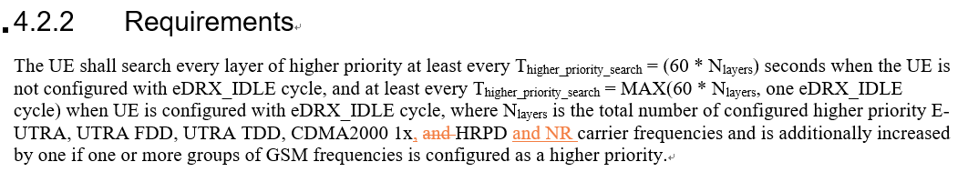
- Recommended WF
  - TBA

Companies views’ collection for 1st round

Open issues
Company | Comments
Apple | Sub topic 8-1:  Issue 8-1: fine with Huawei proposal  Others:
Ericsson | Issue 8-1: Correction for idle mode requirements  We are fine with the proposal.
MTK | Support.
Nokia | CR is agreeable

Summary for 1st round

Open issues
Moderator tries to summarize discussion status for 1st round, list all the identified open issues and tentative agreements or candidate options and suggestion for 2nd round i.e. WF assignment.
 | Status summary
Sub-topic#8-11 | Issue 8-1: Correction for idle mode requirements  4 companies made comments. The proposal is agreeable.  Tentative agreements:  CRs R4-2102734/5/6 are agreeable.  Candidate options:  Recommendations for 2nd round:

Suggestion on WF/LS assignment
 | WF/LS t-doc Title | Assigned Company,  WF or LS lead
#1

CRs/TPs
Moderator tries to summarize discussion status for 1st round and provided recommendation on CRs/TPs Status update suggestion
CR/TP number | CRs/TPs Status update recommendation
R4-2102734 | Agreeable.
R4-2102735 | Agreeable
R4-2102736 | Agreeable

Topic #9: SFTD and other editorial maintenance

Companies’ contributions summary
T-doc number | Company | Proposals / Observations
R4-2101051 | MediaTek inc. | CR on R15 remaining issues (38.133 Section 8.1.2.2)  3. SFTD(9.3.8.3)  SFTD measurement reporting delay doesn’t include RRC procedure delay.
R4-2101052 | MediaTek inc. | CR on R15 remaining issues  Cat A CR
R4-2101053 | MediaTek inc. | CR on R15 remaining issues  Cat A CR

Open issues summary

Sub-topic 9-1 Correction for SFTD requirements
Issue 9-1: Correction for SFTD requirements
- Proposal (Mediatek R4-2101051/2/3)
  - Clarify SFTD measurement reporting delay including measurement period plus the RRC procedure delay
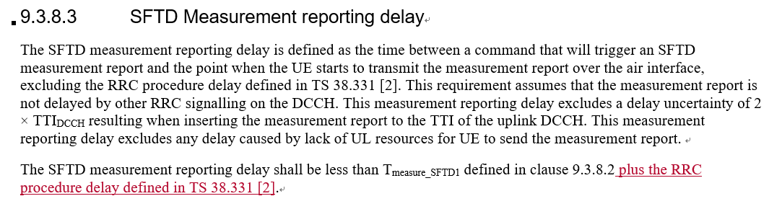
- Recommended WF
  - TBA

Sub-topic 9-2 others
Issue 9-2: Other editorial changes in R4-2101051/2/3
- Proposals
  - Changes in Section 9.2.5.1, 9.2.5.3
- Recommended WF
  - TBA

Companies views’ collection for 1st round

Open issues
Company | Comments
Apple | Sub topic 9-1:  Issue 9-1: fine with the changed proposed by MTK.  Sub topic 9-2:  ….  Others:
Ericsson | Issue 9-1: Correction for SFTD requirements  We disagree with the proposal. It is already clear that RRC delay is excluded from SFTD measurement reporting delay, and hence that the time will be the sum of the two. Please see the highlighted text:  9.3.8.3 SFTD Measurement reporting delay  The SFTD measurement reporting delay is defined as the time between a command that will trigger an SFTD measurement report and the point when the UE starts to transmit the measurement report over the air interface, excluding the RRC procedure delay defined in TS 38.331 [2]. This requirement assumes that the measurement report is not delayed by other RRC signalling on the DCCH. This measurement reporting delay excludes a delay uncertainty of 2 × TTI_{DCCH} resulting when inserting the measurement report to the TTI of the uplink DCCH. This measurement reporting delay excludes any delay caused by lack of UL resources for UE to send the measurement report.  The SFTD measurement reporting delay shall be less than T_{measure_SFTD1} defined in clause 9.3.8.2  Issue 9-2: Other editorial changes in R4-2101051/2/3  These changes concern changing font colour to “automatic”. I have no issue with this being addressed in the same CR as addressing other things, but I think maybe next time we do not need to add such changes as an issue for companies to comment on.
Huawei | Issue 9-1: Correction for SFTD requirements  We think some clarification in the wording may be needed. Technically the actual reporting time will be sum of the RRC procedure delay and the T_{measure_SFTD1}.  Issue 9-2: Other editorial changes in R4-2101051/2/3  We are fine with the changes.

Summary for 1st round

Open issues
Moderator tries to summarize discussion status for 1st round, list all the identified open issues and tentative agreements or candidate options and suggestion for 2nd round i.e. WF assignment.
 | Status summary
Sub-topic#9-1 | Issue 9-1: Correction for SFTD requirements  3 companies made comments. 2 companies supported the change. 1 company opposed it, who commented that it is already clear that RRC delay is excluded from SFTD measurement reporting delay.  Tentative agreements:  N/A  Candidate options:  Further discussion on  - Whether RRC delay is excluded from SFTD measurement reporting  - Yes (Ericsson)  - No (Mediatek, [Huawei], [Apple])  Recommendations for 2nd round:  Further discussion is needed.
Sub-topic#9-2 | Issue 9-2: Other editorial changes in R4-2101051/2/3  2 companies made comments. The changes seemed OK.  Tentative agreements:  The proposed changes are agreeable.  Candidate options:  Recommendations for 2nd round:

Suggestion on WF/LS assignment
 | WF/LS t-doc Title | Assigned Company,  WF or LS lead
#1

CRs/TPs
Moderator tries to summarize discussion status for 1st round and provided recommendation on CRs/TPs Status update suggestion

See Section 1.4.2.

Discussion on 2nd round (if applicable)
See Section 1.5

Summary on 2nd round (if applicable)
Moderator tries to summarize discussion status for 2nd round and provided recommendation on CRs/TPs/WFs/LSs Status update suggestion
CR/TP/LS/WF number | T-doc Status update recommendation
XXX | Based on 2nd round of comments collection, moderator can recommend the next steps such as “agreeable”, “to be revised”

