3GPP TSG-RAN WG4 Meeting#98-e DRAFT_R4-2103135

Electronic meeting, 25 January – 5 February 2021
CR-Form-v12.1
CHANGE REQUEST
 | 38.101-1 | CR | 0647 | rev | 1 | Current version: | 16.6.0
For HELP on using this form: comprehensive instructions can be found at
http://www.3gpp.org/Change-Requests.

Proposed change affects: | UICC apps |  | ME | X | Radio Access Network |  | Core Network

Title: | Applicability of requirements for shared spectrum access
Source to WG: | Ericsson
Source to TSG: | R4
Work item code: | NR_unlic-Core |  |  |  |  |  | Date: |  |  | 2021-01-25
Category: | F |  |  |  |  |  | Release: |  |  | Rel-16
 | Use one of the following categories:  F (correction)  A (mirror corresponding to a change in an earlier release)  B (addition of feature),  C (functional modification of feature)  D (editorial modification)  Detailed explanations of the above categories can  be found in 3GPP TR 21.900. |  |  |  |  |  |  |  | Use one of the following releases:  Rel-8 (Release 8)  Rel-9 (Release 9)  Rel-10 (Release 10)  Rel-11 (Release 11)  …  Rel-15 (Release 15)  Rel-16 (Release 16)  Rel-17 (Release 17)  Rel-18 (Release 18)
Reason for change: |  | The applicability of minimum requirements for the transmitter and receiver characteristics of wideband operation is not specified. For the UL, transmissions in contigous available RB sets where the intra-cell GB posibly scheduled should be assumed for the present release. For the DL, transmissions with no intra-cell GB with all RB sets of a channel scheduled and available should be assumed.
Summary of change: |  | New clause 6.1F: the applicability of requirements for transmitter characteritics is specified.  New clause 7.1F: the applicability of requirements for transmitter characteritics is specified.  A reference is added to clause 2.
Consequences if not approved: |  | The applicability of minimum requirements for the transmitter and receiver characteristics of wideband operation is not specified.
Clauses affected: |  | 2, 6.1F (new), 7.1F (new)
 |  | Y | N
Other specs |  |  | X | Other core specifications
affected: |  |  | X | Test specifications |  |  |  | .
(show related CRs) |  |  | X | O&M Specifications
Other comments:
This CR's revision history: |  | r1: modification of the specification of applicability, changes in section 5.3.3

< start of changes >

2 References
The following documents contain provisions which, through reference in this text, constitute provisions of the present document.
References are either specific (identified by date of publication, edition number, version number, etc.) or non-specific.
For a specific reference, subsequent revisions do not apply.
For a non-specific reference, the latest version applies. In the case of a reference to a 3GPP document (including a GSM document), a non-specific reference implicitly refers to the latest version of that document in the same Release as the present document.
[1] 3GPP TR 21.905: "Vocabulary for 3GPP Specifications".
[2] 3GPP TS 38.101-2: "NR; User Equipment (UE) radio transmission and reception; Part 2: Range 2 Standalone".
[3] 3GPP TS 38.101-3: "NR; User Equipment (UE) radio transmission and reception; Part 3: Range 1 and Range 2 Interworking operation with other radios".
[4] 3GPP TS 38.521-1: "NR; User Equipment (UE) conformance specification; Radio transmission and reception; Part 1: Range 1 Standalone".
[5] Recommendation ITU-R M.1545: "Measurement uncertainty as it applies to test limits for the terrestrial component of International Mobile Telecommunications-2000".
[6] 3GPP TS 38.211: "NR; Physical channels and modulation".
[7] 3GPP TS 38.331: "Radio Resource Control (RRC) protocol specification".
[8] 3GPP TS 38.213: "NR; Physical layer procedures for control".
[9] ITU-R Recommendation SM.329-10, "Unwanted emissions in the spurious domain".
[10] 3GPP TS 38.214: "NR; Physical layer procedures for data".
[11] 3GPP TS 36.101: Evolved Universal Terrestrial Radio Access (E-UTRA); User Equipment (UE) radio transmission and reception;
[12] ETSI TS 102 792: "Intelligent Transport Systems (ITS); Mitigation techniques to avoid interference between European CEN Dedicated Short Range Communication (CEN DSRC) equipment and Intelligent Transport Systems (ITS) operating in the 5 GHz frequency range".
[13] 3GPP TS 38.133: "NR; Requirements for support of radio resource management".
[14] 3GPP TS 37.213: “Physical layer procedures for shared spectrum channel access”.
< text omitted >

5.3.3 Minimum guardband and transmission bandwidth configuration
The minimum guardband for each UE channel bandwidth and SCS is specified in Table 5.3.3-1,
Table 5.3.3-1: Minimum guardband for each UE channel bandwidth and SCS (kHz)
SCS (kHz) | 5 MHz | 10 MHz | 15 MHz | 20 MHz | 25 MHz | 30 MHz | 40 MHz | 50 MHz | 60 MHz | 70 MHz | 80 MHz | 90 MHz | 100 MHz
15 | 242.5 | 312.5 | 382.5 | 452.5 | 522.5 | 592.5 | 552.5 | 692.5 | N/A | N/A | N/A | N/A | N/A
30 | 505 | 665 | 645 | 805 | 785 | 945 | 905 | 1045 | 825 | 965 | 925 | 885 | 845
60 | N/A | 1010 | 990 | 1330 | 1310 | 1290 | 1610 | 1570 | 1530 | 1490 | 1450 | 1410 | 1370

NOTE: The minimum guardbands have been calculated using the following equation: (BW_{Channel} x 1000 (kHz) - N_{RB} x SCS x 12) / 2 - SCS/2, where N_{RB} are from Table 5.3.2-1.
Figure 5.3.3-1: Void
The number of RBs configured in any channel bandwidth shall ensure that the minimum guardband specified in this clause is met.
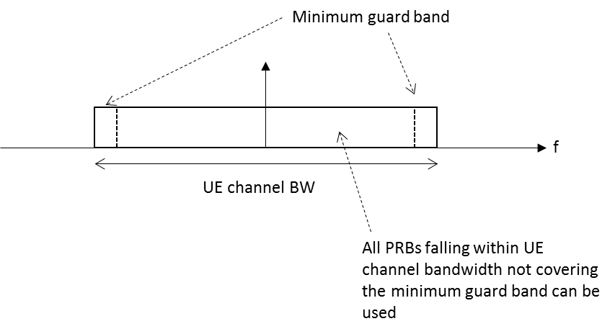
Figure 5.3.3-2: UE PRB utilization
In the case that multiple numerologies are multiplexed in the same symbol due to BS transmission of SSB, the minimum guardband on each side of the carrier is the guardband applied at the configured channel bandwidth for the numerology that is received immediately adjacent to the guard.
If multiple numerologies are multiplexed in the same symbol and the UE channel bandwidth is >50 MHz, the minimum guardband applied adjacent to 15 kHz SCS shall be the same as the minimum guardband defined for 30 kHz SCS for the same UE channel bandwidth.

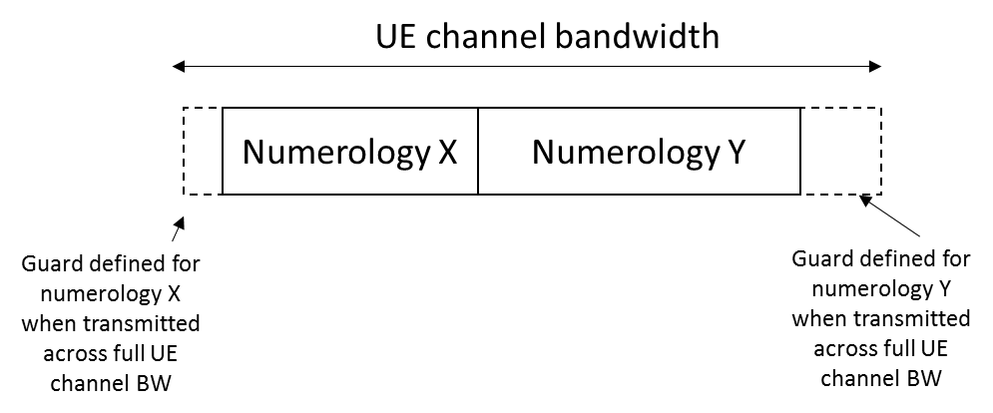
Figure 5.3.3-3 Guard band definition when transmitting multiple numerologies
NOTE: Figure 5.3.3-3 is not intended to imply the size of any guard between the two numerologies. Inter-numerology guard band within the carrier is implementation dependent.
[For a UE supporting wideband operation], the nominal intra-cell guard bands and the corresponding sizes of the RB sets separated by the said guard bands are as specified in Table 5.3.3-2 for each UE channel bandwidth and sub-carrier spacing for the downlink and uplink. The nominal intra-cell guard bands in Table 5.3.3-2 are applicable when the respective IE intraCellGuardBandsUL-List and intraCellGuardBandsDL-List [7] for the uplink and downlink are not provided, as specified in [10] clause 7.
Table 5.3.3-2: Nominal intra-cell guard bands for wideband operation
SCS  (kHz) | 40 MHz | 60 MHz | 80 MHz
15 | 105-6-105  (216) | N/A | N/A
30 | 50-6-50  (106) | 50-6-50-6-50  (162) | 50-6-50-5-50-6-50  (217)
60 | 23-5-23  (51) | 23-5-23-5-23  (79) | 23-5-23-5-23-5-23  (107)
NOTE 1: The intra-cell guard band is denoted TBW₀-GB₀-…-GB_{N_RBset-2}-TBW_{N_RBset-1} for N_RBset > 1 number of RB-sets with TBW_{r} the maximum transmission bandwidth (PRB) of RB-set r and GB_{r} the guard band (PRB) above the upper edge of RB-set r. The RB-set 0 is starting at the first common resource block (CRB) of the carrier as indicated by offsetToCarrier. The total transmission bandwidth configuration (size of resource grid) including guard bands is given in between parentheses.

For a UE that supports shared spectrum channel access, there are no uplink or downlink intra-cell guard bands for operation with 10 MHz and 20 MHz channel bandwidths; the maximum transmission bandwidth configurations for these channel bandwidths are in accordance with clause 5.3.2.
For each UE channel bandwidth and sub-carrier spacing given by Table 5.3.3-2, the maximum transmission bandwidth configuration of the carrier including intra-cell guard bands, if configured for the uplink and downlink by the respective IE intraCellGuardBandsUL-List and intraCellGuardBandsDL-List [7], and corresponding RB-set(s) shall be in accordance with clause 5.3.2 with a minimum inter-cell guard band of the UE channel bandwidth as specified in Table 5.3.3-1 for the uplink and downlink. Minimum requirements specified for wideband operation in Clause 6 and Clause 7 also apply for intra-cell guard bands larger than the nominal sizes in Table 5.3.3-2 as listed in Table 5.3.3-3 for each sub-carrier spacing; each guard band in order of CRB index must be larger than or equal to the corresponding nominal guard band specified in Table 5.3.3-2 for each channel bandwidth.
Table 5.3.3-3: Applicable intra-cell guard bands for wideband operation
Parameter | Unit | SCS
 |  | 15 kHz | 30 kHz
Intra-cell guard band (size) | PRB | 6,7 | 5,6,7
Transmission bandwidth (size) of RB-set | PRB | 104,105 | 49,50,51

If the UE is configured with zero width intra-cell guard bands for the uplink and downlink by the IE intraCellGuardBandsUL-List and intraCellGuardBandsDL-List [7] on a carrier greater than 20 MHz, the maximum transmission bandwidth configuration for the uplink and downlink shall be in accordance with clause 5.3.2 with a minimum inter-cell guard band of the UE channel bandwidth as specified in Table 5.3.3-1.

5.3.4 RB alignment

< text omitted >

6.1 General
Unless otherwise stated, the transmitter characteristics are specified at the antenna connector of the UE with a single or multiple transmit antenna(s). For UE with integral antenna only, a reference antenna with a gain of 0 dBi is assumed.
Transmitter requirements for UL MIMO operation apply when the UE transmits on 2 ports on the same CDM group. The UE may use higher MPR values outside this limitation.
The applicability of transmitter requirements for Band n90 is in accordance with that for Band n41; a UE supporting Band n90 shall meet the minimum requirements for Band n41.

6.1A General
The minimum requirements for band combinations including Band n41 also apply for the corresponding band combinations with Band n90 replacing Band n41 but with otherwise identical parameters. For brevity the said band combinations with Band n90 are not listed in the tables below but are covered by this specification.

6.1F General
For wideband operations, the minimum requirements for the transmitter characteristics are specified for transmissions on one scheduled RB set or ≥ 1 scheduled contiguous RB set(s) within the UE channel with all RB sets available for transmissions according to the channel access procedures in [14]. The requirements apply when the zero width UL intra-cell guard bands are configured and contiguous RB are scheduled and available for transmissions.
The above also applies for wideband operations within a UE channel that is part of a CA band combination.

6.2 Transmitter power

< text omitted >

7.1 General
Unless otherwise stated the receiver characteristics are specified at the antenna connector(s) of the UE. For UE(s) with an integral antenna only, a reference antenna(s) with a gain of 0 dBi is assumed for each antenna port(s). UE with an integral antenna(s) may be taken into account by converting these power levels into field strength requirements, assuming a 0 dBi gain antenna. For UEs with more than one receiver antenna connector, identical interfering signals shall be applied to each receiver antenna port if more than one of these is used (diversity).
The levels of the test signal applied to each of the antenna connectors shall be as defined in the respective clauses below.
The applicability of receiver requirements for Band n90 is in accordance with that for Band n41; a UE supporting Band n90 shall meet the minimum requirements for Band n41.
With the exception of clause 7.3, the requirements shall be verified with the network signalling value NS_01 configured (Table 6.2.3-1).
All the parameters in clause 7 are defined using the UL reference measurement channels specified in Annexes A.2.2 and A.2.3, the DL reference measurement channels specified in Annex A.3.2 and using the set-up specified in Annex C.3.1.
The minium requirements specified in clauses 7.5, 7.6, 7.7 and 7.8 for NR band n48 refer to the minimum requirements for NR bands < 2.7 GHz.
For the additional requirements for intra-band non-contiguous carrier aggregation of two or more sub-blocks, an in-gap test refers to the case when the interfering signal is located at a negative offset with respect to the assigned lowest channel frequency of the highest sub-block and located at a positive offset with respect to the assigned highest channel frequency of the lowest sub-block.
For the additional requirements for intra-band non-contiguous carrier aggregation of two or more sub-blocks, an out-of-gap test refers to the case when the interfering signal(s) is (are) located at a positive offset with respect to the assigned channel frequency of the highest carrier frequency, or located at a negative offset with respect to the assigned channel frequency of the lowest carrier frequency.
For the additional requirements for intra-band non-contiguous carrier aggregation of two or more sub-blocks with channel bandwidth larger than or equal to 5 MHz, the existing adjacent channel selectivity requirements, in-band blocking requirements (for each case), and narrow band blocking requirements apply for in-gap tests only if the corresponding interferer frequency offsets with respect to the two measured carriers satisfy the following condition in relation to the sub-block gap size W_{gap} for at least one of these carriers j = 1,2, so that the interferer frequency position does not change the nature of the core requirement tested:
Wgap ≥ 2∙|FInterferer (offset)_{,j}| – BWChannel(_{j})
where F_{Interferer (offset),j} for a sub-block with a single component carrier is the interferer frequency offset with respect to carrier j as specified in clause 7.5, clause 7.6.2 and clause 7.6.4 for the respective requirement and BW_{Channel(j)} the channel bandwidth of carrier j. F_{Interferer (offset),j} for a sub-block with two or more contiguous component carriers is the interference frequency offset with respect to the carrier adjacent to the gap is specified in clause 7.5A, 7.6A.2 and 7.6A.3. The interferer frequency offsets for adjacent channel selectivity, each in-band blocking case and narrow- band blocking shall be tested separately with a single in-gap interferer at a time.
For the additional requirements for operation with shared spectrum channel access, the receiver requirements apply under the assumption that all 20 MHz sub-bands and all RB’s of each sub-band within the downlink channel are allocated with intra-cell guard bands configured to zero.

7.1A General
The minimum requirements for band combinations including Band n41 also apply for the corresponding band combinations with Band n90 replacing Band n41 but with otherwise identical parameters. For brevity the said band combinations with Band n90 are not listed in the tables below but are covered by this specification.
The minium requirements specified in clauses 7.5A, 7.6A, 7.7A and 7.8A for NR band n48 refer to the minimum requirements for NR bands < 2.7 GHz.

7.1F General
For wideband operations, the minimum requirements for the receiver characteristics are specified when zero width intra-cell guardbands are configured and with all RB set(s) within the UE channel scheduled with all RB sets available for DL transmissions according to the channel access procedures in [14].
The above also applies for wideband operations within a UE channel that is part of a CA band combination.

7.2 Diversity characteristics

< end of changes >

