3GPP TSG-RAN WG4 Meeting #97-e R4-2017164
Electronic Meeting, 2nd– 13th Nov., 2020

Agenda item: 7.9.2 and 7.9.3
Source: Samsung
Title: WF on NR eMIMO RRM Performance requirements
Document for: Approval

0 Introduction
This contribution contains the WF for [216] Rel-16 eMIMO RRM issues in RAN4#97e w.r.t. core part maintenance and performance requirement.

1st Round Agreements

Topic #2: eMIMO RRM Performance General

Issue 2-1-1: Work scope of RRM performance part
Agreement:
RAN4 shall study on and complete Rel-16 eMIMO RRM performance part following the work scope in the Table 1.
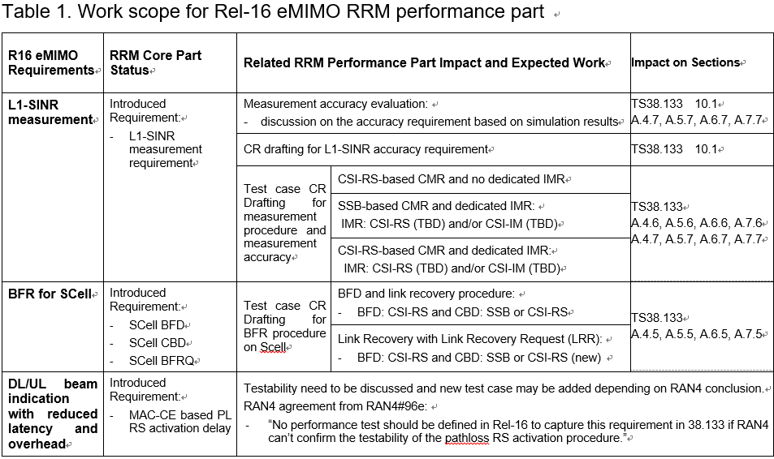

Topic #3: L1-SINR Measurement Accuracy

Issue 3-1-4: Difference of accuracy requirements of L1-SINR between FR1 and FR2
Agreements:
Follow RAN1 assumption that UE uses same Rx beam for channel and interference measurements for both CMR only and CMR+IMR cases
Margins for L1-SINR accuracy requirements
CMR only measurements: same implementation margin is applied for FR1 and FR2. No FR2 specific margin is applied.
CMR+IMR measurements: additional FR2 margin is FFS

Issue 3-1-5: Accuracy requirements of L1-SINR under extreme condition
Agreement:
Accuracy requirements of L1-SINR under extreme condition is
- Option 1: 1dB higher than for normal condition (Samsung, Ericsson)
- Option 2: 2dB higher than for normal condition
- Other options are not precluded

Issue 3-2-1: Measurement samples for defining L1-SINR accuracy requirements
Agreement:
L1-SINR accuracy requirements is defined based on the single shot L1-SINR measurement performance, i.e. M = 1.

Issue 3-2-2: Side condition of Ês/Iot for L1-SINR accuracy requirement
Agreement:
-3dB for Scenario 1A, 2A and 2B; 0dB for Scenario 2C and 2D
Issue 3-2-3: Io condition of dBm/BWChannel for accuracy requirement
Agreement: Define accuracy requirement for “Max Io -50 dBm” only

Topic #4: Test Case for L1-SINR Measurement

Issue 4-2-1: Repetition configuration for NZP-CSI-RS based L1-SINR measurement test case
Agreement:
Repetition = off

Issue 4-2-2: IMR configuration for L1-SINR measurement test case
Agreement:
CSI-IM configurations and one type of aperiodic CSI-RS configuration with repetition=off need to be introduced in 38.133 Annex A.

Topic #5: Test Case for SCell Beam Failure Recovery

Issue 5-1-2: The setting of cases to be defined for each scenario
Agreement:
Define setting combination for each scenario as table below.
Mode | BFD-RSs | DRX | FR | CBD-RSs
ED-DC / Standalone (SA) | CSI-RS | non-DRX | FR1 | SSB
 |  |  | FR2 | CSI-RS
 |  | DRX  (40 ms for FR1 and  640 ms for FR2) | FR1 | SSB
 |  |  | FR2 | CSI-RS

Issue 5-2-1: Configuration for Beam Failure Recovery test cases
Agreement:
Reuse the same test parameters in both scenarios (PUCCH for SR and no PUCCH for SR) for Scell BFR test cases.

2nd Round Agreements

Topic #3: L1-SINR Measurement Accuracy

Issue 3-1-2: Simulation-based accuracy alignment of L1-SINR measurement accuracy
Tentative agreements:
For the L1-SINR measurement accuracy, simulation-based accuracy is set to be:
±4.0dB, ±3.0dB, ±3.0dB, ±2.5dB, ±2.5dB in Scenario 1A, 2A, 2B, 2C, 2D, respectively.
Companies will further study on accuracy requirement on the basis of simulation-based accuracy. Final accuracy requirement should be derived by adding influence of other factors to the simulation-based accuracy.

Topic #4: Test Case for L1-SINR Measurement

Issue 4-1-1: Scenarios defined for L1-SINR measurement procedure test cases in the spec
Agreement:
Scenarios defined for L1-SINR measurement procedure:
Mode | Scenario | CMR | IMR | DRX
(ED-DC + FR1)  and  (SA + FR2) | 1A | CSI-RS | N/A | non-DRX
 | 2A | SSB | CSI-IM | DRX
 | 2D | CSI-RS | CSI-RS | DRX
(ED-DC + FR2)  and  (SA + FR1) | 1A | CSI-RS | N/A | DRX
 | 2C | SSB | CSI-RS | non-DRX
 | 2B | CSI-RS | CSI-IM | non-DRX

Topic #5: Test Case for SCell Beam Failure Recovery

Issue 5-1-1: Scenarios defined for Beam Failure Recovery tests cases
Tentative agreement:
Two scenarios are defined for the test cases
  - Scenario 1: Network does not configure PUCCH for SR for BFR MAC CE
  - Scenario 2: Network configures PUCCH for SR for BFR MAC CE

2nd Round Way Forward on R-16 eMIMO RRM

WF on L1-SINR Measurement Accuracy

FFS on difference of accuracy requirements of L1-SINR between FR1 and FR2 in CMR + IMR case
- Option 1: No obvious difference as it is SINR
- Option 2: Consider RF margin [x]dB higher for FR2 than FR1

FFS on accuracy requirements of L1-SINR under extreme condition
- Option 1: 1dB higher than for normal condition (Similar as SS-SINR)
- Option 2: 2dB higher than for normal condition
- Option 3: other values

FFS on scenarios for L1-SINR measurement accuracy requirement in the spec
- Option 1: Each scenarios (1A, 2A, 2B, 2C, 2D) for one sub-section.
- Option 2: Simplify the scenarios/subsections for accuracy requirement
  - Option 2a: Combine scenarios with the same requirement and side condition into one subsection ([1A], [2A, 2B], [2C, 2D]).
  - Option 2b: [1A], [2A, 2C], [2B, 2D], same as the core requirement.

Submit the Test cases for L1-SINR measurement accuracy
- Companies could update and submit draft CRs on test cases of L1-SINR accuracy requirement next meeting (RAN4#98e) based on the agreement reached in this meeting.

WF on Test Case for L1-SINR Measurement

Complete the test cases of L1-SINR measurement
- Companies could submit draft CRs to introduce CSI-IM configurations and one type of aperiodic CSI-RS configuration with repetition=off to 38.133 Annex A for L1-SINR test case next meeting (RAN4#98e).

WF on Test Case for Pathloss RS Activation Delay

Define the test case for MAC-CE based pathloss RS activation delay
- Further study the testability of PL RS activation delay requirement. Companies are encouraged to contribute to this issue by proposing feasible test methods and provide detailed test parameters.
- Test case for MAC-CE based pathloss RS activation delay shall be defined provided it is testable with feasible test method.

Others

Complete/Update the spec for L1-SINR measurement requirement
- Companies could submit draft CRs to complete the TS 38.133 Annex B.2 for L1-SINR measurement requirement next meeting (RAN4#98e).
- Other necessary update or correction is not preclude.

