3GPP TSG-RAN WG4 Meeting #97-e R4-2017164
Electronic Meeting, 2nd– 13th Nov., 2020

Agenda item: 7.9.2 and 7.9.3
Source: Samsung
Title: WF on NR eMIMO RRM Performance requirements
Document for: Approval

0 Introduction
This contribution contains the WF for [216] Rel-16 eMIMO RRM issues in RAN4#97e w.r.t. core part maintenance and performance requirement.

1st Round Agreements

Topic #2: eMIMO RRM Performance General

Issue 2-1-1: Work scope of RRM performance part
Agreement:
RAN4 shall study on and complete Rel-16 eMIMO RRM performance part following the work scope in the Table 1.
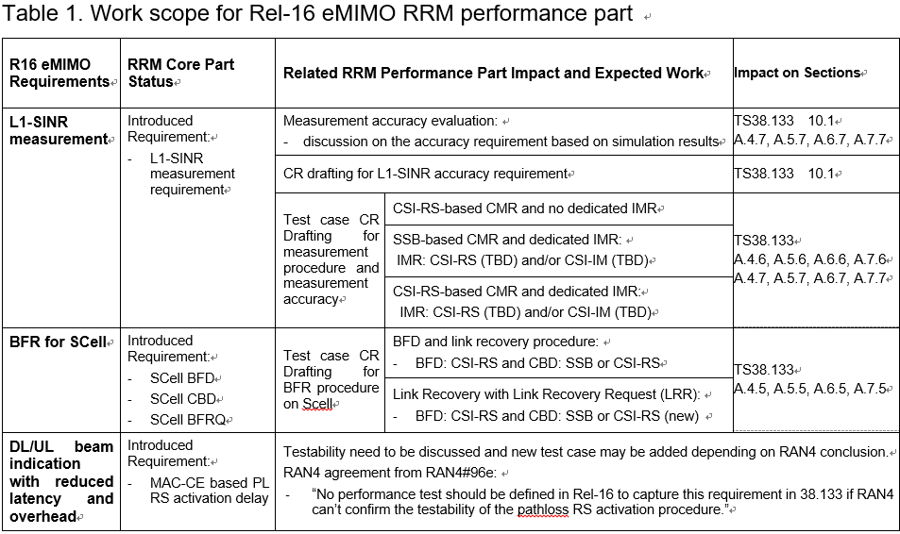

Topic #3: L1-SINR Measurement Accuracy

Issue 3-1-4: Difference of accuracy requirements of L1-SINR between FR1 and FR2
Agreements:
Follow RAN1 assumption that UE uses same Rx beam for channel and interference measurements for both CMR only and CMR+IMR cases
Margins for L1-SINR accuracy requirements
CMR only measurements: same implementation margin is applied for FR1 and FR2. No FR2 specific margin is applied.
CMR+IMR measurements: additional FR2 margin is FFS

Issue 3-1-5: Accuracy requirements of L1-SINR under extreme condition
Agreement:
Accuracy requirements of L1-SINR under extreme condition is
- Option 1: 1dB higher than for normal condition (Samsung, Ericsson)
- Option 2: 2dB higher than for normal condition
- Other options are not precluded

Issue 3-2-1: Measurement samples for defining L1-SINR accuracy requirements
Agreement:
L1-SINR accuracy requirements is defined based on the single shot L1-SINR measurement performance, i.e. M = 1.

Issue 3-2-2: Side condition of Ês/Iot for L1-SINR accuracy requirement
Agreement:
-3dB for Scenario 1A, 2A and 2B; 0dB for Scenario 2C and 2D
Issue 3-2-3: Io condition of dBm/BWChannel for accuracy requirement
Agreement: Define accuracy requirement for “Max Io -50 dBm” only

Topic #4: Test Case for L1-SINR Measurement

Issue 4-2-1: Repetition configuration for NZP-CSI-RS based L1-SINR measurement test case
Agreement:
Repetition = off

Issue 4-2-2: IMR configuration for L1-SINR measurement test case
Agreement:
CSI-IM configurations and one type of aperiodic CSI-RS configuration with repetition=off need to be introduced in 38.133 Annex A.

Topic #5: Test Case for SCell Beam Failure Recovery

Issue 5-1-2: The setting of cases to be defined for each scenario
Agreement:
Define setting combination for each scenario as table below.
Mode | BFD-RSs | DRX | FR | CBD-RSs
ED-DC / Standalone (SA) | CSI-RS | non-DRX | FR1 | SSB
 |  |  | FR2 | CSI-RS
 |  | DRX  (40 ms for FR1 and  640 ms for FR2) | FR1 | SSB
 |  |  | FR2 | CSI-RS

Issue 5-2-1: Configuration for Beam Failure Recovery test cases
Agreement:
Reuse the same test parameters in both scenarios (PUCCH for SR and no PUCCH for SR) for Scell BFR test cases.

2nd Round Agreements

Topic #3: L1-SINR Measurement Accuracy

Issue 3-1-2: Simulation-based accuracy alignment of L1-SINR measurement accuracy
Tentative agreements:
For the L1-SINR measurement accuracy, simulation-based accuracy is set to be:
±4.0dB, ±3.0dB, ±3.0dB, ±2.5dB, ±2.5dB in Scenario 1A, 2A, 2B, 2C, 2D, respectively.
Companies will further study on accuracy requirement on the basis of simulation-based accuracy. Final accuracy requirement should be derived by adding influence of other factors to the simulation-based accuracy.

Topic #4: Test Case for L1-SINR Measurement

Issue 4-1-1: Scenarios defined for L1-SINR measurement procedure test cases in the spec
Agreement:
Scenarios defined for L1-SINR measurement procedure:
Mode | Scenario | CMR | IMR | DRX
(ED-DC + FR1)  and  (SA + FR2) | 1A | CSI-RS | N/A | non-DRX
 | 2A | SSB | CSI-IM | DRX
 | 2D | CSI-RS | CSI-RS | DRX
(ED-DC + FR2)  and  (SA + FR1) | 1A | CSI-RS | N/A | DRX
 | 2C | SSB | CSI-RS | non-DRX
 | 2B | CSI-RS | CSI-IM | non-DRX

Topic #5: Test Case for SCell Beam Failure Recovery

Issue 5-1-1: Scenarios defined for Beam Failure Recovery tests cases
Tentative agreement:
Two scenarios are defined for the test cases
  - Scenario 1: Network does not configure PUCCH for SR for BFR MAC CE
  - Scenario 2: Network configures PUCCH for SR for BFR MAC CE

2nd Round Way Forward on R-16 eMIMO RRM

WF on L1-SINR Measurement Accuracy

FFS on difference of accuracy requirements of L1-SINR between FR1 and FR2 in CMR + IMR case
- Option 1: No obvious difference as it is SINR
- Option 2: Consider RF margin [x]dB higher for FR2 than FR1

FFS on accuracy requirements of L1-SINR under extreme condition
- Option 1: 1dB higher than for normal condition (Similar as SS-SINR)
- Option 2: 2dB higher than for normal condition
- Option 3: other values

FFS on scenarios for L1-SINR measurement accuracy requirement in the spec
- Option 1: Each scenarios (1A, 2A, 2B, 2C, 2D) for one sub-section.
- Option 2: Simplify the scenarios/subsections for accuracy requirement
  - Option 2a: Combine scenarios with the same requirement and side condition into one subsection ([1A], [2A, 2B], [2C, 2D]).
  - Option 2b: [1A], [2A, 2C], [2B, 2D], same as the core requirement.

Submit the Test cases for L1-SINR measurement accuracy
- Companies could update and submit draft CRs on test cases of L1-SINR accuracy requirement next meeting (RAN4#98e) based on the agreement reached in this meeting.

WF on Test Case for L1-SINR Measurement

Complete the test cases of L1-SINR measurement
- Companies could submit draft CRs to introduce CSI-IM configurations and one type of aperiodic CSI-RS configuration with repetition=off to 38.133 Annex A for L1-SINR test case next meeting (RAN4#98e).

WF on Test Case for Pathloss RS Activation Delay

Define the test case for MAC-CE based pathloss RS activation delay
- For further study on the testability of PL RS activation delay requirement. Companies are encouraged to contribute to this issue and proponents are supposed to provide more feasible and detailed method and parameters.
- Test case for the core requirement shall be defined provided it is proved to be testable with feasible test method, or otherwise no test case is defined.

Others

Complete/Update the spec for L1-SINR measurement requirement
- Companies could submit draft CRs to complete the TS 38.133 Annex B.2 for L1-SINR measurement requirement next meeting (RAN4#98e).
- Other necessary update or correction is not preclude.

