**3GPP TSG-RAN4 Meeting #97-e *R4-2017044***

**Online, , 2nd Nov 2020 - 13th Nov 2020**

|  |  |  |  |  |  |  |  |  |
| --- | --- | --- | --- | --- | --- | --- | --- | --- |
| *CR-Form-v12.1* | | | | | | | | |
| **CHANGE REQUEST** | | | | | | | | |
|  | | | | | | | | |
|  | **38.133** | **CR** | **1118** | **rev** | **1** | **Current version:** | **15.11.0** |  |
|  | | | | | | | | |
| *For* [***HE******LP***](http://www.3gpp.org/3G_Specs/CRs.htm#_blank)*on using this form: comprehensive instructions can be found at* [*http://www.3gpp.org/Change-Requests*](http://www.3gpp.org/Change-Requests)*.* | | | | | | | | |
|  | | | | | | | | |

|  |  |  |  |  |  |  |  |  |
| --- | --- | --- | --- | --- | --- | --- | --- | --- |
| ***Proposed change affects:*** | UICC apps |  | ME | **X** | Radio Access Network |  | Core Network |  |

|  |  |  |  |  |  |  |  |  |  |  |
| --- | --- | --- | --- | --- | --- | --- | --- | --- | --- | --- |
|  | | | | | | | | | | |
| ***Title:*** | RB allocation and Noc level in RLM Test cases | | | | | | | | | |
|  |  | | | | | | | | | |
| ***Source to WG:*** | ANRITSU LTD | | | | | | | | | |
| ***Source to TSG:*** | R4 | | | | | | | | | |
|  |  | | | | | | | | | |
| ***Work item code:*** | NR_newRAT-Perf | | | | |  | ***Date:*** | | | 2020-10-19 |
|  |  | | | |  | |  | | |  |
| ***Category:*** | **F** |  | | | | | ***Release:*** | | | Rel-15 |
|  | *Use one of the following categories:* ***F*** *(correction)* ***A*** *(mirror corresponding to a change in an earlier release)* ***B*** *(addition of feature),* ***C*** *(functional modification of feature)* ***D*** *(editorial modification)*  Detailed explanations of the above categories can be found in 3GPP [TR 21.900](http://www.3gpp.org/ftp/Specs/html-info/21900.htm). | | | | | | | | *Use one of the following releases: Rel-8 (Release 8) Rel-9 (Release 9) Rel-10 (Release 10) Rel-11 (Release 11) … Rel-15 (Release 15) Rel-16 (Release 16) Rel-17 (Release 17) Rel-18 (Release 18)* | |
|  |  | | | | | | | | | |
| ***Reason for change:*** | | a) Test cases A.5.5.1.5, A.5.5.1.6, A.7.5.1.5, and A.7.5.1.6 with CSI-RS-based RLM in non-DRX mode do not specify the Noc level.  b) Some table note references are wrong and some [ ] remain. | | | | | | | | |
|  | |  | | | | | | | | |
| ***Summary of change:*** | | a) Specify Noc -92.1dBm/15kHz for Test cases A.5.5.1.5, A.5.5.1.6, A.7.5.1.5, and A.7.5.1.6. This is the same level as used for the related SSB-based RLM test cases.  b) Correct table note references and remove [ ]. | | | | | | | | |
|  | |  | | | | | | | | |
| ***Consequences if not approved:*** | | RAN5 would not be able to implement some RLM test cases. | | | | | | | | |
|  | |  | | | | | | | | |
| ***Clauses affected:*** | | A.3.2.1.5, A.5.5.1.2.1-3, A.5.5.1.3.1-3, A.5.5.1.4.1-3, A.5.5.1.5.1-3, A.5.5.1.6.1-3, A.5.5.1.8.1-3.  Tables A.7.5.1.5.1-3, A.7.5.1.6.1-3. | | | | | | | | |
|  | |  | | | | | | | | |
|  | | **Y** | **N** |  | | | |  | | |
| ***Other specs*** | |  | **X** | Other core specifications | | | | TS/TR ... CR ... | | |
| ***affected:*** | | **X** |  | Test specifications | | | | TS 38.533 | | |
| ***(show related CRs)*** | |  | **X** | O&M Specifications | | | | TS/TR ... CR ... | | |
|  | |  | | | | | | | | |
| ***Other comments:*** | |  | | | | | | | | |
|  | |  | | | | | | | | |
| ***This CR's revision history:*** | | R4-2014017 > R4-2017044  Coversheet error corrected to include “Proposed change affects”.  The changes to RB allocation and OCNG patterns were removed, and will be addressed in a separate CR at a future meeting.  This CR includes all the changes in R4-2015161. | | | | | | | | |

<< Start of changes >>

A.5.5.1.1 Radio Link Monitoring Out-of-sync Test for FR2 PSCell configured with SSB-based RLM RS in non-DRX mode

A.5.5.1.1.1 Test Purpose and Environment

The purpose of this test is to verify that the UE properly detects the out of sync and in sync for the purpose of monitoring downlink radio link quality of the PSCell. This test will partly verify the FR2 radio link monitoring requirements in clause 8.1.

In the test, UE is configured to perform RLM on SSB, with *detectionResource* included in *RadioLinkMonitoringRS* set to SSB#0 and SSB#1, and *purpose* set to ‘*rlf*’. Supported test configurations are shown in table A.5.5.1.1.1-1. The test parameters are given in Tables A.5.5.1.1.1-2, A.5.5.1.1.1-3, and A. 5.5.1.1.1-4 below. There are two cells, Cell 1 is the E-UTRAN PCell, and Cell 2 is the PSCell, in the test. The E-UTRAN PCell setting refers to Table A.3.7.2.1-2. The test consists of three successive time periods, with time duration of T1, T2 and T3 respectively. Figure A.5.5.1.1.1-1 shows the variation of the downlink SNR in the active cell to emulate out-of-sync and in-sync states, and Figure A.5.5.1.1.1-2 shows the Time multiplexed downlink transmissions from each Angle of Arrival. Prior to the start of the time duration T1, the UE shall be fully synchronized to Cell 1 and Cell 2. The UE shall be configured for periodic CSI reporting with a reporting periodicity of 5 ms. In addition to RLM-RS radio link monitoring using SSB index 0 and SSB index 1, the UE is configured to perform inter-frequency measurements using Gap Pattern ID #0 (40ms) in test 1.

**Table A.5.5.1.1.1-1: Supported test configurations for FR2 PSCell**

|  |  |
| --- | --- |
| **Configuration** | **Description** |
| 1 | FDD LTE PCell, NR 120 KHz SSB SCS, 100 MHz bandwidth, TDD duplex mode |
| 2 | TDD LTE PCell, NR 120 KHz SSB SCS, 100 MHz bandwidth, TDD duplex mode |
| Note: The UE is only required to pass in one of the supported test configurations in FR2 | |

**Table A.5.5.1.1.1-2: General test parameters for FR2 out-of-sync testing in non-DRX mode**

|  |  |  |  |  |
| --- | --- | --- | --- | --- |
| **Parameter** | | | **Unit** | **Value** |
| **Test 1** |
| Active E-UTRA PCell | | |  | Cell 1 |
| E-UTRA RF Channel Number | | |  | 1 |
| Active PSCell | | |  | Cell 2 |
| RF Channel Number | | |  | 2 |
| Duplex mode | | Config 1, 2 |  | TDD |
| BWchannel | | Config 1, 2 |  | 100: NRB,c = 66 |
| DL initial BWP configuration | | Config 1, 2 |  | DLBWP.0.1 |
| DL dedicated BWP configuration | | Config 1, 2 |  | DLBWP.1.1 |
| UL initial BWP configuration | | Config 1, 2 |  | ULBWP.0.1 |
| UL dedicated BWP configuration | | Config 1, 2 |  | ULBWP.1.1 |
| TDD Configuration | | Config 1, 2 |  | TDDConf.3.1 |
| CORESET Reference Channel | | Config 1, 2 |  | CR.3.1 TDD |
| SSB Configuration | | Config 1, 2 |  | SSB.1 FR2 |
| SMTC Configuration | | Config 1, 2 |  | SMTC.1 |
| PDSCH/PDCCH subcarrier spacing | | Config 1, 2 |  | 120 KHz |
| PRACH Configuration | | Config 1, 2 |  | Table A.3.8.3.4 |
| SSB index assigned as RLM RS | | Config 1, 2 |  | 0,1 |
| OCNG parameters | | |  | OP.2 |
| CP length | | |  | Normal |
| Out of sync transmission parameters | DCI format | |  | 1-0 |
| Number of Control OFDM symbols | |  | 2 |
| Aggregation level | | CCE | 8 |
| Ratio of hypothetical PDCCH RE energy to average SSS RE energy | | dB | 4 |
| Ratio of hypothetical PDCCH DMRS energy to average SSS RE energy | | dB | 4 |
| DMRS precoder granularity | |  | REG bundle size |
| REG bundle size | |  | 6 |
| DRX | | |  | *OFF* |
| Gap pattern ID | | |  | *gp0* |
| Layer 3 filtering | | |  | *Enabled* |
| T310 timer | | | ms | *0* |
| T311 timer | | | ms | 1000 |
| N310 | | |  | 1 |
| N311 | | |  | 1 |
| CSI-RS for CSI reporting | | Config 1, 2 |  | CSI-RS.3.1 TDD |
| TCI states for PDCCH/PDSCH | | |  | TCI.State.2 |
| CSI-RS for tracking | | Config 1, 2 |  | TRS.2.1 TDD |
| T1 | | | s | 0.2 |
| T2 | | | s | 9.68 |
| T3 | | | s | 9.68 |
| D1 | | | s | 9.64 |
| Note 1: All configurations are assigned to the UE prior to the start of time period T1.  Note 2: UE-specific PDCCH is not transmitted after T1 starts.  Note 3: E-UTRAN is in non-DRX mode under test. | | | | |

**Table A.5.5.1.1.1-3: OTA related cell specific test parameters for FR2 (Cell 2) for out-of-sync radio link monitoring tests in non-DRX mode**

|  |  |  |  |  |  |  |  |  |
| --- | --- | --- | --- | --- | --- | --- | --- | --- |
| **Parameter** | | **Unit** | **Test 1** | | | | | |
| **T1** | **T2** | **T3** | **T1** | **T2** | **T3** |
| AoA setup | |  | Setup 3 defined in A.3.15 | | | | | |
| **AoA1** | | | **AoA2** | | |
| Assumption for UE beamsNote 5 | |  | Rough | | | Rough | | |
| EPRE ratio of PDCCH DMRS to SSS | | dB | 4 | | | Not sent | | |
| EPRE ratio of PDCCH to PDCCH DMRS | | dB | 0 | | |
| EPRE ratio of PBCH DMRS to SSS | | dB |
| EPRE ratio of PBCH to PBCH DMRS | | dB |
| EPRE ratio of PSS to SSS | | dB |
| EPRE ratio of PDSCH DMRS to SSS | | dB |
| EPRE ratio of PDSCH to PDSCH DMRS | | dB |
| EPRE ratio of OCNG DMRS to SSS | | dB |
| EPRE ratio of OCNG to OCNG DMRS | | dB |
| ssb-Index 0 SNR | Config 1, 2 | dB | 2Note 6 | -6Note 6 | -15 |
| ssb-Index 1 SNR | Config 1, 2 |  | Not sent | | | 2Note 6 | -15 | -15 |
| SNR on other channels and signals | Config 1, 2 | dB | 2Note 6 | | | N/A | | |
|  | Config 1, 2 | dBm/ 15kHz | -92.1 | | | -92.1 | | |
| Time multiplexing of the downlink transmissions from each AoA | |  | Defined in Figure A.5.5.1.1.1-2 | | | | | |
| Propagation condition | |  | TDL-A 30ns 75Hz | | | TDL-A 30ns 75Hz | | |
| Note 1: OCNG shall be used such that the resources in Cell 2 are fully allocated and a constant total transmitted power spectral density is achieved for all OFDM symbols.  Note 2: The signal contains PDCCH for UEs other than the device under test as part of OCNG.  Note 3: SNR levels correspond to the signal to noise ratio over the SSS REs.  Note 4: The SNR values are specified for testing a UE which supports 2RX on at least one band. For testing of a UE which supports 4RX on all bands, the SNR during T3 is A.3.6.  Note 5: Information about types of UE beam is given in B.2.1.3, and does not limit UE implementation or test system implementation  Note 6: This value allows up to 1dB degradation from applied SNR to UE baseband | | | | | | | | |

**Table A.5.5.1.1.1-4: Measurement gap configuration for out-of-sync tests in non-DRX mode**

|  |  |
| --- | --- |
| **Field** | **Test 1** |
| **Value** |
| gapOffset | 0 |
| Note 1: E-UTRAN PCell and PSCell are SFN-synchronous and frame boundary aligned. (Ensure that RLM RS is partially overlapped with measurement gap). | | |

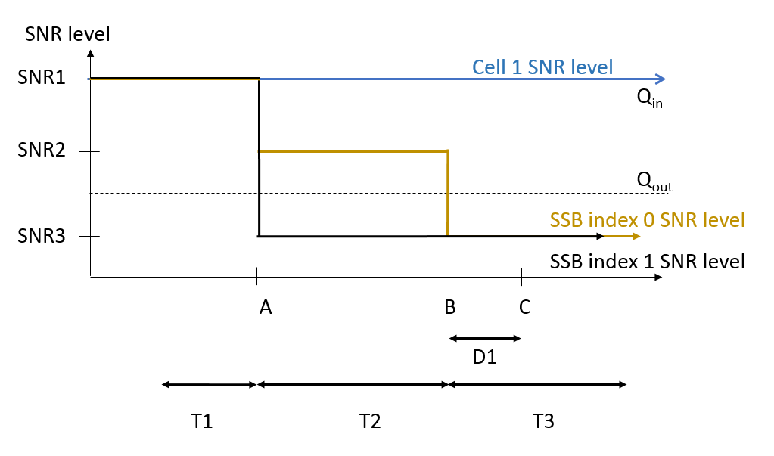

**Figure A.5.5.1.1.1-1: SNR variation for out-of-sync testing**



**Figure A.5.5.1.1.1-2: Time multiplexed downlink transmissions**

A.5.5.1.1.2 Test Requirements

The UE behavior in each test during time durations T1, T2 and T3 shall be as follows:

During the period from time point A to time point B the UE shall transmit uplink signal at least in all uplink slots configured for CSI transmission according to the configured periodic CSI reporting.

The UE shall stop transmitting uplink signal in Cell 2 no later than time point C (D1 second after the start of the time duration T3).

The rate of correct events observed during repeated tests shall be at least 90%.

A.5.5.1.2 Radio Link Monitoring In-sync Test for FR2 PSCell configured with SSB-based RLM RS in non-DRX mode

A.5.5.1.2.1 Test Purpose and Environment

The purpose of this test is to verify that the UE properly detects the out of sync and in sync for the purpose of monitoring downlink radio link quality of the PSCell. This test will partly verify the FR2 radio link monitoring requirements in clause 8.1.

In the test, UE is configured to perform RLM on SSB, with *detectionResource* included in *RadioLinkMonitoringRS* set to SSB#0 and SSB#1, and *purpose* set to ‘*rlf*’. Supported test configurations are shown in table A.5.5.1.2.1-1. The test parameters are given in Tables A.5.5.1.2.1-2, and A.5.5.1.2.1-3 below. There are two cells, Cell 1 is the E-UTRAN PCell, and Cell 2 is the PSCell, in the test. The E-UTRAN PCell setting refers to Table A.3.7.2.1-2. The test consists of five successive time periods, with time duration of T1, T2, T3, T4 and T5 respectively. Figure A.5.5.1.2.1-1 shows the variation of the downlink SNR in the active cell to emulate out-of-sync and in-sync states, and Figure A.5.5.1.2.1-2 shows the Time multiplexed downlink transmissions from each Angle of Arrival. Prior to the start of the time duration T1, the UE shall be fully synchronized to Cell 1 and Cell 2. The UE shall be configured for periodic CSI reporting with a reporting periodicity of 5ms.

**Table A.5.5.1.2.1-1: Supported test configurations for FR2 PSCell**

|  |  |
| --- | --- |
| **Configuration** | **Description** |
| 1 | FDD LTE PCell, NR 120 KHz SSB SCS, 100 MHz bandwidth, TDD duplex mode |
| 2 | TDD LTE PCell, NR 120 KHz SSB SCS, 100 MHz bandwidth, TDD duplex mode |
| Note: The UE is only required to pass in one of the supported test configurations in FR2 | |

**Table A.5.5.1.2.1-2: General test parameters for FR2 in-sync testing in non-DRX mode**

|  |  |  |  |  |
| --- | --- | --- | --- | --- |
| **Parameter** | | | **Unit** | **Value** |
| **Test 1** |
| Active E-UTRA PCell | | |  | Ce1l 1 |
| E-UTRA RF Channel Number | | |  | 1 |
| Active PSCell | | |  | Cell 2 |
| RF Channel Number | | |  | 2 |
| Duplex mode | | Config 1, 2 |  | TDD |
| BWchannel | | Config 1, 2 |  | 100: NRB,c = 66 |
| DL initial BWP configuration | | Config 1, 2 |  | DLBWP.0.1 |
| DL dedicated BWP configuration | | Config 1, 2 |  | DLBWP.1.1 |
| UL initial BWP configuration | | Config 1, 2 |  | ULBWP.0.1 |
| UL dedicated BWP configuration | | Config 1, 2 |  | ULBWP.1.1 |
| TDD Configuration | | Config 1, 2 |  | TDDConf.3.1 |
| CORESET Reference Channel | | Config 1, 2 |  | CR.3.1 TDD |
| SSB Configuration | | Config 1, 2 |  | SSB.1 FR2 |
| SMTC Configuration | | Config 1, 2 |  | SMTC.3 |
| PDSCH/PDCCH subcarrier spacing | | Config 1, 2 |  | 120 KHz |
| PRACH Configuration | | Config 1, 2 |  | Table A.3.8.3.4 |
| SSB index assigned as RLM RS | | Config 1, 2 |  | 0,1 |
| OCNG parameters | | |  | OP.2 |
| CP length | | |  | Normal |
| In sync transmission parameters | DCI format | |  | 1-0 |
| Number of Control OFDM symbols | |  | 2 |
| Aggregation level | | CCE | 4 |
| Ratio of hypothetical PDCCH RE energy to average SSS RE energy | | dB | 0 |
| Ratio of hypothetical PDCCH DMRS energy to average SSS RE energy | | dB | 0 |
| DMRS precoder granularity | |  | REG bundle size |
| REG bundle size | |  | 6 |
| Out of sync transmission parameters | DCI format | |  | 1-0 |
| Number of Control OFDM symbols | |  | 2 |
| Aggregation level | | CCE | 8 |
| Ratio of hypothetical PDCCH RE energy to average SSS RE energy | | dB | 4 |
| Ratio of hypothetical PDCCH DMRS energy to average SSS RE energy | | dB | 4 |
| DMRS precoder granularity | |  | REG bundle size |
| REG bundle size | |  | 6 |
| DRX | | |  | *OFF* |
| Gap pattern ID | | |  | N.A. |
| Layer 3 filtering | | |  | *Enabled* |
| T310 timer | | | ms | 4000 |
| T311 timer | | | ms | 1000 |
| N310 | | |  | 1 |
| N311 | | |  | 1 |
| CSI-RS for CSI reporting | | Config 1, 2 |  | CSI-RS.3.1 TDD |
| TCI states for PDCCH/PDSCH | | |  | TCI.State.2 |
| CSI-RS for tracking | | Config 1, 2 |  | TRS.2.1 TDD |
| T1 | | | s | 0.2 |
| T2 | | | s | 0.2 |
| T3 | | | s | 1.88 |
| T4 | | | s | 0.2 |
| T5 | | | s | 3.84 |
| D1 | | | s | 3.8 |
| Note 1: All configurations are assigned to the UE prior to the start of time period T1.  Note 2: UE-specific PDCCH is not transmitted after T1 starts.  Note 3: E-UTRAN is in non-DRX mode under test. | | | | |

**Table A.5.5.1.2.1-3: OTA related cell specific test parameters for FR2 (Cell 2) for in-sync radio link monitoring tests in non-DRX mode**

|  |  |  |  |  |  |  |  |  |  |  |  |  |
| --- | --- | --- | --- | --- | --- | --- | --- | --- | --- | --- | --- | --- |
| **Parameter** | | **Unit** | **Test 1** | | | | | | | | | |
| **T1** | **T2** | **T3** | **T4** | **T5** | **T1** | **T2** | **T3** | **T4** | **T5** |
| AoA setup | |  | Setup 3 defined in A.3.15 | | | | | | | | | |
| **AoA1** | | | | | **AoA2** | | | | |
| Assumption for UE beamsNote 5 | |  | Rough | | | | | Rough | | | | |
| EPRE ratio of PDCCH DMRS to SSS | | dB | 4 | | | | | Not sent | | | | |
| EPRE ratio of PDCCH to PDCCH DMRS | | dB | 0 | | | | |
| EPRE ratio of PBCH DMRS to SSS | | dB |
| EPRE ratio of PBCH to PBCH DMRS | | dB |
| EPRE ratio of PSS to SSS | | dB |
| EPRE ratio of PDSCH DMRS to SSS | | dB |
| EPRE ratio of PDSCH to PDSCH DMRS | | dB |
| EPRE ratio of OCNG DMRS to SSS | | dB |
| EPRE ratio of OCNG to OCNG DMRS | | dB |
| ssb-Index 0 SNR | Config 1, 2 | dB | 2Note 6 | -6Note 6 | -15 | -4.5 | 2Note 6 |
| ssb-Index 1 SNR | Config 1, 2 |  | Not sent | | | | | 2Note 6 | -15 | -15 | -15 | -15 |
| SNR on other channels and signals | Config 1, 2 | dB | 2Note 6 | | | | | N/A | | | | |
|  | Config 1, 2 | dBm/ 15kHz | -92.1 | | | | | -92.1 | | | | |
| Time multiplexing of the downlink transmissions from each AoA | |  | Defined in Figure A.5.5.1.2.1-2 | | | | | | | | | |
| Propagation condition | |  | TDL-A 30ns 75Hz | | | | | TDL-A 30ns 75Hz | | | | |
| Note 1: OCNG shall be used such that the resources in Cell 2 are fully allocated and a constant total transmitted power spectral density is achieved for all OFDM symbols.  Note 2: The signal contains PDCCH for UEs other than the device under test as part of OCNG.  Note 3: SNR levels correspond to the signal to noise ratio over the SSS REs.  Note 4: The SNR values are specified for testing a UE which supports 2RX on at least one band. For testing of a UE which supports 4RX on all bands, the SNR during T3 is A.3.6.  Note 5: Information about types of UE beam is given in B.2.1.3, and does not limit UE implementation or test system implementation  Note 6: This value allows up to 1dB degradation from applied SNR to UE baseband | | | | | | | | | | | | |

**Table A.5.5.1.2.1-4: Void**

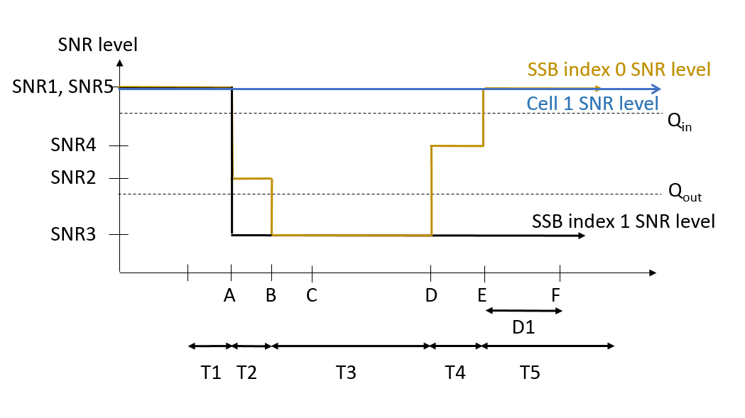

**Figure A.5.5.1.2.1-1: SNR variation for in-sync testing**



**Figure A.5.5.1.2.1-2: Time multiplexed downlink transmissions**

A.5.5.1.2.2 Test Requirements

The UE behaviour in each test during time durations T1, T2, T3, T4 and T5 shall be as follows:

During the period from time point A to time point F (D1 second after the start of time duration T5) the UE shall transmit uplink signal at least in all uplink slots configured for CSI transmission according to the configured periodic CSI reporting.

The rate of correct events observed during repeated tests shall be at least 90%.

A.5.5.1.3 Radio Link Monitoring Out-of-sync Test for FR2 PSCell configured with SSB-based RLM RS in DRX mode

A.5.5.1.3.1 Test Purpose and Environment

The purpose of this test is to verify that the UE properly detects the out of sync and in sync for the purpose of monitoring downlink radio link quality of the PSCell when DRX is used. This test will partly verify the FR2 radio link monitoring requirements in clause 8.1.

In the test, UE is configured to perform RLM on SSB, with *detectionResource* included in *RadioLinkMonitoringRS* set to SSB#0 and SSB#1, and *purpose* set to ‘*rlf*’. Supported test configurations are shown in table A.5.5.1.3.1-1. The test parameters are given in Tables A.5.5.1.3.1-2, and A.5.5.1.3.1-3. There are two cells, Cell 1 is the E-UTRAN PCell, and Cell 2 is the PSCell, in the test. The E-UTRAN PCell setting refers to Table A.3.7.2.1-2. The test consists of three successive time periods, with time duration of T1, T2 and T3 respectively. Figure A.5.5.1.3.1-1 shows the variation of the downlink SNR in the active cell to emulate out-of-sync and in-sync states. Prior to the start of the time duration T1, the UE shall be fully synchronized to Cell 1 and Cell 2. The UE shall be configured for periodic CSI reporting with a reporting periodicity of 5 ms. In the test, DRX configuration is enabled and DRX inactivity timer has already been expired, i.e. UE tries to decode PDCCH and to send periodic CSI during the period when On-duration timer is running. Time alignment timers shall be set to “infinity” so that UL timing alignment is maintained during the test.

**Table A.5.5.1.3.1-1: Supported test configurations for FR2 PSCell**

|  |  |
| --- | --- |
| **Configuration** | **Description** |
| 1 | FDD LTE PCell, NR 120 KHz SSB SCS, 100 MHz bandwidth, TDD duplex mode |
| 2 | TDD LTE PCell, NR 120 KHz SSB SCS, 100 MHz bandwidth, TDD duplex mode |
| Note: The UE is only required to pass in one of the supported test configurations in FR2 | |

**Table A.5.5.1.3.1-2: General test parameters for FR2 out-of-sync testing in DRX mode**

|  |  |  |  |  |
| --- | --- | --- | --- | --- |
| **Parameter** | | | **Unit** | **Value** |
| **Test 1** |
| Active E-UTRA PCell | | |  | Cell 1 |
| E-UTRA RF Channel Number | | |  | 1 |
| Active PSCell | | |  | Cell 2 |
| RF Channel Number | | |  | 2 |
| Duplex mode | | Config 1, 2 |  | TDD |
| BWchannel | | Config 1, 2 |  | 100: NRB,c = 66 |
| DL initial BWP configuration | | Config 1, 2 |  | DLBWP.0.1 |
| DL dedicated BWP configuration | | Config 1, 2 |  | DLBWP.1.1 |
| UL initial BWP configuration | | Config 1, 2 |  | ULBWP.0.1 |
| UL dedicated BWP configuration | | Config 1, 2 |  | ULBWP.1.1 |
| TDD Configuration | | Config 1, 2 |  | TDDConf.3.1 |
| CORESET Reference Channel | | Config 1, 2 |  | CR.3.1 TDD |
| SSB Configuration | | Config 1, 2 |  | SSB.1 FR2 |
| SMTC Configuration | | Config 1, 2 |  | SMTC.1 |
| PDSCH/PDCCH subcarrier spacing | | Config 1, 2 |  | 120 KHz |
| PRACH Configuration | | Config 1, 2 |  | Table A.3.8.3.4 |
| SSB index assigned as RLM RS | | Config 1, 2 |  | 0,1 |
| OCNG parameters | | |  | OP.1 |
| CP length | | |  | Normal |
| Out of sync transmission parameters | DCI format | |  | 1-0 |
| Number of Control OFDM symbols | |  | 2 |
| Aggregation level | | CCE | 8 |
| Ratio of hypothetical PDCCH RE energy to average SSS RE energy | | dB | 4 |
| Ratio of hypothetical PDCCH DMRS energy to average SSS RE energy | | dB | 4 |
| DMRS precoder granularity | |  | REG bundle size |
| REG bundle size | |  | 6 |
| DRX Configuration | | |  | DRX.3 |
| Gap pattern ID | | |  | N.A. |
| Layer 3 filtering | | |  | *Enabled* |
| T310 timer | | | ms | *0* |
| T311 timer | | | ms | 1000 |
| N310 | | |  | 1 |
| N311 | | |  | 1 |
| CSI-RS for CSI reporting | | Config 1, 2 |  | CSI-RS.3.1 TDD |
| TCI states for PDCCH/PDSCH | | |  | TCI.State.2 |
| CSI-RS for tracking | | Config 1, 2 |  | TRS.2.1 TDD |
| T1 | | | s | 0.2 |
| T2 | | | s | 14.48 |
| T3 | | | s | 14.48 |
| D1 | | | s | 14.44 |
| Note 1: All configurations are assigned to the UE prior to the start of time period T1.  Note 2: UE-specific PDCCH is not transmitted after T1 starts.  Note 3: E-UTRAN is in non-DRX mode under test. | | | | |

**Table A.5.5.1.3.1-3: OTA related cell specific test parameters for FR2 (Cell 2) for out-of-sync radio link monitoring tests in DRX mode**

|  |  |  |  |  |  |
| --- | --- | --- | --- | --- | --- |
| **Parameter** | | **Unit** | **Test 1** | | |
| **T1** | **T2** | **T3** |
| AoA setup | |  | Setup 1 defined in A.3.15 | | |
| Assumption for UE beamsNote 5 | |  | Rough | | |
| EPRE ratio of PDCCH DMRS to SSS | | dB | 4 | | |
| EPRE ratio of PDCCH to PDCCH DMRS | | dB | 0 | | |
| EPRE ratio of PBCH DMRS to SSS | | dB | 0 | | |
| EPRE ratio of PBCH to PBCH DMRS | | dB |
| EPRE ratio of PSS to SSS | | dB |
| EPRE ratio of PDSCH DMRS to SSS | | dB |
| EPRE ratio of PDSCH to PDSCH DMRS | | dB |
| EPRE ratio of OCNG DMRS to SSS | | dB |
| EPRE ratio of OCNG to OCNG DMRS | | dB |
| ssb-Index 0 SNR | Config 1, 2 | dB | 2Note 6 | -6Note 6 | -15 |
| ssb-Index 1 SNR | Config 1, 2 | 2Note 6 | -15 | -15 |
| SNR on other channels and signals | Config 1, 2 | dB | 2Note 6 | | |
|  | Config 1, 2 | dBm/15KHz | -104.7dBm | | |
| Propagation condition | |  | TDL-A 30ns 75Hz | | |
| Note 1: OCNG shall be used such that the resources in Cell 2 are fully allocated and a constant total transmitted power spectral density is achieved for all OFDM symbols.  Note 2: The signal contains PDCCH for UEs other than the device under test as part of OCNG.  Note 3: SNR levels correspond to the signal to noise ratio over the SSS REs.  Note 4: The SNR values are specified for testing a UE which supports 2RX on at least one band. For testing of a UE which supports 4RX on all bands, the SNR during T3 is A.3.6.  Note 5: Information about types of UE beam is given in B.2.1.3, and does not limit UE implementation or test system implementation  Note 6: This value allows up to 1dB degradation from applied SNR to UE baseband | | | | | |

**Table A.5.5.1.3.1-4: Void**

**Table A.5.5.1.3.1-5: Void**



**Figure A.5.5.1.3.1-1: SNR variation for out-of-sync testing**

A.5.5.1.3.2 Test Requirements

The UE behavior in each test during time durations T1, T2 and T3 shall be as follows:

During the period from time point A to time point B the UE shall transmit uplink signal at least in all uplink slots configured for CSI transmission according to the configured periodic CSI reporting.

The UE shall stop transmitting uplink signal in Cell 2 no later than time point C (D1 second after the start of the time duration T3).

The rate of correct events observed during repeated tests shall be at least 90%.

A.5.5.1.4 Radio Link Monitoring In-sync Test for FR2 PSCell configured with SSB-based RLM RS in DRX mode

A.5.5.1.4.1 Test Purpose and Environment

The purpose of this test is to verify that the UE properly detects the out of sync and in sync for the purpose of monitoring downlink radio link quality of the PSCell when DRX is used. This test will partly verify the FR2 radio link monitoring requirements in clause 8.1.

In the test, UE is configured to perform RLM on SSB, with *detectionResource* included in *RadioLinkMonitoringRS* set to SSB#0 and SSB#1, and *purpose* set to ‘*rlf*’. Supported test configurations are shown in table A.5.5.1.4.1-1. The test parameters are given in Tables A.5.5.1.4.1-2, and A.5.5.1.4.1-3. There are two cells, Cell 1 is the E-UTRAN PCell, and Cell 2 is the PSCell, in the test. The E-UTRAN PCell setting refers to Table A.3.7.2.1-2. The test consists of five successive time periods, with time duration of T1, T2, T3, T4 and T5 respectively. Figure A.5.5.1.4.1-1 shows the variation of the downlink SNR in the active cell to emulate out-of-sync and in-sync states. Prior to the start of the time duration T1, the UE shall be fully synchronized to Cell 1 and Cell 2. The UE shall be configured for periodic CSI reporting with a reporting periodicity of 5 ms. In the test, DRX configuration is enabled and DRX inactivity timer has already been expired, i.e. UE tries to decode PDCCH and to send periodic CSI during the period when On-duration timer is running. Time alignment timers shall be set to “infinity” so that UL timing alignment is maintained during the test.

**Table A.5.5.1.4.1-1: Supported test configurations for FR2 PSCell**

|  |  |
| --- | --- |
| **Configuration** | **Description** |
| 1 | FDD LTE PCell, NR 120 KHz SSB SCS, 100 MHz bandwidth, TDD duplex mode |
| 2 | TDD LTE PCell, NR 120 KHz SSB SCS, 100 MHz bandwidth, TDD duplex mode |
| Note: The UE is only required to pass in one of the supported test configurations in FR2 | |

**Table A.5.5.1.4.1-2: General test parameters for FR2 in-sync testing in DRX mode**

|  |  |  |  |  |
| --- | --- | --- | --- | --- |
| **Parameter** | | | **Unit** | **Value** |
| **Test 1** |
| Active E-UTRA PCell | | |  | Cell 1 |
| E-UTRA RF Channel Number | | |  | 1 |
| Active PSCell | | |  | Cell 2 |
| RF Channel Number | | |  | 2 |
| Duplex mode | | Config 1, 2 |  | TDD |
| BWchannel | | Config 1, 2 |  | 100: NRB,c = 66 |
| DL initial BWP configuration | | Config 1, 2 |  | DLBWP.0.1 |
| DL dedicated BWP configuration | | Config 1, 2 |  | DLBWP.1.1 |
| UL initial BWP configuration | | Config 1, 2 |  | ULBWP.0.1 |
| UL dedicated BWP configuration | | Config 1, 2 |  | ULBWP.1.1 |
| TDD Configuration | | Config 1, 2 |  | TDDConf.3.1 |
| CORESET Reference Channel | | Config 1, 2 |  | CR.3.1 TDD |
| SSB Configuration | | Config 1, 2 |  | SSB.1 FR2 |
| SMTC Configuration | | Config 1, 2 |  | SMTC.3 |
| PDSCH/PDCCH subcarrier spacing | | Config 1, 2 |  | 120 KHz |
| PRACH Configuration | | Config 1, 2 |  | Table A.3.8.3.4 |
| SSB index assigned as RLM RS | | Config 1, 2 |  | 0,1 |
| OCNG parameters | | |  | OP.1 |
| CP length | | |  | Normal |
| In sync transmission parameters | DCI format | |  | 1-0 |
| Number of Control OFDM symbols | |  | 2 |
| Aggregation level | | CCE | 4 |
| Ratio of hypothetical PDCCH RE energy to average SSS RE energy | | dB | 0 |
| Ratio of hypothetical PDCCH DMRS energy to average SSS RE energy | | dB | 0 |
| DMRS precoder granularity | |  | REG bundle size |
| REG bundle size | |  | 6 |
| Out of sync transmission parameters | DCI format | |  | 1-0 |
| Number of Control OFDM symbols | |  | 2 |
| Aggregation level | | CCE | 8 |
| Ratio of hypothetical PDCCH RE energy to average SSS RE energy | | dB | 4 |
| Ratio of hypothetical PDCCH DMRS energy to average SSS RE energy | | dB | 4 |
| DMRS precoder granularity | |  | REG bundle size |
| REG bundle size | |  | 6 |
| DRX Configuration | | |  | DRX.11 |
| Gap pattern ID | | |  | N.A. |
| Layer 3 filtering | | |  | *Enabled* |
| T310 timer | | | ms | 4000 |
| T311 timer | | | ms | 1000 |
| N310 | | |  | 1 |
| N311 | | |  | 1 |
| CSI-RS for CSI reporting | | Config 1, 2 |  | CSI-RS.3.1 TDD |
| TCI states for PDCCH/PDSCH | | |  | TCI.State.2 |
| CSI-RS for tracking | | Config 1, 2 |  | TRS.2.1 TDD |
| T1 | | | s | 0.2 |
| T2 | | | s | 0.2 |
| T3 | | | s | 2.8 |
| T4 | | | s | 0.2 |
| T5 | | | s | 3.88 |
| D1 | | | s | 3.84 |
| Note 1: All configurations are assigned to the UE prior to the start of time period T1.  Note 2: UE-specific PDCCH is not transmitted after T1 starts.  Note 3: E-UTRAN is in non-DRX mode under test. | | | | |

**Table A.5.5.1.4.1-3: OTA related cell specific test parameters for FR2 (Cell 2) for in-sync radio link monitoring test in DRX mode**

|  |  |  |  |  |  |  |  |
| --- | --- | --- | --- | --- | --- | --- | --- |
| **Parameter** | | **Unit** | **Test 1** | | | | |
| **T1** | **T2** | **T3** | **T4** | **T5** |
| AoA setup | |  | Setup 1 defined in A.3.15 | | | | |
| Assumption for UE beamsNote 5 | |  | Rough | | | | |
| EPRE ratio of PDCCH DMRS to SSS | | dB | 4 | | | | |
| EPRE ratio of PDCCH to PDCCH DMRS | | dB | 0 | | | | |
| EPRE ratio of PBCH DMRS to SSS | | dB | 0 | | | | |
| EPRE ratio of PBCH to PBCH DMRS | | dB |
| EPRE ratio of PSS to SSS | | dB |
| EPRE ratio of PDSCH DMRS to SSS | | dB |
| EPRE ratio of PDSCH to PDSCH DMRS | | dB |
| EPRE ratio of OCNG DMRS to SSS | | dB |
| EPRE ratio of OCNG to OCNG DMRS | | dB |
| ssb-Index 0 SNR | Config 1, 2 | dB | 2Note 6 | -6Note 6 | -15 | -4.5 | 2Note 6 |
| ssb-Index 1 SNR | Config 1, 2 | 2Note 6 | -15 | -15 | -15 | -15 |
| SNR on other channels and signals | Config 1, 2 | dB | 2Note 6 | | | | |
|  | Config 1, 2 | dBm/15KHz | -104.7dBm | | | | |
| Propagation condition | |  | TDL-A 30ns 75Hz | | | | |
| Note 1: OCNG shall be used such that the resources in Cell 2 are fully allocated and a constant total transmitted power spectral density is achieved for all OFDM symbols.  Note 2: The signal contains PDCCH for UEs other than the device under test as part of OCNG.3  Note 3: SNR levels correspond to the signal to noise ratio over the SSS REs.  Note 4: The SNR values are specified for testing a UE which supports 2RX on at least one band. For testing of a UE which supports 4RX on all bands, the SNR during T3 is A.3.6.  Note 5: Information about types of UE beam is given in B.2.1.3, and does not limit UE implementation or test system implementation  Note 6: This value allows up to 1dB degradation from applied SNR to UE baseband | | | | | | | |

**Table A.5.5.1.4.1-4: Void**

**Table A.5.5.1.4.1-5: Void**



**Figure A.5.5.1.4.1-1: SNR variation for in-sync testing.**

A.5.5.1.4.2 Test Requirements

The UE behaviour in each test during time durations T1, T2, T3, T4 and T5 shall be as follows:

During the period from time point A to time point F (D1 second after the start of time duration T5) the UE shall transmit uplink signal at least in all uplink slots configured for CSI transmission according to the configured periodic CSI reporting.

The rate of correct events observed during repeated tests shall be at least 90%.

A.5.5.1.5 EN-DC Radio Link Monitoring Out-of-sync Test for FR2 PSCell configured with CSI-RS-based RLM in non-DRX mode

A.5.5.1.5.1 Test Purpose and Environment

The purpose of this test is to verify that the UE properly detects the out of sync for the purpose of monitoring downlink CSI-RS based radio link quality of the PSCell when no DRX is used. This test will partly verify the FR2 TDD PSCell CSI-RS Out-of-sync radio link monitoring requirements in clause 8.1.

The test parameters are given in Tables A.5.5.1.5.1-1, A.5.5.1.5.1-2, A.5.5.1.5.1-3 and A.5.5.1.5.1-3A below. There are two cells, cell 1 is the E-UTRAN PCell, and cell 2 is the PSCell, in the test. The test consists of three successive time periods, with time duration of T1, T2 and T3 respectively. Figure A.5.5.1.5.1-1 shows the variation of the downlink SNR in the E-UTRAN PCell and the PSCell to emulate out-of-sync and in-sync states. Prior to the start of the time duration T1, the UE shall be fully synchronized to cell 1 and cell 2. The UE shall be configured for periodic CSI reporting with a reporting periodicity defined in CSI-RS configuration. In the test, DRX configuration is not enabled. The UE is configured to perform inter-frequency measurements using GP ID #0 (40ms). In the test, SSB0 and SSB1 are configured as BFD-RS.

**Table A.5.5.1.5.1-1: Supported test configurations for FR2 PSCell**

|  |  |
| --- | --- |
| **Configuration** | **Description** |
| 1 | LTE FDD, NR 120 kHz SSB SCS, 100 MHz bandwidth, TDD duplex mode |
| 2 | LTE TDD, NR 120 kHz SSB SCS, 100 MHz bandwidth, TDD duplex mode |
| Note: The UE is only required to pass in one of the supported test configurations in FR2 | |

**Table A.5.5.1.5.1-2: General test parameters for FR2 PSCell for CSI-RS out-of-sync testing in non-DRX mode**

|  |  |  |  |
| --- | --- | --- | --- |
| **Parameter** | | **Unit** | **Value** |
| **Test 1** |
| Active E-UTRA PCell | |  | Cell 1 |
| E-UTRA RF Channel Number | |  | 1 |
| Active PSCell | |  | Cell 2 |
| RF Channel Number | |  | 2 |
| Duplex Mode | |  | TDD |
| TDD Configuration | Config 1 |  | TDDConf.3.1 |
| Config 2 | TDDConf.3.1 |
| DL initial BWP configuration | Config 1, 2 |  | DLBWP.0.1 |
| DL dedicated BWP configuration | Config 1, 2 |  | DLBWP.1.1 |
| UL initial BWP configuration | Config 1, 2 |  | ULBWP.0.1 |
| UL dedicated BWP configuration | Config 1, 2 |  | ULBWP.1.1 |
| RMC CORESET Reference Channel | Config 1 |  | CCR.3.1 TDD  CCR.3.3 TDD |
| Config 2 | CCR.3.1 TDD  CCR.3.3 TDD |
| SSB Configuration | Config 1 |  | SSB.1 FR2 |
| Config 2 | SSB.1 FR2 |
| SMTC Configuration | Config 1 |  | SMTC.1 |
| Config 2 | SMTC.1 |
| PDSCH/PDCCH subcarrier spacing | Config 1 |  | 120 KHz |
| Config 2 | 120 KHz |
| CSI-RS for RLM | Config 1, 2 |  | Resource #4 in TRS.2.1 TDD  Resource #4 in TRS.2.2 TDD |
| TRS configuration | |  | TRS.2.1 TDD  TRS.2.2 TDD |
| TCI configuration for PDCCH#1/PDSCH | |  | TCI.State.2 |
| TCI configuration for PDCCH#2 | |  | TCI.State.3 |
| OCNG parameters | |  | OP.1 |
| CP length | |  | Normal |
| Out of sync transmission parameters | DCI format |  | 1-0 |
| Number of Control OFDM symbols |  | 2 |
| Aggregation level | CCE | 8 |
| Ratio of hypothetical PDCCH RE energy to average CSI-RS RE energy | dB | 4 |
| Ratio of hypothetical PDCCH DMRS energy to average CSI-RS RE energy | dB | 4 |
| DMRS precoder granularity |  | REG bundle size |
| REG bundle size |  | 6 |
| DRX | |  | *OFF* |
| Gap pattern ID | |  | *gp0* |
| Layer 3 filtering | |  | *Enabled* |
| T310 timer | | ms | *0* |
| T311 timer | | ms | 1000 |
| N310 | |  | 1 |
| N311 | |  | 1 |
| CSI-RS for CSI reporting | Config 1 |  | CSI-RS.3.1 TDD |
| Config 2 | CSI-RS.3.1 TDD |
| T1 | | s | 0.2 |
| T2 | | s | 0.35 |
| T3 | | s | 0.35 |
| D1 | | s | 0.31 |
| Note 1: UE-specific PDCCH is not transmitted after T1 starts.  Note 2: E-UTRAN is in non-DRX mode under test. | | | |

**Table A.5.5.1.5.1-3: Cell specific test parameters for FR2 for CSI-RS out-of-sync radio link monitoring in non-DRX mode**

|  |  |  |  |  |  |  |  |  |
| --- | --- | --- | --- | --- | --- | --- | --- | --- |
| **Parameter** | | **Unit** | **Test 1** | | | | | |
| **T1** | **T2** | **T3** | **T1** | **T2** | **T3** |
| AoA setup | |  | Setup 3 defined in A.3.15 | | | | | |
| **AoA1** | | | **AoA2** | | |
| Assumption for UE beamsNote 10 | |  | Rough | | | Rough | | |
| PDCCH_beta | | dB | 4 | | | Not sent | | |
| PDCCH_DMRS_beta | | dB | 4 | | |
| PBCH_beta | | dB | 0 | | |
| PSS_beta | | dB |
| SSS_beta | | dB |
| PDSCH_beta | | dB |
| OCNG_beta | | dB |
| SNR on RLM-RS1 | Config 1, 2 | dB | 2Note 11 | -6Note 11 | -15 |
| SNR on RLM-RS2 | Config 1, 2 |  | Not sent | | | 2Note 11 | -14 | -15 |
| SNR on other channels and signals | Config 1, 2 | dB | 2Note 11 | | | N/A | | |
|  | Config 1, 2 | dBm/ 15kHz | -92.1 | | | -92.1 | | |
| Propagation condition | |  | TDL-A 30ns 75Hz | | | TDL-A 30ns 75Hz | | |
| Note 1: OCNG shall be used such that the resources in Cell 2 are fully allocated and a constant total transmitted power spectral density is achieved for all OFDM symbols.  Note 2: The uplink resources for CSI reporting are assigned to the UE prior to the start of time period T1.  Note 3: NZP CSI-RS resource set configuration for CSI reporting are assigned to the UE prior to the start of time period T1.  Note 4: Measurement gap configuration is assigned to the UE prior to the start of time period T1.  Note 5: The timers and layer 3 filtering related parameters are configured prior to the start of time period T1.  Note 6: The signal contains PDCCH for UEs other than the device under test as part of OCNG.  Note 7: SNR levels correspond to the signal to noise ratio over the SSS REs.  Note 8: The SNR in time periods T1, T2 and T3 is denoted as SNR1, SNR2 and SNR3 respectively in figure A.5.5.1.5.1-1.  Note 9: The SNR values are specified for testing a UE which supports 2RX on at least one band. For testing of a UE which supports 4RX on all bands, the SNR during T3 is A.3.6.  Note 10: Information about types of UE beam is given in B.2.1.3, and does not limit UE implementation or test system implementation  Note 11: This value allows up to 1dB degradation from applied SNR to UE baseband | | | | | | | | |

**Table A.5.5.1.5.1-3A: Measurement gap configuration for FR2 CSI-RS out-of-sync radio link monitoring in non-DRX mode**

|  |  |
| --- | --- |
| **Field** | **Test 1** |
| **Value** |
| gapOffset | 0 |
| Note 1: E-UTRAN PCell and PSCell are SFN-synchronous and frame boundary aligned. (Ensure that RLM RS is partially overlapped with measurement gap) | |

**Table A.5.5.1.5.1-4: Void**

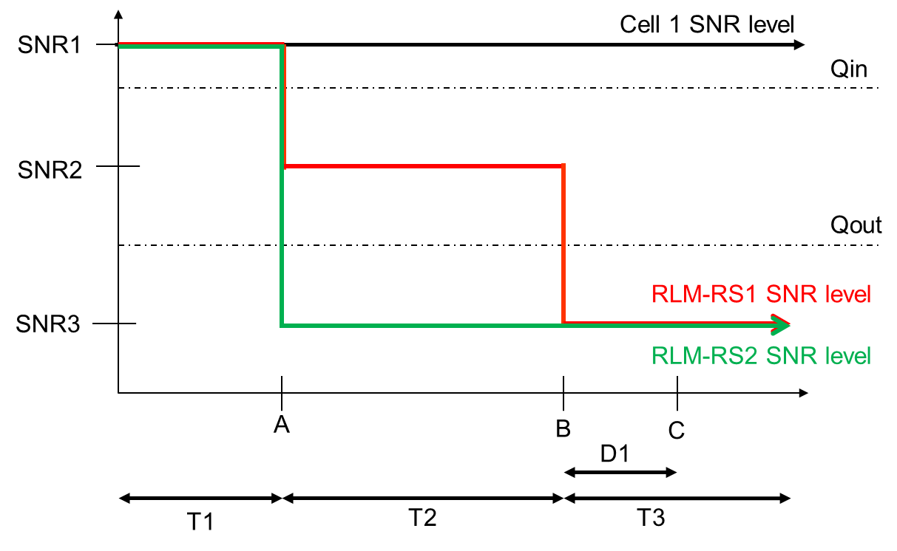

**Figure A.5.5.1.5.1-1: SNR variation for CSI-RS out-of-sync testing**

A.5.5.1.5.2 Test Requirements

The UE behaviour during time durations T1, T2, and T3 shall be as follows:

During the period from time point A to time point B the UE shall transmit uplink signal in Cell 2 (PSCell) at least in all uplink slots configured for CSI transmission according to the configured periodic CSI reporting for Cell 2.

The UE shall stop transmitting uplink signal in Cell 2 (PSCell) no later than time point C (D1 after the start of the time duration T3) on the PSCell.

The rate of correct events observed during repeated tests shall be at least 90%.

A.5.5.1.6 EN-DC Radio Link Monitoring In-sync Test for FR2 PSCell configured with CSI-RS-based RLM in non-DRX mode

A.5.5.1.6.1 Test Purpose and Environment

The purpose of this test is to verify that the UE properly detects the in sync for the purpose of monitoring downlink CSI-RS based radio link quality of the PSCell when no DRX is used. This test will partly verify the FR2 TDD PSCell CSI-RS In-sync radio link monitoring requirements in clause 8.1.

The test parameters are given in Tables A.5.5.1.6.1-1, A.5.5.1.6.1-2, and A.5.5.1.6.1-3 below. There are two cells, cell 1which is the E-UTRAN PCell, and cell 2 is the PSCell, in the test. The test consists of five successive time periods, with time duration of T1, T2, T3, T4 and T5 respectively. Figure A.5.5.1.6.1-1 shows the variation of the downlink SNR in the PSCell to emulate out-of-sync and in-sync states. Prior to the start of the time duration T1, the UE shall be fully synchronized to cell 1 and cell 2. The UE shall be configured for periodic CSI reporting with a reporting periodicity defined in CSI-RS configuration. In the test, DRX configuration is not enabled. In the test, SSB0 and SSB1 are configured as BFD-RS.

**Table A.5.5.1.6.1-1: Supported test configurations for FR2 PSCell**

|  |  |
| --- | --- |
| **Configuration** | **Description** |
| 1 | LTE FDD, NR 120 kHz SSB SCS, 100 MHz bandwidth, TDD duplex mode |
| 2 | LTE TDD, NR 120 kHz SSB SCS, 100 MHz bandwidth, TDD duplex mode |
| Note: The UE is only required to pass in one of the supported test configurations in FR2 | |

**Table A.5.5.1.6.1-2: General test parameters for FR2 PSCell for CSI-RS in-sync testing in non-DRX mode**

|  |  |  |  |
| --- | --- | --- | --- |
| **Parameter** | | **Unit** | **Value** |
| **Test 1** |
| Active E-UTRA PCell | |  | Cell 1 |
| E-UTRA RF Channel Number | |  | 1 |
| Active PSCell | |  | Cell 2 |
| RF Channel Number | |  | 2 |
| Duplex Mode | |  | TDD |
| TDD Configuration | Config 1 |  | TDDConf.3.1 |
| Config 2 | TDDConf.3.1 |
| DL initial BWP configuration | Config 1, 2 |  | DLBWP.0.1 |
| DL dedicated BWP configuration | Config 1, 2 |  | DLBWP.1.1 |
| UL initial BWP configuration | Config 1, 2 |  | ULBWP.0.1 |
| UL dedicated BWP configuration | Config 1, 2 |  | ULBWP.1.1 |
| RMC CORESET Reference Channel | Config 1 |  | CCR.3.1 TDD  CCR.3.3 TDD |
| Config 2 | CCR.3.1 TDD  CCR.3.3 TDD |
| SSB Configuration | Config 1 |  | SSB.1 FR2 |
| Config 2 | SSB.1 FR2 |
| SMTC Configuration | Config 1 |  | SMTC.1 |
| Config 2 | SMTC.1 |
| PDSCH/PDCCH subcarrier spacing | Config 1 |  | 120 KHz |
| Config 2 | 120 KHz |
| CSI-RS for RLM | Config 1, 2 |  | Resource #4 in TRS.2.1 TDD  Resource #4 in TRS.2.2 TDD |
| OCNG parameters | |  | OP.1 |
| TRS configuration | |  | TRS.2.1 TDD  TRS.2.2 TDD |
| TCI configuration for PDCCH#1/PDSCH | |  | TCI.State.2 |
| TCI configuration for PDCCH#2 | |  | TCI.State.3 |
| CP length | |  | Normal |
| Out of sync transmission parameters | DCI format |  | 1-0 |
| Number of Control OFDM symbols |  | 2 |
| Aggregation level | CCE | 8 |
| Ratio of hypothetical PDCCH RE energy to average CSI-RS RE energy | dB | 4 |
| Ratio of hypothetical PDCCH DMRS energy to average CSI-RS RE energy | dB | 4 |
| DMRS precoder granularity |  | REG bundle size |
| REG bundle size |  | 6 |
| In sync transmission parameters | DCI format |  | 1-0 |
| Number of Control OFDM symbols |  | 2 |
| Aggregation level | CCE | 4 |
| Ratio of hypothetical PDCCH RE energy to average CSI-RS RE energy | dB | 0 |
| Ratio of hypothetical PDCCH DMRS energy to average CSI-RS RE energy | dB | 0 |
| DMRS precoder granularity |  | REG bundle size |
| REG bundle size |  | 6 |
| DRX | |  | *OFF* |
| Gap pattern ID | |  | N.A. |
| Layer 3 filtering | |  | *Enabled* |
| T310 timer | | ms | 1000 |
| T311 timer | | ms | 1000 |
| N310 | |  | 1 |
| N311 | |  | 1 |
| CSI-RS for CSI reporting | Config 1 |  | CSI-RS.3.1 TDD |
| Config 2 | CSI-RS.3.1 TDD |
| T1 | | s | 0.2 |
| T2 | | s | 0.2 |
| T3 | | s | 0.24 |
| T4 | | s | 0.2 |
| T5 | | s | 0.88 |
| D1 | | s | 0.84 |
| Note 1: UE-specific PDCCH is not transmitted after T1 starts.  Note 2: E-UTRAN is in non-DRX mode under test. | | | |

**Table A.5.5.1.6.1-3: Cell specific test parameters for FR2 for CSI-RS in-sync radio link monitoring in non-DRX mode**

|  |  |  |  |  |  |  |  |  |  |  |  |  |
| --- | --- | --- | --- | --- | --- | --- | --- | --- | --- | --- | --- | --- |
| **Parameter** | | **Unit** | **Test 1** | | | | | | | | | |
| **T1** | **T2** | **T3** | **T4** | **T5** | **T1** | **T2** | **T3** | **T4** | **T5** |
| AoA setup | |  | Setup 3 defined in A.3.15 | | | | | | | | | |
| AoA1 | | | | | AoA2 | | | | |
| Assumption for UE beamsNote 10 | |  | Rough | | | | | Rough | | | | |
| PDCCH_beta | | dB | 4 | | | | | Not sent | | | | |
| PDCCH_DMRS_beta | | dB | 4 | | | | |
| PBCH_beta | | dB | 0 | | | | |
| PSS_beta | | dB |
| SSS_beta | | dB |
| PDSCH_beta | | dB |
| OCNG_beta | | dB |
| SNR on RLM-RS1 | Config 1, 2 | dB | 2Note 11 | -6Note 11 | -15 | -4.5 | 2Note 11 |
| SNR on RLM-RS2 | Config 1, 2 |  | Not sent | | | | | 2Note 11 | -14 | -15 | -15 | -14 |
| SNR on other channels and signals | Config 1, 2 | dB | 2Note 11 | | | | | N/A | | | | |
|  | Config 1, 2 | dBm/ 15KHz | -92.1 | | | | | -92.1 | | | | |
| Propagation condition | |  | TDL-A 30ns 75Hz | | | | | TDL-A 30ns 75Hz | | | | |
| Note 1: OCNG shall be used such that the resources in Cell 2 are fully allocated and a constant total transmitted power spectral density is achieved for all OFDM symbols.  Note 2: The uplink resources for CSI reporting are assigned to the UE prior to the start of time period T1.  Note 3: NZP CSI-RS resource set configuration for CSI reporting are assigned to the UE prior to the start of time period T1.  Note 4: Measurement gap configuration is assigned to the UE prior to the start of time period T1.  Note 5: The timers and layer 3 filtering related parameters are configured prior to the start of time period T1.  Note 6: The signal contains PDCCH for UEs other than the device under test as part of OCNG.  Note 7: SNR levels correspond to the signal to noise ratio over the SSS REs.  Note 8: The SNR in time periods T1, T2, T3, T4 and T5 is denoted as SNR1, SNR2, SNR3, SNR4 and SNR5 respectively in figure A.5.5.1.6.1-1.  Note 9: The SNR values are specified for testing a UE which supports 2RX on at least one band. For testing of a UE which supports 4RX on all bands, the SNR during T3 is A.3.6.  Note 10: Information about types of UE beam is given in B.2.1.3, and does not limit UE implementation or test system implementation  Note 11: This value allows up to 1dB degradation from applied SNR to UE baseband | | | | | | | | | | | | |

**Table A.5.5.1.6.1-3A: Void**

**Table A.5.5.1.6.1-4: Void**

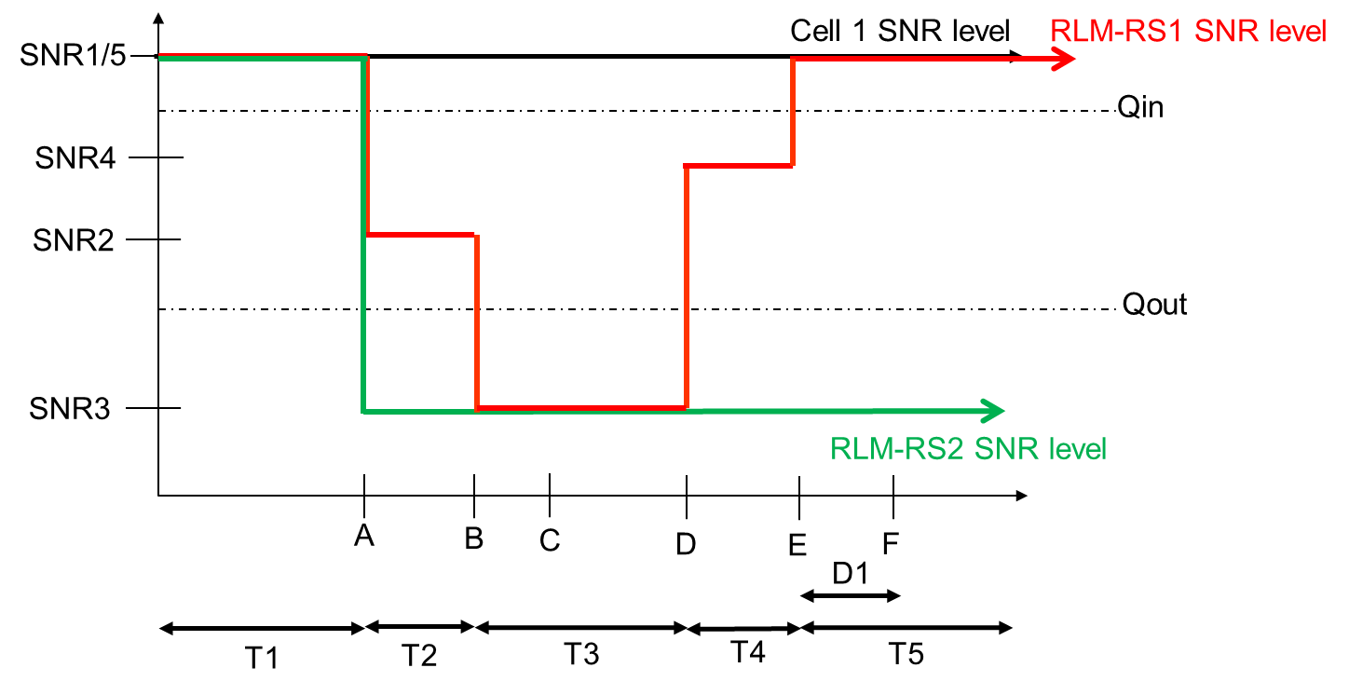

**Figure A.5.5.1.6.1-1: SNR variation for CSI-RS in-sync testing**

A.5.5.1.6.2 Test Requirements

The UE behaviour in each test during time durations T1, T2, T3, T4 and T5 shall be as follows:

During the period from time point A to time point F (D1 second after the start of time duration T5) the UE shall transmit uplink signal at least in all uplink slots configured for CSI transmission according to the configured periodic CSI reporting on the PSCell.

The rate of correct events observed during repeated tests shall be at least 90%.

A.5.5.1.7 EN-DC Radio Link Monitoring Out-of-sync Test for FR2 PSCell configured with CSI-RS-based RLM in DRX mode

A.5.5.1.7.1 Test Purpose and Environment

The purpose of this test is to verify that the UE properly detects the out of sync for the purpose of monitoring downlink CSI-RS based radio link quality of the PSCell when no DRX is used. This test will partly verify the FR2 TDD PSCell CSI-RS Out-of-sync radio link monitoring requirements in clause 8.1.

The test parameters are given in Tables A.5.5.1.7.1-1, A.5.5.1.7.1-2, and A.5.5.1.7.1-3 below. There are two cells, cell 1 is the E-UTRAN PCell, and cell 2 is the PSCell, in the test. The test consists of three successive time periods, with time duration of T1, T2 and T3 respectively. Figure A.5.5.1.7.1-1 shows the variation of the downlink SNR in the E-UTRAN PCell and the PSCell to emulate out-of-sync and in-sync states. Prior to the start of the time duration T1, the UE shall be fully synchronized to cell 1 and cell 2. The UE shall be configured for periodic CSI reporting with a reporting periodicity defined in CSI-RS configuration. In the test, DRX configuration is enabled in PSCell and DRX inactivity timer has already been expired, i.e. UE tries to decode PDCCH and to send periodic CQI during the period when On-duration timer is running. Time alignment timers shall be set to “infinity” so that UL timing alignment is maintained during the test. In the test, SSB0 and SSB1 are configured as BFD-RS.

**Table A.5.5.1.7.1-1: Supported test configurations for FR2 PSCell**

|  |  |
| --- | --- |
| **Configuration** | **Description** |
| 1 | LTE FDD, NR 120 kHz SSB SCS, 100 MHz bandwidth, TDD duplex mode |
| 2 | LTE TDD, NR 120 kHz SSB SCS, 100 MHz bandwidth, TDD duplex mode |
| Note: The UE is only required to pass in one of the supported test configurations in FR2 | |

**Table A.5.5.1.7.1-2: General test parameters for FR2 PSCell for CSI-RS out-of-sync testing in DRX mode**

|  |  |  |  |  |
| --- | --- | --- | --- | --- |
| **Parameter** | | | **Unit** | **Value** |
| **Test 1** |
| Active E-UTRA PCell | | |  | Cell 1 |
| E-UTRA RF Channel Number | | |  | 1 |
| Active PSCell | | |  | Cell 2 |
| RF Channel Number | | |  | 2 |
| Duplex Mode | | |  | TDD |
| TDD Configuration | | Config 1 |  | TDDConf.3.1 |
| Config 2 | TDDConf.3.1 |
| DL initial BWP configuration | | Config 1, 2 |  | DLBWP.0.1 |
| DL dedicated BWP configuration | | Config 1, 2 |  | DLBWP.1.1 |
| UL initial BWP configuration | | Config 1, 2 |  | ULBWP.0.1 |
| UL dedicated BWP configuration | | Config 1, 2 |  | ULBWP.1.1 |
| RMC CORESET Reference Channel | | Config 1 |  | CCR. 3.1 TDD  CCR.3.3 TDD |
| Config 2 | CCR. 3.1 TDD  CCR.3.3 TDD |
| SSB Configuration | | Config 1 |  | SSB.1 FR2 |
| Config 2 | SSB.1 FR2 |
| SMTC Configuration | | Config 1 |  | SMTC.1 |
| Config 2 | SMTC.1 |
| PDSCH/PDCCH subcarrier spacing | | Config 1 |  | 120 KHz |
| Config 2 | 120 KHz |
| CSI-RS for RLM | | Config 1, 2 |  | Resource #4 in TRS.2.1 TDD  Resource #4 in TRS.2.2 TDD |
| TRS configuration | | |  | TRS.2.1 TDD  TRS.2.2 TDD |
| TCI configuration for PDCCH#1/PDSCH | | |  | TCI.State.2 |
| TCI configuration for PDCCH#2 | | |  | TCI.State.3 |
| OCNG parameters | | |  | OP.1 |
| CP length | | |  | Normal |
| Out of sync transmission parameters | DCI format | |  | 1-0 |
| Number of Control OFDM symbols | |  | 2 |
| Aggregation level | | CCE | 8 |
| Ratio of hypothetical PDCCH RE energy to average CSI-RS RE energy | | dB | 4 |
| Ratio of hypothetical PDCCH DMRS energy to average CSI-RS RE energy | | dB | 4 |
| DMRS precoder granularity | |  | REG bundle size |
| REG bundle size | |  | 6 |
| DRX | | |  | DRX.3 |
| Gap pattern ID | | |  | N.A. |
| Layer 3 filtering | | |  | *Enabled* |
| T310 timer | | | ms | *0* |
| T311 timer | | | ms | 1000 |
| N310 | | |  | 1 |
| N311 | | |  | 1 |
| CSI-RS for CSI reporting | Config 1 | |  | CSI-RS.3.1 TDD |
| Config 2 | | CSI-RS.3.1 TDD |
| T1 | | | s | 0.2 |
| T2 | | | s | 1.28 |
| T3 | | | s | 1.28 |
| D1 | | | s | 1.24 |
| Note 1: UE-specific PDCCH is not transmitted after T1 starts.  Note 2: E-UTRAN is in non-DRX mode under test. | | | | |

**Table A.5.5.1.7.1-3: Cell specific test parameters for FR2 for CSI-RS out-of-sync radio link monitoring in DRX mode**

|  |  |  |  |  |  |
| --- | --- | --- | --- | --- | --- |
| **Parameter** | | **Unit** | **Test 1** | | |
| **T1** | **T2** | **T3** |
| AoA setup | |  | Setup 1 defined in A.3.15 | | |
| Assumption for UE beamsNote 10 | |  | Rough | | |
| PDCCH_beta | | dB | 4 | | |
| PDCCH_DMRS_beta | | dB | 4 | | |
| PBCH_beta | | dB | 0 | | |
| PSS_beta | | dB |
| SSS_beta | | dB |
| PDSCH_beta | | dB |
| OCNG_beta | | dB |
| SNR on RLM-RS1 | Config 1, 2 | dB | 2Note 11 | -6Note 11 | -15 |
| SNR on RLM-RS2 | Config 1, 2 | 2Note 11 | -14 | -15 |
| SNR on other channels and signals | Config 1, 2 | dB | 2Note 11 | | |
|  | Config 1 | dBm/15KHz | -104.7 | | |
| Config 2 | -104.7 | | |
| Propagation condition | |  | DL-A 30ns 75Hz | | |
| Note 1: OCNG shall be used such that the resources in Cell 2 are fully allocated and a constant total transmitted power spectral density is achieved for all OFDM symbols.  Note 2: The uplink resources for CSI reporting are assigned to the UE prior to the start of time period T1.  Note 3: NZP CSI-RS resource set configuration for CSI reporting are assigned to the UE prior to the start of time period T1.  Note 4: Measurement gap configuration is assigned to the UE prior to the start of time period T1.  Note 5: The timers and layer 3 filtering related parameters are configured prior to the start of time period T1.  Note 6: The signal contains PDCCH for UEs other than the device under test as part of OCNG.  Note 7: SNR levels correspond to the signal to noise ratio over the SSS REs.  Note 8: The SNR in time periods T1, T2 and T3 is denoted as SNR1, SNR2 and SNR3 respectively in figure A.5.5.1.7.1-1.  Note 9: The SNR values are specified for testing a UE which supports 2RX on at least one band. For testing of a UE which supports 4RX on all bands, the SNR during T3 is A.3.6.  Note 10: Information about types of UE beam is given in B.2.1.3, and does not limit UE implementation or test system implementation  Note 11: This value allows up to 1dB degradation from applied SNR to UE baseband | | | | | |

**Table A.5.5.1.7.1-3A: Void**

**Table A.5.5.1.7.1-4: Void**

**Table A.5.5.1.7.1-5: Void**

**Table A.5.5.1.7.1-6: Void**



**Figure A.5.5.1.7.1-1: SNR variation for CSI-RS out-of-sync testing**

A.5.5.1.7.2 Test Requirements

The UE behaviour during time durations T1, T2, and T3 shall be as follows:

During the period from time point A to time point B the UE shall transmit uplink signal in Cell 2 (PSCell) at least in all uplink slots configured for CSI transmission according to the configured periodic CSI reporting for Cell 2.

The UE shall stop transmitting uplink signal in Cell 2 (PSCell) no later than time point C (D1 after the start of the time duration T3) on the PSCell.

The rate of correct events observed during repeated tests shall be at least 90%.

A.5.5.1.8 EN-DC Radio Link Monitoring In-sync Test for FR2 PSCell configured with CSI-RS-based RLM in DRX mode

A.5.5.1.8.1 Test Purpose and Environment

The purpose of this test is to verify that the UE properly detects the in sync for the purpose of monitoring downlink CSI-RS based radio link quality of the PSCell when no DRX is used. This test will partly verify the FR2 TDD PSCell CSI-RS In-sync radio link monitoring requirements in clause 8.1.

The test parameters are given in Tables A.5.5.1.8.1-1, A.5.5.1.8.1-2, A.5.5.1.8.1-3 and A.5.5.1.8.1-3A below. There are two cells, cell 1which is the E-UTRAN PCell, and cell 2 is the NR PSCell, in the test. The test consists of five successive time periods, with time duration of T1, T2, T3, T4 and T5 respectively. Figure A.5.5.1.8.1-1 shows the variation of the downlink SNR in the PSCell to emulate out-of-sync and in-sync states. Prior to the start of the time duration T1, the UE shall be fully synchronized to cell 1 and cell 2. The UE shall be configured for periodic CSI reporting with a reporting periodicity defined in CSI-RS configuration. In the test, DRX configuration is not enabled. The UE is configured to perform inter-frequency measurements using GP ID #0 (40ms).

**Table A.5.5.1.8.1-1: Supported test configurations for FR2 PSCell**

|  |  |
| --- | --- |
| **Configuration** | **Description** |
| 1 | LTE FDD, NR 120 kHz SSB SCS, 100 MHz bandwidth, TDD duplex mode |
| 2 | LTE TDD, NR 120 kHz SSB SCS, 100 MHz bandwidth, TDD duplex mode |
| Note: The UE is only required to pass in one of the supported test configurations in FR2 | |

**Table A.5.5.1.8.1-2: General test parameters for FR2 PSCell for CSI-RS in-sync testing in non-DRX mode**

|  |  |  |  |
| --- | --- | --- | --- |
| **Parameter** | | **Unit** | **Value** |
| **Test 1** |
| Active E-UTRA PCell | |  | Cell 1 |
| E-UTRA RF Channel Number | |  | 1 |
| Active PSCell | |  | Cell 2 |
| RF Channel Number | |  | 2 |
| Duplex Mode | |  | TDD |
| TDD Configuration | Config 1 |  | TDDConf.3.1 |
| Config 2 | TDDConf.3.1 |
| DL initial BWP configuration | Config 1, 2 |  | DLBWP.0.1 |
| DL dedicated BWP configuration | Config 1, 2 |  | DLBWP.1.1 |
| UL initial BWP configuration | Config 1, 2 |  | ULBWP.0.1 |
| UL dedicated BWP configuration | Config 1, 2 |  | ULBWP.1.1 |
| RMCCORESET Reference Channel | Config 1 |  | CCR.3.1 TDD  CCR.3.3 TDD |
| Config 2 | CCR.3.1 TDD  CCR.3.3 TDD |
| SSB Configuration | Config 1 |  | SSB.1 FR2 |
| Config 2 | SSB.1 FR2 |
| SMTC Configuration | Config 1 |  | SMTC.1 |
| Config 2 | SMTC.1 |
| PDSCH/PDCCH subcarrier spacing | Config 1 |  | 120 KHz |
| Config 2 | 120 KHz |
| CSI-RS for RLM | Config 1, 2 |  | Resource #4 in TRS.2.1 TDD  Resource #4 in TRS.2.2 TDD |
| TRS configuration | |  | TRS.2.1 TDD  TRS.2.2 TDD |
| TCI configuration for PDCCH#1/PDSCH | |  | TCI.State.2 |
| TCI configuration for PDCCH#2 | |  | TCI.State.3 |
| OCNG parameters | |  | OP.1 |
| CP length | |  | Normal |
| Out of sync transmission parameters | DCI format |  | 1-0 |
| Number of Control OFDM symbols |  | 2 |
| Aggregation level | CCE | 8 |
| Ratio of hypothetical PDCCH RE energy to average CSI-RS RE energy | dB | 4 |
| Ratio of hypothetical PDCCH DMRS energy to average CSI-RS RE energy | dB | 4 |
| DMRS precoder granularity |  | REG bundle size |
| REG bundle size |  | 6 |
| In sync transmission parameters | DCI format |  | 1-0 |
| Number of Control OFDM symbols |  | 2 |
| Aggregation level | CCE | 4 |
| Ratio of hypothetical PDCCH RE energy to average CSI-RS RE energy | dB | 0 |
| Ratio of hypothetical PDCCH DMRS energy to average CSI-RS RE energy | dB | 0 |
| DMRS precoder granularity |  | REG bundle size |
| REG bundle size |  | 6 |
| DRX | |  | DRX.3 |
| Gap pattern ID | |  | *gp0* |
| Layer 3 filtering | |  | *Enabled* |
| T310 timer | | ms | 2000 |
| T311 timer | | ms | 1000 |
| N310 | |  | 1 |
| N311 | |  | 1 |
| CSI-RS for CSI reporting | Config 1 |  | CSI-RS.3.1 TDD |
| Config 2 | CSI-RS.3.1 TDD |
| T1 | | s | 0.2 |
| T2 | | s | 0.2 |
| T3 | | s | 1.64 |
| T4 | | s | 0.2 |
| T5 | | s | 1.88 |
| D1 | | s | 1.84 |
| Note 1: UE-specific PDCCH is not transmitted after T1 starts.  Note 2: E-UTRAN is in non-DRX mode under test. | | | |

**Table A.5.5.1.8.1-3: Cell specific test parameters for FR2 for CSI-RS in-sync radio link monitoring in DRX mode**

|  |  |  |  |  |  |  |  |
| --- | --- | --- | --- | --- | --- | --- | --- |
| **Parameter** | | **Unit** | **Test 1** | | | | |
| **T1** | **T2** | **T3** | **T4** | **T5** |
| AoA setup | |  | Setup 1 defined in A.3.15 | | | | |
| Assumption for UE beamsNote 10 | |  | Rough | | | | |
| PDCCH_beta | | dB | 4 | | | | |
| PDCCH_DMRS_beta | | dB | 4 | | | | |
| PBCH_beta | | dB | 0 | | | | |
| PSS_beta | | dB |
| SSS_beta | | dB |
| PDSCH_beta | | dB |
| OCNG_beta | | dB |
| SNR on RLM-RS1 | Config 1, 2 | dB | 2Note 11 | -6Note 11 | -15 | -4.5 | 2Note 11 |
| SNR on RLM-RS2 | Config 1, 2 | dB | 2Note 11 | -14 | -15 | -15 | -14 |
| SNR on other channels and signals | Config 1, 2 | dB | 2Note 11 | | | | |
|  | Config 1, 2 | dBm/15KHz | -104.7 | | | | |
| Propagation condition | |  | TDL-A 30ns 75Hz | | | | |
| Note 1: OCNG shall be used such that the resources in Cell 2 are fully allocated and a constant total transmitted power spectral density is achieved for all OFDM symbols.  Note 2: The uplink resources for CSI reporting are assigned to the UE prior to the start of time period T1.  Note 3: NZP CSI-RS resource set configuration for CSI reporting are assigned to the UE prior to the start of time period T1.  Note 4: Measurement gap configuration is assigned to the UE prior to the start of time period T1.  Note 5: The timers and layer 3 filtering related parameters are configured prior to the start of time period T1.  Note 6: The signal contains PDCCH for UEs other than the device under test as part of OCNG.  Note 7: SNR levels correspond to the signal to noise ratio over the SSS REs.  Note 8: The SNR in time periods T1, T2, T3, T4 and T5 is denoted as SNR1, SNR2, SNR3, SNR4 and SNR5 respectively in figure A.5.5.1.8.1-1.  Note 9: The SNR values are specified for testing a UE which supports 2RX on at least one band. For testing of a UE which supports 4RX on all bands, the SNR during T3 is A.3.6.  Note 10: Information about types of UE beam is given in B.2.1.3, and does not limit UE implementation or test system implementation  Note 11: This value allows up to 1dB degradation from applied SNR to UE baseband | | | | | | | |

**Table A.5.5.1.8.1-3A: Measurement gap configuration for FR2 CSI-RS in-sync radio link monitoring in DRX mode**

|  |  |
| --- | --- |
| **Field** | **Test 1** |
| **Value** |
| gapOffset | 0 |
| Note 1: E-UTRAN PCell and PSCell are SFN-synchronous and frame boundary aligned. (Ensure that RLM RS is partially overlapped with measurement gap) | |

**Table A.5.5.1.8.1-4: Void**

**Table A.5.5.1.8.1-5: Void**

**Table A.5.5.1.8.1-6: Void**



**Figure A.5.5.1.8.1-1: SNR variation for CSI-RS in-sync testing**

A.5.5.1.8.2 Test Requirements

The UE behaviour in each test during time durations T1, T2, T3, T4 and T5 shall be as follows:

During the period from time point A to time point F (D1 second after the start of time duration T5) the UE shall transmit uplink signal at least in all uplink slots configured for CSI transmission according to the configured periodic CSI reporting on the PSCell.

The rate of correct events observed during repeated tests shall be at least 90%.

<< Unchanged sections skipped >>

A.7.5.1.1 Radio Link Monitoring Out-of-sync Test for FR2 PCell configured with SSB-based RLM RS in non-DRX mode

A.7.5.1.1.1 Test Purpose and Environment

The purpose of this test is to verify that the UE properly detects the out of sync and in sync for the purpose of monitoring downlink radio link quality of the PCell. This test will partly verify the FR2 radio link monitoring requirements in clause 8.1.

In the test, UE is configured to perform RLM on SSB, with *detectionResource* included in *RadioLinkMonitoringRS* set to SSB#0 and SSB#1, and *purpose* set to ‘*rlf*’. Supported test configurations are shown in table A.7.5.1.1.1-1. The test parameters are given in Tables A.7.5.1.1.1-2, A.7.5.1.1.1-3, and A.7.5.1.1.1-4 below. There is one cell (Cell 1), which is the active NR cell, in the test. The test consists of three successive time periods, with time duration of T1, T2 and T3 respectively. Figure A.7.5.1.1.1-1 shows the variation of the downlink SNR in the active cell to emulate out-of-sync and in-sync states, and Figure A.7.5.1.1.1-2 shows the Time multiplexed downlink transmissions from each Angle of Arrival. Prior to the start of the time duration T1, the UE shall be fully synchronized to Cell 1. The UE shall be configured for periodic CSI reporting with a reporting periodicity of 5 ms. In addition to RLM-RS radio link monitoring using SSB index 0 and SSB index 1, the UE is configured to perform inter-frequency measurements using Gap Pattern ID #0 (40ms) in test 1.

**Table A.7.5.1.1.1-1: Supported test configurations for FR2 PCell**

|  |  |
| --- | --- |
| **Configuration** | **Description** |
| 1 | TDD, SSB SCS 120 KHz, data SCS 120KHz, BW 100 MHz |

**Table A.7.5.1.1.1-2: General test parameters for FR2 out-of-sync testing in non-DRX mode**

|  |  |  |  |  |
| --- | --- | --- | --- | --- |
| **Parameter** | | | **Unit** | **Value** |
| **Test 1** |
| Active PCell | | |  | Cell 1 |
| RF Channel Number | | |  | 1 |
| Duplex mode | | Config 1 |  | TDD |
| BWchannel | | Config 1 |  | 100: NRB,c = 66 |
| DL initial BWP configuration | | Config 1 |  | DLBWP.0.1 |
| DL dedicated BWP configuration | | Config 1 |  | DLBWP.1.1 |
| UL initial BWP configuration | | Config 1 |  | ULBWP.0.1 |
| UL dedicated BWP configuration | | Config 1 |  | ULBWP.1.1 |
| TDD Configuration | | Config 1 |  | TDDConf.3.1 |
| CORESET Reference Channel | | Config 1 |  | CR.3.1 TDD |
| SSB Configuration | | Config 1 |  | SSB.1 FR2 |
| SMTC Configuration | | Config 1 |  | SMTC.1 |
| PDSCH/PDCCH subcarrier spacing | | Config 1 |  | 120 KHz |
| PRACH Configuration | | Config 1 |  | Table A.3.8.3.4 |
| SSB index assigned as RLM RS | | Config 1 |  | 0,1 |
| OCNG parameters | | |  | OP.2 |
| CP length | | |  | Normal |
| Out of sync transmission parameters | DCI format | |  | 1-0 |
| Number of Control OFDM symbols | |  | 2 |
| Aggregation level | | CCE | 8 |
| Ratio of hypothetical PDCCH RE energy to average SSS RE energy | | dB | 4 |
| Ratio of hypothetical PDCCH DMRS energy to average SSS RE energy | | dB | 4 |
| DMRS precoder granularity | |  | REG bundle size |
| REG bundle size | |  | 6 |
| DRX | | |  | *OFF* |
| Gap pattern ID | | |  | *gp0* |
| Layer 3 filtering | | |  | *Enabled* |
| T310 timer | | | ms | *0* |
| T311 timer | | | ms | 1000 |
| N310 | | |  | 1 |
| N311 | | |  | 1 |
| CSI-RS for CSI reporting | | Config 1 |  | CSI-RS.3.1 TDD |
| TCI states for PDCCH/PDSCH | | |  | TCI.State.2 |
| CSI-RS for tracking | | Config 1 |  | TRS.2.1 TDD |
| T1 | | | s | 0.2 |
| T2 | | | s | 9.68 |
| T3 | | | s | 9.68 |
| D1 | | | s | 9.64 |
| Note 1: All configurations are assigned to the UE prior to the start of time period T1.  Note 2: UE-specific PDCCH is not transmitted after T1 starts. | | | | |

**Table A.7.5.1.1.1-3: OTA related cell specific test parameters for FR2 (Cell 1) for out-of-sync radio link monitoring tests in non-DRX mode**

|  |  |  |  |  |  |  |  |  |
| --- | --- | --- | --- | --- | --- | --- | --- | --- |
| **Parameter** | | **Unit** | **Test 1** | | | | | |
| **T1** | **T2** | **T3** | **T1** | **T2** | **T3** |
| AoA setup | |  | Setup 3 defined in A.3.15 | | | | | |
| AoA1 | | | AoA2 | | |
| Assumption for UE beams Note 5 | |  | Rough | | | Rough | | |
| EPRE ratio of PDCCH DMRS to SSS | | dB | 4 | | | Not sent | | |
| EPRE ratio of PDCCH to PDCCH DMRS | | dB | 0 | | |
| EPRE ratio of PBCH DMRS to SSS | | dB |
| EPRE ratio of PBCH to PBCH DMRS | | dB |
| EPRE ratio of PSS to SSS | | dB |
| EPRE ratio of PDSCH DMRS to SSS | | dB |
| EPRE ratio of PDSCH to PDSCH DMRS | | dB |
| EPRE ratio of OCNG DMRS to SSS | | dB |
| EPRE ratio of OCNG to OCNG DMRS | | dB |
| ssb-Index 0 SNR | Config 1 | dB | 2Note 6 | -6Note 6 | -15 |
| ssb-Index 1 SNR | Config 1 |  | Not sent | | | 2Note 6 | -15 | -15 |
| SNR on other channels and signals | Config 1 | dB | 2Note 6 | | | N/A | | |
|  | Config 1 | dBm/ 15kHz | -92.1 | | | -92.1 | | |
| Time multiplexing of the downlink transmissions from each AoA | |  | Defined in Figure A.7.5.1.1.1-2 | | | | | |
| Propagation condition | |  | TDL-A 30ns 75Hz | | | TDL-A 30ns 75Hz | | |
| Note 1: OCNG shall be used such that the resources in Cell 1 are fully allocated and a constant total transmitted power spectral density is achieved for all OFDM symbols.  Note 2: The signal contains PDCCH for UEs other than the device under test as part of OCNG.  Note 3: SNR levels correspond to the signal to noise ratio over the SSS REs.  Note 4: The SNR values are specified for testing a UE which supports 2RX on at least one band. For testing of a UE which supports 4RX on all bands, the SNR during T3 is A.3.6.  Note 5: Information about types of UE beam is given in B.2.1.3 and does not limit UE implementation or test system implementation.  Note 6: This value allows up to 1dB degradation from applied SNR to UE baseband | | | | | | | | |

**Table A.7.5.1.1.1-4: Measurement gap configuration for out-of-sync tests in non-DRX mode**

|  |  |
| --- | --- |
| **Field** | **Test 1** |
| **Value** |
| gapOffset | 0 |

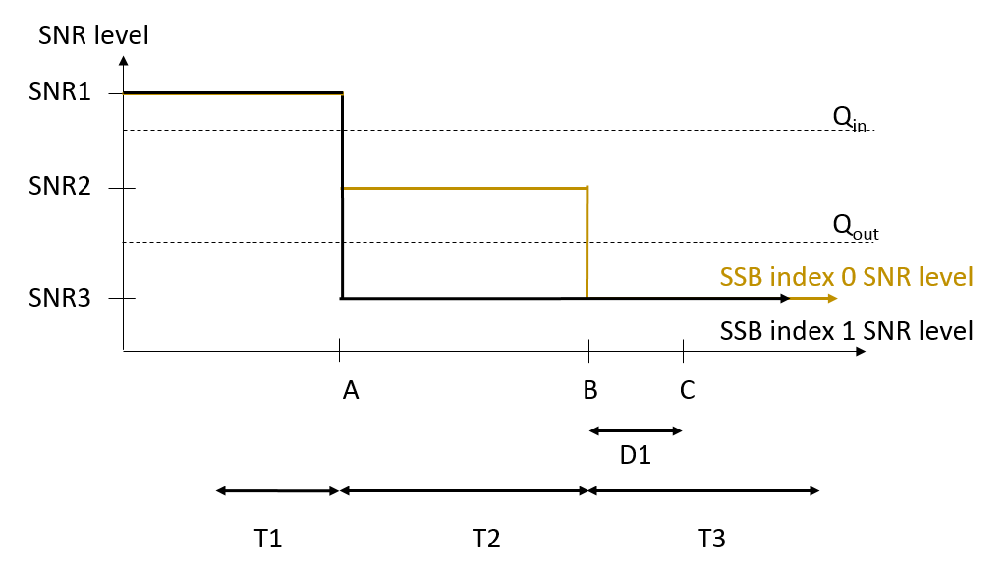

**Figure A.7.5.1.1.1-1: SNR variation for out-of-sync testing**



**Figure A.7.5.1.1.1-2: Time multiplexed downlink transmissions**

A.7.5.1.1.2 Test Requirements

The UE behavior in each test during time durations T1, T2 and T3 shall be as follows:

During the period from time point A to time point B the UE shall transmit uplink signal at least in all uplink slots configured for CSI transmission according to the configured periodic CSI reporting.

The UE shall stop transmitting uplink signal no later than time point C (D1 second after the start of the time duration T3).

The rate of correct events observed during repeated tests shall be at least 90%.

A.7.5.1.2 Radio Link Monitoring In-sync Test for FR2 PCell configured with SSB-based RLM RS in non-DRX mode

A.7.5.1.2.1 Test Purpose and Environment

The purpose of this test is to verify that the UE properly detects the out of sync and in sync for the purpose of monitoring downlink radio link quality of the PCell. This test will partly verify the FR2 radio link monitoring requirements in clause 8.1.

In the test, UE is configured to perform RLM on SSB, with *detectionResource* included in *RadioLinkMonitoringRS* set to SSB#0 and SSB#1, and *purpose* set to ‘*rlf*’. Supported test configurations are shown in table A.7.5.1.2.1-1.The test parameters are given in Tables A.7.5.1.2.1-2, and A.7.5.1.2.1-3 below. There is one cell (Cell 1), which is the active cell, in the test. The test consists of five successive time periods, with time duration of T1, T2, T3, T4 and T5 respectively. Figure A.7.5.1.2.1-1 shows the variation of the downlink SNR in the active cell to emulate out-of-sync and in-sync states, and Figure A.7.5.1.2.1-2 shows the Time multiplexed downlink transmissions from each Angle of Arrival. Prior to the start of the time duration T1, the UE shall be fully synchronized to Cell 1. Prior to the start of the time duration T1, the UE shall be fully synchronized to Cell 1. The UE shall be configured for periodic CSI reporting with a reporting periodicity of 5 ms.

**Table A.7.5.1.2.1-1: Supported test configurations for FR2 PCell**

|  |  |
| --- | --- |
| **Configuration** | **Description** |
| 1 | TDD, SSB SCS 120 KHz, data SCS 120KHz, BW 100 MHz |

**Table A.7.5.1.2.1-2: General test parameters for FR2 in-sync testing in non-DRX mode**

|  |  |  |  |  |
| --- | --- | --- | --- | --- |
| **Parameter** | | | **Unit** | **Value** |
| **Test 1** |
| Active PCell | | |  | Cell 1 |
| RF Channel Number | | |  | 1 |
| Duplex mode | | Config 1 |  | TDD |
| BWchannel | | Config 1 |  | 100: NRB,c = 66 |
| DL initial BWP configuration | | Config 1 |  | DLBWP.0.1 |
| DL dedicated BWP configuration | | Config 1 |  | DLBWP.1.1 |
| UL initial BWP configuration | | Config 1 |  | ULBWP.0.1 |
| UL dedicated BWP configuration | | Config 1 |  | ULBWP.1.1 |
| TDD Configuration | | Config 1 |  | TDDConf.3.1 |
| CORESET Reference Channel | | Config 1 |  | CR.3.1 TDD |
| SSB Configuration | | Config 1 |  | SSB.1 FR2 |
| SMTC Configuration | | Config 1 |  | SMTC.3 |
| PDSCH/PDCCH subcarrier spacing | | Config 1 |  | 120 KHz |
| PRACH Configuration | | Config 1 |  | Table A.3.8.3.4 |
| SSB index assigned as RLM RS | | Config 1 |  | 0,1 |
| OCNG parameters | | |  | OP.2 |
| CP length | | |  | Normal |
| In sync transmission parameters | DCI format | |  | 1-0 |
| Number of Control OFDM symbols | |  | 2 |
| Aggregation level | | CCE | 4 |
| Ratio of hypothetical PDCCH RE energy to average SSS RE energy | | dB | 0 |
| Ratio of hypothetical PDCCH DMRS energy to average SSS RE energy | | dB | 0 |
| DMRS precoder granularity | |  | REG bundle size |
| REG bundle size | |  | 6 |
| Out of sync transmission parameters | DCI format | |  | 1-0 |
| Number of Control OFDM symbols | |  | 2 |
| Aggregation level | | CCE | 8 |
| Ratio of hypothetical PDCCH RE energy to average SSS RE energy | | dB | 4 |
| Ratio of hypothetical PDCCH DMRS energy to average SSS RE energy | | dB | 4 |
| DMRS precoder granularity | |  | REG bundle size |
| REG bundle size | |  | 6 |
| DRX | | |  | *OFF* |
| Gap pattern ID | | |  | N.A. |
| Layer 3 filtering | | |  | *Enabled* |
| T310 timer | | | ms | 4000 |
| T311 timer | | | ms | 1000 |
| N310 | | |  | 1 |
| N311 | | |  | 1 |
| CSI-RS for CSI reporting | | Config 1 |  | CSI-RS.3.1 TDD |
| TCI states for PDCCH/PDSCH | | |  | TCI.State.2 |
| CSI-RS for tracking | | Config 1 |  | TRS.2.1 TDD |
| T1 | | | s | 0.2 |
| T2 | | | s | 0.2 |
| T3 | | | s | 1.88 |
| T4 | | | s | 0.2 |
| T5 | | | s | 3.84 |
| D1 | | | s | 3.8 |
| Note 1: All configurations are assigned to the UE prior to the start of time period T1.  Note 2: UE-specific PDCCH is not transmitted after T1 starts. | | | | |

**Table A.7.5.1.2.1-3: OTA related cell specific test parameters for FR2 (Cell 1) for in-sync radio link monitoring tests in non-DRX mode**

|  |  |  |  |  |  |  |  |  |  |  |  |  |
| --- | --- | --- | --- | --- | --- | --- | --- | --- | --- | --- | --- | --- |
| **Parameter** | | **Unit** | **Test 1** | | | | | | | | | |
| **T1** | **T2** | **T3** | **T4** | **T5** | **T1** | **T2** | **T3** | **T4** | **T5** |
| AoA setup | |  | Setup 3 defined in A.3.15 | | | | | | | | | |
| AoA1 | | | | | AoA2 | | | | |
| Assumption for UE beams Note 5 | |  | Rough | | | | | Rough | | | | |
| EPRE ratio of PDCCH DMRS to SSS | | dB | 4 | | | | | Not sent | | | | |
| EPRE ratio of PDCCH to PDCCH DMRS | | dB | 0 | | | | |
| EPRE ratio of PBCH DMRS to SSS | | dB |
| EPRE ratio of PBCH to PBCH DMRS | | dB |
| EPRE ratio of PSS to SSS | | dB |
| EPRE ratio of PDSCH DMRS to SSS | | dB |
| EPRE ratio of PDSCH to PDSCH DMRS | | dB |
| EPRE ratio of OCNG DMRS to SSS | | dB |
| EPRE ratio of OCNG to OCNG DMRS | | dB |
| ssb-Index 0 SNR | Config 1 | dB | 2Note 6 | -6Note 6 | -15 | -4.5 | 2Note 6 |
| ssb-Index 1 SNR | Config 1 |  | Not sent | | | | | 2Note 6 | -15 | -15 | -15 | -15 |
| SNR on other channels and signals | Config 1 | dB | 2Note 6 | | | | | N/A | | | | |
|  | Config 1 | dBm/ 15kHz | -92.1 | | | | | -92.1 | | | | |
| Time multiplexing of the downlink transmissions from each AoA | |  | Defined in Figure A.7.5.1.2.1-2 | | | | | | | | | |
| Propagation condition | |  | TDL-A 30ns 75Hz | | | | | TDL-A 30ns 75Hz | | | | |
| Note 1: OCNG shall be used such that the resources in Cell 1 are fully allocated and a constant total transmitted power spectral density is achieved for all OFDM symbols.  Note 2: The signal contains PDCCH for UEs other than the device under test as part of OCNG.  Note 3: SNR levels correspond to the signal to noise ratio over the SSS REs.  Note 4: The SNR values are specified for testing a UE which supports 2RX on at least one band. For testing of a UE which supports 4RX on all bands, the SNR during T3 is A.3.6.  Note 5: Information about types of UE beam is given in B.2.1.3 and does not limit UE implementation or test system implementation.  Note 6: This value allows up to 1dB degradation from applied SNR to UE baseband | | | | | | | | | | | | |

**Table A.7.5.1.2.1-4: Void**

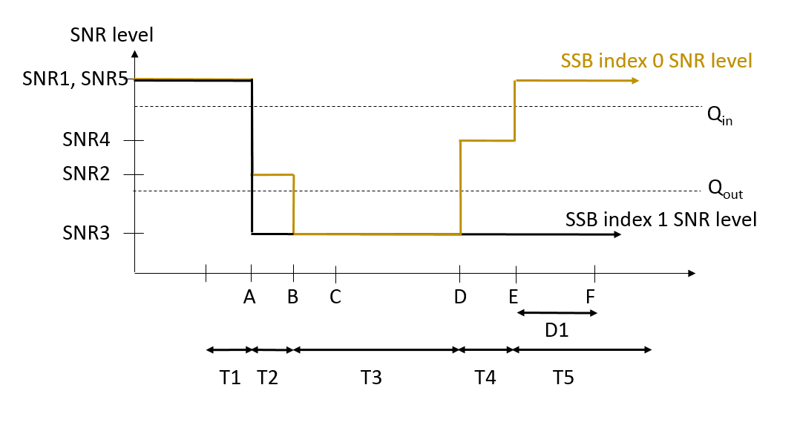

**Figure A.7.5.1.2.1-1: SNR variation for in-sync testing**



**Figure A.7.5.1.2.1-2: Time multiplexed downlink transmissions**

A.7.5.1.2.2 Test Requirements

The UE behaviour in each test during time durations T1, T2, T3, T4 and T5 shall be as follows:

During the period from time point A to time point F (D1 second after the start of time duration T5) the UE shall transmit uplink signal at least in all uplink slots configured for CSI transmission according to the configured periodic CSI reporting.

The rate of correct events observed during repeated tests shall be at least 90%.

A.7.5.1.3 Radio Link Monitoring Out-of-sync Test for FR2 PCell configured with SSB-based RLM RS in DRX mode

A.7.5.1.3.1 Test Purpose and Environment

The purpose of this test is to verify that the UE properly detects the out of sync and in sync for the purpose of monitoring downlink radio link quality of the PCell when DRX is used. This test will partly verify the FR2 radio link monitoring requirements in clause 8.1.

In the test, UE is configured to perform RLM on SSB, with *detectionResource* included in *RadioLinkMonitoringRS* set to SSB#0 and SSB#1, and *purpose* set to ‘*rlf*’. Supported test configurations are shown in table A.7.5.1.3.1-1. The test parameters are given in Tables A.7.5.1.3.1-2, and A.7.5.1.3.1-3. There is one cell (Cell 1), which is the active NR cell, in the test. The test consists of three successive time periods, with time duration of T1, T2 and T3 respectively. Figure A.7.5.1.3.1-1 shows the variation of the downlink SNR in the active cell to emulate out-of-sync and in-sync states. Prior to the start of the time duration T1, the UE shall be fully synchronized to Cell 1. The UE shall be configured for periodic CSI reporting with a reporting periodicity of 5 ms. In the test, DRX configuration is enabled and DRX inactivity timer has already been expired, i.e. UE tries to decode PDCCH and to send periodic CSI during the period when On-duration timer is running. Time alignment timers shall be set to “infinity” so that UL timing alignment is maintained during the test.

**Table A.7.5.1.3.1-1: Supported test configurations for FR2 PCell**

|  |  |
| --- | --- |
| **Configuration** | **Description** |
| 1 | TDD, SSB SCS 120 KHz, data SCS 120KHz, BW 100 MHz |

**Table A.7.5.1.3.1-2: General test parameters for FR2 out-of-sync testing in DRX mode**

|  |  |  |  |  |
| --- | --- | --- | --- | --- |
| **Parameter** | | | **Unit** | **Value** |
| **Test 1** |
| Active PCell | | |  | Cell 1 |
| RF Channel Number | | |  | 1 |
| Duplex mode | | Config 1 |  | TDD |
| BWchannel | | Config 1 |  | 100: NRB,c = 66 |
| DL initial BWP configuration | | Config 1 |  | DLBWP.0.1 |
| DL dedicated BWP configuration | | Config 1 |  | DLBWP.1.1 |
| UL initial BWP configuration | | Config 1 |  | ULBWP.0.1 |
| UL dedicated BWP configuration | | Config 1 |  | ULBWP.1.1 |
| TDD Configuration | | Config 1 |  | TDDConf.3.1 |
| CORESET Reference Channel | | Config 1 |  | CR.3.1 TDD |
| SSB Configuration | | Config 1 |  | SSB.1 FR2 |
| SMTC Configuration | | Config 1 |  | SMTC.1 |
| PDSCH/PDCCH subcarrier spacing | | Config 1 |  | 120 KHz |
| PRACH Configuration | | Config 1 |  | Table A.3.8.3.4 |
| SSB index assigned as RLM RS | | Config 1 |  | 0,1 |
| OCNG parameters | | |  | OP.1 |
| CP length | | |  | Normal |
| Out of sync transmission parameters | DCI format | |  | 1-0 |
| Number of Control OFDM symbols | |  | 2 |
| Aggregation level | | CCE | 8 |
| Ratio of hypothetical PDCCH RE energy to average SSS RE energy | | dB | 4 |
| Ratio of hypothetical PDCCH DMRS energy to average SSS RE energy | | dB | 4 |
| DMRS precoder granularity | |  | REG bundle size |
| REG bundle size | |  | 6 |
| DRX Configuration | | |  | DRX.3 |
| Gap pattern ID | | |  | N.A. |
| Layer 3 filtering | | |  | *Enabled* |
| T310 timer | | | ms | *0* |
| T311 timer | | | ms | 1000 |
| N310 | | |  | 1 |
| N311 | | |  | 1 |
| CSI-RS for CSI reporting | | Config 1 |  | CSI-RS.3.1 TDD |
| TCI states for PDCCH/PDSCH | | |  | TCI.State.2 |
| CSI-RS for tracking | | Config 1 |  | TRS.2.1 TDD |
| T1 | | | s | 0.2 |
| T2 | | | s | 14.48 |
| T3 | | | s | 14.48 |
| D1 | | | s | 14.44 |
| Note 1: All configurations are assigned to the UE prior to the start of time period T1.  Note 2: UE-specific PDCCH is not transmitted after T1 starts. | | | | |

**Table A.7.5.1.3.1-3: OTA related cell specific test parameters for FR2 (Cell 1) for out-of-sync radio link monitoring tests in DRX mode**

|  |  |  |  |  |  |
| --- | --- | --- | --- | --- | --- |
| **Parameter** | | **Unit** | **Test 1** | | |
| **T1** | **T2** | **T3** |
| AoA setup | |  | Setup 1 defined in A.3.15 | | |
| Assumption for UE beams Note 5 | |  | Rough | | |
| EPRE ratio of PDCCH DMRS to SSS | | dB | 4 | | |
| EPRE ratio of PDCCH to PDCCH DMRS | | dB | 0 | | |
| EPRE ratio of PBCH DMRS to SSS | | dB | 0 | | |
| EPRE ratio of PBCH to PBCH DMRS | | dB |
| EPRE ratio of PSS to SSS | | dB |
| EPRE ratio of PDSCH DMRS to SSS | | dB |
| EPRE ratio of PDSCH to PDSCH DMRS | | dB |
| EPRE ratio of OCNG DMRS to SSS | | dB |
| EPRE ratio of OCNG to OCNG DMRS | | dB |
| ssb-Index 0 SNR | Config 1 | dB | 2Note 6 | -6Note 6 | -15 |
| ssb-Index 1 SNR | Config 1 | 2Note 6 | -15 | -15 |
| SNR on other channels and signals | Config 1 | dB | 2Note 6 | | |
|  | Config 1 | dBm/15KHz | -104.7dBm | | |
| Propagation condition | |  | TDL-A 30ns 75Hz | | |
| Note 1: OCNG shall be used such that the resources in Cell 1 are fully allocated and a constant total transmitted power spectral density is achieved for all OFDM symbols.  Note 2: The signal contains PDCCH for UEs other than the device under test as part of OCNG.  Note 3: SNR levels correspond to the signal to noise ratio over the SSS REs.  Note 4: The SNR values are specified for testing a UE which supports 2RX on at least one band. For testing of a UE which supports 4RX on all bands, the SNR during T3 is A.3.6.  Note 5: Information about types of UE beams is given in B.2.1.3 and does not limit UE implementation or test system implementation.  Note 6: This value allows up to 1dB degradation from applied SNR to UE baseband | | | | | |

**Table A.7.5.1.3.1-4: Void**

**Table A.7.5.1.3.1-5: Void**



**Figure A.7.5.1.3.1-1: SNR variation for out-of-sync testing**

A.7.5.1.3.2 Test Requirements

The UE behavior in each test during time durations T1, T2 and T3 shall be as follows:

During the period from time point A to time point B the UE shall transmit uplink signal at least in all uplink slots configured for CSI transmission according to the configured periodic CSI reporting.

The UE shall stop transmitting uplink signal no later than time point C (D1 second after the start of the time duration T3).

The rate of correct events observed during repeated tests shall be at least 90%.

A.7.5.1.4 Radio Link Monitoring In-sync Test for FR2 PCell configured with SSB-based RLM RS in DRX mode

A.7.5.1.4.1 Test Purpose and Environment

The purpose of this test is to verify that the UE properly detects the out of sync and in sync for the purpose of monitoring downlink radio link quality of the PCell when DRX is used. This test will partly verify the FR2 radio link monitoring requirements in clause 8.1.

In the test, UE is configured to perform RLM on SSB, with *detectionResource* included in *RadioLinkMonitoringRS* set to SSB#0 and SSB#1, and *purpose* set to ‘*rlf*’. Supported test configurations are shown in table A.7.5.1.4.1-1. The test parameters are given in Tables A.7.5.1.4.1-2, and A.7.5.1.4.1-3. There is one cell (Cell 1), which is the active NR cell, in the test. The test consists of five successive time periods, with time duration of T1, T2, T3, T4 and T5 respectively. Figure A.7.5.1.4.1-1 shows the variation of the downlink SNR in the active cell to emulate out-of-sync and in-sync states. Prior to the start of the time duration T1, the UE shall be fully synchronized to Cell 1. The UE shall be configured for periodic CSI reporting with a reporting periodicity of 5 ms. In the test, DRX configuration is enabled and DRX inactivity timer has already been expired, i.e. UE tries to decode PDCCH and to send periodic CSI during the period when On-duration timer is running. Time alignment timers shall be set to “infinity” so that UL timing alignment is maintained during the test.

**Table A.7.5.1.4.1-1: Supported test configurations for FR2 PCell**

|  |  |
| --- | --- |
| **Configuration** | **Description** |
| 1 | TDD, SSB SCS 120 KHz, data SCS 120KHz, BW 100 MHz |

**Table A.7.5.1.4.1-2: General test parameters for FR2 in-sync testing in DRX mode**

|  |  |  |  |  |
| --- | --- | --- | --- | --- |
| **Parameter** | | | **Unit** | **Value** |
| **Test 1** |
| Active PCell | | |  | Cell 1 |
| RF Channel Number | | |  | 1 |
| Duplex mode | | Config 1 |  | TDD |
| BWchannel | | Config 1 |  | 100: NRB,c = 66 |
| DL initial BWP configuration | | Config 1 |  | DLBWP.0.1 |
| DL dedicated BWP configuration | | Config 1 |  | DLBWP.1.1 |
| UL initial BWP configuration | | Config 1 |  | ULBWP.0.1 |
| UL dedicated BWP configuration | | Config 1 |  | ULBWP.1.1 |
| TDD Configuration | | Config 1 |  | TDDConf.3.1 |
| CORESET Reference Channel | | Config 1 |  | CR.3.1 TDD |
| SSB Configuration | | Config 1 |  | SSB.1 FR2 |
| SMTC Configuration | | Config 1 |  | SMTC.3 |
| PDSCH/PDCCH subcarrier spacing | | Config 1 |  | 120 KHz |
| PRACH Configuration | | Config 1 |  | Table A.3.8.3.4 |
| SSB index assigned as RLM RS | | Config 1 |  | 0,1 |
| OCNG parameters | | |  | OP.1 |
| CP length | | |  | Normal |
| In sync transmission parameters | DCI format | |  | 1-0 |
| Number of Control OFDM symbols | |  | 2 |
| Aggregation level | | CCE | 4 |
| Ratio of hypothetical PDCCH RE energy to average SSS RE energy | | dB | 0 |
| Ratio of hypothetical PDCCH DMRS energy to average SSS RE energy | | dB | 0 |
| DMRS precoder granularity | |  | REG bundle size |
| REG bundle size | |  | 6 |
| Out of sync transmission parameters | DCI format | |  | 1-0 |
| Number of Control OFDM symbols | |  | 2 |
| Aggregation level | | CCE | 8 |
| Ratio of hypothetical PDCCH RE energy to average SSS RE energy | | dB | 4 |
| Ratio of hypothetical PDCCH DMRS energy to average SSS RE energy | | dB | 4 |
| DMRS precoder granularity | |  | REG bundle size |
| REG bundle size | |  | 6 |
| DRX Configuration | | |  | DRX.11 |
| Gap pattern ID | | |  | N.A. |
| Layer 3 filtering | | |  | *Enabled* |
| T310 timer | | | ms | 4000 |
| T311 timer | | | ms | 1000 |
| N310 | | |  | 1 |
| N311 | | |  | 1 |
| CSI-RS for CSI reporting | | Config 1 |  | CSI-RS.3.1 TDD |
| TCI states for PDCCH/PDSCH | | |  | TCI.State.2 |
| CSI-RS for tracking | | Config 1 |  | TRS.2.1 TDD |
| T1 | | | s | 0.2 |
| T2 | | | s | 0.2 |
| T3 | | | s | 2.8 |
| T4 | | | s | 0.2 |
| T5 | | | s | 3.88 |
| D1 | | | s | 3.84 |
| Note 1: All configurations are assigned to the UE prior to the start of time period T1.  Note 2: UE-specific PDCCH is not transmitted after T1 starts. | | | | |

**Table A.7.5.1.4.1-3: OTA related cell specific test parameters for FR2 (Cell 1) for in-sync radio link monitoring test in DRX mode**

|  |  |  |  |  |  |  |  |
| --- | --- | --- | --- | --- | --- | --- | --- |
| **Parameter** | | **Unit** | **Test 1** | | | | |
| **T1** | **T2** | **T3** | **T4** | **T5** |
| AoA setup | |  | Setup 1 defined in A.3.15 | | | | |
| Assumption for UE beams Note 5 | |  | Rough | | | | |
| EPRE ratio of PDCCH DMRS to SSS | | dB | 4 | | | | |
| EPRE ratio of PDCCH to PDCCH DMRS | | dB | 0 | | | | |
| EPRE ratio of PBCH DMRS to SSS | | dB | 0 | | | | |
| EPRE ratio of PBCH to PBCH DMRS | | dB |
| EPRE ratio of PSS to SSS | | dB |
| EPRE ratio of PDSCH DMRS to SSS | | dB |
| EPRE ratio of PDSCH to PDSCH DMRS | | dB |
| EPRE ratio of OCNG DMRS to SSS | | dB |
| EPRE ratio of OCNG to OCNG DMRS | | dB |
| ssb-Index 0 SNR | Config 1 | dB | 2Note 6 | -6Note 6 | -15 | -4.5 | 2Note 6 |
| ssb-Index 1 SNR | Config 1 | 2Note 6 | -15 | -15 | -15 | -15 |
| SNR on other channels and signals | Config 1 | dB | 2Note 6 | | | | |
|  | Config 1 | dBm/15KHz | -104.7dBm | | | | |
| Propagation condition | |  | TDL-A 30ns 75Hz | | | | |
| Note 1: OCNG shall be used such that the resources in Cell 1 are fully allocated and a constant total transmitted power spectral density is achieved for all OFDM symbols.  Note 2: The signal contains PDCCH for UEs other than the device under test as part of OCNG.3  Note 3: SNR levels correspond to the signal to noise ratio over the SSS REs.  Note 4: The SNR values are specified for testing a UE which supports 2RX on at least one band. For testing of a UE which supports 4RX on all bands, the SNR during T3 is A.3.6.  Note 5: Information about types of UE beam is given in B.2.1.3 and does not limit UE implementation or test system implementation.  Note 6: This value allows up to 1dB degradation from applied SNR to UE baseband | | | | | | | |

**Table A.7.5.1.4.1-4: Void**

**Table A.7.5.1.4.1-5: Void**



**Figure A.7.5.1.4.1-1: SNR variation for in-sync testing**

A.7.5.1.4.2 Test Requirements

The UE behaviour in each test during time durations T1, T2, T3, T4 and T5 shall be as follows:

During the period from time point A to time point F (D1 second after the start of time duration T5) the UE shall transmit uplink signal at least in all uplink slots configured for CSI transmission according to the configured periodic CSI reporting.

The rate of correct events observed during repeated tests shall be at least 90%.

A.7.5.1.5 Radio Link Monitoring Out-of-sync Test for FR2 PCell configured with CSI-RS-based RLM in non-DRX mode

A.7.5.1.5.1 Test Purpose and Environment

The purpose of this test is to verify that the UE properly detects the out of sync for the purpose of monitoring downlink CSI-RS based radio link quality of the PCell when no DRX is used. This test will partly verify the FR2 PCell CSI-RS Out-of-sync radio link monitoring requirements in clause 8.1.

The test parameters are given in Tables A.7.5.1.5.1-1, A.7.5.1.5.1-2, A.7.5.1.5.1-3 and A.7.5.1.5.1-4 below. There is one cell, cell 1 which is the PCell, in the test. The test consists of three successive time periods, with time duration of T1, T2 and T3 respectively. Figure A.7.5.1.5.1-1 shows the variation of the downlink SNR in the PCell to emulate out-of-sync and in-sync states. Prior to the start of the time duration T1, the UE shall be fully synchronized to cell 1. The UE shall be configured for periodic CSI reporting with a reporting periodicity of 10 ms. In the test, DRX configuration is not enabled. The UE is configured to perform inter-frequency measurements using GP ID #0 (40ms) in test. In the test, SSB0 and SSB1 are configured as BFD-RS.

**Table A.7.5.1.5.1-1: Supported test configurations for FR2 PCell**

|  |  |
| --- | --- |
| **Configuration** | **Description** |
| 1 | TDD duplex mode, 120 kHz SSB SCS, 100 MHz bandwidth |

**Table A.7.5.1.5.1-2: General test parameters for FR2 PCell for CSI-RS out-of-sync testing in non-DRX mode**

|  |  |  |  |
| --- | --- | --- | --- |
| **Parameter** | | **Unit** | **Value** |
| **Test 1** |
| Active PCell | |  | Cell 1 |
| RF Channel Number | |  | 1 |
| Duplex mode | Config 1 |  | TDD |
| TDD Configuration | Config 1 |  | TDDConf.3.1 |
| DL initial BWP configuration | Config 1 |  | DLBWP.0.1 |
| DL dedicated BWP configuration | Config 1 |  | DLBWP.1.1 |
| UL initial BWP configuration | Config 1 |  | ULBWP.0.1 |
| UL dedicated BWP configuration | Config 1 |  | ULBWP.1.1 |
| CORESET Reference Channel | Config 1 |  | CCR.3.1 TDD  CCR.3.3 TDD |
| SSB Configuration | Config 1 |  | SSB.1 FR2 |
| SMTC Configuration | Config 1 |  | SMTC.1 |
| PDSCH/PDCCH subcarrier spacing | Config 1 |  | 120 KHz |
| CSI-RS for RLM | Config 1 |  | Resource #4 in TRS.2.1 TDD  Resource #4 in TRS.2.2 TDD |
| TRS configuration | |  | TRS.2.1 TDD  TRS.2.2 TDD |
| TCI configuration for PDCCH#1/PDSCH | |  | TCI.State.2 |
| TCI configuration for PDCCH#2 | |  | TCI.State.3 |
| OCNG parameters | |  | OP.1 |
| CP length | |  | Normal |
| Out of sync transmission parameters | DCI format |  | 1-0 |
| Number of Control OFDM symbols |  | 2 |
| Aggregation level | CCE | 8 |
| Ratio of hypothetical PDCCH RE energy to average CSI-RS RE energy | dB | 4 |
| Ratio of hypothetical PDCCH DMRS energy to average CSI-RS RE energy | dB | 4 |
| DMRS precoder granularity |  | REG bundle size |
| REG bundle size |  | 6 |
| DRX | |  | OFF |
| Gap pattern ID | |  | \**gp0* |
| Layer 3 filtering | |  | *Enabled* |
| T310 timer | | ms | *0* |
| T311 timer | | ms | 1000 |
| N310 | |  | 1 |
| N311 | |  | 1 |
| CSI-RS for CSI reporting | Config 1 |  | CSI-RS.3.1 TDD |
| T1 | | s | 0.2 |
| T2 | | s | 0.35 |
| T3 | | s | 0.35 |
| D1 | | s | 0.31 |
| Note 1: UE-specific PDCCH is not transmitted after T1 starts. | | | |

**Table A.7.5.1.5.1-3: Cell specific test parameters for FR2 for CSI-RS out-of-sync radio link monitoring in non-DRX mode**

|  |  |  |  |  |  |  |  |  |
| --- | --- | --- | --- | --- | --- | --- | --- | --- |
| **Parameter** | | **Unit** | **Test 1** | | | | | |
| **T1** | **T2** | **T3** | **T1** | **T2** | **T3** |
| AoA setup | |  | Setup 3 defined in A.3.15 | | | | | |
| AoA1 | | | AoA2 | | |
| Assumption for UE beams Note 10 | |  | Rough | | | Rough | | |
| PDCCH_beta | | dB | 4 | | | Not sent | | |
| PDCCH_DMRS_beta | | dB | 4 | | |
| PBCH_beta | | dB | 0 | | |
| PSS_beta | | dB |
| SSS_beta | | dB |
| PDSCH_beta | | dB |
| OCNG_beta | | dB |
| SNR on RLM-RS1 | Config 1 | dB | 2Note 11 | -6Note 11 | -15 |
| SNR on RLM-RS2 | Config 1 |  | Not sent | | | 2Note 11 | -14 | -15 |
| SNR on other channels and signals | Config 1 | dB | 2Note 11 | | | N/A | | |
|  | Config 1 | dBm/ 15kHz | -92.1 | | | -92.1 | | |
| Propagation condition | |  | TDL-C 300ns 100Hz | | | TDL-C 300ns 100Hz | | |
| Note 1: OCNG shall be used such that the resources in Cell 1 are fully allocated and a constant total transmitted power spectral density is achieved for all OFDM symbols.  Note 2: The uplink resources for CSI reporting are assigned to the UE prior to the start of time period T1.  Note 3: NZP CSI-RS resource set configuration for CSI reporting are assigned to the UE prior to the start of time period T1.  Note 4: Measurement gap configuration is assigned to the UE prior to the start of time period T1.  Note 5: The timers and layer 3 filtering related parameters are configured prior to the start of time period T1.  Note 6: The signal contains PDCCH for UEs other than the device under test as part of OCNG.  Note 7: SNR levels correspond to the signal to noise ratio over the SSS REs.  Note 8: The SNR in time periods T1, T2 and T3 is denoted as SNR1, SNR2 and SNR3 respectively in figure A.7.5.1.5.1-1.  Note 9: The SNR values are specified for testing a UE which supports 2RX on at least one band. For testing of a UE which supports 4RX on all bands, the SNR during T3 is A.3.6.  Note 10: Information about types of UE beams is given in B.2.1.3 and does not limit UE implementation or test system implementation.  Note 11: This value allows up to 1dB degradation from applied SNR to UE baseband. | | | | | | | | |

**Table A.7.5.1.5.1-4: Measurement gap configuration for FR2 CSI-RS out-of-sync radio link monitoring in non-DRX mode**

|  |  |
| --- | --- |
| **Field** | **Test 1** |
| **Value** |
| gapOffset | 0 |
| Note 1: RLM RS is partially overlapped with measurement gap | |

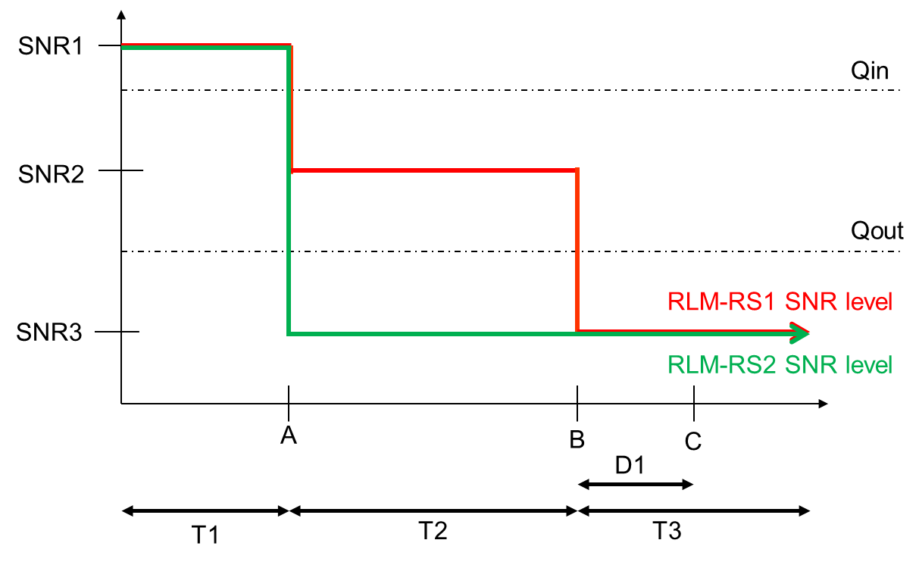

**Figure A.7.5.1.5.1-1: SNR variation for CSI-RS out-of-sync testing**

A.7.5.1.5.2 Test Requirements

The UE behaviour during time durations T1, T2, and T3 shall be as follows:

During time durations T1, T2 and T3, the UE shall transmit uplink signal at least in all subframes configured for CSI transmission on Cell 1.

During the period from time point A to time point B the UE shall transmit uplink signal in Cell 1 at least in all uplink slots configured for CSI transmission according to the configured periodic CSI reporting for Cell 1.

The UE shall stop transmitting uplink signal in Cell 1 no later than time point C (D1 second after the start of the time duration T3) on the PCell.

The rate of correct events observed during repeated tests shall be at least 90%.

A.7.5.1.6 Radio Link Monitoring In-sync Test for FR2 PCell configured with CSI-RS-based RLM in non-DRX mode

A.7.5.1.6.1 Test Purpose and Environment

The purpose of this test is to verify that the UE properly detects the in sync for the purpose of monitoring downlink CSI-RS based radio link quality of the PCell when no DRX is used. This test will partly verify the FR2 PCell CSI-RS In-sync radio link monitoring requirements in clause 8.1.

The test parameters are given in Tables A.7.5.1.6.1-1, A.7.5.1.6.1-2 and A.7.5.1.6.1-3 below. There is one cells, cell 1which is the PCell, in the test. The test consists of five successive time periods, with time duration of T1, T2, T3, T4 and T5 respectively. Figure A.7.5.1.6.1-1 shows the variation of the downlink SNR in the PCell to emulate out-of-sync and in-sync states. Prior to the start of the time duration T1, the UE shall be fully synchronized to cell 1. The UE shall be configured for periodic CSI reporting with a reporting periodicity of 10 ms. In the test, DRX configuration is not enabled. In the test, SSB0 and SSB1 are configured as BFD-RS.

**Table A.7.5.1.6.1-1: Supported test configurations for FR2 PCell**

|  |  |
| --- | --- |
| **Configuration** | **Description** |
| 1 | TDD duplex mode, 120 kHz SSB SCS, 100 MHz bandwidth |

**Table A.7.5.1.6.1-2: General test parameters for FR2 PCell for CSI-RS in-sync testing in non-DRX mode**

|  |  |  |  |
| --- | --- | --- | --- |
| **Parameter** | | **Unit** | **Value** |
| **Test 1** |
| Active PCell | |  | Cell 1 |
| RF Channel Number | |  | 1 |
| Duplex mode | Config 1 |  | TDD |
| TDD Configuration | Config 1 |  | TDDConf.3.1 |
| DL initial BWP configuration | Config 1 |  | DLBWP.0.1 |
| DL dedicated BWP configuration | Config 1 |  | DLBWP.1.1 |
| UL initial BWP configuration | Config 1 |  | ULBWP.0.1 |
| UL dedicated BWP configuration | Config 1 |  | ULBWP.1.1 |
| CORESET Reference Channel | Config 1 |  | CCR.3.1 TDD  CCR.3.3 TDD |
| SSB Configuration | Config 1 |  | SSB.1 FR2 |
| SMTC Configuration | Config 1 |  | SMTC.1 |
| PDSCH/PDCCH subcarrier spacing | Config 1 |  | 120 KHz |
| CSI-RS for RLM | Config 1 |  | Resource #4 in TRS.2.1 TDD  Resource #4 in TRS.2.2 TDD |
| TRS configuration | |  | TRS.2.1 TDD  TRS.2.2 TDD |
| TCI configuration for PDCCH#1/PDSCH | |  | TCI.State.2 |
| TCI configuration for PDCCH#2 | |  | TCI.State.3 |
| OCNG parameters | |  | OP.1 |
| CP length | |  | Normal |
| Out of sync transmission parameters | DCI format |  | 1-0 |
| Number of Control OFDM symbols |  | 2 |
| Aggregation level | CCE | 8 |
| Ratio of hypothetical PDCCH RE energy to average CSI-RS RE energy | dB | 4 |
| Ratio of hypothetical PDCCH DMRS energy to average CSI-RS RE energy | dB | 4 |
| DMRS precoder granularity |  | REG bundle size |
| REG bundle size |  | 6 |
| In sync transmission parameters | DCI format |  | 1-0 |
| Number of Control OFDM symbols |  | 2 |
| Aggregation level | CCE | 4 |
| Ratio of hypothetical PDCCH RE energy to average CSI-RS RE energy | dB | 0 |
| Ratio of hypothetical PDCCH DMRS energy to average CSI-RS RE energy | dB | 0 |
| DMRS precoder granularity |  | REG bundle size |
| REG bundle size |  | 6 |
| DRX | |  | OFF |
| Gap pattern ID | |  | N.A. |
| Layer 3 filtering | |  | *Enabled* |
| T310 timer | | ms | 1000 |
| T311 timer | | ms | 1000 |
| N310 | |  | 1 |
| N311 | |  | 1 |
| CSI-RS for CSI reporting | Config 1 |  | CSI-RS.3.1 TDD |
| T1 | | s | 0.2 |
| T2 | | s | 0.2 |
| T3 | | s | 0.24 |
| T4 | | s | 0.2 |
| T5 | | s | 0.88 |
| D1 | | s | 0.84 |
| Note 1: UE-specific PDCCH is not transmitted after T1 starts. | | | |

**Table A.7.5.1.6.1-3: Cell specific test parameters for FR2 for CSI-RS in-sync radio link monitoring in non-DRX mode**

|  |  |  |  |  |  |  |  |  |  |  |  |  |
| --- | --- | --- | --- | --- | --- | --- | --- | --- | --- | --- | --- | --- |
| **Parameter** | | **Unit** | **Test 1** | | | | | | | | | |
| **T1** | **T2** | **T3** | **T4** | **T5** | **T1** | **T2** | **T3** | **T4** | **T5** |
| AoA setup | |  | Setup 3 defined in A.3.15 | | | | | | | | | |
| **AoA1** | | | | | **AoA2** | | | | |
| Assumption for UE beams Note 10 | |  | Rough | | | | | Rough | | | | |
| PDCCH_beta | | dB | 4 | | | | | Not sent | | | | |
| PDCCH_DMRS_beta | | dB | 4 | | | | |
| PBCH_beta | | dB | 0 | | | | |
| PSS_beta | | dB |
| SSS_beta | | dB |
| PDSCH_beta | | dB |
| OCNG_beta | | dB |
| SNR on RLM-RS1 | Config 1 | dB | 2Note 11 | -6Note 11 | -15 | -4.5 | 2Note 11 |
| SNR on RLM-RS2 | Config 1 |  | Not sent | | | | | 2Note 11 | -14 | -15 | -15 | -14 |
| SNR on other channels and signals | Config 1 | dB | 2Note 11 | | | | | N/A | | | | |
|  | Config 1 | dBm/ 15KHz | -92.1 | | | | | -92.1 | | | | |
| Propagation condition | |  | TDL-C 300ns 100Hz | | | | | TDL-C 300ns 100Hz | | | | |
| Note 1: OCNG shall be used such that the resources in Cell 1 are fully allocated and a constant total transmitted power spectral density is achieved for all OFDM symbols.  Note 2: The uplink resources for CSI reporting are assigned to the UE prior to the start of time period T1.  Note 3: NZP CSI-RS resource set configuration for CSI reporting are assigned to the UE prior to the start of time period T1.  Note 4: Measurement gap configuration is assigned to the UE prior to the start of time period T1.  Note 5: The timers and layer 3 filtering related parameters are configured prior to the start of time period T1.  Note 6: The signal contains PDCCH for UEs other than the device under test as part of OCNG.  Note 7: SNR levels correspond to the signal to noise ratio over the SSS REs.  Note 8: The SNR in time periods T1, T2, T3, T4 and T5 is denoted as SNR1, SNR2, SNR3, SNR4 and SNR5 respectively in figure A.7.5.1.6.1-1.  Note 9: The SNR values are specified for testing a UE which supports 2RX on at least one band. For testing of a UE which supports 4RX on all bands, the SNR during T3 is A.3.6.  Note 10: Information about types of UE beam is given in B.2.1.3 and does not limit UE implementation or test system implementation.  Note 11: This value allows up to 1dB degradation from applied SNR to UE baseband | | | | | | | | | | | | |

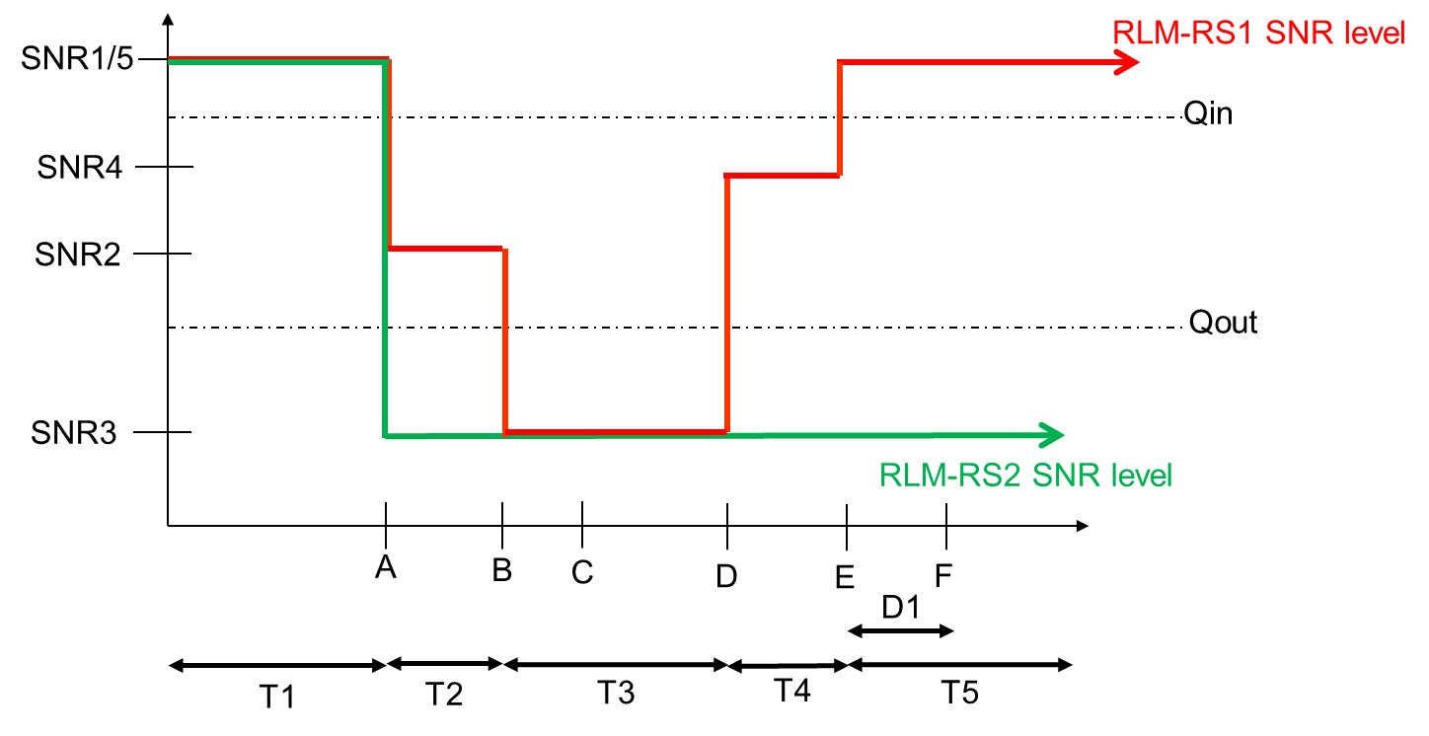

**Figure A.7.5.1.6.1-1: SNR variation for CSI-RS in-sync testing**

A.7.5.1.6.2 Test Requirements

The UE behaviour in each test during time durations T1, T2, T3, T4 and T5 shall be as follows:

During the period from time point A to time point F (D1 second after the start of time duration T5) the UE shall transmit uplink signal at least in all uplink slots configured for CSI transmission according to the configured periodic CSI reporting on the PCell.

The rate of correct events observed during repeated tests shall be at least 90%.

A.7.5.1.7 Radio Link Monitoring Out-of-sync Test for FR2 PCell configured with CSI-RS-based RLM in DRX mode

A.7.5.1.7.1 Test Purpose and Environment

The purpose of this test is to verify that the UE properly detects the out of sync for the purpose of monitoring downlink CSI-RS based radio link quality of the PCell when DRX is used. This test will partly verify the FR2 PCell CSI-RS Out-of-sync radio link monitoring requirements in clause 8.1.

The test parameters are given in Tables A.7.5.1.7.1-1, A.7.5.1.7.1-2, and A.7.5.1.7.1-3 below. There is one cell, cell 1 is the PCell, in the test. The test consists of three successive time periods, with time duration of T1, T2 and T3 respectively. Figure A.7.5.1.7.1-1 shows the variation of the downlink SNR in the PCell to emulate out-of-sync and in-sync states. Prior to the start of the time duration T1, the UE shall be fully synchronized to cell 1. The UE shall be configured for periodic CSI reporting with a reporting periodicity of 10 ms. In the test, DRX configuration is enabled in PCell and DRX inactivity timer has already been expired, i.e. UE tries to decode PDCCH and to send periodic CQI during the period when On-duration timer is running. Time alignment timers shall be set to “infinity” so that UL timing alignment is maintained during the test. In the test, SSB0 and SSB1 are configured as BFD-RS.

**Table A.7.5.1.7.1-1: Supported test configurations for FR2 PCell**

|  |  |
| --- | --- |
| **Configuration** | **Description** |
| 1 | TDD duplex mode, 120 kHz SSB SCS, 100 MHz bandwidth |

**Table A.7.5.1.7.1-2: General test parameters for FR2 PCell for CSI-RS out-of-sync testing in DRX mode**

|  |  |  |  |
| --- | --- | --- | --- |
| **Parameter** | | **Unit** | **Value** |
| **Test 1** |
| Active PCell | |  | Cell 1 |
| RF Channel Number | |  | 1 |
| Duplex mode | Config 1 |  | TDD |
| TDD Configuration | Config 1 |  | TDDConf.3.1 |
| DL initial BWP configuration | Config 1 |  | DLBWP.0.1 |
| DL dedicated BWP configuration | Config 1 |  | DLBWP.1.1 |
| UL initial BWP configuration | Config 1 |  | ULBWP.0.1 |
| UL dedicated BWP configuration | Config 1 |  | ULBWP.1.1 |
| CORESET Reference Channel | Config 1 |  | CCR.3.1 TDD  CCR.3.3 TDD |
| SSB Configuration | Config 1 |  | SSB.1 FR2 |
| SMTC Configuration | Config 1 |  | SMTC.1 |
| PDSCH/PDCCH subcarrier spacing | Config 1 |  | 120 KHz |
| CSI-RS for RLM | Config 1 |  | Resource #4 in TRS.2.1 TDD  Resource #4 in TRS.2.2 TDD |
| TRS configuration | |  | TRS.2.1 TDD  TRS.2.2 TDD |
| TCI configuration for PDCCH#1/PDSCH | |  | TCI.State.2 |
| TCI configuration for PDCCH#2 | |  | TCI.State.3 |
| OCNG parameters | |  | OP.1 |
| CP length | |  | Normal |
| Out of sync transmission parameters | DCI format |  | 1-0 |
| Number of Control OFDM symbols |  | 2 |
| Aggregation level | CCE | 8 |
| Ratio of hypothetical PDCCH RE energy to average CSI-RS RE energy | dB | 4 |
| Ratio of hypothetical PDCCH DMRS energy to average CSI-RS RE energy | dB | 4 |
| DMRS precoder granularity |  | REG bundle size |
| REG bundle size |  | 6 |
| DRX | |  | DRX.3 |
| Gap pattern ID | |  | N.A. |
| Layer 3 filtering | |  | *Enabled* |
| T310 timer | | ms | *0* |
| T311 timer | | ms | 1000 |
| N310 | |  | 1 |
| N311 | |  | 1 |
| CSI-RS for CSI reporting | Config 1 |  | CSI-RS.3.1 TDD |
| T1 | | s | 0.2 |
| T2 | | s | 1.28 |
| T3 | | s | 1.28 |
| D1 | | s | 1.24 |
| Note 1: UE-specific PDCCH is not transmitted after T1 starts. | | | |

**Table A.7.5.1.7.1-3: Cell specific test parameters for FR2 for CSI-RS out-of-sync radio link monitoring in DRX mode**

|  |  |  |  |  |  |
| --- | --- | --- | --- | --- | --- |
| **Parameter** | | **Unit** | **Test 1** | | |
| **T1** | **T2** | **T3** |
| AoA setup | | dB | Setup 1 defined in A.3.15 | | |
| Assumption for UE beams Note 10 | |  | Rough | | |
| PDCCH_beta | | dB | 4 | | |
| PDCCH_DMRS_beta | | dB | 4 | | |
| PBCH_beta | | dB | 0 | | |
| PSS_beta | | dB |
| SSS_beta | | dB |
| PDSCH_beta | | dB |
| OCNG_beta | | dB |
| SNR on RLM-RS1 | Config 1 | dB | 2Note 11 | -6Note 11 | -15 |
| SNR on RLM-RS2 | Config 1 | dB | 2Note 11 | -14 | -15 |
| SNR on other channels and signals | Config 1 | dB | 2Note 11 | | |
|  | Config 1 | dBm/15KHz | -104.7 | | |
| Propagation condition | |  | TDL-C 300ns 100Hz | | |
| Note 1: OCNG shall be used such that the resources in Cell 1 are fully allocated and a constant total transmitted power spectral density is achieved for all OFDM symbols.  Note 2: The uplink resources for CSI reporting are assigned to the UE prior to the start of time period T1.  Note 3: NZP CSI-RS resource set configuration for CSI reporting are assigned to the UE prior to the start of time period T1.  Note 4: Measurement gap configuration is assigned to the UE prior to the start of time period T1.  Note 5: The timers and layer 3 filtering related parameters are configured prior to the start of time period T1.  Note 6: The signal contains PDCCH for UEs other than the device under test as part of OCNG.  Note 7: SNR levels correspond to the signal to noise ratio over the SSS REs.  Note 8: The SNR in time periods T1, T2 and T3 is denoted as SNR1, SNR2 and SNR3 respectively in figure A.7.5.1.7.1-1.  Note 9: The SNR values are specified for testing a UE which supports 2RX on at least one band. For testing of a UE which supports 4RX on all bands, the SNR during T3 is [A.3.6].  Note 10: Information about types of UE beam is given in B.2.1.3 and does not limit UE implementation or test system implementation.  Note 11: This value allows up to 1dB degradation from applied SNR to UE baseband | | | | | |

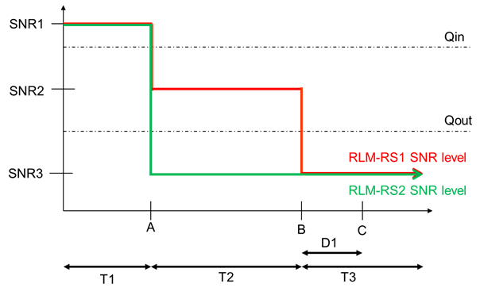

**Figure A.7.5.1.7.1-1: SNR variation for CSI-RS out-of-sync testing**

A.7.5.1.7.2 Test Requirements

The UE behaviour during time durations T1, T2, and T3 shall be as follows:

During time durations T1, T2 and T3, the UE shall transmit uplink signal at least in all subframes configured for CSI transmission on PCell.

During the period from time point A to time point B the UE shall transmit uplink signal in Cell 1 (PCell) at least in all uplink slots configured for CSI transmission according to the configured periodic CSI reporting for Cell 1.

The UE shall stop transmitting uplink signal in Cell 1 (PCell) no later than time point C (D1 secondafter the start of the time duration T3) on the PCell.

The rate of correct events observed during repeated tests shall be at least 90%.

A.7.5.1.8 Radio Link Monitoring In-sync Test for FR2 PCell configured with CSI-RS-based RLM in DRX mode

A.7.5.1.8.1 Test Purpose and Environment

The purpose of this test is to verify that the UE properly detects the in sync for the purpose of monitoring downlink CSI-RS based radio link quality of the PCell when DRX is used. This test will partly verify the FR2 PCell CSI-RS In-sync radio link monitoring requirements in clause 8.1.

The test parameters are given in Tables A.7.5.1.8.1-1, A.7.5.1.8.1-2, A.7.5.1.8.1-3 and A.7.5.1.8.1-4 below. There is one cells, cell 1which is the PCell, in the test. The test consists of five successive time periods, with time duration of T1, T2, T3, T4 and T5 respectively. Figure A.7.5.1.8.1-1 shows the variation of the downlink SNR in the PCell to emulate out-of-sync and in-sync states. Prior to the start of the time duration T1, the UE shall be fully synchronized to cell 1. The UE shall be configured for periodic CSI reporting with a reporting periodicity of 10 ms. The UE is configured to perform inter-frequency measurements using GP ID #0 (40ms) in test. In the test, SSB0 and SSB1 are configured as BFD-RS.

**Table A.7.5.1.8.1-1: Supported test configurations for FR2 PSCell**

|  |  |
| --- | --- |
| **Configuration** | **Description** |
| 1 | TDD duplex mode, 120 kHz SSB SCS, 100 MHz bandwidth |

**Table A.7.5.1.8.1-2: General test parameters for FR2 PCell for CSI-RS in-sync testing in non-DRX mode**

|  |  |  |  |
| --- | --- | --- | --- |
| **Parameter** | | **Unit** | **Value** |
| **Test 1** |
| Active PCell | |  | Cell 1 |
| RF Channel Number | |  | 1 |
| Duplex mode | Config 1 |  | TDD |
| TDD Configuration | Config 1 |  | TDDConf.3.1 |
| DL initial BWP configuration | Config 1 |  | DLBWP.0.1 |
| DL dedicated BWP configuration | Config 1 |  | DLBWP.1.1 |
| UL initial BWP configuration | Config 1 |  | ULBWP.0.1 |
| UL dedicated BWP configuration | Config 1 |  | ULBWP.1.1 |
| CORESET Reference Channel | Config 1 |  | CCR.3.1 TDD  CCR.3.3 TDD |
| SSB Configuration | Config 1 |  | SSB.1 FR2 |
| SMTC Configuration | Config 1 |  | SMTC.1 |
| PDSCH/PDCCH subcarrier spacing | Config 1 |  | 120 KHz |
| CSI-RS for RLM | Config 1 |  | Resource #4 in TRS.2.1 TDD  Resource #4 in TRS.2.2 TDD |
| TRS configuration | |  | TRS.2.1 TDD  TRS.2.2 TDD |
| TCI configuration for PDCCH#1/PDSCH | |  | TCI.State.2 |
| TCI configuration for PDCCH#2 | |  | TCI.State.3 |
| OCNG parameters | |  | OP.1 |
| CP length | |  | Normal |
| Out of sync transmission parameters | DCI format |  | 1-0 |
| Number of Control OFDM symbols |  | 2 |
| Aggregation level | CCE | 8 |
| Ratio of hypothetical PDCCH RE energy to average CSI-RS RE energy | dB | 4 |
| Ratio of hypothetical PDCCH DMRS energy to average CSI-RS RE energy | dB | 4 |
| DMRS precoder granularity |  | REG bundle size |
| REG bundle size |  | 6 |
| In sync transmission parameters | DCI format |  | 1-0 |
| Number of Control OFDM symbols |  | 2 |
| Aggregation level | CCE | 4 |
| Ratio of hypothetical PDCCH RE energy to average CSI-RS RE energy | dB | 0 |
| Ratio of hypothetical PDCCH DMRS energy to average CSI-RS RE energy | dB | 0 |
| DMRS precoder granularity |  | REG bundle size |
| REG bundle size |  | 6 |
| DRX | |  | DRX.3 |
| Gap pattern ID | |  | \**gp0* |
| Layer 3 filtering | |  | *Enabled* |
| T310 timer | | ms | *2000* |
| T311 timer | | ms | 1000 |
| N310 | |  | 1 |
| N311 | |  | 1 |
| CSI-RS for CSI reporting | Config 1 |  | CSI-RS.3.1 TDD |
| T1 | | s | 0.2 |
| T2 | | s | 0.2 |
| T3 | | s | 1.64 |
| T4 | | s | 0.2 |
| T5 | | s | 1.88 |
| D1 | | s | 1.84 |
| Note 1: UE-specific PDCCH is not transmitted after T1 starts. | | | |

**Table A.7.5.1.8.1-3: Cell specific test parameters for FR2 for CSI-RS in-sync radio link monitoring in non-DRX mode**

|  |  |  |  |  |  |  |  |
| --- | --- | --- | --- | --- | --- | --- | --- |
| **Parameter** | | **Unit** | **Test 1** | | | | |
| **T1** | **T2** | **T3** | **T4** | **T5** |
| AoA setup | | dB | Setup 1 defined in A.3.15 | | | | |
| Assumption for UE beams Note 10 | |  | Rough | | | | |
| PDCCH_beta | | dB | 4 | | | | |
| PDCCH_DMRS_beta | | dB | 4 | | | | |
| PBCH_beta | | dB | 0 | | | | |
| PSS_beta | | dB |
| SSS_beta | | dB |
| PDSCH_beta | | dB |
| OCNG_beta | | dB |
| SNR on RLM-RS1 | Config 1 | dB | 2Note 11 | -6Note 11 | -15 | -4.5 | 2Note 11 |
| SNR on RLM-RS1 | Config 1 | dB | 2Note 11 | -14 | -15 | -15 | -14 |
| SNR on RLM-RS1 | Config 1 | dB | 2Note 11 | | | | |
|  | Config 1 | dBm/15KHz | -104.7 | | | | |
| Propagation condition | |  | TDL-C 300ns 100Hz | | | | |
| Note 1: OCNG shall be used such that the resources in Cell 1 are fully allocated and a constant total transmitted power spectral density is achieved for all OFDM symbols.  Note 2: The uplink resources for CSI reporting are assigned to the UE prior to the start of time period T1.  Note 3: NZP CSI-RS resource set configuration for CSI reporting are assigned to the UE prior to the start of time period T1.  Note 4: Measurement gap configuration is assigned to the UE prior to the start of time period T1.  Note 5: The timers and layer 3 filtering related parameters are configured prior to the start of time period T1.  Note 6: The signal contains PDCCH for UEs other than the device under test as part of OCNG.  Note 7: SNR levels correspond to the signal to noise ratio over the SSS REs.  Note 8: The SNR in time periods T1, T2, T3, T4 and T5 is denoted as SNR1, SNR2, SNR3, SNR4 and SNR5 respectively in figure A.7.5.1.8.1-1.  Note 9: The SNR values are specified for testing a UE which supports 2RX on at least one band. For testing of a UE which supports 4RX on all bands, the SNR during T3 is A.3.6.  Note 10: Information about types of UE beams is given in B.2.1.3 and does not limit UE implementation or test system implementation.  Note 11: This value allows up to 1dB degradation from applied SNR to UE baseband. | | | | | | | |

**Table A.7.5.1.8.1-4: Measurement gap configuration for FR2 CSI-RS in-sync radio link monitoring in non-DRX mode**

|  |  |
| --- | --- |
| **Field** | **Test 1** |
| **Value** |
| gapOffset | 0 |
| Note 1: RLM RS is partially overlapped with measurement gap | |

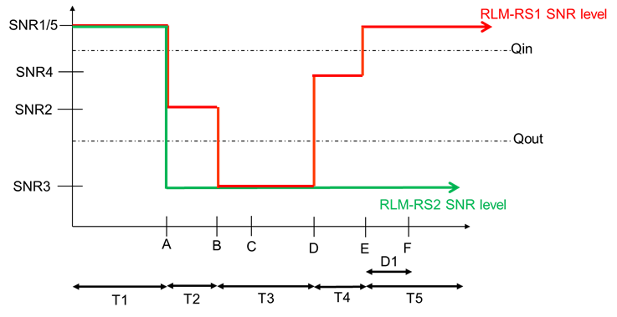

**Figure A.7.5.1.8.1-1: SNR variation for CSI-RS in-sync testing**

A.7.5.1.8.2 Test Requirements

The UE behaviour in each test during time durations T1, T2, T3, T4 and T5 shall be as follows:

During the period from time point A to time point F (D1 second after the start of time duration T5) the UE shall transmit uplink signal at least in all uplink slots configured for CSI transmission according to the configured periodic CSI reporting on the PCell.

The rate of correct events observed during repeated tests shall be at least 90%.

<< End of changes >>