3GPP TSG-RAN WG4 Meeting # 97-e R4-2016870
Electronic Meeting, 2nd – 13th November, 2020

Source: Huawei, HiSilicon
Title: TP for TR 37.875: adding some UE RF study for NR V2X band combinations
Agenda Item: 10.23.1
Document for: Approval

Introduction
A general discussion paper [1] was provided in last meeting to discuss the band n47/47 filter performance and UE architecture. In this paper, we provide our proposals into the general part of this TR.

References
[1] R4-2010931, “General discussion about Rel-17 band combinations for Uu and V2X con-current operation”, Huawei, HiSilicon

Text Proposal
<TP for TR 37.875>

5 Additional UE RF: General part

5.1 UE RF aspects

5.1.1 Basic UE RF architecture and assumed performance with ITS band 47/n47
Based on the investigation, the band 47/n47 filter performance are shown in table 5.1.1-1.
Table 5.1.1-1 Filter performance for band n47/47
Filter | IL [dB] | Min Attenuation [dB] @
 | Worst Case | 410-2690  MHz | 3300-4200  MHz | 4400-5000  MHz
n47/47 (5855-5925 MHz) | 2 | > 35 | > 32 | > 30

It’s assumed that the antenna isolation between band n47 and Uu licensed bands which is below 5GHz is about 15dB. An example RF architecture for NR V2X band combinations with ITS band 47/n47 is shown in figure 5.1.1-1. It’s assumed that separate antennas is used for NR V2X band combination with ITS band 47/n47. Since separate antennas are assumed, there is no need to specify ΔT_{IB,c} and ΔR_{IB,c} for band 47/n47.
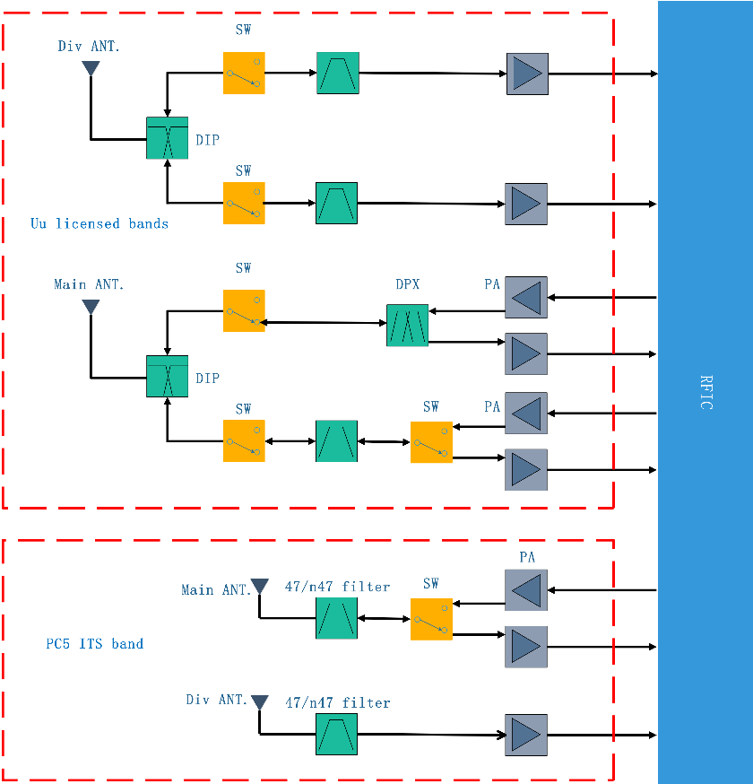
Figure 5.1.1-1 NR V2X band combinations RF architecture with separate antennas

5.2 RRM aspects
Editor Note: It will be added in the future [FFS]
<End of TP >

