**3GPP TSG-RAN WG4 Meeting #94-eR4-2000708**

**Online, 24th February – 6th March, 2020**

**Source:** Skyworks Solutions, Inc.

**Title:** [NRU] Single Carrier Back-off Measurements for UE Power Class and MPR

**Agenda Item:** 8.1.2.1 Transmitter characteristics [NR_unlic-Core]

**Document for:** Approval

# Introduction

In RAN4#93 meeting, agreements were reached for the NRU spectrum mask in [2] and as a continuation of our effort in [1] to define the NRU UE power class we have performed more measurements on UE Wi-Fi PAs that are presented here.

# Discussion

## Mask Measurement Procedure

If there is an agreed spectrum mask for NRU from last meeting, there has been still a lot of discussion on the measurement setup, in our measurements we reused the recommended Wi-Fi 802.11ax spectral mask setup:

The mask (in dBr) is used as defined in [2] with the following procedure.

* A 100 kHz resolution bandwidth is used (note that 30kHz was used for 11ac) with a video bandwidth of 7.5 kHz
* The mask is applied as is (no offsets applied) and being in dBr, is referred to the in band peak measured in 1 MHz
* Sweep average is used.

Using this definition it is easy to pick the carrier leakage exceptions as they are limited to a 200 kHz bandwidth.

The same procedure was applied for both the single carrier and the wideband operation masks which is discussed in [3].

**Proposal on spectrum mask: the 802.11ax test procedure is adopted for 3GPP measurements and should be reflected in BRAN.**

## PA EVM budget

During offline discussions on the PC5 NRU UE definition, on top of the mask criteria, an ACLR relaxation to 27dBc (or less) was assumed. This raises the question whether, compared to PC3 at 30dBc ACLR we could have issues with PA EVM. Figure 1 provides the ACLR and EVM profiles for CP-OFDM and DFT-s-OFDM measured on a UE Wi-Fi PA with fully allocated QPSK waveforms, it can be observed that at 27dBc ACLR:

* QPSK CP-OFDM EVM is 12% at 17.5dBm
* QPSK DFT-s-OFDM EVM is 8% at 20dBm
* Note that QPSK EVM requirement is 17.5%

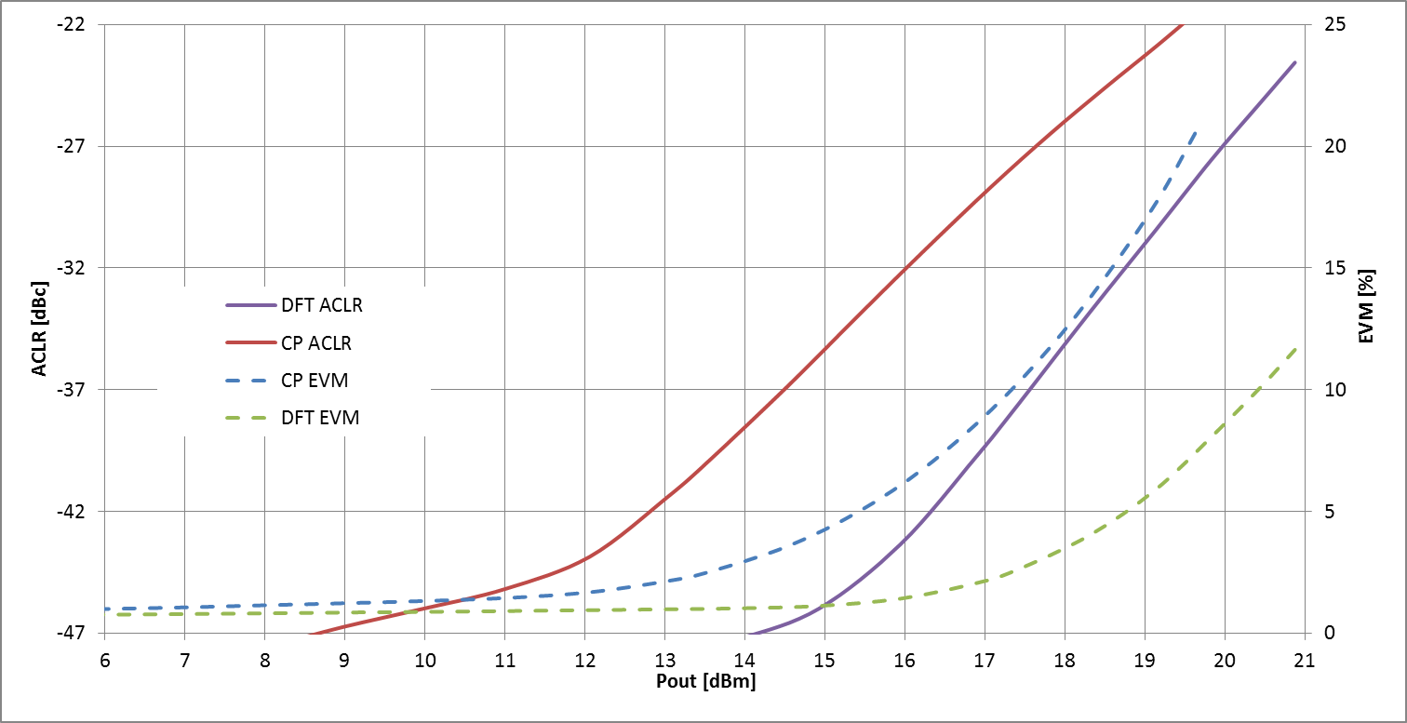

Figure : Measured ACLR and EVM for CP-OFDM and DFT-s-OFDM of a Wi-Fi PA (referred at antenna)

As such, the PA EVM performance is good since being at the ACLR limit it has not reached the EVM limit. Especially typical designs have good margin to ACLR, this linearity margin is taken into account when we consider the PA capability together with the post-PA losses.

To be complete though the contribution from the RF transceiver must be taken into account. In Table 1 we start from the 64QAM and 256QAM EVM budgets for the PA and TRX then apply the measured PA EVM for the QPSK case for the two TRX EVM performances.

Table : EVM budget for PA+ RF transceiver with 64QAM or 256QAM capability

|  |  |  |  |
| --- | --- | --- | --- |
| PA | TRX | total | case |
| 5.6% | 5.6% | 7.9% | 64QAM EVM budget with equal PA and TRX contribution |
| 1.8% | 3.0% | 3.5% | 256QAM EVM budget with equal PA and TRX contribution |
| 8.0% | 5.6% | 9.8% | 64QAM capable TRX paired with PA QPSK DFT-S-OFDM EVM at ACLR limit |
| 12.0% | 5.6% | 13.2% | 64QAM capable TRX paired with PA QPSK CP-OFDM EVM at ACLR limit |
| 8.0% | 3.0% | 8.5% | 256QAM capable TRX paired with PA QPSK DFT-S-OFDM EVM at ACLR limit |
| 12.0% | 3.0% | 12.4% | 256QAM capable TRX paired with PA QPSK CP-OFDM EVM at ACLR limit |

Observation on EVM:

* With the worst case PA EVM for CP-OFDM the worst case EVM for QPSK is 13% for a requirement of 17.5%
* Given the linearity margin of the PA design a PA budget of 12% EVM for PC5 QPSK is acceptable
* At 30dBc ACLR, 8% EVM is observed for CP-OFDM thus 8% is definitively fine for DFT-s-OFDM QPSK
* For higher order modulations, better PA EVM should be targeted but can be easily achieved with MPR:
  + The 5.6% 64 QAM PA budget is achieved at:
    - 19 dBm for DFT-s-OFDM
    - 15.5 dBm for CP-OFDM
  + The 1.8% 256 QAM PA budget is achieved at:
    - <16 dBm for DFT-s-OFDM
    - <12 dBm for CP-OFDM

**Proposal on QPSK PA EVM target: PA QPSK EVM budget for PC5 is 12%**

## Single Carrier Measurements

The measurements were performed on a UE Wi-Fi PA, the reported power is at the antenna with 4dB post-PA losses assumed and margins for PVT variations and extra linearity. Note that some of the variations are anyhow part of the power class tolerances. Measurements were done at the top of the 5GHz band.

The measurements are presented in table 2 in term of achievable power at the antenna and focused on the following:

* PC5 target
* QPSK CP-OFDM and DFT-s-OFDM waveforms to establish baseline MPR and power class
* Full allocation and 11/10RB interlace0 waveforms as worst cases.
* 20, 40, 60, 80 and 100 MHz channels
* NRU SEM, ACLR for MPR
* EVM was verified for the full allocation case (see above) and will need further verification for interlace case
  + NR SEM as verification point
* in band dBm/MHz for A-MPR cases
* To limit the number of measurements, only the critical measurements were performed depending on the waveform characteristics

Table : Single carrier power capability measurements



Observations for PC5:

* Using ACLR of 27 dB, NRU SEM and NR SEM, at 20 MHz as a baseline:
* **For full allocation:**
  + 20 dBm antenna power can be achieved for DFT-s-OFDM limited by the NRU SEM (as desired)
  + 18 dBm antenna power can be achieved for CP-OFDM limited by 27 dB ACLR or NRU SEM
  + **Power capability reduces slightly for DFT-s-OFDM at larger bandwidths**
  + **A-MPR is only required at 4dBm/MHz in-band PSD for the 20 MHz case**
* **For 10/11RB interlace0:**
  + 20 dBm antenna power can be achieved for DFT-s-OFDM
  + Slightly higher than 18dBm antenna power can be achieved for CP-OFDM
  + **There is no A-MPR required for in-band PSD restrictions over than for 4 dBm/MHz cases below 80 MHz channel BW**
* **Overall performance is similar for full and interlace waveforms opening up for a simple MPR table**

Observations for PC3: in the case where PC3 is implemented with two PC5 PAs, a 1 dB additional back-off is sufficient to reach 30 dB ACLR.

## Proposals for Power Class Definition

**Power class definition of PC5:**

* **0 dB MPR waveform: 20 MHz 100RB0 fully allocated DFT-s-OFDM QPSK for 27 dB ACLR and NRU SEM passed**
* **Power class tolerance: 20 dBm +2/-3 dB**

**Power class definition of PC3:**

* **1 dB MPR waveform: 20 MHz 100RB0 fully allocated DFT-s-OFDM QPSK for 30 dB ACLR and NRU SEM passed**
* **Power class tolerance: 23 dBm +2/-3 dB**
* **Note that a 0dB MPR waveform using a centered interlace can be defined but a 1 dB MPR fully allocated waveform is a more convenient reference**

## Proposals for MPR

Given the fact that we see very close results for the fully allocated waveforms and the worst case interlace and there is no possible concept of inner/outer allocation (to the exception maybe of interlaces that are centered on the carrier), we believe the MPR table should only distinguish for:

* CP-OFDM and DFT-s-OFDM waveforms
* Modulation order

**MPR for PC5 QPSK:**

* **For all (full and interlace) DFT-s-OFDM QPSK waveforms 1 dB MPR**
* **For all (full and interlace) CP-OFDM QPSK waveforms 2.5 dB MPR**

**MPR for PC3 QPSK: one additional dB MPR is added to the PC5 case**

## Preliminary Results for A-MPR

At this point, our measurements have only focused on the in-band PSD requirements and more work will be needed for some OOB requirements in some regions and sub-bands

**For PC5 QPSK:**

* **A-MPR for 10 and 11 dBm/MHz in-band PSD: no A-MPR needed**
* **A-MPR for 4 dBm/MHz in-band PSD:**
* **4 dB A-MPR for fully allocated CP-OFDM and DFT-s-OFDM QPSK waveforms at 20MHz**
* **1 dB A-MPR for fully allocated CP-OFDM and DFT-s-OFDM QPSK waveforms at 40MHz**
* **5 dB A-MPR for interlaces CP-OFDM and DFT-s-OFDM QPSK waveforms at 20MHz**
* **2 dB A-MPR for interlaces CP-OFDM and DFT-s-OFDM QPSK waveforms at 40MHz**

**For PC3 QPSK:**

* **3 dB additional AMPR will be needed for 4 dBm/MHz in-band PSD compared to PC5 A-MPR for a single antenna case and AMPR may be needed at higher channel bandwidths**
* **Depending on a per antenna or per UE requirement, the two PA implementation may or may not need additional A-MPR compared to PC5**
* **For 10 and 11 dBm/MHz a single PA PC3 implementation may need >1 dB A-MPR for 20 MHz DFT-s_OFDM cases**

# Conclusions

In this contribution, we present our measurement results for NRU single carrier operation and we discuss the requirements for EVM, ACLR and NRU SEM and derive the corresponding power class definitions, MPR and A-MPR proposals.

**Proposal on spectrum mask: the 802.11ax test procedure is adopted for 3GPP measurements and should be reflected in BRAN.**

**Proposal on QPSK PA EVM target: PA QPSK EVM budget for PC5 is 12%**

**Proposals on power class and MPR**

**Power class definition of PC5 QPSK:**

* **0 dB MPR waveform: 20 MHz 100RB0 fully allocated DFT-s-OFDM QPSK for 27 dB ACLR and NRU SEM passed**
* **Power class tolerance: 20 dBm +2/-3 dB**

**Power class definition of PC3 QPSK:**

* **1 dB MPR waveform: 20 MHz 100RB0 fully allocated DFT-s-OFDM QPSK for 30 dB ACLR and NRU SEM passed**
* **Power class tolerance: 23 dBm +2/-3 dB**
* **Note that a 0 dB MPR waveform using a centered interlace can be defined but a 1 dB MPR fully allocated waveform is more convenient**

**MPR for PC5 QPSK:**

* **For all (full and interlace) DFT-s-OFDM QPSK waveforms 1 dB MPR**
* **For all (full and interlace) CP-OFDM QPSK waveforms 2.5 dB MPR**

**MPR for PC3 QPSK: one additional dB MPR is added to the PC5 case**

**Inputs for future A-MPR studies**

**For PC5 QPSK:**

* **A-MPR for 10 and 11 dBm/MHz in-band PSD: no A-MPR needed**
* **A-MPR for 4 dBm/MHz in-band PSD:**
* **4 dB A-MPR for fully allocated CP-OFDM and DFT-s-OFDM QPSK waveforms at 20MHz**
* **1 dB A-MPR for fully allocated CP-OFDM and DFT-s-OFDM QPSK waveforms at 40MHz**
* **5 dB A-MPR for interlaces CP-OFDM and DFT-s-OFDM QPSK waveforms at 20MHz**
* **2 dB A-MPR for interlaces CP-OFDM and DFT-s-OFDM QPSK waveforms at 40MHz**

**For PC3 QPSK:**

* **3 dB additional AMPR will be needed for 4 dBm/MHz in-band PSD compared to PC5 A-MPR for a single antenna case and AMPR may be needed at higher channel bandwidths**
* **Depending on a per antenna or per UE requirement, the two PA implementation may or may not need additional A-MPR compared to PC5**
* **For 10 and 11 dBm/MHz a single PA PC3 implementation may need >1 dB A-MPR for 20 MHz DFT-s_OFDM cases**

# References

[1] R4-1913810 [NRU] Measurements for PC5 and PC3 Definition, Skyworks Solutions Inc., RAN4#93

[2] R4-1915979 WF on NR-U spectrum emission mask, Nokia, CableLabs, Charter, RAN4#93

[3] R4-2000709 [NRU] Wideband operation Back-off measurements for UE, Skyworks Solutions Inc., RAN4#94-e