**3GPP TSG RAN WG4 Meeting #94-e R4-2002479**

**Online, 24th February – 6th March 2020**

**Source:** Rohde & Schwarz

**Title:** Discussion on test system implementation for FR2 MIMO OTA

**Agenda Item:** 10.2.3.2

**Document for:** Approval

# Introduction

In this contribution we discuss another implementation method for test system implementation with respect to FR2 MIMO OTA test systems.

# Discussion

During discussions at RAN4 #93 the WF on FR2 MIMO OTA was approved [1]. For several meetings there has been an ongoing discussion on the test system design. So far the discussion was focussed on the number of probes and the required range length in the test system. All these parameters have been discussed in the context of direct far field (DFF) systems.

However it should be noted that a different implementation based on IFF may also be feasible. IFF system types were first introduced for RF and Demod requirements, but have recently been expanded to be also applicable for all RRM scenarios. One of the reasons why IFF systems were widely adopted for RF/RRM testing are the improved MU values compared to DFF systems.

**Observation 1:** IFF systems are preferred over DFF systems for RF/RRM/Demod testing.

As an example, the quality of the quiet zone measurement uncertainties for DFF systems have been estimated to be around 0.8 dB (TRP) / 1.2 dB (EIS) [2] for a 15cm QZ. In comparison RAN5 has agreed on a measurement uncertainty value for IFF systems of only 0.6 dB for TRP and EIS [3] for QZ sizes up to 30cm. Additionally as can be seen from TS 38.810 [4], IFF provides a higher feasible SNR for Demod testing compared to DFF systems, which is one of the critical parameters for FR2 MIMO OTA testing.

**Observation 2:** For RF testing IFF systems can provide smaller uncertainties than DFF systems and a higher SNR range.

Whether a test system can be used for MIMO OTA testing in the end is decided whether the system meets the defined Figure of Merit (e.g. PSP). In the past it has been discussed whether the system layout shall be unified to guarantee that the test system meets this number. However since the Figure of merit to be guaranteed will be defined, it can be left up to the system implementation how to guarantee this.

**Observation 3:** It is only important for a test system to meet the specified figure of merit.

Therefor other implementations than the ones discussed so far should not be ruled out, since they may bring further improvements to the test method/system, like better uncertainties, larger quiet zone, etc..

**Proposal 1:** Whether to utilize a DFF or IFF system is left up to the system implementation. Only the figure of merit and measurement uncertainty are defined.

Since the system implementation may differ based in the system type used (DFF/IFF), the system layout (number of antennas, antenna positions) can be different as well, even though the channel model generation, validation and test procedure are the same for both approaches. Therefore these parameters need to be fixed per system type. Of course both system types/layouts would need to meet the same Figure of Merit and measurement uncertainty.

**Proposal 2:** Specific system implementation details like the antenna position and number of antennas are defined separately for each system type (DFF/IFF).

**Observation 4:** channel model generation, validation and test procedure are the same for both DFF and IFF approaches.

# Simulation results

As it has been agreed, the NR FR2 MIMO OTA test system should support the emulation of the two channel models, CDL-A InO and CDL-C Umi. Furthermore, the PSP metric has been adopted to evaluate the performance of test system.

A probe location optimization study is underway using a cluster-based implementation, where the probes locations are optimized to maximize the reproducibility of the PAS after filtering the original channel models with the strongest BS beam and with a 4x4 UE antenna array beam-former.

Bearing in mind the significantly reduced amplitude and phase tapper in comparison with DFF based system, and thus improved QoQZ and overall MU; in addition, improved PSP which due to Far Field conditions resulting in a reduced PSP standard deviation over the full test volume, work has been carried out to find a reliable and reduced complexity probe configuration for the IFF approach.Current preliminary results show the following PSP performance for the 0cm offset case:

* CDL-A InO using 3 probes 🡪 PSP = 91.40%
* CLD-C UMi using 4 probes 🡪 PSP = 89.17%

The following figures show the comparison between ideal Power Angular Spectrum (PAS) compared to the simulated PAS after filtering the channel models with both the BS and UE beams as mentioned above.

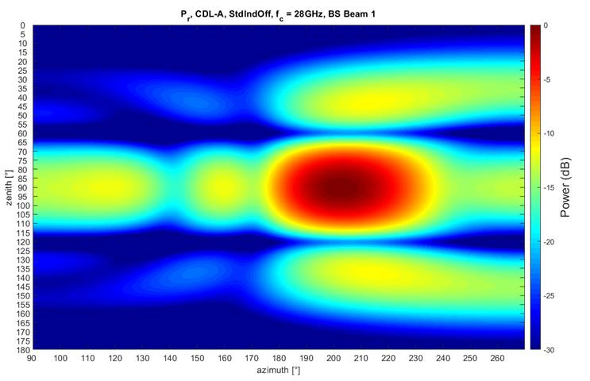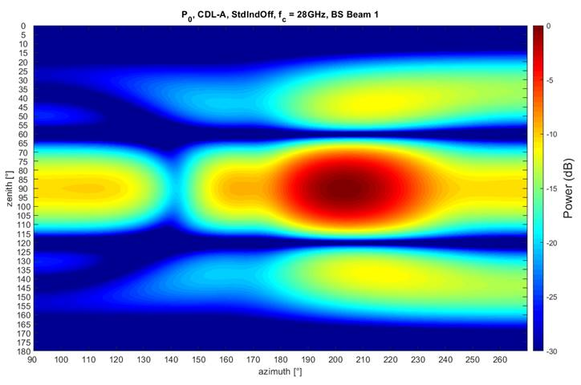

a) b)

Figure 3-2: CDL-A InO, a) Ideal PAS, b) simulated PAS

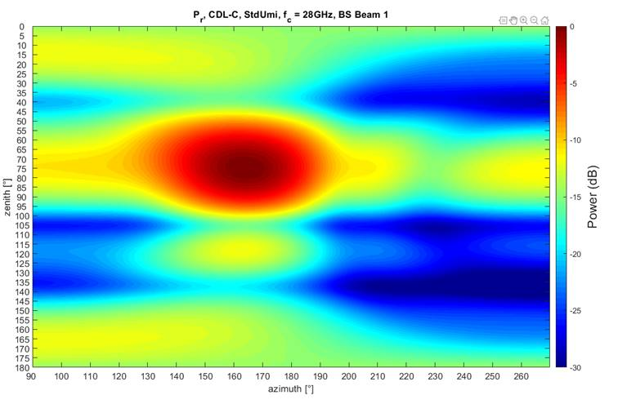 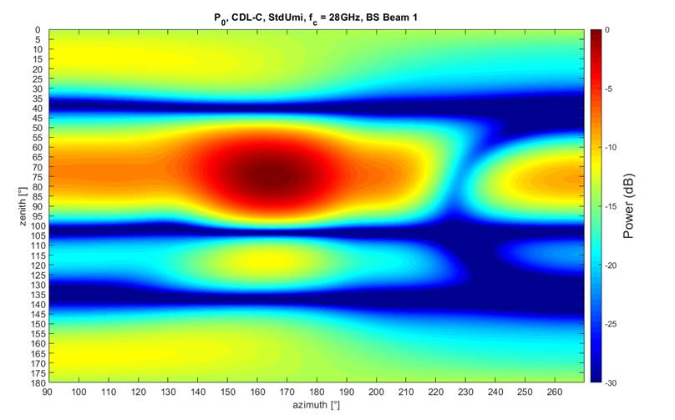

a) b)

Figure 3-2: CDL-C UMi, a) Ideal PAS, b) simulated PAS

With the IFF approach, the offset of UE antenna array from the centre of the test volume will introduce a minor PSP deviation with significantly lower uncertainty for different UE array designs and offsets compared to the DFF approach.

**Observation 5:** PSP deviation over the volume is minimized in IFF approach compared to DFF.

It is important to emphasize that our goal is to reproduce the original continuous PAS, whereas the reduced complexity cluster emulation with 20 sub-paths is only a simplification used to reduce channel emulation complexity in the channel emulator.

In our simulation, our reference PAS, namely the Pr, is the targeted PAS in the probe location and weight optimizations and not the fixed discrete 20 subpath AoAs.

**Note: the following content was revised after the probe positions were optimized and the channel models were aligned so that a total number of 4 probes with the same locations was used to reproduce the PSP for both channel models.**

For the IFF approach, the optimization of the system guarantees phase and power deviations equivalent to a range length of $RL= \frac{4D^{2}}{λ}$. Thus for a 20cm diameter test zone at fc=28GHz with the IFF, this is equivalent to a DFF with RL = 14.99m.

Similar to the results presented in [6], the PSP values are sampled over the test volume using a radial grid: every 30º in both azimuth and elevation, and every 1cm from the centre to the edge of the test volume (i.e. 10cm radius). According to this grid, we calculated the PSP and the CDF for both channel models. The results are shown in the following graphs:

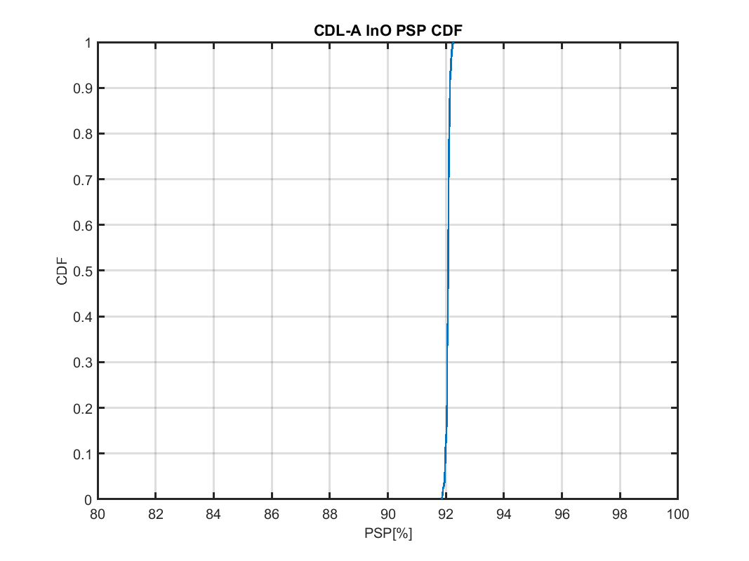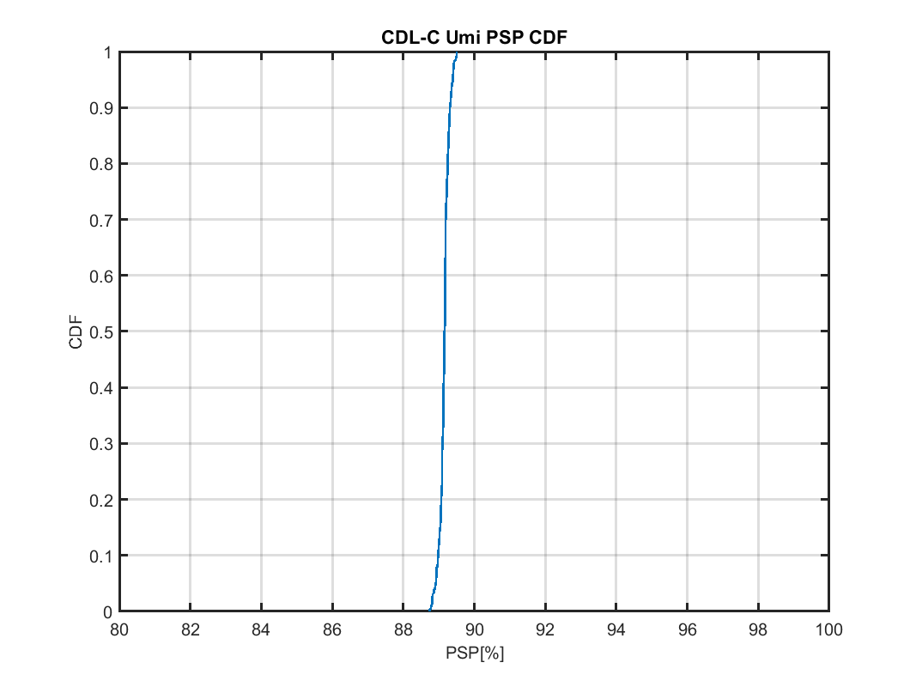

**Observation 6:** With a total number of 4 fixed probe positions we observe a mean PSP of 89.16% and a maximum peak to peak deviation of 0.764% for CDL-C Umi. The PSP standard deviation within the test volume is 0.134%.

**Observation 7:** With a total number of 4 fixed probe positions we observe a mean PSP of 92.07% and a maximum peak to peak deviation of 0.382% for CDL-A InO. The PSP standard deviation within the test volume is 0.063%.

The probe positions and weights can be further optimized to produce even better results. Results to be provided in further contributions.

# Conclusion

In this paper we have shared our views on the FR2 MIMO OTA test system implementation and we make the following observations and proposals.

**Observation 1:** IFF are preferred over DFF systems for RF/RRM/Demod testing.

**Observation 2:** For RF testing IFF systems provide smaller uncertainties than DFF systems and a higher SNR range.

**Observation 3:** It is only important for a test system to meet the specified figure of merit.

**Observation 4:** channel model generation, validation and test procedure are the same for both DFF and IFF approaches.

**Observation 5:** PSP deviation over the volume is minimized in IFF approach compared to DFF.

**Observation 6:** With a total number of 4 fixed probe position we observe a mean PSP of 89.16% and a maximum peak to peak deviation of 0.764% for CDL-C Umi. The PSP standard deviation within the test volume is 0.134%.

**Observation 7:** With a total number of 4 fixed probe position we observe a mean PSP of 92.07% and a maximum peak to peak deviation of 0.382% for CDL-A InO. The PSP standard deviation within the test volume is 0.063%.

**Proposal 1:** Whether to utilize a DFF or IFF system is left up to the system implementation. Only the figure of merit and measurement uncertainty are defined.

**Proposal 2:** Specific system implementation details like the antenna position and number of antennas are defined separately for each system type (DFF/IFF).

# References

1. R4-1916174, WF on FR2 MIMO OTA, CAICT, Spirent, RAN4 #93, Reno, USA, November 2019
2. R4-1713682, Measurement Results for the NR UE RF Baseline System QZ Validation, Rohde & Schwarz, RAN4 #85, Reno, USA, November 2017
3. TR 38.903 v16.2.0
4. TR 38.810 v16.5.0
5. R4-2002154, “PSP Correlation between two CE Vendors”, Keysight Technologies, Spirent Communications**,** 3GPP TSG-RAN WG4 Meeting #94-e, Feb 2020
6. R4-1916175, “System Implementation of FR2 3D MPAC”, Keysight Technologies, 3GPP TSG-RAN WG4 Meeting #93, Nov 2019