3GPP TSG-RAN WG4 #94 R4-200
e Meeting, February 24 – March 6 2020

Agenda item: 10.2.3.2
Source: Spirent Communications
Title: TP on Verification of Channel Model implementation
Document for: Approval

Introduction
This contribution is providing draft text to define Verification of channel model implementation in TR38.827 chapter 7.4 [1].

Discussion
In the last RAN4 meeting, verification of channel model implementation for FR2 MPAC was discussed [2]. Few concerns were risen, e.g. verification antenna and the newly introduced method. It is well known that target of the verification is to verify Power Delay Profile (PDP), Doppler/Temporal correlation, PAS similarity percentage (PSP), Cross-polarization and Power validation [1].
Fundamentally, target of the verification in FR2 is same as in 4G MIMO OTA or in NR FR1: Is the channel model properly created in test zone? Therefore, it is beneficial to re-use as much as possible the existing equipment and methodologies. The only parameter that is not in existing verification process is PSP (PAS Similarity Percentage). However, as known the PAS can be calculated theoretically and we can always compare the theoretical PAS to measured PAS, therefore calculate how accurately the PAS is created.
Obviously, the key problem in channel model verification is the link budget and measurement antenna. In 4G MIMO OTA, magnetic loop and sleeve dipole were used as they are easily available from the market. This is not the case in FR2; therefore, we have to find a way that universal, easily available antennas can be used in verification.
This contribution proposes using existing 4G methodology as much as possible to verify the channel model parameters. It is proposed a two-step method where temporal and spatial channel model parameters are verified separately.
Proposal: Include the following draft text on channel model verification.

References
- TR 38.827, Study on radiated metrics and test methodology for the verification of multi-antenna reception performance of NR User Equipment (UE), V0.4.0 (2019-10)
- R4-1915078, ‘Channel Model Validation for FR2 MIMO OTA’, Keysight Technologies, 3GPP November, 2019

Draft Text Proposal

========================== Start of change 1==========================

7.4 Verification of Channel Model implementation

7.4.1 Channel Models validation
This clause describes the MIMO OTA validation measurements, in order to ensure that the channel models are correctly implemented and hence capable of generating the propagation environment, as described by the model, within the test zone.
The following measurements shall be done for FR1 channel model validation:
Power Delay Profile (PDP)
Doppler/Temporal correlation
Spatial correlation
Cross-polarization
Power validation

The following measurements shall be done for FR2 channel model validation:
Power Delay Profile (PDP)
Doppler/Temporal correlation
PAS similarity percentage (PSP)
Cross-polarization
Power validation
Frequencies to be used to test for channel model validation and quality of quiet zone validation:
Table 7.4.1-1: Channel model validation and Quality of Quiet Zone validation frequencies
NR FR1 Bands | Range | Test frequency (MHz)
n71 | Low | 617MHz
n12, n17, n29, n14, n28, [n29] | Low | 722MHz
n5, n8, n18, n20 | Low | 836.5MHz
n50, n51, n74 | Mid | 1575.42MHz
n3, n2, n25, n39 | Mid | 1880MHz
n1, n34, n65 | Mid | 2132.5MHz
n7, n30, n41, n40, n38, [n90] | Mid | 2450MHz
n77,n78 | High | 3600MHz
n79 | High | [4700MHz]

Table 7.4.1-2: Channel model validation and Quality of Quiet Zone validation frequencies
NR FR2 Bands | Range | Test Frequency (MHz)
n257 | Low | 27750
n260 | High | 38500
n258 | Low | 25875
n261 | Low | 27925

7.4.1.1 Power Delay Profile (PDP)
This measurement checks that the resulting power delay profile (PDP) is in-line with the PDP defined for the channel model. For PDP validation measurement, only Vertical validation is required.

FR1 PDP validation procedure for MPAC system:
The PDP measurement is performed with a Vector Network Analyzer (VNA). An example setup for PDP measurement is shown in Figure 7.4.1.1-1. VNA transmits frequency sweep signals thorough the NR MIMO OTA test system. A reference antenna (i.e dipole antenna), within the center of the test zone, receives the signal and VNA analyses the frequency response of the system. A number of traces (frequency responses) are measured and recorded by VNA and analyzed by a post processing SW, e.g., Matlab. Special care has to be taken into account to keep the fading conditions unchanged, i.e. frozen, during the short period of time of a single trace measurement. The fading may proceed only in between traces.
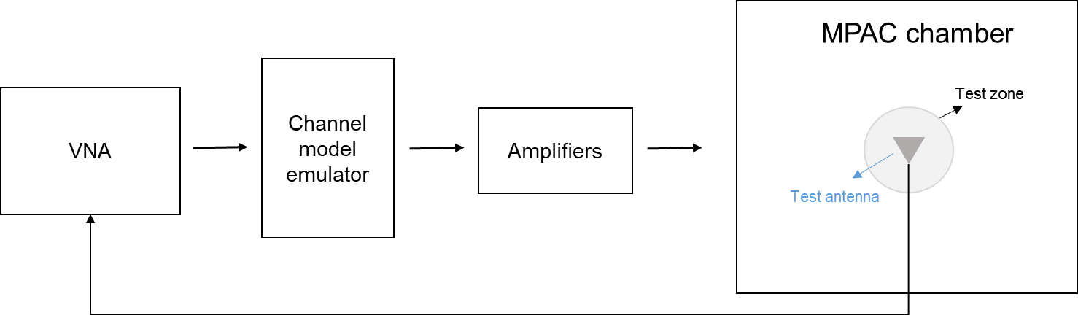
Figure 7.4.1.1-1: Setup for PDP measurements
Step the emulation and store traces from VNA. I.e. run the emulation to CIR number 1, pause, measure VNA trace, run the emulation to CIR number 10, pause, measure VNA trace. Continue until 1000 VNA traces are measured.
VNA settings:
Table 7.4.1.1-1: VNA settings for PDP measurements
Item | Unit | Value
Center frequency | MHz | Downlink center frequency  in Table 7.4.1-1
Span | MHz | 200
Number of traces |  | 1000
Number of points |  | 1101
Averaging |  | 1

Channel model specification:
Table 7.4.1.1-2: Channel model specification for PDP measurements
Item | Unit | Value
Center frequency | MHz | Downlink center frequency  in Table 7.4.1-1
Distance between traces in channel model | wavelength (Note) | > 2
Channel model |  | As specified in Clause 7.2
NOTE: Time [s] = distance [λ] / MS speed [λ/s]
MS speed [λ/s] = MS speed [m/s] / Speed of light [m/s] * Center frequency [Hz]

Method of measurement result analysis:
Measured VNA traces (frequency responses H(t,f)) are saved into a hard drive. The data is read into, e.g., Matlab.
The analysis is performed by taking the Inverse Fourier transform of each FR. The resulting impulse responses h(t,τ) are averaged in power over time:
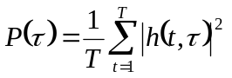
Finally, the resulting PDP is shifted in delay, such that the first tap is on delay zero.
FR2 PDP validation procedure for MPAC system:
The PDP measurement is performed with a Vector Network Analyzer (VNA). An example setup for PDP measurement is shown in Figure 7.4.1.1-2. VNA transmits frequency sweep signals thorough the NR MIMO OTA test system. A reference antenna, within the centre of the test zone, receives the signal and VNA analyses the frequency response of the system. A number of traces (frequency responses) are measured and recorded by VNA and analyzed by a post processing SW, e.g., Matlab. Special care has to be taken into account to keep the fading conditions unchanged, i.e. frozen, during the short period of time of a single trace measurement. The fading may proceed only in between traces.
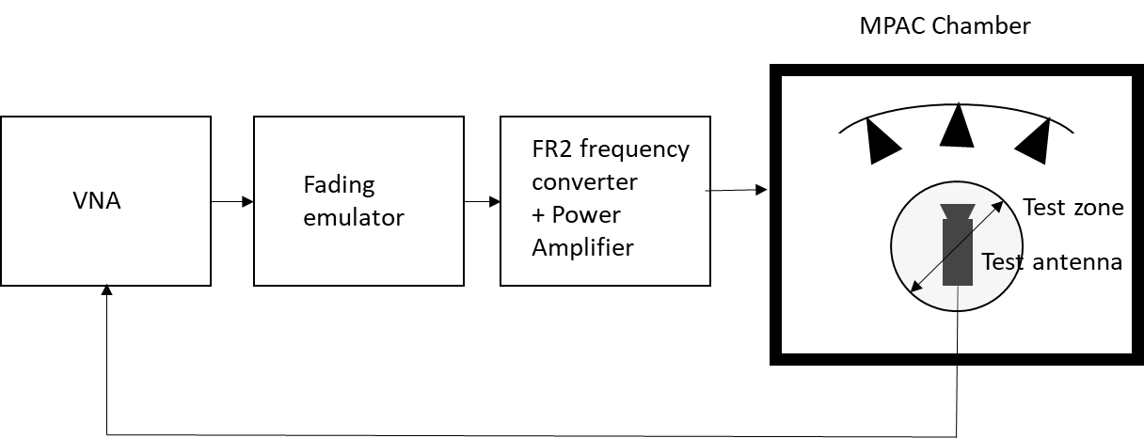
Figure 7.4.1.1-2: Setup for PDP measurements (FR2)
Step the emulation and store traces from VNA. I.e. run the emulation to CIR number 1, pause, measure VNA trace, run the emulation to CIR number 10, pause, measure VNA trace. Continue until 1000 VNA traces are measured.
VNA settings:
Table 7.4.1.1-1: VNA settings for PDP measurements
Item | Unit | Value
Center frequency | MHz | Downlink center frequency  in Table 7.4.1-2
Span | MHz | 200
Number of traces |  | 1000
Number of points |  | 1101
Averaging |  | 1

Channel model specification:
Table 7.4.1.1-3: Channel model specification for FR2 PDP measurements
Item | Unit | Value
Center frequency | MHz | Downlink center frequency  in Table 7.4.1-2
Distance between traces in channel model | wavelength (Note) | > 2
Channel model |  | As specified in Clause 7.2
NOTE: Time [s] = distance [λ] / MS speed [λ/s]
MS speed [λ/s] = MS speed [m/s] / Speed of light [m/s] * Center frequency [Hz]

Method of measurement result analysis:
Measured VNA traces (frequency responses H(t,f)) are saved into a hard drive. The data is read into, e.g., Matlab.
The analysis is performed by taking the Inverse Fourier transform of each trace. The resulting impulse responses h(t,τ) are averaged in power over time:
Finally, the resulting PDP is shifted in delay, such that the first tap is on delay zero.

7.4.1.2 Doppler/Temporal correlation
This measurement checks the Doppler/temporal correlation. For Doppler/Temporal correlation validation measurement, only Vertical validation is required.

FR1 Doppler/Temporal correlation validation procedure for MPAC system:
The Doppler spectrum is measured with a spectrum analyzer as shown in Figure 7.4.1.2-1. In this case a signal generator transmits CW signal through the NR MIMO OTA test system. The signal is received by a test antenna within the test area. Finally the signal is analyzed by a spectrum analyzer and the measured spectrum is compared to the target spectrum. This setup can be used to measure Doppler Spectrum of the Channel models defined in Clause 7.2.
Method of measurement:
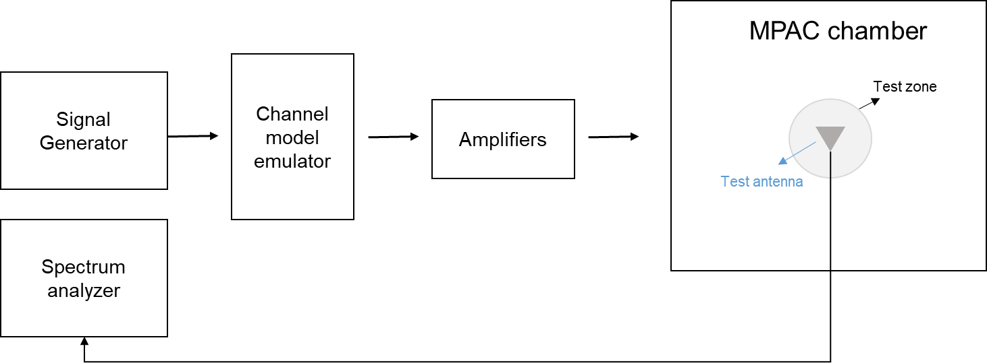
Figure 7.4.1.2-1: Setup for Doppler measurements
Sine wave (CW, carrier wave) signal is transmitted from the signal generator. The signal is connected from the signal generator to fading emulator via cables. The fading emulator output signals are connected to power amplifier boxes via cables. The amplified signals are then transferred via cables to the probe antennas. The probe antennas radiate the signals over the air to the test antenna The Doppler spectrum is measured by the spectrum analyzer and the trace is saved.
Signal generator settings:
Table 7.4.1.2-1: Signal generator settings for Doppler/Temporal correlation measurements
Item | Unit | Value
Center frequency | MHz | Downlink center frequency  in Table 7.4.1-1
Modulation |  | OFF

Spectrum analyzer settings:
Table 7.4.1.2-2: Spectrum analyzer settings for Doppler/Temporal correlation measurements
Item | Unit | Value
Center frequency | MHz | Downlink center frequency  in Table 7.4.1-1
Minimum Span | Hz | 4 kHz
RBW | Hz | 1
VBW | Hz | 1
Number of points |  | 16002
Averaging |  | 100

Channel model specification:
Table 7.4.1.2-3: Channel model specification for Doppler/Temporal correlation measurements
Item | Unit | Value
Center frequency | MHz | Downlink center frequency  in Table 7.4.1-1
Channel model |  | As specified in Clause 7.2
Mobile speed | km/h | 100

Method of measurement result analysis: Measurement data file (Doppler power spectrum) is saved into hard drive. The data is read into, e.g., Matlab. The analysis is performed by taking the Fourier transformation of the Doppler spectrum. The resulting temporal correlation function 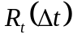 is normalized such that 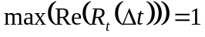. Then the function values left from the maximum is cut out. Further on the function values after, e.g. seven periods is cut out.
FR2 Doppler/Temporal correlation validation procedure for MPAC system:
The Doppler spectrum is measured with a spectrum analyzer as shown in Figure 7.4.1.2-2. In this case a signal generator transmits CW signal through the NR MIMO OTA test system. The signal is received by a test antenna within the test area. Finally, the signal is analysed by a spectrum analyser and the measured spectrum is compared to the target spectrum. This setup can be used to measure Doppler Spectrum of the Channel models defined in Clause 7.2.
Method of measurement:
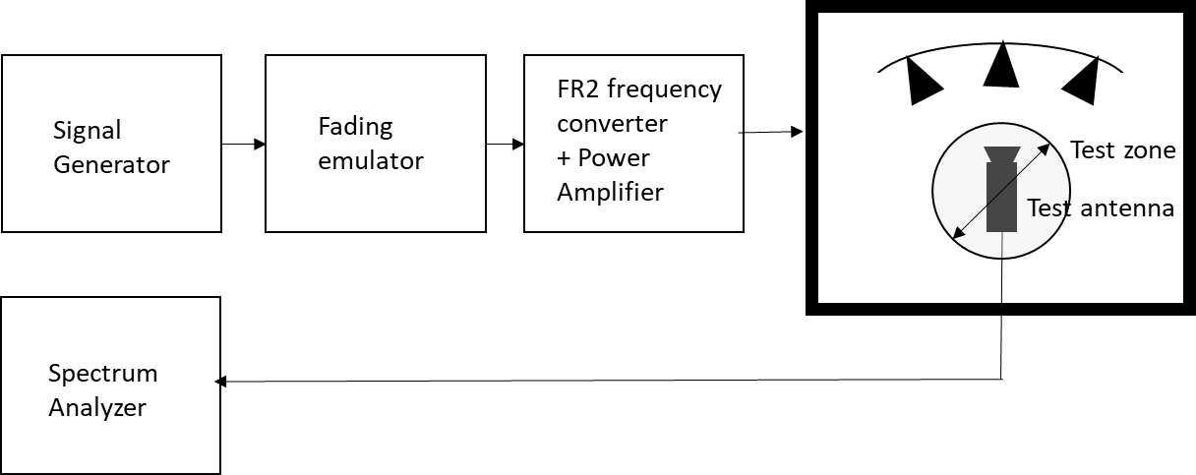
Figure 7.4.1.2-2: Setup for Doppler measurements
Sine wave (CW, carrier wave) signal is transmitted from the signal generator. The signal is connected from the signal generator to fading emulator via cables. The fading emulator output signals are connected to frequency converter and power amplifier boxes via cables. The amplified signals are then transferred via cables to the probe antennas. The probe antennas radiate the signals over the air to the test antenna The Doppler spectrum is measured by the spectrum analyzer and the trace is saved.
Signal generator settings:
Table 7.4.1.2-2: Signal generator settings for Doppler/Temporal correlation measurements
Item | Unit | Value
Center frequency | MHz | Downlink center frequency  in Table 7.4.1-2
Modulation |  | OFF

Spectrum analyzer settings:
Table 7.4.1.2-2: Spectrum analyzer settings for Doppler/Temporal correlation measurements
Item | Unit | Value
Center frequency | MHz | Downlink center frequency  in Table 7.4.1-2
Minimum Span | Hz | 4 kHz
RBW | Hz | 1
VBW | Hz | 1
Number of points |  | 16002
Averaging |  | 100

Channel model specification:
Table 7.4.1.2-3: Channel model specification for Doppler/Temporal correlation measurements
Item | Unit | Value
Center frequency | MHz | Downlink center frequency  in Table 7.4.1-2
Channel model |  | As specified in Clause 7.2
Mobile speed | km/h | 3

Method of measurement result analysis: Measurement data file (Doppler power spectrum) is saved into hard drive. The data is read into, e.g., Matlab. The analysis is performed by taking the Fourier transformation of the Doppler spectrum. The resulting temporal correlation function is normalized such that . Then the function values left from the maximum is cut out. Further on the function values after, e.g. seven periods is cut out.

7.4.1.3 Spatial correlation
This measurement checks whether the measured correlation curve follows the theoretical curve. For spatial correlation validation measurement, both Vertical and Horizontal validation are required.
The spatial correlation validation measurement setup is illustrated in Figure 7.4.1.3-1. The network analyser transmits signals through the fading emulator and probes. The 16 probes radiate the signals within the anechoic chamber and a receiving test antenna is placed within the test zone. The test antenna is attached to a positioner that can move the antenna to pre-defined spatial locations on a fixed radius from the centre of the quiet zone. The received signal is measured with the network analyser.
The measurement and analysis procedure is as follows:
- Set the target channel model to fading emulator.
- For each position of the test antenna in the test zone, step & pause the emulator to different time instances. Measure the frequency responses for all stepped channel snapshots 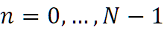, where the interval between frequency and time samples is 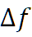 and 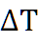, respectively. The number of channel snapshots and frequency samples should be sufficiently high so that the matrix can be estimated reliably.
- Move the measurement antenna with a positioner to another location and repeat step 2 to record frequency responses 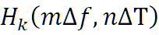 of all stepped channel snapshots.
- Repeat step 3 to record frequency responses at all 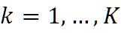 spatial sample points.
- Stack measured time and frequency samples to a vector and calculate correlation between the first spatial sample point (i.e. 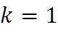) and other spatial points 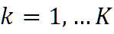
- Take the theoretical reference spatial correlation of the corresponding spatial sample points. Plot both the measured and theoretical curves.
- Calculate the weighted rms correlation error between the measured and the refence.

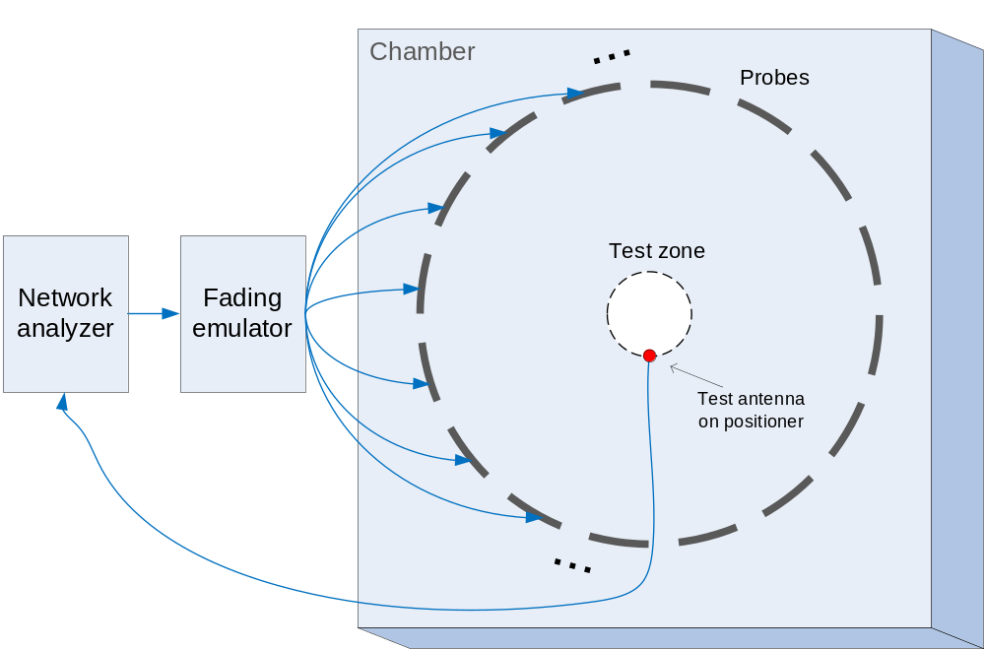
Figure 7.4.1.3-1: Configuration for spatial correlation validation

Time and frequency samples
The number of temporal snapshots N and frequency samples M is TBD. They must be chosen to minimize the validation measurement time, but sufficiently high to keep an adequate correlation estimation accuracy. It is beneficial to choose the time sampling interval 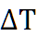 larger than the coherence time of the channel model. such that the recorded time samples represent independent fading occasions. The same principle applies also to frequency sampling interval 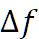 and the channel coherence bandwidth.
Spatial samples
The spatial samples for the correlation validation measurement are on the circumference of the quiet zone, as illustrated in Figure 7.4.1.3-2. The test zone is a circle with 20 cm diameter in the horizontal plane. The reference point (denoted by a red marker) is in AoA 270°. The mean AoAs of the CDL-A and CDL-C models are slightly different, but the underlying geometry for the CDL model indicates that the mean AoA (or assumed LoS direction) of the model is 180°. The reference point orientation of the validation measurement is proposed to be with 90° offset to the channel model reference AoA to enable accurate sampling of the main lobe of the spatial correlation curve. The reference point orientation must be defined in the channel model coordinate system instead of the chamber/probe coordinate system to enable optimization of OTA model implementation to achieve better alignment with the cluster AoAs and probe directions. The spacing of the spatial samples is TBD.

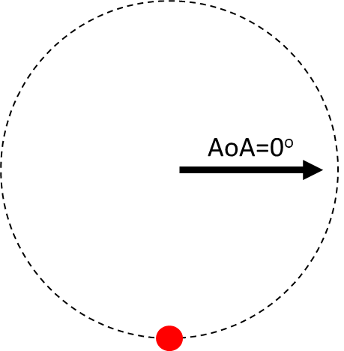
Figure 7.4.1.3-2: Spatial sampling for spatial correlation validation measurement

7.4.1.4 Cross-polarization
FR1 Cross-Polarization
This measurement checks how well the measured vertically or horizontally polarized power levels follow expected values. The test setup for cross-polarization is the same as PDP validation in Figure 7.4.1.1-1.
Method of measurement: Step the emulation and store traces from VNA.
VNA settings:
Table 7.4.1.4-1: VNA settings for cross-polarization
Item | Unit | Value
Center frequency | MHz | Downlink Center Frequency  in Table 7.4.1-1
Span | MHz | 40
Number of traces |  | 1000
Number of points |  | 802
Averaging |  | 1

Channel model specification:
Table 7.4.1.4-2: Channel model specification for cross-polarization.
Item | Unit | Value
Center frequency | MHz | Downlink center frequency  in Table 7.4.1-1
Distance between traces in channel model | wavelength (Note) | > 2
Channel model |  | As specified in Clause 7.2
Mobile speed | km/h | 30
NOTE: Time [s] = distance [λ] / MS speed [λ/s]
MS speed [λ/s] = MS speed [m /s] / Speed of light [m/s] * Center frequency [Hz]

Measurement Procedure:
1. Play or step through the channel model listed in clause 7.2.
2. Measure the absolute power received at the center of the test zone, averaged over a statistically significant number of fades.
a. Use a vertically polarized sleeve dipole to measure the V component.
b. Use a horizontally polarized (vertically oriented) magnetic loop dipole, or a horizontally polarized sleeve dipole measured in four orthogonal horizontal positions and summed to measure the H component.
3. Calculate the V/H ratio.
4. Compare it with the theory value.
FR2 Cross polarization
This measurement checks how well the measured vertically or horizontally polarized power levels follow expected values. The test setup for cross-polarization is the same as PDP validation in Figure 7.4.1.1-2.
Method of measurement: Step the emulation and store traces from VNA.
VNA settings:
Table 7.4.1.4-1: VNA settings for cross-polarization
Item | Unit | Value
Center frequency | MHz | Downlink Center Frequency  in Table 7.4.1-2
Span | MHz | 40
Number of traces |  | 1000
Number of points |  | 802
Averaging |  | 1

Channel model specification:
Table 7.4.1.4-2: Channel model specification for cross-polarization.
Item | Unit | Value
Center frequency | MHz | Downlink center frequency  in Table 7.4.1-2
Distance between traces in channel model | wavelength (Note) | > 2
Channel model |  | As specified in Clause 7.2
Mobile speed | km/h | 3
NOTE: Time [s] = distance [λ] / MS speed [λ/s]
MS speed [λ/s] = MS speed [m /s] / Speed of light [m/s] * Center frequency [Hz]

Measurement Procedure:
1. Play or step through the channel model listed in clause 7.2.
2. Measure the absolute power received at the center of the test zone, averaged over a statistically significant number of fades.
a. Use a dual polarized horn antenna and by terminating the H branch of antenna to measure the V component.
b. Use a dual polarized horn antenna and by terminating the V branch of antenna to measure the H component.
3. Calculate the V/H ratio.
4. Compare it with the theory value.

7.4.1.5 Power validation
FR1 Power validation
This measurement checks the total power in the center of the test zone. The power validation is measured with a spectrum analyzer as shown in Figure 7.4.1.5-1.
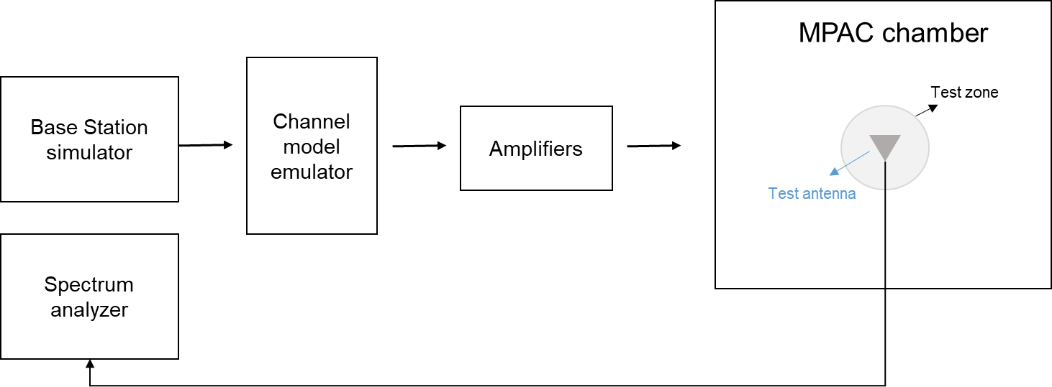
Figure 7.4.1.5-1: Setup for power validation measurements
Spectrum analyzer settings:
Table 7.4.1.5-1: Spectrum analyzer settings for Doppler/Temporal correlation measurements
Item | Unit | Value
Center frequency | MHz | Downlink center frequency  in Table 7.4.1-1
Integrated Channel Span | Hz | 20MHz
RBW | Hz | 30 kHz
VBW | Hz | ≥10MHz
Number of points |  | ≥400
Averaging |  | ≥100
Detector |  | RMS

Measurement Procedure:
1. Place a vertical reference dipole in the center of the test zone connected to a spectrum analyzer (or power meter) via a cable.
2. Record the cable and reference dipole gains.
3. Load the target channel model into the channel emulator.
4. Start the NR FR1 signaling in the base station emulator with the required parameter identical to the measurements conditions.
5. Average the power received by the spectrum analyzer for a sufficient amount of time to account for the fading channel – one full channel simulation might be unnecessary.
6. Repeat steps 1 to 4 with a magnetic loop for the horizontal polarization, or a horizontally polarized sleeve dipole measured in four orthogonal horizontal positions and summed to measure the H component.
7. Calculate the total power received at the test area as the sum of the power in the two polarizations.

FR2 Power validation
This measurement checks the total power in the centre of the test zone. The power validation is measured with a spectrum analyser as shown in Figure 7.4.1.5-2.
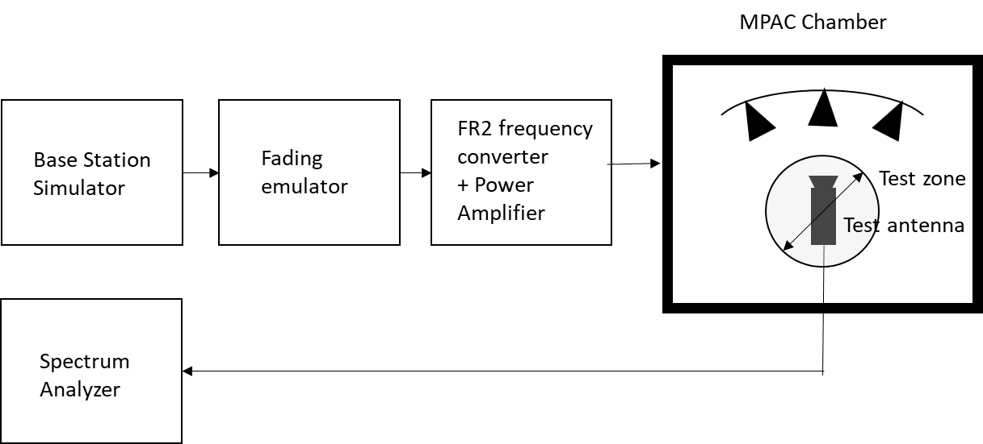
Figure 7.4.1.5-2: Setup for power validation measurements
Spectrum analyzer settings:
Table 7.4.1.5-1: Spectrum analyzer settings for Doppler/Temporal correlation measurements
Item | Unit | Value
Center frequency | MHz | Downlink center frequency  in Table 7.4.1-2
Integrated Channel Span | Hz | 20MHz
RBW | Hz | 30 kHz
VBW | Hz | ≥10MHz
Number of points |  | ≥400
Averaging |  | ≥100
Detector |  | RMS

Measurement Procedure:
1. Place a horn antenna with H polarization terminated in the centre of the test zone connected to a spectrum analyzer (or power meter) via a cable.
2. Record the cable and horn antenna gains.
3. Load the target channel model into the channel emulator.
4. Start the NR FR2 signalling in the base station emulator with the required parameter identical to the measurements conditions.
5. Average the power received by the spectrum analyzer for a sufficient amount of time to account for the fading channel – one full channel simulation might be unnecessary.
6. Repeat steps 1 to 4 with a horn antenna V polarization terminated for the horizontal polarization, in four orthogonal horizontal positions and summed to measure the H component.
7. Calculate the total power received at the test area as the sum of the power in the two polarizations.

7.4.1.6 PAS similarity percentage (PSP)
This measurement validates the proper angular behaviour in the test zone. The PSP validation is measured with a vector network analyzer as shown in Figure 7.4.1.6-1). To limit the measurement time, 7 positions in test zone is used: One in centre and 6 in boundary of the test zone.
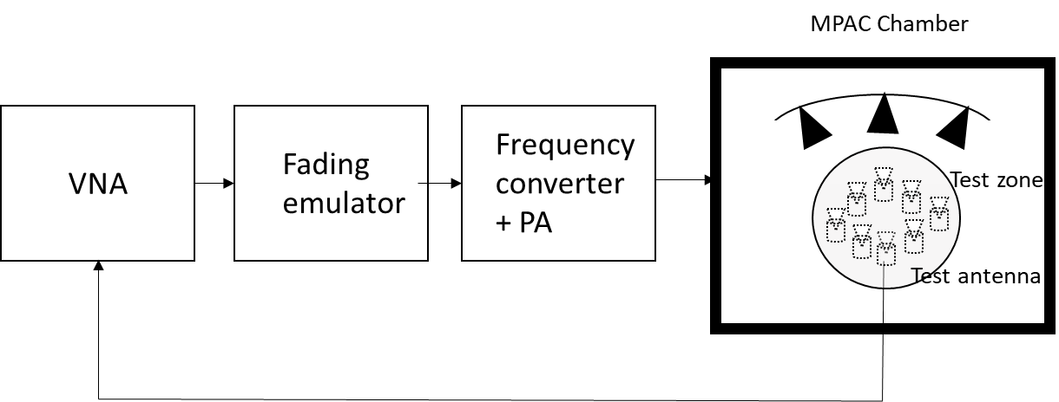
Figure 7.4.1.6-1: Setup for PSP validation measurements

The PSP validation measurement setup is illustrated in Figure 7.4.1.6-1. The network analyser transmits signals through the fading emulator and probes. The N (N to be defined) probes radiate the signals within the anechoic chamber and a receiving test antenna is placed within the test zone. The test antenna is attached to a positioner that can move the antenna to pre-defined spatial locations on a fixed radius from the centre of the quiet zone. The received signal is measured with the network analyser. Test antenna is directive antenna with sufficient 3dB bandwidth. If the directive antenna has V (vertical) and H (horizontal) connectors, H connector shall be terminated. It is enough to validate PSP in vertical domain only.
The measurement and analysis procedure are as follows:
- Set the target channel model to fading emulator.
- For each position of the test antenna in the test zone, step & pause the emulator to different time instances. Measure the frequency responses for all stepped channel snapshots , where the interval between frequency and time samples is and , respectively. The number of channel snapshots and frequency samples should be sufficiently high so that the matrix can be estimated reliably.
- Move the measurement antenna with a positioner to another location and repeat step 2 to record frequency responses of all stepped channel snapshots.
- Repeat step 3 to record frequency responses at all spatial sample points.
- Stack measured time and frequency samples to a vector and calculate correlation between the first spatial sample point (i.e. ) and other spatial points
- Take the theoretical reference spatial correlation with theoretical PAS in all antenna position combinations
- Calculate the weighted rms correlation error between the measured and the refence.
VNA settings:
Table 7.4.1.6-1: VNA settings for PDP measurements
Item | Unit | Value
Center frequency | MHz | Downlink center frequency  in Table 7.4.1-2
Span | MHz | 200
Number of traces |  | 300
Number of points |  | 1101
Averaging |  | 1

Channel model specification:
Table 7.4.1.6-2: Channel model specification for FR2 PSP measurements
Item | Unit | Value
Center frequency | MHz | Downlink center frequency  in Table 7.4.1-2
Distance between traces in channel model | wavelength (Note) | > 2
Channel model |  | As specified in Clause 7.2
NOTE: Time [s] = distance [λ] / MS speed [λ/s]
MS speed [λ/s] = MS speed [m/s] / Speed of light [m/s] * Center frequency [Hz]

Method of measurement result analysis:
Measured correlation is compared to theoretical correlation with the filtered channel model PAS and mean angle. Weighted difference is calculated.

Time Domain Alternative Method:
Chamber
Fading
emulator
Signal
Analyzer
Test antenna
Signal
Generator
Trigger
Figure 7.4.1.6-2: Setup for PSP validation measurements based on time domain
Table 7.4.1.6-3: Signal Generator Settings
Item | Unit | Value
Center frequency | MHz | Downlink centre frequency in 3GPP as required per band
Output power | dBm | Function of the CE. Sufficiently above Noise Floor

Table 7.4.1.6-4: CE Settings

Item | Unit | Value
Center frequency | MHz | Downlink center frequency  in Table 7.4.1-2
Output power | dBm | Sufficiently above Noise Floor
Input power | dBm | Matched to output power of SG
Channel |  | As per required CDL
Mobile Speed | Km/hr | As per required CDL
Doppler Spread |  | As per required CDL

Table 7.4.1.6-4: Signal Analyzer Settings
Item | Unit | Value
Center frequency | MHz | Downlink centre frequency in 3GPP as required per band
Sampling | Hz | At least 8 times bigger than the max Doppler spread
Observation time | s | At least 32s

The measurement and analysis procedure are as follows:
- Set the target channel model to fading emulator.
- For each position of the test antenna in the test zone, rewind the channel emulator fading sequence to the same initial point.
- Begin playing. At this time, a trigger signal will prompt the signal analyzer to begin collecting time domain fading h_{k}(t). Stop collecting after at least 32s. The vector is a column vector with n samples.
- Move the measurement antenna with a positioner to another location and repeat step 2 to record time domain fading h_{k}(t).
- Repeat step 3 to record frequency responses at all spatial sample points.
- Create an observation matrix P with the K h_{k}(t) time domain vectors. Where P = [h₁(t),… h_{k}(t)]
- Calculate ρ=corr(P)
- Take the theoretical reference spatial correlation with theoretical PAS in all antenna position combinations
- Calculate the weighted rms correlation error between the measured and the refence.
Method of measurement result analysis:
Measured correlation is compared to theoretical correlation with the filtered channel model PAS and mean angle. Weighted difference is calculated.

7.4.1.7 Correlation matrix
<Editor’s note: whether using the correlation matrix to validate the FR1 channel model is FFS >

7.4.2 Pass/Fail Criteria

========================== End of change 1==========================

